Table S1 Coding methods and cutpoint rationale for all variables
Covariate | Definition | Coding Method | Cutpoint Rationale
Age | Age was calculated based on the date of birth recorded in the patient's ID card, with precision to the year. | Continuous: years | /
Sex | / | Categorical: 0 = female, 1 = male | /
Alcohol Consumption | Based on patients' self-report | Categorical: 0 = never, 1 = past, 2 = current drinker | One standard alcohol unit was defined as 10 grams (g) of pure ethanol, consistent with the Chinese Guidelines for Dietary Guidelines (2022) and international standards for alcohol research. Alcohol consumption: Categorized as never drank, past drinker (ceased ≥1 year), or current drinker. One standard alcohol unit = 10 g pure ethanol (equivalent to 250 mL beer, 100 mL wine, or 30 mL liquor). Current drinker thresholds: men ≥14 units/week, women ≥7 units/week (based on sex-specific metabolism differences and WHO guidelines);
Smoking History | Based on patients' self-report | Categorical: 0 = never, 1 = past, 2 = current drinker | The critical value is based on the definition of "regular smoking" as stated in the "Chinese Clinical Smoking Cessation Guidelines (2022)". Categorized as never smoked, past smoker (quit ≥1 year), or current smoker (≥1 cigarette/day for ≥6 months).
Educational Level | Based on patients' self-report | Categorical：0 = < 5 years (incomplete primary school or lower)1 = ≥ 5 years (completed primary school or higher) | With reference to the distribution characteristics of educational levels among the elderly population in China, 5 years is a common duration for completing primary education.
Residence | Classified by patients' long-term residential address (residing for ≥ 6 months) | Categorical: 0 = Rural (townships and below)  1 = Urban (county-level cities and above) | In accordance with the standards specified in the National Bureau of Statistics' Statistical Division Code and Urban-Rural Division Code.
BMI | kg/m² | Continuous，kg/m² | /
Comorbidities | Based on electronic medical records | Categorical: 0 = No(＜2 chronic diseases), 1 = Yes(≥2 chronic diseases) | China Chronic Disease Coding Catalogue
Polypharmacy | Based on electronic medical records | Categorical: 0 = No(＜5 medications), 1 = Yes (≥5 medications) | five or more medications are considered polypharmacy, with polypharmacy referenced from the Chinese Geriatric Inappropriate Medication Directory
Abbreviations: BMI, Body Mass Index.

Table S2 Chronic diseases included in comorbidities and their corresponding ICD-10 codes
Disease category | Diseases | ICD-10
Cardiovascular diseases | Hypertension | I10-I15
 | Coronary heart disease | I20-I25
 | Heart failure | I50
 | Stroke/transient ischemic attack | I60-I69
Metabolic diseases | Type 2 diabetes mellitus | E11
 | Dyslipidemia | E78
 | Obesity | E66
Respiratory diseases | Chronic obstructive pulmonary disease | J44
 | Asthma | J45-J46
 | Interstitial lung disease | J84
Musculoskeletal diseases | Osteoarthritis | M15-M19
 | Rheumatoid arthritis | M05-M06
 | Osteoporosis | M80-M81
Neurological diseases | Parkinson’s disease | G20
 | Alzheimer’s disease/dementia | G30, F01-F03
Renal/hepatic diseases | Chronic kidney disease | N18
 | Chronic liver disease | K70, K73-K74
Abbreviations: ICD-10, International Classification of Diseases, 10th Revision

Table S3 Laboratory details of inflammatory biomarkers
 | IL-6、IL-10、TNF-α | hs-CRP
Manufacturer | Jiangxi Saiji Biotechnology Co., Ltd. | Micon Bioengineering Co., Ltd.
Registration Certificate Number | Jiangxi Medical Device Registration Approval 20192400359 | Zhejiang Medical Device Registration Approval 20222401135
Production License Number | Jiangxi Pharmaceutical Supervision Medical Device Production License No. 20190277 | Zhejiang Pharmaceutical Pharmaceutical Supervision Medical Device Production License No. 20130042
Limit of Detection | 2.5pg/mL | 0.5mg/L
Limit of Quantitation | 2500pg/mL | 300mg/L
Dynamic Range | 2.5-2500pg/mL | 0.5-300mg/L
Intra-assay Coefficient of Variation | ≤15% | ≤10%
Inter-assay Coefficient of Variation | ≤15% | ≤15%
Abbreviations: hs-CRP, high-sensitivity C-reactive protein; IL-6, interleukin-6; IL-10, interleukin-10; TNF-α, tumor necrosis factor-alpha.

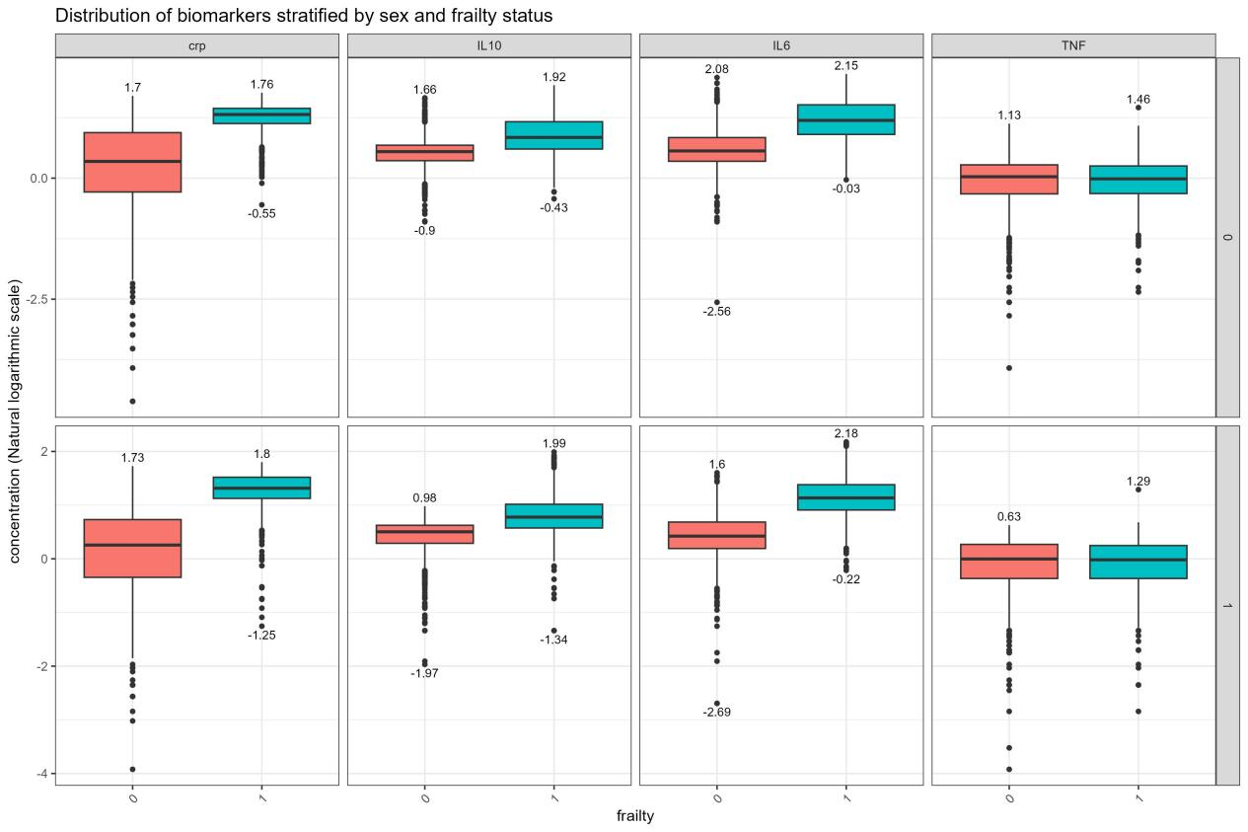
Figure S1 Boxplots of Inflammatory Biomarkers Stratified by Sex and Frailty Status

