Table S1 Clinical Design Used to Build the Non-Pregnant Women PBPK Model of Venlafaxine and ODV
Ref. | Trial size | Age (years) | Proportion of females | Dosing regimen | Population
Model development
²⁹ | 10×22 | 18–45 | 1.0 | 150 mg XR qd |  | Non-pregnant women  Gestational week: 0
²⁹ | 10×22 | 18–45 | 1.0 | 150 mg XR qd
Model evaluation
³⁴ | 10×12 | 18–45 | 1.0 | 75 mg XR qd |  | Non-pregnant women  Gestational week: 0
³⁴ | 10×15 | 18–45 | 1.0 | 150 mg XR qd
³⁴ | 10×18 | 18–45 | 1.0 | 75 mg XR qd for 4 days

Abbreviations: PBPK: physiologically based pharmacokinetic, ODV: O-desmethylvenlafaxine, XR: extended release, qd: once daily

Table S2 Clinical Design Used to Build the Pregnant Women PBPK Model of Venlafaxine and ODV
Ref. | Age (years) | Proportion of females | Trial size | Dosing regimen | Population
¹⁶ | 26–34 | 1.0 | 10×10 | 37.5 mg for 7 days | Non-pregnant women:  0 week
 |  |  |  |  | First trimester: 7 weeks
 |  |  |  |  | Second trimester: 21 weeks
 |  |  |  |  | Third trimester: 35 weeks
¹⁶ | 26–34 | 1.0 | 10×10 | 75 mg daily for 7 days | Non-pregnant women:  0 week
 |  |  |  |  | First trimester: 7 weeks
 |  |  |  |  | Second trimester: 21 week
 |  |  |  |  | Third trimester: 35 weeks
¹⁶ | 26–34 | 1.0 | 10×10 | 150 mg daily for 7 days | Non-pregnant women:  0 week
 |  |  |  |  | First trimester: 7 weeks
 |  |  |  |  | Second trimester: 21 weeks
 |  |  |  |  | Third trimester: 35 weeks
¹⁶ | 26–34 | 1.0 | 10×10 | 225 mg daily for 7 days | Non-pregnant women: 0 week
 |  |  |  |  | First trimester: 7 weeks
 |  |  |  |  | Second trimester: 21 weeks
 |  |  |  |  | Third trimester: 35 weeks
Abbreviations: PBPK: physiologically based pharmacokinetic, ODV: O-desmethylvenlafaxine

Table S3 Clinical Design Used to Build the Fetoplacental PBPK Model of Venlafaxine
Ref. | Trial size | Age (years) | Proportion of females | Gestational week | Dosing regimen | Population
⁴¹ | 10x10 | 28-40 | 1.0 | 39 | 37.5 mg for 7 days | Pregnant women
 |  |  |  | 38 | 75 mg for 7 days | Pregnant women
 |  |  |  | 39 | 112.5 mg for 7 days | Pregnant women
 |  |  |  | 39 | 150 mg for 7 days | Pregnant women
 |  |  |  | 37 | 225 mg for 7 days | Pregnant women

Abbreviation: PBPK: physiologically based pharmacokinetic

Table S4 Clinical Design Used to Build the Fetoplacental PBPK Model of Venlafaxine at a Dose of 375 mg
Trial Size | Age (year) | Proportion of Female | Gestational week | Dosing Regimen | Population
10×10 | 18–45 | 1.0 | 40 | 375 mg for 7 days | Pregnant women

Table S5 Predicted and Observed Parameters and Prediction Ratios After Single or Multiple Oral Administration of Venlafaxine in Non-Pregnant Women
References | Dose | Simulation | C_{max} (ng/mL) |  |  | T_{max} (h) |  |  | AUC (ng·h/mL)
References | Dose | Simulation | Observed | Predicted | Prediction ratio | Observed | Predicted | Observed |  | Predicted | Prediction ratio
²⁹ | 2×75 mg XR | Venlafaxine | 107  (65–149) | 104.24  (42.66–182.29) | 0.97  (0.93–1.02) | 6.1  (4.6–7.6) | 5.79  (4.04–8.00) | 1775  (569–2981) |  | 1863.26  (629.18–3572.87) | 1.05  (0.99–1.10)
²⁹ | 2×75 mg XR | ODV | 163  (110–216) | 161.07  (51.48–298.83) | 0.99  (0.94–1.04) | 10.5  (7.5–13.5) | 11.13  (7.25–15.12) | 4516  (2993–6039) |  | 3878.30  (1199.32–7378.42) | 0.86  (0.81–0.90)
²⁹ | 150 mg XR | Venlafaxine | 101  (65–137) | 104.24  (42.66–182.29) | 1.03  (0.98–1.08) | 5.7  (4.2–7.2) | 5.79  (4.04–8.00) | 1777  (354–3200) |  | 1863.26  (629.18–3572.87) | 1.05  (0.99–1.10)
²⁹ | 150 mg XR | ODV | 167  (118–216) | 161.07  (51.48–298.83) | 0.96  (0.92–1.01) | 12.3  (3.1–21.5) | 11.13  (7.25–15.12) | 4787  (3236–6338) |  | 3878.30  (1199.32–7378.42) | 0.81  (0.77–0.85)
³⁴ | 75 mg XR | Venlafaxine | 45  (29–61) | 51.89  (20.75–91.27) | 1.15  (1.10–1.21) | 6.5  (5.3–7.7) | 5.85  (4.05–8.01) | 841  (545–1137) |  | 1000.56  (315.72–1849.41) | 1.19  (1.13–1.25)
³⁴ | 75 mg XR | ODV | 65  (47–83) | 82.34  (26.45–151.49) | 1.27  (1.20–1.33) | 10.7  (8.5–12.9) | 11.29  (7.54–15.07) | 1967  (1358–2576) |  | 2185.03  (634.52–4401.54) | 1.11  (1.06–1.17)
³⁴ | 150 mg XR | Venlafaxine | 89  (33–145) | 104.16  (43.61–181.28) | 1.17  (1.11–1.23) | 6.1  (5.6–6.6) | 5.82  (4.05–8.00) | 1834  (–677–4345) |  | 2000.16  (659.32–3733.60) | 1.09  (1.04–1.15)
³⁴ | 150 mg XR | ODV | 151  (93–209) | 162.82  (53.19–300.64) | 1.08  (1.02–1.13) | 11.5  (7.5–15.5) | 11.24  (7.35–15.06) | 4418  (3141–5695) |  | 4316.00  (1378.73–8706.90) | 0.98  (0.93–1.03)
³⁴ | 75 mg XR daily | Venlafaxine | 75  (23–127) | 68.78  (24.69–124.18) | 0.92  (0.87–0.96) | 7.2  (5.0–9.4) | 5.44  (4.00–7.16) | 1220  (181–2259) |  | 1027.56  (324.70–1976.55) | 0.84  (0.80–0.88)
³⁴ | 75 mg XR daily | ODV | 121  (68–174) | 116.77  (38.34–223.32) | 0.97  (0.92–1.01) | 9.9  (7.1–12.7) | 9.22  (6.95–11.40) | 2251  (1288–3214) |  | 2185.71  (703.20–4235.30) | 0.97  (0.92–1.02)
All parameters are presented as the arithmetic mean (5th-95th percentile) except prediction ratio, which is presented as the arithmetic mean (95% confidential interval). Abbreviations: ODV: O-desmethylvenlafaxine, C_{max}: maximum plasma concentration, T_{max}: time to maximum plasma concentration, AUC: area under the plasma concentration–time curve

Table S6 Summary of Venlafaxine Dose Optimization Throughout Gestation
Dose | 37.5 mg |  |  | 75 mg |  |  | 150 mg |  |  | 225 mg
Trimester | First | Second | Third | First | Second | Third | First | Second | Third | First | Second | Third
Ven+ODV  C_{min,ss} (ng/mL) | 37.72 | 28.57 | 21.19 | 75.44 | 57.15 | 42.40 | 150.91 | 114.38 | 84.89 | 226.41 | 171.68 | 127.47
Ven+ODV  C_{max,ss} (ng/mL) | 82.23 | 73.49 | 60.25 | 172.39 | 146.93 | 120.48 | 344.46 | 293.68 | 240.90 | 516.21 | 440.24 | 361.25
Abbreviations: C_{min,ss}$:$ minimum plasma concentration, steady state, C_{max,ss}: maximum plasma concentration, steady state

Table S7 Simulated Enzyme Abundance of CYP2D6 by Trimester in Pregnant Women
Population | Trimester | Abundance  (pmol)
Pregnant women | Baseline | 374432.62  (-)
Pregnant women | First | 433667.86  (↑13.66%)
Pregnant women | Second | 651213.21  (↑42.50%)
Pregnant women | Third | 1000858.40  (↑62.59%)
Abundance is presented as the arithmetic mean (percentage compared to baseline). Upward arrows indicate an increase. Abbreviation: CYP2D6: cytochrome P450 2D6

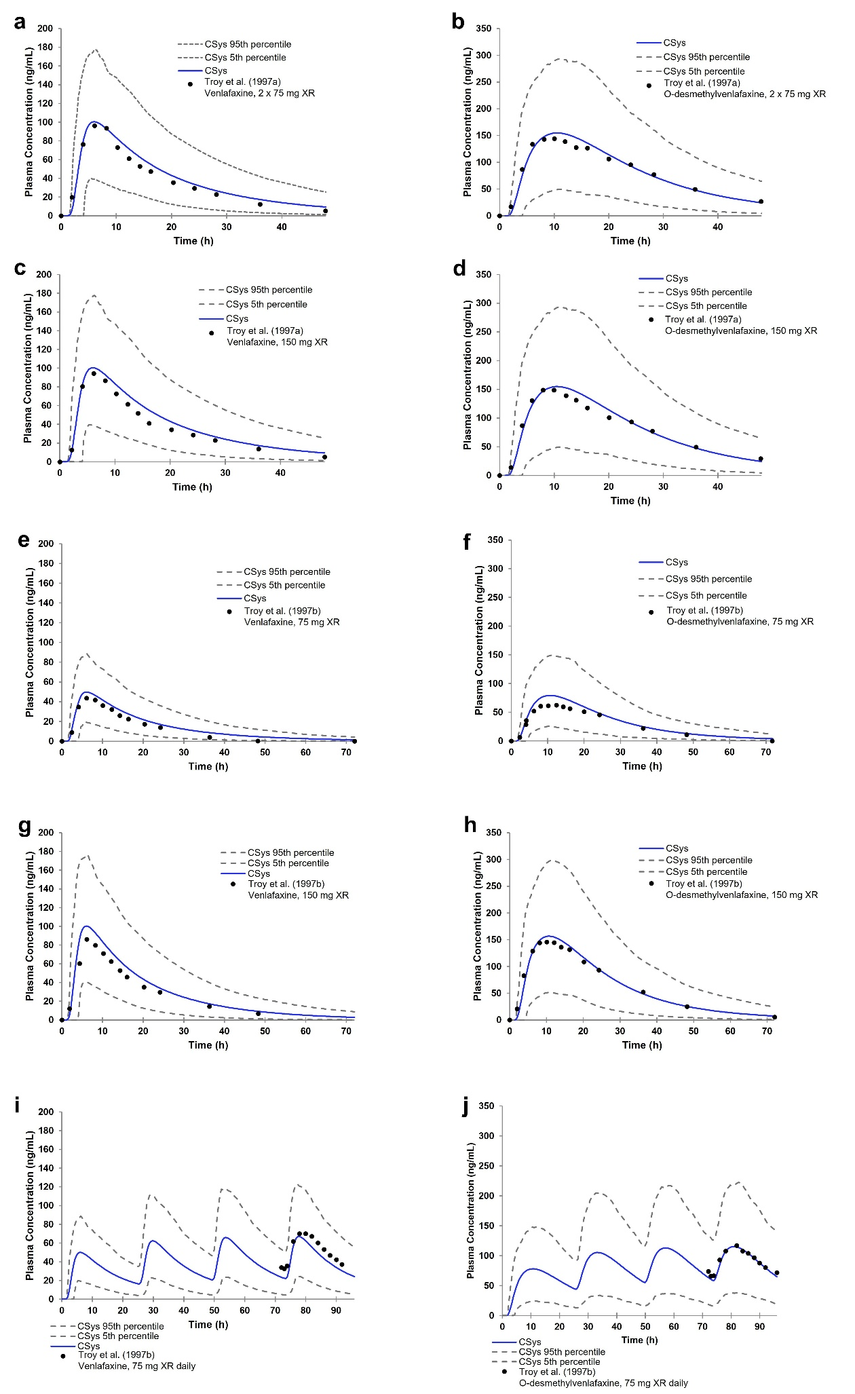
Figure S1 Predicted and observed plasma concentration–time profiles of venlafaxine and ODV following: (a, b) a single 2 × 75 mg dose,²⁹ (c, d) a single 150 mg dose,²⁹ (e, f) a single 75 mg dose,³⁴ (g, h) a single 150 mg dose,³⁴ and (i, j) once-daily 75 mg venlafaxine XR³⁴ in non-pregnant women. The blue line represents the mean predicted plasma concentrations, and the gray dotted lines indicate the 5th and 95th percentiles of predicted concentrations. Circles denote observed mean plasma concentrations. Sample sizes were: (a, b) n = 22; (c, d) n = 22; (e, f) n = 12; (g, h) n = 15; (i, j) n = 18. Abbreviations: ODV, O-desmethylvenlafaxine; XR, extended-release.
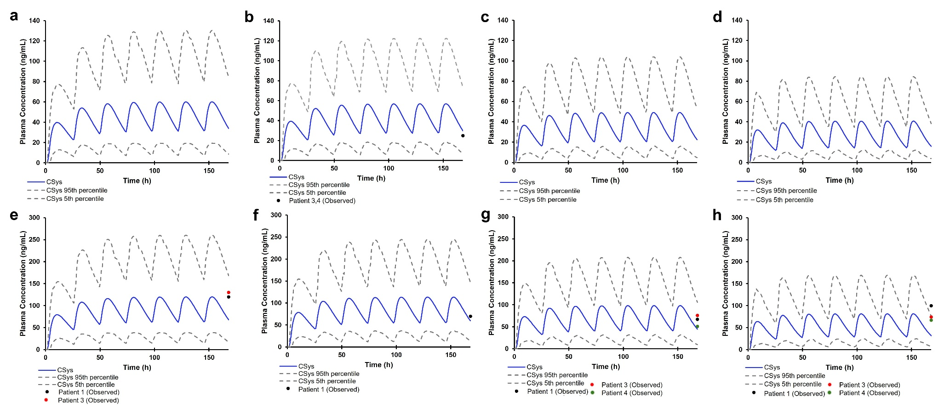
Figure S2 Predicted plasma concentration–time profiles of O-desmethylvenlafaxine (ODV) following once-daily administration of venlafaxine in (a–d) non-pregnant and pregnant women receiving 37.5 mg, and (e–h) those receiving 75 mg. Subfigures (a, e) represent non-pregnant women; (b, f) the first trimester; (c, g) the second trimester; and (d, h) the third trimester. The blue line represents the mean predicted plasma concentrations, and the gray dotted lines denote the 5th and 95th percentiles of predicted concentrations. Circles indicate observed plasma concentrations. Abbreviation: ODV, O-desmethylvenlafaxine.
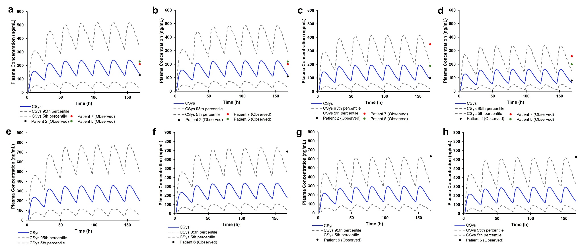
Figure S3 Predicted plasma concentration–time profiles of O-desmethylvenlafaxine (ODV) following once-daily administration of venlafaxine in (a–d) non-pregnant and pregnant women receiving 150 mg, and (e–h) those receiving 225 mg. Subfigures (a, e) represent non-pregnant women; (b, f) the first trimester; (c, g) the second trimester; and (d, h) the third trimester. The blue line represents the mean predicted plasma concentrations, and the gray dotted lines denote the 5th and 95th percentiles of predicted concentrations. Circles indicate observed plasma concentrations. Abbreviation: ODV, O-desmethylvenlafaxine.
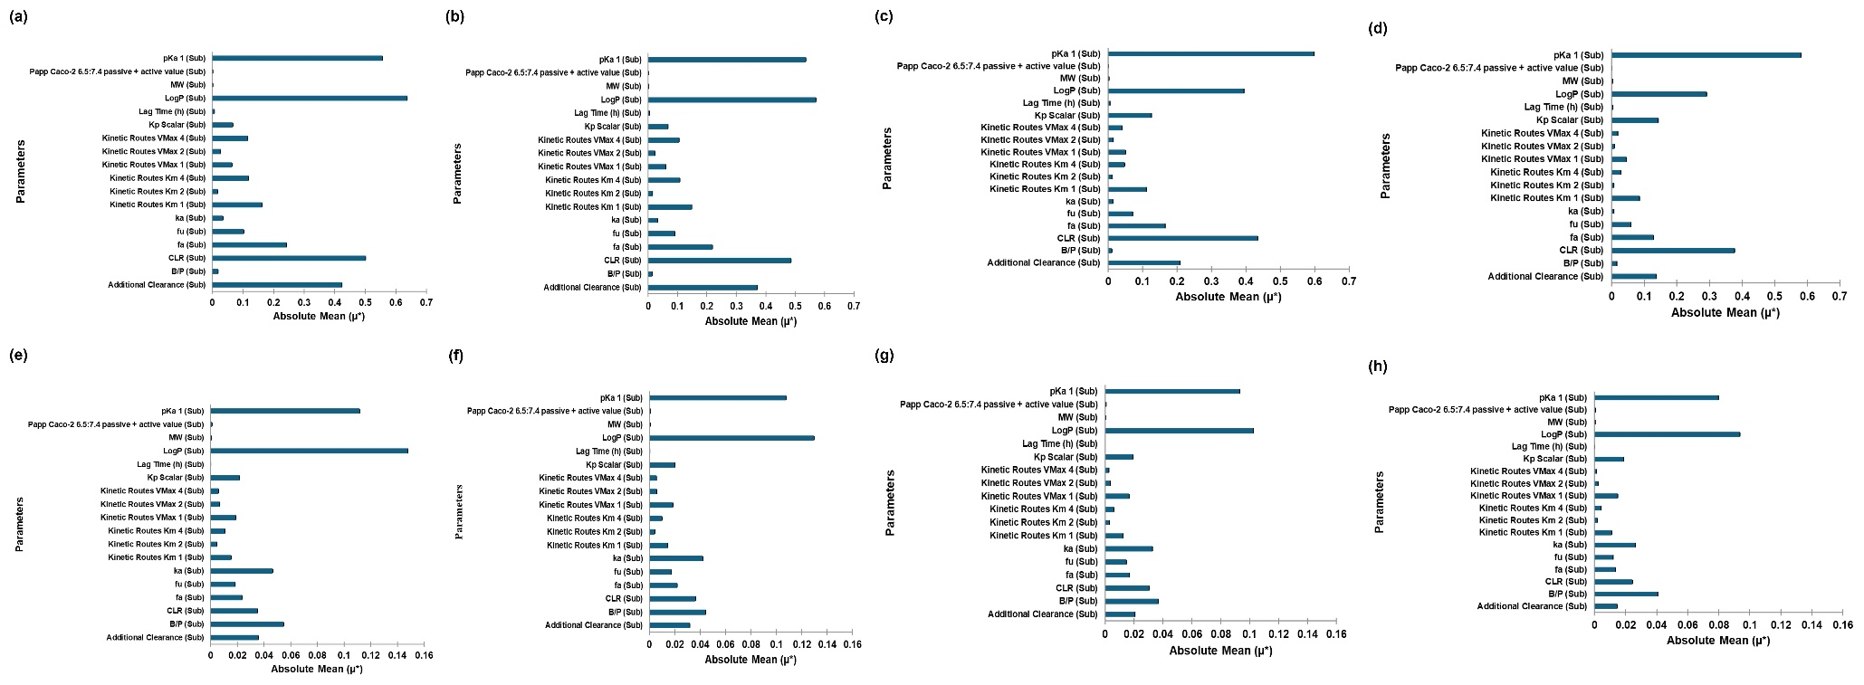
Figure S4 Absolute mean (µ*) of (a–d) AUC and (e–h) Cmax of venlafaxine in (a, e) non-pregnant women and pregnant women during the (b, f) first, (c, g) second, and (d, h) third trimesters. Abbreviations: LogP_{o:w}, logarithm of octanol/water partition coefficient; pK_{a}, negative logarithm of acid dissociation constant; B/P, blood-to-plasma ratio; f_{up}, fraction unbound in plasma; f_{a}, fraction absorbed; k_{a}, absorption rate constant; K_{p} scalar, tissue-to-plasma partition coefficient; V_{max}, maximum reaction rate; K_{m}, substrate concentration at which the reaction rate is half-maximal; CL_{R}, renal clearance; AUC, area under the curve; C_{max}, maximum concentration.
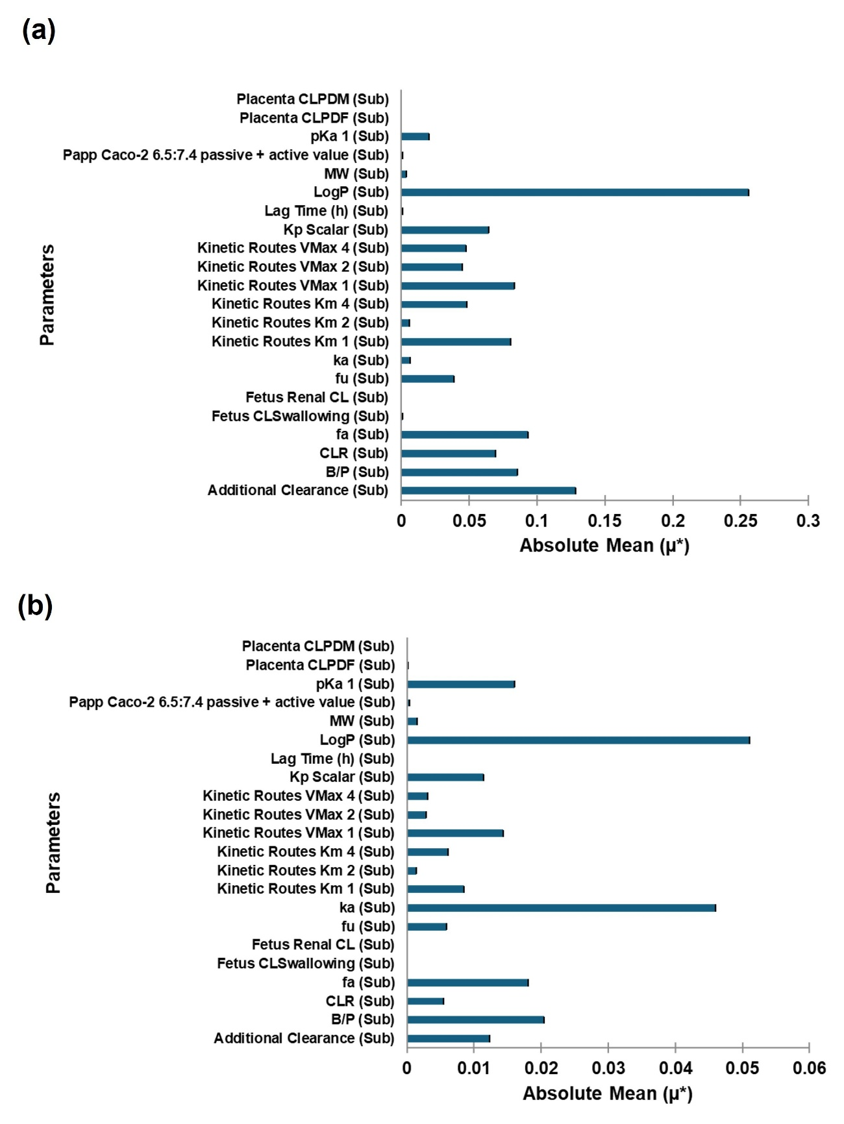
Figure S5 Absolute mean (µ*) of (a) AUC and (b) Cmax of venlafaxine in the fetoplacental unit. Abbreviations: LogP_{o:w}, logarithm of octanol/water partition coefficient; pK_{a}, negative logarithm of acid dissociation constant; B/P, blood-to-plasma ratio; f_{up}, fraction unbound in plasma; f_{a}, fraction absorbed; k_{a}, absorption rate constant; K_{p} scalar, tissue-to-plasma partition coefficient; Vmax, maximum reaction rate; K_{m}, substrate concentration at which the reaction rate is half of its maximal value; CL_{R}, renal clearance; CL_{PDM}, maternal-placental barrier; CL_{PDF}, placenta-fetal barrier; AUC, area under the curve; C_{max}, maximum concentration.
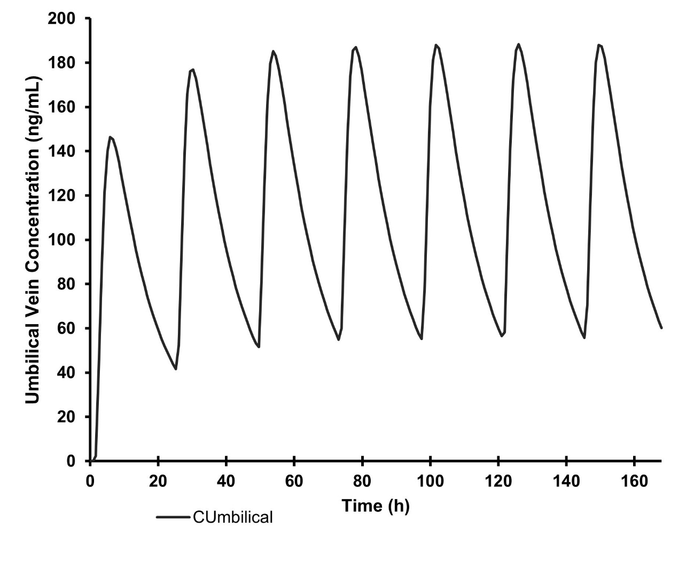
Figure S6 Predicted umbilical vein concentration–time profiles of venlafaxine in pregnant women at term following multiple oral doses of 375 mg venlafaxine administered once daily. The black line represents the mean predicted plasma concentrations.
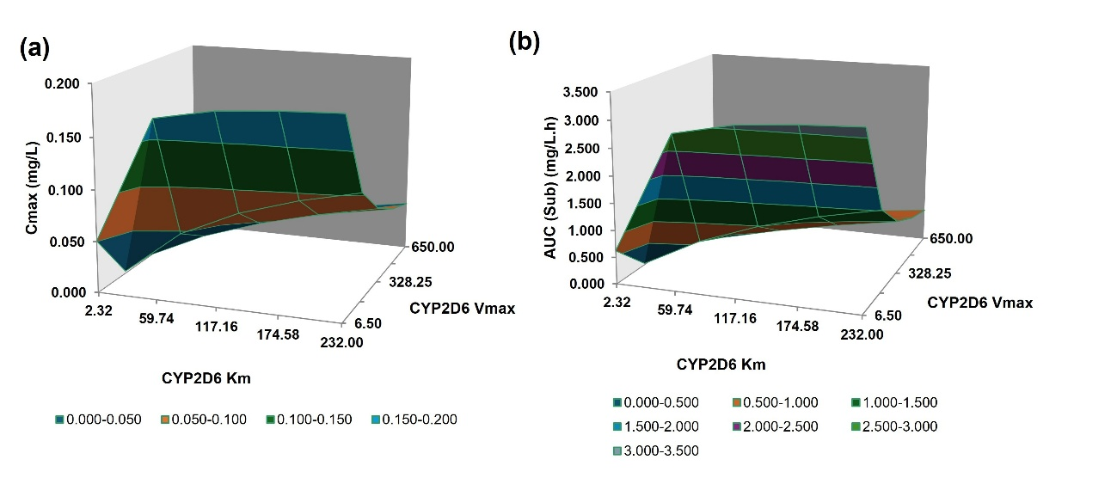
Figure S7 Local sensitivity analysis of CYP2D6 Vmax and Km on (a) Cmax and (b) AUC of venlafaxine in pregnant women. Abbreviations: CYP2D6, cytochrome P450 2D6; Vmax, maximum reaction rate; Km, substrate concentration at which the reaction rate is half of its maximal value.

