Supplements

Supplement 1: Institutional protocol for Y-90 radioembolization
One to two weeks before treatment, all patients were assessed angiographically for vascular anatomy and with Tc-99m-macroaggregated albumin (MAA) SPECT/CT to estimate shunting to the lung and exclude microsphere deposition to the gastrointestinal tract. After local anesthesia with lidocaine 1%, a 5F vascular sheath was placed preferably in the right common femoral artery in Seldinger-technique via a 0.035-inch guide wire. An overview angiography of the celiac trunc and the superior mesentery artery was generated with a 5-F Cobra (Radifocus, Terumo Europe NV) or a 5-F SOS Omni Selective catheter (Soft-Vu, Angiodynamics). Afterwards, a microcatheter (Cantata 2.5 F or MicroFerret-18 3 F, Cook Medical) was advanced into the proper hepatic artery. Additional DSA runs allowed for analysis of hepatic artery anatomy, HCC tumour blushes and aberrant arterial blood supply. If necessary, coil-embolization of the gastroduodenal artery, the right gastric artery or any accessory artery was carried out to avoid later off-target embolization. After selective placement of a microcatheter in both the right and the left liver lobe, scintigraphy was performed with 120–200 MBq of technetium-99m-labelledmacroaggregated albumin (99mTc-MAA) to assess hepatopulmonary shunting. Y-90 radioembolization was considered feasible if there was no relevant abdominal off-target distribution of 99mTv-MAA and if later pulmonary radiation exposure due to hepatopulmonary shunting did not exceed 30 Gy. The radiation dose of Y90 was calculated based on the body surface area and the tumour burden of each lobe according to the equation below. If the hepatopulmonary shunt fraction of 99mTc-MAA was between 10 and 15% the total dose for Y-90 radioembolization was reduced by 20%, for a shunt fraction between 15 and 20% the dose could be reduced by up to 40%.
$$Radiation Dose =Body surface area in m^{2} - 0,2 + \frac{\frac{Tumour Volume}{Treated Liver Volume} in \%}{100}$$

Therapy was performed in a separate session according to the angiographic standard protocol above by placement of a microcatheter in a lobar liver artery and application of the calculated dose. Depending on liver function, ECOG overall performance status, tumour burden and hepatopulmonary shunting the whole liver was treated in a single session or the right and left liver lobes were treated in a sequential fashion in accordance with the tumour board decision.

Supplement 2: Patient characteristics before and after 2017

Demographics |  | Total | Years  2008-2016 | Years  2017-2022 | Sign.
Number of patients (%) |  | 92 | 53 | 39
Mean age (years, SD) |  | 65.3 (10.1) | 65.7 (9.1) | 64.9 (11.4) | 0.725
Male sex |  | 73 | 43 | 30 | 0.795
Median survival (months, 95% CI)* |  | 13 (10.5-15.5) | 11 (7.3-14.7) | 20.8 (10.5-15.5) | 0.024
Liver Disease
BCLC stage | B | 62 | 37 | 25 | 0.654
BCLC stage | C | 30 | 16 | 14 | 0.654
Cirrhosis |  | 67 | 37 | 30 | 0.486
Hepatitis |  | 36 | 21 | 15 | 1.000
Portal vein thrombosis |  | 28 | 15 | 13 | 0.651
Previous treatments
Resection |  | 21 | 13 | 8 | 0.803
TACE |  | 29 | 16 | 13 | 0.822
Ablation (brachytherapy, RFA, PEI) (%) |  | 33 (36) | 14 (26) | 19 (49) | 0.047
Targeted therapy |  | 45 | 26 | 19 | 1.000
Pre-interventional targeted therapy |  | 21 | 13 | 8 | 0.803
Specifics of TARE
Median hepatopulmonary shunt, % (IQR) |  | 6.4 (5.1) | 8.1 (4.8) | 4.2 (3.9) | <0.001
Median tumour volumes, ml (IQR) |  | 238 (371) | 192 (302) | 288 (478) | 0.348
Median activity, mBq (IQR) |  | 1.7 (0.6) | 1.7 (0.5) | 1.7 (0.7) | 0.470
Dose reduction |  | 23 | 12 | 11 | 0.629
Lobar execution |  | 52 | 30 | 22 | 1.000
Tumour characterization at baseline (up to 3 lesions)
TTV (in ml) |  | 165 (306) | 177 (307) | 119 (313) | 0.054
ETV (in ml) |  | 69 (194) | 60 (154) | 81 (262) | 0.525
ETV/TTV (in %) |  | 71.5 | 48.0 | 87.1 | <0.001
ETV/TTV > 50% (%) |  | 56 | 22 (42) | 34 (87) | <0.001
ETV reduction by 65% |  | 18 | 11 | 7 | 0.796
* Kaplan-Meier estimator

Abbreviations:
BCLC: Barcelona Clinic liver cancer stage (BCLC)
CI: confidence interval
ETV: enhancing tumour volume
IQR: interquartile range
mBq: megabecquerel
ml: milliliter
PEI: percutaneous ethanol Injection
RFA: radiofrequency ablation
SD: standard deviation
TACE: transarterial chemoembolization
TTV: total tumour volume

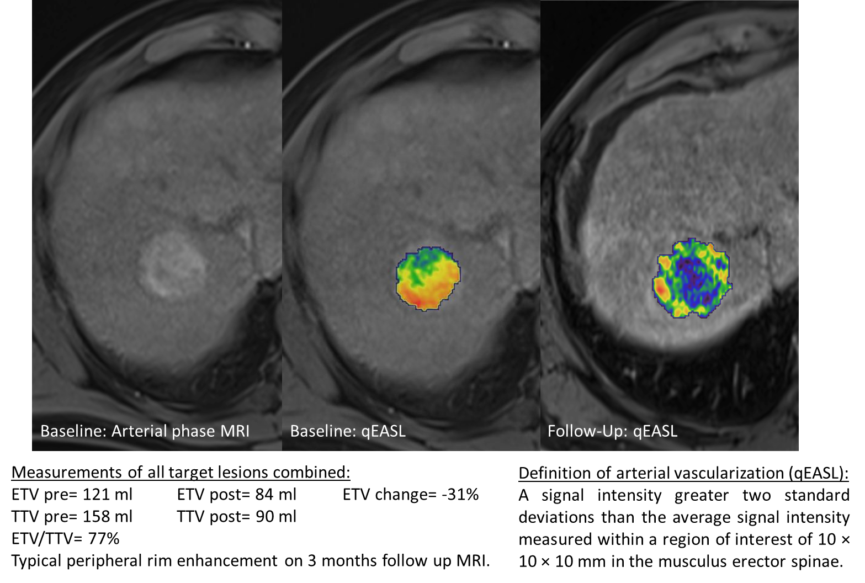
Supplement 3: Example of baseline and follow-up segmentations
Supplement 4: Predictors of time to progression of target lesions

Univariable analysis | All patients  n=92 |  | Pre-interventional targeted therapy*  n=21 |  | Other  n=71
Targeted therapy † | HR  (95% CI) | Sign. | HR  (95% CI) | Sign. | HR  (95% CI) | Sign.
Before TARE (> 2months) | 1.12 | 0.818
Pre-interventional (within 2 months) | 0.85 | 0.625
After TARE | 0.51 | 0.059

Demographics
Sex (male) | 1.18 | 0.681 | 0.65 | 0.499 | 1.63 | 0.361
Age > 65 years | 1.42 | 0.269 | 1.35 | 0.646 | 1.45 | 0.303

Liver disease
BCLC tumour stage C (versus B) | 1.08 | 0.822 | 1.18 | 0.799 | 1.00 | 0.988
Portal vein thrombosis | 1.02 | 0.950 | 0.99 | 0.992 | 0.99 | 0.998
Hepatitis | 1.10 | 0.769 | 1.60 | 0.475 | 0.98 | 0.948
Cirrhosis | 1.18 | 0.642 | 1.72 | 0.436 | 0.97 | 0.936
Resection | 1.01 | 0.978 | 1.38 | 0.618 | 0.94 | 0.907
TACE | 1.75 | 0.093 | 1.44 | 0.586 | 1.80 | 0.121
Ablation | 1.60 | 0.138 | 1.32 | 0.664 | 1.67 | 0.162

Radioembolization approach
Sequential lobar therapy | 1.16 | 0.649 | 0.61 | 0.440 | 1.42 | 0.346
Dose reduction | 1.15 | 0.678 | 0.90 | 0.880 | 1.17 | 0.700
Applied dose (GBq) | 0.63 | 0.237 | 0.13 | 0.052 | 0.82 | 0.651

MRI tumour characterization
TTV (in ml) | 1.00 | 0.418 | 0.99 | 0.266 | 1.00 | 0.479
ETV (in ml) | 0.99 | 0.169 | 0.99 | 0.119 | 0.99 | 0.235
ETV/TTV | 0.23 | 0.002 | 0.21 | 0.170 | 0.26 | 0.010
ETV/TTV > 50% | 0.40 | 0.004 | 0.26 | 0.092 | 0.46 | 0.031
Hepatopulmonary shunt in % | 1.00 | 0.956 | 1.05 | 0.477 | 0.98 | 0.609
* Pre-interventional: within 2 months before TARE
† Therapy with multikinase or immune checkpoint inhibition

Abbreviations:  BCLC: Barcelona Clinic Liver Cancer stage  CI: confidence interval  ETV: enhancing tumour volume  HR: hazard ratio  ml: milliliter |  | Sign.: significance  TACE: transarterial chemoembolization  TKI: tyrosine kinase inhibitor  TTV: total tumour volume

Supplement 5: Univariable and multivariabel Cox regression analysis by timing of targeted therapy (95% Confidence Intervals included)
Univariable analysis | All patients  n=92 |  | Pre-interventional targeted therapy*  n=21 |  | Other  n=71
Targeted therapy † | HR  (95% CI) | Sign. | HR  (95% CI) | Sign. | HR  (95% CI) | Sign.
Before TARE (> 2months) | 1.12  (0.43-2.94) | 0.82
Pre-interventional (within 2 months) | 0.85  (0.72-1.32) | 0.63
After TARE** | 0.73  (0.39-1.37) | 0.327

Demographics
Sex (male) | 1.67  (0.87-3.2) | 0.125 | 2.54  (0.68-9.57) | 0.167 | 1.34  (0.73-2.46) | 0.457
Age (years) | 0.99  (0.97-1.03) | 0.929 | 1.00  (0.92-1.09) | 0.933 | 1.00  (0.97-1.03) | 0.913
Age > 65 years | 1.31  (0.78-2.20) | 0.302 | 1.01  (0.34-3.02) | 0.992 | 1.46  (0.81-2.65) | 0.208

Liver disease
BCLC tumour stage C (versus B) | 1.35  (0.78-2.34) | 0.282 | 1.55  (0.51-4.66) | 0.440 | 1.31  (0.68-2.46) | 0.411
Portal vein tumour thrombosis | 1.16  (0.66-2.04) | 0.609 | 0.83  (0.23-2.99) | 0.774 | 1.31  (0.69-2.45) | 0.411
Tumor volume assessed for dosimetry | 1.00  (1.00-1.00) | 0.269 | 1.00  (0.99-1.00) | 0.196 | 1.00  (1.00-1.00) | 0.312
ALBI Grade > 1 | 2.35  (1.38-4.00) | 0.002 | 4.65  (1.52-14.2) | 0.007 | 1.96  (1.07-3.58) | 0.030
Hepatitis | 1.65  (0.98-2.76) | 0.059 | 2.63  (0.87-8.01) | 0.088 | 1.34  (0.73-2.46) | 0.339
Cirrhosis | 1.58  (0.88-2.84) | 0.129 | 1.91  (0.62-5.89) | 0.353 | 1.42  (0.70-2.88) | 0.717

Previous surgical or interventional treatments
Resection | 0.82  (0.44-1.53) | 0.530 | 0.40  (0.12-1.31) | 0.130 | 1.27  (0.61-2.65) | 0.527
TACE | 1.12  (0.65-1.94) | 0.679 | 3.11  (1.05-9.21) | 0.040 | 0.76  (0.39-1.47) | 0.407
Ablation | 0.864  (0.50-1.48) | 0.593 | 1.26  (0.43-3.72) | 0.671 | 0.72  (0.38-1.35) | 0.301

Radioembolization approach
Sequential lobar therapy | 0.87  (0.52-1.45) | 0.582 | 0.89  (0.31-2.54) | 0.824 | 0.85  (0.47-1.53) | 0.582
Dose reduction | 1.00  (0.56-1.77) | 0.993 | 1.59  (0.53-4.82) | 0.411 | 0.79  (0.40-1.56) | 0.490
Applied dose (GBq) | 0.96  (0.49-1.89) | 0.913 | 0.36  (0.05-2.79) | 0.330 | 1.13  (0.55-2.33) | 0.734
Treatment after 2017 | 0.54  (0.31-0.94) | 0.028 | 0.56  (0.16-2.02) | 0.367 | 0.50  (0.27-0.93) | 0.028

MRI tumour characterization
TTV (in ml) | 1.00  (0.99-1.00) | 0.909 | 1.00  (0.99-1.00) | 0.570 | 1.00  (0.99-1.00) | 0.884
ETV (in ml) | 1.00  (0.99-1.00) | 0.792 | 1.00  (0.99-1.00) | 0.565 | 1.00  (0.99-1.00) | 0.726
ETV/TTV | 0.60  (0.27-1.36) | 0.222 | 0.12  (0.02-0.85) | 0.034 | 0.95  (0.38-2.41) | 0.915
ETV/TTV > 50% | 0.67  (0.40-1.13) | 0.131 | 0.31  (0.10-0.94) | 0.039 | 0.91  (0.49-1.68) | 0.755
Hepatopulmonary shunt in % | 1.02  (0.97-1.07) | 0.482 | 1.04  (0.93-1.16) | 0.467 | 1.02  (0.96-1.08) | 0.608

MRI response assessment
Reduction in ETV by 65% | 0.64  (0.31-1.30) | 0.219 | 0.20  (0.04-0.91) | 0.038 | 1.18  (0.53-2.64) | 0.692
* Pre-interventional: within 2 months before TARE
† Therapy with multikinase or immune checkpoint inhibition
** Time-dependent Cox regression was used to avoid immortal time bias

Abbreviations:  BCLC: Barcelona Clinic Liver Cancer stage  CI: confidence interval  ETV: enhancing tumour volume  HR: hazard ratio  ml: milliliter |  | Sign.: significance  TACE: transarterial chemoembolization  TKI: tyrosine kinase inhibitor  TTV: total tumour volume

Multivariable analysis | All patients  n=92 |  | Pre-interventional targeted therapy*  n=21 |  | Other  n=71
Demographics | HR  (95% CI) | Sign. | HR  (95% CI) | Sign. | HR  (95% CI) | Sign.
Age (years) | 0.99  (0.96-1.02) | 0.486 | 0.81  (0.69-0.94) | 0.008 | 1.00  (0.96-1.03) | 0.879

Liver disease
BCLC tumour stage C (versus B) | 1.12  (0.59-2.15) | 0.725 | 0.04  (0.01-0.66) | 0.024 | 1.41  (0.63-3.18) | 0.405
Tumor volume assessed for dosimetry | 1.00  (1.00-1.00) | 0.620 | 1.01  (1.00-1.02) | 0.022 | 1.00  (0.99-1.00) | 0.886
ALBI Grade > 1 | 2.55  (1.42-4.57) | 0.002 | 10.17  (0.74-140) | 0.083 | 2.18  (1.15-4.14) | 0.017

Radioembolization approach
Treatment after 2017 | 0.51  (0.26-1.01) | 0.052 | 0.20  (0.02-2.29) | 0.198 | 0.31  (0.14-0.71) | 0.005

MRI tumour characterization
ETV/TTV > 50% | 1.02  (0.54-1.96) | 0.942 | 0.046  (0.01-0.82) | 0.036 | 1.64  (0.76-3.53) | 0.206
* Pre-interventional: within 2 months before TARE
† Therapy with multikinase or immune checkpoint inhibition
** Time-dependent Cox regression was used to avoid immortal time bias

Abbreviations:  ALBI Grade: Albumin-Bilirubin Grade  BCLC: Barcelona Clinic Liver Cancer stage  ETV: enhancing tumour volume  HR: hazard ratio  ml: milliliter |  | Sign.: significance  TACE: transarterial chemoembolization  TKI: tyrosine kinase inhibitor  TTV: total tumour volume

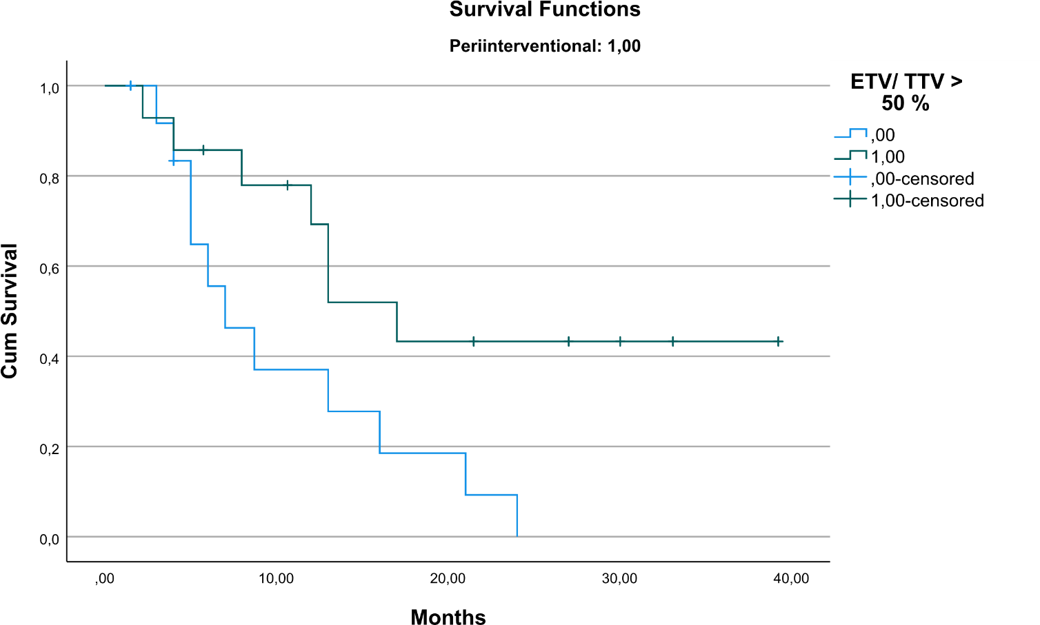
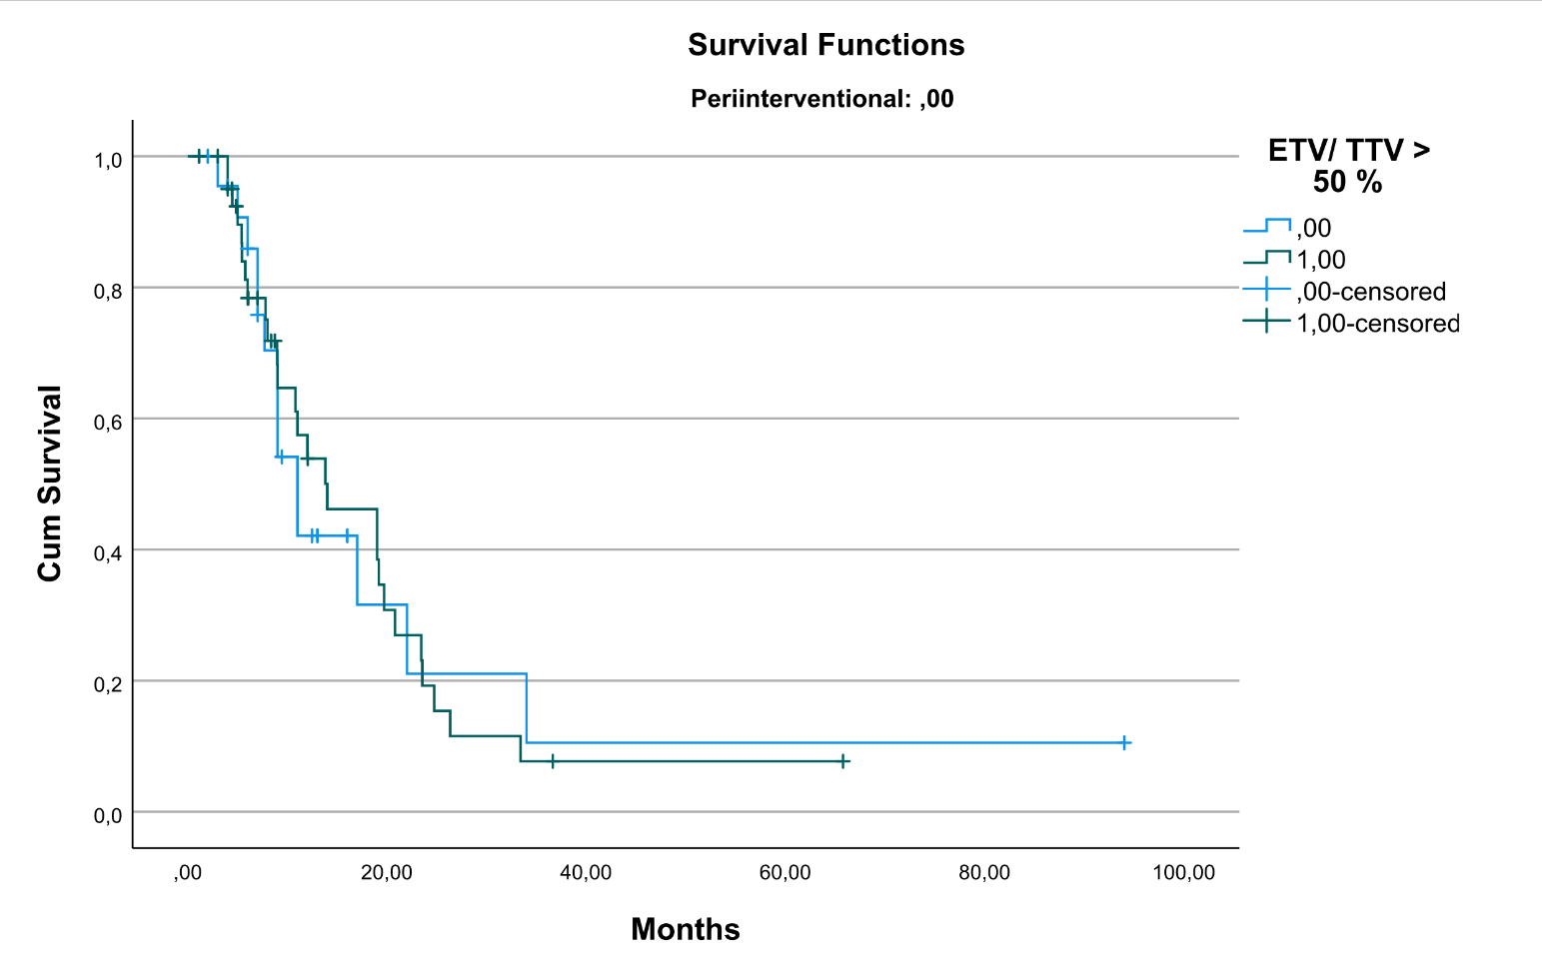
Supplement 6: Impact of baseline vascularity in patients with or without peri-interventional (pre and post) targeted therapy

