Supplement Table 1. PRISMA 2020 Checklist
Section and Topic | Item # | Checklist item | Location where item is reported
TITLE
Title | 1 | Identify the report as a systematic review. | 1
ABSTRACT
Abstract | 2 | See the PRISMA 2020 for Abstracts checklist. | 2
INTRODUCTION
Rationale | 3 | Describe the rationale for the review in the context of existing knowledge. | 4-5
Objectives | 4 | Provide an explicit statement of the objective(s) or question(s) the review addresses. | 5
METHODS
Eligibility criteria | 5 | Specify the inclusion and exclusion criteria for the review and how studies were grouped for the syntheses. | 6-7
Information sources | 6 | Specify all databases, registers, websites, organisations, reference lists and other sources searched or consulted to identify studies. Specify the date when each source was last searched or consulted. | 6
Search strategy | 7 | Present the full search strategies for all databases, registers and websites, including any filters and limits used. | Supplement Table 1
Selection process | 8 | Specify the methods used to decide whether a study met the inclusion criteria of the review, including how many reviewers screened each record and each report retrieved, whether they worked independently, and if applicable, details of automation tools used in the process. | 6-7
Data collection process | 9 | Specify the methods used to collect data from reports, including how many reviewers collected data from each report, whether they worked independently, any processes for obtaining or confirming data from study investigators, and if applicable, details of automation tools used in the process. | 7
Data items | 10a | List and define all outcomes for which data were sought. Specify whether all results that were compatible with each outcome domain in each study were sought (e.g. for all measures, time points, analyses), and if not, the methods used to decide which results to collect. | 7
Data items | 10b | List and define all other variables for which data were sought (e.g. participant and intervention characteristics, funding sources). Describe any assumptions made about any missing or unclear information.
Study risk of bias assessment | 11 | Specify the methods used to assess risk of bias in the included studies, including details of the tool(s) used, how many reviewers assessed each study and whether they worked independently, and if applicable, details of automation tools used in the process. | 7-8
Effect measures | 12 | Specify for each outcome the effect measure(s) (e.g. risk ratio, mean difference) used in the synthesis or presentation of results. | 8
Synthesis methods | 13a | Describe the processes used to decide which studies were eligible for each synthesis (e.g. tabulating the study intervention characteristics and comparing against the planned groups for each synthesis (item #5)).
Synthesis methods | 13b | Describe any methods required to prepare the data for presentation or synthesis, such as handling of missing summary statistics, or data conversions.
Synthesis methods | 13c | Describe any methods used to tabulate or visually display results of individual studies and syntheses.
Synthesis methods | 13d | Describe any methods used to synthesize results and provide a rationale for the choice(s). If meta-analysis was performed, describe the model(s), method(s) to identify the presence and extent of statistical heterogeneity, and software package(s) used. | 8
Synthesis methods | 13e | Describe any methods used to explore possible causes of heterogeneity among study results (e.g. subgroup analysis, meta-regression). | 5,8
Synthesis methods | 13f | Describe any sensitivity analyses conducted to assess robustness of the synthesized results.
Reporting bias assessment | 14 | Describe any methods used to assess risk of bias due to missing results in a synthesis (arising from reporting biases). | 7
Certainty assessment | 15 | Describe any methods used to assess certainty (or confidence) in the body of evidence for an outcome. | 9
RESULTS
Study selection | 16a | Describe the results of the search and selection process, from the number of records identified in the search to the number of studies included in the review, ideally using a flow diagram. | 9,  Figure 1
Study selection | 16b | Cite studies that might appear to meet the inclusion criteria, but which were excluded, and explain why they were excluded. | Supplement Table 3
Study characteristics | 17 | Cite each included study and present its characteristics. | 9,  Table 1
Risk of bias in studies | 18 | Present assessments of risk of bias for each included study. | 9,  Supplement Table 2
Results of individual studies | 19 | For all outcomes, present, for each study: (a) summary statistics for each group (where appropriate) and (b) an effect estimate and its precision (e.g. confidence/credible interval), ideally using structured tables or plots. | Table 2
Results of syntheses | 20a | For each synthesis, briefly summarise the characteristics and risk of bias among contributing studies.
Results of syntheses | 20b | Present results of all statistical syntheses conducted. If meta-analysis was done, present for each the summary estimate and its precision (e.g. confidence/credible interval) and measures of statistical heterogeneity. If comparing groups, describe the direction of the effect. | 10-14
Results of syntheses | 20c | Present results of all investigations of possible causes of heterogeneity among study results.
Results of syntheses | 20d | Present results of all sensitivity analyses conducted to assess the robustness of the synthesized results.
Reporting biases | 21 | Present assessments of risk of bias due to missing results (arising from reporting biases) for each synthesis assessed. | Table 2
Certainty of evidence | 22 | Present assessments of certainty (or confidence) in the body of evidence for each outcome assessed. | Table 2
DISCUSSION
Discussion | 23a | Provide a general interpretation of the results in the context of other evidence. | 14
Discussion | 23b | Discuss any limitations of the evidence included in the review. | 15
Discussion | 23c | Discuss any limitations of the review processes used.
Discussion | 23d | Discuss implications of the results for practice, policy, and future research. | 16
OTHER INFORMATION
Registration and protocol | 24a | Provide registration information for the review, including register name and registration number, or state that the review was not registered. | 6
Registration and protocol | 24b | Indicate where the review protocol can be accessed, or state that a protocol was not prepared.
Registration and protocol | 24c | Describe and explain any amendments to information provided at registration or in the protocol. | 6
Support | 25 | Describe sources of financial or non-financial support for the review, and the role of the funders or sponsors in the review. | 17
Competing interests | 26 | Declare any competing interests of review authors. | 17
Availability of data, code and other materials | 27 | Report which of the following are publicly available and where they can be found: template data collection forms; data extracted from included studies; data used for all analyses; analytic code; any other materials used in the review.

From: Page MJ, McKenzie JE, Bossuyt PM, Boutron I, Hoffmann TC, Mulrow CD, et al. The PRISMA 2020 statement: an updated guideline for reporting systematic reviews. BMJ 2021;372:n71. doi: 10.1136/bmj.n71
For more information, visit: http://www.prisma-statement.org/
Supplement Table 2. Literature Search Strategies in Databases

Search Strategy and Search Results
Pubmed search <inception to January 8, 2025>
inception to March 5,2024
#1 Polycystic Ovary Syndrome[MeSH Terms] OR amenorrhea[MeSH Terms] OR Hyperandrogenism[MeSH Terms] (29123)
#2 Polycystic Ovary Syndrome or Ovary Syndrome, Polycystic or Syndrome, Polycystic Ovary or Stein-Leventhal Syndrome or Stein Leventhal Syndrome or Syndrome, Stein-Leventhal or Sclerocystic Ovarian Degeneration or Ovarian Degeneration, Sclerocystic or Sclerocystic Ovary Syndrome or Polycystic Ovarian Syndrome or Ovarian Syndrome, Polycystic or Polycystic Ovary Syndrome 1 or Sclerocystic Ovaries or Ovary, Sclerocystic or Sclerocystic Ovary or cystic ovary or micropolycystic ovary or multiple follicle cyst or PCOS or PCOD or ovary polycystic disease or Hyperandrogenism or hyper-androgenism or hyperandro-genism or Hyperandrogenaemia or Hyperandrogenemia or Hyperandrogenism or Hirsutism or Acne or Androgens or Virilism or Amenorrhea or amenorrhoea or menstrual retention or amenorrhea or Amenorrhea or Oligomenorrhea or ovulatory or Dysfunction or Anovulation or Infertility (2689639)
#3 #1 OR #2 (2689639)
#4 Obesity[MeSH Terms] OR Overweight[MeSH Terms] OR Body Mass Index[MeSH Terms] OR adiposity[MeSH Terms] (369560)
#5 Index, Body Mass OR Quetelet Index OR Index, Quetelet OR Quetelet's Index OR Quetelets Index OR polysarcia OR corpulent OR Obesity OR Overweight OR Body Mass Index OR adiposity OR BMI OR obese OR weight loss OR weight control OR weight reduction OR Body Fat Distribution (1330418)
#6 #4 OR #5 (1330418)
#7 acupuncture therapy[MeSH Terms] OR Acupuncture Points[MeSH Terms] OR Acupuncture[MeSH Terms] OR catgut embedding OR acupoint catgut embedding OR catgut implantation OR embedding thread OR point embedding therapy OR Acupoint Ligat Thread Embed OR Embedding Therapy OR acupuncture therapy OR Acupoint Therapy OR Acupuncture OR Acupuncture Point* OR Acupoint* (76723)
#8 Placebos[MeSH Terms] or "Randomized Controlled Trial" or "Clinical Study" or randomized controlled trial OR controlled clinical trial OR placebo OR random* OR trial OR groups OR Clinical randomised controlled trial OR randomised control OR randomized OR RCT OR clinical trial (7375719)
#9 #3 AND #6 AND #7 AND #8 (332)

March 6,2024 to January 8, 2025
#1 Polycystic Ovary Syndrome[MeSH Terms] OR amenorrhea[MeSH Terms] OR Hyperandrogenism[MeSH Terms] (30182)
#2 Polycystic Ovary Syndrome or Ovary Syndrome, Polycystic or Syndrome, Polycystic Ovary or Stein-Leventhal Syndrome or Stein Leventhal Syndrome or Syndrome, Stein-Leventhal or Sclerocystic Ovarian Degeneration or Ovarian Degeneration, Sclerocystic or Sclerocystic Ovary Syndrome or Polycystic Ovarian Syndrome or Ovarian Syndrome, Polycystic or Polycystic Ovary Syndrome 1 or Sclerocystic Ovaries or Ovary, Sclerocystic or Sclerocystic Ovary or cystic ovary or micropolycystic ovary or multiple follicle cyst or PCOS or PCOD or ovary polycystic disease or Hyperandrogenism or hyper-androgenism or hyperandro-genism or Hyperandrogenaemia or Hyperandrogenemia or Hyperandrogenism or Hirsutism or Acne or Androgens or Virilism or Amenorrhea or amenorrhoea or menstrual retention or amenorrhea or Amenorrhea or Oligomenorrhea or ovulatory or Dysfunction or Anovulation or Infertility (2779827)
#3 #1 OR #2 (2779827)
#4 Obesity[MeSH Terms] OR Overweight[MeSH Terms] OR Body Mass Index[MeSH Terms] OR adiposity[MeSH Terms] (383967)
#5 Index, Body Mass OR Quetelet Index OR Index, Quetelet OR Quetelet's Index OR Quetelets Index OR polysarcia OR corpulent OR Obesity OR Overweight OR Body Mass Index OR adiposity OR BMI OR obese OR weight loss OR weight control OR weight reduction OR Body Fat Distribution (1398048)
#6 #4 OR #5 (1398048)
#7 acupuncture therapy[MeSH Terms] OR Acupuncture Points[MeSH Terms] OR Acupuncture[MeSH Terms] OR catgut embedding OR acupoint catgut embedding OR catgut implantation OR embedding thread OR point embedding therapy OR Acupoint Ligat Thread Embed OR Embedding Therapy OR acupuncture therapy OR Acupoint Therapy OR Acupuncture OR Acupuncture Point* OR Acupoint* (81961)
#8 Placebos[MeSH Terms] or "Randomized Controlled Trial" or "Clinical Study" or randomized controlled trial OR controlled clinical trial OR placebo OR random* OR trial OR groups OR Clinical randomised controlled trial OR randomised control OR randomized OR RCT OR clinical trial (7762255)
#9 #3 AND #6 AND #7 AND #8 (359)
#10 “2024/03/06” to “2025/01/08”[Date - Publication] AND #9 (27)

Cochrane Library search <inception to January 8, 2025>
inception to March 5,2024
#1 Polycystic Ovary Syndrome[MeSH Terms] (2125)
#2 Hyperandrogenism[MeSH Terms] (171)
#3 Amenorrhea[MeSH Terms] (408)
#4 Polycystic Ovary Syndrome or Ovary Syndrome, Polycystic or Syndrome, Polycystic Ovary or Stein-Leventhal Syndrome or Stein Leventhal Syndrome or Syndrome, Stein-Leventhal or Sclerocystic Ovarian Degeneration or Ovarian Degeneration, Sclerocystic or Sclerocystic Ovary Syndrome or Polycystic Ovarian Syndrome or Ovarian Syndrome, Polycystic or Polycystic Ovary Syndrome 1 or Sclerocystic Ovaries or Ovary, Sclerocystic or Sclerocystic Ovary or cystic ovary or micropolycystic ovary or multiple follicle cyst or PCOS or PCOD or ovary polycystic disease or Hyperandrogenism or hyper-androgenism or hyperandro-genism or Hyperandrogenaemia or Hyperandrogenemia or Hyperandrogenism or Hirsutism or Acne or Androgens or Virilism or Amenorrhea or amenorrhoea or menstrual retention or amenorrhea or Amenorrhea or Oligomenorrhea or ovulatory or Dysfunction or Anovulation or Infertility (82319)
#5 #1 OR #2 OR #3 OR #4 (82319)
#6 Obesity[MeSH Terms] (21150)
#7 Overweight[MeSH Terms] (24772)
#8 Body Mass Index[MeSH Terms] (13996)
#9 adiposity[MeSH Terms] (1118)
#10 Index, Body Mass OR Quetelet Index OR Index, Quetelet OR Quetelet's Index OR Quetelets Index OR polysarcia OR corpulent OR Obesity OR Overweight OR Body Mass Index OR BMI OR obese OR adiposity OR weight loss OR weight control OR weight reduction OR Body Fat Distribution (178048)
#11 #6 OR #7 OR #8 OR #9 OR #10 (178129)
#12 Acupuncture Therapy[MeSH Terms] (7020)
#13 Acupuncture Points[MeSH Terms] (2733)
#14 Acupuncture[MeSH Terms] (213)
#15 catgut embedding OR acupoint catgut embedding OR catgut implantation OR embedding thread OR point embedding therapy OR Acupoint Ligat Thread Embed OR Embedding Therapy OR acupuncture therapy OR Acupoint Therapy OR Acupuncture Therapy OR Acupuncture Treatment OR Therapy, Acupuncture OR Acupoints OR Point, Acupuncture OR Acupuncture Point OR Acupuncture Points OR Points, Acupuncture OR Acupoint OR Acupuncture (24007)
#16 #12 OR #13 OR #14 OR #15 (24194)
#17 Randomized Controlled Trial OR Controlled Clinical Trials, Randomized OR Clinical Trials, Randomized OR Trials, Randomized Clinical OR Real World Clinical Trials OR Naturalistic Randomized Clinical Trial OR Practical Clinical Trials OR Trials, Practical Clinical OR Clinical Trials, Pragmatic OR Clinical Trials, Practical OR Trials, Pragmatic Clinical OR Pragmatic Clinical Trials OR Trials, Pragmatic OR Pragmatic Trials OR Clinical Trial OR Clinical study OR Placebo OR RCT (1534769)
#18 #5 AND #11 AND #16 AND #17 (244)

March 6,2024 to January 8, 2025
#1 Polycystic Ovary Syndrome[MeSH Terms] (2207)
#2 Hyperandrogenism[MeSH Terms] (174)
#3 Amenorrhea[MeSH Terms] (411)
#4 Polycystic Ovary Syndrome or Ovary Syndrome, Polycystic or Syndrome, Polycystic Ovary or Stein-Leventhal Syndrome or Stein Leventhal Syndrome or Syndrome, Stein-Leventhal or Sclerocystic Ovarian Degeneration or Ovarian Degeneration, Sclerocystic or Sclerocystic Ovary Syndrome or Polycystic Ovarian Syndrome or Ovarian Syndrome, Polycystic or Polycystic Ovary Syndrome 1 or Sclerocystic Ovaries or Ovary, Sclerocystic or Sclerocystic Ovary or cystic ovary or micropolycystic ovary or multiple follicle cyst or PCOS or PCOD or ovary polycystic disease or Hyperandrogenism or hyper-androgenism or hyperandro-genism or Hyperandrogenaemia or Hyperandrogenemia or Hyperandrogenism or Hirsutism or Acne or Androgens or Virilism or Amenorrhea or amenorrhoea or menstrual retention or amenorrhea or Amenorrhea or Oligomenorrhea or ovulatory or Dysfunction or Anovulation or Infertility (87739)
#5 #1 OR #2 OR #3 OR #4 (87739)
#6 Obesity[MeSH Terms] (22114)
#7 Overweight[MeSH Terms] (25912)
#8 Body Mass Index[MeSH Terms] (14351)
#9 adiposity[MeSH Terms] (1141)
#10 Index, Body Mass OR Quetelet Index OR Index, Quetelet OR Quetelet's Index OR Quetelets Index OR polysarcia OR corpulent OR Obesity OR Overweight OR Body Mass Index OR BMI OR obese OR adiposity OR weight loss OR weight control OR weight reduction OR Body Fat Distribution (191331)
#11 #6 OR #7 OR #8 OR #9 OR #10 (191416)
#12 Acupuncture Therapy[MeSH Terms] (7309)
#13 Acupuncture Points[MeSH Terms] (2854)
#14 Acupuncture[MeSH Terms] (225)
#15 catgut embedding OR acupoint catgut embedding OR catgut implantation OR embedding thread OR point embedding therapy OR Acupoint Ligat Thread Embed OR Embedding Therapy OR acupuncture therapy OR Acupoint Therapy OR Acupuncture Therapy OR Acupuncture Treatment OR Therapy, Acupuncture OR Acupoints OR Point, Acupuncture OR Acupuncture Point OR Acupuncture Points OR Points, Acupuncture OR Acupoint OR Acupuncture (25705)
#16 #12 OR #13 OR #14 OR #15 (25911)
#17 Randomized Controlled Trial OR Controlled Clinical Trials, Randomized OR Clinical Trials, Randomized OR Trials, Randomized Clinical OR Real World Clinical Trials OR Naturalistic Randomized Clinical Trial OR Practical Clinical Trials OR Trials, Practical Clinical OR Clinical Trials, Pragmatic OR Clinical Trials, Practical OR Trials, Pragmatic Clinical OR Pragmatic Clinical Trials OR Trials, Pragmatic OR Pragmatic Trials OR Clinical Trial OR Clinical study OR Placebo OR RCT (1637207)
#18 #5 AND #11 AND #16 AND #17 (261)
#19 #5 with Cochrane Library publication date from Mar 2024 to Jan 2025 (20)

Embase search <inception to January 8, 2025>
inception to March 5,2024
#1 'ovary polycystic disease'/exp OR 'hyperandrogenism'/exp OR 'amenorrhea'/exp OR 'cystic ovary' OR 'micropolycystic ovary' OR 'multiple follicle cyst' OR 'ovary polycystic syndrome' OR 'ovary, micropolycystic' OR 'ovary, polycystic' OR 'polycystic ovarian disease' OR 'polycystic ovary' OR 'polycystic ovary disease' OR 'polycystic ovary syndrome' OR 'stein cohen leventhal syndrome' OR 'stein leventhal disease' OR 'stein leventhal syndrome' OR 'syndrome stein leventhal' OR 'ovary polycystic disease' OR 'PCOS' OR 'PCOD' OR 'Hyperandrogenism' OR 'hyper-androgenism' OR 'hyperandro-genism' OR 'Hyperandrogenaemia' OR 'Hyperandrogenemia' OR 'Hyperandrogenism' OR 'Hirsutism' OR 'Acne' OR 'Androgens' OR 'Virilism' OR 'amenorrhea' OR 'Amenorrhea' OR 'amenorrhoea' OR 'menstrual retention' OR 'Amenorrhea' OR 'Oligomenorrhea' OR 'ovulatory' OR 'Dysfunction' OR 'Anovulation' OR 'Infertility' (1332811)
#2 'obesity'/exp OR 'adipose tissue hyperplasia' OR 'adipositas' OR 'alimentary obesity' OR 'adiposity' OR 'body weight, excess' OR 'corpulency' OR 'fat overload syndrome' OR 'nutritional obesity' OR 'obesitas' OR 'overweight' OR 'obese' OR 'weight loss' OR 'weight control' OR 'weight reduction' OR 'Body Fat Distribution' OR 'body mass'/exp OR 'bmi' OR 'body mass index' OR 'quetelet index' OR 'body mass' (1518851)
#3 'catgut embedding'/exp OR 'acupuncture'/exp OR 'acupuncture point'/exp OR 'acupuncture' OR 'acu-point' OR 'acupoint' OR 'acupoints' OR 'acupuncture points' OR 'point, acupuncture' OR 'acupuncture point' OR 'acupoint catgut embedding therapy' OR 'catgut implantation' OR 'catgut embedding' OR 'embedding thread' OR 'point embedding therapy' OR 'Acupoint Ligat Thread Embed' OR 'Embedding Therapy' OR 'acupuncture therapy' OR 'Acupoint Therapy' (71328)
#4 'randomized controlled trial'/exp OR 'controlled trial, randomized' OR 'randomised controlled study' OR 'randomised controlled trial' OR 'randomized controlled study' OR 'trial, randomized controlled' OR 'randomized controlled trial' OR 'clinical trial'/exp OR 'clinical drug trial' OR 'major clinical trial' OR 'trial, clinical' OR 'clinical trial' OR 'placebo'/exp OR 'placebo gel' OR 'placebos' OR 'placebo' OR 'clinical study'/exp OR 'clinical data' OR 'clinical studies as topic' OR 'medical trial' OR 'clinical study' (13308426)
#5 #1 AND #2 AND #3 AND #4 (223)

March 6,2024 to January 8, 2025
#1 'ovary polycystic disease'/exp OR 'hyperandrogenism'/exp OR 'amenorrhea'/exp OR 'cystic ovary' OR 'micropolycystic ovary' OR 'multiple follicle cyst' OR 'ovary polycystic syndrome' OR 'ovary, micropolycystic' OR 'ovary, polycystic' OR 'polycystic ovarian disease' OR 'polycystic ovary' OR 'polycystic ovary disease' OR 'polycystic ovary syndrome' OR 'stein cohen leventhal syndrome' OR 'stein leventhal disease' OR 'stein leventhal syndrome' OR 'syndrome stein leventhal' OR 'ovary polycystic disease' OR 'PCOS' OR 'PCOD' OR 'Hyperandrogenism' OR 'hyper-androgenism' OR 'hyperandro-genism' OR 'Hyperandrogenaemia' OR 'Hyperandrogenemia' OR 'Hyperandrogenism' OR 'Hirsutism' OR 'Acne' OR 'Androgens' OR 'Virilism' OR 'amenorrhea' OR 'Amenorrhea' OR 'amenorrhoea' OR 'menstrual retention' OR 'Amenorrhea' OR 'Oligomenorrhea' OR 'ovulatory' OR 'Dysfunction' OR 'Anovulation' OR 'Infertility' (1408028)
#2 'obesity'/exp OR 'adipose tissue hyperplasia' OR 'adipositas' OR 'alimentary obesity' OR 'adiposity' OR 'body weight, excess' OR 'corpulency' OR 'fat overload syndrome' OR 'nutritional obesity' OR 'obesitas' OR 'overweight' OR 'obese' OR 'weight loss' OR 'weight control' OR 'weight reduction' OR 'Body Fat Distribution' OR 'body mass'/exp OR 'bmi' OR 'body mass index' OR 'quetelet index' OR 'body mass' (1631614)
#3 'catgut embedding'/exp OR 'acupuncture'/exp OR 'acupuncture point'/exp OR 'acupuncture' OR 'acu-point' OR 'acupoint' OR 'acupoints' OR 'acupuncture points' OR 'point, acupuncture' OR 'acupuncture point' OR 'acupoint catgut embedding therapy' OR 'catgut implantation' OR 'catgut embedding' OR 'embedding thread' OR 'point embedding therapy' OR 'Acupoint Ligat Thread Embed' OR 'Embedding Therapy' OR 'acupuncture therapy' OR 'Acupoint Therapy' (76256)
#4 'randomized controlled trial'/exp OR 'controlled trial, randomized' OR 'randomised controlled study' OR 'randomised controlled trial' OR 'randomized controlled study' OR 'trial, randomized controlled' OR 'randomized controlled trial' OR 'clinical trial'/exp OR 'clinical drug trial' OR 'major clinical trial' OR 'trial, clinical' OR 'clinical trial' OR 'placebo'/exp OR 'placebo gel' OR 'placebos' OR 'placebo' OR 'clinical study'/exp OR 'clinical data' OR 'clinical studies as topic' OR 'medical trial' OR 'clinical study' (13892782)
#5 #1 AND #2 AND #3 AND #4 AND [06-03-2024]/sd NOT [09-01-2025]/sd (31)

Web of Science search <inception to January 8, 2025>
inception to March 5,2024
#1 (TS=(Polycystic Ovary Syndrome) OR TS=(Ovary Syndrome, Polycystic) OR TS=(Syndrome, Polycystic Ovary) OR TS=(Stein-Leventhal Syndrome) OR TS=(Stein Leventhal Syndrome) OR TS=(Syndrome, Stein-Leventhal) OR TS=(Sclerocystic Ovarian Degeneration) OR TS=(Ovarian Degeneration, Sclerocystic) OR TS=(Sclerocystic Ovary Syndrome) OR TS=(Polycystic Ovarian Syndrome) OR TS=(Ovarian Syndrome, Polycystic) OR TS=(Polycystic Ovary Syndrome 1) OR TS=(Sclerocystic Ovaries) OR TS=(Ovary, Sclerocystic) OR TS=(Sclerocystic Ovary) OR TS=(cystic ovary) OR TS=(micropolycystic ovary) OR TS=(multiple follicle cyst) OR TS=(PCOS) OR TS=(PCOD) OR TS=(ovary polycystic disease) OR TS=(Hyperandrogenism) OR TS=(hyper-androgenism) OR TS=(hyperandro-genism) OR TS=(Hyperandrogenaemia) OR TS=(Hyperandrogenemia) OR TS=(Hyperandrogenism) OR TS=(Hirsutism) OR TS=(Acne) OR TS=(Amenorrhea) OR TS=(amenorrhoea) OR TS=(menstrual retention) OR TS=(amenorrhea) OR TS=(Amenorrhea) OR TS=(Oligomenorrhea) OR TS=(ovulatory) OR TS=(Dysfunction) OR TS=(Anovulation) OR TS=(Infertility) OR TS=(Androgens) OR TS=(Virilism)) (1691035)
#2 (TS=(Obesity) OR TS=(Overweight) OR TS=(Body Mass Index) OR TS=(adiposity) OR TS=(Quetelet Index) OR TS=(Index, Quetelet) OR TS=(Quetelet's Index) OR TS=(Quetelets Index) OR TS=(Index, Body Mass) OR TS=(polysarcia) OR TS=(corpulent) OR TS=(BMI) OR TS=(obese) OR TS=(weight loss) OR TS=(weight control) OR TS=(weight reduction) OR TS=(Body Fat Distribution)) (3159036)
#3 (TS=(catgut embedding) OR TS=(acupoint catgut embedding) OR TS=(catgut implantation) OR TS=(embedding thread) OR TS=(point embedding therapy) OR TS=(Acupoint Ligat Thread Embed) OR TS=(Embedding Therapy) OR TS=(acupuncture therapy) OR TS=(Acupoint Therapy) OR TS=(Acupuncture Point*) OR TS=(Acupuncture) OR TS=(Acupoint*)) (224148)
#4 (TS=(randomized controlled trial) OR TS=(randomized) OR TS=(placebo) OR TS=(randomised) OR TS=(random) OR TS=(RCT) OR TS=(clinical trial) OR TS=(clinical study) OR TS=(trial)) (15413247)
#5 #1 AND #2 AND #3 AND #4 (234)

March 6,2024 to January 8, 2025
#1 (TS=(Polycystic Ovary Syndrome) OR TS=(Ovary Syndrome, Polycystic) OR TS=(Syndrome, Polycystic Ovary) OR TS=(Stein-Leventhal Syndrome) OR TS=(Stein Leventhal Syndrome) OR TS=(Syndrome, Stein-Leventhal) OR TS=(Sclerocystic Ovarian Degeneration) OR TS=(Ovarian Degeneration, Sclerocystic) OR TS=(Sclerocystic Ovary Syndrome) OR TS=(Polycystic Ovarian Syndrome) OR TS=(Ovarian Syndrome, Polycystic) OR TS=(Polycystic Ovary Syndrome 1) OR TS=(Sclerocystic Ovaries) OR TS=(Ovary, Sclerocystic) OR TS=(Sclerocystic Ovary) OR TS=(cystic ovary) OR TS=(micropolycystic ovary) OR TS=(multiple follicle cyst) OR TS=(PCOS) OR TS=(PCOD) OR TS=(ovary polycystic disease) OR TS=(Hyperandrogenism) OR TS=(hyper-androgenism) OR TS=(hyperandro-genism) OR TS=(Hyperandrogenaemia) OR TS=(Hyperandrogenemia) OR TS=(Hyperandrogenism) OR TS=(Hirsutism) OR TS=(Acne) OR TS=(Amenorrhea) OR TS=(amenorrhoea) OR TS=(menstrual retention) OR TS=(amenorrhea) OR TS=(Amenorrhea) OR TS=(Oligomenorrhea) OR TS=(ovulatory) OR TS=(Dysfunction) OR TS=(Anovulation) OR TS=(Infertility) OR TS=(Androgens) OR TS=(Virilism)) (1733473)
#2 (TS=(Obesity) OR TS=(Overweight) OR TS=(Body Mass Index) OR TS=(adiposity) OR TS=(Quetelet Index) OR TS=(Index, Quetelet) OR TS=(Quetelet's Index) OR TS=(Quetelets Index) OR TS=(Index, Body Mass) OR TS=(polysarcia) OR TS=(corpulent) OR TS=(BMI) OR TS=(obese) OR TS=(weight loss) OR TS=(weight control) OR TS=(weight reduction) OR TS=(Body Fat Distribution)) (3226291)
#3 (TS=(catgut embedding) OR TS=(acupoint catgut embedding) OR TS=(catgut implantation) OR TS=(embedding thread) OR TS=(point embedding therapy) OR TS=(Acupoint Ligat Thread Embed) OR TS=(Embedding Therapy) OR TS=(acupuncture therapy) OR TS=(Acupoint Therapy) OR TS=(Acupuncture Point*) OR TS=(Acupuncture) OR TS=(Acupoint*)) (233180)
#4 (TS=(randomized controlled trial) OR TS=(randomized) OR TS=(placebo) OR TS=(randomised) OR TS=(random) OR TS=(RCT) OR TS=(clinical trial) OR TS=(clinical study) OR TS=(trial)) (15544241)
#5 #1 AND #2 AND #3 AND #4 AND Timespan: 2024-03-06 to 2025-01-08 (Index Date) (29)

CNKI/Wan Fang/VIP/Sinomed search <inception to January 8, 2025>
#1 Polycystic Ovary Syndrome OR Polycystic ovary OR Insulin resistance OR Hyperandrogenism OR Hirsutism OR Acne OR Ovulation disorder OR Infertility OR PCOS OR PCOD
#2 Body Mass Index OR Weight Control OR Obesity OR BMI
#3 acupoint catgut embedding OR atgut implantation OR point embedding therapy OR Acupoint Therapy OR Acupuncture
#4 Randomization OR Clinical Trial OR Blank OR Randomized Control OR RCT
#5 #1 AND #2 AND #3 AND #4
#6 "until 2025-01-08"[Date - Publication]
#7 #5 AND #6

Supplement Table 3. Risk bias of included studies

Study | Adequate randomization sequence generation | Adequate allocation concealment | Blinding of patients | Blinding of health care providers | Blinding of data collectors | Blinding of outcome assessors | Blinding of data analyst | Loss to follow-up (%)
Bian YY 2023 ⁴¹ | low | high | high | high | high | high | high | 0
Xiao M 2023 ⁵⁰ | low | high | high | high | high | high | high | 3.60
Li YR 2022 ⁴² | low | high | high | high | high | high | high | 3.30
Sheng WZ 2021 ⁴⁵ | high | high | high | high | high | high | high | 4.35
He DJ 2020A ³² | low | high | high | high | high | high | high | 6.57
Ma GZ 2020 ³³ | low | high | high | high | high | high | high | 3.57
Jiang XL 2020 ³¹ | low | high | high | high | high | high | high | 30.00
He DJ 2020B ⁴⁰ | low | high | high | high | high | high | high | 8.00
Zhang R 2019 ³⁷ | high | high | high | high | high | high | high | 6.94
Zhang XS 2016 ²⁸ | high | high | high | high | high | high | high | 0
Zhang JF 2016 ³⁵ | low | high | high | high | high | high | high | 5.00
Cai XB 2016 ⁴⁸ | low | high | high | high | high | high | high | 0
Tang LY 2015 ³⁴ | low | high | high | high | high | high | high | 5.00
Cheng R 2015 ³⁹ | low | high | high | high | high | high | high | 0
Lu J 2014 ⁴⁹ | low | high | high | high | high | high | high | 0
Xiao SF 2014 ⁵² | high | high | high | high | high | high | high | 0
Wan QZ 2014 ⁴³ | high | high | high | high | high | high | high | 2.00
Yu W 2011 ⁴⁶ | high | high | high | high | high | high | high | 3.70
Liu GY 2010 ²⁹ | low | high | high | high | high | high | high | 15.56
Tao LL 2010 ³⁰ | low | high | high | high | high | high | high | 14.63
Long YL 2007 ³⁸ | low | high | high | high | high | high | high | 9.52
Gu N 2018 ⁴⁴ | low | high | high | high | high | high | high | 0
Gao YC 2023 ⁴⁷ | high | high | high | high | high | high | high | 0
Zhao Y 2022 ⁵¹ | high | high | high | high | high | high | high | 0
Qin WM 2016 ³⁶ | high | high | high | high | high | high | high | 9.76

Reference ID | RCT | Reasons to exclude
1 | Yang YM 2016 ⁵⁶ | ineligible population
2 | Liu XQ 2014 ⁵⁷ | ineligible intervention
3 | Zhang T 2013 ⁵⁸ | ineligible intervention
4 | Gong XH 2012 ⁵⁹ | ineligible intervention
5 | Wang J 2008 ⁶⁰ | ineligible intervention
6 | Weng SY 2014 ⁶¹ | ineligible population
7 | Kang CJ 2012 ⁶² | ineligible intervention
8 | Peng YT 2012 ⁶³ | ineligible population
9 | Wang WX 2013 ⁶⁴ | ineligible intervention
Supplement Table 4. The reasons to exclude included studies of previous systematic reviews of ACE for PCOS

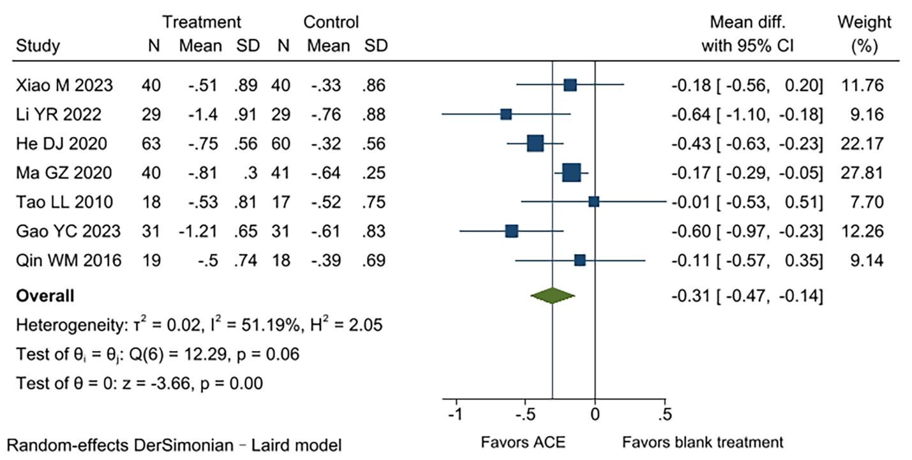

Supplement Figure 1 TG among patients who received acupoint catgut embedding compared to blank treatment, on the basis of usual care

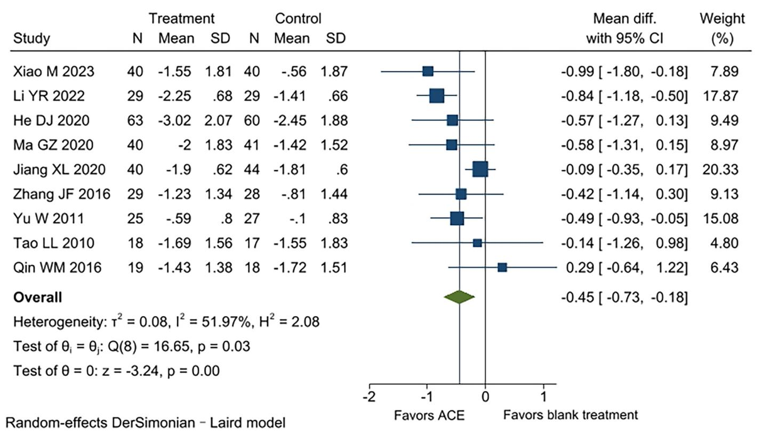

Supplement Figure 2 HOMA-IR among patients who received acupoint catgut embedding compared to blank treatment, on the basis of usual care

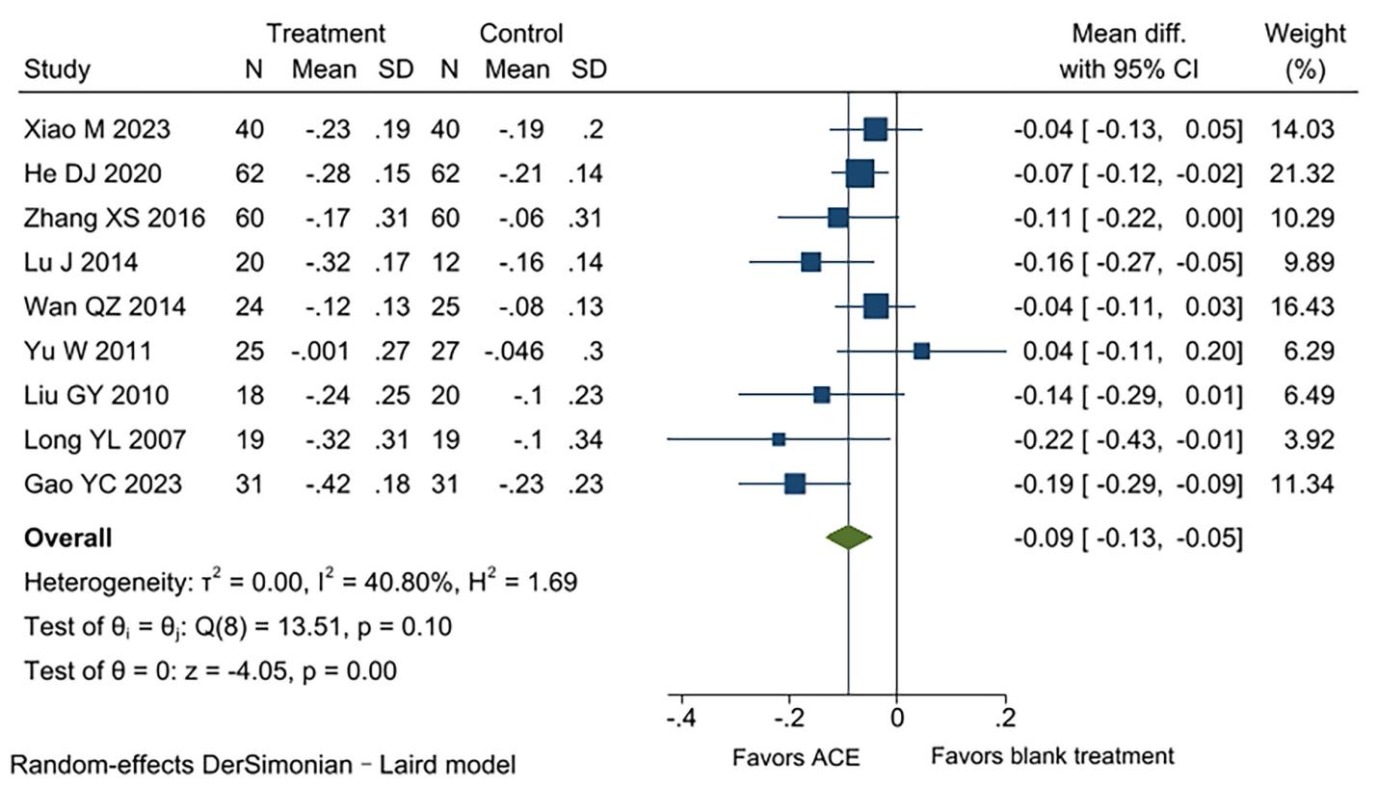

Supplement Figure 3 T among patients who received acupoint catgut embedding compared to blank treatment, on the basis of usual care

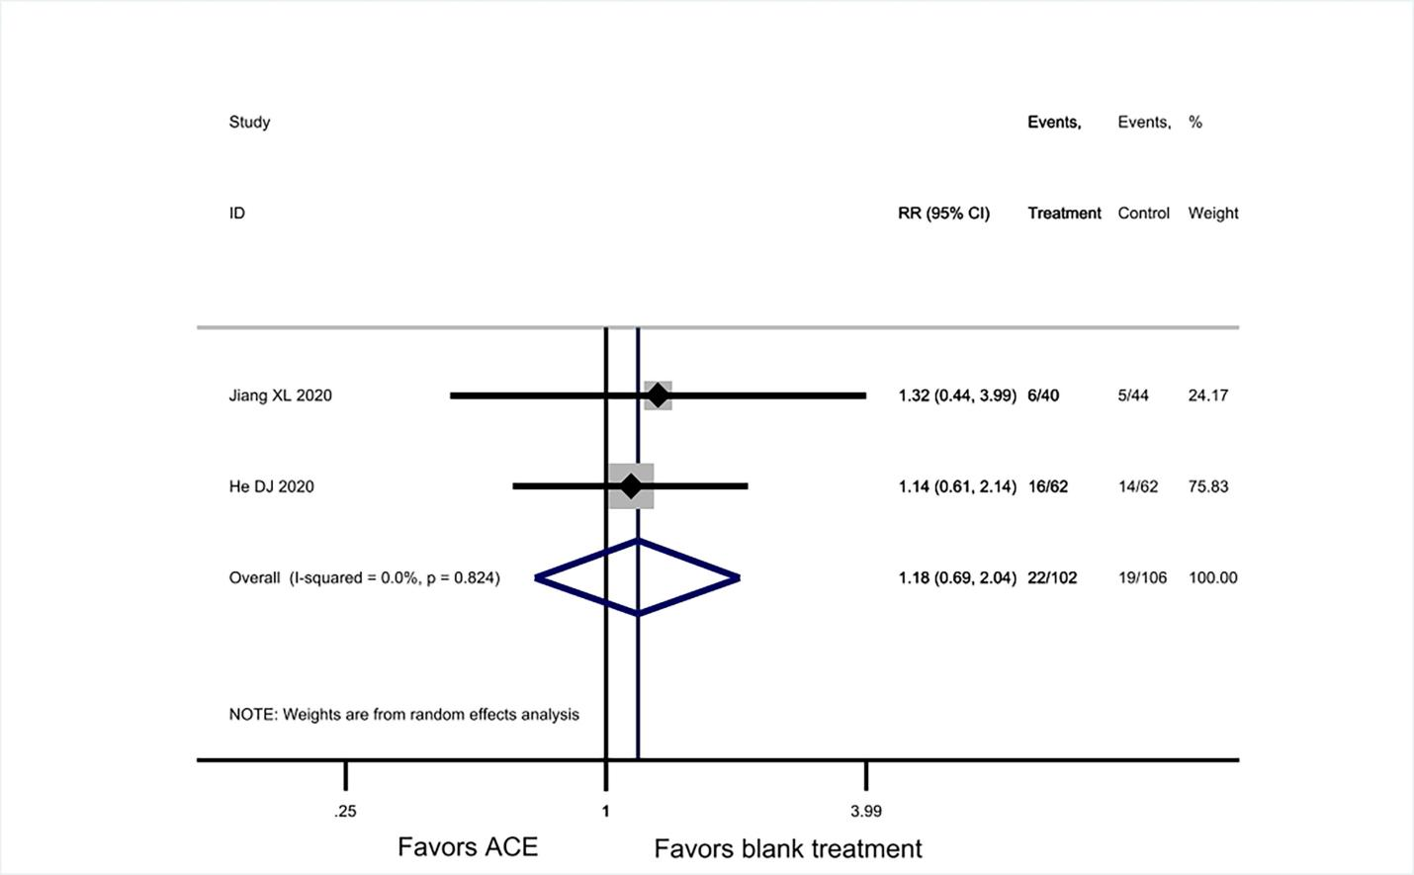

Supplement Figure 4 Adverse effects among patients who received acupoint catgut embedding compared to blank treatment,on the basis of usual care

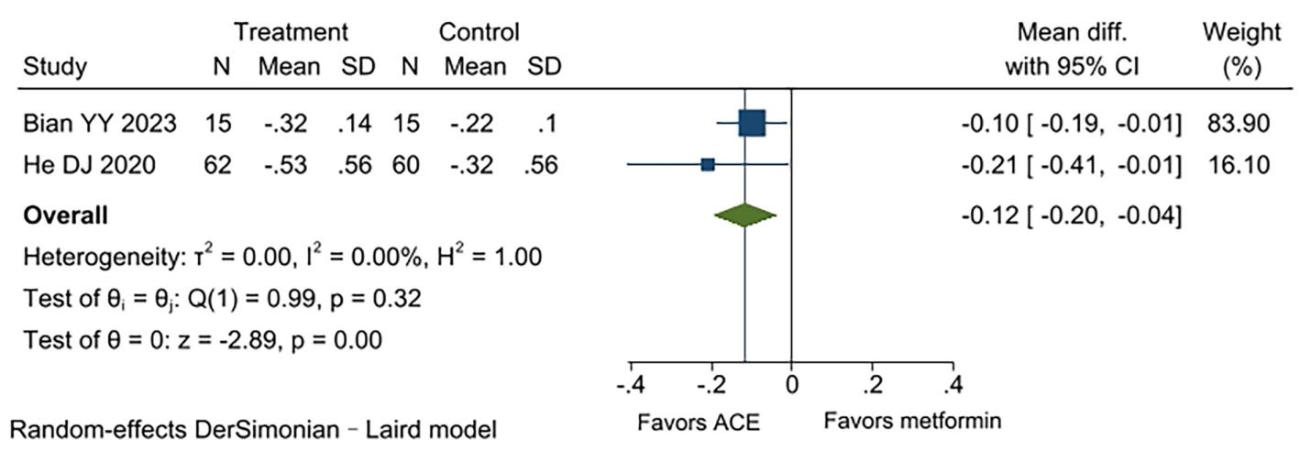

Supplement Figure 5 TG among patients who received acupoint catgut embedding compared to metformin

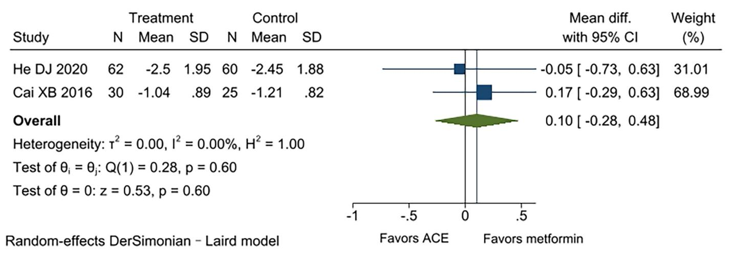

Supplement Figure 6 HOMA-IR among patients who received acupoint catgut embedding compared to metformin

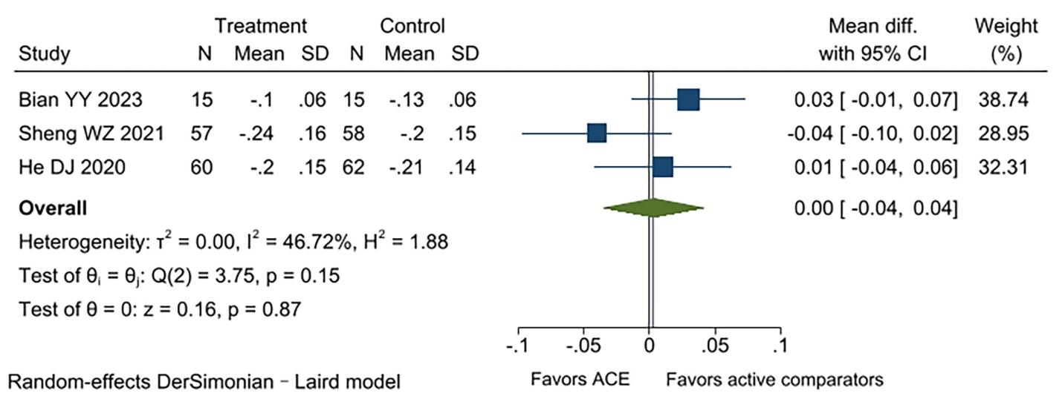

Supplement Figure 7 T among patients who received acupoint catgut embedding compared to active comparators

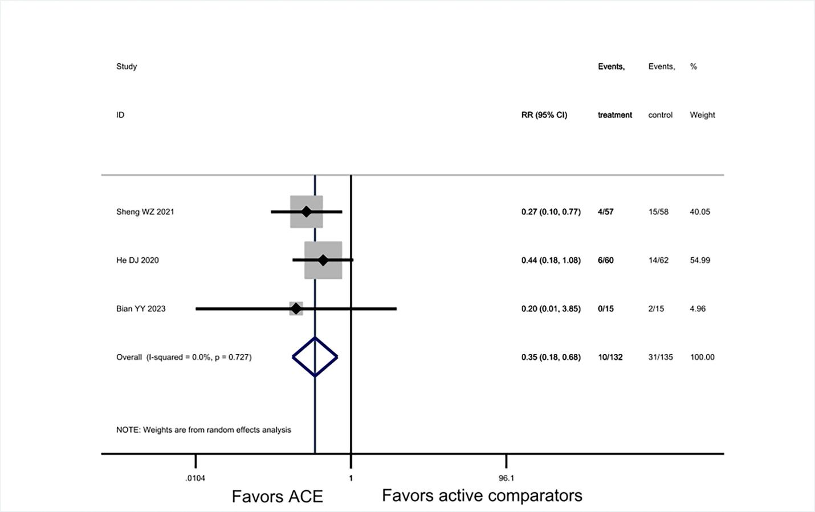

Supplement Figure 8 Adverse effects among patients who received acupoint catgut embedding compared to active comparators

