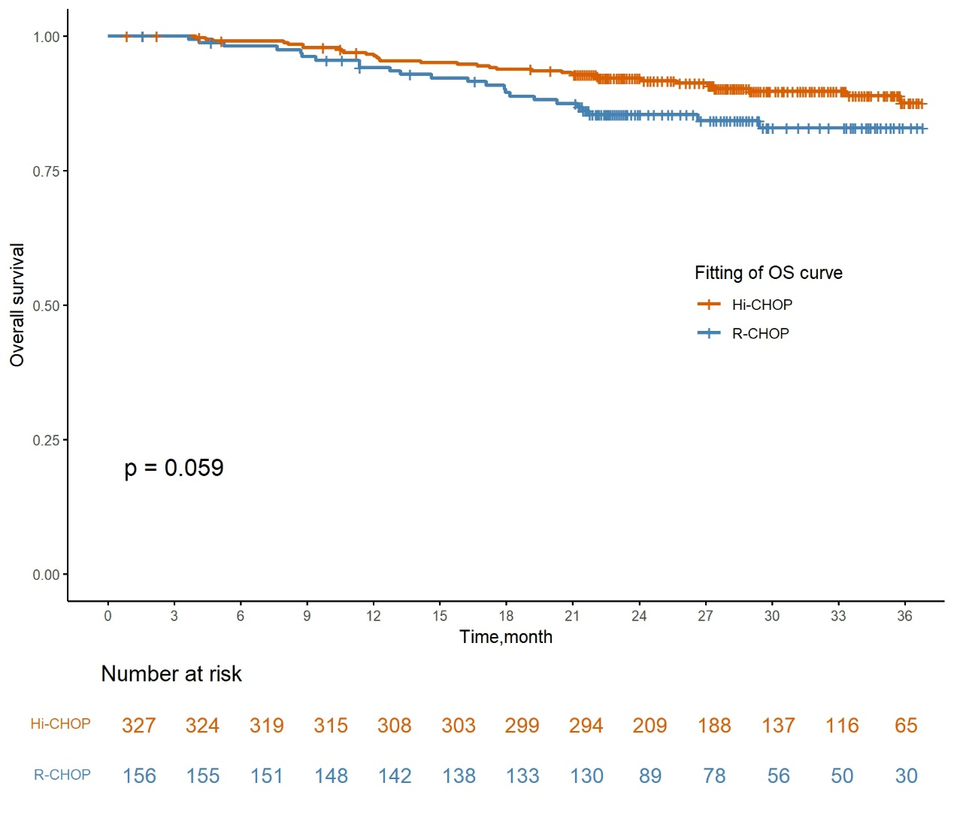
Figure S1 Overall Survival Curve Data Extraction.

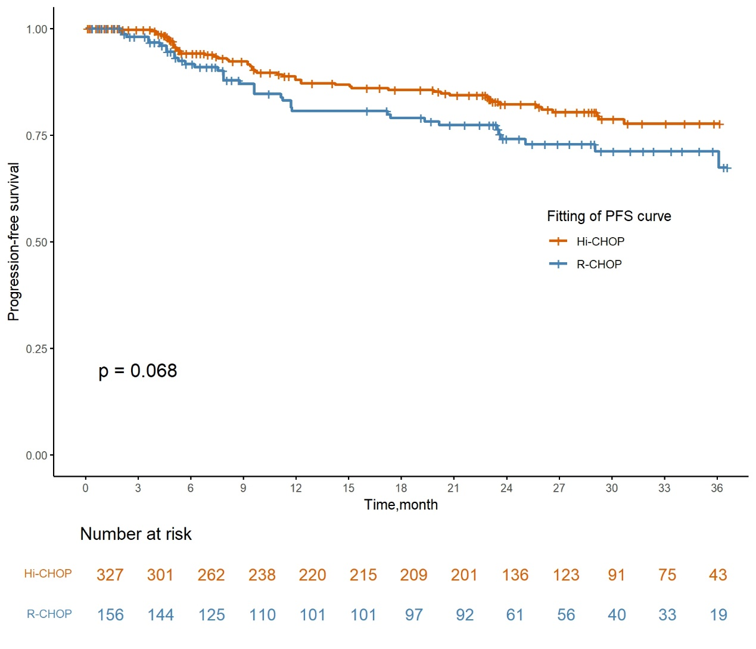
Figure S2 Progression-free Survival Curve Data Extraction.

Table S1 Summary of Statistical Goodness-of-fit of Partitioned Survival Model
 | Exponential | Gamma | Weibull(PH) | Loglogistic | Lognormal
OS Curve of Hi-CHOP
AIC | 427.458 | 426.1848 | 426.4805 | 426.161 | 424.0895
BIC | 431.2479 | 433.7647 | 434.0605 | 433.7409 | 431.1694
OS Curve of R-CHOP
AIC | 296.9697 | 297.2109 | 297.5309 | 296.9267 | 294.9697
BIC | 300.0196 | 303.3106 | 303.6306 | 303.0264 | 301.0694
PFS Curve of Hi-CHOP
AIC | 612.791 | 614.5255 | 614.6904 | 613.1339 | 607.5426
BIC | 616.5814 | 622.1054 | 622.2703 | 620.7138 | 615.1225
PFS Curve of R-CHOP
AIC | 396.3753 | 398.3752 | 398.3414 | 396.9136 | 393.36
BIC | 399.4251 | 404.4749 | 404.4411 | 403.0133 | 399.4597
Abbreviations: OS, overall survival; PFS, progression-free survival; AIC, Akaike information criterion; BIC, Bayesian information criterion; Hi-CHOP, zuberitamab combined with CHOP; R-CHOP, rituximab combined with CHOP.

Table S2 OS and PFS Model parameters
 | Distributions | Scale | Shape
OS Curve of Hi-CHOP | Lognormal | 1.514 | 5.321
OS Curve of R-CHOP | Exponential | 0.00583 | /
PFS Curve of Hi-CHOP | Lognormal | 1.701 | 4.772
PFS Curve of R-CHOP | Exponential | 0.01136 | /
Abbreviations: OS, overall survival; PFS, progression-free survival; Hi-CHOP, zuberitamab combined with CHOP; R-CHOP, rituximab combined with CHOP.

Table S3a Summary of scenario analysis results (25% off)
Parameter | Treatment
Parameter | Hi-CHOP | R-CHOP
Total cost, $ | 682,701.95 | 486,204.93
Incremental total cost | 196,497.02
QALYs | 6.45 | 4.88
QALY gain | 1.57
ICER, $ (Hi-CHOP vs R-CHOP, Per QALY) | 124,889.93

Table S3b Summary of scenario analysis results (50% off)
Parameter | Treatment
Parameter | Hi-CHOP | R-CHOP
Total cost, $ | 641,032.73 | 486,204.93
Incremental total cost | 154,827.81
QALYs | 6.45 | 4.88
QALY gain | 1.57
ICER, $ (Hi-CHOP vs R-CHOP, Per QALY) | 98,405.73

Table S3c Summary of scenario analysis results (75% off)
Parameter | Treatment
Parameter | Hi-CHOP | R-CHOP
Total cost, $ | 599,364.82 | 486,204.93
Incremental total cost | 113,159.89
QALYs | 6.45 | 4.88
QALY gain | 1.57
ICER, $ (Hi-CHOP vs R-CHOP, Per QALY) | 71,922.37
Abbreviations: QALY, quality-adjusted life year; ICER, incremental cost-effectiveness ratio; Hi-CHOP, zuberitamab combined with CHOP; R-CHOP, rituximab combined with CHOP.

