Supplementary Table 1 General Characteristics of All Patients in the Training and Validation Cohorts
 | Total  (n = 1343) | Training cohorts  (n = 1074) | Validation cohorts  (n = 269) | p
IPN, n (%) |  |  |  | 1.000
No | 1232 (92) | 985 (92) | 247 (92)
Yes | 111 (8) | 89 (8) | 22 (8)
Sex, n (%) |  |  |  | 0.826
Female | 489 (36) | 389 (36) | 100 (37)
Male | 854 (64) | 685 (64) | 169 (63)
Age, Median (Q1,Q3) | 47 (35, 61) | 47 (35, 62) | 47 (35, 60) | 0.921
BMI, Median (Q1,Q3) | 25.71 (23.15, 28.88) | 25.65 (23.11, 29.07) | 26.12 (23.45, 28.72) | 0.361
DM, n (%) |  |  |  | 0.146
noDM | 1132 (84) | 897 (84) | 235 (87)
DM | 211 (16) | 177 (16) | 34 (13)
HTN, n (%) |  |  |  | 1.000
No | 996 (74) | 796 (74) | 200 (74)
Yes | 347 (26) | 278 (26) | 69 (26)
HPL, n (%) |  |  |  | 0.300
No | 1033 (77) | 833 (78) | 200 (74)
Yes | 310 (23) | 241 (22) | 69 (26)
SHG, n (%) |  |  |  | 0.513
'No stress hyperglycaemia' | 995 (74) | 791 (74) | 204 (76)
'Stress hyperglycaemia' | 348 (26) | 283 (26) | 65 (24)
Fattyliver, n (%) |  |  |  | *0.019
No | 1015 (76) | 827 (77) | 188 (70)
Yes | 328 (24) | 247 (23) | 81 (30)
SIRS, n (%) |  |  |  | 0.403
No | 771 (57) | 610 (57) | 161 (60)
Yes | 572 (43) | 464 (43) | 108 (40)
MODS, n (%) |  |  |  | 0.269
No | 982 (73) | 793 (74) | 189 (70)
Yes | 361 (27) | 281 (26) | 80 (30)
Peripancreatic Effusion, n (%) |  |  |  | 0.568
No | 846 (63) | 672 (63) | 174 (65)
Yes | 497 (37) | 402 (37) | 95 (35)
Hydrothorax, n (%) |  |  |  | 0.158
No | 882 (66) | 695 (65) | 187 (70)
Yes | 461 (34) | 379 (35) | 82 (30)
Seroperitoneum, n (%) |  |  |  | 0.682
No | 897 (67) | 714 (66) | 183 (68)
Yes | 446 (33) | 360 (34) | 86 (32)
MCTSI, n (%) |  |  |  | 0.630
0 | 28 (2) | 23 (2) | 5 (2)
2 | 572 (43) | 450 (42) | 122 (45)
4 | 349 (26) | 274 (26) | 75 (28)
6 | 315 (23) | 261 (24) | 54 (20)
8 | 76 (6) | 63 (6) | 13 (5)
10 | 3 (0) | 3 (0) | 0 (0)
BISAP, n (%) |  |  |  | 0.706
0 | 627 (47) | 493 (46) | 134 (50)
1 | 528 (39) | 424 (39) | 104 (39)
2 | 173 (13) | 144 (13) | 29 (11)
3 | 13 (1) | 11 (1) | 2 (1)
4 | 2 (0) | 2 (0) | 0 (0)
qSOFA, n (%) |  |  |  | 0.188
0 | 997 (74) | 784 (73) | 213 (79)
1 | 306 (23) | 257 (24) | 49 (18)
2 | 38 (3) | 31 (3) | 7 (3)
3 | 2 (0) | 2 (0) | 0 (0)
OPNI, Median (Q1,Q3) | 42.05 (34.9, 48.17) | 42.05 (35.26, 48.05) | 42 (33.9, 49.55) | 0.695
PLR, Median (Q1,Q3) | 174.6 (123.69, 256.67) | 178.44 (124.78, 257.94) | 164.79 (119.86, 238.88) | 0.161
NLR, Median (Q1,Q3) | 7.58 (4.28, 13) | 7.86 (4.29, 13.41) | 6.96 (4.24, 11.5) | 0.023
Bloodglucose, Median (Q1,Q3) | 8.39 (6.06, 11.4) | 8.5 (6.04, 11.4) | 8.09 (6.1, 11.04) | 0.241
ALT, Median (Q1,Q3) | 39.9 (20.4, 119.9) | 40 (20.45, 120.88) | 38 (20, 110.9) | 0.528
AST, Median (Q1,Q3) | 33.2 (21.6, 93.85) | 33.7 (21.92, 93.6) | 32 (20.3, 94.6) | 0.250
Alb, Median (Q1,Q3) | 36.3 (30.1, 41.25) | 36.35 (30.5, 41.3) | 35.7 (28.7, 40.8) | 0.269
Total bilirubin, Median (Q1,Q3) | 20.9 (12.05, 35.7) | 21.15 (12.4, 35.77) | 20.6 (10.4, 33.4) | 0.153
Direct bilirubin, Median (Q1,Q3) | 6.5 (3.5, 14.6) | 6.4 (3.42, 14.3) | 7.7 (3.6, 16.9) | 0.306
Total cholesterol, Median (Q1,Q3) | 4.03 (2.85, 5.29) | 4.03 (2.85, 5.22) | 4.07 (2.88, 5.53) | 0.745
HDL-C, Median (Q1,Q3) | 1.21 (0.89, 1.53) | 1.2 (0.88, 1.48) | 1.28 (0.96, 1.8) | *0.007
LDL-C, Median (Q1,Q3) | 2.57 (1.92, 3.86) | 2.54 (1.86, 3.7) | 2.68 (2.06, 27.5) | *0.001
Urea, Median (Q1,Q3) | 5.1 (4, 6.6) | 5.1 (4, 6.7) | 4.8 (3.7, 6.1) | *0.007
SCr, Median (Q1,Q3) | 73.1 (61.7, 87) | 73.5 (62.35, 87.07) | 71.9 (60.4, 87) | 0.332
AMY, Median (Q1,Q3) | 188.8 (75.55, 618.65) | 207.45 (80.25, 679.28) | 149.9 (64.5, 448.5) | *0.001
LPS, Median (Q1,Q3) | 238.6 (85.65, 758.1) | 254.4 (89.9, 792.62) | 181.4 (71.2, 598.9) | *0.014
K, Median (Q1,Q3) | 3.93 (3.64, 4.22) | 3.95 (3.66, 4.24) | 3.87 (3.61, 4.16) | *0.018
Na, Median (Q1,Q3) | 136.6 (134.3, 138.8) | 136.6 (134.3, 138.8) | 136.9 (134.4, 138.8) | 0.384
Cl, Median (Q1,Q3) | 102.8 (99.8, 105.4) | 102.8 (99.9, 105.3) | 102.8 (99.5, 105.7) | 0.977
P, Median (Q1,Q3) | 0.98 (0.73, 1.18) | 0.98 (0.74, 1.18) | 0.95 (0.72, 1.15) | 0.376
Mg, Median (Q1,Q3) | 0.82 (0.75, 0.89) | 0.82 (0.75, 0.89) | 0.82 (0.76, 0.89) | 0.525
Ca, Median (Q1,Q3) | 2.17 (2.04, 2.27) | 2.17 (2.03, 2.27) | 2.18 (2.08, 2.3) | 0.140
PT-S, Median (Q1,Q3) | 12.5 (11.8, 13.6) | 12.6 (11.9, 13.6) | 12.5 (11.8, 13.4) | 0.166
PT(%), Median (Q1,Q3) | 81 (71, 88.5) | 80 (71, 88) | 82 (73, 90) | *0.032
APTT, Median (Q1,Q3) | 29.9 (28, 32.3) | 29.9 (28, 32.4) | 29.9 (27.8, 32) | 0.665
TT, Median (Q1,Q3) | 13.8 (12.7, 14.8) | 13.8 (12.7, 14.8) | 13.8 (12.6, 14.8) | 0.769
D-Dimer, Median (Q1,Q3) | 497 (228.5, 1064.5) | 518 (229.75, 1070.5) | 425 (228, 1024) | 0.241
WBC, Median (Q1,Q3) | 10.9 (7.6, 14.4) | 11 (7.7, 14.5) | 10.87 (7.3, 14.1) | 0.405
NEUT, Median (Q1,Q3) | 9.02 (5.72, 12.14) | 9.07 (5.74, 12.29) | 8.52 (5.64, 11.7) | 0.279
LYMPH, Median (Q1,Q3) | 1.15 (0.78, 1.61) | 1.12 (0.76, 1.6) | 1.22 (0.87, 1.65) | *0.030
MONO, Median (Q1,Q3) | 0.59 (0.4, 0.83) | 0.59 (0.4, 0.83) | 0.58 (0.37, 0.8) | 0.702
RBC, Median (Q1,Q3) | 4.55 (4.08, 5.01) | 4.55 (4.08, 5.03) | 4.56 (4.07, 4.99) | 0.945
HGB, Median (Q1,Q3) | 135 (110, 155) | 134 (108.93, 154) | 139 (116, 157) | 0.326
HCT, Median (Q1,Q3) | 0.46 (0.4, 19) | 0.46 (0.4, 19.35) | 0.46 (0.4, 15.3) | 0.848
MCV, Median (Q1,Q3) | 91.9 (88.9, 95.52) | 92 (89, 95.8) | 91.42 (88.3, 94.9) | 0.058
MCH, Median (Q1,Q3) | 31.2 (30, 32.4) | 31.3 (30.02, 32.4) | 31.1 (29.9, 32.2) | 0.273
MCHC, Median (Q1,Q3) | 338 (332, 344) | 338 (332, 344) | 338 (333, 344) | 0.399
RDW, Median (Q1,Q3) | 13.3 (12.4, 14.1) | 13.3 (12.4, 14.1) | 13.2 (12.5, 14.1) | 0.647
PCT, Median (Q1,Q3) | 0.18 (0.15, 0.22) | 0.18 (0.14, 0.22) | 0.18 (0.15, 0.22) | *0.086
PLT, Median (Q1,Q3) | 203 (160.5, 254) | 203 (158, 253) | 206 (165, 260) | 0.244
PDW, Median (Q1,Q3) | 16.8 (16.2, 17.4) | 16.77 (16.2, 17.4) | 16.8 (16.3, 17.4) | 0.347
MPV, Median (Q1,Q3) | 8.6 (7.9, 9.5) | 8.6 (7.9, 9.5) | 8.6 (8, 9.4) | 0.646
Notes: Value are presented as number (%), mean±standard deviation or IQR, 50 (25, 75). Normally distributed data were tested using independent samples t-tests, and nonparametric tests were used for nonnormal data. *Statistically significant p-values (p < 0.05) are indicated in bold.

Supplementary table 2.Comparison of General Characteristics of Study Populations Stratified by Infectious Necrosis
 | Total  (n = 1343) | Non-IPN  (n = 1232) | IPN  (n = 111) | p
Sex, n (%) |  |  |  | 0.85
Female | 489 (36) | 450 (37) | 39 (35)
Male | 854 (64) | 782 (63) | 72 (65)
Age, Median (Q1,Q3) | 47 (35, 61) | 47 (35, 61) | 49 (37, 62) | 0.231
BMI, Median (Q1,Q3) | 25.71 (23.15, 28.88) | 25.68 (23.15, 28.72) | 26.56 (23.08, 30.06) | 0.086
AP etiology, n (%) |  |  |  | 0.055
Biliary | 622 (46) | 560 (45) | 62 (56)
Hypertriglyceridemia | 160 (12) | 154 (12) | 6 (5)
Alcoholic | 164 (12) | 149 (12) | 15 (14)
Others | 397 (30) | 369 (30) | 28 (25)
Others, n (%) |  |  |  | 0.54
No | 551 (41) | 509 (41) | 42 (38)
Yes | 792 (59) | 723 (59) | 69 (62)
Smoking, n (%) |  |  |  | 0.676
No | 816 (61) | 746 (61) | 70 (63)
Yes | 527 (39) | 486 (39) | 41 (37)
Drinking, n (%) |  |  |  | 0.706
No | 855 (64) | 782 (63) | 73 (66)
Yes | 488 (36) | 450 (37) | 38 (34)
DM, n (%) |  |  |  | 0.773
noDM | 1132 (84) | 1040 (84) | 92 (83)
DM | 211 (16) | 192 (16) | 19 (17)
HTN, n (%) |  |  |  | 0.275
No | 996 (74) | 919 (75) | 77 (69)
Yes | 347 (26) | 313 (25) | 34 (31)
HPL, n (%) |  |  |  | 0.056
No | 1033 (77) | 939 (76) | 94 (85)
Yes | 310 (23) | 293 (24) | 17 (15)
Fattyliver, n (%) |  |  |  | 0.079
No | 1015 (76) | 923 (75) | 92 (83)
Yes | 328 (24) | 309 (25) | 19 (17)
Hospitalization days, Median (Q1,Q3) | 13 (9, 18) | 12 (9, 17) | 20 (13, 38) | <0.001*
Infection, n (%) |  |  |  | < 0.001*
No | 1269 (94) | 1190 (97) | 79 (71)
Yes | 74 (6) | 42 (3) | 32 (29)
Severity of pancreatitis, n (%) |  |  |  | < 0.001*
Mild | 821 (61) | 815 (66) | 6 (5)
'Moderate or severe' | 522 (39) | 417 (34) | 105 (95)
SIRS, n (%) |  |  |  | < 0.001*
No | 771 (57) | 751 (61) | 20 (18)
Yes | 572 (43) | 481 (39) | 91 (82)
MODS, n (%) |  |  |  | < 0.001*
No | 982 (73) | 937 (76) | 45 (41)
Yes | 361 (27) | 295 (24) | 66 (59)
Peripancreatic Effusion, n (%) |  |  |  | < 0.001*
No | 846 (63) | 840 (68) | 6 (5)
Yes | 497 (37) | 392 (32) | 105 (95)
pleural effusion, n (%) |  |  |  | < 0.001*
No | 882 (66) | 852 (69) | 30 (27)
Yes | 461 (34) | 380 (31) | 81 (73)
Seroperitoneum, n (%) |  |  |  | < 0.001*
No | 897 (67) | 859 (70) | 38 (34)
Yes | 446 (33) | 373 (30) | 73 (66)
Surgical Intervention, n (%) |  |  |  | < 0.001*
No | 1068 (80) | 994 (81) | 74 (67)
Yes | 275 (20) | 238 (19) | 37 (33)
Thoracocentesis, n (%) |  |  |  | < 0.001*
No | 1313 (98) | 1217 (99) | 96 (86)
Yes | 30 (2) | 15 (1) | 15 (14)
Abdominocentesis, n (%) |  |  |  | < 0.001*
No | 1266 (94) | 1195 (97) | 71 (64)
Yes | 77 (6) | 37 (3) | 40 (36)
Operative Treatment, n (%) |  |  |  | < 0.001*
Peripancreatic debridement | 37 (3) | 9 (1) | 28 (25)
LC | 188 (14) | 181 (15) | 7 (6)
ERCP | 16 (1) | 14 (1) | 2 (2)
Bile duct exploration | 34 (3) | 34 (3) | 0 (0)
No | 1068 (80) | 994 (81) | 74 (67)
Enteral Nutrition, n (%) |  |  |  | < 0.001*
No | 1146 (85) | 1078 (88) | 68 (61)
Yes | 197 (15) | 154 (12) | 43 (39)
ICU admission, n (%) |  |  |  | < 0.001*
No | 1301 (97) | 1205 (98) | 96 (86)
Yes | 42 (3) | 27 (2) | 15 (14)
Mortality, n (%) |  |  |  | < 0.001*
No | 1318 (98) | 1216 (99) | 102 (92)
Yes | 25 (2) | 16 (1) | 9 (8)
MCTSI, n (%) |  |  |  | < 0.001*
0 | 28 (2) | 26 (2) | 2 (2)
2 | 572 (43) | 554 (45) | 18 (16)
4 | 349 (26) | 336 (27) | 13 (12)
6 | 315 (23) | 287 (23) | 28 (25)
8 | 76 (6) | 28 (2) | 48 (43)
10 | 3 (0) | 1 (0) | 2 (2)
BISAP, n (%) |  |  |  | < 0.001*
0 | 627 (47) | 609 (49) | 18 (16)
1 | 528 (39) | 467 (38) | 61 (55)
2 | 173 (13) | 147 (12) | 26 (23)
3 | 13 (1) | 7 (1) | 6 (5)
4 | 2 (0) | 2 (0) | 0 (0)
qSOFA, n (%) |  |  |  | < 0.001*
0 | 997 (74) | 935 (76) | 62 (56)
1 | 306 (23) | 270 (22) | 36 (32)
2 | 38 (3) | 26 (2) | 12 (11)
3 | 2 (0) | 1 (0) | 1 (1)
OPNI, Median (Q1,Q3) | 42.05 (34.9, 48.17) | 42.62 (35.75, 48.5) | 34.55 (30, 41.75) | < 0.001*
PLR, Median (Q1,Q3) | 174.6 (123.69, 256.67) | 171.9 (121.8, 250.22) | 208.11 (149.45, 323.03) | < 0.001*
NLR, Median (Q1,Q3) | 7.58 (4.28, 13) | 7.38 (4.1, 12.35) | 11.87 (6.81, 17.59) | < 0.001*
SHG, n (%) |  |  |  | < 0.001*
'No stress hyperglycaemia' | 995 (74) | 935 (76) | 60 (54)
'Stress hyperglycaemia' | 348 (26) | 297 (24) | 51 (46)
Bloodglucose, Median (Q1,Q3) | 8.39 (6.06, 11.4) | 8.2 (6, 11.05) | 10.6 (7.55, 14.51) | < 0.001*
ALT, Median (Q1,Q3) | 39.9 (20.4, 119.9) | 39.85 (20.38, 119.93) | 41.2 (20.85, 110.15) | 0.882
AST, Median (Q1,Q3) | 33.2 (21.6, 93.85) | 32.65 (21.28, 93.6) | 42.9 (24.8, 104.95) | 0.075
Alb, Median (Q1,Q3) | 36.3 (30.1, 41.25) | 36.65 (31, 41.5) | 29.9 (25.55, 36.25) | < 0.001*
Total bilirubin, Median (Q1,Q3) | 20.9 (12.05, 35.7) | 21.1 (12.4, 35.92) | 19.5 (9.75, 29.2) | 0.103
Direct bilirubin, Median (Q1,Q3) | 6.5 (3.5, 14.6) | 6.2 (3.4, 14.3) | 9.4 (4.7, 19.1) | 0.002*
Total cholesterol, Median (Q1,Q3) | 4.03 (2.85, 5.29) | 4.08 (2.93, 5.3) | 3.37 (2.01, 5.08) | 0.005*
Triglyceride, Median (Q1,Q3) | 1.13 (0.77, 2.21) | 1.13 (0.77, 2.22) | 1.04 (0.8, 1.84) | 0.966
HDL-C, Median (Q1,Q3) | 1.21 (0.89, 1.53) | 1.22 (0.91, 1.52) | 1.15 (0.69, 1.69) | 0.088
LDL-C, Median (Q1,Q3) | 2.57 (1.92, 3.86) | 2.55 (1.93, 3.75) | 2.83 (1.85, 27.9) | 0.204
Urea, Median (Q1,Q3) | 5.1 (4, 6.6) | 5 (4, 6.4) | 6.2 (4.6, 10.3) | < 0.001*
SCr, Median (Q1,Q3) | 73.1 (61.7, 87) | 72.8 (61.6, 86.1) | 81.1 (65.05, 109.6) | < 0.001*
AMY, Median (Q1,Q3) | 188.8 (75.55, 618.65) | 185 (73.75, 598.25) | 275 (102.15, 811.4) | 0.06
LPS, Median (Q1,Q3) | 238.6 (85.65, 758.1) | 230.95 (85.6, 758.25) | 318.8 (96.15, 731.2) | 0.444
K, Median (Q1,Q3) | 3.93 (3.64, 4.22) | 3.92 (3.64, 4.21) | 4.04 (3.72, 4.33) | 0.034*
Na, Median (Q1,Q3) | 136.6 (134.3, 138.8) | 136.7 (134.4, 138.8) | 135.7 (132.9, 138.8) | 0.067
Cl, Median (Q1,Q3) | 102.8 (99.8, 105.4) | 102.9 (99.9, 105.4) | 101.4 (98.45, 105.75) | 0.15
P, Median (Q1,Q3) | 0.98 (0.73, 1.18) | 0.98 (0.75, 1.18) | 0.9 (0.51, 1.15) | 0.015*
Mg, Median (Q1,Q3) | 0.82 (0.75, 0.89) | 0.82 (0.75, 0.89) | 0.82 (0.74, 0.9) | 0.93
Ca, Median (Q1,Q3) | 2.17 (2.04, 2.27) | 2.18 (2.06, 2.28) | 2.01 (1.89, 2.16) | < 0.001*
PT-S, Median (Q1,Q3) | 12.5 (11.8, 13.6) | 12.5 (11.8, 13.5) | 13.6 (12.4, 14.75) | < 0.001*
PT(%), Median (Q1,Q3) | 81 (71, 88.5) | 81 (72, 89) | 72 (64, 83) | < 0.001*
APTT, Median (Q1,Q3) | 29.9 (28, 32.3) | 29.9 (28, 32.3) | 30.2 (27.4, 32.6) | 0.999
TT, Median (Q1,Q3) | 13.8 (12.7, 14.8) | 13.8 (12.7, 14.8) | 13.9 (12.75, 14.9) | 0.195
FIB-C, Median (Q1,Q3) | 3.93 (3.16, 5.14) | 3.91 (3.14, 4.98) | 4.49 (3.39, 5.89) | 0.034*
D-Dimer, Median (Q1,Q3) | 497 (228.5, 1064.5) | 452 (215, 982) | 1260 (626.5, 2172.5) | < 0.001*
WBC, Median (Q1,Q3) | 10.9 (7.6, 14.4) | 10.8 (7.5, 14.1) | 12.9 (9.4, 17.05) | < 0.001*
NEUT, Median (Q1,Q3) | 9.02 (5.72, 12.14) | 8.75 (5.6, 11.93) | 10.29 (7.4, 14.7) | < 0.001*
LYMPH, Median (Q1,Q3) | 1.15 (0.78, 1.61) | 1.17 (0.8, 1.64) | 0.98 (0.7, 1.27) | < 0.001*
MONO, Median (Q1,Q3) | 0.59 (0.4, 0.83) | 0.58 (0.39, 0.81) | 0.66 (0.46, 1.02) | 0.02*
RBC, Median (Q1,Q3) | 4.55 (4.08, 5.01) | 4.55 (4.09, 5.01) | 4.48 (3.92, 5.08) | 0.522
HGB, Median (Q1,Q3) | 135 (110, 155) | 135 (110.75, 154) | 138.5 (104, 160.5) | 0.425
HCT, Median (Q1,Q3) | 0.46 (0.4, 19) | 0.45 (0.4, 17.7) | 0.47 (0.41, 34.4) | 0.226
MCV, Median (Q1,Q3) | 91.9 (88.9, 95.52) | 91.9 (88.9, 95.5) | 92.5 (88.35, 97.03) | 0.501
MCH, Median (Q1,Q3) | 31.2 (30, 32.4) | 31.2 (30, 32.4) | 31.3 (29.8, 32.9) | 0.907
MCHC, Median (Q1,Q3) | 338 (332, 344) | 338 (332, 344) | 336 (331, 343) | 0.097
RDW, Median (Q1,Q3) | 13.3 (12.4, 14.1) | 13.2 (12.3, 14.1) | 13.8 (13.1, 14.5) | < 0.001*
PCT, Median (Q1,Q3) | 0.18 (0.15, 0.22) | 0.18 (0.15, 0.22) | 0.18 (0.14, 0.23) | 0.513
PLT, Median (Q1,Q3) | 203 (160.5, 254) | 203 (161, 254) | 198 (156.5, 269.5) | 0.987
PDW, Median (Q1,Q3) | 16.8 (16.2, 17.4) | 16.76 (16.2, 17.4) | 17 (16.5, 17.6) | 0.003*
MPV, Median (Q1,Q3) | 8.6 (7.9, 9.5) | 8.6 (7.9, 9.5) | 8.8 (8.15, 9.85) | 0.043*
Notes: Value are presented as number (%), mean±standard deviation or IQR, 50 (25, 75). Normally distributed data were tested using independent samples t-tests, and nonparametric tests were used for nonnormal data. *Statistically significant p-values (p < 0.05) are indicated in bold.

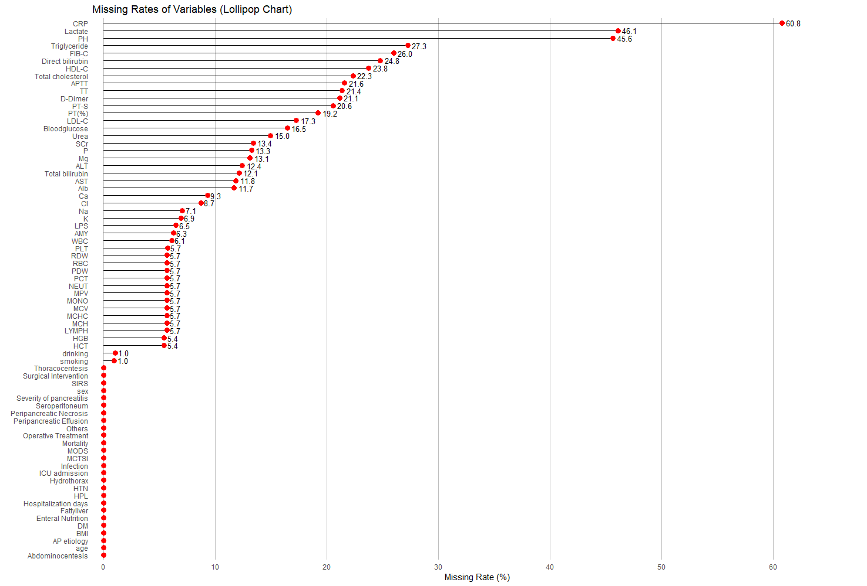
Supplementary Figure 1. Lollipop chart illustrating the missing rates of variables in the study cohort. Each lollipop corresponds to one variable, where the horizontal line represents the range and the red dot indicates the respective missing rate (%).

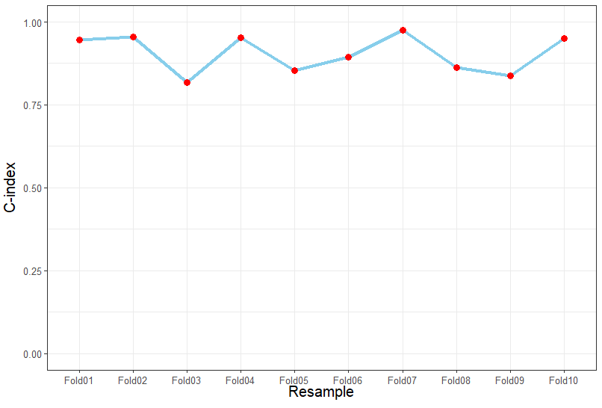
A
B

Supplementary Figure 2. (A) Distribution of C-index values from 1000-iteration Bootstrap internal validation in the training cohort. The C-index (concordance index) measures the model's probability of correctly predicting event timing, where C=0.5 indicates random guessing and C=1 denotes perfect prediction. (B) Distribution of C-index values from 10-fold cross-validation internal validation in the training cohort.
