S1(a)
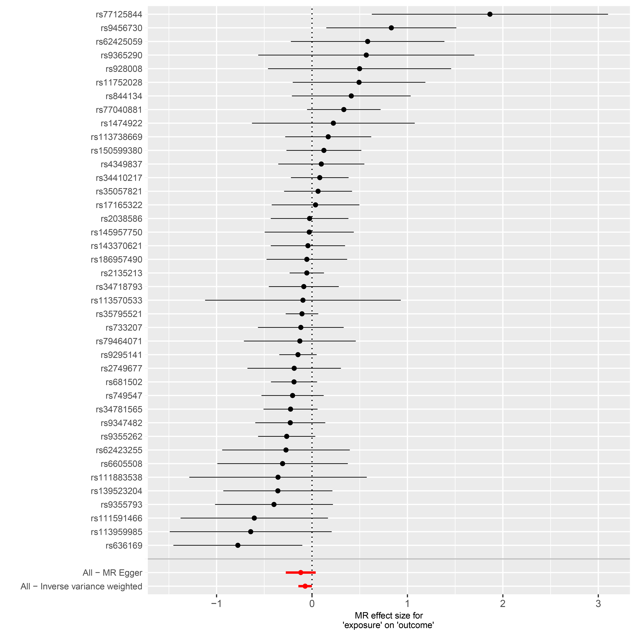

S1(b)
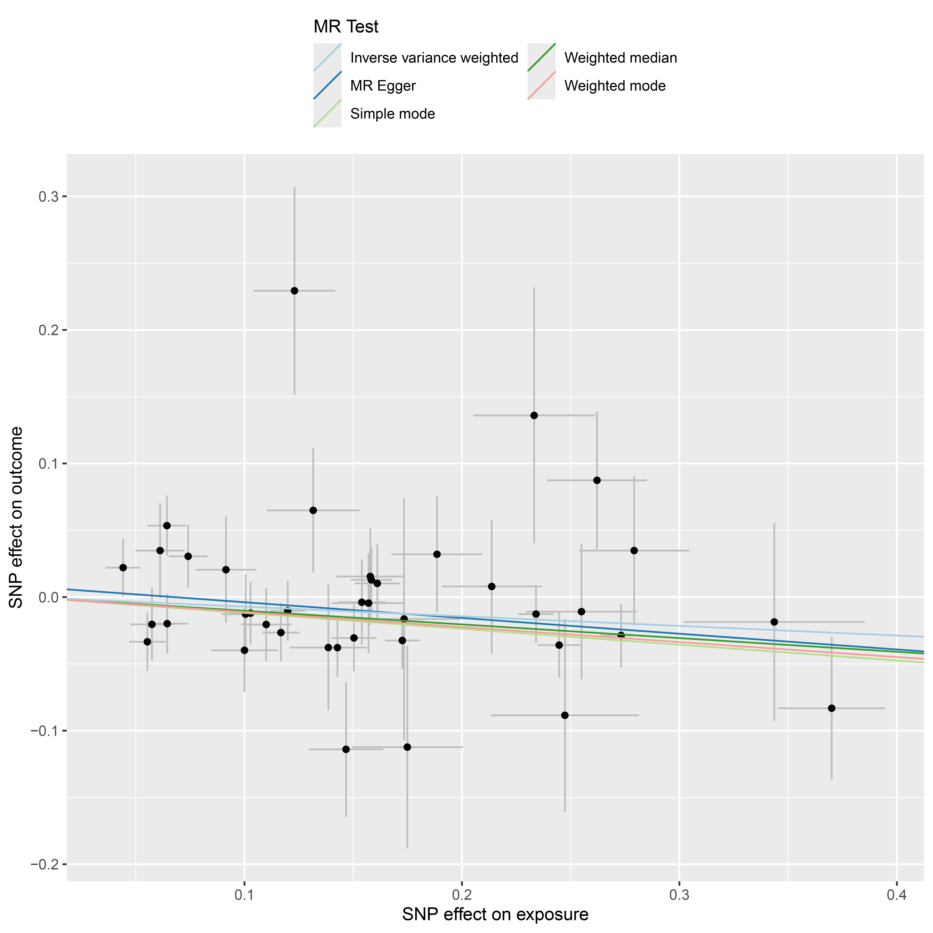

S1(c)
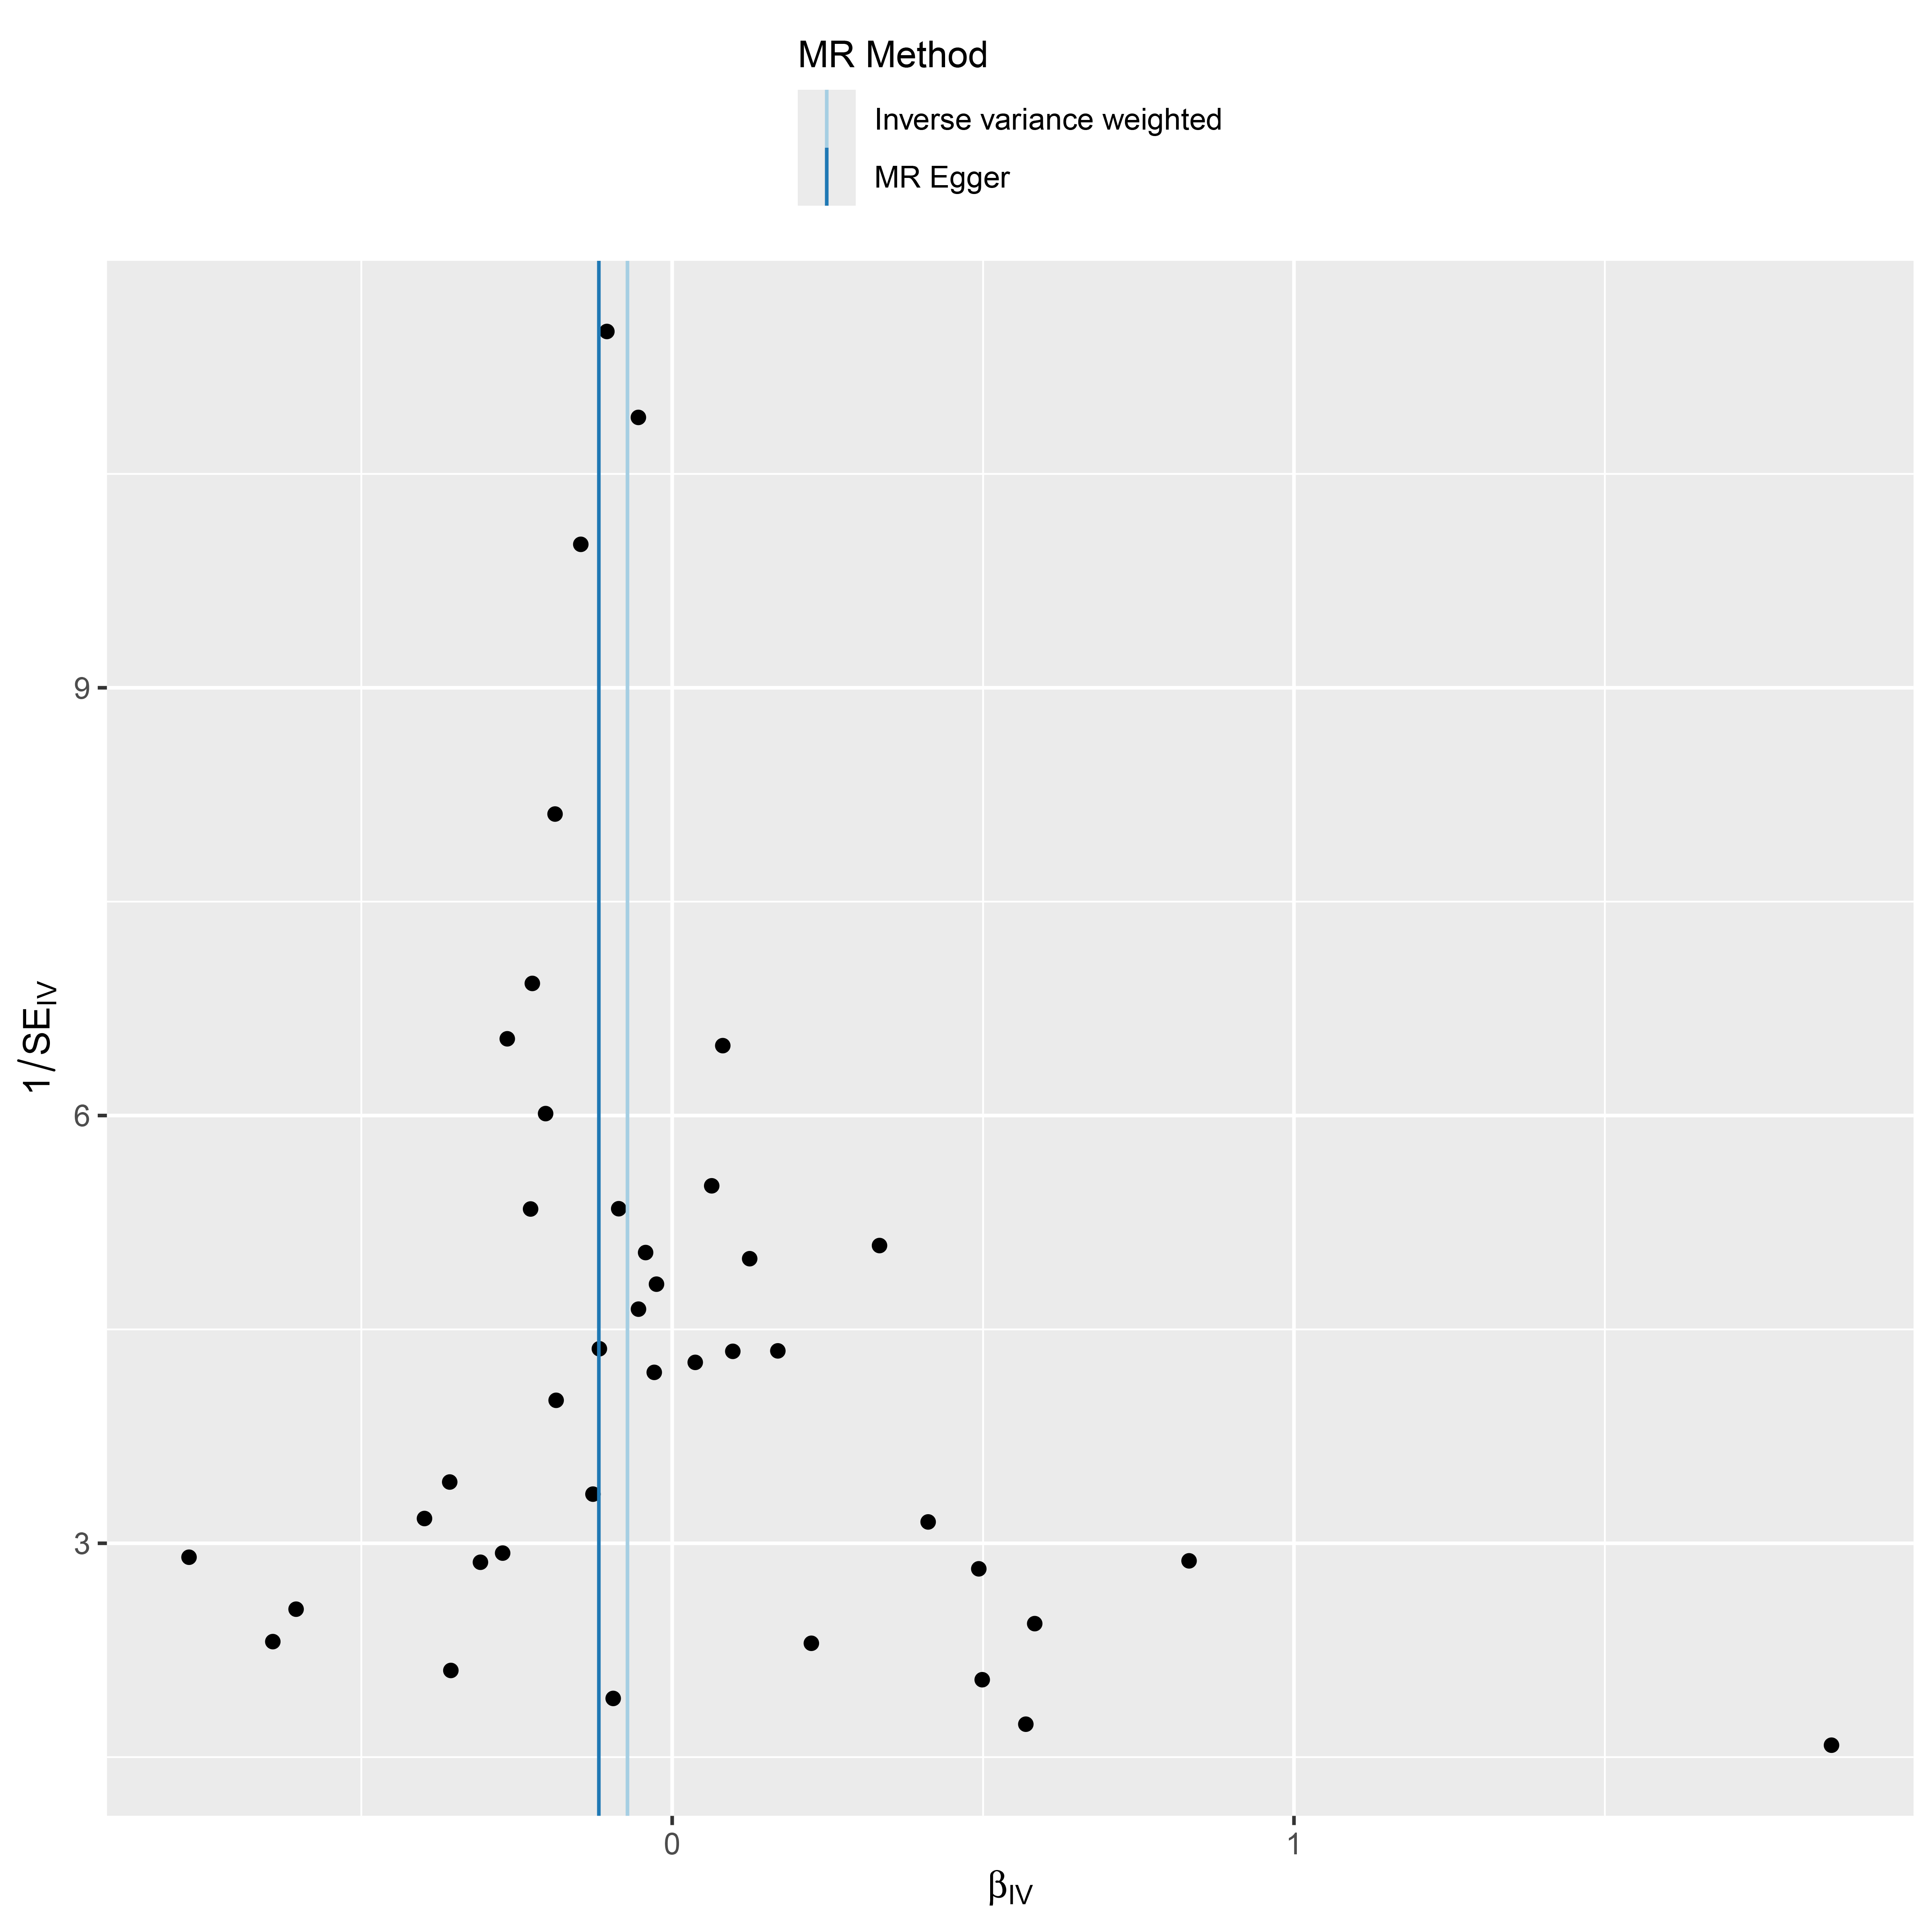
S1(d)
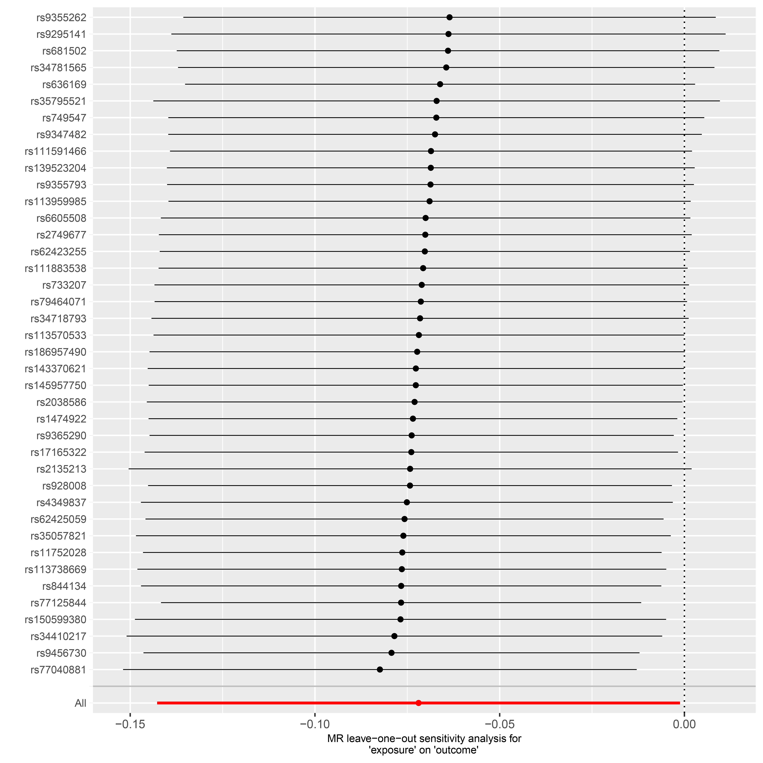
Supplementary Figure S1. Forest plot (a), scatter plot (b), funnel plot (c) and sensitivity analysis (d) of SNPs associated with ZDHHC14 on Acne vulgaris.

S2(a)
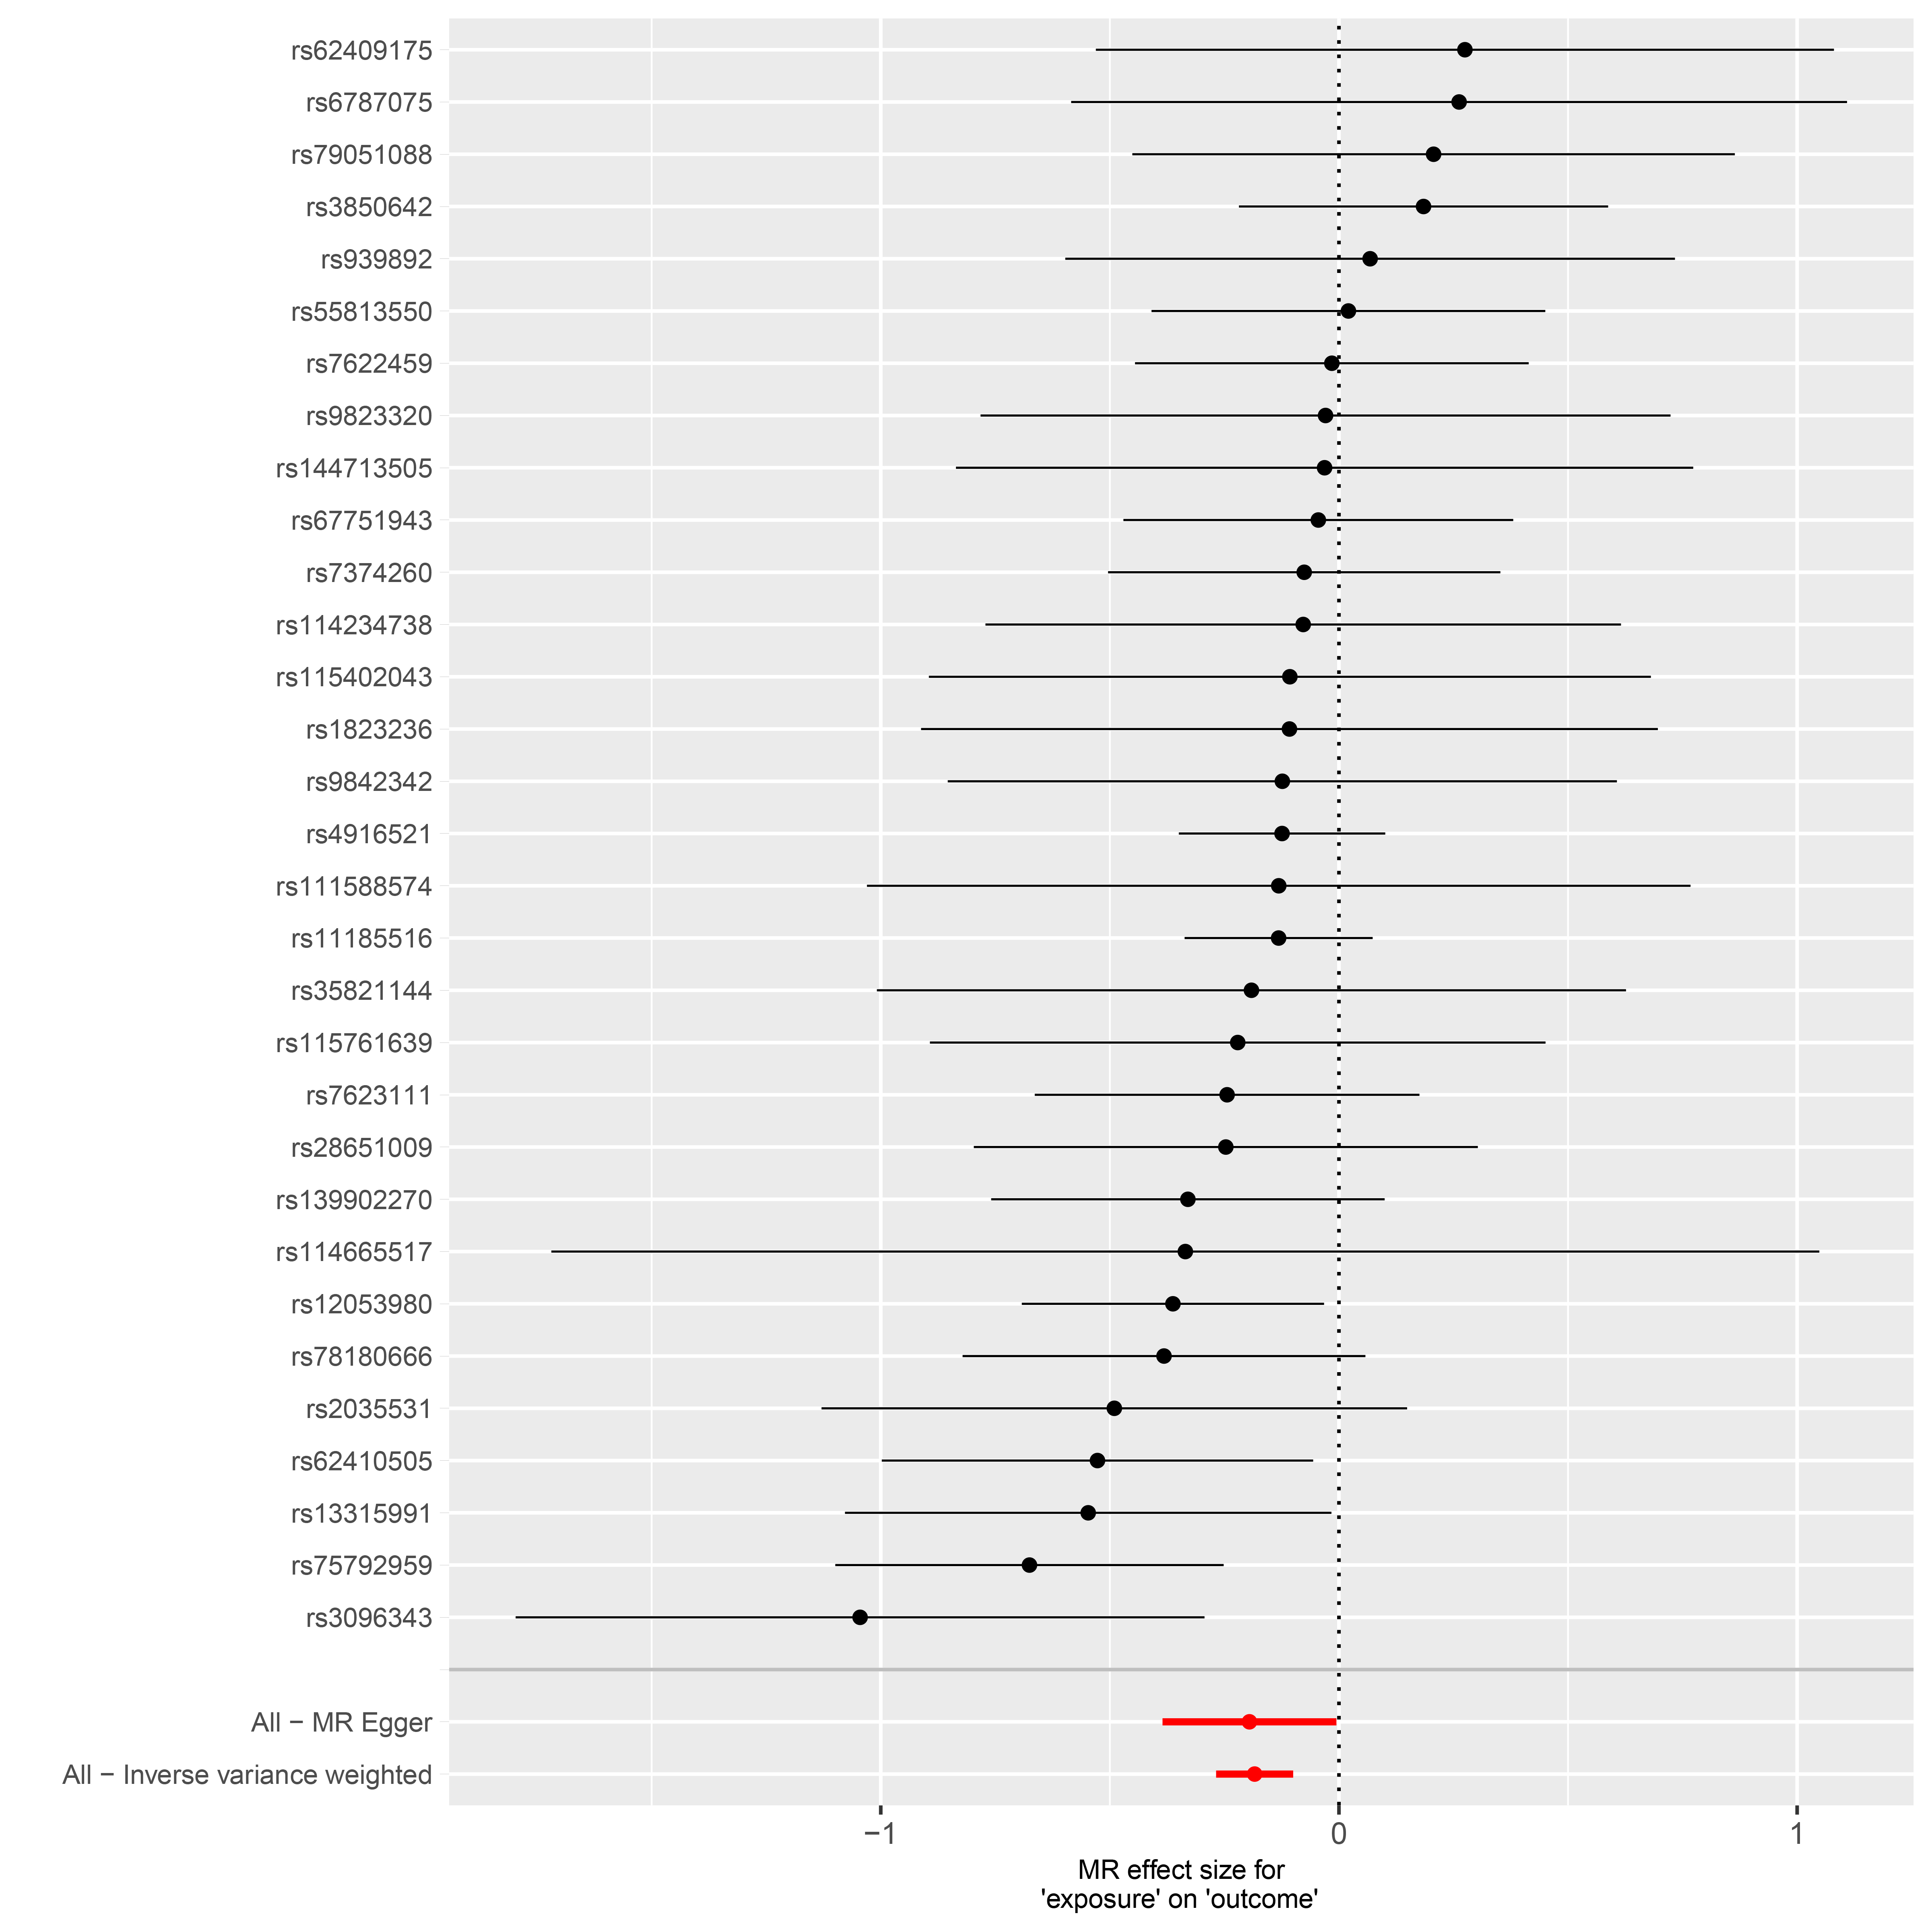
S2(b)
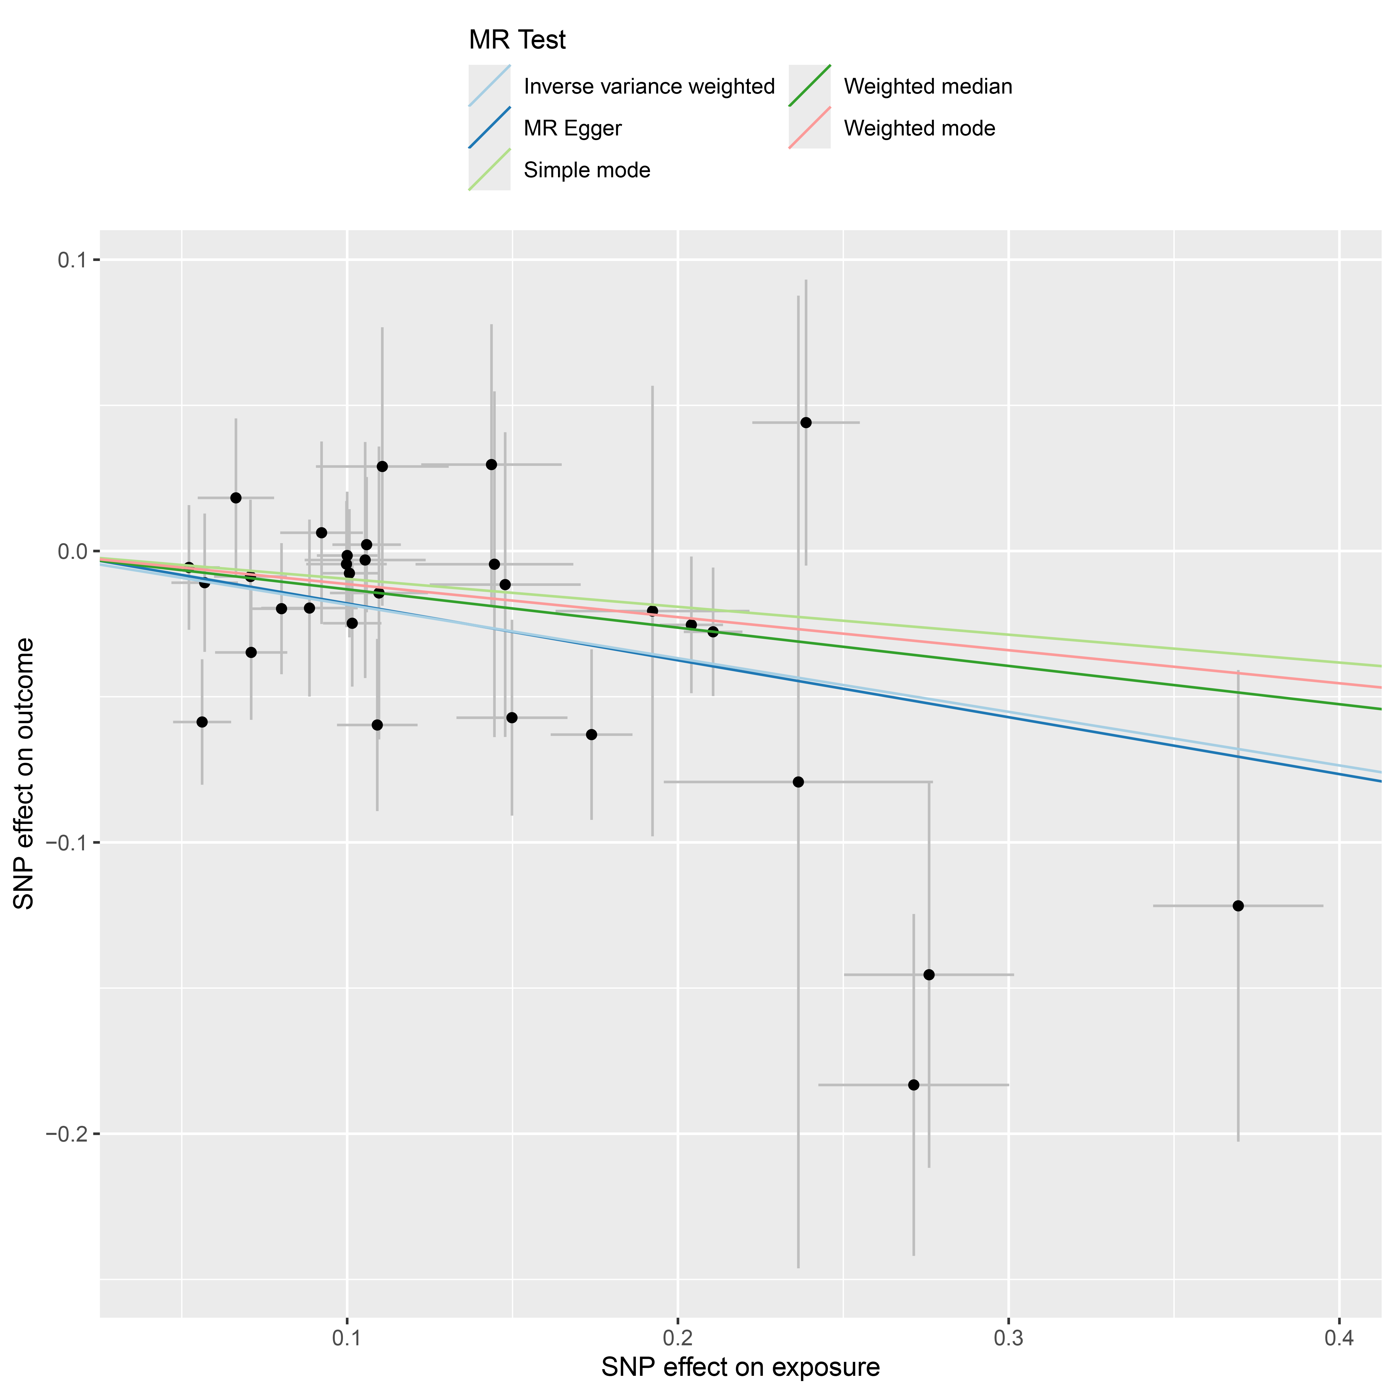
S2(c)
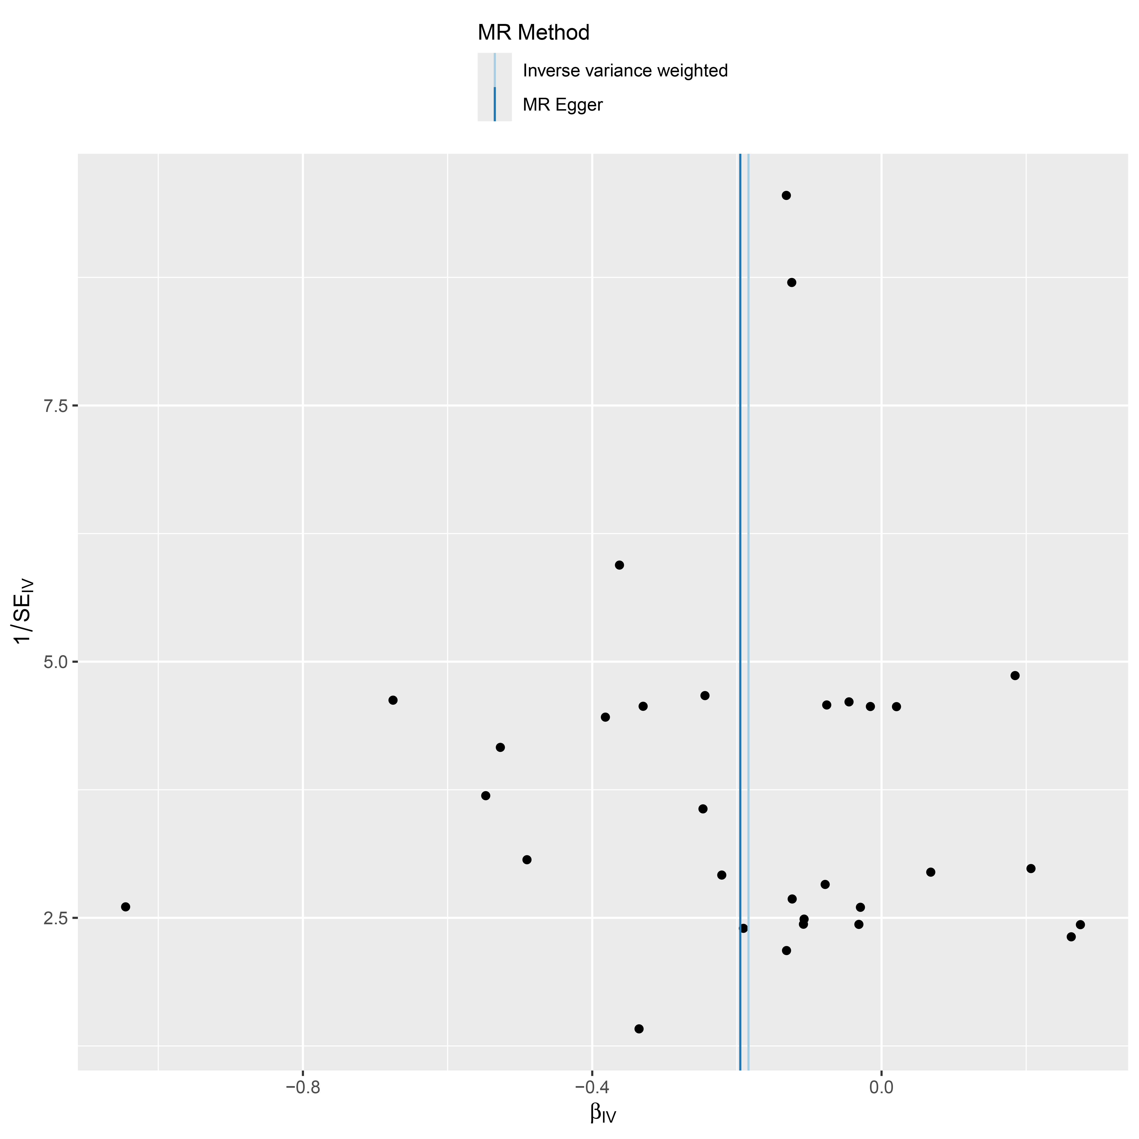
S2(d)
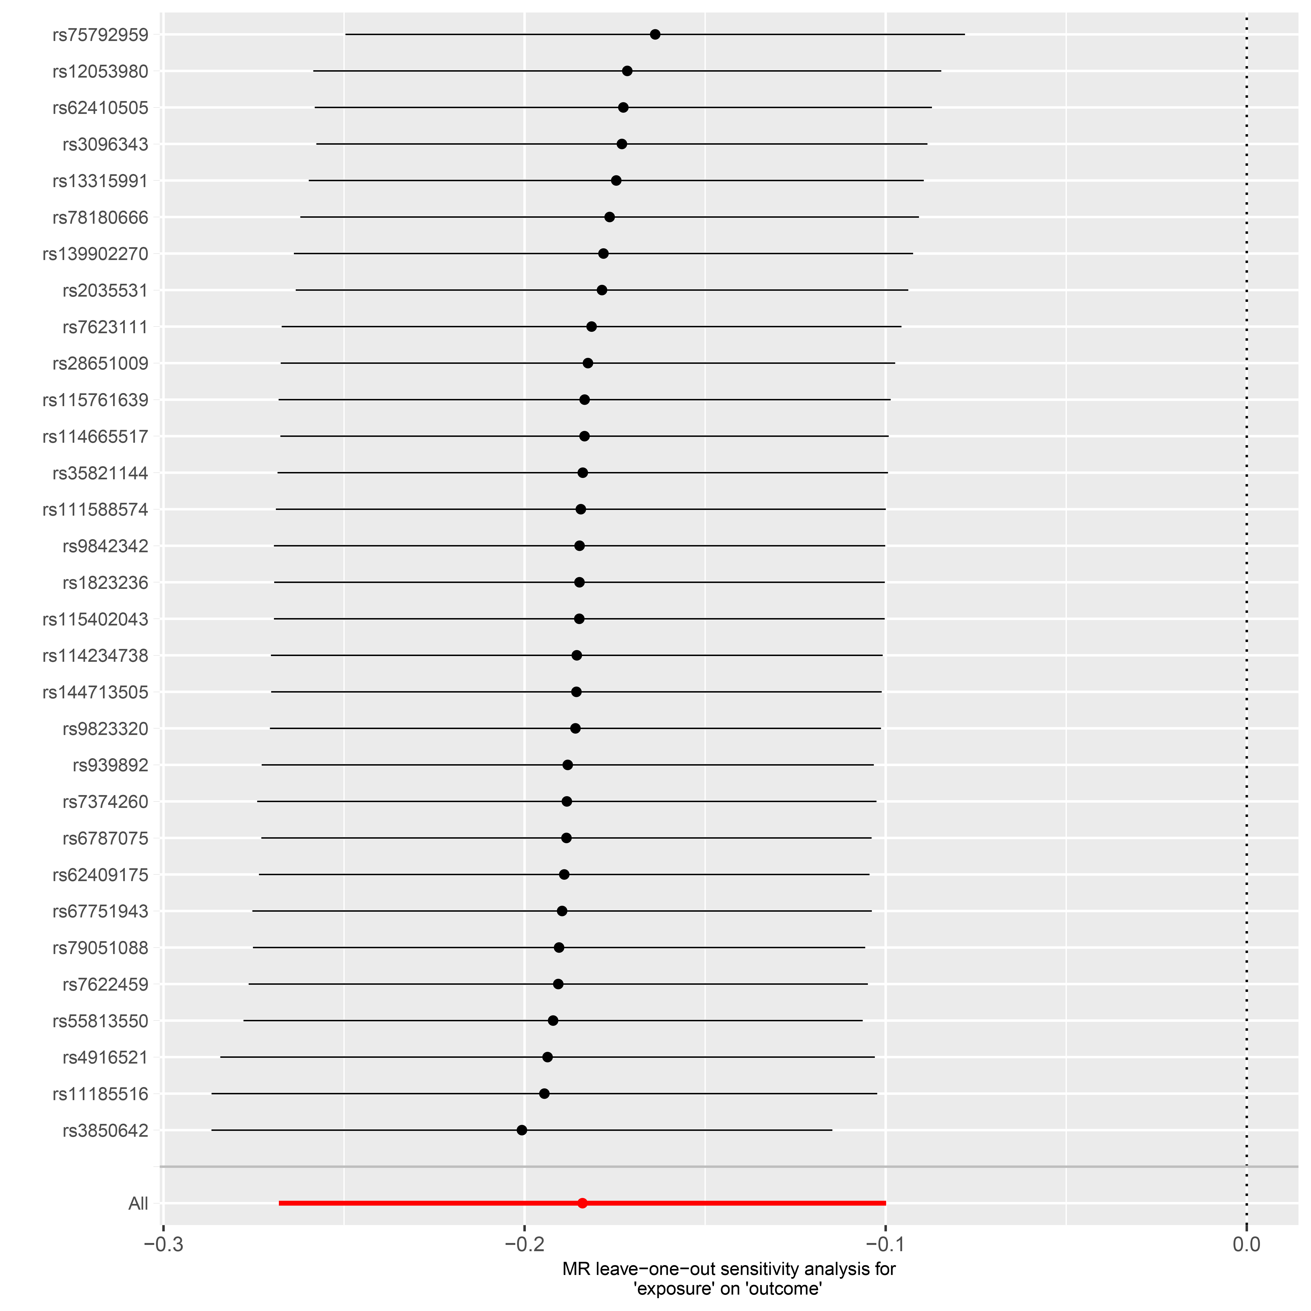
Supplementary Figure S2. Forest plot (a), scatter plot (b), funnel plot (c) and sensitivity analysis (d) of SNPs associated with ZDHHC19 on Acne vulgaris.

S3(a)
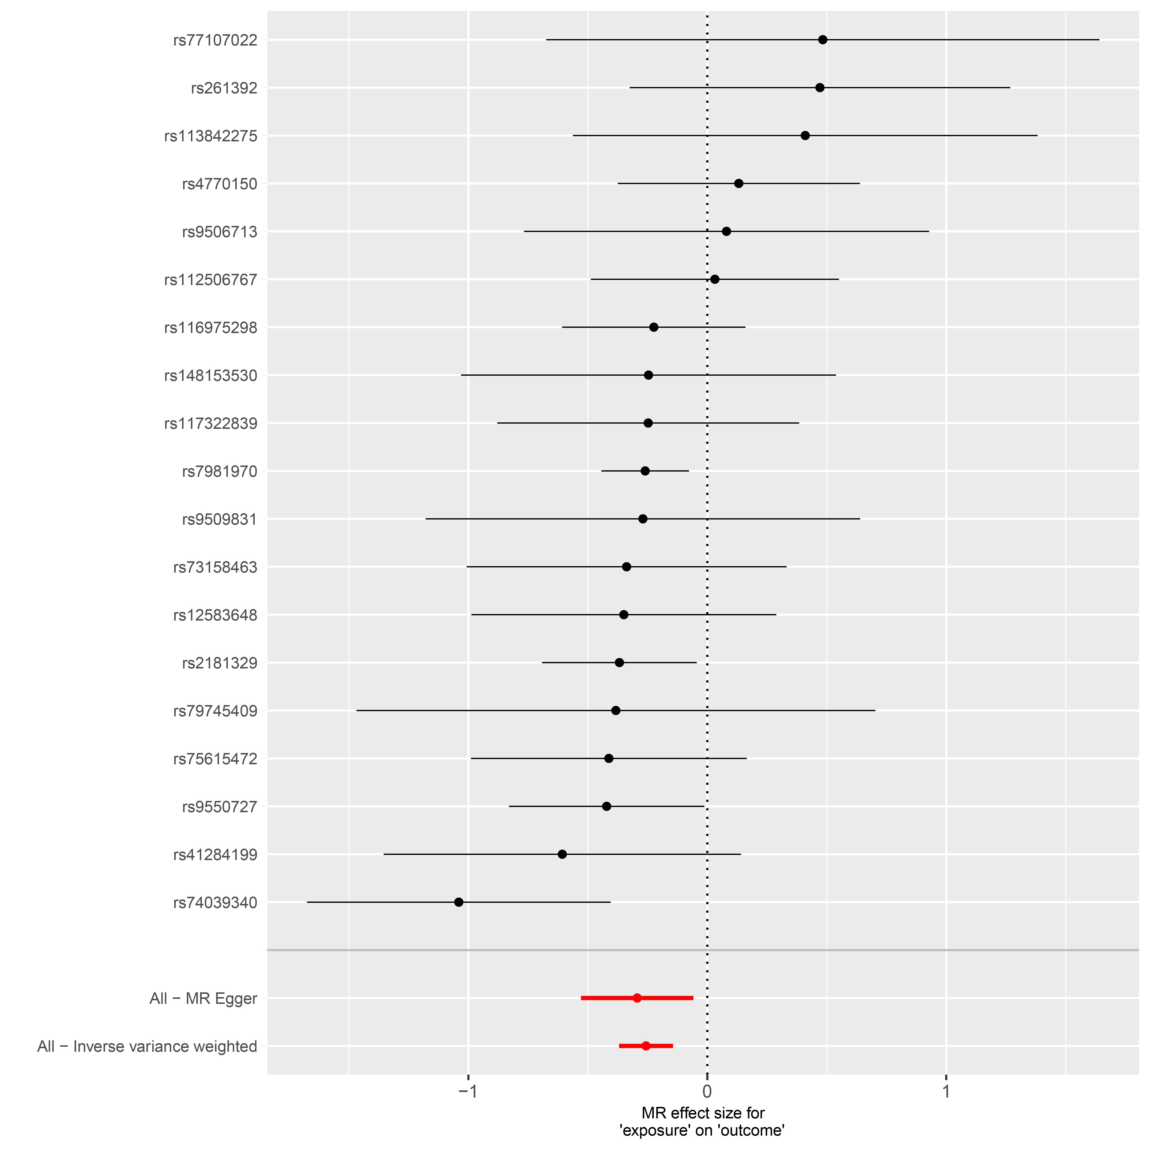
S3(b)
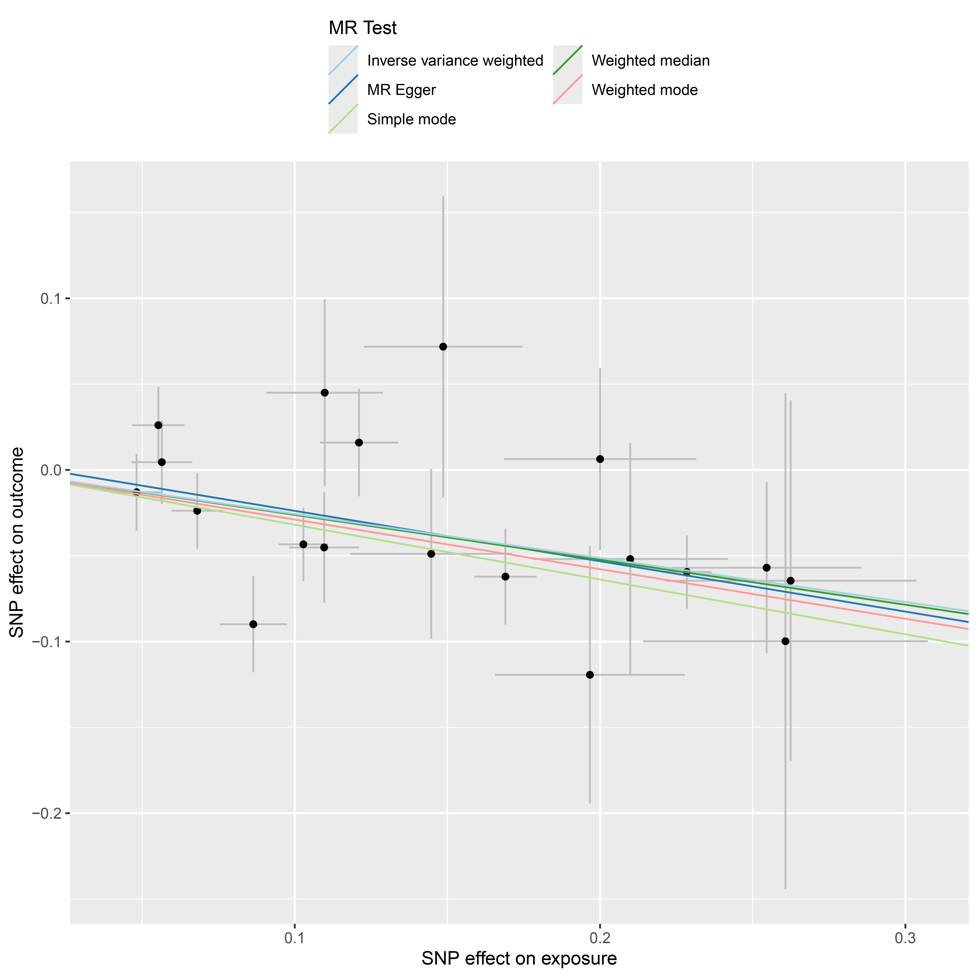
S3(c)
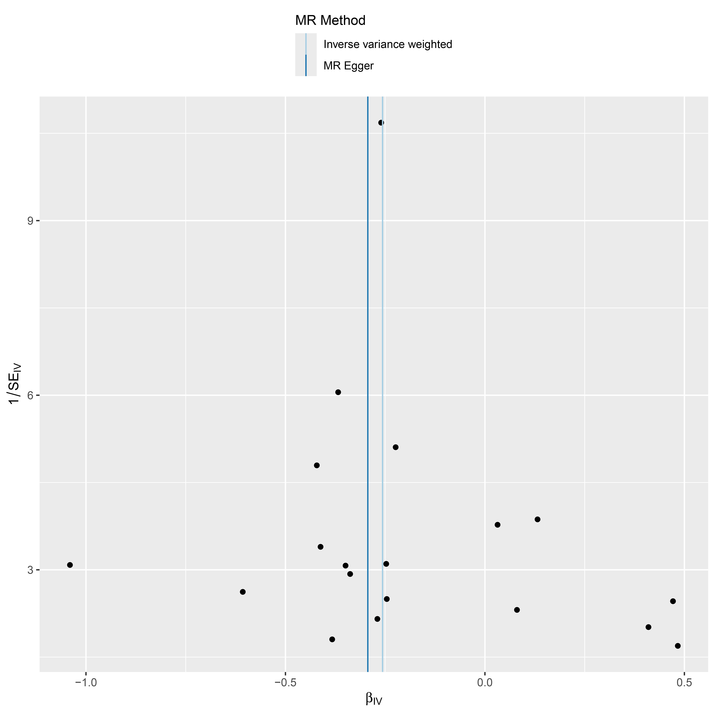
S3(d)
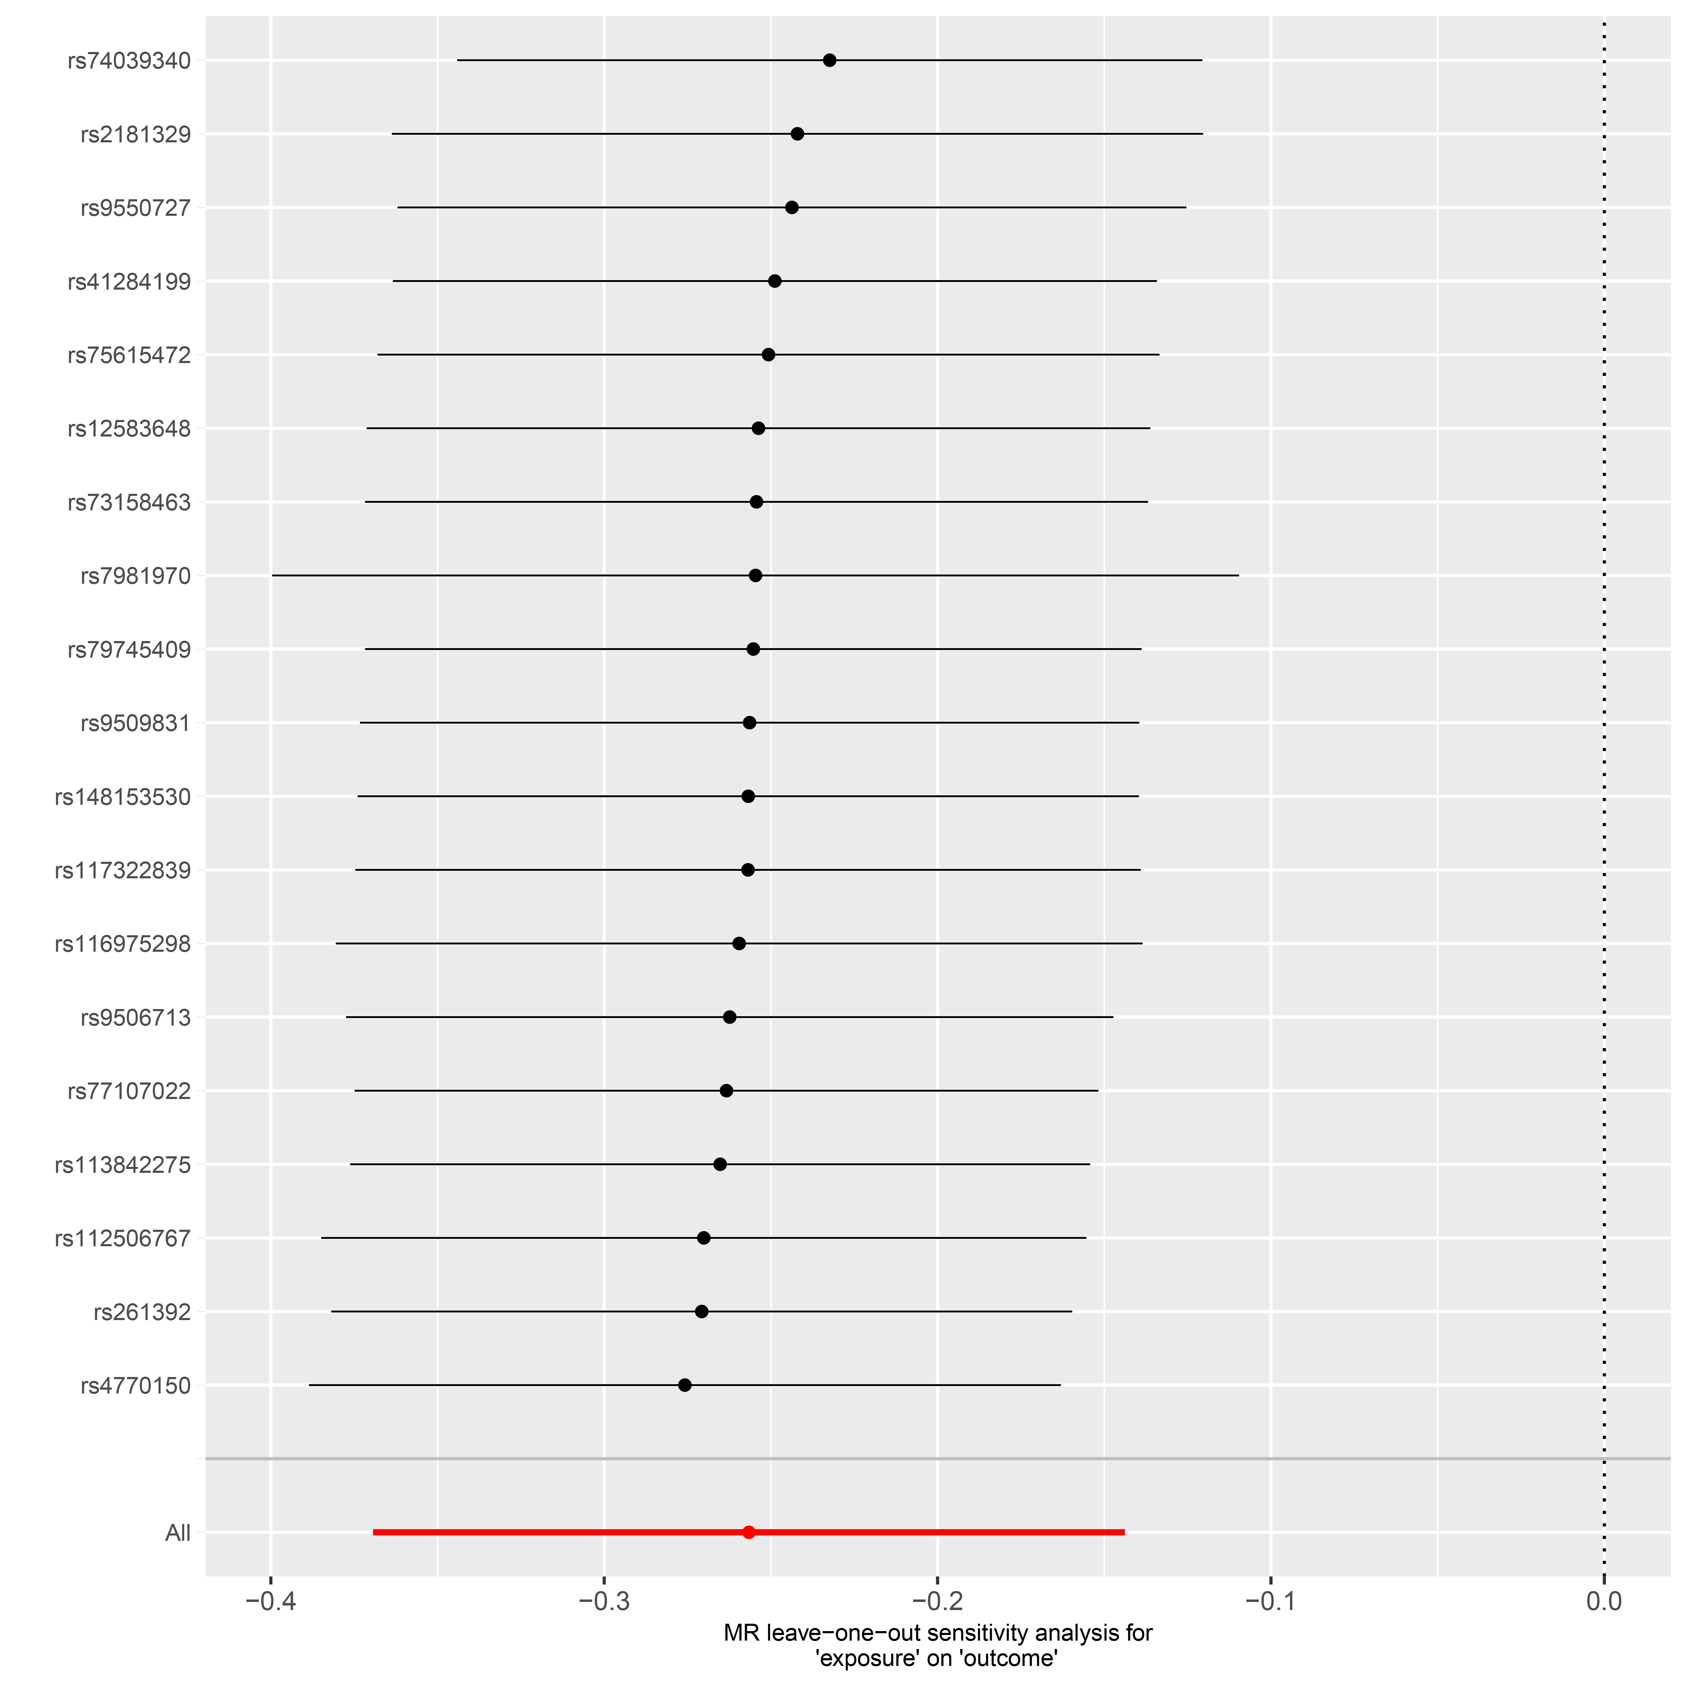
Supplementary Figure S3. Forest plot (a), scatter plot (b), funnel plot (c) and sensitivity analysis (d) of SNPs associated with ZDHHC20 on Acne vulgaris.

S4
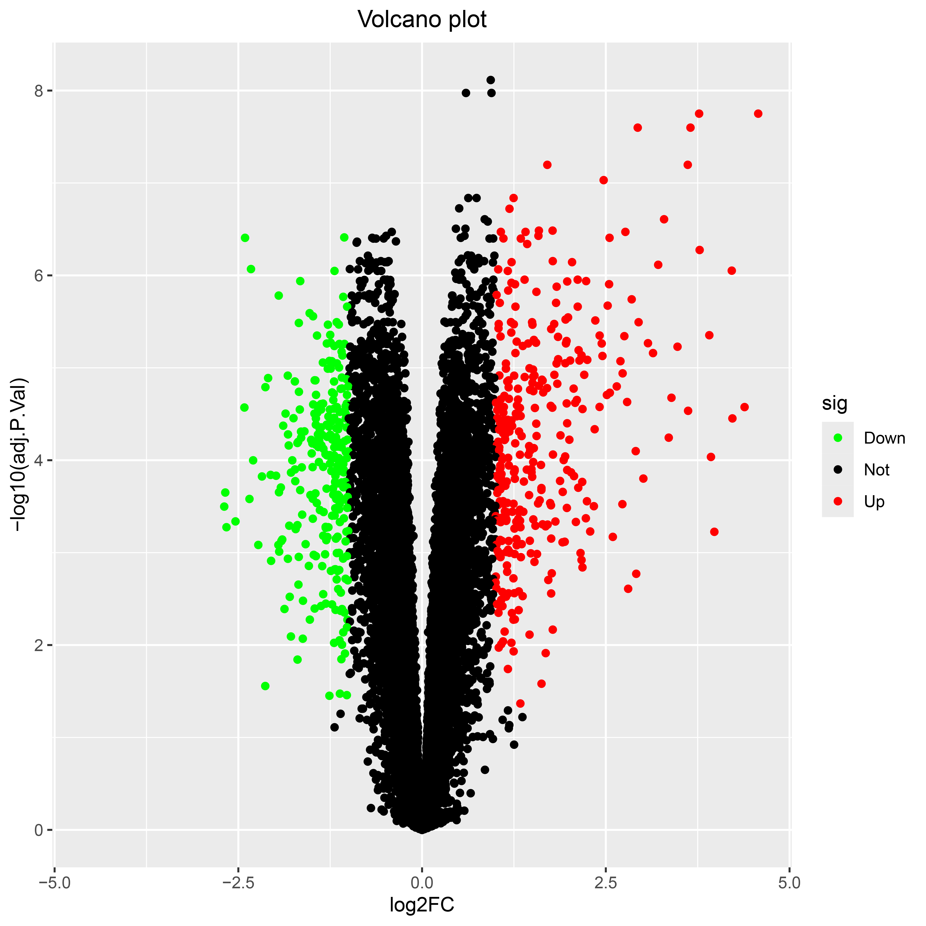
Supplementary Figure S4. Volcano plot of Differentially Expressed Genes (DEGs).
“sig” indicates significance (sig) classes of differential expression derived from limma.
S5
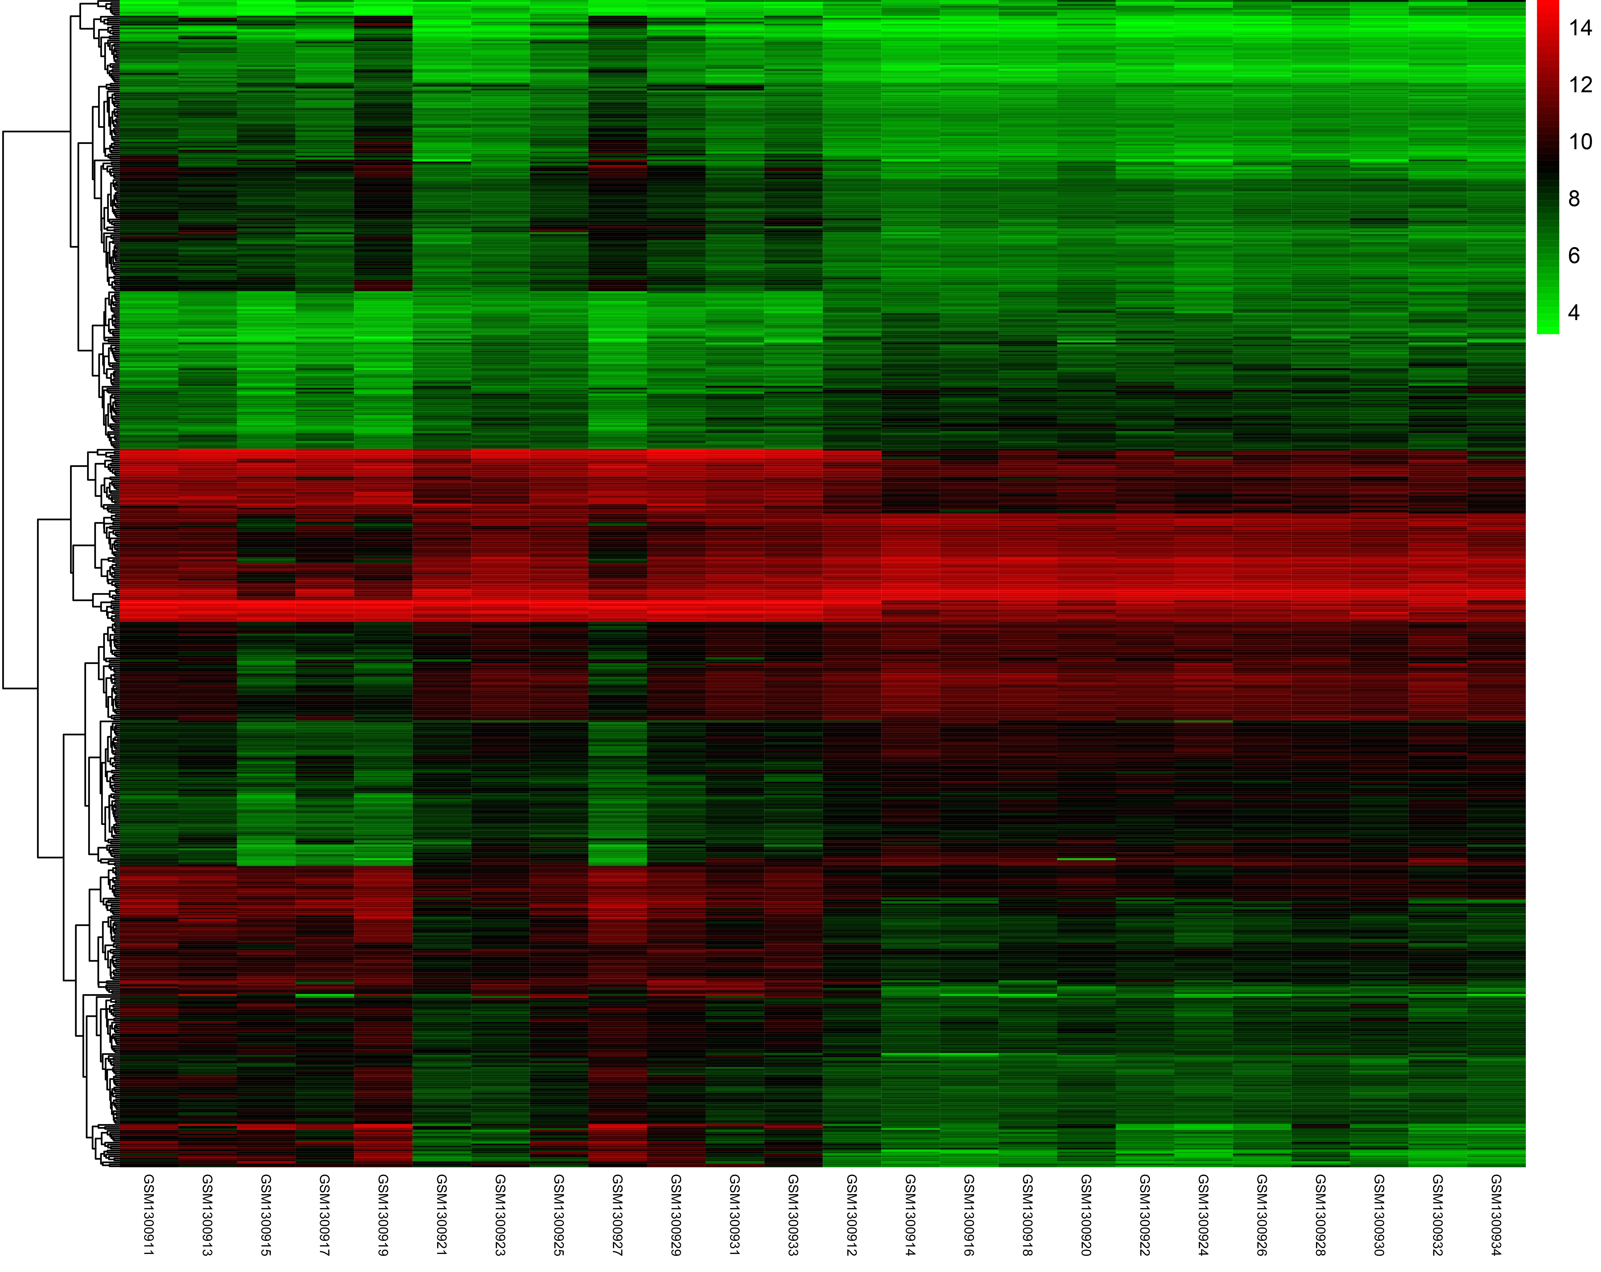
Supplementary Figure S5. Heatmap of top DEGs.
The color scale (green–black–red) represents relative gene expression values ranging from low (green) to high (red).
S6(a)
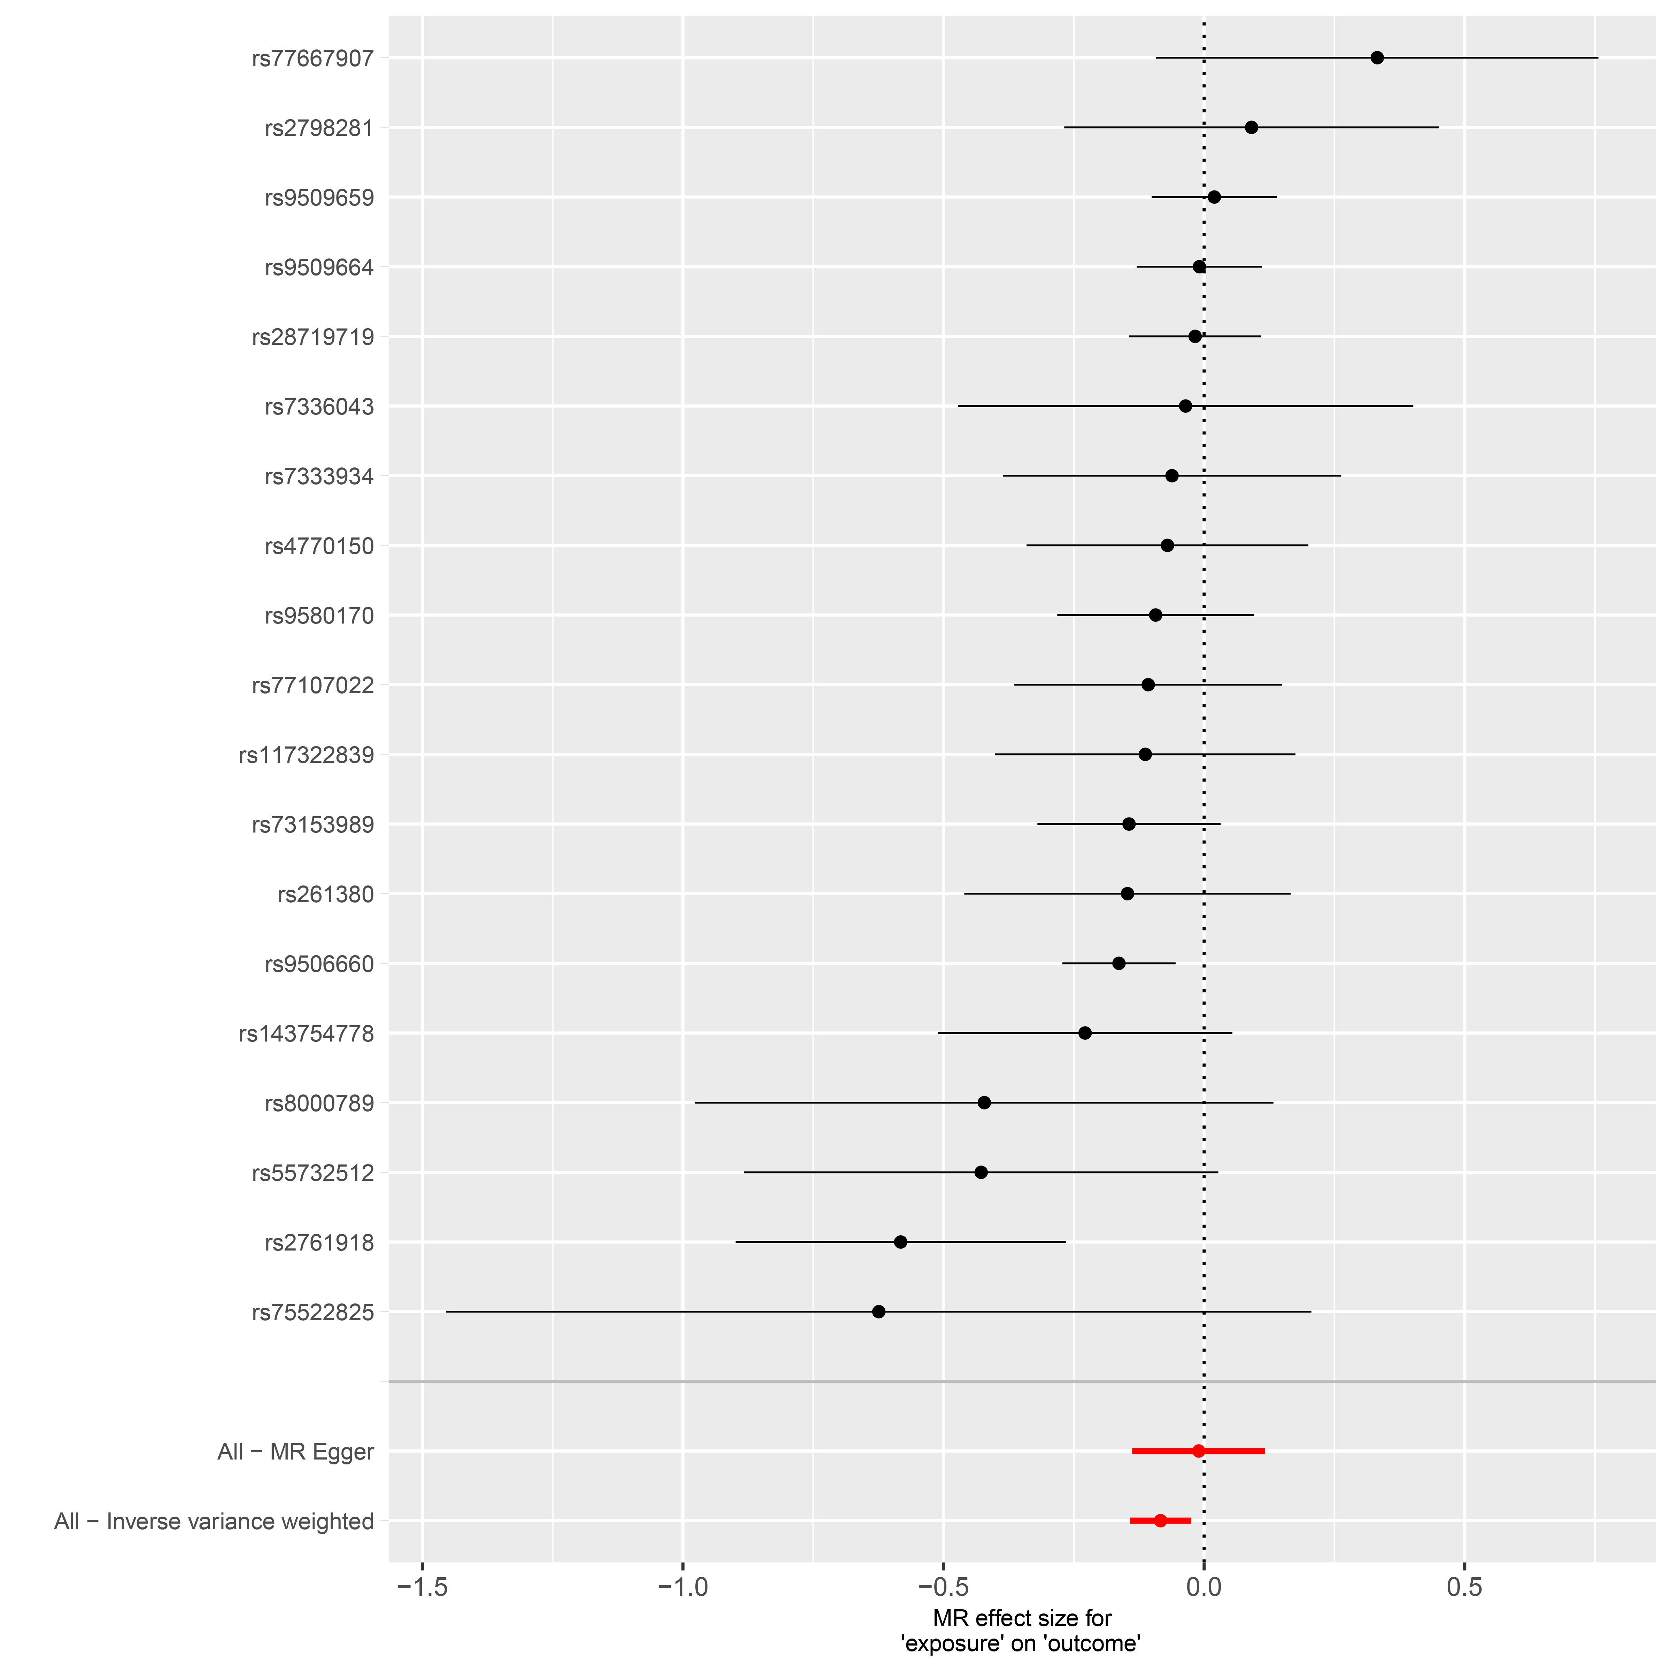
S6(b)
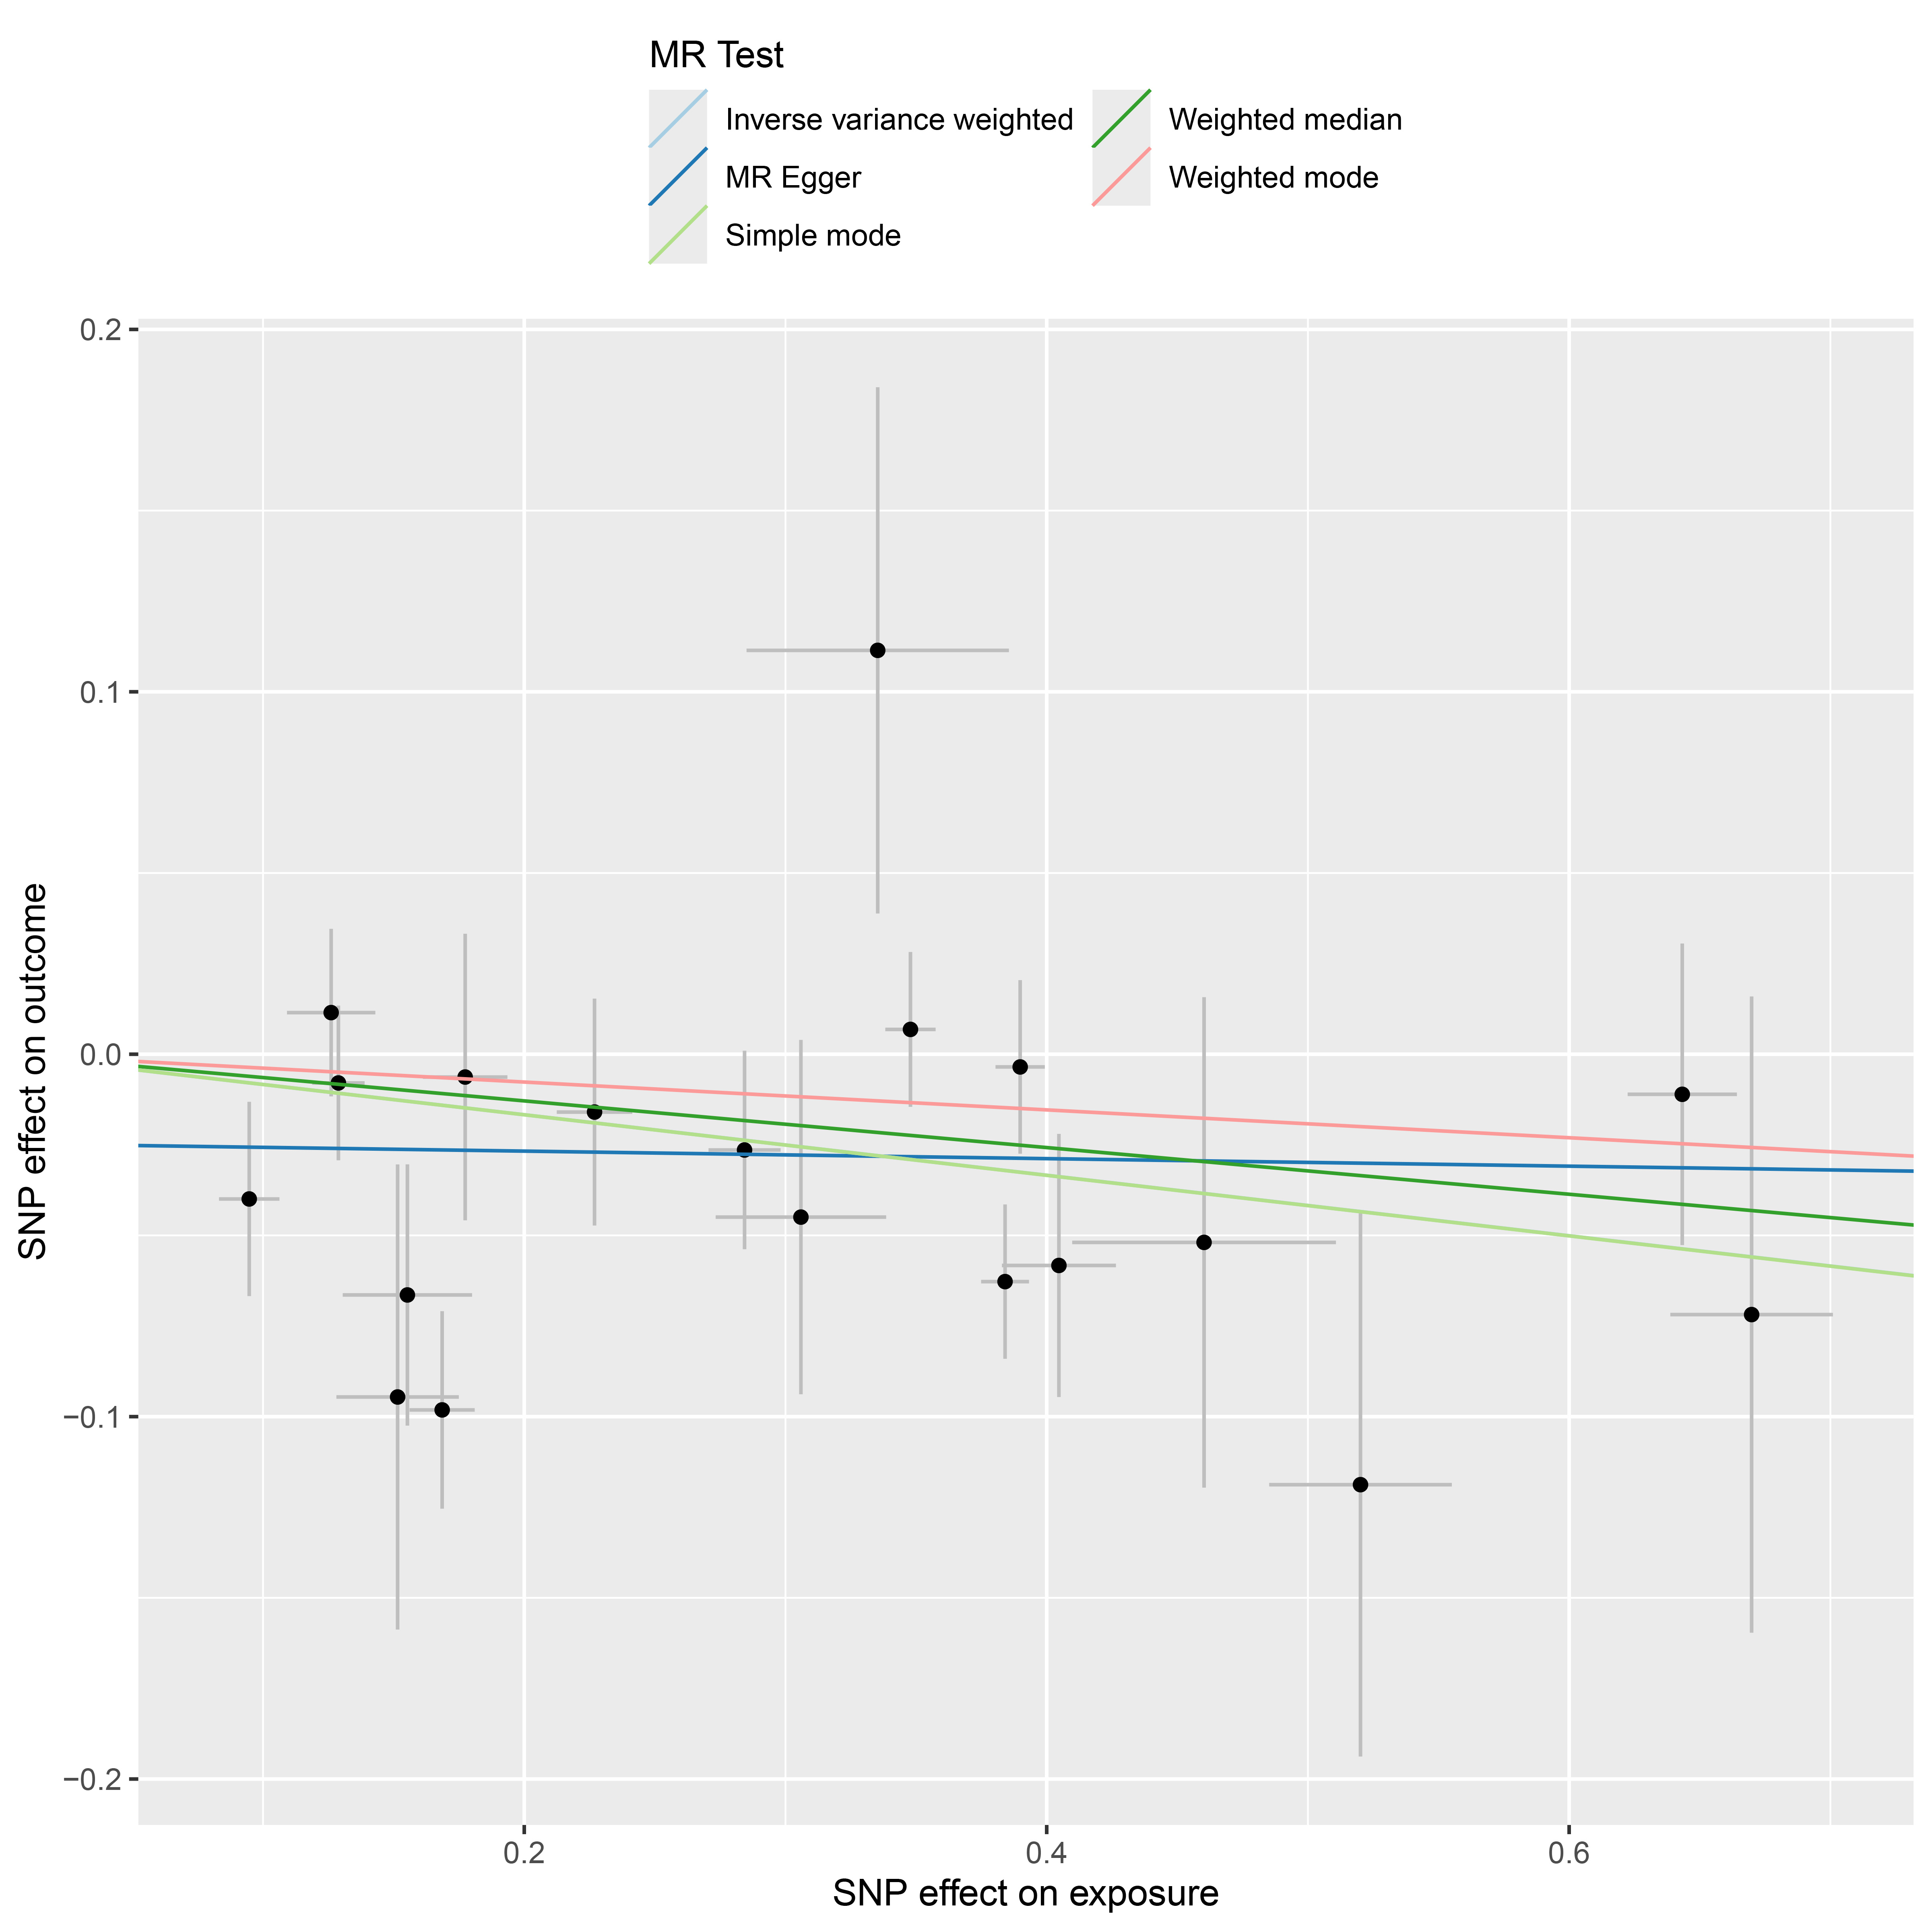
S6(c)
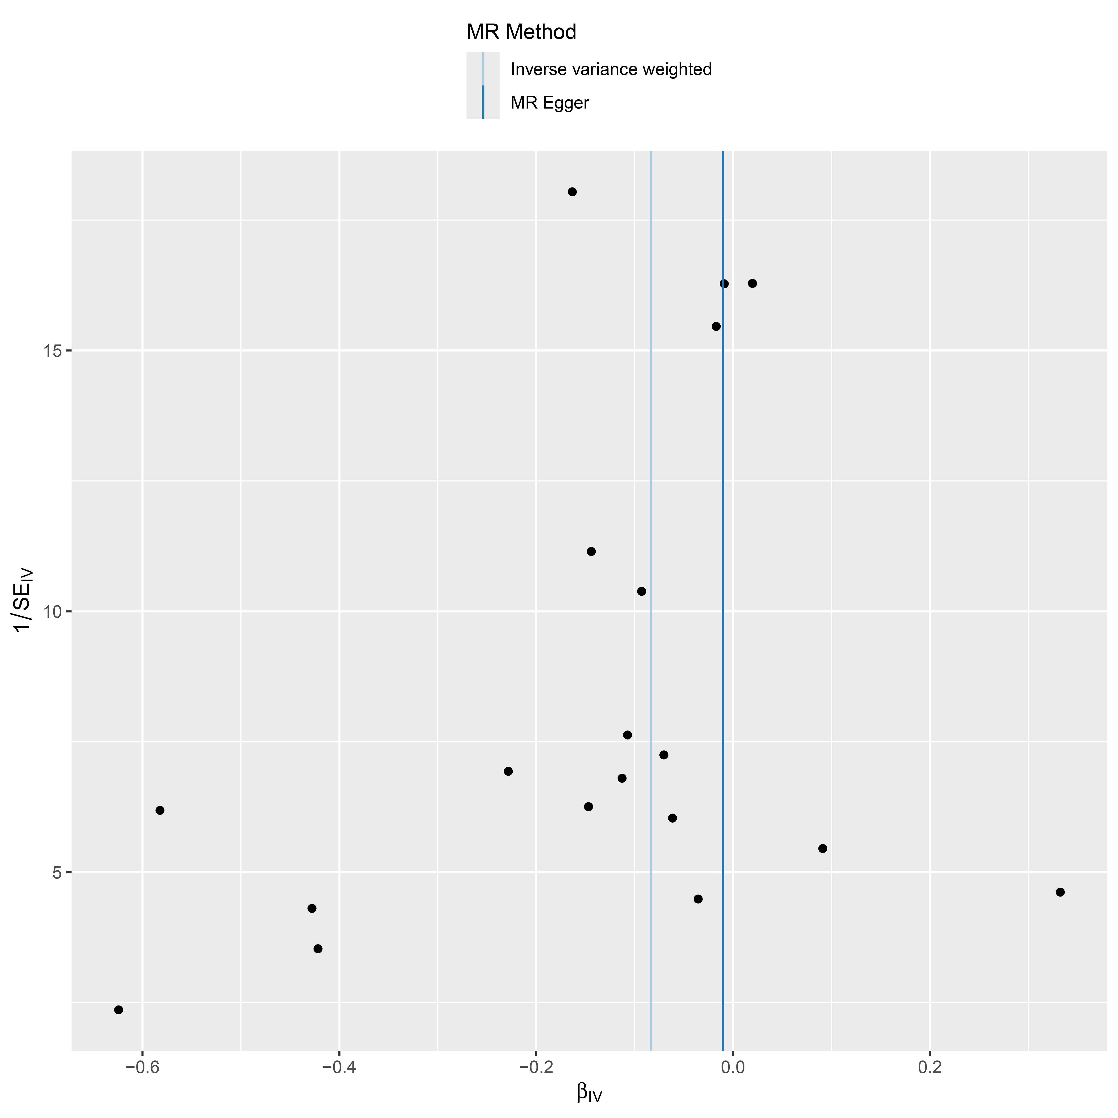
S6(d)
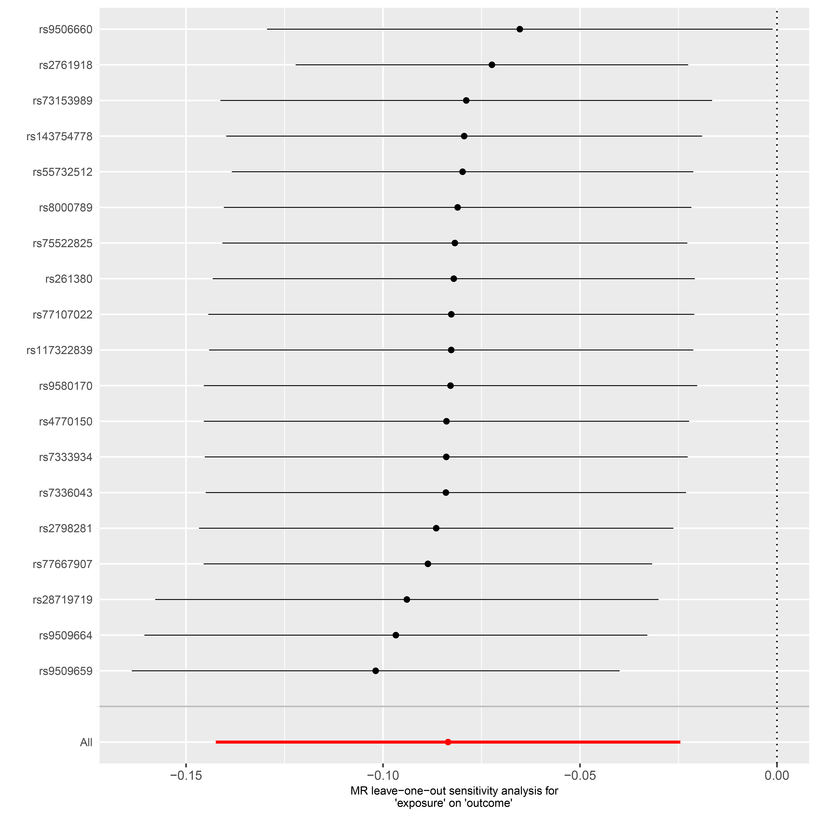
Supplementary Figure S6. Forest plot (a), scatter plot (b), funnel plot (c) and sensitivity analysis (d) of SNPs associated with cg18095732 on Acne vulgaris.

Supplementary Table S1. The Palmitoylation genes
gene_name | Description
PPT1 | Palmitoylprotein Thioesterase 1
PPT2 | Palmitoylprotein Thioesterase 2
ZDHHC1 | Zinc Finger DHHC-Type Containing 1
ZDHHC2 | Zinc Finger DHHC-Type Containing 2
ZDHHC3 | Zinc Finger DHHC-Type Containing 3
ZDHHC4 | Zinc Finger DHHC-Type Containing 4
ZDHHC5 | Zinc Finger DHHC-Type Containing 5
ZDHHC6 | Zinc Finger DHHC-Type Containing 6
ZDHHC7 | Zinc Finger DHHC-Type Containing 7
ZDHHC8 | Zinc Finger DHHC-Type Containing 8
ZDHHC11 | Zinc Finger DHHC-Type Containing 11
ZDHHC12 | Zinc Finger DHHC-Type Containing 12
ZDHHC13 | Zinc Finger DHHC-Type Containing 13
ZDHHC14 | Zinc Finger DHHC-Type Containing 14
ZDHHC16 | Zinc Finger DHHC-Type Containing 16
ZDHHC17 | Zinc Finger DHHC-Type Containing 17
ZDHHC18 | Zinc Finger DHHC-Type Containing 18
ZDHHC19 | Zinc Finger DHHC-Type Containing 19
ZDHHC20 | Zinc Finger DHHC-Type Containing 20
ZDHHC21 | Zinc Finger DHHC-Type Containing 21
ZDHHC23 | Zinc Finger DHHC-Type Containing 23
ZDHHC24 | Zinc Finger DHHC-Type Containing 24
Supplementary Table S1. Palmitoylation-related genes considered for analysis. From an initial list of 31 candidates, 22 genes with available cis-eQTL data in eQTLGen were retained for MR and SMR analyses..

Supplementary Table S2A: Instrumental variables for Palmitoylation genes

NO. | Gene | SNP | effect_allele.exposure | other_allele.exposure | effect_allele.outcome | other_allele.outcome | beta.exposure | beta.outcome | eaf.exposure | eaf.outcome | remove | palindromic | ambiguous | id.outcome | pos.outcome | pval.outcome | se.outcome | outcome | mr_keep.outcome | pval_origin.outcome | data_source.outcome | samplesize.outcome | chr.exposure | pos.exposure
1 | ZDHHC14 | rs111591466 | T | C | T | C | -0.055326072 | 0.0334646 | 0.62854811099168 | 0.397106 | FALSE | FALSE | FALSE | SdAemx | 157612268 | 0.124786 | 0.0218012 | outcome | TRUE | reported | textfile | 4617 | 6 | 158033300
2 | ZDHHC14 | rs111883538 | C | T | C | T | 0.0574267794762207 | -0.0204437 | 0.217193457139343 | 0.193148 | FALSE | FALSE | FALSE | SdAemx | 157589311 | 0.452985 | 0.027242 | outcome | TRUE | reported | textfile | 4617 | 6 | 158010343
3 | ZDHHC14 | rs113570533 | C | T | C | T | 0.173386846873112 | -0.0164477 | 0.0338809587934285 | 0.0144287 | FALSE | FALSE | FALSE | SdAemx | 157181236 | 0.856093 | 0.0906958 | outcome | TRUE | reported | textfile | 4617 | 6 | 157502370
4 | ZDHHC14 | rs113738669 | C | T | C | T | 0.188515301653129 | 0.0320336 | 0.0418092297421347 | 0.0654916 | FALSE | FALSE | FALSE | SdAemx | 157635900 | 0.459872 | 0.0433439 | outcome | TRUE | reported | textfile | 4617 | 6 | 158056932
5 | ZDHHC14 | rs113959985 | G | A | G | A | 0.17488323440232 | -0.112326 | 0.0395967848201344 | 0.0211563 | FALSE | FALSE | FALSE | SdAemx | 157331012 | 0.137847 | 0.0756983 | outcome | TRUE | reported | textfile | 4617 | 6 | 157752044
6 | ZDHHC14 | rs11752028 | T | C | T | C | -0.131593143 | -0.0648897 | 0.0417954605669875 | 0.0553114 | FALSE | FALSE | FALSE | SdAemx | 158261854 | 0.164246 | 0.046652 | outcome | TRUE | reported | textfile | 4617 | 6 | 158682886
7 | ZDHHC14 | rs139523204 | A | G | A | G | 0.247329616062578 | -0.0884936 | 0.0194193801490781 | 0.0226912 | FALSE | FALSE | FALSE | SdAemx | 157495013 | 0.219804 | 0.072119 | outcome | TRUE | reported | textfile | 4617 | 6 | 157916045
8 | ZDHHC14 | rs143370621 | G | A | G | A | -0.254959089 | 0.0108975 | 0.0278641066030908 | 0.0461705 | FALSE | FALSE | FALSE | SdAemx | 157448933 | 0.82948 | 0.0505991 | outcome | TRUE | reported | textfile | 4617 | 6 | 157869965
9 | ZDHHC14 | rs145957750 | T | C | T | C | 0.15704254762657 | -0.00453179 | 0.0670869075470063 | 0.0899563 | FALSE | FALSE | FALSE | SdAemx | 157574492 | 0.903566 | 0.0374041 | outcome | TRUE | reported | textfile | 4617 | 6 | 157995524
10 | ZDHHC14 | rs1474922 | C | A | C | A | 0.0914754295962626 | 0.0204724 | 0.100721143403276 | 0.0782 | FALSE | FALSE | FALSE | SdAemx | 157451378 | 0.606978 | 0.0397993 | outcome | TRUE | reported | textfile | 4617 | 6 | 157872410
11 | ZDHHC14 | rs150599380 | T | C | T | C | -0.27917974 | -0.0347918 | 0.0301704069280194 | 0.0379837 | FALSE | FALSE | FALSE | SdAemx | 157524385 | 0.533566 | 0.055884 | outcome | TRUE | reported | textfile | 4617 | 6 | 157945417
12 | ZDHHC14 | rs17165322 | C | T | C | T | -0.213684516 | -0.00792432 | 0.0383052814857806 | 0.0479248 | FALSE | FALSE | FALSE | SdAemx | 157432627 | 0.874221 | 0.0500591 | outcome | TRUE | reported | textfile | 4617 | 6 | 157853659
13 | ZDHHC14 | rs186957490 | G | A | G | A | 0.343615256875172 | -0.018621 | 0.0180985742379548 | 0.0219282 | FALSE | FALSE | FALSE | SdAemx | 157413718 | 0.80138 | 0.0740216 | outcome | TRUE | reported | textfile | 4617 | 6 | 157834750
14 | ZDHHC14 | rs2038586 | T | C | T | C | -0.153951638 | 0.00388678 | 0.160703914508073 | 0.129666 | FALSE | FALSE | FALSE | SdAemx | 157670076 | 0.903202 | 0.0319589 | outcome | TRUE | reported | textfile | 4617 | 6 | 158091108
15 | ZDHHC14 | rs2135213 | T | G | T | G | -0.234064329 | 0.0127309 | 0.599330015313936 | 0.419976 | FALSE | FALSE | FALSE | SdAemx | 157546675 | 0.553416 | 0.0214814 | outcome | TRUE | reported | textfile | 4617 | 6 | 157967707
16 | ZDHHC14 | rs2749677 | T | G | T | G | -0.109968402 | 0.020527 | 0.162882882882883 | 0.183111 | FALSE | FALSE | FALSE | SdAemx | 157375962 | 0.454975 | 0.0274739 | outcome | TRUE | reported | textfile | 4617 | 6 | 157796994
17 | ZDHHC14 | rs34410217 | T | C | T | C | -0.158324668 | -0.0128805 | 0.253436707307094 | 0.254316 | FALSE | FALSE | FALSE | SdAemx | 157557156 | 0.597493 | 0.0243946 | outcome | TRUE | reported | textfile | 4617 | 6 | 157978188
18 | ZDHHC14 | rs34718793 | G | A | G | A | -0.119873004 | 0.0103053 | 0.452873652975168 | 0.644904 | FALSE | FALSE | FALSE | SdAemx | 157573874 | 0.645795 | 0.0224218 | outcome | TRUE | reported | textfile | 4617 | 6 | 157994906
19 | ZDHHC14 | rs34781565 | G | A | G | A | -0.370017622 | 0.0832231 | 0.0308471454880295 | 0.0411548 | FALSE | FALSE | FALSE | SdAemx | 157634100 | 0.119269 | 0.0534217 | outcome | TRUE | reported | textfile | 4617 | 6 | 158055132
20 | ZDHHC14 | rs35057821 | A | G | A | G | -0.161070984 | -0.0102328 | 0.179232105104198 | 0.157018 | FALSE | FALSE | FALSE | SdAemx | 157698790 | 0.726445 | 0.0292485 | outcome | TRUE | reported | textfile | 4617 | 6 | 158119822
21 | ZDHHC14 | rs35795521 | T | C | T | C | -0.273196659 | 0.0286934 | 0.251987661293826 | 0.274584 | FALSE | FALSE | FALSE | SdAemx | 157442532 | 0.227164 | 0.0237588 | outcome | TRUE | reported | textfile | 4617 | 6 | 157863564
22 | ZDHHC14 | rs4349837 | A | G | A | G | 0.15783843576021 | 0.0153874 | 0.923954614992351 | 0.09405 | FALSE | FALSE | FALSE | SdAemx | 157540864 | 0.671789 | 0.0363172 | outcome | TRUE | reported | textfile | 4617 | 6 | 157961896
23 | ZDHHC14 | rs62423255 | C | A | C | A | 0.138559888069742 | -0.0377805 | 0.0599415204678363 | 0.0539635 | FALSE | FALSE | FALSE | SdAemx | 157632552 | 0.424184 | 0.0472738 | outcome | TRUE | reported | textfile | 4617 | 6 | 158053584
24 | ZDHHC14 | rs62425059 | A | G | A | G | -0.233200844 | -0.135971 | 0.0253206650831354 | 0.0124323 | FALSE | FALSE | FALSE | SdAemx | 157556297 | 0.155434 | 0.0957138 | outcome | TRUE | reported | textfile | 4617 | 6 | 157977329
25 | ZDHHC14 | rs636169 | A | G | A | G | 0.146680770330171 | -0.113977 | 0.058245748136824 | 0.04792 | FALSE | FALSE | FALSE | SdAemx | 157653472 | 0.0241263 | 0.0505416 | outcome | TRUE | reported | textfile | 4617 | 6 | 158074504
26 | ZDHHC14 | rs6605508 | G | C | G | C | 0.0644517750358158 | -0.0198752 | 0.319315047103524 | 0.339317 | FALSE | TRUE | FALSE | SdAemx | 157247242 | 0.376672 | 0.0224821 | outcome | TRUE | reported | textfile | 4617 | 6 | 157632391
27 | ZDHHC14 | rs681502 | T | G | T | G | 0.17256129698401 | -0.0325092 | 0.533813247124276 | 0.468293 | FALSE | FALSE | FALSE | SdAemx | 157650269 | 0.126339 | 0.021266 | outcome | TRUE | reported | textfile | 4617 | 6 | 158071301
28 | ZDHHC14 | rs733207 | G | T | G | T | -0.10278813 | 0.0120357 | 0.219880269393864 | 0.287785 | FALSE | FALSE | FALSE | SdAemx | 157494655 | 0.609345 | 0.0235529 | outcome | TRUE | reported | textfile | 4617 | 6 | 157915687
29 | ZDHHC14 | rs749547 | A | G | A | G | -0.150326865 | 0.0306 | 0.195284926835072 | 0.23683 | FALSE | FALSE | FALSE | SdAemx | 157592693 | 0.220924 | 0.0249985 | outcome | TRUE | reported | textfile | 4617 | 6 | 158013725
30 | ZDHHC14 | rs77040881 | A | G | A | G | -0.262103881 | -0.0873997 | 0.0335678143897322 | 0.0457918 | FALSE | FALSE | FALSE | SdAemx | 157728307 | 0.0897677 | 0.0515137 | outcome | TRUE | reported | textfile | 4617 | 6 | 158149339
31 | ZDHHC14 | rs77125844 | G | A | G | A | -0.122988386 | -0.229312 | 0.0481834975369458 | 0.0231056 | FALSE | FALSE | FALSE | SdAemx | 157109754 | 0.00314811 | 0.0776568 | outcome | TRUE | reported | textfile | 4617 | 6 | 157430888
32 | ZDHHC14 | rs79464071 | T | G | T | G | 0.100485239056765 | -0.012804 | 0.18647452035767 | 0.14809 | FALSE | FALSE | FALSE | SdAemx | 157445336 | 0.669982 | 0.0300442 | outcome | TRUE | reported | textfile | 4617 | 6 | 157866368
33 | ZDHHC14 | rs844134 | T | C | T | C | 0.074090641278726 | 0.0304986 | 0.68579862249918 | 0.29714 | FALSE | FALSE | FALSE | SdAemx | 157760016 | 0.194787 | 0.0235229 | outcome | TRUE | reported | textfile | 4617 | 6 | 158181048
34 | ZDHHC14 | rs928008 | G | A | G | A | -0.044175383 | -0.0220263 | 0.5195234695028 | 0.582924 | FALSE | FALSE | FALSE | SdAemx | 157774663 | 0.308375 | 0.0216233 | outcome | TRUE | reported | textfile | 4617 | 6 | 158195695
35 | ZDHHC14 | rs9295141 | T | C | T | C | -0.244681696 | 0.035964 | 0.206787687450671 | 0.251261 | FALSE | FALSE | FALSE | SdAemx | 157684859 | 0.141366 | 0.0244533 | outcome | TRUE | reported | textfile | 4617 | 6 | 158105891
36 | ZDHHC14 | rs9347482 | A | G | A | G | 0.116746207248892 | -0.0265911 | 0.668138599721899 | 0.375191 | FALSE | FALSE | FALSE | SdAemx | 157678704 | 0.223494 | 0.0218445 | outcome | TRUE | reported | textfile | 4617 | 6 | 158099736
37 | ZDHHC14 | rs9355262 | T | C | T | C | 0.142739036219093 | -0.0378576 | 0.323231656322902 | 0.388708 | FALSE | FALSE | FALSE | SdAemx | 157483719 | 0.0829125 | 0.0218321 | outcome | TRUE | reported | textfile | 4617 | 6 | 157904751
38 | ZDHHC14 | rs9355793 | A | G | A | G | -0.099986229 | 0.0398322 | 0.0911191335740072 | 0.138133 | FALSE | FALSE | FALSE | SdAemx | 157586675 | 0.206133 | 0.0315061 | outcome | TRUE | reported | textfile | 4617 | 6 | 158007707
39 | ZDHHC14 | rs9365290 | A | G | A | G | 0.0611825040724537 | 0.0347966 | 0.150056625141563 | 0.101941 | FALSE | FALSE | FALSE | SdAemx | 157709840 | 0.324852 | 0.0353431 | outcome | TRUE | reported | textfile | 4617 | 6 | 158130872
40 | ZDHHC14 | rs9456730 | G | T | G | T | -0.06433458 | -0.0534825 | 0.712608017054323 | 0.345539 | FALSE | FALSE | FALSE | SdAemx | 157762711 | 0.0167803 | 0.0223637 | outcome | TRUE | reported | textfile | 4617 | 6 | 158183743
41 | ZDHHC19 | rs111588574 | T | G | T | G | -0.109614764 | 0.0144007 | 0.10137189024878 | 0.0485645 | FALSE | FALSE | FALSE | 2rKQmZ | 196343513 | 0.774496 | 0.0502643 | outcome | TRUE | reported | textfile | 4617 | 3 | 196070384
42 | ZDHHC19 | rs11185516 | A | G | A | G | -0.210640403 | 0.0277265 | 0.395223420647149 | 0.364647 | FALSE | FALSE | FALSE | 2rKQmZ | 196201840 | 0.208739 | 0.022057 | outcome | TRUE | reported | textfile | 4617 | 3 | 195928711
43 | ZDHHC19 | rs114234738 | C | T | C | T | -0.147774562 | 0.0115204 | 0.0490215121643277 | 0.044582 | FALSE | FALSE | FALSE | 2rKQmZ | 195918356 | 0.82563 | 0.0522919 | outcome | TRUE | reported | textfile | 4617 | 3 | 195645227
44 | ZDHHC19 | rs114665517 | A | G | A | G | -0.236421871 | 0.0792634 | 0.0195146676804156 | 0.0048407 | FALSE | FALSE | FALSE | 2rKQmZ | 195807414 | 0.634867 | 0.16691 | outcome | TRUE | reported | textfile | 4617 | 3 | 195534285
45 | ZDHHC19 | rs115402043 | G | A | G | A | 0.1923238424715 | -0.0205955 | 0.0239357429718875 | 0.0195002 | FALSE | FALSE | FALSE | 2rKQmZ | 196563292 | 0.789945 | 0.0773156 | outcome | TRUE | reported | textfile | 4617 | 3 | 196290163
46 | ZDHHC19 | rs115761639 | T | A | T | A | -0.08860294 | 0.019573 | 0.149856298465376 | 0.142949 | FALSE | TRUE | FALSE | 2rKQmZ | 196331284 | 0.519265 | 0.0303704 | outcome | TRUE | reported | textfile | 4617 | 3 | 196058155
47 | ZDHHC19 | rs12053980 | C | A | C | A | -0.173895357 | 0.0630101 | 0.855738014345036 | 0.15569 | FALSE | FALSE | FALSE | 2rKQmZ | 196240624 | 0.0313033 | 0.0292635 | outcome | TRUE | reported | textfile | 4617 | 3 | 195967495
48 | ZDHHC19 | rs13315991 | T | C | T | C | -0.109106399 | 0.0597085 | 0.186395322689454 | 0.156496 | FALSE | FALSE | FALSE | 2rKQmZ | 196116126 | 0.0433301 | 0.0295511 | outcome | TRUE | reported | textfile | 4617 | 3 | 195842997
49 | ZDHHC19 | rs139902270 | T | C | T | C | -0.369423238 | 0.121774 | 0.032457528314457 | 0.0187486 | FALSE | FALSE | FALSE | 2rKQmZ | 196207382 | 0.13243 | 0.0809353 | outcome | TRUE | reported | textfile | 4617 | 3 | 195934253
50 | ZDHHC19 | rs144713505 | T | C | T | C | 0.144524608819793 | -0.00453131 | 0.962441893948743 | 0.0337611 | FALSE | FALSE | FALSE | 2rKQmZ | 196219187 | 0.939117 | 0.0593264 | outcome | TRUE | reported | textfile | 4617 | 3 | 195946058
51 | ZDHHC19 | rs1823236 | T | C | T | C | 0.0521622805311394 | -0.00563314 | 0.486730268863833 | 0.54681 | FALSE | FALSE | FALSE | 2rKQmZ | 196037428 | 0.792359 | 0.0213985 | outcome | TRUE | reported | textfile | 4617 | 3 | 195764299
52 | ZDHHC19 | rs2035531 | C | A | C | A | 0.0709788060823619 | -0.0347968 | 0.687429653125959 | 0.34638 | FALSE | FALSE | FALSE | 2rKQmZ | 196590044 | 0.13266 | 0.0231409 | outcome | TRUE | reported | textfile | 4617 | 3 | 196316915
53 | ZDHHC19 | rs28651009 | T | C | T | C | 0.0801517915173294 | -0.0197875 | 0.356483279395901 | 0.363201 | FALSE | FALSE | FALSE | 2rKQmZ | 196137525 | 0.379015 | 0.0224931 | outcome | TRUE | reported | textfile | 4617 | 3 | 195864396
54 | ZDHHC19 | rs3096343 | C | A | C | A | -0.05614577 | 0.0586806 | 0.464882431657427 | 0.401725 | FALSE | FALSE | FALSE | 2rKQmZ | 195798429 | 0.00643102 | 0.0215345 | outcome | TRUE | reported | textfile | 4617 | 3 | 195525300
55 | ZDHHC19 | rs35821144 | T | C | T | C | -0.056917279 | 0.0108694 | 0.318544848165701 | 0.280836 | FALSE | FALSE | FALSE | 2rKQmZ | 195590839 | 0.647061 | 0.0237401 | outcome | TRUE | reported | textfile | 4617 | 3 | 195317710
56 | ZDHHC19 | rs3850642 | A | G | A | G | 0.238744660210931 | 0.0440802 | 0.917486601071914 | 0.0495296 | FALSE | FALSE | FALSE | 2rKQmZ | 196191775 | 0.369141 | 0.0490825 | outcome | TRUE | reported | textfile | 4617 | 3 | 195918646
57 | ZDHHC19 | rs4916521 | A | G | A | G | 0.204065001657168 | -0.0253389 | 0.289034296028881 | 0.288382 | FALSE | FALSE | FALSE | 2rKQmZ | 196221636 | 0.27999 | 0.0234545 | outcome | TRUE | reported | textfile | 4617 | 3 | 195948507
58 | ZDHHC19 | rs55813550 | G | A | G | A | -0.105887849 | -0.00218814 | 0.294432071269488 | 0.298019 | FALSE | FALSE | FALSE | 2rKQmZ | 195826531 | 0.924909 | 0.0232157 | outcome | TRUE | reported | textfile | 4617 | 3 | 195553402
59 | ZDHHC19 | rs62409175 | A | C | A | C | -0.066368575 | -0.0182481 | 0.173573940969567 | 0.185943 | FALSE | FALSE | FALSE | 2rKQmZ | 196307591 | 0.503445 | 0.0272734 | outcome | TRUE | reported | textfile | 4617 | 3 | 196034462
60 | ZDHHC19 | rs62410505 | A | G | A | G | -0.275938723 | 0.145429 | 0.0364653451557495 | 0.0267751 | FALSE | FALSE | FALSE | 2rKQmZ | 196163884 | 0.028213 | 0.0662757 | outcome | TRUE | reported | textfile | 4617 | 3 | 195890755
61 | ZDHHC19 | rs67751943 | G | A | G | A | -0.099791804 | 0.00448993 | 0.542037513791835 | 0.426445 | FALSE | FALSE | FALSE | 2rKQmZ | 196200556 | 0.83577 | 0.0216584 | outcome | TRUE | reported | textfile | 4617 | 3 | 195927427
62 | ZDHHC19 | rs6787075 | C | G | C | G | 0.110626285031358 | 0.0290145 | 0.0506763303747917 | 0.053406 | FALSE | TRUE | FALSE | 2rKQmZ | 196203342 | 0.543765 | 0.0477896 | outcome | TRUE | reported | textfile | 4617 | 3 | 195930213
63 | ZDHHC19 | rs7374260 | C | T | C | T | 0.100680832155991 | -0.00763059 | 0.53808861663347 | 0.374417 | FALSE | FALSE | FALSE | 2rKQmZ | 196431461 | 0.728645 | 0.0219947 | outcome | TRUE | reported | textfile | 4617 | 3 | 196158332
64 | ZDHHC19 | rs75792959 | C | T | C | T | -0.271309602 | 0.183248 | 0.0309273207961291 | 0.031302 | FALSE | FALSE | FALSE | 2rKQmZ | 196533072 | 0.00178875 | 0.0586725 | outcome | TRUE | reported | textfile | 4617 | 3 | 196259943
65 | ZDHHC19 | rs7622459 | A | G | A | G | -0.100004425 | 0.00154398 | 0.391188704903608 | 0.389944 | FALSE | FALSE | FALSE | 2rKQmZ | 196199814 | 0.943845 | 0.0219195 | outcome | TRUE | reported | textfile | 4617 | 3 | 195926685
66 | ZDHHC19 | rs7623111 | G | A | G | A | -0.101531288 | 0.0247853 | 0.588442950992977 | 0.392275 | FALSE | FALSE | FALSE | 2rKQmZ | 196526851 | 0.254402 | 0.0217468 | outcome | TRUE | reported | textfile | 4617 | 3 | 196253722
67 | ZDHHC19 | rs78180666 | C | T | C | T | 0.14982370267268 | -0.0572021 | 0.073246703611695 | 0.112368 | FALSE | FALSE | FALSE | 2rKQmZ | 196169101 | 0.0887115 | 0.0336041 | outcome | TRUE | reported | textfile | 4617 | 3 | 195895972
68 | ZDHHC19 | rs79051088 | T | C | T | C | -0.143631526 | -0.0296722 | 0.0535518376302798 | 0.0518936 | FALSE | FALSE | FALSE | 2rKQmZ | 196176584 | 0.538016 | 0.0481835 | outcome | TRUE | reported | textfile | 4617 | 3 | 195903455
69 | ZDHHC19 | rs939892 | T | C | T | C | 0.0922645457302751 | 0.00627811 | 0.140428021438816 | 0.135419 | FALSE | FALSE | FALSE | 2rKQmZ | 196199363 | 0.841126 | 0.0313195 | outcome | TRUE | reported | textfile | 4617 | 3 | 195926234
70 | ZDHHC19 | rs9823320 | G | A | G | A | -0.105441383 | 0.00307855 | 0.0702206685601923 | 0.0760262 | FALSE | FALSE | FALSE | 2rKQmZ | 196044758 | 0.939419 | 0.0405073 | outcome | TRUE | reported | textfile | 4617 | 3 | 195771629
71 | ZDHHC19 | rs9842342 | T | G | T | G | -0.070766978 | 0.00874291 | 0.199558601463585 | 0.209428 | FALSE | FALSE | FALSE | 2rKQmZ | 196173437 | 0.74019 | 0.0263656 | outcome | TRUE | reported | textfile | 4617 | 3 | 195900308
72 | ZDHHC20 | rs112506767 | C | T | C | T | -0.200008568 | -0.0063373 | 0.0297937137275182 | 0.0427938 | FALSE | FALSE | FALSE | yaBhmT | 21354741 | 0.904825 | 0.0530014 | outcome | TRUE | reported | textfile | 4617 | 13 | 21928880
73 | ZDHHC20 | rs113842275 | A | C | A | C | 0.109807283287037 | 0.0450122 | 0.951663866890649 | 0.0417921 | FALSE | FALSE | FALSE | yaBhmT | 21345471 | 0.408735 | 0.0544862 | outcome | TRUE | reported | textfile | 4617 | 13 | 21919610
74 | ZDHHC20 | rs116975298 | T | C | T | C | -0.254561849 | 0.0569605 | 0.0226386481802426 | 0.0472144 | FALSE | FALSE | FALSE | yaBhmT | 21420710 | 0.253198 | 0.0498509 | outcome | TRUE | reported | textfile | 4617 | 13 | 21994849
75 | ZDHHC20 | rs117322839 | A | G | A | G | 0.209880887388646 | -0.0519275 | 0.0201786892735672 | 0.0261218 | FALSE | FALSE | FALSE | yaBhmT | 21493363 | 0.442833 | 0.0676652 | outcome | TRUE | reported | textfile | 4617 | 13 | 22067502
76 | ZDHHC20 | rs12583648 | C | G | C | G | -0.068052132 | 0.0237746 | 0.358887985441592 | 0.357427 | FALSE | TRUE | FALSE | yaBhmT | 21325916 | 0.283174 | 0.0221527 | outcome | TRUE | reported | textfile | 4617 | 13 | 21900055
77 | ZDHHC20 | rs148153530 | T | C | T | C | -0.262408429 | 0.0645498 | 0.0143746854554605 | 0.0106899 | FALSE | FALSE | FALSE | yaBhmT | 21339492 | 0.538912 | 0.105052 | outcome | TRUE | reported | textfile | 4617 | 13 | 21913631
78 | ZDHHC20 | rs2181329 | A | C | A | C | 0.168990710877357 | -0.0621683 | 0.806365431525148 | 0.178898 | FALSE | FALSE | FALSE | yaBhmT | 21510813 | 0.0259974 | 0.0279251 | outcome | TRUE | reported | textfile | 4617 | 13 | 22084952
79 | ZDHHC20 | rs261392 | T | A | T | A | 0.0553259385918111 | 0.0260787 | 0.66755720757347 | 0.653745 | FALSE | TRUE | FALSE | yaBhmT | 21231023 | 0.246174 | 0.0224876 | outcome | TRUE | reported | textfile | 4617 | 13 | 21805162
80 | ZDHHC20 | rs41284199 | C | T | C | T | 0.196672940591035 | -0.119375 | 0.0177233137532915 | 0.0210002 | FALSE | FALSE | FALSE | yaBhmT | 21376570 | 0.11165 | 0.0750398 | outcome | TRUE | reported | textfile | 4617 | 13 | 21950709
81 | ZDHHC20 | rs4770150 | A | G | A | G | 0.121039171024016 | 0.0159634 | 0.126165142455153 | 0.133664 | FALSE | FALSE | FALSE | yaBhmT | 21384495 | 0.61009 | 0.0313043 | outcome | TRUE | reported | textfile | 4617 | 13 | 21958634
82 | ZDHHC20 | rs73158463 | G | A | G | A | -0.144691022 | 0.048881 | 0.0302724781552143 | 0.0502064 | FALSE | FALSE | FALSE | yaBhmT | 21598063 | 0.322614 | 0.0494196 | outcome | TRUE | reported | textfile | 4617 | 13 | 22172202
83 | ZDHHC20 | rs74039340 | C | T | C | T | -0.086426024 | 0.0898947 | 0.158884113524606 | 0.167281 | FALSE | FALSE | FALSE | yaBhmT | 21530207 | 0.00134267 | 0.0280334 | outcome | TRUE | reported | textfile | 4617 | 13 | 22104346
84 | ZDHHC20 | rs75615472 | G | A | G | A | 0.109624596213837 | -0.0451663 | 0.858372663771946 | 0.124134 | FALSE | FALSE | FALSE | yaBhmT | 21296984 | 0.161928 | 0.0322936 | outcome | TRUE | reported | textfile | 4617 | 13 | 21871123
85 | ZDHHC20 | rs77107022 | T | C | T | C | -0.148607759 | -0.071845 | 0.0268492100668569 | 0.0144928 | FALSE | FALSE | FALSE | yaBhmT | 21381496 | 0.413112 | 0.087784 | outcome | TRUE | reported | textfile | 4617 | 13 | 21955635
86 | ZDHHC20 | rs79745409 | A | G | A | G | -0.26071531 | 0.0998109 | 0.0173170442414897 | 0.00551584 | FALSE | FALSE | FALSE | yaBhmT | 21420417 | 0.489648 | 0.144471 | outcome | TRUE | reported | textfile | 4617 | 13 | 21994556
87 | ZDHHC20 | rs7981970 | A | G | A | G | -0.228437868 | 0.0594128 | 0.425357641641188 | 0.428716 | FALSE | FALSE | FALSE | yaBhmT | 21445776 | 0.00546148 | 0.0213833 | outcome | TRUE | reported | textfile | 4617 | 13 | 22019915
88 | ZDHHC20 | rs9506713 | G | A | G | A | 0.0564621971984954 | 0.00453631 | 0.212802494966642 | 0.256546 | FALSE | FALSE | FALSE | yaBhmT | 21609313 | 0.852694 | 0.0244305 | outcome | TRUE | reported | textfile | 4617 | 13 | 22183452
89 | ZDHHC20 | rs9509831 | C | A | C | A | 0.0481900546003871 | -0.0129901 | 0.381189504839613 | 0.384055 | FALSE | FALSE | FALSE | yaBhmT | 21666816 | 0.561184 | 0.022355 | outcome | TRUE | reported | textfile | 4617 | 13 | 22240955
90 | ZDHHC20 | rs9550727 | T | G | T | G | 0.10282285473924 | -0.0433287 | 0.513667866960932 | 0.512788 | FALSE | FALSE | FALSE | yaBhmT | 21345254 | 0.0433401 | 0.0214455 | outcome | TRUE | reported | textfile | 4617 | 13 | 21919393

Supplementary Table S2B: Instrumental variables for Palmitoylation genes

NO. | gene.exposure | SNP | pval.exposure | samplesize.exposure | se.exposure | exposure | mr_keep.exposure | pval_origin.exposure | id.exposure | data_source.exposure | action | SNP_index | mr_keep | R² | f | meanf | units.outcome | units.exposure | rsq.exposure | effective_n.exposure | rsq.outcome | effective_n.outcome | steiger_dir | steiger_pval
1 | ZDHHC14 | rs111591466 | 5.0518e-11 | 30194 | 0.00842178457921728 | exposure | TRUE | reported | YRAE8b | textfile | 2 | 1 | TRUE | 0.00142728419661444 | 43.1541577115029 | 159.32308789477 | NA | NA | 0.00142737860883766 | 30194 | 0.00051029005014057 | 4617 | TRUE | 0.336078399150921
2 | ZDHHC14 | rs111883538 | 1.0186e-08 | 29254 | 0.0100263250709234 | exposure | TRUE | reported | YRAE8b | textfile | 2 | 1 | TRUE | 0.00112014271648858 | 32.8031589623133 | 159.32308789477 | NA | NA | 0.00112021921641413 | 29254 | 0.00012201587031166 | 4617 | TRUE | 0.156671382880974
3 | ZDHHC14 | rs113570533 | 9.0535e-12 | 23640 | 0.0254195641215528 | exposure | TRUE | reported | YRAE8b | textfile | 2 | 1 | TRUE | 0.00196424080591077 | 46.5221047867176 | 159.32308789477 | NA | NA | 0.00196440667292474 | 23640 | 7.12625239379039e-06 | 4617 | TRUE | 0.00960453992881085
4 | ZDHHC14 | rs113738669 | 1.3069e-19 | 28827 | 0.0208076581036357 | exposure | TRUE | reported | YRAE8b | textfile | 2 | 1 | TRUE | 0.00283930802824887 | 82.0760932246938 | 159.32308789477 | NA | NA | 0.00283950447201646 | 28827 | 0.00011834023360122 | 4617 | TRUE | 0.00741293312862335
5 | ZDHHC14 | rs113959985 | 6.7146e-12 | 20253 | 0.0254790690874325 | exposure | TRUE | reported | YRAE8b | textfile | 2 | 1 | TRUE | 0.00232076310806414 | 47.1070981168444 | 159.32308789477 | NA | NA | 0.00232099177594582 | 20253 | 0.000476880400118009 | 4617 | TRUE | 0.105947227325093
6 | ZDHHC14 | rs11752028 | 6.5414e-10 | 27507 | 0.0213044201719981 | exposure | TRUE | reported | YRAE8b | textfile | 2 | 1 | TRUE | 0.00138510243295262 | 38.1500841927946 | 159.32308789477 | NA | NA | 0.00138520300985027 | 27507 | 0.000419041723888712 | 4617 | TRUE | 0.29204793537381
7 | ZDHHC14 | rs139523204 | 3.5263e-13 | 22704 | 0.0340074821337832 | exposure | TRUE | reported | YRAE8b | textfile | 2 | 1 | TRUE | 0.00232428998103176 | 52.8889604302182 | 159.32308789477 | NA | NA | 0.00232449427027344 | 22704 | 0.000326145178077581 | 4617 | TRUE | 0.0615631934708363
8 | ZDHHC14 | rs143370621 | 1.6521e-23 | 28350 | 0.0255165773296503 | exposure | TRUE | reported | YRAE8b | textfile | 2 | 1 | TRUE | 0.00350926656875013 | 99.8310223602217 | 159.32308789477 | NA | NA | 0.00350951328462082 | 28350 | 1.00506025857337e-05 | 4617 | TRUE | 0.000405549769981807
9 | ZDHHC14 | rs145957750 | 1.131e-20 | 28157 | 0.016844275316047 | exposure | TRUE | reported | YRAE8b | textfile | 2 | 1 | TRUE | 0.00307754914706124 | 86.9158841406122 | 159.32308789477 | NA | NA | 0.00307776708896624 | 28157 | 3.18073910260972e-06 | 4617 | TRUE | 0.000713537939032364
10 | ZDHHC14 | rs1474922 | 6.773e-11 | 28094 | 0.0140175043054128 | exposure | TRUE | reported | YRAE8b | textfile | 2 | 1 | TRUE | 0.00151354771828574 | 42.5830339559648 | 159.32308789477 | NA | NA | 0.0015136553116738 | 28094 | 5.73310696788394e-05 | 4617 | TRUE | 0.0484054316411614
11 | ZDHHC14 | rs150599380 | 3.6071e-28 | 26553 | 0.0253682146969425 | exposure | TRUE | reported | YRAE8b | textfile | 2 | 1 | TRUE | 0.00454044074583683 | 121.103103709242 | 159.32308789477 | NA | NA | 0.00454078120936723 | 26553 | 8.39789905110104e-05 | 4617 | TRUE | 0.000255504558581272
12 | ZDHHC14 | rs17165322 | 1.3075e-20 | 25751 | 0.0229583148875594 | exposure | TRUE | reported | YRAE8b | textfile | 2 | 1 | TRUE | 0.00335284458124934 | 86.6228280020686 | 159.32308789477 | NA | NA | 0.00335310413324315 | 25751 | 5.42980048246988e-06 | 4617 | TRUE | 0.000500540166174231
13 | ZDHHC14 | rs186957490 | 1.4158e-16 | 16272 | 0.0415822904187295 | exposure | TRUE | reported | YRAE8b | textfile | 2 | 1 | TRUE | 0.00417896202199925 | 68.2770392519362 | 159.32308789477 | NA | NA | 0.00417947357653651 | 16272 | 1.37123346308355e-05 | 4617 | TRUE | 0.000252808782730069
14 | ZDHHC14 | rs2038586 | 1.4045e-44 | 30688 | 0.0109908146213023 | exposure | TRUE | reported | YRAE8b | textfile | 2 | 1 | TRUE | 0.00635290617852064 | 196.191666242732 | 159.32308789477 | NA | NA | 0.00635331760680376 | 30688 | 3.20496414848273e-06 | 4617 | TRUE | 7.59989813453895e-07
15 | ZDHHC14 | rs2135213 | 2.7142e-179 | 30981 | 0.00819805575093918 | exposure | TRUE | reported | YRAE8b | textfile | 2 | 1 | TRUE | 0.025637395801222 | 815.118397507821 | 159.32308789477 | NA | NA | 0.025639008511664 | 30981 | 7.61006371261787e-05 | 4617 | TRUE | 3.58564959182904e-22
16 | ZDHHC14 | rs2749677 | 2.4425e-21 | 27275 | 0.01159502762539 | exposure | TRUE | reported | YRAE8b | textfile | 2 | 1 | TRUE | 0.00328698422184889 | 89.9415571617641 | 159.32308789477 | NA | NA | 0.00328722447258529 | 27275 | 0.0001209444946566 | 4617 | TRUE | 0.00355913484730942
17 | ZDHHC14 | rs34410217 | 2.0947e-62 | 29303 | 0.00949644122319093 | exposure | TRUE | reported | YRAE8b | textfile | 2 | 1 | TRUE | 0.00939643694777535 | 277.93661286503 | 159.32308789477 | NA | NA | 0.00939707229386938 | 29303 | 6.04060031640497e-05 | 4617 | TRUE | 1.61424972862284e-08
18 | ZDHHC14 | rs34718793 | 4.0763e-49 | 30473 | 0.00813757593676983 | exposure | TRUE | reported | YRAE8b | textfile | 2 | 1 | TRUE | 0.00707059281879468 | 216.982226755798 | 159.32308789477 | NA | NA | 0.00707105362390628 | 30473 | 4.57708255484692e-05 | 4617 | TRUE | 9.22913459866941e-07
19 | ZDHHC14 | rs34781565 | 3.4733e-51 | 27667 | 0.0245867053490627 | exposure | TRUE | reported | YRAE8b | textfile | 2 | 1 | TRUE | 0.00811972510264116 | 226.471077860494 | 159.32308789477 | NA | NA | 0.00812030733943417 | 27667 | 0.000525596349957902 | 4617 | TRUE | 2.23353756466806e-05
20 | ZDHHC14 | rs35057821 | 5.5999e-54 | 31349 | 0.0104125014112566 | exposure | TRUE | reported | YRAE8b | textfile | 2 | 1 | TRUE | 0.00757527429612168 | 239.274694805801 | 159.32308789477 | NA | NA | 0.00757575395196639 | 31349 | 2.65215285988323e-05 | 4617 | TRUE | 1.91587776926573e-07
21 | ZDHHC14 | rs35795521 | 6.569e-174 | 28092 | 0.00971739045511042 | exposure | TRUE | reported | YRAE8b | textfile | 2 | 1 | TRUE | 0.0273664244001807 | 790.35196880491 | 159.32308789477 | NA | NA | 0.0273683195551364 | 28092 | 0.000315941069106694 | 4617 | TRUE | 5.88778194809036e-21
22 | ZDHHC14 | rs4349837 | 2.0664e-23 | 28393 | 0.0158313375887874 | exposure | TRUE | reported | YRAE8b | textfile | 2 | 1 | TRUE | 0.00348868108197928 | 99.3938982108261 | 159.32308789477 | NA | NA | 0.00348892598418998 | 28393 | 3.88970955024762e-05 | 4617 | TRUE | 0.000860300539322643
23 | ZDHHC14 | rs62423255 | 4.2679e-15 | 28459 | 0.0176576893169035 | exposure | TRUE | reported | YRAE8b | textfile | 2 | 1 | TRUE | 0.00215898200218532 | 61.5710816934188 | 159.32308789477 | NA | NA | 0.00215913341101071 | 28459 | 0.00013837657266836 | 4617 | TRUE | 0.0286175635439417
24 | ZDHHC14 | rs62425059 | 7.4416e-17 | 25911 | 0.0279624024126174 | exposure | TRUE | reported | YRAE8b | textfile | 2 | 1 | TRUE | 0.0026770895142313 | 69.5468954888793 | 159.32308789477 | NA | NA | 0.00267729561420846 | 25911 | 0.000437101088616874 | 4617 | TRUE | 0.0533029807374855
25 | ZDHHC14 | rs636169 | 1.1524e-17 | 31026 | 0.017140409732889 | exposure | TRUE | reported | YRAE8b | textfile | 2 | 1 | TRUE | 0.00235480144785498 | 73.2277970407478 | 159.32308789477 | NA | NA | 0.0023549528955085 | 31026 | 0.0011007443245549 | 4617 | TRUE | 0.32980644198382
26 | ZDHHC14 | rs6605508 | 3.5341e-11 | 24288 | 0.00973209540600607 | exposure | TRUE | reported | YRAE8b | textfile | 2 | 1 | TRUE | 0.00180252692838059 | 43.8552191962022 | 159.32308789477 | NA | NA | 0.00180267510243626 | 24288 | 0.000169318346664737 | 4617 | TRUE | 0.0664945997734469
27 | ZDHHC14 | rs681502 | 2.0452e-103 | 31463 | 0.0079911687035292 | exposure | TRUE | reported | YRAE8b | textfile | 2 | 1 | TRUE | 0.0146041668245442 | 466.271194781047 | 159.32308789477 | NA | NA | 0.0146050816633462 | 31463 | 0.000506115201158864 | 4617 | TRUE | 3.46472311647686e-10
28 | ZDHHC14 | rs733207 | 9.0966e-25 | 29129 | 0.0100034188444347 | exposure | TRUE | reported | YRAE8b | textfile | 2 | 1 | TRUE | 0.003611537556723 | 105.574540833926 | 159.32308789477 | NA | NA | 0.00361178464660255 | 29129 | 5.65793108849671e-05 | 4617 | TRUE | 0.000891454907115452
29 | ZDHHC14 | rs749547 | 2.2142e-48 | 30078 | 0.0102850189188697 | exposure | TRUE | reported | YRAE8b | textfile | 2 | 1 | TRUE | 0.00705245563000859 | 213.616174117957 | 159.32308789477 | NA | NA | 0.00705292129799738 | 30078 | 0.000324565435059668 | 4617 | TRUE | 2.85639867640018e-05
30 | ZDHHC14 | rs77040881 | 4.0488e-30 | 29170 | 0.022986326041758 | exposure | TRUE | reported | YRAE8b | textfile | 2 | 1 | TRUE | 0.00443751539845412 | 130.010372170575 | 159.32308789477 | NA | NA | 0.00443781832100701 | 29170 | 0.000623349890841617 | 4617 | TRUE | 0.00842009975719535
31 | ZDHHC14 | rs77125844 | 6.0702e-11 | 30845 | 0.0188003891609548 | exposure | TRUE | reported | YRAE8b | textfile | 2 | 1 | TRUE | 0.00138550346620723 | 42.7923723885011 | 159.32308789477 | NA | NA | 0.00138559318405064 | 30845 | 0.00188583242117306 | 4617 | FALSE | 0.693880981250665
32 | ZDHHC14 | rs79464071 | 2.3524e-20 | 27899 | 0.0108691443003532 | exposure | TRUE | reported | YRAE8b | textfile | 2 | 1 | TRUE | 0.00305419487750329 | 85.4638978968775 | 159.32308789477 | NA | NA | 0.00305441317094735 | 27899 | 3.93533080923509e-05 | 4617 | TRUE | 0.00202661780823296
33 | ZDHHC14 | rs844134 | 8.8858e-17 | 29253 | 0.00890630266967099 | exposure | TRUE | reported | YRAE8b | textfile | 2 | 1 | TRUE | 0.00236012603215543 | 69.199365791191 | 159.32308789477 | NA | NA | 0.00236028702189645 | 29253 | 0.000364123084233 | 4617 | TRUE | 0.0622318124759523
34 | ZDHHC14 | rs928008 | 3.0735e-08 | 31470 | 0.00797807207528135 | exposure | TRUE | reported | YRAE8b | textfile | 2 | 1 | TRUE | 0.000973296334731027 | 30.6575279208733 | 159.32308789477 | NA | NA | 0.000973358133953655 | 31470 | 0.000224786286553833 | 4617 | TRUE | 0.303675749942519
35 | ZDHHC14 | rs9295141 | 1.9861e-136 | 31468 | 0.00984222682850896 | exposure | TRUE | reported | YRAE8b | textfile | 2 | 1 | TRUE | 0.0192619437618052 | 618.00020765357 | 159.32308789477 | NA | NA | 0.0192631444799236 | 31468 | 0.000468474349951714 | 4617 | TRUE | 6.98410343975071e-14
36 | ZDHHC14 | rs9347482 | 2.8634e-43 | 31470 | 0.00846496133536056 | exposure | TRUE | reported | YRAE8b | textfile | 2 | 1 | TRUE | 0.00600788759609805 | 190.198900489053 | 159.32308789477 | NA | NA | 0.00600826714297757 | 31470 | 0.000320979474744684 | 4617 | TRUE | 0.000150472032973044
37 | ZDHHC14 | rs9355262 | 8.0444e-56 | 27794 | 0.00906843853439557 | exposure | TRUE | reported | YRAE8b | textfile | 2 | 1 | TRUE | 0.00883517831867809 | 247.73606817096 | 159.32308789477 | NA | NA | 0.0088358085081121 | 27794 | 0.000651119283545898 | 4617 | TRUE | 1.52522580934725e-05
38 | ZDHHC14 | rs9355793 | 6.0458e-11 | 25850 | 0.0152825722372761 | exposure | TRUE | reported | YRAE8b | textfile | 2 | 1 | TRUE | 0.00165313520095109 | 42.8009945048355 | 159.32308789477 | NA | NA | 0.00165326290151855 | 25850 | 0.000346224023440089 | 4617 | TRUE | 0.167230338030009
39 | ZDHHC14 | rs9365290 | 4.47e-08 | 31351 | 0.0111824436737985 | exposure | TRUE | reported | YRAE8b | textfile | 2 | 1 | TRUE | 0.000953927076169296 | 29.9332140141561 | 159.32308789477 | NA | NA | 0.000953987876644036 | 31351 | 0.000209991361602447 | 4617 | TRUE | 0.298173507622528
40 | ZDHHC14 | rs9456730 | 3.7359e-13 | 31130 | 0.00885590125366157 | exposure | TRUE | reported | YRAE8b | textfile | 2 | 1 | TRUE | 0.00169242199108902 | 52.7710225777219 | 159.32308789477 | NA | NA | 0.00169253054657059 | 31130 | 0.00123773167691343 | 4617 | TRUE | 0.705212416085898
41 | ZDHHC19 | rs111588574 | 1.3804e-13 | 25002 | 0.0148166101710192 | exposure | TRUE | reported | gcns9I | textfile | 2 | 1 | TRUE | 0.00218431852422865 | 54.7275054095671 | 105.156873208603 | NA | NA | 0.00218449288798032 | 25002 | 1.77855991112317e-05 | 4617 | TRUE | 0.00790956404558753
42 | ZDHHC19 | rs11185516 | 9.3015e-125 | 26609 | 0.00886649364125894 | exposure | TRUE | reported | gcns9I | textfile | 2 | 1 | TRUE | 0.0207699625048128 | 564.347876602253 | 105.156873208603 | NA | NA | 0.0207714913159834 | 26609 | 0.000342276305469358 | 4617 | TRUE | 2.01252979084914e-15
43 | ZDHHC19 | rs114234738 | 9.4561e-11 | 20593 | 0.0228216212822244 | exposure | TRUE | reported | gcns9I | textfile | 2 | 1 | TRUE | 0.002031905059376 | 41.9241429557931 | 105.156873208603 | NA | NA | 0.00203210201688374 | 20593 | 1.05169546248703e-05 | 4617 | TRUE | 0.0101585798025145
44 | ZDHHC19 | rs114665517 | 6.2324e-09 | 15783 | 0.0406901314950272 | exposure | TRUE | reported | gcns9I | textfile | 2 | 1 | TRUE | 0.00213441861502971 | 33.7553081217951 | 105.156873208603 | NA | NA | 0.00213468854244826 | 15783 | 4.88638580128451e-05 | 4617 | TRUE | 0.0190311945148718
45 | ZDHHC19 | rs115402043 | 5.3808e-11 | 24900 | 0.0293172120046189 | exposure | TRUE | reported | gcns9I | textfile | 2 | 1 | TRUE | 0.00172532781843955 | 43.0314553905612 | 105.156873208603 | NA | NA | 0.00172546617098382 | 24900 | 1.53755987074481e-05 | 4617 | TRUE | 0.0188502488754424
46 | ZDHHC19 | rs115761639 | 1.2507e-09 | 18441 | 0.0145884481750154 | exposure | TRUE | reported | gcns9I | textfile | 2 | 1 | TRUE | 0.00199629976344093 | 36.8834016641043 | 105.156873208603 | NA | NA | 0.00199651586128998 | 18441 | 8.99918082266529e-05 | 4617 | TRUE | 0.0323609478860345
47 | ZDHHC19 | rs12053980 | 6.3568e-45 | 26490 | 0.0123651007038664 | exposure | TRUE | reported | gcns9I | textfile | 2 | 1 | TRUE | 0.00741085340720461 | 197.764287191593 | 105.156873208603 | NA | NA | 0.00741140882313204 | 26490 | 0.00100359853949363 | 4617 | TRUE | 0.000618323326675293
48 | ZDHHC19 | rs13315991 | 3.2409e-19 | 22235 | 0.0121770534369368 | exposure | TRUE | reported | gcns9I | textfile | 2 | 1 | TRUE | 0.00359760640439332 | 80.2743788081857 | 105.156873208603 | NA | NA | 0.00359792886762117 | 22235 | 0.000883831143558372 | 4617 | TRUE | 0.0609294606297821
49 | ZDHHC19 | rs139902270 | 1.0997e-46 | 24016 | 0.0257479064986827 | exposure | TRUE | reported | gcns9I | textfile | 2 | 1 | TRUE | 0.00849879097128784 | 205.839352010912 | 105.156873208603 | NA | NA | 0.00849949277486565 | 24016 | 0.00049028487581991 | 4617 | TRUE | 1.21947177053554e-05
50 | ZDHHC19 | rs144713505 | 1.3731e-09 | 24309 | 0.0238540625579403 | exposure | TRUE | reported | gcns9I | textfile | 2 | 1 | TRUE | 0.00150777483746477 | 36.7048255866894 | 105.156873208603 | NA | NA | 0.00150789871135013 | 24309 | 1.26409380657169e-06 | 4617 | TRUE | 0.0188063145975044
51 | ZDHHC19 | rs1823236 | 2.1559e-08 | 23060 | 0.00931619019684225 | exposure | TRUE | reported | gcns9I | textfile | 2 | 1 | TRUE | 0.00135764781693197 | 31.3472018229392 | 105.156873208603 | NA | NA | 0.00135776541641585 | 23060 | 1.50160671160777e-05 | 4617 | TRUE | 0.0408038319155591
52 | ZDHHC19 | rs2035531 | 7.7693e-11 | 19546 | 0.010911087450403 | exposure | TRUE | reported | gcns9I | textfile | 2 | 1 | TRUE | 0.0021603502580326 | 42.313296985049 | 105.156873208603 | NA | NA | 0.00216057085593152 | 19546 | 0.000489704042975565 | 4617 | TRUE | 0.136308619495677
53 | ZDHHC19 | rs28651009 | 1.3993e-16 | 23175 | 0.0096978537571331 | exposure | TRUE | reported | gcns9I | textfile | 2 | 1 | TRUE | 0.00293884890777806 | 68.3026769876044 | 105.156873208603 | NA | NA | 0.00293910180652502 | 23175 | 0.000167663566767075 | 4617 | TRUE | 0.0103785006859195
54 | ZDHHC19 | rs3096343 | 1.5037e-10 | 26155 | 0.00876620188519734 | exposure | TRUE | reported | gcns9I | textfile | 2 | 1 | TRUE | 0.00156594248855221 | 41.0183262429791 | 105.156873208603 | NA | NA | 0.00156606205343008 | 26155 | 0.00160638483722536 | 4617 | FALSE | 0.974668591909711
55 | ZDHHC19 | rs35821144 | 1.5014e-08 | 22788 | 0.0100537472838707 | exposure | TRUE | reported | gcns9I | textfile | 2 | 1 | TRUE | 0.00140448058807105 | 32.047504778144 | 105.156873208603 | NA | NA | 0.0014046036906647 | 22788 | 4.54207836482272e-05 | 4617 | TRUE | 0.0567624268681176
56 | ZDHHC19 | rs3850642 | 7.5601e-49 | 25002 | 0.0162530743819221 | exposure | TRUE | reported | gcns9I | textfile | 2 | 1 | TRUE | 0.00855637014780405 | 215.755336213104 | 105.156873208603 | NA | NA | 0.00855704880003372 | 25002 | 0.000174737517987666 | 4617 | TRUE | 6.87841687244803e-07
57 | ZDHHC19 | rs4916521 | 5.5853e-101 | 26592 | 0.00956556189887019 | exposure | TRUE | reported | gcns9I | textfile | 2 | 1 | TRUE | 0.0168265553741199 | 455.075459821945 | 105.156873208603 | NA | NA | 0.0168277997066863 | 26592 | 0.000252837583933231 | 4617 | TRUE | 6.82033656142468e-13
58 | ZDHHC19 | rs55813550 | 1.5072e-24 | 22450 | 0.0103541596361024 | exposure | TRUE | reported | gcns9I | textfile | 2 | 1 | TRUE | 0.0046369000015828 | 104.574030557991 | 105.156873208603 | NA | NA | 0.00463731120946352 | 22450 | 1.92492628596799e-06 | 4617 | TRUE | 3.57158861196184e-05
59 | ZDHHC19 | rs62409175 | 8.9561e-09 | 26156 | 0.0115439669374945 | exposure | TRUE | reported | gcns9I | textfile | 2 | 1 | TRUE | 0.00126210368357194 | 33.0507732427953 | 105.156873208603 | NA | NA | 0.00126220007499629 | 26156 | 9.69935621157255e-05 | 4617 | TRUE | 0.10759585087599
60 | ZDHHC19 | rs62410505 | 6.8968e-27 | 21541 | 0.0257026698548865 | exposure | TRUE | reported | gcns9I | textfile | 2 | 1 | TRUE | 0.00532212928127052 | 115.246700428204 | 105.156873208603 | NA | NA | 0.00532262083627354 | 21541 | 0.00104224256863165 | 4617 | TRUE | 0.0119194899657124
61 | ZDHHC19 | rs67751943 | 2.432e-16 | 13595 | 0.0121721072883327 | exposure | TRUE | reported | gcns9I | textfile | 2 | 1 | TRUE | 0.00491968312955199 | 67.2038745478538 | 105.156873208603 | NA | NA | 0.00492040342327727 | 13595 | 9.31216473791839e-06 | 4617 | TRUE | 7.99328483850181e-05
62 | ZDHHC19 | rs6787075 | 3.5518e-08 | 25801 | 0.020070444861365 | exposure | TRUE | reported | gcns9I | textfile | 2 | 1 | TRUE | 0.00117612920350876 | 30.3786865817757 | 105.156873208603 | NA | NA | 0.00117622027260574 | 25801 | 7.98650925119496e-05 | 4617 | TRUE | 0.112432655598344
63 | ZDHHC19 | rs7374260 | 5.2534e-31 | 26609 | 0.00869489797794265 | exposure | TRUE | reported | gcns9I | textfile | 2 | 1 | TRUE | 0.00501364044623798 | 134.070110682604 | 105.156873208603 | NA | NA | 0.00501401542289643 | 26609 | 2.60793715074637e-05 | 4617 | TRUE | 3.66829440763445e-05
64 | ZDHHC19 | rs75792959 | 5.203e-21 | 20047 | 0.028847686020206 | exposure | TRUE | reported | gcns9I | textfile | 2 | 1 | TRUE | 0.00439285611156802 | 88.4433195331194 | 105.156873208603 | NA | NA | 0.00439329248542782 | 20047 | 0.00210921381288851 | 4617 | TRUE | 0.211075281328317
65 | ZDHHC19 | rs7622459 | 9.9465e-28 | 25002 | 0.00916353668588832 | exposure | TRUE | reported | gcns9I | textfile | 2 | 1 | TRUE | 0.00474103906022507 | 119.090589642829 | 105.156873208603 | NA | NA | 0.0047414165450106 | 25002 | 1.07510252489191e-06 | 4617 | TRUE | 2.23947704949307e-05
66 | ZDHHC19 | rs7623111 | 1.3192e-30 | 26486 | 0.00882896123861409 | exposure | TRUE | reported | gcns9I | textfile | 2 | 1 | TRUE | 0.00496822378982953 | 132.235413979436 | 105.156873208603 | NA | NA | 0.00496859711249132 | 26486 | 0.000281386794319732 | 4617 | TRUE | 0.0007400904288944
67 | ZDHHC19 | rs78180666 | 4.2755e-19 | 26165 | 0.0167783218366646 | exposure | TRUE | reported | gcns9I | textfile | 2 | 1 | TRUE | 0.00303823787080076 | 79.7316611662172 | 105.156873208603 | NA | NA | 0.0030384694196505 | 26165 | 0.000627473096708372 | 4617 | TRUE | 0.0592170248576893
68 | ZDHHC19 | rs79051088 | 1.3442e-11 | 21876 | 0.0212356441677717 | exposure | TRUE | reported | gcns9I | textfile | 2 | 1 | TRUE | 0.00208686088564152 | 45.7434552400372 | 105.156873208603 | NA | NA | 0.00208705129484879 | 21876 | 8.2166618983029e-05 | 4617 | TRUE | 0.0236739942901794
69 | ZDHHC19 | rs939892 | 1.5972e-13 | 26494 | 0.0125038346813583 | exposure | TRUE | reported | gcns9I | textfile | 2 | 1 | TRUE | 0.00205089822467858 | 54.4440549838956 | 105.156873208603 | NA | NA | 0.00205105273862424 | 26494 | 8.70668263990036e-06 | 4617 | TRUE | 0.00790860826978296
70 | ZDHHC19 | rs9823320 | 8.2143e-09 | 22885 | 0.0182930920566436 | exposure | TRUE | reported | gcns9I | textfile | 2 | 1 | TRUE | 0.00144966278541905 | 33.2207924652831 | 105.156873208603 | NA | NA | 0.00144978930388951 | 22885 | 1.25156549500022e-06 | 4617 | TRUE | 0.0219502066550917
71 | ZDHHC19 | rs9842342 | 1.2912e-10 | 25827 | 0.0110090038603959 | exposure | TRUE | reported | gcns9I | textfile | 2 | 1 | TRUE | 0.00159733870850034 | 41.3172698214367 | 105.156873208603 | NA | NA | 0.0015974622157236 | 25827 | 2.38261924012645e-05 | 4617 | TRUE | 0.0280484550448573
72 | ZDHHC20 | rs112506767 | 2.2358e-10 | 17403 | 0.0315267047583778 | exposure | TRUE | reported | R9SlkW | textfile | 2 | 1 | TRUE | 0.00230734584074251 | 40.2429794460043 | 104.855875704671 | NA | NA | 0.00230761042569573 | 17403 | 3.09785295706708e-06 | 4617 | TRUE | 0.00515911944746187
73 | ZDHHC20 | rs113842275 | 8.6335e-09 | 29863 | 0.019078338190117 | exposure | TRUE | reported | R9SlkW | textfile | 2 | 1 | TRUE | 0.00110806765826415 | 33.1247127663313 | 104.855875704671 | NA | NA | 0.0011081417910636 | 29863 | 0.000147860276612436 | 4617 | TRUE | 0.181397957959036
74 | ZDHHC20 | rs116975298 | 2.104e-16 | 23539 | 0.030984049070756 | exposure | TRUE | reported | R9SlkW | textfile | 2 | 1 | TRUE | 0.00285942473106754 | 67.495277561025 | 104.855875704671 | NA | NA | 0.00285966700898983 | 23539 | 0.000282817989058959 | 4617 | TRUE | 0.0226097353232603
75 | ZDHHC20 | rs117322839 | 5.0654e-11 | 24774 | 0.0319497172198088 | exposure | TRUE | reported | R9SlkW | textfile | 2 | 1 | TRUE | 0.00173884065911659 | 43.1495910710148 | 104.855875704671 | NA | NA | 0.0017389808025728 | 24774 | 0.000127595972422589 | 4617 | TRUE | 0.0577313664301746
76 | ZDHHC20 | rs12583648 | 6.1052e-16 | 30688 | 0.00841500332187732 | exposure | TRUE | reported | R9SlkW | textfile | 2 | 1 | TRUE | 0.0021265801477741 | 65.395306775743 | 104.855875704671 | NA | NA | 0.00212671845563505 | 30688 | 0.000249512911741943 | 4617 | TRUE | 0.0545769573642482
77 | ZDHHC20 | rs148153530 | 1.9631e-10 | 20757 | 0.0412332540377297 | exposure | TRUE | reported | R9SlkW | textfile | 2 | 1 | TRUE | 0.00194737324361596 | 40.496593654189 | 104.855875704671 | NA | NA | 0.00194756053155779 | 20757 | 8.18038828676345e-05 | 4617 | TRUE | 0.030970901869243
78 | ZDHHC20 | rs2181329 | 1.7924e-61 | 30688 | 0.0102151162337007 | exposure | TRUE | reported | R9SlkW | textfile | 2 | 1 | TRUE | 0.00883923251698527 | 273.659630117329 | 104.855875704671 | NA | NA | 0.00883980353278649 | 30688 | 0.00107277995854555 | 4617 | TRUE | 9.73795653897839e-05
79 | ZDHHC20 | rs261392 | 1.0694e-10 | 30688 | 0.0085683658962074 | exposure | TRUE | reported | R9SlkW | textfile | 2 | 1 | TRUE | 0.00135676100652456 | 41.6901317913841 | 104.855875704671 | NA | NA | 0.00135684931520515 | 30688 | 0.000291331479332493 | 4617 | TRUE | 0.210268560849496
80 | ZDHHC20 | rs41284199 | 2.4389e-10 | 29760 | 0.0310655579129406 | exposure | TRUE | reported | R9SlkW | textfile | 2 | 1 | TRUE | 0.00134497271193528 | 40.0776012418001 | 104.855875704671 | NA | NA | 0.00134506298437556 | 29760 | 0.000548066983697813 | 4617 | TRUE | 0.401407265749447
81 | ZDHHC20 | rs4770150 | 3.6226e-21 | 27605 | 0.0128176011335157 | exposure | TRUE | reported | R9SlkW | textfile | 2 | 1 | TRUE | 0.00321995615957021 | 89.1675655244609 | 104.855875704671 | NA | NA | 0.00322018871308201 | 27605 | 5.63438633862063e-05 | 4617 | TRUE | 0.00193659217680911
82 | ZDHHC20 | rs73158463 | 4.9194e-08 | 24202 | 0.0265283675392606 | exposure | TRUE | reported | R9SlkW | textfile | 2 | 1 | TRUE | 0.00122765791698559 | 29.745839306173 | 104.855875704671 | NA | NA | 0.00122775925174994 | 24202 | 0.000211942450661177 | 4617 | TRUE | 0.202028877432089
83 | ZDHHC20 | rs74039340 | 4.9806e-15 | 30688 | 0.0110416138277599 | exposure | TRUE | reported | R9SlkW | textfile | 2 | 1 | TRUE | 0.0019924580978335 | 61.262632418175 | 104.855875704671 | NA | NA | 0.00199258770012447 | 30688 | 0.00222319892515325 | 4617 | FALSE | 0.873314102754503
84 | ZDHHC20 | rs75615472 | 1.067e-21 | 31346 | 0.0114546666472145 | exposure | TRUE | reported | R9SlkW | textfile | 2 | 1 | TRUE | 0.0029134116266332 | 91.5847982412098 | 104.855875704671 | NA | NA | 0.0029135969841574 | 31346 | 0.000423682337159202 | 4617 | TRUE | 0.0339249283262492
85 | ZDHHC20 | rs77107022 | 1.069e-08 | 28344 | 0.0259835571864612 | exposure | TRUE | reported | R9SlkW | textfile | 2 | 1 | TRUE | 0.00115271967883411 | 32.7080843900499 | 104.855875704671 | NA | NA | 0.00115280092862753 | 28344 | 0.000145120120739042 | 4617 | TRUE | 0.167367845299436
86 | ZDHHC20 | rs79745409 | 2.2733e-08 | 13506 | 0.0466420934241804 | exposure | TRUE | reported | R9SlkW | textfile | 2 | 1 | TRUE | 0.0023080580041241 | 31.2401192950807 | 104.855875704671 | NA | NA | 0.00230839904827179 | 13506 | 0.000103413673565983 | 4617 | TRUE | 0.0261944060564067
87 | ZDHHC20 | rs7981970 | 5.787e-176 | 31354 | 0.00807723256522095 | exposure | TRUE | reported | R9SlkW | textfile | 2 | 1 | TRUE | 0.0248758528631322 | 799.80353399602 | 104.855875704671 | NA | NA | 0.0248774002608303 | 31354 | 0.00166998667113388 | 4617 | TRUE | 6.67998330805104e-14
88 | ZDHHC20 | rs9506713 | 1.358e-08 | 30192 | 0.00994280331739578 | exposure | TRUE | reported | R9SlkW | textfile | 2 | 1 | TRUE | 0.00106694578739669 | 32.2454975192468 | 104.855875704671 | NA | NA | 0.00106701639404384 | 30192 | 7.47077729514853e-06 | 4617 | TRUE | 0.0581796810810975
89 | ZDHHC20 | rs9509831 | 1.0665e-08 | 29863 | 0.00842498201024269 | exposure | TRUE | reported | R9SlkW | textfile | 2 | 1 | TRUE | 0.00109437936309833 | 32.7150648533171 | 104.855875704671 | NA | NA | 0.00109445258111626 | 29863 | 7.31597412686371e-05 | 4617 | TRUE | 0.120799937983996
90 | ZDHHC20 | rs9550727 | 3.9265e-37 | 30688 | 0.00807593895218662 | exposure | TRUE | reported | R9SlkW | textfile | 2 | 1 | TRUE | 0.00525456332091467 | 162.093259360792 | 104.855875704671 | NA | NA | 0.00525490399425725 | 30688 | 0.000883737508511079 | 4617 | TRUE | 0.00661233794114579
Supplementary Table S2A & S2B. Instrumental variables (IVs) for MR analysis of palmitoylation gene expression on acne. SNPs were selected from eQTLGen cis-eQTL data (P < 5×10⁻⁸, F > 10, LD-clumped).
S2A provides harmonized SNP-level data (effect/other alleles, betas, SEs, allele frequencies, positions, outcome statistics, and QC flags such as palindromic/ambiguous markers).
S2B reports instrument strength metrics (eQTL p-values, SEs, sample sizes, R², F-statistics, mean F, and Steiger tests for causal directionality)..

Supplementary Table S3: Variant-Level MR Effects of Palmitoylation-Related Genes on Acne Risk

gene | id.exposure | id.outcome | samplesize | SNP | b | se | p | lo_ci | up_ci | or | or_lci95 | or_uci95
ZDHHC14 | YRAE8b | SdAemx | 4617 | rs111591466 | -0.604861307 | 0.394049303768091 | 0.124786554698142 | -1.377197943 | 0.167475328169449 | 0.546150168474508 | 0.252284479166522 | 1.18231611992211
ZDHHC14 | YRAE8b | SdAemx | 4617 | rs111883538 | -0.355995934 | 0.474377986167244 | 0.452985028545629 | -1.285776787 | 0.573784918822484 | 0.700475468316965 | 0.27643576851163 | 1.77497248042715
ZDHHC14 | YRAE8b | SdAemx | 4617 | rs113570533 | -0.09486129 | 0.523083507403379 | 0.856092718014814 | -1.120104965 | 0.930382384299625 | 0.909499082144853 | 0.326245548552573 | 2.53547851945337
ZDHHC14 | YRAE8b | SdAemx | 4617 | rs113738669 | 0.169925728676085 | 0.229922449901459 | 0.459872564069632 | -0.280722273 | 0.620573730482945 | 1.18521682042894 | 0.755238056257197 | 1.85999487153664
ZDHHC14 | YRAE8b | SdAemx | 4617 | rs113959985 | -0.642291415 | 0.432850526002141 | 0.137844941832644 | -1.490678445 | 0.206095616444762 | 0.526085561765542 | 0.225219804335621 | 1.22887069862529
ZDHHC14 | YRAE8b | SdAemx | 4617 | rs11752028 | 0.493108521904383 | 0.354516953597925 | 0.16424643587886 | -0.201744707 | 1.18796175095631 | 1.63739820531917 | 0.817303553066232 | 3.28038814064127
ZDHHC14 | YRAE8b | SdAemx | 4617 | rs139523204 | -0.357796213 | 0.291590635800578 | 0.219803897573466 | -0.929313859 | 0.213721433128436 | 0.699215551499744 | 0.394824522663255 | 1.23827766360925
ZDHHC14 | YRAE8b | SdAemx | 4617 | rs143370621 | -0.042742151 | 0.198459683059208 | 0.82947929169117 | -0.43172313 | 0.346238827332134 | 0.958158417963182 | 0.649389148001971 | 1.41374021530603
ZDHHC14 | YRAE8b | SdAemx | 4617 | rs145957750 | -0.028857084 | 0.238178127936022 | 0.903566227828227 | -0.495686215 | 0.437972046680954 | 0.971555305271541 | 0.609152754188692 | 1.54956159142455
ZDHHC14 | YRAE8b | SdAemx | 4617 | rs1474922 | 0.223802173877262 | 0.435081859420161 | 0.606978680643397 | -0.628958271 | 1.07656261834078 | 1.25082354937815 | 0.533146906636257 | 2.9345749402357
ZDHHC14 | YRAE8b | SdAemx | 4617 | rs150599380 | 0.124621507472816 | 0.200172118821413 | 0.533565976440848 | -0.267715845 | 0.516958860362784 | 1.1327196460004 | 0.765125164038035 | 1.67692013900552
ZDHHC14 | YRAE8b | SdAemx | 4617 | rs17165322 | 0.0370842031756057 | 0.234266389442623 | 0.874220967398729 | -0.42207792 | 0.496246326483147 | 1.03778040156463 | 0.655682946501186 | 1.64254411010474
ZDHHC14 | YRAE8b | SdAemx | 4617 | rs186957490 | -0.054191424 | 0.215420003969412 | 0.801379860780142 | -0.476414632 | 0.368031784007602 | 0.947250762831135 | 0.62100594020153 | 1.44488796257404
ZDHHC14 | YRAE8b | SdAemx | 4617 | rs2038586 | -0.02524676 | 0.207590516664079 | 0.903201495423466 | -0.432124172 | 0.381630652968376 | 0.975069274544684 | 0.649128767832876 | 1.4646710133264
ZDHHC14 | YRAE8b | SdAemx | 4617 | rs2135213 | -0.054390603 | 0.0917756245006822 | 0.553417021107343 | -0.234270827 | 0.12548962108318 | 0.947062109003053 | 0.791147522800608 | 1.13370340228615
ZDHHC14 | YRAE8b | SdAemx | 4617 | rs2749677 | -0.186662711 | 0.249834494498041 | 0.454975754148999 | -0.676338321 | 0.303012897749594 | 0.829723545432354 | 0.508475461811367 | 1.35393192700464
ZDHHC14 | YRAE8b | SdAemx | 4617 | rs34410217 | 0.08135497870779 | 0.154079590356357 | 0.59749503404569 | -0.220641018 | 0.383350975806249 | 1.0847558934752 | 0.802004533498226 | 1.46719288891872
ZDHHC14 | YRAE8b | SdAemx | 4617 | rs34718793 | -0.085968481 | 0.18704628502566 | 0.645795651665304 | -0.452579199 | 0.280642237927295 | 0.917623153582703 | 0.635985700507661 | 1.32397984941946
ZDHHC14 | YRAE8b | SdAemx | 4617 | rs34781565 | -0.224916585 | 0.144376096709901 | 0.119268345661186 | -0.507893735 | 0.0580605644540062 | 0.798582829690123 | 0.601761714784542 | 1.05977917871399
ZDHHC14 | YRAE8b | SdAemx | 4617 | rs35057821 | 0.0635297539312783 | 0.181587640514717 | 0.726445825711941 | -0.292382021 | 0.419441529340123 | 1.06559119085685 | 0.746483308838759 | 1.52111182204208
ZDHHC14 | YRAE8b | SdAemx | 4617 | rs35795521 | -0.105028371 | 0.086965924510864 | 0.227164342304615 | -0.275481583 | 0.065424841148823 | 0.900298979938382 | 0.759206414320112 | 1.0676124937695
ZDHHC14 | YRAE8b | SdAemx | 4617 | rs4349837 | 0.0974882950777383 | 0.23009097768286 | 0.671788584538235 | -0.353490021 | 0.548466611336144 | 1.10239853799862 | 0.702233000009341 | 1.73059730397935
ZDHHC14 | YRAE8b | SdAemx | 4617 | rs62423255 | -0.272665492 | 0.341179548125829 | 0.424183293679184 | -0.941377406 | 0.396046422701922 | 0.761347422127086 | 0.390090152642041 | 1.48593829722091
ZDHHC14 | YRAE8b | SdAemx | 4617 | rs62425059 | 0.583063928402712 | 0.410435050344202 | 0.15543315228724 | -0.22138877 | 1.38751662707735 | 1.79151911655327 | 0.801405057257203 | 4.00489205291567
ZDHHC14 | YRAE8b | SdAemx | 4617 | rs636169 | -0.777041188 | 0.344568683994728 | 0.0241262606987239 | -1.452395808 | -0.101686567 | 0.459764357173157 | 0.234008975295317 | 0.903312635167445
ZDHHC14 | YRAE8b | SdAemx | 4617 | rs6605508 | -0.308373198 | 0.348820493888752 | 0.376671635562174 | -0.992061366 | 0.375314969782567 | 0.734641100078296 | 0.37081152428307 | 1.45544976512719
ZDHHC14 | YRAE8b | SdAemx | 4617 | rs681502 | -0.188392186 | 0.123237367658233 | 0.126340397452563 | -0.429937427 | 0.0531530543656606 | 0.828289799658838 | 0.650549800397004 | 1.0545910425308
ZDHHC14 | YRAE8b | SdAemx | 4617 | rs733207 | -0.117092314 | 0.229140272127632 | 0.609346059180008 | -0.566207248 | 0.33202261891009 | 0.889503075377008 | 0.567674409214446 | 1.39378437403942
ZDHHC14 | YRAE8b | SdAemx | 4617 | rs749547 | -0.20355643 | 0.166294294746711 | 0.220924522765305 | -0.529493248 | 0.12238038754777 | 0.815824165938934 | 0.588903322095723 | 1.13018392791775
ZDHHC14 | YRAE8b | SdAemx | 4617 | rs77040881 | 0.333454428673813 | 0.196539249017722 | 0.0897665933294684 | -0.051762499 | 0.718671356748549 | 1.39578143748098 | 0.949554359793782 | 2.05170541435835
ZDHHC14 | YRAE8b | SdAemx | 4617 | rs77125844 | 1.86450125744728 | 0.631415718537766 | 0.003148139664068 | 0.626926449113262 | 3.10207606578131 | 6.45271683885189 | 1.87184850715048 | 22.2440835587639
ZDHHC14 | YRAE8b | SdAemx | 4617 | rs79464071 | -0.1274217 | 0.298991178027927 | 0.669982441191657 | -0.713444409 | 0.45860100879063 | 0.880362345380376 | 0.489953686800149 | 1.58185942884796
ZDHHC14 | YRAE8b | SdAemx | 4617 | rs844134 | 0.411639033940407 | 0.317488141471307 | 0.19478629979973 | -0.210637723 | 1.03391579122417 | 1.50928953569286 | 0.810067482268428 | 2.81205572673158
ZDHHC14 | YRAE8b | SdAemx | 4617 | rs928008 | 0.49861027930022 | 0.489487551354175 | 0.308375187767351 | -0.460785321 | 1.4580058799544 | 1.64643159999197 | 0.630788079594418 | 4.29738148380205
ZDHHC14 | YRAE8b | SdAemx | 4617 | rs9295141 | -0.146982797 | 0.0999392288634632 | 0.14136638356194 | -0.342863685 | 0.0488980916964819 | 0.863308828897488 | 0.709734952168318 | 1.05011333001901
ZDHHC14 | YRAE8b | SdAemx | 4617 | rs9347482 | -0.227768427 | 0.187111003558596 | 0.223493748044497 | -0.594505994 | 0.138969139831769 | 0.796308641952891 | 0.551835108332948 | 1.14908863838774
ZDHHC14 | YRAE8b | SdAemx | 4617 | rs9355262 | -0.265222472 | 0.152951151824295 | 0.0829120806658649 | -0.565006729 | 0.0345617858343092 | 0.767035287316736 | 0.568356322094853 | 1.03516598499432
ZDHHC14 | YRAE8b | SdAemx | 4617 | rs9355793 | -0.398376861 | 0.315104393459674 | 0.20613332763565 | -1.015981472 | 0.219227750155178 | 0.671408952111437 | 0.362046916411763 | 1.2451148194912
ZDHHC14 | YRAE8b | SdAemx | 4617 | rs9365290 | 0.56873448590455 | 0.57766677804076 | 0.324851404450059 | -0.563492399 | 1.70096137086444 | 1.76603069992127 | 0.569217653278104 | 5.47921241567789
ZDHHC14 | YRAE8b | SdAemx | 4617 | rs9456730 | 0.831318084214952 | 0.347615542279398 | 0.0167802737553205 | 0.149991621347331 | 1.51264454708257 | 2.29634352051521 | 1.16182450816349 | 4.53871779013131
ZDHHC14 | YRAE8b | SdAemx | 4617 | All - Inverse variance weighted | -0.071949478 | 0.0361054165517817 | 0.0462875862743902 | -0.142716095 | -0.001182862 | 0.930577908820922 | 0.867000179699643 | 0.998817837252954
ZDHHC14 | YRAE8b | SdAemx | 4617 | All - MR Egger | -0.117927969 | 0.0799690445075356 | 0.148538771626688 | -0.274667296 | 0.0388113583274998 | 0.888760068667938 | 0.759824877844651 | 1.03957435810641
ZDHHC19 | gcns9I | 2rKQmZ | 4617 | rs111588574 | -0.131375551 | 0.458554106221635 | 0.77449552788792 | -1.030141599 | 0.767390497008654 | 0.876888396068791 | 0.356956412183715 | 2.15413768436341
ZDHHC19 | gcns9I | 2rKQmZ | 4617 | rs11185516 | -0.131629543 | 0.104714004095435 | 0.208739665165761 | -0.336868991 | 0.0736099048184535 | 0.876665701693754 | 0.714002374344474 | 1.07638683027042
ZDHHC19 | gcns9I | 2rKQmZ | 4617 | rs114234738 | -0.07795929 | 0.35386266247353 | 0.825630156880506 | -0.771530109 | 0.615611528065478 | 0.925002082257884 | 0.462305149661053 | 1.85078806240584
ZDHHC19 | gcns9I | 2rKQmZ | 4617 | rs114665517 | -0.335262553 | 0.705983753854808 | 0.634867471610623 | -1.71899071 | 1.04846560483063 | 0.715150297042216 | 0.179246968768708 | 2.8532697142539
ZDHHC19 | gcns9I | 2rKQmZ | 4617 | rs115402043 | -0.107087607 | 0.402007359079555 | 0.789944868716158 | -0.89502203 | 0.680846817104354 | 0.898446959576763 | 0.408598596915411 | 1.9755499535889
ZDHHC19 | gcns9I | 2rKQmZ | 4617 | rs115761639 | -0.220906891 | 0.342769664337324 | 0.51926668572354 | -0.892735433 | 0.450921651178597 | 0.801791330865937 | 0.409533966430054 | 1.56975828856327
ZDHHC19 | gcns9I | 2rKQmZ | 4617 | rs12053980 | -0.362344924 | 0.168282238609866 | 0.0313031467681748 | -0.692178112 | -0.032511736 | 0.696042244767339 | 0.500484769299354 | 0.968011088886859
ZDHHC19 | gcns9I | 2rKQmZ | 4617 | rs13315991 | -0.547250213 | 0.270846626104267 | 0.0433297883069508 | -1.0781096 | -0.016390826 | 0.57853848261798 | 0.340238104082846 | 0.983742772644934
ZDHHC19 | gcns9I | 2rKQmZ | 4617 | rs139902270 | -0.329632756 | 0.219085568148293 | 0.132430926999705 | -0.759040469 | 0.0997749578300784 | 0.719187802531955 | 0.468115382657648 | 1.10492223599714
ZDHHC19 | gcns9I | 2rKQmZ | 4617 | rs144713505 | -0.031353207 | 0.410493413436419 | 0.939117322995109 | -0.835920297 | 0.773213883175692 | 0.969133207828959 | 0.433475371512652 | 2.16671865633186
ZDHHC19 | gcns9I | 2rKQmZ | 4617 | rs1823236 | -0.107992594 | 0.410229379967881 | 0.792358439750011 | -0.912042179 | 0.696056990420984 | 0.897634244001322 | 0.40170303628655 | 2.00582809493393
ZDHHC19 | gcns9I | 2rKQmZ | 4617 | rs2035531 | -0.490242115 | 0.326025489540468 | 0.132660536458953 | -1.129252074 | 0.148767844696446 | 0.612478086220256 | 0.323274951669755 | 1.16040356409439
ZDHHC19 | gcns9I | 2rKQmZ | 4617 | rs28651009 | -0.24687533 | 0.280631281898881 | 0.379014142149723 | -0.796912643 | 0.303161982283907 | 0.781238084226517 | 0.450718346804605 | 1.35413379236259
ZDHHC19 | gcns9I | 2rKQmZ | 4617 | rs3096343 | -1.045147304 | 0.383546259380699 | 0.00643097400182713 | -1.796897973 | -0.293396636 | 0.351640017414706 | 0.165812445982126 | 0.745726300067632
ZDHHC19 | gcns9I | 2rKQmZ | 4617 | rs35821144 | -0.190968368 | 0.417098290875976 | 0.64706035575737 | -1.008481019 | 0.62654428170872 | 0.826158720453302 | 0.364772641849214 | 1.87113328434093
ZDHHC19 | gcns9I | 2rKQmZ | 4617 | rs3850642 | 0.184633239382423 | 0.20558574988289 | 0.36914085451269 | -0.21831483 | 0.587581309152887 | 1.20277722790409 | 0.803872318389266 | 1.79963039760267
ZDHHC19 | gcns9I | 2rKQmZ | 4617 | rs4916521 | -0.124170729 | 0.114936416384637 | 0.27998956104101 | -0.349446105 | 0.101104647207765 | 0.883229035282629 | 0.705078521033055 | 1.10639241658265
ZDHHC19 | gcns9I | 2rKQmZ | 4617 | rs55813550 | 0.0206646940325721 | 0.219248008469286 | 0.924908504882682 | -0.409061403 | 0.450390790632373 | 1.02087968719117 | 0.664273442975204 | 1.56892518697071
ZDHHC19 | gcns9I | 2rKQmZ | 4617 | rs62409175 | 0.274950909791257 | 0.410938461708389 | 0.503444130840577 | -0.530488475 | 1.0803902947397 | 1.31646604768827 | 0.588317520984759 | 2.94582906831508
ZDHHC19 | gcns9I | 2rKQmZ | 4617 | rs62410505 | -0.527033678 | 0.240182672706118 | 0.0282135985243412 | -0.997791716 | -0.056275639 | 0.590353553912882 | 0.368692721049294 | 0.94527854421887
ZDHHC19 | gcns9I | 2rKQmZ | 4617 | rs67751943 | -0.044992973 | 0.217035859125037 | 0.835770393569183 | -0.470383257 | 0.380397310490857 | 0.956004199274136 | 0.624762777510032 | 1.46286568587244
ZDHHC19 | gcns9I | 2rKQmZ | 4617 | rs6787075 | 0.262274919489302 | 0.431991366124729 | 0.543764640269043 | -0.584428158 | 1.10897799709377 | 1.29988385671684 | 0.557424529383293 | 3.03125885547672
ZDHHC19 | gcns9I | 2rKQmZ | 4617 | rs7374260 | -0.075789898 | 0.218459656411285 | 0.728644976150683 | -0.503970825 | 0.352391028562718 | 0.927010952952448 | 0.604127008264281 | 1.42246463928637
ZDHHC19 | gcns9I | 2rKQmZ | 4617 | rs75792959 | -0.675420252 | 0.216256629006538 | 0.00178874921323995 | -1.099283245 | -0.251557259 | 0.508942491413645 | 0.333109756190427 | 0.777588932034324
ZDHHC19 | gcns9I | 2rKQmZ | 4617 | rs7622459 | -0.015439117 | 0.219185301238689 | 0.943844528967476 | -0.445042307 | 0.41416407359549 | 0.984679455331153 | 0.640797165086447 | 1.51310536715694
ZDHHC19 | gcns9I | 2rKQmZ | 4617 | rs7623111 | -0.244114897 | 0.214188161419038 | 0.254402261057957 | -0.663923693 | 0.17569389960481 | 0.783397619230573 | 0.514827341806745 | 1.19207310874818
ZDHHC19 | gcns9I | 2rKQmZ | 4617 | rs78180666 | -0.381796064 | 0.224290945962101 | 0.0887111856393157 | -0.821406318 | 0.0578141899144206 | 0.682634252593039 | 0.439812702752885 | 1.05951810826865
ZDHHC19 | gcns9I | 2rKQmZ | 4617 | rs79051088 | 0.206585564686372 | 0.335466044178248 | 0.538015558460713 | -0.450927882 | 0.864099011275738 | 1.2294729291821 | 0.637036782401872 | 2.37286719597617
ZDHHC19 | gcns9I | 2rKQmZ | 4617 | rs939892 | 0.0680446638555328 | 0.339453250998049 | 0.841125756531103 | -0.597283708 | 0.733373035811708 | 1.07041311618791 | 0.550304395162276 | 2.08209174664004
ZDHHC19 | gcns9I | 2rKQmZ | 4617 | rs9823320 | -0.029196791 | 0.384168900251426 | 0.939419192473884 | -0.782167835 | 0.72377425359661 | 0.971225317358616 | 0.457413338895341 | 2.06220181369519
ZDHHC19 | gcns9I | 2rKQmZ | 4617 | rs9842342 | -0.123545053 | 0.372569252655924 | 0.740189112889557 | -0.853780788 | 0.606690682381553 | 0.883781823480134 | 0.425802017655137 | 1.8343508934391
ZDHHC19 | gcns9I | 2rKQmZ | 4617 | All - Inverse variance weighted | -0.18395803 | 0.0429011037577463 | 1.80325098492185e-05 | -0.268044193 | -0.099871866 | 0.831970721290793 | 0.764873978355503 | 0.904953365747015
ZDHHC19 | gcns9I | 2rKQmZ | 4617 | All - MR Egger | -0.19530396 | 0.0968222826536726 | 0.0530220116216989 | -0.385075634 | -0.005532286 | 0.822584586937207 | 0.680399172695246 | 0.994482988546677
ZDHHC20 | R9SlkW | yaBhmT | 4617 | rs112506767 | 0.0316851426627293 | 0.264995648040077 | 0.90482494257124 | -0.487706327 | 0.551076612821281 | 1.03219246076673 | 0.614033171226254 | 1.73512006515214
ZDHHC20 | R9SlkW | yaBhmT | 4617 | rs113842275 | 0.409919985747556 | 0.49619841570593 | 0.408735394070302 | -0.562628909 | 1.38246888053118 | 1.50669722303761 | 0.56970937931021 | 3.98472730896213
ZDHHC20 | R9SlkW | yaBhmT | 4617 | rs116975298 | -0.223758981 | 0.195830208818589 | 0.253197525867666 | -0.607586191 | 0.160068227813463 | 0.799507807345227 | 0.544663998609859 | 1.17359093980404
ZDHHC20 | R9SlkW | yaBhmT | 4617 | rs117322839 | -0.247414144 | 0.322398103237963 | 0.442832963550848 | -0.879314426 | 0.384486138800104 | 0.780817256133774 | 0.415067373604699 | 1.46885933765759
ZDHHC20 | R9SlkW | yaBhmT | 4617 | rs12583648 | -0.349358637 | 0.32552543753169 | 0.283174863155355 | -0.987388494 | 0.288671221046432 | 0.705140195893992 | 0.372548333924587 | 1.33465285061795
ZDHHC20 | R9SlkW | yaBhmT | 4617 | rs148153530 | -0.245989812 | 0.400337750284911 | 0.538914239587037 | -1.030651802 | 0.538672178719137 | 0.78193019131535 | 0.356774338396328 | 1.71372982383968
ZDHHC20 | R9SlkW | yaBhmT | 4617 | rs2181329 | -0.367879984 | 0.165246360909543 | 0.0259973299678192 | -0.691762851 | -0.043997117 | 0.69220025186534 | 0.500692643942211 | 0.956956716819156
ZDHHC20 | R9SlkW | yaBhmT | 4617 | rs261392 | 0.471364800377015 | 0.406456728477959 | 0.246174044088652 | -0.325290387 | 1.26801998819381 | 1.60217935671228 | 0.722317571234236 | 3.55380900770381
ZDHHC20 | R9SlkW | yaBhmT | 4617 | rs41284199 | -0.606972162 | 0.381546133263137 | 0.111649534523216 | -1.354802583 | 0.140858258979338 | 0.544998540547807 | 0.2579982225534 | 1.15126145544574
ZDHHC20 | R9SlkW | yaBhmT | 4617 | rs4770150 | 0.131886230423973 | 0.258629497667237 | 0.610091589350128 | -0.375027585 | 0.638800045851756 | 1.14097850324225 | 0.687270320175085 | 1.89420655402269
ZDHHC20 | R9SlkW | yaBhmT | 4617 | rs73158463 | -0.337830221 | 0.341552635660718 | 0.322613488649629 | -1.007273387 | 0.331612945016417 | 0.713316383847147 | 0.365213418968246 | 1.39321349391329
ZDHHC20 | R9SlkW | yaBhmT | 4617 | rs74039340 | -1.040134625 | 0.324362949149286 | 0.00134266999346933 | -1.675886006 | -0.404383245 | 0.353407101218976 | 0.187142296877181 | 0.667388299043734
ZDHHC20 | R9SlkW | yaBhmT | 4617 | rs75615472 | -0.412008815 | 0.294583525188153 | 0.161928589933243 | -0.989392525 | 0.1653748941947 | 0.662318437574065 | 0.371802483316981 | 1.17983534923451
ZDHHC20 | R9SlkW | yaBhmT | 4617 | rs77107022 | 0.483453896814308 | 0.590709400486425 | 0.413112081758973 | -0.674336528 | 1.6412443217677 | 1.62166580693131 | 0.509494343654247 | 5.16158819449978
ZDHHC20 | R9SlkW | yaBhmT | 4617 | rs79745409 | -0.382834825 | 0.554133166227834 | 0.489646282460772 | -1.468935831 | 0.703266180540241 | 0.681925526851411 | 0.230170294979999 | 2.02034074037218
ZDHHC20 | R9SlkW | yaBhmT | 4617 | rs7981970 | -0.260082973 | 0.0936066343324141 | 0.0054616008734427 | -0.443551977 | -0.07661397 | 0.770987611716292 | 0.64175287670127 | 0.926247343799115
ZDHHC20 | R9SlkW | yaBhmT | 4617 | rs9506713 | 0.0803424277672439 | 0.432687731122356 | 0.852693955392674 | -0.767725525 | 0.928410380767061 | 1.08365807876545 | 0.46406737839842 | 2.53048347359903
ZDHHC20 | R9SlkW | yaBhmT | 4617 | rs9509831 | -0.269559769 | 0.46389239824228 | 0.561184830997112 | -1.17878887 | 0.639669331268041 | 0.763715631419571 | 0.307651118603263 | 1.89585387604831
ZDHHC20 | R9SlkW | yaBhmT | 4617 | rs9550727 | -0.421391724 | 0.208567444021916 | 0.0433408898406624 | -0.830183914 | -0.012599533 | 0.656133028167899 | 0.435969098110544 | 0.987479508338036
ZDHHC20 | R9SlkW | yaBhmT | 4617 | All - Inverse variance weighted | -0.256570565 | 0.0575283404647401 | 8.19984374180622e-06 | -0.369326113 | -0.143815018 | 0.773700396262002 | 0.691199964693136 | 0.866047936564549
ZDHHC20 | R9SlkW | yaBhmT | 4617 | All - MR Egger | -0.293543229 | 0.120045416199227 | 0.0256589754474491 | -0.528832244 | -0.058254213 | 0.745616990172258 | 0.589292717926763 | 0.943410089962505
Supplementary Table S3. Individual SNP effects for MR analysis of ZDHHC14, ZDHHC19, and ZDHHC20 on acne risk. Estimates include beta coefficients, standard errors, p-values, and odds ratios (OR) with 95% confidence intervals (CI) per standard deviation increase in gene expression

Supplementary Table S4: All MR Method effects of Palmitoylation genes on Acne vulgaris

Palmitoylation genes | method | nsnp | b | se | pval | lo_ci | up_ci | or | or_lci95 | or_uci95
ZDHHC14 | MR Egger | 40 | -0.117927969 | 0.0799690445075356 | 0.148538771626688 | -0.274667296 | 0.0388113583274998 | 0.888760068667938 | 0.759824877844651 | 1.03957435810641
ZDHHC14 | Weighted median | 40 | -0.102378674 | 0.0456602431809119 | 0.0249494729293442 | -0.19187275 | -0.012884597 | 0.902687662888243 | 0.825411895219285 | 0.9871980540263
ZDHHC14 | Inverse variance weighted | 40 | -0.071949478 | 0.0361054165517817 | 0.0462875862743902 | -0.142716095 | -0.001182862 | 0.930577908820922 | 0.867000179699643 | 0.998817837252954
ZDHHC14 | Simple mode | 40 | -0.118773363 | 0.0700067134856928 | 0.0977413206248016 | -0.255986522 | 0.0184397953068639 | 0.888009033549956 | 0.774152403090927 | 1.01861085816937
ZDHHC14 | Weighted mode | 40 | -0.112246236 | 0.0483279031886957 | 0.0255103012013484 | -0.206968926 | -0.017523546 | 0.89382413867419 | 0.813044913907658 | 0.98262909860278
ZDHHC19 | MR Egger | 31 | -0.19530396 | 0.0968222826536726 | 0.0530220116216989 | -0.385075634 | -0.005532286 | 0.822584586937207 | 0.680399172695246 | 0.994482988546677
ZDHHC19 | Weighted median | 31 | -0.131448845 | 0.0638284713899894 | 0.0394551989266949 | -0.256552649 | -0.006345041 | 0.876824127628966 | 0.773714257999045 | 0.993675045850383
ZDHHC19 | Inverse variance weighted | 31 | -0.18395803 | 0.0429011037577463 | 1.80325098492185e-05 | -0.268044193 | -0.099871866 | 0.831970721290793 | 0.764873978355503 | 0.904953365747015
ZDHHC19 | Simple mode | 31 | -0.095714818 | 0.115881956463053 | 0.415342738064189 | -0.322843453 | 0.131413816327325 | 0.908723130290179 | 0.724087199168879 | 1.14043961621228
ZDHHC19 | Weighted mode | 31 | -0.1134684 | 0.076895322382006 | 0.150464964408749 | -0.264183232 | 0.037246431994634 | 0.892732406421903 | 0.767832835417723 | 1.03794877311058
ZDHHC20 | MR Egger | 19 | -0.293543229 | 0.120045416199227 | 0.0256589754474491 | -0.528832244 | -0.058254213 | 0.745616990172258 | 0.589292717926763 | 0.943410089962505
ZDHHC20 | Weighted median | 19 | -0.261796687 | 0.0809310460852324 | 0.0012172302022054 | -0.420421537 | -0.103171836 | 0.769667491453916 | 0.656769908633294 | 0.901971968590484
ZDHHC20 | Inverse variance weighted | 19 | -0.256570565 | 0.0575283404647401 | 8.19984374180622e-06 | -0.369326113 | -0.143815018 | 0.773700396262002 | 0.691199964693136 | 0.866047936564549
ZDHHC20 | Simple mode | 19 | -0.319214172 | 0.129277185585831 | 0.0237789698485476 | -0.572597456 | -0.065830888 | 0.726719889442889 | 0.564058417373272 | 0.93628918822143
ZDHHC20 | Weighted mode | 19 | -0.289096629 | 0.0746257714171363 | 0.0011121365339141 | -0.435363141 | -0.142830118 | 0.748939832229081 | 0.647029661107177 | 0.86690132773745
Supplementary Table S4. Mendelian randomization estimates for the causal effects of palmitoylation-related genes on acne vulgaris. Results are shown for IVW (primary), MR-Egger, weighted median, simple mode, and weighted mode, reporting b, SE, p-value, 95% CI, and OR.
Supplementary Table S5: Sensitivity Analyses for MR Estimates of Palmitoylation Genes on Acne Risk

EXPOSE | OUTCOME | METHOD | nSNPs | HORIZONTAL PLEIOTROPY |  |  |  | HETEROGENEITY
 |  |  |  | MR-EGGER RGRESSION |  |  | MR-PRESSO | Q | Q DEGREES OF FREEDOM | Q P-VALUE
 |  |  |  | MR-EGGER INTERCEPT | SE | P-VALUE | GLOBAL TEXT P-VALUE | Q | Q DEGREES OF FREEDOM | Q P-VALUE
ZDHHC14 | acne | MR-Egger | 40 | 0.00793163073240961 | 0.0122852152119894 | 0.522402549970816 | 0.091 | 51.7107934861241 | 38 | 0.0681074797539299
ZDHHC14 | acne | Inverse Variance Weighted |  |  |  |  |  | 52.2780206771512 | 39 | 0.0757922176524745
ZDHHC19 | acne | MR-Egger | 31 | 0.00155526347352718 | 0.0118981127888816 | 0.896903219768807 | 0.557 | 28.0150436202256 | 29 | 0.517108756158468
ZDHHC19 | acne | Inverse Variance Weighted |  |  |  |  |  | 28.032130067932 | 30 | 0.568733998794339
ZDHHC20 | acne | MR-Egger | 19 | 0.00551854271878815 | 0.0156062825332439 | 0.727978236703487 | 0.478 | 18.7458731012775 | 17 | 0.343312329580337
ZDHHC20 | acne | Inverse Variance Weighted |  |  |  |  |  | 18.8837548042835 | 18 | 0.399014466269956
Supplementary Table S5. Sensitivity analyses for Mendelian randomization of palmitoylation-related genes and acne. Results include MR-Egger intercept (horizontal pleiotropy), Cochran’s Q statistic with degrees of freedom (heterogeneity), and MR-PRESSO global test (outlier detection) for ZDHHC14, ZDHHC19, and ZDHHC20

Supplementary Table S6: The result of SMR

gene | probeID | ProbeChr | Gene | Probe_bp | topSNP | topSNP_chr | topSNP_bp | A1 | A2 | Freq | b_GWAS | se_GWAS | p_GWAS | b_eQTL | se_eQTL | p_eQTL | b_SMR | se_SMR | p_SMR | p_HEIDI | nsnp_HEIDI | or | or_lci95 | or_uci95
ZDHHC14 | ENSG00000163958 | 3 | ENSG00000163958 | 195931314 | rs11185516 | 3 | 195928711 | A | G | 0.39165 | 0.0277265 | 0.022057 | 0.208739 | -0.208441 | 0.00877389 | 9.301578e-125 | -0.133018 | 0.105967 | 0.2093762 | 0.7876287 | 20 | 0.875449333878938 | 0.711262783796345 | 1.07753639533672
ZDHHC19 | ENSG00000175048 | 6 | ENSG00000175048 | 157950671 | rs2135213 | 6 | 157967707 | T | G | 0.404573 | 0.0127309 | 0.0214814 | 0.553416 | -0.231044 | 0.00809229 | 2.714323e-179 | -0.0551015 | 0.0929952 | 0.5535025 | 0.7436289 | 20 | 0.946389084586265 | 0.788697765283386 | 1.13560902394875
ZDHHC20 | ENSG00000180776 | 13 | ENSG00000180776 | 21991886 | rs7981970 | 13 | 22019915 | A | G | 0.445328 | 0.0594128 | 0.0213833 | 0.00546148 | -0.225579 | 0.00797614 | 5.803613e-176 | -0.263379 | 0.0952494 | 0.005689571 | 0.08450685 | 20 | 0.768450599336532 | 0.63758490659656 | 0.926176760947594
Supplementary Table S6. SMR and HEIDI test results for palmitoylation-related genes and acne. For each gene/probe, the table reports the top cis-eQTL, GWAS and eQTL effect sizes, SMR estimate (b_SMR), standard error, p_SMR, and HEIDI p-value with number of SNPs used.

Supplementary Table S7:Methylation sites of ZDHHC20

Probe Name | chr | pos | strand | Relation_to_Island | UCSC_RefGene_Group | UCSC_RefGene_Name
cg04071097 | chr13 | 22033473 | - | Island | TSS200 | ZDHHC20
cg18095732 | chr13 | 22033692 | - | Island | TSS1500 | ZDHHC20
cg20512924 | chr13 | 22021376 | + | OpenSea | Body | ZDHHC20
cg21080246 | chr13 | 22033151 | - | Island | Body | ZDHHC20
cg25082671 | chr13 | 21951379 | + | Island | Body | ZDHHC20
cg25084027 | chr13 | 22033455 | + | Island | TSS200 | ZDHHC20
cg25539435 | chr13 | 22032727 | + | N_Shore | Body | ZDHHC20
cg26751406 | chr13 | 21951631 | + | Island | Body | ZDHHC20
cg00907661 | chr13 | 22034728 | + | S_Shore | TSS1500 | ZDHHC20
cg01477963 | chr13 | 22032863 | - | Island | Body | ZDHHC20
cg02847037 | chr13 | 22033729 | + | Island | TSS1500 | ZDHHC20
cg11281377 | chr13 | 21950690 | - | N_Shore | 3'UTR | ZDHHC20
cg11335321 | chr13 | 21955582 | - | S_Shelf | Body | ZDHHC20
cg17205254 | chr13 | 22032670 | - | N_Shore | Body | ZDHHC20
cg19445072 | chr13 | 22033450 | - | Island | TSS200 | ZDHHC20
cg21011702 | chr13 | 21951294 | - | Island | Body | ZDHHC20
cg23063374 | chr13 | 22030131 | - | N_Shelf | Body | ZDHHC20
Supplementary Table S7.17 CpG sites annotated to ZDHHC20 on the Illumina 450K array, with genomic position, CpG island context, and gene annotation. cg18095732 was prioritized for subsequent MR and mediation analyses.

Supplementary Table S8: MR Effects for DNA methylation sites on acne

DNA methylation sites | nsnp | beta | se | pvalue | or | or_lci95 | or_uci95 | FDR | Heter.Stat | Heter.p | egger_intercept | egger_intercept_se | egger_intercept_pval
cg18095732 | 19 | -0.083487125 | 0.0300856392212228 | 0.00552046651873296 | 0.919902930661458 | 0.867226598096973 | 0.97577888373866 | 0.0386432656311307 | 28.5703346861538 | 0.0538897118677704 | -0.024664405 | 0.0195619570034288 | 0.224398371108516
Supplementary Table S8. MR results for DNA methylation at cg18095732 and acne risk, including IVW estimates (beta, SE, p, OR with 95% CI), FDR, heterogeneity statistics, and MR-Egger intercept.

Supplementary Table S9A: Instrumental variables for DNA methylation sites and ance

NO. | DNA methylation sites | SNP | effect_allele.exposure | other_allele.exposure | effect_allele.outcome | other_allele.outcome | beta.exposure | beta.outcome | eaf.exposure | eaf.outcome | remove | palindromic | ambiguous | id.outcome | chr.outcome | pos.outcome | pval.outcome | se.outcome
1 | cg18095732 | rs117322839 | A | G | A | G | 0.4602363 | -0.0519275 | 0.0207 | 0.0261218 | FALSE | FALSE | FALSE | X8VvMa | 13 | 21493363 | 0.442833 | 0.0676652
2 | cg18095732 | rs143754778 | T | C | T | C | 0.5201224 | -0.11878 | 0.0237 | 0.0210484 | FALSE | FALSE | FALSE | X8VvMa | 13 | 21410277 | 0.11328 | 0.0750057
3 | cg18095732 | rs261380 | G | C | G | C | 0.3059093 | -0.0449448 | 0.0261 | 0.049438 | FALSE | TRUE | FALSE | X8VvMa | 13 | 21246611 | 0.3579 | 0.0488864
4 | cg18095732 | rs2761918 | A | C | A | C | -0.1685685 | 0.098151 | 0.1513 | 0.176025 | FALSE | FALSE | FALSE | X8VvMa | 13 | 21581764 | 0.000315689 | 0.0272485
5 | cg18095732 | rs2798281 | C | T | C | T | -0.1260786 | -0.0114806 | 0.2661 | 0.30637 | FALSE | FALSE | FALSE | X8VvMa | 13 | 21539496 | 0.619474 | 0.0231186
6 | cg18095732 | rs28719719 | T | C | T | C | 0.6432978 | -0.0110629 | 0.0941 | 0.0720783 | FALSE | FALSE | FALSE | X8VvMa | 13 | 21424431 | 0.79032 | 0.0416061
7 | cg18095732 | rs4770150 | A | G | A | G | -0.2269006 | 0.0159634 | 0.1238 | 0.133664 | FALSE | FALSE | FALSE | X8VvMa | 13 | 21384495 | 0.61009 | 0.0313043
8 | cg18095732 | rs55732512 | A | G | A | G | -0.1552639 | 0.0664276 | 0.0838 | 0.0972519 | FALSE | FALSE | FALSE | X8VvMa | 13 | 21314417 | 0.0653507 | 0.0360461
9 | cg18095732 | rs73153989 | C | A | C | A | 0.4046737 | -0.0582902 | 0.0909 | 0.0954705 | FALSE | FALSE | FALSE | X8VvMa | 13 | 21492662 | 0.108346 | 0.0363027
10 | cg18095732 | rs7333934 | A | C | A | C | -0.1288544 | 0.00793192 | 0.4113 | 0.498246 | FALSE | FALSE | FALSE | X8VvMa | 13 | 21339938 | 0.71016 | 0.0213429
11 | cg18095732 | rs7336043 | C | T | C | T | -0.1773818 | 0.00629859 | 0.1088 | 0.0819432 | FALSE | FALSE | FALSE | X8VvMa | 13 | 21343214 | 0.873426 | 0.0395371
12 | cg18095732 | rs75522825 | C | T | C | T | 0.1515176 | -0.094581 | 0.0405 | 0.028145 | FALSE | FALSE | FALSE | X8VvMa | 13 | 21720569 | 0.140502 | 0.0641694
13 | cg18095732 | rs77107022 | T | C | T | C | 0.6698501 | -0.071845 | 0.0343 | 0.0144928 | FALSE | FALSE | FALSE | X8VvMa | 13 | 21381496 | 0.413112 | 0.087784
14 | cg18095732 | rs77667907 | A | G | A | G | -0.3353042 | -0.111438 | 0.0297 | 0.0222698 | FALSE | FALSE | FALSE | X8VvMa | 13 | 21439167 | 0.12483 | 0.0726068
15 | cg18095732 | rs8000789 | C | T | C | T | 0.0947139 | -0.0399417 | 0.2148 | 0.195925 | FALSE | FALSE | FALSE | X8VvMa | 13 | 21253801 | 0.136256 | 0.0268087
16 | cg18095732 | rs9506660 | C | T | C | T | 0.3840587 | -0.062747 | 0.4724 | 0.461603 | FALSE | FALSE | FALSE | X8VvMa | 13 | 21360462 | 0.00320324 | 0.021288
17 | cg18095732 | rs9509659 | C | T | C | T | -0.3478425 | -0.00684018 | 0.4475 | 0.468505 | FALSE | FALSE | FALSE | X8VvMa | 13 | 21350023 | 0.748792 | 0.02136
18 | cg18095732 | rs9509664 | A | G | A | G | 0.3898434 | -0.00351022 | 0.3143 | 0.273015 | FALSE | FALSE | FALSE | X8VvMa | 13 | 21358320 | 0.883473 | 0.0239495
19 | cg18095732 | rs9580170 | T | C | T | C | 0.2843326 | -0.026425 | 0.1699 | 0.1839 | FALSE | FALSE | FALSE | X8VvMa | 13 | 21612764 | 0.334539 | 0.0273831

Supplementary Table S9B: Instrumental variables for DNA methylation sites and ance

NO. | DNA methylation sites | SNP | outcome | mr_keep.outcome | pval_origin.outcome | data_source.outcome | se.exposure | pval.exposure | samplesize.exposure | chr.exposure | pos.exposure | exposure | mr_keep.exposure | pval_origin.exposure | id.exposure | data_source.exposure | action | SNP_index | mr_keep | samplesize.outcome | R2 | f | meanf
1 | cg18095732 | rs117322839 | outcome | TRUE | reported | textfile | 0.0504838 | 7.758e-20 | 9719 | 13 | 22067502 | exposure | TRUE | reported | 2273EE | textfile | 2 | 1 | TRUE | NA | 0.00847887153149525 | 83.0937357823096 | 436.959189439834
2 | cg18095732 | rs143754778 | outcome | TRUE | reported | textfile | 0.0349567 | 4.508e-50 | 19118 | 13 | 21984416 | exposure | TRUE | reported | 2273EE | textfile | 2 | 1 | TRUE | NA | 0.0114474189666287 | 221.362894766128 | 436.959189439834
3 | cg18095732 | rs261380 | outcome | TRUE | reported | textfile | 0.0326313 | 6.936e-21 | 19361 | 13 | 21820750 | exposure | TRUE | reported | 2273EE | textfile | 2 | 1 | TRUE | NA | 0.00451878721903684 | 87.876296056812 | 436.959189439834
4 | cg18095732 | rs2761918 | outcome | TRUE | reported | textfile | 0.0124716 | 1.255e-41 | 24638 | 13 | 22155903 | exposure | TRUE | reported | 2273EE | textfile | 2 | 1 | TRUE | NA | 0.00736028605967572 | 182.67252943808 | 436.959189439834
5 | cg18095732 | rs2798281 | outcome | TRUE | reported | textfile | 0.0169077 | 8.86e-14 | 9005 | 13 | 22113635 | exposure | TRUE | reported | 2273EE | textfile | 2 | 1 | TRUE | NA | 0.00613700521017145 | 55.5926301681627 | 436.959189439834
6 | cg18095732 | rs28719719 | outcome | TRUE | reported | textfile | 0.0209051 | 1e-200 | 13019 | 13 | 21998570 | exposure | TRUE | reported | 2273EE | textfile | 2 | 1 | TRUE | NA | 0.0678031160770588 | 946.788363270299 | 436.959189439834
7 | cg18095732 | rs4770150 | outcome | TRUE | reported | textfile | 0.0144583 | 1.678e-55 | 22169 | 13 | 21958634 | exposure | TRUE | reported | 2273EE | textfile | 2 | 1 | TRUE | NA | 0.0109873402156943 | 246.262136436567 | 436.959189439834
8 | cg18095732 | rs55732512 | outcome | TRUE | reported | textfile | 0.0247523 | 1e-200 | 11111 | 13 | 21888556 | exposure | TRUE | reported | 2273EE | textfile | 2 | 1 | TRUE | NA | 0.00352875482345949 | 39.3397576935263 | 436.959189439834
9 | cg18095732 | rs73153989 | outcome | TRUE | reported | textfile | 0.0218208 | 1e-200 | 12322 | 13 | 22066801 | exposure | TRUE | reported | 2273EE | textfile | 2 | 1 | TRUE | NA | 0.0271538602445408 | 343.873038646001 | 436.959189439834
10 | cg18095732 | rs7333934 | outcome | TRUE | reported | textfile | 0.0100277 | 1e-200 | 20381 | 13 | 21914077 | exposure | TRUE | reported | 2273EE | textfile | 2 | 1 | TRUE | NA | 0.00803648338822968 | 165.102337158666 | 436.959189439834
11 | cg18095732 | rs7336043 | outcome | TRUE | reported | textfile | 0.0161712 | 5.386e-28 | 19373 | 13 | 21917353 | exposure | TRUE | reported | 2273EE | textfile | 2 | 1 | TRUE | NA | 0.00617231145319402 | 120.306413815709 | 436.959189439834
12 | cg18095732 | rs75522825 | outcome | TRUE | reported | textfile | 0.0234346 | 1.009e-10 | 23466 | 13 | 22294708 | exposure | TRUE | reported | 2273EE | textfile | 2 | 1 | TRUE | NA | 0.00177827542220581 | 41.7997860388035 | 436.959189439834
13 | cg18095732 | rs77107022 | outcome | TRUE | reported | textfile | 0.0311219 | 9.4e-103 | 16646 | 13 | 21955635 | exposure | TRUE | reported | 2273EE | textfile | 2 | 1 | TRUE | NA | 0.0270764590655177 | 463.202467332244 | 436.959189439834
14 | cg18095732 | rs77667907 | outcome | TRUE | reported | textfile | 0.050216 | 2.435e-11 | 7221 | 13 | 22013306 | exposure | TRUE | reported | 2273EE | textfile | 2 | 1 | TRUE | NA | 0.00613653388969194 | 44.5731628742346 | 436.959189439834
15 | cg18095732 | rs8000789 | outcome | TRUE | reported | textfile | 0.0115688 | 1e-200 | 22063 | 13 | 21827940 | exposure | TRUE | reported | 2273EE | textfile | 2 | 1 | TRUE | NA | 0.00302878793333905 | 67.0210832456065 | 436.959189439834
16 | cg18095732 | rs9506660 | outcome | TRUE | reported | textfile | 0.0091628 | 1e-200 | 21895 | 13 | 21934601 | exposure | TRUE | reported | 2273EE | textfile | 2 | 1 | TRUE | NA | 0.0742802537823518 | 1756.70617668199 | 436.959189439834
17 | cg18095732 | rs9509659 | outcome | TRUE | reported | textfile | 0.0096283 | 1e-200 | 20141 | 13 | 21924162 | exposure | TRUE | reported | 2273EE | textfile | 2 | 1 | TRUE | NA | 0.060857818164814 | 1305.03732419537 | 436.959189439834
18 | cg18095732 | rs9509664 | outcome | TRUE | reported | textfile | 0.0094358 | 1e-200 | 24156 | 13 | 21932459 | exposure | TRUE | reported | 2273EE | textfile | 2 | 1 | TRUE | NA | 0.0660001189128917 | 1706.81699698558 | 436.959189439834
19 | cg18095732 | rs9580170 | outcome | TRUE | reported | textfile | 0.0137947 | 2.16e-94 | 18532 | 13 | 22186903 | exposure | TRUE | reported | 2273EE | textfile | 2 | 1 | TRUE | NA | 0.0224110792779847 | 424.797468770765 | 436.959189439834

Supplementary Table S9A & S9B. Instrumental variables for MR analysis of DNA methylation at cg18095732 on acne. SNPs were selected from GoDMC mQTL data (P < 5×10⁻⁸, F > 10, LD-clumped).
S9A provides harmonized SNP-level data (alleles, betas, SEs, allele frequencies, positions, outcome statistics, and QC flags).
S9B reports instrument strength metrics (exposure SEs, p-values, sample sizes, R², F-statistics, mean F, and data provenance).
Supplementary Table S10: Individual SNP Effects of DNA Methylation at cg18095732 on Acne Risk
sites | id.exposure | id.outcome | samplesize | SNP | b | se | p | lo_ci | up_ci | or | or_lci95 | or_uci95
cg18095732 | 2273EE | X8VvMa | NA | rs117322839 | -0.11282791 | 0.147022735929348 | 0.442832963550848 | -0.400992473 | 0.175336652063299 | 0.893304375319186 | 0.66965510166041 | 1.19164731962137
cg18095732 | 2273EE | X8VvMa | NA | rs143754778 | -0.228369322 | 0.144207786474876 | 0.113281818589589 | -0.511016584 | 0.0542779391927746 | 0.795830287682909 | 0.599885434925374 | 1.05577800346536
cg18095732 | 2273EE | X8VvMa | NA | rs261380 | -0.14692198 | 0.159806844708546 | 0.357900894224107 | -0.460143395 | 0.166299435813164 | 0.863361334399209 | 0.631193128798073 | 1.18092666052143
cg18095732 | 2273EE | X8VvMa | NA | rs2761918 | -0.58226181 | 0.161646452332435 | 0.000315693519625018 | -0.899088857 | -0.265434764 | 0.558633413652977 | 0.406940271633437 | 0.766872469016006
cg18095732 | 2273EE | X8VvMa | NA | rs2798281 | 0.091059069501089 | 0.183366566570378 | 0.619474105197546 | -0.268339401 | 0.450457539979029 | 1.09533370416301 | 0.764648214705793 | 1.56902991519713
cg18095732 | 2273EE | X8VvMa | NA | rs28719719 | -0.017197167 | 0.0646762665751383 | 0.790319223695148 | -0.14396265 | 0.109568315016778 | 0.982949859790084 | 0.865920089607142 | 1.11579629397407
cg18095732 | 2273EE | X8VvMa | NA | rs4770150 | -0.070354155 | 0.137964818074522 | 0.610091589350128 | -0.340765199 | 0.200056888346703 | 0.932063666364892 | 0.71122588550328 | 1.22147224372018
cg18095732 | 2273EE | X8VvMa | NA | rs55732512 | -0.427836735 | 0.232160212386781 | 0.0653507334669001 | -0.882870751 | 0.0271972815316374 | 0.651917841642299 | 0.413593880735399 | 1.02757050345107
cg18095732 | 2273EE | X8VvMa | NA | rs73153989 | -0.144042472 | 0.089708572610476 | 0.108346171610724 | -0.319871274 | 0.0317863305670717 | 0.865850973072662 | 0.726242517303251 | 1.03229691144319
cg18095732 | 2273EE | X8VvMa | NA | rs7333934 | -0.06155723 | 0.16563578736931 | 0.710159345518824 | -0.386203374 | 0.263088912757345 | 0.940299130422813 | 0.67963229226973 | 1.30094238418412
cg18095732 | 2273EE | X8VvMa | NA | rs7336043 | -0.03550866 | 0.222892653023027 | 0.87342594570988 | -0.47237826 | 0.401360940073897 | 0.965114376446886 | 0.62351761667129 | 1.49385636382991
cg18095732 | 2273EE | X8VvMa | NA | rs75522825 | -0.624224513 | 0.423511196059072 | 0.14050129433152 | -1.454306457 | 0.205857431743903 | 0.535676678038565 | 0.233562293280644 | 1.22857803528089
cg18095732 | 2273EE | X8VvMa | NA | rs77107022 | -0.10725534 | 0.131050215563154 | 0.413112081758973 | -0.364113762 | 0.149603082838981 | 0.898296273034851 | 0.694812146910081 | 1.16137318228654
cg18095732 | 2273EE | X8VvMa | NA | rs77667907 | 0.33234895357708 | 0.21654008509288 | 0.124829296612215 | -0.092069613 | 0.756767520359125 | 1.39423928842211 | 0.912041657192345 | 2.1313754454637
cg18095732 | 2273EE | X8VvMa | NA | rs8000789 | -0.421708957 | 0.283049267319792 | 0.136256241990198 | -0.976485521 | 0.133067606760993 | 0.655924913848607 | 0.376632442333836 | 1.14232722476401
cg18095732 | 2273EE | X8VvMa | NA | rs9506660 | -0.163378671 | 0.0554290268649037 | 0.00320324576735301 | -0.272019564 | -0.054737778 | 0.84926953375645 | 0.761839356565652 | 0.946733369378959
cg18095732 | 2273EE | X8VvMa | NA | rs9509659 | 0.0196645895771793 | 0.0614071023523578 | 0.74879159819455 | -0.100693331 | 0.140022510187801 | 1.01985921124392 | 0.90421028360482 | 1.15029969202789
cg18095732 | 2273EE | X8VvMa | NA | rs9509664 | -0.00900418 | 0.0614336423292019 | 0.88347335316129 | -0.129414119 | 0.111405759338237 | 0.991036236602416 | 0.87861004144343 | 1.11784839226916
cg18095732 | 2273EE | X8VvMa | NA | rs9580170 | -0.092936934 | 0.0963065789853151 | 0.334539168948235 | -0.281697829 | 0.0958239610934518 | 0.911250967694709 | 0.754501638960821 | 1.10056530462707
cg18095732 | 2273EE | X8VvMa | NA | All - Inverse variance weighted | -0.083487125 | 0.0300856392212228 | 0.00552046651873296 | -0.142454978 | -0.024519272 | 0.919902930661458 | 0.867226598096973 | 0.97577888373866
cg18095732 | 2273EE | X8VvMa | NA | All - MR Egger | -0.010378759 | 0.0651044197200058 | 0.875218952139793 | -0.137983421 | 0.117225903944926 | 0.989674914761377 | 0.871113133499306 | 1.1243734013898
Supplementary Table S10. SNP-level MR effects of cg18095732 methylation on acne risk, including beta, standard error, p-value, OR, and 95% CI for each IV.
Supplementary Table S11: MR Effects for cg18095732 DNA Methylation on Acne Risk

sites | method | nsnp | b | se | pval | lo_ci | up_ci | or | or_lci95 | or_uci95
cg18095732 | MR Egger | 19 | -0.010378759 | 0.0651044197200058 | 0.875218952139793 | -0.137983421 | 0.117225903944926 | 0.989674914761377 | 0.871113133499306 | 1.1243734013898
cg18095732 | Weighted median | 19 | -0.064398686 | 0.0368456147891662 | 0.0804990394471575 | -0.136616091 | 0.00781871903641608 | 0.937631104654328 | 0.872305047670886 | 1.00784936503886
cg18095732 | Inverse variance weighted | 19 | -0.083487125 | 0.0300856392212228 | 0.00552046651873296 | -0.142454978 | -0.024519272 | 0.919902930661458 | 0.867226598096973 | 0.97577888373866
cg18095732 | Simple mode | 19 | -0.083545814 | 0.0537912513738444 | 0.137793115156462 | -0.188976667 | 0.0218850387087449 | 0.919848943761094 | 0.82780582193024 | 1.02212627275978
cg18095732 | Weighted mode | 19 | -0.038411201 | 0.0448431650836934 | 0.402943791065699 | -0.126303804 | 0.0494814029157062 | 0.962317154085219 | 0.881347049160356 | 1.05072605159217
Supplementary Table S11. MR estimates for cg18095732 methylation on acne risk using IVW (primary), MR-Egger, weighted median, simple mode, and weighted mode. Reported statistics include beta, standard error, p-value, OR, and 95% CI

Supplementary Table S12: MR Effects for DNA methylation sites on ZDHHC20

id | nsnp | beta | se | pvalue | or | or_lci95 | or_uci95 | Heter.Stat | Heter.p | egger_intercept | egger_intercept_se | egger_intercept_pval
cg18095732 | 20 | 0.201433328485889 | 0.0613574757908178 | 0.00102728052186943 | 1.22315468476941 | 1.08455815749344 | 1.37946256965238 | 889.4505337 | 1.9897552906541e-176 | -0.025215624 | 0.0414494037326133 | 0.550557487105412
Supplementary Table S12. MR estimates for the effect of DNA methylation at cg18095732 on ZDHHC20 expression. Reported statistics include IVW estimate (beta, SE, p, OR with 95% CI) and sensitivity metrics (heterogeneity tests and MR-Egger intercept), showing no evidence of pleiotropy or heterogeneity.

Supplementary Table S13A: SNPS associated with the MR Effect of DNA methylation sites and ZDHHC20

NO. | DNA methylation sites | SNP | effect_allele.exposure | other_allele.exposure | effect_allele.outcome | other_allele.outcome | beta.exposure | beta.outcome | eaf.exposure | eaf.outcome | remove | palindromic | ambiguous | id.outcome | chr.outcome | pos.outcome | gene.outcome | pval.outcome | se.outcome
1 | cg18095732 | rs112159210 | A | G | A | G | -0.2514819 | -0.15775382 | 0.1009 | 0.0917230890000981 | FALSE | FALSE | FALSE | O72f5Q | 13 | 21953993 | ZDHHC20 | 1.4402e-24 | 0.01541934924634
2 | cg18095732 | rs117322839 | A | G | A | G | 0.4602363 | 0.209880887388646 | 0.0207 | 0.0201786892735672 | FALSE | FALSE | FALSE | O72f5Q | 13 | 22067502 | ZDHHC20 | 5.0654e-11 | 0.0319497172198088
3 | cg18095732 | rs143754778 | T | C | T | C | 0.5201224 | 0.169637660986224 | 0.0237 | 0.0188201478237065 | FALSE | FALSE | FALSE | O72f5Q | 13 | 21984416 | ZDHHC20 | 8.5085e-08 | 0.0316718621732648
4 | cg18095732 | rs261380 | G | C | G | C | 0.3059093 | 0.133553950584936 | 0.0261 | 0.0289108023307934 | FALSE | TRUE | FALSE | O72f5Q | 13 | 21820750 | ZDHHC20 | 5.7502e-08 | 0.024611434734163
5 | cg18095732 | rs2761918 | A | C | A | C | -0.1685685 | -0.048508191 | 0.1513 | 0.155544651619235 | FALSE | FALSE | FALSE | O72f5Q | 13 | 22155903 | ZDHHC20 | 1.0696e-05 | 0.0110183284173335
6 | cg18095732 | rs2798281 | C | T | C | T | -0.1260786 | 0.0621947280657564 | 0.2661 | 0.274038076953844 | FALSE | FALSE | FALSE | O72f5Q | 13 | 22113635 | ZDHHC20 | 1.2068e-11 | 0.0091739402707805
7 | cg18095732 | rs28719719 | T | C | T | C | 0.6432978 | 0.201898573588231 | 0.0941 | 0.922466202703784 | FALSE | FALSE | FALSE | O72f5Q | 13 | 21998570 | ZDHHC20 | 9.2765e-40 | 0.0153002147340995
8 | cg18095732 | rs4770150 | A | G | A | G | -0.2269006 | 0.121039171024016 | 0.1238 | 0.126165142455153 | FALSE | FALSE | FALSE | O72f5Q | 13 | 21958634 | ZDHHC20 | 3.6226e-21 | 0.0128176011335157
9 | cg18095732 | rs55732512 | A | G | A | G | -0.1552639 | -0.092451453 | 0.0838 | 0.072294216462683 | FALSE | FALSE | FALSE | O72f5Q | 13 | 21888556 | ZDHHC20 | 4.8745e-09 | 0.0158001560188326
10 | cg18095732 | rs73153989 | C | A | C | A | 0.4046737 | 0.144159974592833 | 0.0909 | 0.0831533477321814 | FALSE | FALSE | FALSE | O72f5Q | 13 | 22066801 | ZDHHC20 | 2.295e-22 | 0.014819381010386
11 | cg18095732 | rs7333934 | A | C | A | C | -0.1288544 | 0.00480637103591606 | 0.4113 | 0.435532582181438 | FALSE | FALSE | FALSE | O72f5Q | 13 | 21914077 | ZDHHC20 | 0.55505657 | 0.00814087235080633
12 | cg18095732 | rs7336043 | C | T | C | T | -0.1773818 | -0.001636109 | 0.1088 | 0.110731819576557 | FALSE | FALSE | FALSE | O72f5Q | 13 | 21917353 | ZDHHC20 | 0.89830725 | 0.0128121314791531
13 | cg18095732 | rs75522825 | C | T | C | T | 0.1515176 | 0.0695957164656433 | 0.0405 | 0.0362589656474141 | FALSE | FALSE | FALSE | O72f5Q | 13 | 22294708 | ZDHHC20 | 0.00112359 | 0.0213634516578087
14 | cg18095732 | rs77107022 | T | C | T | C | 0.6698501 | -0.148607759 | 0.0343 | 0.0268492100668569 | FALSE | FALSE | FALSE | O72f5Q | 13 | 21955635 | ZDHHC20 | 1.069e-08 | 0.0259835571864612
15 | cg18095732 | rs77667907 | A | G | A | G | -0.3353042 | 0.105292159895425 | 0.0297 | 0.0206279982555604 | FALSE | FALSE | FALSE | O72f5Q | 13 | 22013306 | ZDHHC20 | 0.0004184 | 0.029842178923398
16 | cg18095732 | rs8000789 | C | T | C | T | 0.0947139 | 0.0923565212847661 | 0.2148 | 0.80025666188571 | FALSE | FALSE | FALSE | O72f5Q | 13 | 21827940 | ZDHHC20 | 2.3175e-20 | 0.00998805209261316
17 | cg18095732 | rs9506660 | C | T | C | T | 0.3840587 | 0.171708757478164 | 0.4724 | 0.538047583081571 | FALSE | FALSE | FALSE | O72f5Q | 13 | 21934601 | ZDHHC20 | 6.6654e-102 | 0.00801160655444601
18 | cg18095732 | rs9509659 | C | T | C | T | -0.3478425 | 0.0167271790624121 | 0.4475 | 0.470452815829528 | FALSE | FALSE | FALSE | O72f5Q | 13 | 21924162 | ZDHHC20 | 0.03719657 | 0.00802801836360725
19 | cg18095732 | rs9509664 | A | G | A | G | 0.3898434 | 0.0951370849650769 | 0.3143 | 0.698271306710953 | FALSE | FALSE | FALSE | O72f5Q | 13 | 21932459 | ZDHHC20 | 7.8061e-28 | 0.00869983859586456
20 | cg18095732 | rs9580170 | T | C | T | C | 0.2843326 | 0.0267235142225993 | 0.1699 | 0.150385255740117 | FALSE | FALSE | FALSE | O72f5Q | 13 | 22186903 | ZDHHC20 | 0.01796203 | 0.0112924209687722

Supplementary Table S13B: SNPS associated with the MR Effect of DNA methylation sites and ZDHHC20

NO. | DNA methylation sites | SNP | outcome | mr_keep.outcome | pval_origin.outcome | data_source.outcome | se.exposure | pval.exposure | samplesize.exposure | chr.exposure | pos.exposure | exposure | mr_keep.exposure | pval_origin.exposure | id.exposure | data_source.exposure | action | SNP_index | mr_keep | samplesize.outcome | R² | f | meanf
1 | cg18095732 | rs112159210 | outcome | TRUE | reported | textfile | 0.0277741 | 1.371e-19 | 7263 | 13 | 21953993 | exposure | TRUE | reported | 2c6eUP | textfile | 2 | 1 | TRUE | NA | 0.0111620142648762 | 81.9622493739592 | 419.209342436541
2 | cg18095732 | rs117322839 | outcome | TRUE | reported | textfile | 0.0504838 | 7.758e-20 | 9719 | 13 | 22067502 | exposure | TRUE | reported | 2c6eUP | textfile | 2 | 1 | TRUE | NA | 0.00847887153149525 | 83.0937357823096 | 419.209342436541
3 | cg18095732 | rs143754778 | outcome | TRUE | reported | textfile | 0.0349567 | 4.508e-50 | 19118 | 13 | 21984416 | exposure | TRUE | reported | 2c6eUP | textfile | 2 | 1 | TRUE | NA | 0.0114474189666287 | 221.362894766128 | 419.209342436541
4 | cg18095732 | rs261380 | outcome | TRUE | reported | textfile | 0.0326313 | 6.936e-21 | 19361 | 13 | 21820750 | exposure | TRUE | reported | 2c6eUP | textfile | 2 | 1 | TRUE | NA | 0.00451878721903684 | 87.876296056812 | 419.209342436541
5 | cg18095732 | rs2761918 | outcome | TRUE | reported | textfile | 0.0124716 | 1.255e-41 | 24638 | 13 | 22155903 | exposure | TRUE | reported | 2c6eUP | textfile | 2 | 1 | TRUE | NA | 0.00736028605967572 | 182.67252943808 | 419.209342436541
6 | cg18095732 | rs2798281 | outcome | TRUE | reported | textfile | 0.0169077 | 8.86e-14 | 9005 | 13 | 22113635 | exposure | TRUE | reported | 2c6eUP | textfile | 2 | 1 | TRUE | NA | 0.00613700521017145 | 55.5926301681627 | 419.209342436541
7 | cg18095732 | rs28719719 | outcome | TRUE | reported | textfile | 0.0209051 | 1e-200 | 13019 | 13 | 21998570 | exposure | TRUE | reported | 2c6eUP | textfile | 2 | 1 | TRUE | NA | 0.0678031160770588 | 946.788363270299 | 419.209342436541
8 | cg18095732 | rs4770150 | outcome | TRUE | reported | textfile | 0.0144583 | 1.678e-55 | 22169 | 13 | 21958634 | exposure | TRUE | reported | 2c6eUP | textfile | 2 | 1 | TRUE | NA | 0.0109873402156943 | 246.262136436567 | 419.209342436541
9 | cg18095732 | rs55732512 | outcome | TRUE | reported | textfile | 0.0247523 | 1e-200 | 11111 | 13 | 21888556 | exposure | TRUE | reported | 2c6eUP | textfile | 2 | 1 | TRUE | NA | 0.00352875482345949 | 39.3397576935263 | 419.209342436541
10 | cg18095732 | rs73153989 | outcome | TRUE | reported | textfile | 0.0218208 | 1e-200 | 12322 | 13 | 22066801 | exposure | TRUE | reported | 2c6eUP | textfile | 2 | 1 | TRUE | NA | 0.0271538602445408 | 343.873038646001 | 419.209342436541
11 | cg18095732 | rs7333934 | outcome | TRUE | reported | textfile | 0.0100277 | 1e-200 | 20381 | 13 | 21914077 | exposure | TRUE | reported | 2c6eUP | textfile | 2 | 1 | TRUE | NA | 0.00803648338822968 | 165.102337158666 | 419.209342436541
12 | cg18095732 | rs7336043 | outcome | TRUE | reported | textfile | 0.0161712 | 5.386e-28 | 19373 | 13 | 21917353 | exposure | TRUE | reported | 2c6eUP | textfile | 2 | 1 | TRUE | NA | 0.00617231145319402 | 120.306413815709 | 419.209342436541
13 | cg18095732 | rs75522825 | outcome | TRUE | reported | textfile | 0.0234346 | 1.009e-10 | 23466 | 13 | 22294708 | exposure | TRUE | reported | 2c6eUP | textfile | 2 | 1 | TRUE | NA | 0.00177827542220581 | 41.7997860388035 | 419.209342436541
14 | cg18095732 | rs77107022 | outcome | TRUE | reported | textfile | 0.0311219 | 9.4e-103 | 16646 | 13 | 21955635 | exposure | TRUE | reported | 2c6eUP | textfile | 2 | 1 | TRUE | NA | 0.0270764590655177 | 463.202467332244 | 419.209342436541
15 | cg18095732 | rs77667907 | outcome | TRUE | reported | textfile | 0.050216 | 2.435e-11 | 7221 | 13 | 22013306 | exposure | TRUE | reported | 2c6eUP | textfile | 2 | 1 | TRUE | NA | 0.00613653388969194 | 44.5731628742346 | 419.209342436541
16 | cg18095732 | rs8000789 | outcome | TRUE | reported | textfile | 0.0115688 | 1e-200 | 22063 | 13 | 21827940 | exposure | TRUE | reported | 2c6eUP | textfile | 2 | 1 | TRUE | NA | 0.00302878793333905 | 67.0210832456065 | 419.209342436541
17 | cg18095732 | rs9506660 | outcome | TRUE | reported | textfile | 0.0091628 | 1e-200 | 21895 | 13 | 21934601 | exposure | TRUE | reported | 2c6eUP | textfile | 2 | 1 | TRUE | NA | 0.0742802537823518 | 1756.70617668199 | 419.209342436541
18 | cg18095732 | rs9509659 | outcome | TRUE | reported | textfile | 0.0096283 | 1e-200 | 20141 | 13 | 21924162 | exposure | TRUE | reported | 2c6eUP | textfile | 2 | 1 | TRUE | NA | 0.060857818164814 | 1305.03732419537 | 419.209342436541
19 | cg18095732 | rs9509664 | outcome | TRUE | reported | textfile | 0.0094358 | 1e-200 | 24156 | 13 | 21932459 | exposure | TRUE | reported | 2c6eUP | textfile | 2 | 1 | TRUE | NA | 0.0660001189128917 | 1706.81699698558 | 419.209342436541
20 | cg18095732 | rs9580170 | outcome | TRUE | reported | textfile | 0.0137947 | 2.16e-94 | 18532 | 13 | 22186903 | exposure | TRUE | reported | 2c6eUP | textfile | 2 | 1 | TRUE | NA | 0.0224110792779847 | 424.797468770765 | 419.209342436541
Supplementary Table S13A & S13B. Instrumental variables for MR analysis of DNA methylation at cg18095732 on ZDHHC20 expression. SNPs were selected from GoDMC mQTL and eQTLGen cis-eQTL data (P < 5×10⁻⁸, F > 10, LD-clumped).
S13A provides harmonized SNP-level data (alleles, betas, SEs, allele frequencies, positions, outcome gene label, and QC flags).
S13B reports instrument strength metrics (exposure SEs, p-values, sample sizes, R², F-statistics, mean F, and data provenance).

Supplementary Table S14: Individual SNP effects of MR Analysis of DNA methylation sites and ZDHHC20

sites | id.exposure | id.outcome | samplesize | SNP | b | se | p | lo_ci | up_ci | or | or_lci95 | or_uci95
cg18095732 | 2c6eUP | O72f5Q | NA | rs112159210 | 0.627296915620488 | 0.0613139524011072 | 1.44173220560428e-24 | 0.507121568914318 | 0.747472262326658 | 1.87254209279617 | 1.66050466116231 | 2.11165555346233
cg18095732 | 2c6eUP | O72f5Q | NA | rs117322839 | 0.456028538793324 | 0.0694202461209792 | 5.06202818931409e-11 | 0.319964856396205 | 0.592092221190443 | 1.577795373 | 1.37707936795385 | 1.80776670932292
cg18095732 | 2c6eUP | O72f5Q | NA | rs143754778 | 0.326149500552608 | 0.0608930939587774 | 8.503745644864e-08 | 0.206799036393405 | 0.445499964711812 | 1.3856225047191 | 1.22973541488268 | 1.56127058092996
cg18095732 | 2c6eUP | O72f5Q | NA | rs261380 | 0.436580223566057 | 0.0804533720751968 | 5.74698252128644e-08 | 0.278891614298671 | 0.594268832833443 | 1.54740637597091 | 1.32166408661721 | 1.81170580077125
cg18095732 | 2c6eUP | O72f5Q | NA | rs2761918 | 0.287765453553366 | 0.0653641007503389 | 1.07010589976288e-05 | 0.159651816082702 | 0.41587909102403 | 1.33344451277051 | 1.17310234450506 | 1.51570259574238
cg18095732 | 2c6eUP | O72f5Q | NA | rs2798281 | -0.493301227 | 0.0727636591045625 | 1.20592497916885e-11 | -0.635917999 | -0.350684455 | 0.610607310013833 | 0.529449231430474 | 0.704205927421936
cg18095732 | 2c6eUP | O72f5Q | NA | rs28719719 | 0.313849314560428 | 0.0237840308704608 | 9.27648118444409e-40 | 0.267232614054324 | 0.360466015066531 | 1.36868348033599 | 1.30634428503119 | 1.43399752332511
cg18095732 | 2c6eUP | O72f5Q | NA | rs4770150 | -0.533445795 | 0.0564899393545707 | 3.61565058280628e-21 | -0.644166076 | -0.422725514 | 0.586580247824495 | 0.525100253040647 | 0.655258467588686
cg18095732 | 2c6eUP | O72f5Q | NA | rs55732512 | 0.595447189675096 | 0.101763230337719 | 4.87745545140453e-09 | 0.395991258213167 | 0.794903121137026 | 1.8138418949901 | 1.48585632845533 | 2.21422647466968
cg18095732 | 2c6eUP | O72f5Q | NA | rs73153989 | 0.356237567681895 | 0.0366205686467542 | 2.29502714776142e-22 | 0.284461253134257 | 0.428013882229533 | 1.42794674196888 | 1.3290458159425 | 1.53420737903873
cg18095732 | 2c6eUP | O72f5Q | NA | rs7333934 | -0.037300791 | 0.0631788464406829 | 0.554922510596127 | -0.16113133 | 0.0865297480851593 | 0.963386313889835 | 0.851180278292565 | 1.09038380406558
cg18095732 | 2c6eUP | O72f5Q | NA | rs7336043 | 0.00922365874000517 | 0.0722291209084196 | 0.89838639009322 | -0.132345418 | 0.150792735720508 | 1.00926632776757 | 0.876038343188528 | 1.16275563539599
cg18095732 | 2c6eUP | O72f5Q | NA | rs75522825 | 0.459324305992461 | 0.140996502438058 | 0.00112319078893563 | 0.182971161213867 | 0.735677450771055 | 1.58300399722819 | 1.20077977855027 | 2.08689528255204
cg18095732 | 2c6eUP | O72f5Q | NA | rs77107022 | -0.22185226 | 0.0387901071992991 | 1.06963794761831e-08 | -0.29788087 | -0.14582365 | 0.801033700227781 | 0.7423897752139 | 0.864310110838654
cg18095732 | 2c6eUP | O72f5Q | NA | rs77667907 | -0.314019806 | 0.0890003135164964 | 0.000418237863662865 | -0.488460421 | -0.139579192 | 0.730504559511159 | 0.613570307544632 | 0.869724145554054
cg18095732 | 2c6eUP | O72f5Q | NA | rs8000789 | 0.975110530606026 | 0.105454976435488 | 2.31530484186376e-20 | 0.76841877679247 | 1.18180228441958 | 2.65146026229638 | 2.15635387983502 | 3.26024479946431
cg18095732 | 2c6eUP | O72f5Q | NA | rs9506660 | 0.447089878391413 | 0.0208603699237799 | 6.65112683706208e-102 | 0.406203553340804 | 0.487976203442021 | 1.56375484074015 | 1.50110807692567 | 1.62901608453563
cg18095732 | 2c6eUP | O72f5Q | NA | rs9509659 | -0.048088371 | 0.0230794637331759 | 0.0371965670178641 | -0.09332412 | -0.002852622 | 0.953049561761606 | 0.910898212524377 | 0.997151443141823
cg18095732 | 2c6eUP | O72f5Q | NA | rs9509664 | 0.244039234639029 | 0.0223162392793223 | 7.79749488561151e-28 | 0.200299405651557 | 0.287779063626501 | 1.27639440838093 | 1.22176850779981 | 1.33346266117135
cg18095732 | 2c6eUP | O72f5Q | NA | rs9580170 | 0.093986810596461 | 0.0397155337403175 | 0.0179571742627653 | 0.0161443644654387 | 0.171829256727483 | 1.09854525666493 | 1.01627538886971 | 1.18747506252533
cg18095732 | 2c6eUP | O72f5Q | NA | All - Inverse variance weighted | 0.201433328485889 | 0.0613574757908178 | 0.00102728052186943 | 0.0811726759358866 | 0.321693981035892 | 1.22315468476941 | 1.08455815749344 | 1.37946256965238
cg18095732 | 2c6eUP | O72f5Q | NA | All - MR Egger | 0.275345499019068 | 0.136584350420502 | 0.058983117078978 | 0.00764017219488466 | 0.543050825843251 | 1.31698561351026 | 1.00766943278164 | 1.72125009429442
Supplementary Table S14. Variant-level MR associations of cg18095732 methylation with ZDHHC20 expression. Estimates include beta, standard error, p-value, and OR with 95% CI for each instrumental SNP..

Supplementary Table S15: Results of MR Analysis of DNA methylation sites and ZDHHC20

site | method | nsnp | b | se | pval | lo_ci | up_ci | or | or_lci95 | or_uci95
cg18095732 | MR Egger | 20 | 0.275345499019068 | 0.136584350420502 | 0.058983117078978 | 0.00764017219488466 | 0.543050825843251 | 1.31698561351026 | 1.00766943278164 | 1.72125009429442
cg18095732 | Weighted median | 20 | 0.262027380038824 | 0.0198280498536213 | 7.19007162920531e-40 | 0.223164402325727 | 0.300890357751922 | 1.29956212400368 | 1.25002606403613 | 1.35106120002962
cg18095732 | Inverse variance weighted | 20 | 0.201433328485889 | 0.0613574757908178 | 0.00102728052186943 | 0.0811726759358866 | 0.321693981035892 | 1.22315468476941 | 1.08455815749344 | 1.37946256965238
cg18095732 | Simple mode | 20 | 0.371186402393779 | 0.0341362248483143 | 1.34315837304127e-09 | 0.304279401691083 | 0.438093403096475 | 1.44945322975866 | 1.35564777346049 | 1.54974965207587
cg18095732 | Weighted mode | 20 | 0.294735198284978 | 0.0236909611212376 | 1.40535735050852e-10 | 0.248300914487352 | 0.341169482082604 | 1.34277074360882 | 1.2818456000762 | 1.40659161273762
Supplementary Table S15. MR estimates for cg18095732 methylation on ZDHHC20 expression across multiple methods. Results are reported for IVW (primary), MR-Egger, weighted median, simple mode, and weighted mode, including beta, standard error, p-value, 95% CI, and OR.

