（a）
（b）
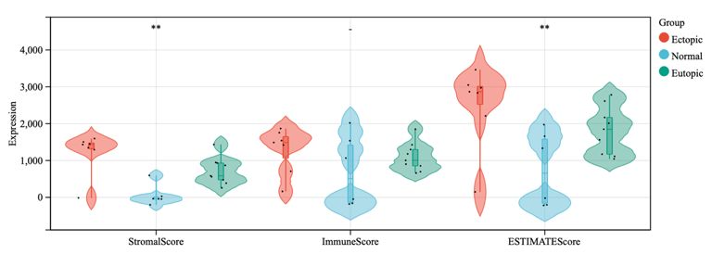

Figure S1. （a）Candidate m6A regulators were screening out and 3-fold cross-validation for shrinking parameters. （b）Immune Score, Stromal Score, and ESTIMATE Score for ectopic, normal, and EU samples. not significant, p ≥ 0.05；*p < 0.05，** p < 0.01, ***p < 0.001.

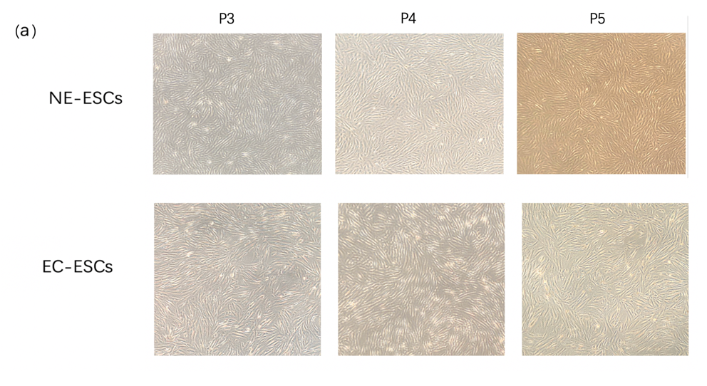
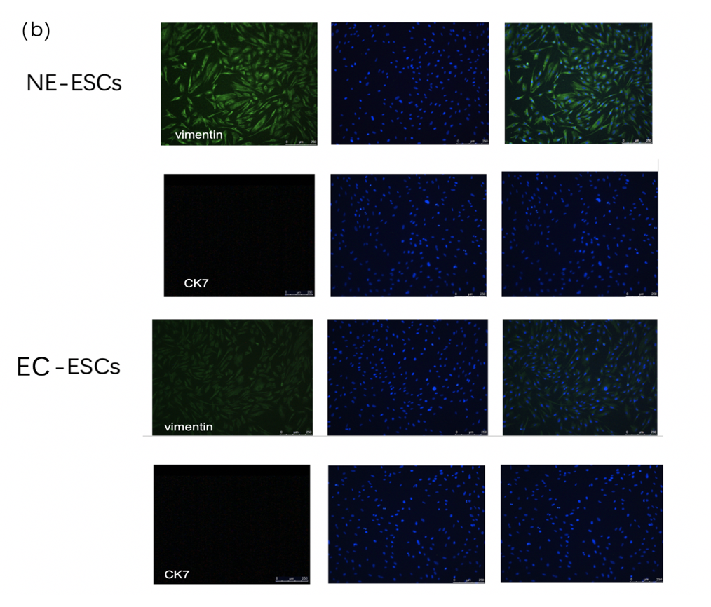
Figure S2. Morphology and identification of primary endometrial stromal cells. (a) Endometrial stromal cell morphology under light microscopy. (b) Endometrial stromal cell identification with nuclei stained with DAPI.

Figure S3. qPCR was used to detect the effect of transfection of METTL3 and YTHDF2 on mRNA expression levels in ovarian endometriotic stromal cells. not significant, p ≥ 0.05；*p < 0.05，** p < 0.01, ***p < 0.001.

