Supplementary Figures

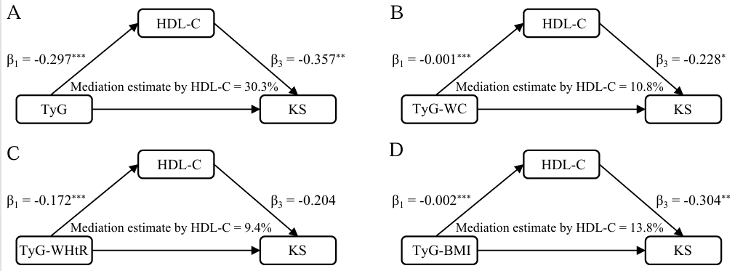
Figure S1. Mediation analyses of associations between TyG, TyG combined with obesity indicators and KS through HDL-C. (A) TyG. (B) TyG-WC. (C) TyG-WHtR. (D) TyG-BMI.
Model 3 was used for the mediation analysis.
(TyG, triglyceride-glucose; TyG-WC, triglyceride glucose-waist circumference; TyG-WHtR, triglyceride glucose-waist height ratio; TyG-BMI, triglyceride glucose-body mass index; KS, kidney stone; HDL-C, high-density lipoprotein cholesterol. * P < 0.05, ** P < 0.01, and *** P < 0.001.)

Figure S2. Forest plot showing TyG-WC association with KS.
Model 3 was used for subgroup analysis.
(TyG‑WC, triglyceride glucose-waist circumference; KS, kidney stone; OR, odds ratio; CI, confidence interval)

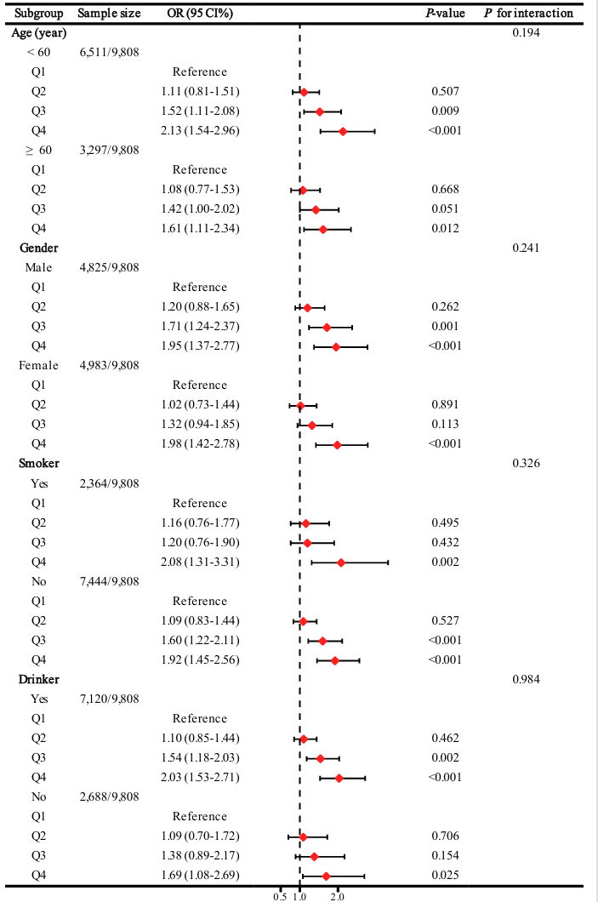
Figure S3. Forest plot showing TyG-BMI association with kidney stone.
Model 3 was used for subgroup analysis.
(TyG‑BMI, triglyceride glucose-body mass index; KS, kidney stone; OR, odds ratio; CI, confidence interval)

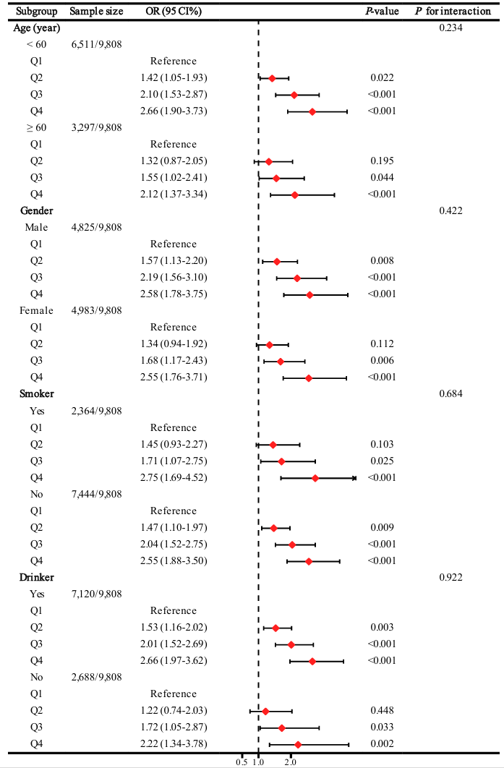

Figure S4. Forest plot showing TyG-WHtR association with KS.
Model 3 was used for subgroup analysis.
(TyG‑WHtR, triglyceride glucose-waist height ratio; KS, kidney stone; OR, odds ratio; CI, confidence interval)

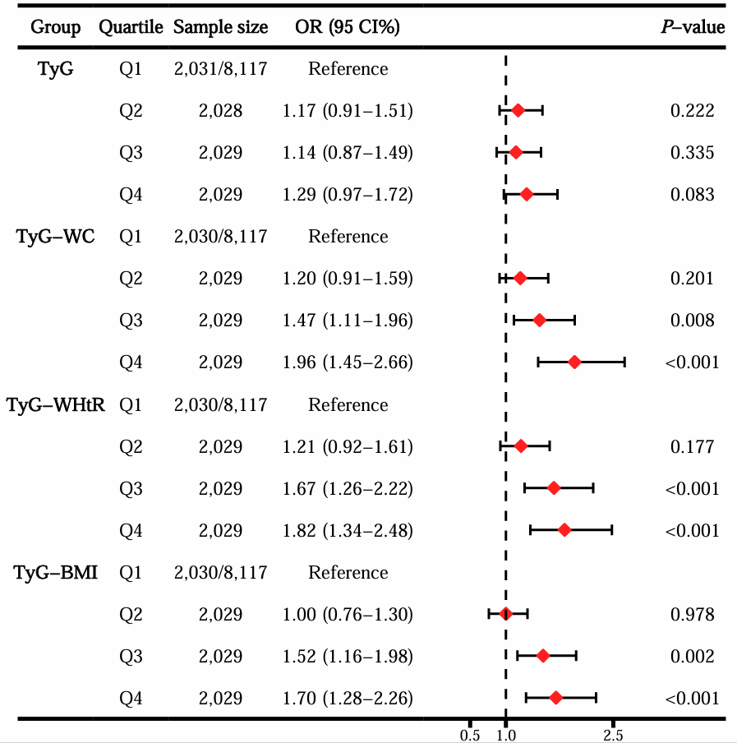

Figure S5. Forest plot showing sensitivity analysis 1 of the associations between TyG, TyG combined with obesity indicators and kidney stone, excluding populations with diabetes.
(TyG, triglyceride-glucose; TyG-WC, triglyceride glucose-waist circumference; TyG-WHtR, triglyceride glucose-waist height ratio; TyG-BMI, triglyceride glucose-body mass index; KS, kidney stone; OR, odds ratio; CI, confidence interval)

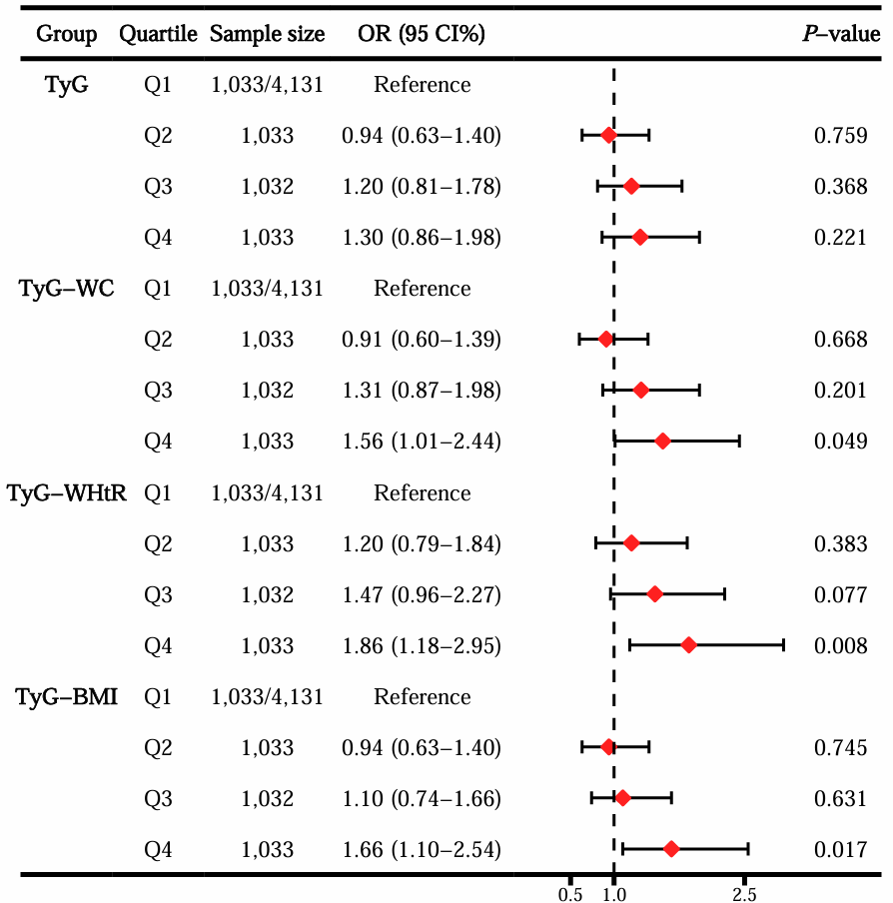
Figure S6. Forest plot showing sensitivity analysis 2 of the associations between TyG, TyG combined with obesity indicators and kidney stone, excluding populations with diabetes and prediabetes.
(TyG, triglyceride-glucose; TyG-WC, triglyceride glucose-waist circumference; TyG-WHtR, triglyceride glucose-waist height ratio; TyG-BMI, triglyceride glucose-body mass index; KS, kidney stone; OR, odds ratio; CI, confidence interval)

Figure S7. Forest plot showing sensitivity analysis 3 of the associations between TyG, TyG combined with obesity indicators and kidney stone, excluding populations with hypertension.
(TyG, triglyceride-glucose; TyG-WC, triglyceride glucose-waist circumference; TyG-WHtR, triglyceride glucose-waist height ratio; TyG-BMI, triglyceride glucose-body mass index; KS, kidney stone; OR, odds ratio; CI, confidence interval)

Supplementary Table 1. Baseline characteristics of the study population based on TyG-WC quartiles.
Variable | Total | TyG-WC (N = 9,808) |  |  |  | P
Variable | Total | Q1 (＜730.75) | Q2 (730.75 to ＜846.10) | Q3 (846.10 to ＜964.59) | Q4 (≥964.59) | P
Variable | Total | N = 2,452 | N = 2,452 | N = 2,452 | N = 2,452 | P
Age (year) | 49.62 ± 17.63 | 41.39 ± 17.51 | 50.52 ± 17.41 | 52.90 ± 16.86 | 53.68 ± 15.92 | <0.001
BMI (kg/m² ) | 28.97 ± 6.74 | 22.62 ± 2.91 | 26.73 ± 3.22 | 29.89 ± 3.83 | 36.61 ± 6.60 | <0.001
WC (cm) | 99.24 ± 16.30 | 80.85 ± 6.55 | 93.51 ± 5.53 | 102.95 ± 6.32 | 119.67 ± 12.13 | <0.001
Height (cm) | 167.52 ± 10.04 | 165.87 ± 9.43 | 166.76 ± 10.09 | 168.08 ± 10.21 | 169.35 ± 10.07 | <0.001
HDL-C (mmol/L) | 1.40 ± 0.41 | 1.66 ± 0.44 | 1.46 ± 0.40 | 1.31 ± 0.35 | 1.18 ± 0.30 | <0.001
LDL-C (mmol/L) | 2.95 ± 0.92 | 2.67 ± 0.82 | 3.02 ± 0.91 | 3.09 ± 0.92 | 3.00 ± 0.95 | <0.001
TC (mmol/L) | 4.96 ± 1.05 | 4.71 ± 0.96 | 5.01 ± 1.05 | 5.08 ± 1.06 | 5.04 ± 1.08 | <0.001
Insulin (pmol/L) | 80.47 ± 93.05 | 41.33 ± 32.96 | 59.14 ± 40.04 | 82.98 ± 72.93 | 138.45 ± 145.87 | <0.001
ALT (U/L) | 25.31 ± 18.28 | 20.67 ± 12.92 | 24.10 ± 18.06 | 27.52 ± 21.57 | 28.93 ± 18.36 | <0.001
AST (U/L) | 25.86 ± 20.43 | 24.51 ± 14.43 | 25.55 ± 20.69 | 26.72 ± 28.33 | 26.66 ± 15.12 | <0.001
GGT (U/L) | 28.67 ± 37.62 | 20.13 ± 23.63 | 26.15 ± 33.85 | 31.96 ± 41.56 | 36.45 ± 45.61 | <0.001
Serum calcium (mmol/L) | 2.34 ± 0.09 | 2.35 ± 0.08 | 2.34 ± 0.09 | 2.34 ± 0.09 | 2.33 ± 0.09 | <0.001
Serum phosphorus (mmol/L) | 1.19 ± 0.17 | 1.23 ± 0.17 | 1.19 ± 0.17 | 1.17 ± 0.18 | 1.17 ± 0.17 | <0.001
Scr (umol/L) | 78.73 ± 39.34 | 73.45 ± 31.14 | 78.52 ± 39.14 | 82.00 ± 49.74 | 80.94 ± 34.27 | <0.001
SUA (umol/L) | 327.59 ± 84.16 | 283.15 ± 69.93 | 316.59 ± 76.86 | 343.26 ± 79.55 | 367.36 ± 85.39 | <0.001
Gender (%) |  |  |  |  |  | <0.001
Male | 4,825 (49.19) | 924 (37.68) | 1,184 (48.29) | 1,375 (56.08) | 1,342 (54.73)
Female | 4,983 (50.81) | 1,528 (62.32) | 1,268 (51.71) | 1,077 (43.92) | 1,110 (45.27)
Race (%) |  |  |  |  |  | <0.001
Mexican American | 1,471 (15.00) | 253 (10.32) | 363 (14.80) | 461 (18.80) | 394 (16.07)
Non-Hispanic Black | 1,865 (19.02) | 492 (20.07) | 489 (19.94) | 439 (17.90) | 445 (18.15)
Non-Hispanic White | 4,474 (45.62) | 1,070 (43.64) | 1,056 (43.07) | 1,093 (44.58) | 1,255 (51.18)
Other Hispanic | 1,024 (10.44) | 226 (9.22) | 273 (11.13) | 270 (11.01) | 255 (10.40)
Other Race | 974 (9.93) | 411 (16.76) | 271 (11.05) | 189 (7.71) | 103 (4.20)
Education (%) |  |  |  |  |  | <0.001
Below high school | 935 (9.53) | 134 (5.46) | 241 (9.83) | 288 (11.75) | 272 (11.09)
High school | 3,629 (37.00) | 794 (32.38) | 892 (36.38) | 947 (38.62) | 996 (40.62)
Above high school | 5,244 (53.47) | 1,524 (62.15) | 1,319 (53.79) | 1,217 (49.64) | 1,184 (48.29)
Marital status (%) |  |  |  |  |  | <0.001
Having a partner | 5,904 (60.20) | 1,323 (53.96) | 1,505 (61.38) | 1,565 (63.83) | 1,511 (61.62)
No partner | 3,904 (39.80) | 1,129 (46.04) | 947 (38.62) | 887 (36.17) | 941 (38.38)
Income (%) |  |  |  |  |  | 0.032
Poverty | 2,098 (21.39) | 542 (22.10) | 508 (20.72) | 485 (19.78) | 563 (22.96)
Richer | 7,710 (78.61) | 1,910 (77.90) | 1,944 (79.28) | 1,967 (80.22) | 1,889 (77.04)
Smoker (%) |  |  |  |  |  | 0.082
Yes | 2,364 (24.10) | 636 (25.94) | 567 (23.12) | 590 (24.06) | 571 (23.29)
No | 7,444 (75.90) | 1,816 (74.06) | 1,885 (76.88) | 1,862 (75.94) | 1,881 (76.71)
Drinker (%) |  |  |  |  |  | 0.602
Yes | 7,120 (72.59) | 1,787 (72.88) | 1,783 (72.72) | 1,795 (73.21) | 1,755 (71.57)
No | 2,688 (27.41) | 665 (27.12) | 669 (27.28) | 657 (26.79) | 697 (28.43)
Hypertension (%) |  |  |  |  |  | <0.001
Yes | 3,580 (36.50) | 389 (15.86) | 795 (32.42) | 1,043 (42.54) | 1,353 (55.18)
No | 6,228 (63.50) | 2,063 (84.14) | 1,657 (67.58) | 1,409 (57.46) | 1,099 (44.82)
Diabetes (%) |  |  |  |  |  | <0.001
Diabetes | 1,691 (17.24) | 71 (2.90) | 246 (10.03) | 456 (18.60) | 918 (37.44)
Normal | 4,131 (42.12) | 1,735 (70.76) | 1,170 (47.72) | 780 (31.81) | 446 (18.19)
Prediabetes | 3,986 (40.64) | 646 (26.35) | 1,036 (42.25) | 1,216 (49.59) | 1,088 (44.37)
Kidney stone (%) |  |  |  |  |  | <0.001
Yes | 944 (9.62) | 130 (5.30) | 199 (8.12) | 250 (10.20) | 365 (14.89)
No | 8,864 (90.38) | 2,322 (94.70) | 2,253 (91.88) | 2,202 (89.80) | 2,087 (85.11)
Mean ± SD for continuous data, and P-values were obtained from one-way ANOVA test or Kruskal-Wallis test.
Frequency (percentage) for categorical data, and P-values were obtained from Chi-square test or Fisher’s test.
(TyG‑WC, triglyceride glucose-waist circumference; BMI, body mass index; HDL-C, high-density lipoprotein cholesterol; LDL-C, low-density lipoprotein cholesterol; TC, total cholesterol; ALT, alanine aminotransferase; AST, aspartate aminotransferase; GGT, γ-glutamyl transferase; Scr, serum creatinine; SUA, serum uric acid)

Supplementary Table 2. Baseline characteristics of the study population based on TyG-WHtR quartiles.
Variable | Total | TyG-WHtR (N = 9,808) |  |  |  | P
Variable | Total | Q1 (＜4.38) | Q2 (4.38 to ＜5.06) | Q3 (5.06 to ＜5.77) | Q4 (≥5.77) | P
Variable | Total | N = 2,452 | N = 2,452 | N = 2,452 | N = 2,452 | P
Age (year) | 49.62 ± 17.63 | 40.15 ± 16.56 | 50.53 ± 17.37 | 53.13 ± 16.89 | 54.68 ± 15.91 | <0.001
BMI (kg/m² ) | 28.97 ± 6.74 | 22.66 ± 2.88 | 26.61 ± 3.18 | 29.87 ± 3.66 | 36.71 ± 6.61 | <0.001
WC (cm) | 99.24 ± 16.30 | 81.74 ± 7.49 | 94.09 ± 7.34 | 102.68 ± 8.08 | 118.47 ± 13.15 | <0.001
Height (cm) | 167.52 ± 10.04 | 169.19 ± 9.56 | 168.33 ± 10.03 | 167.14 ± 10.02 | 165.41 ± 10.15 | <0.001
HDL-C (mmol/L) | 1.40 ± 0.41 | 1.63 ± 0.44 | 1.45 ± 0.41 | 1.31 ± 0.36 | 1.22 ± 0.32 | <0.001
LDL-C (mmol/L) | 2.95 ± 0.92 | 2.67 ± 0.81 | 3.00 ± 0.90 | 3.10 ± 0.95 | 3.01 ± 0.95 | <0.001
TC (mmol/L) | 4.96 ± 1.05 | 4.68 ± 0.94 | 4.98 ± 1.02 | 5.11 ± 1.09 | 5.07 ± 1.08 | <0.001
Insulin (pmol/L) | 80.47 ± 93.05 | 41.55 ± 35.05 | 58.63 ± 38.31 | 86.24 ± 79.39 | 135.48 ± 143.50 | <0.001
ALT (U/L) | 25.31 ± 18.28 | 21.15 ± 13.46 | 24.70 ± 18.88 | 27.57 ± 20.91 | 27.80 ± 18.24 | <0.001
AST (U/L) | 25.86 ± 20.43 | 25.05 ± 20.74 | 25.67 ± 21.66 | 26.29 ± 18.15 | 26.43 ± 20.99 | 0.068
GGT (U/L) | 28.67 ± 37.62 | 20.77 ± 24.72 | 26.74 ± 34.82 | 31.47 ± 38.63 | 35.72 ± 47.15 | <0.001
Serum calcium (mmol/L) | 2.34 ± 0.09 | 2.35 ± 0.08 | 2.34 ± 0.08 | 2.34 ± 0.09 | 2.33 ± 0.09 | <0.001
Serum phosphorus (mmol/L) | 1.19 ± 0.17 | 1.22 ± 0.18 | 1.18 ± 0.17 | 1.18 ± 0.17 | 1.19 ± 0.17 | <0.001
Scr (umol/L) | 78.73 ± 39.34 | 76.65 ± 36.05 | 79.42 ± 38.03 | 80.81 ± 47.70 | 78.03 ± 34.10 | 0.002
SUA (umol/L) | 327.59 ± 84.16 | 291.53 ± 72.71 | 318.69 ± 78.00 | 342.03 ± 83.64 | 358.13 ± 86.33 | <0.001
Gender (%) |  |  |  |  |  | <0.001
Male | 4,825 (49.19) | 1,192 (48.61) | 1,317 (53.71) | 1,310 (53.43) | 1,006 (41.03)
Female | 4,983 (50.81) | 1,260 (51.39) | 1,135 (46.29) | 1,142 (46.57) | 1,446 (58.97)
Race (%) |  |  |  |  |  | <0.001
Mexican American | 1,471 (15.00) | 205 (8.36) | 321 (13.09) | 467 (19.05) | 478 (19.49)
Non-Hispanic Black | 1,865 (19.02) | 546 (22.27) | 461 (18.80) | 444 (18.11) | 414 (16.88)
Non-Hispanic White | 4,474 (45.62) | 1,119 (45.64) | 1,141 (46.53) | 1,052 (42.90) | 1,162 (47.39)
Other Hispanic | 1,024 (10.44) | 199 (8.12) | 253 (10.32) | 287 (11.70) | 285 (11.62)
Other Race | 974 (9.93) | 383 (15.62) | 276 (11.26) | 202 (8.24) | 113 (4.61)
Education (%) |  |  |  |  |  | <0.001
Below high school | 935 (9.53) | 102 (4.16) | 208 (8.48) | 280 (11.42) | 345 (14.07)
High school | 3,629 (37.00) | 802 (32.71) | 877 (35.77) | 965 (39.36) | 985 (40.17)
Above high school | 5,244 (53.47) | 1,548 (63.13) | 1,367 (55.75) | 1,207 (49.23) | 1,122 (45.76)
Marital status (%) |  |  |  |  |  | <0.001
Having a partner | 5,904 (60.20) | 1,323 (53.96) | 1,549 (63.17) | 1,593 (64.97) | 1,439 (58.69)
No partner | 3,904 (39.80) | 1,129 (46.04) | 903 (36.83) | 859 (35.03) | 1,013 (41.31)
Income (%) |  |  |  |  |  | <0.001
Poverty | 2,098 (21.39) | 524 (21.37) | 458 (18.68) | 485 (19.78) | 631 (25.73)
Richer | 7,710 (78.61) | 1,928 (78.63) | 1,994 (81.32) | 1,967 (80.22) | 1,821 (74.27)
Smoker (%) |  |  |  |  |  | <0.001
Yes | 2,364 (24.10) | 709 (28.92) | 598 (24.39) | 542 (22.10) | 515 (21.00)
No | 7,444 (75.90) | 1,743 (71.08) | 1,854 (75.61) | 1,910 (77.90) | 1,937 (79.00)
Drinker (%) |  |  |  |  |  | <0.001
Yes | 7,120 (72.59) | 1,905 (77.69) | 1,812 (73.90) | 1,778 (72.51) | 1,625 (66.27)
No | 2,688 (27.41) | 547 (22.31) | 640 (26.10) | 674 (27.49) | 827 (33.73)
Hypertension (%) |  |  |  |  |  | <0.001
Yes | 3,580 (36.50) | 350 (14.27) | 790 (32.22) | 1,076 (43.88) | 1,364 (55.63)
No | 6,228 (63.50) | 2,102 (85.73) | 1,662 (67.78) | 1,376 (56.12) | 1,088 (44.37)
Diabetes (%) |  |  |  |  |  | <0.001
Diabetes | 1,691 (17.24) | 63 (2.57) | 241 (9.83) | 456 (18.60) | 931 (37.97)
Normal | 4,131 (42.12) | 1,735 (70.76) | 1,175 (47.92) | 772 (31.48) | 449 (18.31)
Prediabetes | 3,986 (40.64) | 654 (26.67) | 1,036 (42.25) | 1,224 (49.92) | 1,072 (43.72)
Kidney stone (%) |  |  |  |  |  | <0.001
Yes | 944 (9.62) | 125 (5.10) | 204 (8.32) | 271 (11.05) | 344 (14.03)
No | 8,864 (90.38) | 2,327 (94.90) | 2,248 (91.68) | 2,181 (88.95) | 2,108 (85.97)
Mean ± SD for continuous data, and P-values were obtained from one-way ANOVA test or Kruskal-Wallis test.
Frequency (percentage) for categorical data, and P-values were obtained from Chi-square test or Fisher’s test.
(TyG‑WHtR, triglyceride glucose-waist height ratio; BMI, body mass index; WC, waist circumference; HDL-C, high-density lipoprotein cholesterol; LDL-C, low-density lipoprotein cholesterol; TC, total cholesterol; ALT, alanine aminotransferase; AST, aspartate aminotransferase; GGT, γ-glutamyl transferase; Scr, serum creatinine; SUA, serum uric acid)

Supplementary Table 3. Baseline characteristics of the study population based on TyG-BMI quartiles.
Variable | Total | TyG-BMI (N = 9,808) |  |  |  | P
Variable | Total | Q1 (＜203.58) | Q2 (203.58 to ＜240.83) | Q3 (240.83 to ＜285.26) | Q4 (≥285.26) | P
Variable | Total | N = 2,452 | N = 2,452 | N = 2,452 | N = 2,452 | P
Age (year) | 49.62 ± 17.63 | 44.46 ± 18.82 | 51.19 ± 17.76 | 51.95 ± 17.01 | 50.88 ± 15.74 | <0.001
BMI (kg/m² ) | 28.97 ± 6.74 | 21.96 ± 2.15 | 26.23 ± 1.80 | 29.87 ± 2.19 | 37.79 ± 5.81 | <0.001
WC (cm) | 99.24 ± 16.30 | 81.66 ± 7.43 | 93.79 ± 6.96 | 102.59 ± 7.64 | 118.93 ± 12.76 | <0.001
Height (cm) | 167.52 ± 10.04 | 167.30 ± 9.67 | 168.02 ± 10.04 | 167.57 ± 10.23 | 167.18 ± 10.20 | 0.019
HDL-C (mmol/L) | 1.40 ± 0.41 | 1.64 ± 0.45 | 1.44 ± 0.40 | 1.30 ± 0.35 | 1.21 ± 0.31 | <0.001
LDL-C (mmol/L) | 2.95 ± 0.92 | 2.70 ± 0.85 | 2.99 ± 0.91 | 3.10 ± 0.95 | 3.00 ± 0.91 | <0.001
TC (mmol/L) | 4.96 ± 1.05 | 4.74 ± 1.00 | 4.99 ± 1.05 | 5.11 ± 1.09 | 5.00 ± 1.02 | <0.001
Insulin (pmol/L) | 80.47 ± 93.05 | 40.96 ± 32.61 | 58.87 ± 43.20 | 83.69 ± 76.66 | 138.39 ± 142.97 | <0.001
ALT (U/L) | 25.31 ± 18.28 | 20.97 ± 13.46 | 24.50 ± 18.51 | 27.11 ± 20.71 | 28.66 ± 18.71 | <0.001
AST (U/L) | 25.86 ± 20.43 | 24.77 ± 14.97 | 25.93 ± 21.24 | 26.26 ± 23.76 | 26.47 ± 20.71 | 0.017
GGT (U/L) | 28.67 ± 37.62 | 21.14 ± 25.10 | 27.50 ± 37.12 | 30.84 ± 38.43 | 35.22 ± 45.53 | <0.001
Serum calcium (mmol/L) | 2.34 ± 0.09 | 2.35 ± 0.08 | 2.34 ± 0.09 | 2.34 ± 0.09 | 2.33 ± 0.09 | <0.001
Serum phosphorus (mmol/L) | 1.19 ± 0.17 | 1.23 ± 0.18 | 1.18 ± 0.17 | 1.18 ± 0.17 | 1.18 ± 0.18 | <0.001
Scr (umol/L) | 78.73 ± 39.34 | 76.31 ± 40.73 | 80.02 ± 36.54 | 80.42 ± 45.31 | 78.17 ± 33.70 | 0.002
SUA (umol/L) | 327.59 ± 84.16 | 289.23 ± 72.36 | 319.50 ± 79.93 | 342.57 ± 82.02 | 359.07 ± 85.07 | <0.001
Gender (%) |  |  |  |  |  | <0.001
Male | 4,825 (49.19) | 1,067 (43.52) | 1,345 (54.85) | 1,329 (54.20) | 1,084 (44.21)
Female | 4,983 (50.81) | 1,385 (56.48) | 1,107 (45.15) | 1,123 (45.80) | 1,368 (55.79)
Race (%) |  |  |  |  |  | <0.001
Mexican American | 1,471 (15.00) | 224 (9.14) | 341 (13.91) | 464 (18.92) | 442 (18.03)
Non-Hispanic Black | 1,865 (19.02) | 423 (17.25) | 450 (18.35) | 459 (18.72) | 533 (21.74)
Non-Hispanic White | 4,474 (45.62) | 1,178 (48.04) | 1,133 (46.21) | 1,055 (43.03) | 1,108 (45.19)
Other Hispanic | 1,024 (10.44) | 198 (8.08) | 265 (10.81) | 303 (12.36) | 258 (10.52)
Other Race | 974 (9.93) | 429 (17.50) | 263 (10.73) | 171 (6.97) | 111 (4.53)
Education (%) |  |  |  |  |  | <0.001
Below high school | 935 (9.53) | 150 (6.12) | 237 (9.67) | 287 (11.70) | 261 (10.64)
High school | 3,629 (37.00) | 830 (33.85) | 882 (35.97) | 937 (38.21) | 980 (39.97)
Above high school | 5,244 (53.47) | 1,472 (60.03) | 1,333 (54.36) | 1,228 (50.08) | 1,211 (49.39)
Marital status (%) |  |  |  |  |  | <0.001
Having a partner | 5,904 (60.20) | 1,346 (54.89) | 1,508 (61.50) | 1,571 (64.07) | 1,479 (60.32)
No partner | 3,904 (39.80) | 1,106 (45.11) | 944 (38.50) | 881 (35.93) | 973 (39.68)
Income (%) |  |  |  |  |  | <0.001
Poverty | 2,098 (21.39) | 548 (22.35) | 486 (19.82) | 478 (19.49) | 586 (23.90)
Richer | 7,710 (78.61) | 1,904 (77.65) | 1,966 (80.12) | 1,974 (80.51) | 1,866 (76.10)
Smoker (%) |  |  |  |  |  | <0.001
Yes | 2,364 (24.10) | 673 (27.45) | 618 (25.20) | 551 (22.47) | 522 (21.29)
No | 7,444 (75.90) | 1,779 (72.55) | 1,834 (74.80) | 1,901 (77.53) | 1,930 (78.71)
Drinker (%) |  |  |  |  |  | <0.001
Yes | 7,120 (72.59) | 1,800 (73.41) | 1,833 (74.76) | 1,802 (73.49) | 1,685 (68.72)
No | 2,688 (27.41) | 652 (26.59) | 619 (25.24) | 650 (26.51) | 767 (31.28)
Hypertension (%) |  |  |  |  |  | <0.001
Yes | 3,580 (36.50) | 475 (19.37) | 790 (32.22) | 1,019 (41.56) | 1,296 (52.85)
No | 6,228 (63.50) | 1,977 (80.63) | 1,662 (67.78) | 1,433 (58.44) | 1,156 (47.15)
Diabetes (%) |  |  |  |  |  | <0.001
Diabetes | 1,691 (17.24) | 116 (4.73) | 281 (11.46) | 474 (19.33) | 820 (33.44)
Normal | 4,131 (42.12) | 1,617 (65.95) | 1,136 (46.33) | 833 (33.97) | 545 (22.23)
Prediabetes | 3,986 (40.64) | 719 (29.32) | 1,035 (42.21) | 1,145 (46.70) | 1,087 (44.33)
Kidney stone (%) |  |  |  |  |  | <0.001
Yes | 944 (9.62) | 153 (6.24) | 197 (8.03) | 264 (10.77) | 330 (13.46)
No | 8,864 (90.38) | 2,299 (93.76) | 2,255 (91.97) | 2,188 (89.23) | 2,122 (86.54)
Mean ± SD for continuous data, and P-values were obtained from one-way ANOVA test or Kruskal-Wallis test.
Frequency (percentage) for categorical data, and P-values were obtained from Chi-square test or Fisher’s test.
(TyG‑BMI, triglyceride glucose-body mass index; WC, waist circumference; HDL-C, high-density lipoprotein cholesterol; LDL-C, low-density lipoprotein cholesterol; TC, total cholesterol; ALT, alanine aminotransferase; AST, aspartate aminotransferase; GGT, γ-glutamyl transferase; Scr, serum creatinine; SUA, serum uric acid)

Supplementary Table 4. Association between TyG-WC and KS.
 | Model 1 |  |  | Model 2 |  |  | Model 3
 | OR | 95% CI | P | OR | 95% CI | P | OR | 95% CI | P
TyG-WC | 1.01 | 1.01, 1.01 | <0.001 | 1.01 | 1.01, 1.01 | <0.001 | 1.01 | 1.01, 1.01 | <0.001
TyG-WC (Quartile)
Q1 | Reference |  |  | Reference |  |  | Reference
Q2 | 1.58 | 1.26, 1.99 | <0.001 | 1.31 | 1.04, 1.66 | 0.022 | 1.25 | 0.98, 1.59 | 0.071
Q3 | 2.03 | 1.63, 2.53 | <0.001 | 1.61 | 1.28, 2.02 | <0.001 | 1.49 | 1.16, 1.92 | 0.002
Q4 | 3.12 | 2.54, 3.86 | <0.001 | 2.47 | 1.99, 3.08 | <0.001 | 2.19 | 1.69, 2.84 | <0.001
P for trend | <0.001 |  |  | <0.001 |  |  | <0.001
Model 1 no variable was adjusted.
Model 2 continuous variables (age), categorical variables (gender and race).
Model 3 continuous variables (age, high-density lipoprotein cholesterol, low-density lipoprotein cholesterol, alanine aminotransferase, aspartate aminotransferase, γ-glutamyl transferase, serum calcium, serum phosphorus, serum creatinine, and serum uric acid), categorical variables (gender, race, education level, marital status, household income, smoking status, alcohol consumption, hypertension, and diabetes).
(TyG-WC, triglyceride glucose-waist circumference; KS, kidney stone; OR, odds ratio; CI, confidence interval. Bold font indicates statistically significant differences.)

Supplementary Table 5. Association between TyG-WHtR and KS.
 | Model 1 |  |  | Model 2 |  |  | Model 3
 | OR | 95% CI | P | OR | 95% CI | P | OR | 95% CI | P
TyG-WHtR | 1.04 | 1.03, 1.04 | <0.001 | 1.03 | 1.02, 1.04 | <0.001 | 1.03 | 1.02, 1.04 | <0.001
TyG-WHtR (Quartile)
Q1 | Reference |  |  | Reference |  |  | Reference
Q2 | 1.69 | 1.34, 2.13 | <0.001 | 1.39 | 1.10, 1.76 | 0.007 | 1.31 | 1.03, 1.68 | 0.028
Q3 | 2.31 | 1.86, 2.89 | <0.001 | 1.84 | 1.47, 2.31 | <0.001 | 1.72 | 1.34, 2.21 | <0.001
Q4 | 3.04 | 2.46, 3.77 | <0.001 | 2.48 | 1.99, 3.10 | <0.001 | 2.26 | 1.73, 2.95 | <0.001
P for trend | <0.001 |  |  | <0.001 |  |  | <0.001
Model 1 no variable was adjusted.
Model 2 continuous variables (age), categorical variables (gender and race).
Model 3 continuous variables (age, high-density lipoprotein cholesterol, low-density lipoprotein cholesterol, alanine aminotransferase, aspartate aminotransferase, γ-glutamyl transferase, serum calcium, serum phosphorus, serum creatinine, and serum uric acid), categorical variables (gender, race, education level, marital status, household income, smoking status, alcohol consumption, hypertension, and diabetes).
(TyG‑WHtR, triglyceride glucose-waist height ratio ; KS, kidney stone; OR, odds ratio; CI, confidence interval. Bold font indicates statistically significant differences.)

Supplementary Table 6. Association between TyG-BMI and KS.
 | Model 1 |  |  | Model 2 |  |  | Model 3
 | OR | 95% CI | P | OR | 95% CI | P | OR | 95% CI | P
TyG-BMI | 1.01 | 1.01, 1.01 | <0.001 | 1.01 | 1.01, 1.01 | <0.001 | 1.01 | 1.01, 1.01 | <0.001
TyG-BMI (Quartile)
Q1 | Reference |  |  | Reference |  |  | Reference
Q2 | 1.31 | 1.06, 1.64 | 0.015 | 1.12 | 0.90, 1.40 | 0.306 | 1.05 | 0.83, 1.32 | 0.682
Q3 | 1.81 | 1.48, 2.24 | <0.001 | 1.57 | 1.27, 1.94 | <0.001 | 1.42 | 1.13, 1.79 | 0.003
Q4 | 2.34 | 1.92, 2.86 | <0.001 | 2.17 | 1.77, 2.67 | <0.001 | 1.88 | 1.48, 2.39 | <0.001
P for trend | <0.001 |  |  | <0.001 |  |  | <0.001
Model 1 no variable was adjusted.
Model 2 continuous variables (age), categorical variables (gender and race).
Model 3 continuous variables (age, high-density lipoprotein cholesterol, low-density lipoprotein cholesterol, alanine aminotransferase, aspartate aminotransferase, γ-glutamyl transferase, serum calcium, serum phosphorus, serum creatinine, and serum uric acid), categorical variables (gender, race, education level, marital status, household income, smoking status, alcohol consumption, hypertension, and diabetes).
(TyG‑BMI, triglyceride glucose-body mass index; KS, kidney stone; OR, odds ratio; CI, confidence interval. Bold font indicates statistically significant differences.)

