Supporting Information

Polysarcosine-functionalized graphene oxide improves biological safety and enhances Chemo-Photothermal therapy synergistic anticancer effect
Weiwei Ma^{1,}*, Yan zhang^{2,}*, Xuejing Zhai¹, Qian Qu¹, Xueying Guo¹, Sen Zhang¹, Ruiyao Hou¹, Ping Lu², Yanyan Yin¹
¹College of Pharmacy, Xinxiang Medical University, Xinxiang, People’s Republic of China; ²Department of Oncology, The First Affiliated Hospital of Xinxiang Medical University, Xinxiang, People’s Republic of China
*These authors contributed equally to this work
Correspondence: Weiwei Ma, College of Pharmacy, Xinxiang Medical University, Xinxiang, 453003, People’s Republic of China, Tel +86 0373 3029879, Fax +86 0373 3029879, Email 081011@xxmu.edu.cn; Yanyan Yin, Email 105772801@qq.com.
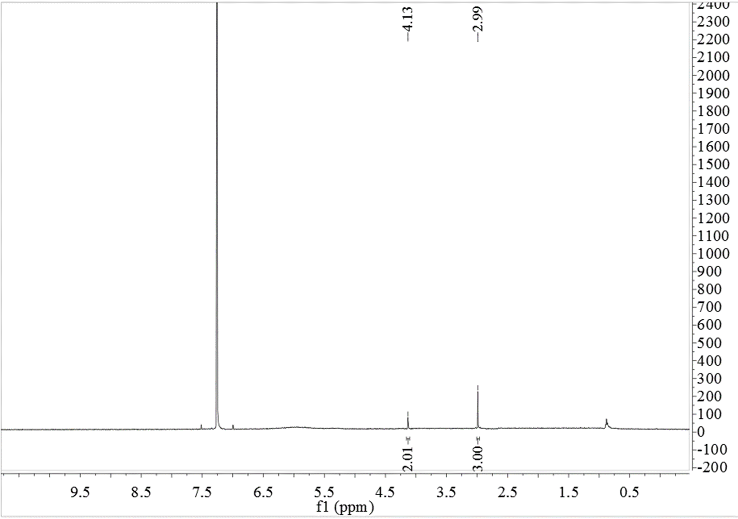
Figure S1. ¹H-NMR spectrum of Sar-NCA.

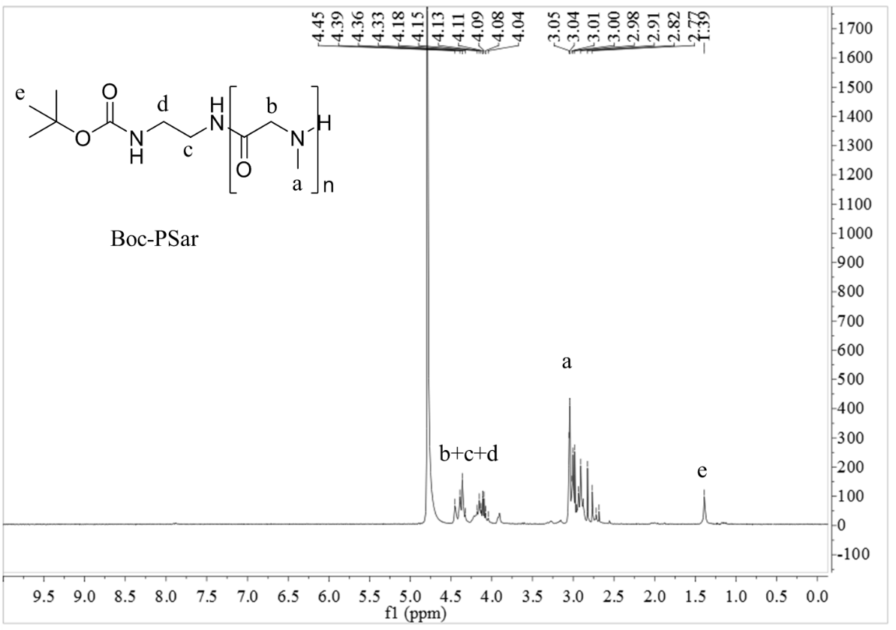
Figure S2. ¹H-NMR spectrum of Boc-PSar.

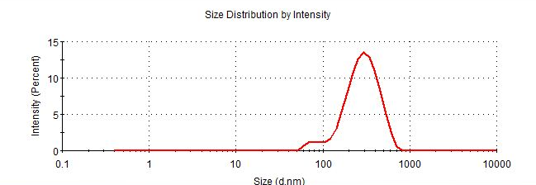
Figure S3. Particle size distribution of GO.

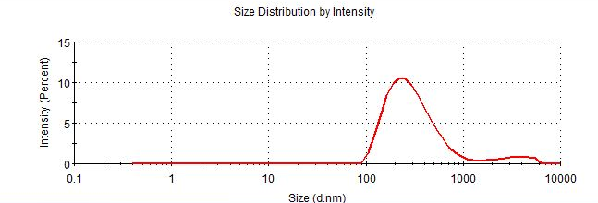
Figure S4. Particle size distribution of B-PSar-GO.

y = 0.0247x + 0.0059
R² = 0.9998

Figure S5. Ultraviolet curves and standard curve of DOX solutions (insert).

