1. Assessment for depressive symptoms
This study uses the 9-item Patient Health Questionnaire (PHQ-9) to assess the severity of patients' depressive symptoms. The PHQ-9 consists of 9 items that assess the frequency of certain symptoms experienced by patients in the past two weeks. The score ranges from 0 to 27, with higher scores indicating greater severity. A recommended binary threshold for the presence of depressive symptoms is a PHQ-9 score of 10 or higher, with a sensitivity of 88% and specificity of 88% for screening severe depressive symptoms.
- Calculate the weights
Due to the complex sampling design of NHANES, sample weights, clustering, and stratification are incorporated into all analyses to analyze the NHANES data. Through the NHANES database analysis guide (2005-2008), the following formula was used for calculating the weights: WTMEC4YR = 1/2*WTMEC2YR. In addition, the primary sampling units (PSU) are identified by the variable representing masked variance pseudo-PSU (SDMVPSU), and the strata from which the PSUs are selected are identified by the variable indicating masked variance pseudo-stratum (SDMVSTRA).
- Detailed LOD handling
The detection limits were constant for all of the analytes in the data set. Two variables are provided for each of these analytes. The variable name ending in “1LC” (ex., URDNA1LC) indicates whether the result was below the limit of detection: the value “0” means that the result was at or above the limit of detection, “1” indicates that the result was below the limit of detection. For analytes with analytic results below the lower limit of detection (ex., URDNA1LC=1), an imputed fill value was placed in the analyte results field. This value is the lower limit of detection divided by the square root of 2 (LLOD/sqrt). The other variable prefixed UR1 (ex., UR1NASI) provides the analytic result for that analyte. As the detection methods varied across cycles, the LOD changed accordingly, from 2005–2006 onward, the LOD for enterolactone has been 0.1 ng/mL.
- Description of Laboratory Methodology
The test principle utilizes high performance liquid chromatography-atmospheric pressure photoionization-tandem mass spectrometry (HPLC-APPI-MS/MS) for the quantitative detection of genistein, daidzein, equol, O-desmethylangolensin, enterodiol, and enterolactone. Human urine samples are processed using enzymatic deconjugation of the glucuronidated phytoestrogens followed by size-exclusion filtration. Phytoestrogens are then separated from other urine components by reversed phase HPLC, detected by APPI-MS/MS, and quantified by isotope dilution. Assay precision is improved by incorporating carbon-13 labeled internal standards for each of the analytes, as well as a 4-methylumbelliferyl glucuronide and 4-methylumbelliferyl sulfate standards to monitor deconjugation efficiency. This selective method allows for rapid detection of phytoestrogens in human urine with limits of detection in the low parts per billion (ng/mL) range. In 2003-2004 high performance liquid chromatography electrospry ionization mass spectrometric (LC-ESI-MS/MS) detection (Rybak, M. E. et al., 2008) was utilized and in 2005-2006 high performance liquid chromatography-atmospheric pressure photoionization-tandem mass spectrometry (LC-ESI-MS/MS) was utilized. Crossover studies comparing samples analyzed by LC-ESI-MS/MS and LC-APPI-MS/MS demonstrated high correlation coefficients (r>0.99) and regression slopes approximately equal to 1 and intercepts close to 0.
- Variable codes
URXETL – Enterolactone concentration (ng/ mL)
URDETLLC – Detection flag (0 = detected, 1 = < LOD)
URXUCR – Urinary creatinine (mg/ dL) for creatinine correction
SEQN – Unique participant ID for merging with demographic/exam data
- Laboratory Weights (mandatory for unbiased population estimates)
1999-2002: WTSPH2YR (1/3 MEC subsample)
2003-2010 & 2013-2016: WTSB2YR (subsample B)
2011-2012: WTSA2YR (subsample A)
When combining cycles, rescale weights (divide by number of cycles) and use SDMVPSU + SDMVSTRA as survey design variables per CDC analytic guidelines.
- Distribution summaries and key percentiles of urinary enterolactone
Geometric mean: 741.6 ng/ mL
Creatinine-adjusted: 631.417 ng /mg
Percentiles (ng /mL)
25th=82.7ng/ mL, Creatinine-adjusted: 73.276 ng /mg
50th (median) = 321ng/ mL, Creatinine-adjusted: 272.441ng /mg
75th=827ng/ mL, Creatinine-adjusted: 685.714ng/ mL
Max recorded: 35 000 ng/ mL, Creatinine-adjusted:26315.789ng/ mL
Minimum record :0.1ng/ mL, Creatinine-adjusted:0.094ng/ mL
- MET-min/week calculation
In the NHANES questionnaire, respondents report the number of days per month and the minutes per session for each activity (e.g., walking, cycling, moderate or vigorous work, running). Monthly minutes × MET → divided by 30 × 7 = MET-min/week.
Vigorous work/vigorous leisure = 8 MET
Moderate work/moderate leisure/transport cycling = 4 MET
Walking = 3.3 MET
9. Key percentiles of urinary enterolactone
Before log transformation:
25th=82.7ng/ mL,
50th (median) = 321ng/ mL,
75th=827ng/ mL
Max recorded: 35 000 ng/ mL
Minimum record :0.1ng/ mL,
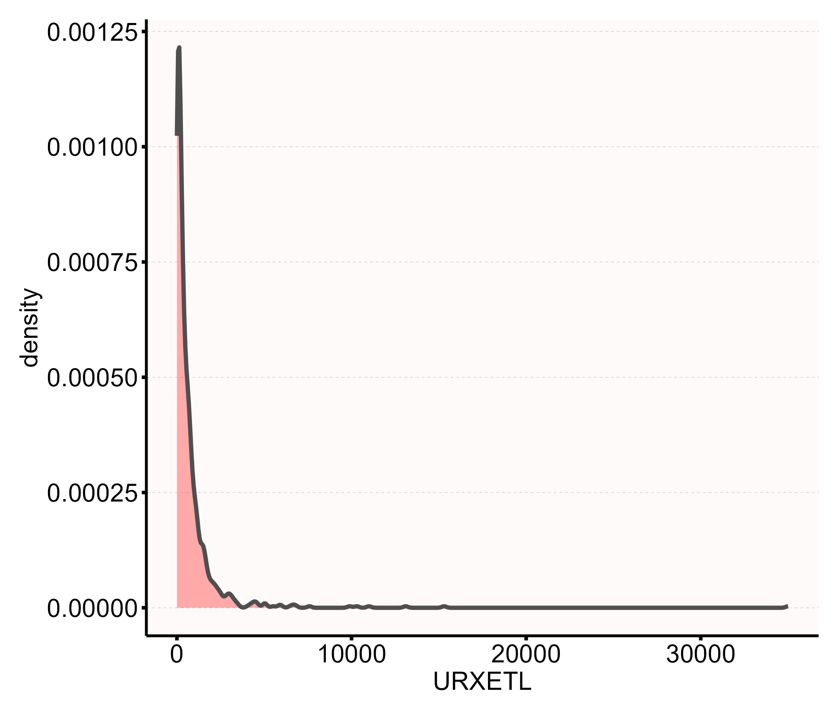
Figure S1. Histogram of urinary enterolactone concentrations before log-transformation
After log transformation:
25th=2.660
50th (median) =3.701,
75th=4.673
Max recorded: 8.852
Minimum record :-3.507
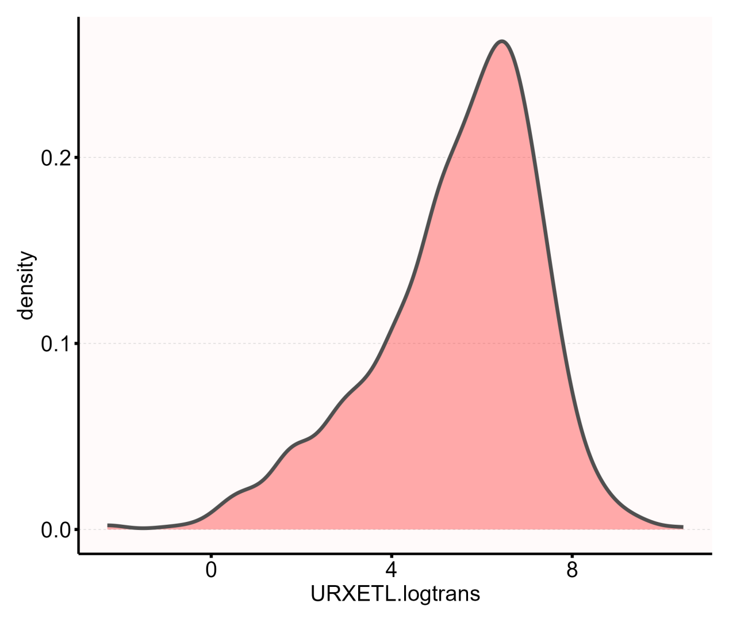
Figure S2. Histogram of urinary enterolactone concentrations after log-transformation

Table S1 Associations between urinary enterolactone and sleep quality in the multiple regression model.
Enterolactone | Non-adjusted Model | Model 1 | Model 2 | Model 3
Enterolactone | 0.9 (0.84~0.97) | 0.91 (0.85~0.99) | 0.92 (0.85~0.99) | 0.92 (0.84~0.99)
P-value | 0.01 | 0.019 | 0.023 | 0.027
Subgroups
Quartile 1 | 1.00 (Ref.) | 1.00 (Ref.) | 1.00 (Ref.) | 1.00 (Ref.)
Quartile 2 | 0.66 (0.47~0.91) | 0.68 (0.49~0.95) | 0.69 (0.5~0.97) | 0.73 (0.52~1.02)
Quartile 3 | 0.62 (0.44~0.85) | 0.64 (0.46~0.89) | 0.63 (0.45~0.89) | 0.65 (0.46~0.92)
P-trend | 0.004 | 0.009 | 0.008 | 0.016

Model 1：Age, sex, family PIR, race and ethnicity, educational level
Model 2：Model 1 + smoking status, alcohol drinking status, physical activity, energy intake, BMI
Model 3：Model 2 + hypertension, diabetes, depression, Sleep Apnea

Table S2. Threshold effect analysis of urinary enterolactone on sleep quality

Threshold of enterolactone | OR | 95% CI | P value
＜2.336 | 0.7 | (0.293~1.67) | 0.421
≥2.336 | 0.898 | (0.811~0.993) | 0.0365
Notes: OR – Odds Ratio; 95% CI – 95% Confidence Interval

Table S3. Associations between urinary enterolactone and sleep quality in the multiple regression model.
Enterolactone | Non-adjusted Model | Model 1 | Model 2 | Model 3
Enterolactone | 0.96 (0.93~0.98) | 0.97 (0.95~0.99) | 0.98 (0.95~0.99) | 0.98 (0.94~0.99)
P-value | 0.004 | 0.02 | 0.024 | 0.028
Subgroups
Quartile 1 | 1.00 (Ref.) | 1.00 (Ref.) | 1.00 (Ref.) | 1.00 (Ref.)
Quartile 2 | 0.81 (0.71~0.92) | 0.87 (0.76~0.93) | 0.86 (0.71~0.93) | 0.85 (0.7~0.94)
Quartile 3 | 0.83 (0.74~0.95) | 0.92 (0.8~0.95) | 0.92 (0.75~0.95) | 0.93 (0.76~0.96)

Model 1：Age, sex, family PIR, race and ethnicity, educational level
Model 2：Model 1 + smoking status, alcohol drinking status, physical activity, energy intake, BMI
Model 3：Model 2 + hypertension, diabetes

Table S4. Associations between urinary enterolactone and sleep quality in the Weighted multivariable logistic regression model.

Enterolactone | Non-adjusted Model | Model 1 | Model 2 | Model 3
Enterolactone | 0.91 (0.84, 0.99) | 0.9 (0.84, 0.99) | 0.91 (0.83, 0.99) | 0.91 (0.83, 1.00)
P-value | 0.036 | 0.025 | 0.039 | 0.043
Subgroups
Quartile 1 | 1.00 (Ref.) | 1.00 (Ref.) | 1.00 (Ref.) | 1.00 (Ref.)
Quartile 2 | 0.80 (0.52, 1.24) | 0.81 (0.52, 1.27) | 0.83 (0.53, 1.32) | 084 (0.52, 1.35)
Quartile 3 | 0.59 (0.42, 0.82) | 0.60 (0.44, 0.82) | 0.59 (0.42, 0.83) | 0.60 (0.42, 0.84)
P-trend | 0.003 | 0.003 | 0.005 | 0.006

Model 1：Age, sex, family PIR, race and ethnicity, educational level
Model 2：Model 1 + smoking status, alcohol drinking status, physical activity, energy intake, BMI
Model 3：Model 2 + hypertension, diabetes

Table S5. Associations between urinary enterolactone and sleep quality in the multiple regression model.
Enterolactone | Non-adjusted Model | Model 1 | Model 2 | Model 3
Enterolactone* | 0.82 (0.71~0.95) | 0.84 (0.72~0.97) | 0.84 (0.72~0.98) | 0.84 (0.72~0.98)
P-value | 0.007 | 0.019 | 0.023 | 0.027
*:per doubling of exposure
Model 1：Age, sex, family PIR, race and ethnicity, educational level
Model 2：Model 1 + smoking status, alcohol drinking status, physical activity, energy intake, BMI
Model 3：Model 2 + hypertension, diabetes

Table S6. Associations between urinary enterolactone and sleep quality in the multiple regression model.
Enterolactone | Non-adjusted Model | Model 1 | Model 2 | Model 3
Enterolactone* | 0.93 (0.88~0.98) | 0.93 (0.88~0.99) | 0.94 (0.88~0.99) | 0.94 (0.89~0.99)
P-value | 0.007 | 0.019 | 0.023 | 0.027
*:per IQR increment
Model 1：Age, sex, family PIR, race and ethnicity, educational level
Model 2：Model 1 + smoking status, alcohol drinking status, physical activity, energy intake, BMI
Model 3：Model 2 + hypertension, diabetes

