Supplementary material

Supplementary deviations from pre-registration

Pillai’s trace was used as the criterion for significance instead of Wilk’s Lamda in the MANOVA for the SPQ variables due to unbalanced sample sizes and violations in normality.
For the SPQ variables, an additional MANCOVA was conducted with just age and gender added as covariates, to determine whether age and gender biased the results without the PHQ- 15 score.
Non-parametric alternatives were chosen to analyse the SHS variables due to violations of normality. Due to the use of non-parametric statistics, PHQ-15, age and gender were unable to be added as covariates as planned.
Within the regression analyses, PHQ-15 was not included as a predictor variable in either regression equations as it was concluded that the PHQ-15 and FIQR both measure similar aspects of symptom reporting.

Supplementary analysis 1- factor analyses
An additional aim of the study was to attempt to validate a new scale (containing questions from the SPQ and SHS) measuring three different aspects of perception (detection, discrimination and intolerance). For the purpose of this study, detection is defined as the ability to identify a stimulus (e.g., I would feel if a single hair touched the back of my hand). Discrimination refers to the ability to discriminate between stimuli (e.g., I would be able to taste the difference between two brands of salty potato chips/crisps). Finally, intolerance refers to the reported unpleasantness to a stimulus (e.g., I am sensitive to bright lights). To ensure that the number of questions for each modality were more evenly spread, twenty-five items were added to the SPQ to create the adapted SPQ. Twenty-three of these questions were added from the 92-item version, whilst the remaining two were developed by the research team. Further justification for including more questions was to ensure that the number of variables representing each hypothesised factor were roughly equal (see Supplementary Table 1-3 for a list of questionnaire items and what aspect of perception we predicted each item would pertain to and therefore what we expected to see in each factor). For the SHS, three additional questions were developed to ensure that the number of questions were equally spread across the modalities.

To investigate whether the measured variables in each questionnaire separated into three different underlying factors (e.g., detection, discrimination and intolerance), a series of exploratory factor analyses were conducted on the standardised scores (using min-max normalisation) from the adapted SPQ and SHS combined. Exploratory factor analyses were conducted for five separate sensory modalities (touch, hearing, vision, smell and taste). These five factor analyses were conducted across all participants to ensure that the emerging factor structure could be used to compare participants from both populations. Pain, heat and cold variables were included in the touch modality. Questions relating to allergies were excluded as they do not easily separate into the three question types or relate to a specific sensory modality. If meaningful factors emerged (e.g., detection, discrimination and intolerance), our pre-registered plan was to conduct further exploratory factor analyses to explore if each factor from the previous analyses separated into the five sensory modalities, however, the findings did not warrant further analysis.
For each factor analysis, factors were extracted using principal factor analysis. Deciding the number of factors to extract was determined based on a combination of scree plots, the Kaiser criterion (eigen values greater than 1) and parallel analysis. To improve interpretation of the factor solution, Promax rotations were performed. As a minimum threshold, variables with factor loadings lower than .32 were not interpreted as recommended by Tabachnick.¹ To aid interpretation of the scales the SPQ scale was reversed scored prior to the factor analyses.
Supplementary Table 1
Questionnaire items predicted to represent Detection
Questionnaire | Code | Questions | Perception type
SPQ | hearing1 | I would be able to hear the sound of a leaf blown by the wind on a quiet street. | Detection
SPQ | hearing2 | I can hear electricity humming in the walls. | Detection
SPQ | hearing3 | I would be able to hear the sound of a vacuum cleaner from any room in a two-storey building. | Detection
SPQ | hearing4 | I would be the first to hear if there was a fly in the room. | Detection
SPQ adapted | Addhearing10 | I can’t hear the TV when it is quiet, even when other people can. | Detection
SHS | shssmell1 | I often react to odours that other do not initially notice | Detection
SHS | shssmell2 | I seem to notice smells that other people do not | Detection
SHS | shssmell3 | I rarely notice smells | Detection
SPQ | smell10 | I would detect a new smell in my house instantly before anyone else. | Detection
SPQ | smell2 | I would be able to tell if a strawberry was ripe just by smelling it. | Detection
SPQ | smell4 | I could not tell if bread was stale purely by its smell. | Detection
SPQ | smell5 | I would be able to smell the smallest gas leak from anywhere in the house. | Detection
SPQ | smell9 | I would be able to smell the smallest amount of burning from anywhere in the house. | Detection
SPQ | taste1 | I would notice right away if someone added 5 drops of lemon juice to my cup of water. | Detection
SPQ adapted | Addtaste10 | I couldn’t taste if there were two slices of lemon in my glass of water if I was drinking it with my eyes closed. | Detection
SPQ adapted | Addtaste7 | I wouldn’t notice if someone added a spoonful of sugar to my tea. | Detection
SPQ adapted | Addtaste8 | I would notice if someone added 5 grains of salt to my cup of water. | Detection
SPQ adapted | Addtaste9 | I would be able to notice if someone added 5 grains of sugar to my glass of water. | Detection
SPQ | touch1 | I would not be able to feel the label at the back of my shirt even if I thought about it. | Detection
SPQ | touch10 | If my mobile phone was vibrating in my pocket, I would be quick to sense it. | Detection
SPQ | touch3 | I would be able to feel a small (e.g., one millimetre) paper cut in my skin. | Detection
SPQ | touch5 | I would be able to feel the elastic holding up my socks if I stop and thought about it. | Detection
SPQ | touch6 | I notice the weight and pressure of a hat on my head. | Detection
SPQ | touch7 | I would feel if a single hair touched the back of my hand. | Detection
SPQ | touch8 | If I was walking along, I would be able to feel a passing truck’s vibrations even if my eyes were closed | Detection
SPQ | vision2 | I notice the flickering of a desktop computer even when it is working properly. | Detection
SPQ | vision6 | I can see dust particles in the air in most environments. | Detection
SPQ adapted | Addvision7 | I wouldn’t be able to detect the motion of the blades of a rotating fan even when it is at minimum speed. | Detection
SPQ adapted | Addvision8 | I wouldn’t be able to detect large objects, such as parked cars, clearly on a dark night. | Detection
SPQ adapted | Addvision9 | I can’t see written words on a page that other people can see. | Detection

Supplementary Table 2
Questionnaire items predicted to represent discrimination

Questionnaire | Code | Questions | Perception type
SPQ | hearing5 | I would be able to hear each note in a chord even if there were 10 notes. | Discriminate
SPQ adapted | Addhearing6 | I can hear the difference between different people coming up the stairs based on their footsteps | Discriminate
SPQ adapted | Addhearing7 | I wouldn't notice if the volume of the TV got louder if the volume was increased by one notch | Discriminate
SPQ adapted | Addhearing8 | The sound of a piano and a violin playing the same note seems very similar to me. | Discriminate
SPQ adapted | Addhearing9 | When people are talking the words seem to merge together. | Discriminate
SPQ | smell1 | I can recognize different people by the way they smell. | Discriminate
SPQ | smell3 | I could not distinguish a familiar person and a stranger by their smell. | Discriminate
SPQ | smell6 | I wouldn’t notice if someone changed their perfume, by smell alone. | Discriminate
SPQ | smell7 | I would be able to smell the difference between most men and women. | Discriminate
SPQ | smell8 | I would be able to distinguish two brands of coffee by their smell, even with my eyes closed. | Discriminate
SPQ | taste2 | I would be able to taste the difference between two brands of salty potato chips/crisps. | Discriminate
SPQ | taste3 | I would be able to taste the difference between apparently identical pieces of candy. | Discriminate
SPQ | taste4 | I wouldn’t be able to taste the difference between two brands of tomato sauce if they had different concentrations of salt. | Discriminate
SPQ adapted | Addtaste5 | I would be able to distinguish milk chocolate and dark chocolate by their taste alone. | Discriminate
SPQ adapted | Addtaste6 | I would be able to distinguish between two oranges purely by their taste | Discriminate
SPQ | touch2 | I would be able to notice a small change (e.g. 1 degree) in the temperature of the weather. | Discriminate
SPQ | touch4 | I would be able to tell the weight difference between two different coin sizes on the palm of my hand with my eyes closed. | Discriminate
SPQ | touch9 | I would be able to feel a change in the temperature of a cup of coffee after it had sat for 1 minute. | Discriminate
SPQ adapted | Addtouch11 | I wouldn’t be able to feel a small volume change in music as a difference in vibration on my skin. | Discriminate
SPQ adapted | Addtouch12 | I wouldn’t notice a 10-degree difference in temperature of the weather | Discriminate
SPQ adapted | Addtouch13 | I wouldn’t notice the difference between even and uneven ground when driving over it sitting in the back seat of a car. | Discriminate
SPQ | vision1 | I would notice right away that it got brighter if a dimmer control switch moved up one notch. | Discriminate
SPQ | vision4 | If I look at a pile of blue sweaters in a shop that are meant to be identical, I would be able to see differences between them. | Discriminate
SPQ adapted | Addvision10 | I would be able to see the individual blades in a rotating fan even if it was at maximum speed. | Discriminate
SPQ adapted | Addvision11 | I couldn’t tell two types of green apples apart purely from their colour. | Discriminate
SPQ adapted | Addvision12 | I can’t tell if cars passing me on the street are going at different speeds | Discriminate

Supplementary Table 3
Questionnaire items predicted to represent intolerance
Questionnaire | Code | Questions | Measures
SHS | hot1 | I often feel too hot in an environment where others don’t seem to be bothered | Intolerance
SHS | hot2 | I am easily disturbed by high temperatures | Intolerance
SHS | cold1 | I often feel too cold in an environment where others don’t seem to be bothered | Intolerance
SHS | cold2 | I am easily disturbed by low temperatures | Intolerance
SHS | shsvision1 | My eyes are sensitive to sunlight | Intolerance
SHS | shsvision2 | I am sensitive to bright light | Intolerance
SHS | shsvision3 | I am not really bothered by bright lights | Intolerance
SPQ | vision3 | I can’t go out in bright sunlight without sunglasses. | Intolerance
SPQ | vision5 | I close curtains to avoid bright lights. | Intolerance
SHS | shspain1 | I am quite sensitive to pain | Intolerance
SHS | shspain2 | I can tolerate a large amount of pain | Intolerance
SHS | shspain3 | Things that would ordinarily hurt others are not painful to me | Intolerance
SHS | shssound1 | When I read, it must be totally quiet | Intolerance
SHS | shssound2 | I cannot study or read if there is any conversation or noise around | Intolerance
SHS | shssound3 | I can work even in noisy circumstances | Intolerance
SHS | shstaste1 | I tend to be a picky eater | Intolerance
SHS | shstaste2 | There are many foods that taste bad to me | Intolerance
SHS | shstaste3 | I can eat almost anything | Intolerance
SHS | shstouch1 | I am generally unable to wear clothes made of rough material | Intolerance
SHS | shstouch2 | I am sensitive to rough textures | Intolerance
SHS | shstouch3 | I can wear almost any kind of fabric without it bothering me | Intolerance
SHS adapted | Addshssmell4 | I am sensitive to strong smells | Intolerance
SHS adapted | Addshssmell5 | I am unable to wear strong smelling perfume/aftershave | Intolerance
SHS adapted | Addshssmell6 | I'm not really bothered by strong smells | Intolerance

Supplementary Results 1

Touch
In the touch modality six factors were identified which explained 47% of the variance. See Supplementary Table 4 for factor loadings, eigen values for each factor and the predicted perception type for each question.
Supplementary Table 4
Factor loadings and eigen values for touch items
Question | Factor 1 | Factor 2 | Factor 3 | Factor 4 | Factor 5 | Factor 6 | Predicted perception type
touch5 |  | 0.53 |  |  |  |  | Detection
touch4 |  | 0.57 |  |  |  |  | Discrimination
touch7 |  | 0.36 |  |  |  |  | Detection
touch10 |  | 0.62 |  |  |  |  | Detection
touch2 |  | 0.41 |  |  |  |  | Discrimination
touch8 |  | 0.46 |  |  |  |  | Detection
touch9 |  | 0.39 |  |  |  |  | Discrimination
addtouch12 |  |  |  |  |  | 0.71 | Discrimination
addtouch13 |  |  |  |  |  | 0.50 | Discrimination
hot1 |  |  |  |  | 0.66 |  | Intolerance
hot2 |  |  |  |  | 0.884 |  | Intolerance
cold1 |  |  |  | 0.90 |  |  | Intolerance
cold2 |  |  |  | 0.71 |  |  | Intolerance
shspain1 |  |  | 0.71 |  |  |  | Intolerance
shspain2 |  |  | 0.74 |  |  |  | Intolerance
shspain3 |  |  | 0.76 |  |  |  | Intolerance
shstouch1 | 0.90 |  |  |  |  |  | Intolerance
shstouch2 | 0.81 |  |  |  |  |  | Intolerance
shstouch3 | 0.73 |  |  |  |  |  | Intolerance
touch3 | 0.35 |  |  |  |  |  | Detection
eigen values | 4.46 | 2.07 | 1.79 | 1.57 | 1.33 | 0.99

In the smell modality, three factors were identified which explained 52% of the variance. See Supplementary Table 5 for factor loadings, eigen values for each factor and the predicted perception type for each question.
Supplementary Table 5
Question | Factor 1 | Factor 2 | Factor 3 | Predicted perception type
smell1 |  | 1.03 |  | Discrimination
smell3 |  | 0.67 |  | Discrimination
smell7 |  | 0.53 |  | Discrimination
smell5 | 0.74 |  |  | Detection
smell9 | 0.86 |  |  | Detection
smell10 | 0.75 |  |  | Detection
shssmell1 | 0.51 |  |  | Detection
shssmell2 | 0.61 |  |  | Detection
shssmell3 | 0.62 |  |  | Detection
addshssmell5 |  |  | 0.52 | Intolerance
addshssmell4 |  |  | 0.68 | Intolerance
addshssmell6 |  |  | 0.67 | Intolerance
eigen value | 4.60 | 1.82 | 1.27
Factor loadings and eigen values for smell items

In the taste modality, four factors were identified which explained 44% of the variance. See Supplementary Table 6 for factor loadings, eigen values for each factor and the predicted perception type for each question.
Supplementary Table 6
Factor loadings and eigen values for taste items
Question | Factor 1 | Factor 2 | Factor 3 | Factor 4 | Predicted perception type
taste2 |  |  | 0.57 |  | Discrimination
taste3 |  |  | 0.48 |  | Discrimination
taste4 |  |  | 0.44 |  | Discrimination
addtaste6 |  |  | 0.67 |  | Discrimination
addtaste5 |  |  |  | 0.4 | Discrimination
addtaste7 |  |  |  | 0.33 | Detection
addtaste10 |  |  |  | 0.64 | Detection
shstaste1 | 0.9 |  |  |  | Intolerance
shstaste2 | 0.81 |  |  |  | Intolerance
shstaste3 | 0.76 |  |  |  | Intolerance
taste1 |  | 0.53 |  |  | Detection
addtaste9 |  | 0.67 |  |  | Detection
addtaste8 |  | 0.78 |  |  | Detection
eigen value | 2.84 | 2.46 | 1.46 | 1.17

In the vision modality, four factors were identified that explained 51% of the variance. See Supplementary Table 7 for factor loadings, eigen values for each factor and the predicted perception type for each question.

Supplementary Table 7
Factor loadings and eigen values for vision items
Question | Factor 1 | Factor 2 | Factor 3 | Factor 4 | Predicted perception type
vision2 |  | 0.48 |  |  | Detection
vision4 |  | 0.63 |  |  | Discrimination
vision6 |  | 0.60 |  |  | Detection
addvision10 |  | 0.66 | 0.35 |  | Discrimination
addvision7 |  |  | 0.68 |  | Detection
addvision9 |  |  | 0.62 |  | Detection
addvision12 |  |  |  | 0.62 | Discrimination
addvision8 |  |  |  | 0.33 | Detection
vision1 |  |  |  | 0.39 | Discrimination
shsvision1 | 0.99 |  |  |  | Intolerance
shsvision2 | 1.01 |  |  |  | Intolerance
shsvision3 | 0.90 |  |  |  | Intolerance
vision3 | 0.68 |  |  |  | Intolerance
vision5 | 0.48 |  |  |  | Intolerance
eigen value | 4.30 | 1.99 | 1.41 | 1.18

In the hearing modality, three factors were identified and explained 43% of the variance. See Supplementary Table 8 for factor loadings, eigen values for each factor and the predicted perception type for each question.
Supplementary Table 8
Factor loadings and eigen values for hearing items
Question | Factor 1 | Factor 2 | Factor 3 | Predicted perception type
hearing1 |  | 0.41 |  | Detection
hearing3 |  | 0.58 |  | Detection
hearing4 |  | 0.77 |  | Detection
addhearing7 |  | 0.42 |  | Discrimination
addhearing6 |  | 0.56 |  | Discrimination
hearing2 |  |  | -0.47 | Detection
addhearing9 |  |  | 0.65 | Discrimination
addhearing10 |  | 0.36 | 0.45 | Detection
shssound1 | 0.86 |  |  | Intolerance
shssound2 | 0.98 |  |  | Intolerance
shssound3 | 0.44 |  |  | Intolerance
eigen value | 2.59 | 2.32 | 1.25

In each modality, a clear intolerance factor emerged which mostly consisted of SHS variables. In contrast, discrimination and detection did not clearly separate into separate factors in the touch, vision and hearing modality suggesting an overlap in the construct that the SPQ measures. Interestingly, discrimination and detection separated reasonably well in the smell and taste modality. Overall, the results suggest that in general the questionnaires’ measure two different aspects of perception (intolerance and discrimination/detection) and may therefore be best used in their original form.

Supplementary analyses 2- Vestibular sensitivity

An additional exploratory analysis was to explore how people with fibromyalgia differed to healthy controls on vestibular sensitivity. This was measured by vestibular questions taken from the 92-item version of the SPQ.
A Mann Whitney U test revealed that the fibromyalgia group had significantly lower vestibular scores (Mdn= 3.00, range =13.00, r=.561) than the healthy controls (Mdn= 6.00, range= 12.00; W= 3866.5, p < .001), indicating increased vestibular disturbances.
These findings suggest that people with fibromyalgia are more sensitive to vestibular disturbances which supports previous findings of fibromyalgia patients experiencing balance problems and increased fall frequency ².

Supplementary analyses 3- Cluster analysis

See supplementary Figure 1 for a silhouette plot that suggest that the optimal number of clusters is two based on the highest point of the graph.
See supplementary Figure 2 which based on the elbow formation in the curve suggests that the optimal number of clusters is four.
While the silhouette plot suggested that the optimal number of clusters was two followed by four, a two-cluster solution was not informative and could not account for the notable variability in the data.
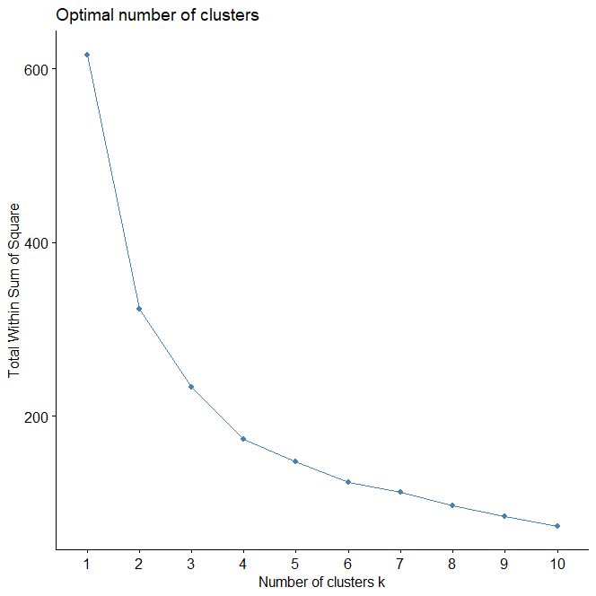
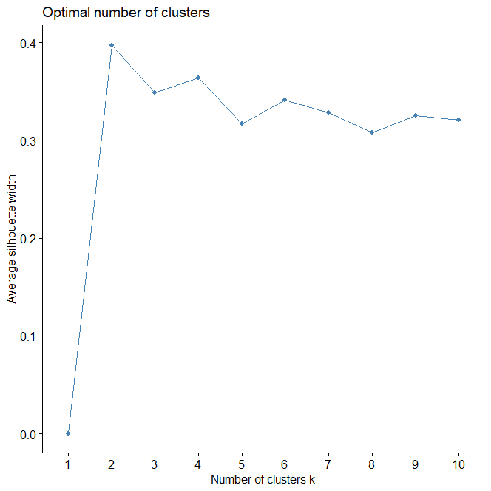
Supplementary Figure 2
Elbow plot
Supplementary Figure 1
Silhouette plot

References

1. Tabachnick BG. Using Multivariate Statistics. 6th ed. (Fidell LS, ed.). Pearson Education UK; 2013.
2. Jones K, Horak F, Winters K, Morea J, Bennett RM. Fibromyalgia is Associated with Impaired Balance and Falls. Journal Clinical Rheumatol. 2008;23(1):1-7. doi:10.1097/RHU.0b013e318190f991.Fibromyalgia

