Supplementary Material for
Detailed in silico evaluation of WNV proteins: dynamic and thermodynamic insights into doravirine as a potential multitarget agent

Antonio Curcio¹
Carlo Torti²
Eugenia Quiros-Roldan³
Stefano Alcaro¹
Anna Artese¹

¹Department of Health Sciences, University Magna Græcia, 88100 Catanzaro, Italy; ²Infectious Diseases Unit, Fondazione Policlinico Universitario A. Gemelli IRCCS, Catholic University of the Sacred Heart, Rome, Italy; ³Department of Clinical and Experimental Sciences, Unit of Infectious and Tropical Diseases University of Brescia and ASST Spedali Civili di Brescia, Brescia, Italy.

Correspondence: Anna Artese
Email: artese@unicz.it

Table S1. SiteScore, druggability score, and pocket size (in Å³) for C-terminal tunnel and N-terminal hydrophobic pocket of the core protein, as calculated by SiteMap.
Table S2. Best G-Score values, reported in kcal/mol, of remdesivir, rilpivirine, and doravirine for C-terminal tunnel and N-terminal hydrophobic pocket of the core protein.
Figure S1. Protein–ligand interactions between the three antivirals (remdesivir, rilpivirine, and doravirine) and C-terminal tunnel and N-terminal hydrophobic pocket of the core protein. Only interactions occurring for more than 30% of the 500 ns simulation time are displayed. Hydrogen bonds are depicted as purple dashed lines and arrows, π–π interactions as green lines, and cation–π interactions as red lines.
Figure S2. Alignment between the initial docking poses and the most representative ligand conformations obtained from MD clustering. For each complex, the five most populated clusters (covering more than 50% of the total conformational ensemble) are shown, highlighting the overall preservation of the ligand binding mode during the simulations.

Table S3. Best G-Score values, reported in kcal/mol, of remdesivir, rilpivirine, and doravirine for proteolytic site of NS3.
Table S4. SiteScore, druggability score, and pocket size (in Å³) for Motif A/C of RdRp NS5, as calculated by SiteMap.
Table S5. Best G-Score values, reported in kcal/mol, of remdesivir, rilpivirine, and doravirine for Motif A/C of RdRp NS5.
Figure S3. Protein–ligand interactions between the three antivirals (remdesivir, rilpivirine, and doravirine) and Motif A/C of RdRp NS5. Only interactions occurring for more than 30% of the 500 ns simulation time are displayed. Hydrogen bonds are depicted as purple dashed lines and arrows, π–π interactions as green lines, and cation–π interactions as red lines.
Table S6. SiteScore, druggability score, and pocket size (in Å³) for KDKE Motif of MTase NS5, as calculated by SiteMap.
Table S7. Best G-Score values, reported in kcal/mol, of remdesivir, rilpivirine, and doravirine for SAH site and KDKE Motif of MTase NS5.
Figure S4. Protein–ligand interactions between the three antivirals (remdesivir, rilpivirine, and doravirine) and SAH site and KDKE Motif of MTase NS5. Only interactions occurring for more than 30% of the 500 ns simulation time are displayed. Hydrogen bonds are depicted as purple dashed lines and arrows, π–π interactions as green lines, and cation–π interactions as red lines.
Table S1. SiteScore, druggability score, and pocket size (in Å³) for C-terminal tunnel and N-terminal hydrophobic pocket of the core protein, as calculated by SiteMap.
 | Core protein
 | C-terminal tunnel | N-terminal pocket
SiteScore | 0.843 | 1,277
DScore | 0.826 | 1.403
Size | 39 Å³ | 120 Å³

Table S2. Best G-Score values, reported in kcal/mol, of remdesivir, rilpivirine, and doravirine for C-terminal tunnel and N-terminal hydrophobic pocket of the core protein.
 | XP G-Score (kcal/mol)
 | C-terminal tunnel | N-terminal pocket
Remdesivir (RDV) | -3.45 | -3.40
Rilpivirine (RPV) | -5.67 | -2.87
Doravirine (DOR) | -5.42 | -3.63

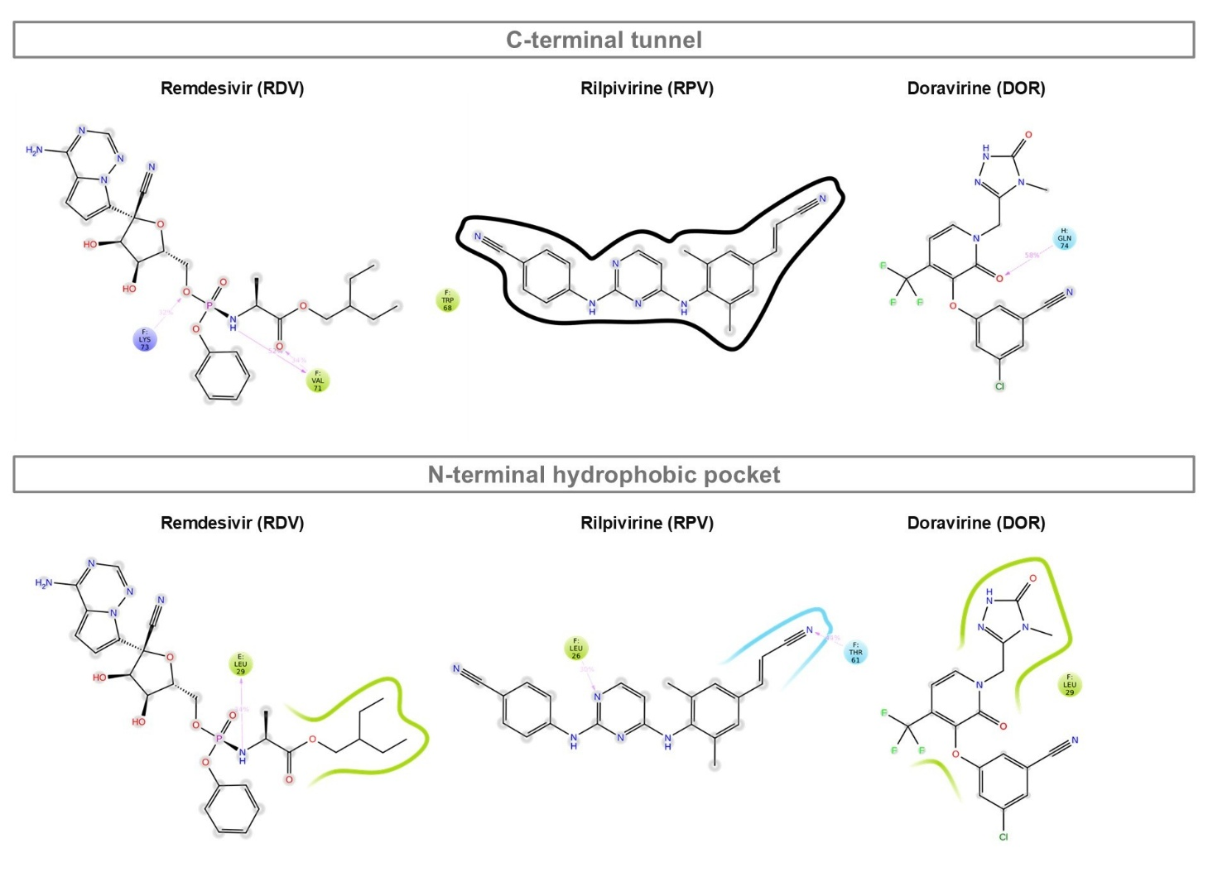
Figure S1. Protein–ligand interactions between the three antivirals (remdesivir, rilpivirine, and doravirine) and C-terminal tunnel and N-terminal hydrophobic pocket of the core protein. Only interactions occurring for more than 30% of the 500 ns simulation time are displayed. Hydrogen bonds are depicted as purple dashed lines and arrows, π–π interactions as green lines, and cation–π interactions as red lines.
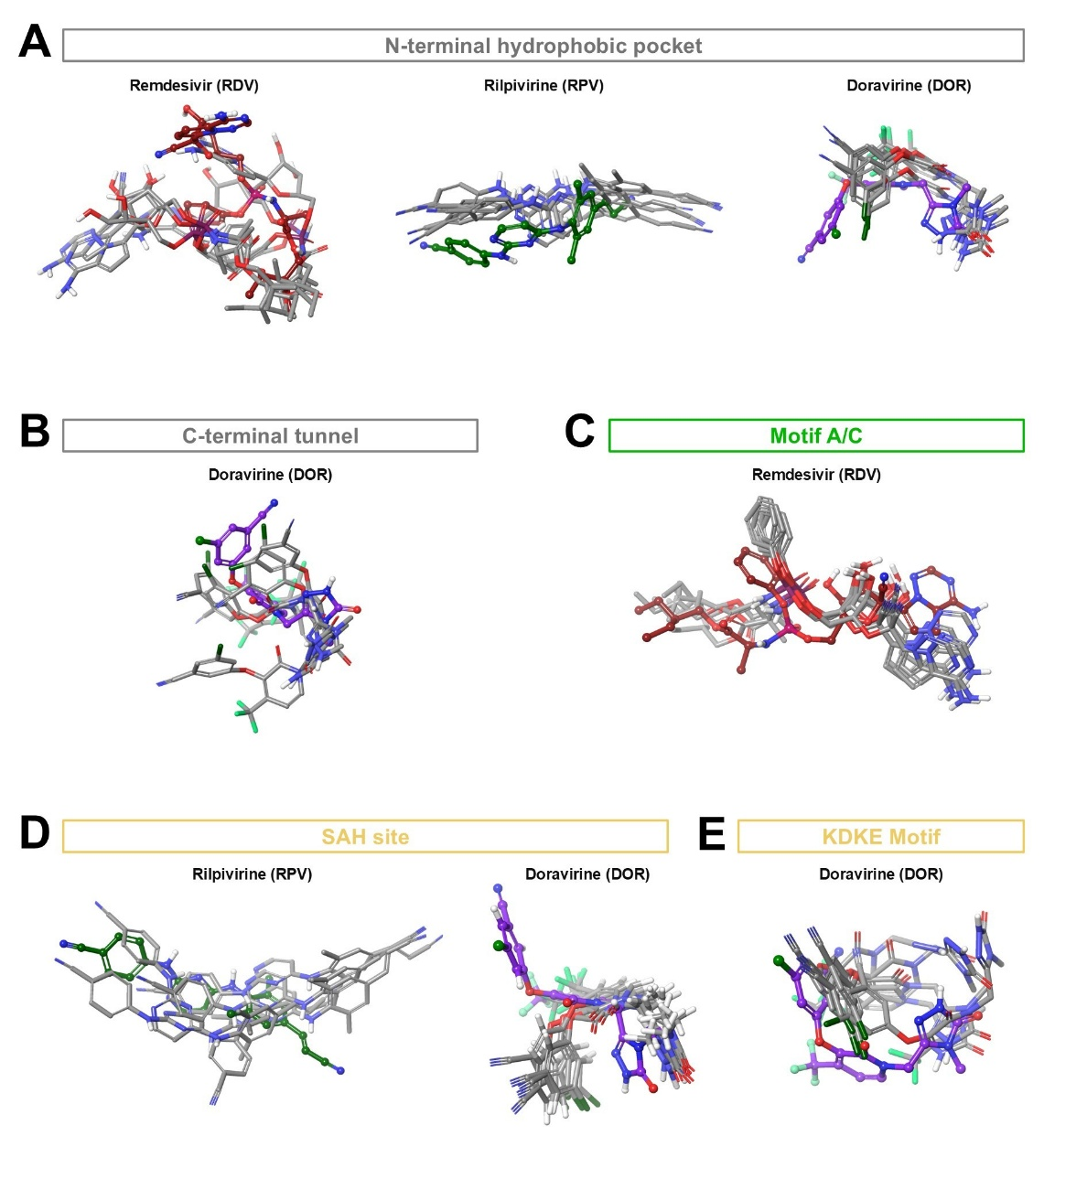
Figure S2. Alignment between the initial docking poses and the most representative ligand conformations obtained from MD clustering. For each complex, the five most populated clusters (covering more than 50% of the total conformational ensemble) are shown, highlighting the overall preservation of the ligand binding mode during the simulations.

Table S3. Best G-Score values, reported in kcal/mol, of remdesivir, rilpivirine, and doravirine for proteolytic site of NS3.
 | XP G-Score (kcal/mol)
 | Proteolytic site
Remdesivir (RDV) | -7.37
Rilpivirine (RPV) | -5.54
Doravirine (DOR) | -4.26

Table S4. SiteScore, druggability score, and pocket size (in Å³) for Motif A/C of RdRp NS5, as calculated by SiteMap.
 | RdRp NS5
 | Motif A/C
SiteScore | 0.999
DScore | 0.993
Size | 193 Å³

Table S5. Best G-Score values, reported in kcal/mol, of remdesivir, rilpivirine, and doravirine for Motif A/C of RdRp NS5.
 | XP G-Score (kcal/mol)
 | Motif A/C
Remdesivir (RDV) | -9.59
Rilpivirine (RPV) | -6.19
Doravirine (DOR) | -5.56

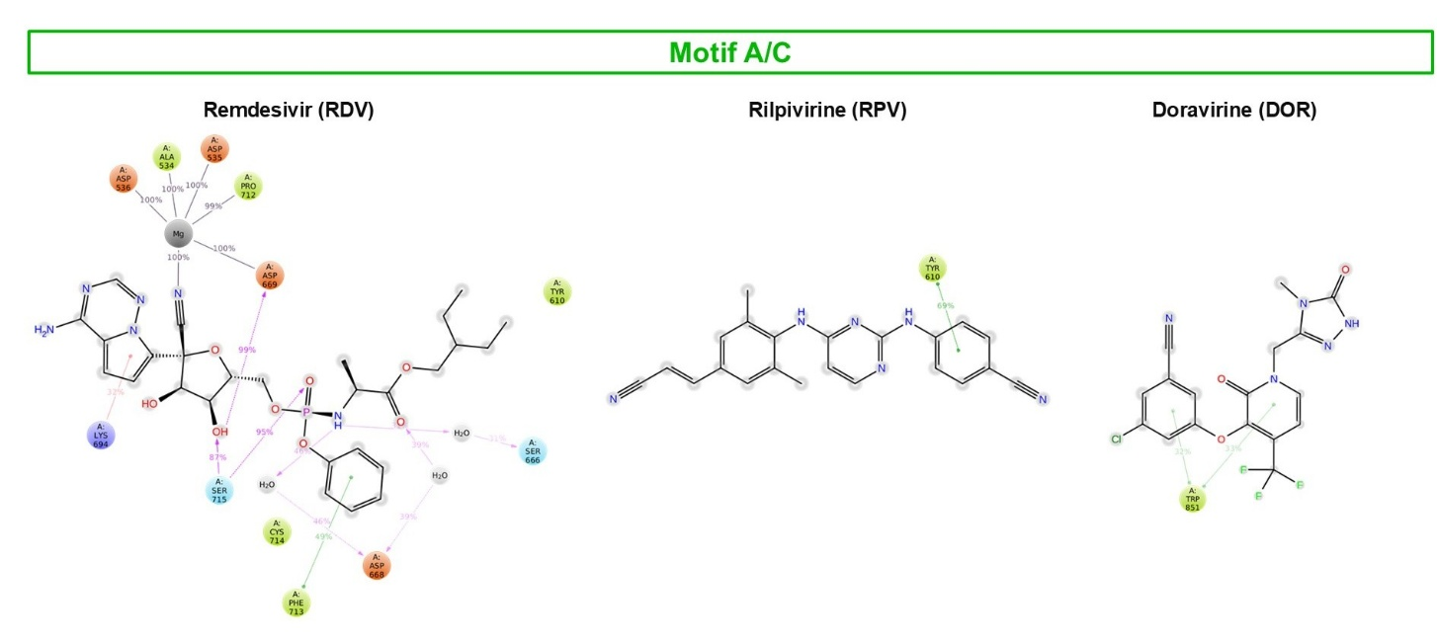
Figure S3. Protein–ligand interactions between the three antivirals (remdesivir, rilpivirine, and doravirine) and Motif A/C of RdRp NS5. Only interactions occurring for more than 30% of the 500 ns simulation time are displayed. Hydrogen bonds are depicted as purple dashed lines and arrows, π–π interactions as green lines, and cation–π interactions as red lines.
Table S6. SiteScore, druggability score, and pocket size (in Å³) for KDKE Motif of MTase NS5, as calculated by SiteMap.
 | MTase NS5
 | KDKE Motif
SiteScore | 1.017
DScore | 0.963
Size | 119 Å³

Table S7. Best G-Score values, reported in kcal/mol, of remdesivir, rilpivirine, and doravirine for SAH site and KDKE Motif of MTase NS5.
 | XP G-Score (kcal/mol)
 | SAH site | KDKE Motif
Remdesivir (RDV) | 2.27 | -4.88
Rilpivirine (RPV) | -3.80 | -1.03
Doravirine (DOR) | -1.56 | -3.04

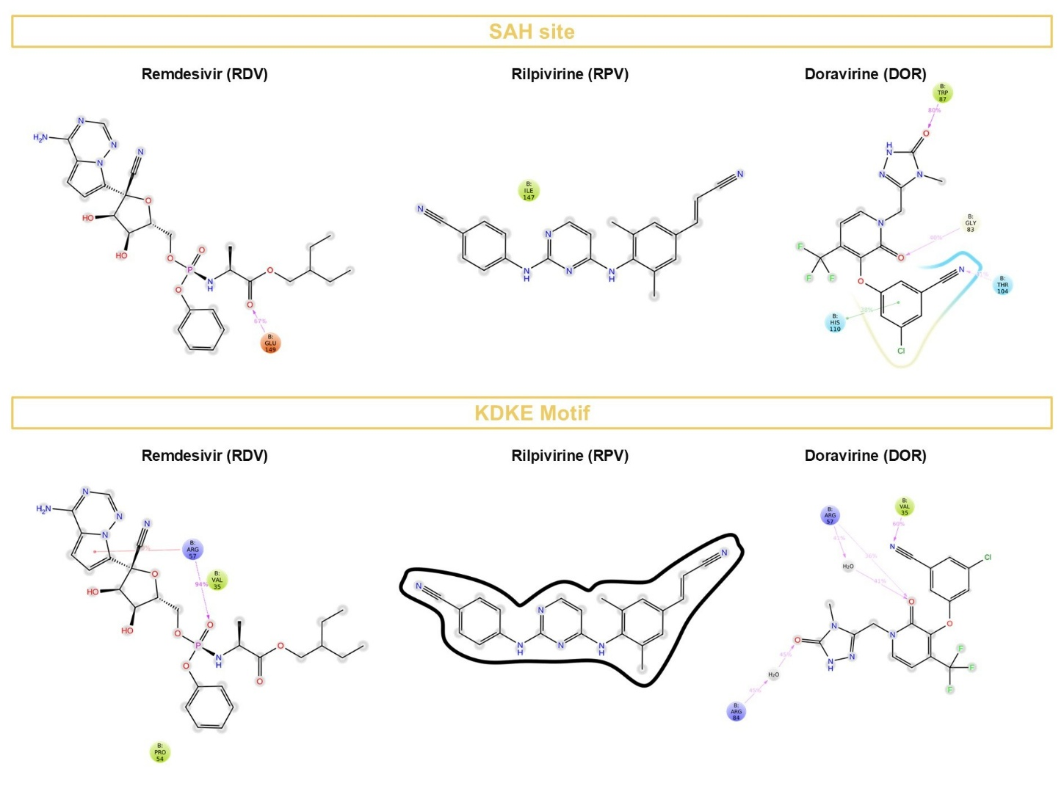
Figure S4. Protein–ligand interactions between the three antivirals (remdesivir, rilpivirine, and doravirine) and SAH site and KDKE Motif of MTase NS5. Only interactions occurring for more than 30% of the 500 ns simulation time are displayed. Hydrogen bonds are depicted as purple dashed lines and arrows, π–π interactions as green lines, and cation–π interactions as red lines.

