Peking University Shenzhen Hospital ECG training questionnaire
In order to do a good job in hospital teaching and training, please help to conduct this questionnaire survey, improve the relevant training work and improve the training effect. The questionnaire is confidential and does not involve personal privacy, and the data may be used in teaching and research.
一.Basic situation
1. Basic information：
Job Number： |  | ________________________
Major： | ________________________
Gender： | ________________________
Age： | ________________________

2.What is the effect of systematic learning of electrocardiogram in school?
[Enter numbers from 1(not good) to 5(very familiar)]
________________________________

3. Whether the ECG was studied again during the clinical internship or internship?
○A. yes
○B. no

4. What approaches have you tried to learn ECG?
□A. Textbooks and related books
□B. Teaching during internships/rotations
□C. Network resource self-study
□D. Attend ECG training classes
□F. other
What other ways to learn ECG? （Non-required field） [Gap filling]
_________________________________

5. When learning the basic knowledge of electrocardiogram, you think the difficulty of learning is?
□A. arrhythmia
□B. Myocardial infarction
□C. Myocardial hypertrophy
□D. Composition and nomenclature of electrocardiogram

What are the main difficulties you have encountered in learning ECG? [Gap filling]
_________________________________

二. Based on the scenario provided, fill in the diagnosis you think is possible below the picture and select your level of confidence in this diagnosis.

1. A 53-year-old male patient was brought to the emergency room complaining of chest pain after treadmill exercise 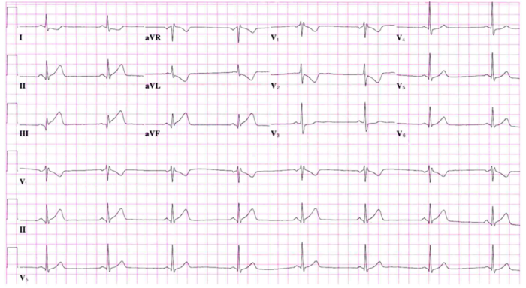
answer：_________________________________
How confident you are with the diagnosis in question 1
[Enter a number from 1(completely guessing) to 5(absolutely confident)]:________________________________

2. 50-year-old female patient with recurrent palpitations. 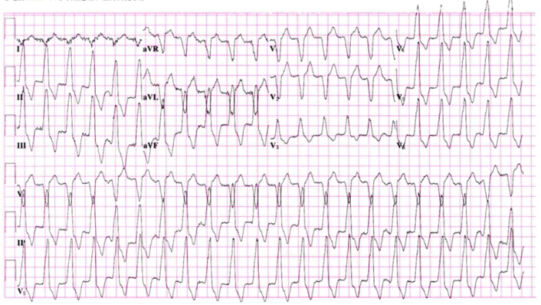
answer：_________________________________
How confident you are with the diagnosis in question 2
[Enter a number from 1(completely guessing) to 5(absolutely confident)]:________________________________

3. A 28-year-old female patient presented to the emergency department with upper respiratory disease and complained of heart palpitations in the waiting room. 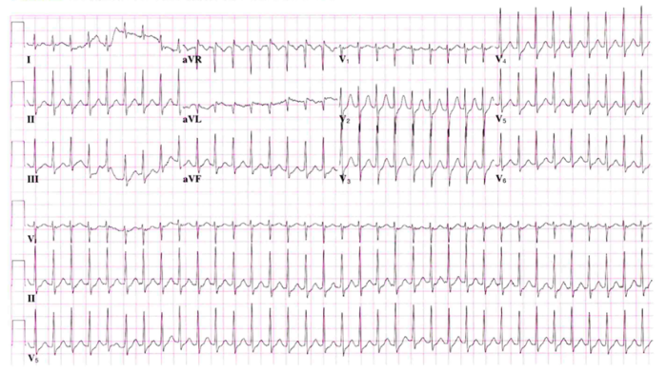 answer：_________________________________
How confident you are with the diagnosis in question 3
[Enter a number from 1(completely guessing) to 5(absolutely confident)]:________________________________

4. An asymptomatic 27-year-old male. 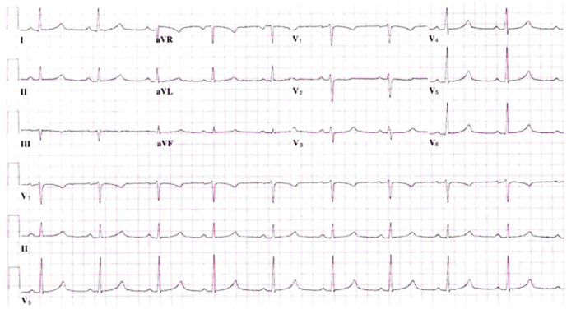 answer：_________________________________
How confident you are with the diagnosis in question 4
[Enter a number from 1(completely guessing) to 5(absolutely confident)]:________________________________
5. An asymptomatic male patient. 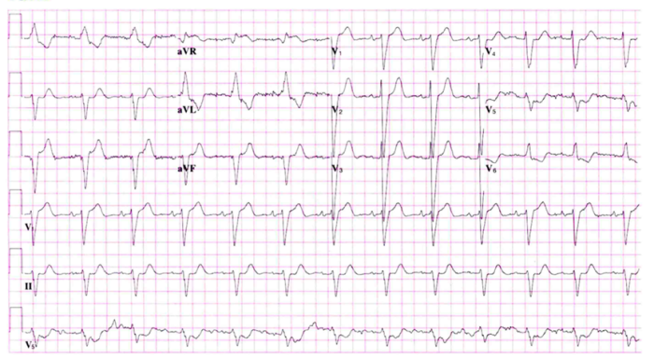 answer：_________________________________
How confident you are with the diagnosis in question 5
[Enter a number from 1(completely guessing) to 5(absolutely confident)]:________________________________

6. 67-year-old female with palpitations. 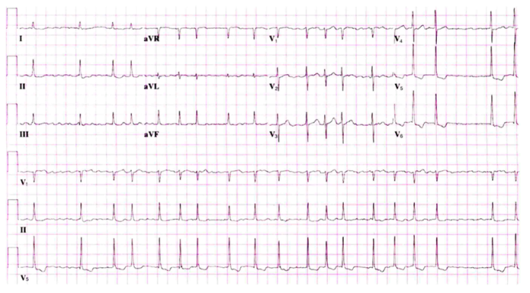 answer：_________________________________
How confident you are with the diagnosis in question 6
[Enter a number from 1(completely guessing) to 5(absolutely confident)]:________________________________

7. 56-year-old male, previously hospitalized for an unspecified arrhythmia. 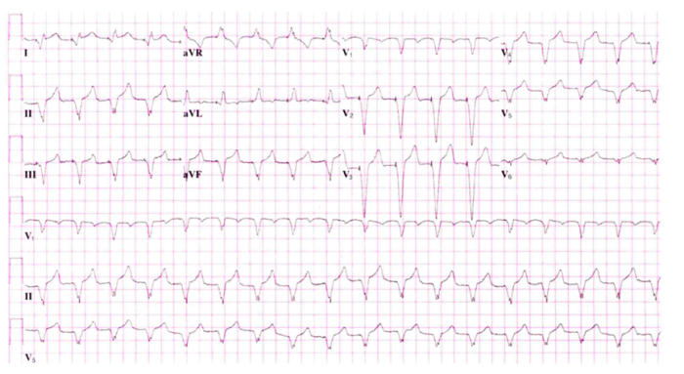 answer：_________________________________
How confident you are with the diagnosis in question 7
[Enter a number from 1(completely guessing) to 5(absolutely confident)]:________________________________

8. 43-year-old male with back pain
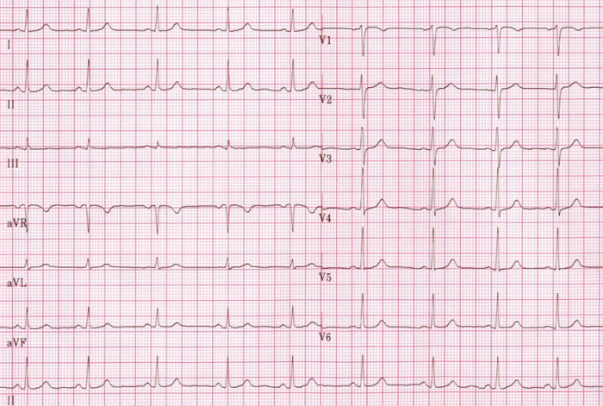 answer：_________________________________
How confident you are with the diagnosis in question 8
[Enter a number from 1(completely guessing) to 5(absolutely confident)]:________________________________

How difficult or easy do you think this assessment is
[Enter numbers from 1(very easy) to 10(very difficult)]*
________________________________

