Supplementary Figures
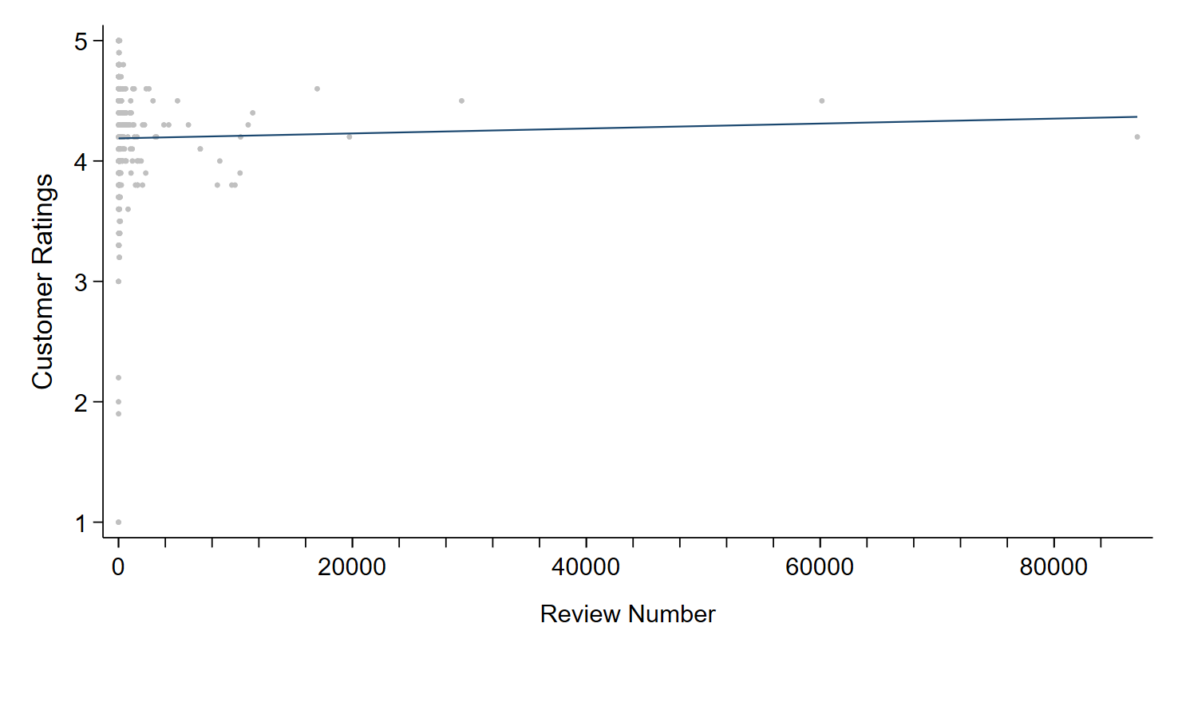
Supplementary Figure 1: Relationship between number of reviews and customer ratings with fitted regression line.

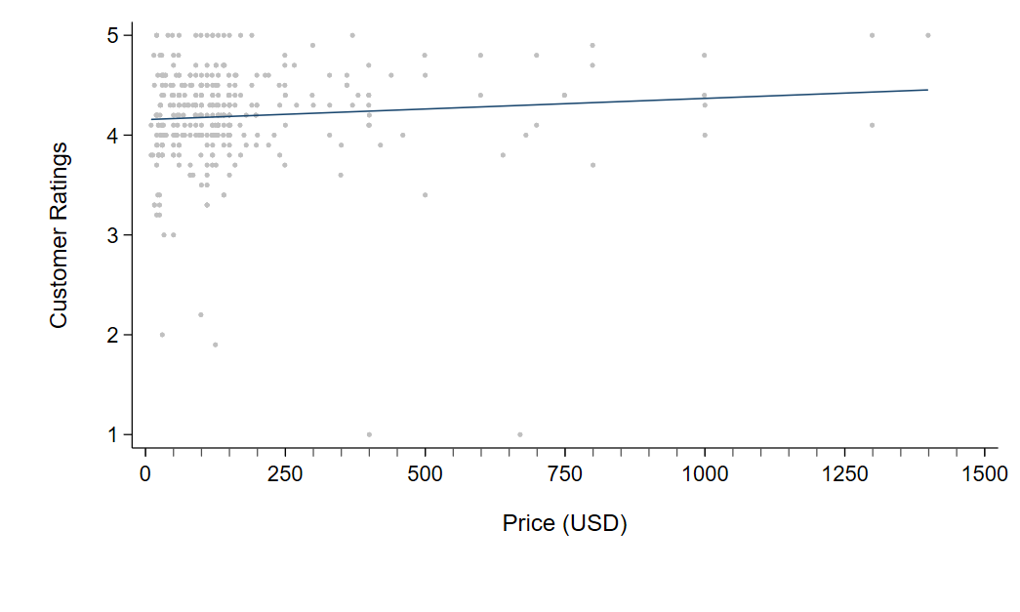
Supplementary Figure 2: Relationship between price and customer ratings with fitted regression line.

Supplementary Tables:
Supplementary Table 1: ChatGPT prompt for refining and interpreting extracted product data.
Prompt | Example Output
You are an advanced NLP model specializing in data refinement and extraction. Your task is to process raw product data from e-commerce websites and standardize it into a structured format while filtering out irrelevant content. Extract the Product Name exactly as listed, excluding promotional text. Categorize the Product Type consistently. Extract the Price as a numerical value, excluding currency symbols, and use the final price after any discounts. Extract the Number of Reviews as an integer, removing any non-numeric characters. Ensure the Customer Rating is accurate on a 1–5 scale with decimal precision. Remove advertisements, sponsored listings, duplicate entries, and unrelated text. If any attribute is missing or ambiguous, indicate this clearly instead of leaving it blank. Maintain a uniform structure and formatting to ensure accuracy and reliability for downstream analysis. For example, given a product listing, the output should be:  Product Name: XYZ Massage Gun, Product Type: Massage Gun, Price: 129.99, Number of Reviews: 15,234, Customer Rating: 4.5. | Product Name: LOVTRAVEL 360pcs LED 660nm Red Light and 850nm Near Infrared Light Therapy Devices Mat Large Wearable Pads Wrap for Body Pain-Relief  Product Type: Red Light Therapy Device  Price: 149.99  Number of Reviews: 713  Customer Rating: 4.2

Supplementary Table 2: Univariable and multivariable regression analysis of predictors for customer ratings of pain-relief products using a Gaussian family regression model.

Variables | Univariable  coefficient [95% CI] | P- value | Multivariable  coefficient [95% CI] | P- value
Device type | 0.107 [-0.012 to 0.033] | 0.345 | 0.009 [-0.013 to 0.031] | 0.413
Price | 0.0002 [-0.000048 to 0.00047] | 0.109 | 0.0002 [-0.0001 to 0.0006] | 0.246
Review numbers | 0.0000021 [-0.0000065 to 0.000011] | 0.638 | 0.0000033 [-0.0000008 to 0.0000073] | 0.116

