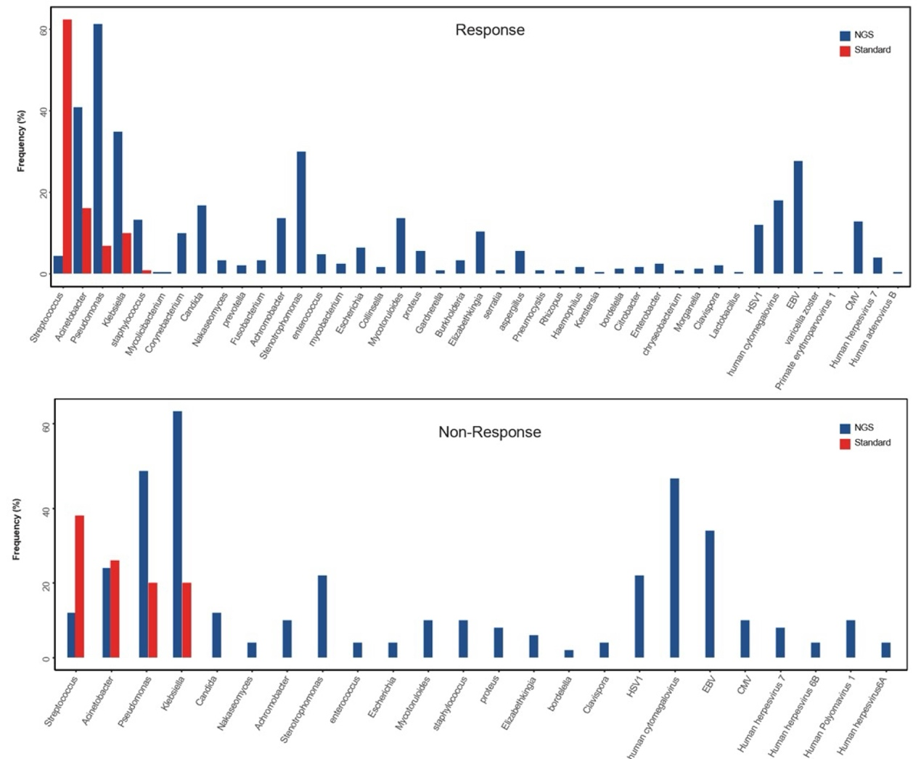
Figure S1: Distribution of Pathogens Detected by mNGS and Standard Methods. mNGS achieved an overall pathogen detection rate of 92%, significantly outperforming traditional culture methods, which detected pathogens in 72% of the cases. The Venn diagram in this figure highlights the overlap between the two methods, showing that mNGS detected 20% more pathogens that were missed by culture, particularly in non-responder patients. Non-responders, who failed to improve with standard antibiotic therapy, had a higher incidence of difficult-to-culture pathogens like Aspergillus and Pseudomonas, which were often only identified by mNGS.

