Appendix 1. Comparison of resilience, hope, social relations, and marital relations across different levels of depressive symptoms (N = 315).
Variables | Depressive symptoms |  |  | F | Pairwise comparison
Variables | ① None (n=151) | ② Mild (n=126) | ③ Moderate - to - severe (n=38) | F | Pairwise comparison
HHI | 39.71 ± 4.58 | 36.58 ± 3.92 | 33.89 ± 2.65 | 52.972*** | ①>②>③
Temporality and Future | 13.48 ± 1.60 | 12.33 ± 1.56 | 11.18 ± 1.23 | 49.531*** | ①>②>③
Positive Readiness and Expectancy | 12.85 ± 1.74 | 12.04 ± 1.31 | 11.42 ± 1.06 | 21.769*** | ①>②>③
Interconnectedness | 13.38 ± 1.70 | 12.21 ± 1.54 | 11.29 ± 0.98 | 49.816*** | ①>②>③
CD-RISC-10 | 31.83 ± 5.63 | 26.39 ± 6.03 | 22.50 ± 5.73 | 53.514*** | ①>②>③
Social Relations subscale | 82.67 ± 12.26 | 72.59 ± 12.36 | 61.51 ± 13.95 | 51.610*** | ①>②>③
Marriage Relations subscale | 75.06 ± 14.57 | 68.95 ± 13.95 | 62.39 ± 12.39 | 14.701*** | ①>②>③
Abbreviations: HHI, Herth Hope Index; CD-RISC-10, 10-item Connor-Davidson Resilence Scale.
***P < 0.001.

Appendix 2. Group differences in primary variables by demographic variables and disease-related variables (N = 315).

Varibales |  | PHQ-9 | HHI | Temporality and Future | Positive Readiness and Expectancy | Interconnectedness | CD-RISC-10 | Social Relations subscale | Marriage Relations subscale
Age ( years) | ＜35 (n=183) | 5.57 ± 3.84 | 37.34 ± 4.34 | 12.54 ± 1.63 | 12.26 ± 1.59 | 12.54 ± 1.63 | 27.38 ± 6.40 | 75.34 ± 14.09 | 70.77 ± 14.01
Age ( years) | ≥35 (n=132) | 4.38 ± 3.47 | 38.33 ± 4.90 | 13.02 ± 1.84 | 12.49 ± 1.59 | 12.83 ± 1.85 | 30.11 ± 6.82 | 77.11 ± 14.78 | 71.53 ± 15.60
Age ( years) | t | 2.824** | -1.865 | -2.370* | -1.300 | -1.415 | -3.638*** | -1.080 | -.447
Number of IVF-ET failed cycles | 1 (n=93) | 4.97 ± 3.80 | 39.20 ± 4.83 | 13.20 ± 1.81 | 12.83 ± 1.69 | 13.17 ± 1.88 | 29.38 ± 7.44 | 79.08 ± 14.59 | 74.10 ± 14.60
Number of IVF-ET failed cycles | 2 (n=107) | 5.32 ± 3.98 | 37.48 ± 4.53 | 12.65 ± 1.74 | 12.29 ± 1.62 | 12.53 ± 1.61 | 28.07 ± 6.41 | 75.78 ± 14.25 | 70.56 ± 15.05
Number of IVF-ET failed cycles | ≥3 (n=115) | 4.92 ± 3.45 | 36.84 ± 4.21 | 12.44 ± 1.59 | 12.03 ± 1.39 | 12.37 ± 1.63 | 28.27 ± 6.32 | 73.95 ± 14.06 | 69.13 ± 14.12
Number of IVF-ET failed cycles | F | 0.360 | 6.978** | 5.307** | 6.637** | 5.553** | 1.086 | 3.351* | 3.095*
Residence | Rural (n=151) | 5.58 ± 3.74 | 37.05 ± 4.30 | 12.47 ± 1.57 | 12.16 ± 1.49 | 12.42 ± 1.69 | 27.75 ± 6.81 | 75.08 ± 13.87 | 68.90 ± 14.37
Residence | Urban (n=164) | 4.60 ± 3.67 | 38.40 ± 4.78 | 12.99 ± 1.83 | 12.54 ± 1.66 | 12.88 ± 1.74 | 29.24 ± 6.54 | 77.01 ± 14.83 | 73.09 ± 14.72
Residence | t | 2.328* | -2.638** | -2.694** | -2.129* | -2.346* | -1.988* | -1.187 | -2.554*
Education ( years) | ≤9 (n=33) | 5.88 ± 4.44 | 36.67 ± 4.98 | 12.27 ± 1.88 | 12.15 ± 1.77 | 12.24 ± 1.79 | 26.42 ± 7.31 | 71.34 ± 14.04 | 65.78 ± 14.20
Education ( years) | 9~12 (n=58) | 5.52 ± 3.80 | 36.74 ± 3.73 | 12.34 ± 1.38 | 12.12 ± 1.38 | 12.28 ± 1.41 | 27.59 ± 6.55 | 74.93 ± 14.69 | 68.89 ± 12.32
Education ( years) | ＞12 (n=224) | 4.83 ± 3.59 | 38.18 ± 4.69 | 12.91 ± 1.77 | 12.45 ± 1.61 | 12.82 ± 1.78 | 29.08 ± 6.59 | 77.08 ± 14.26 | 72.43 ± 15.12
Education ( years) | F | 1.645 | 3.748* | 4.321* | 1.275 | 3.868* | 2.998 | 2.547 | 3.810*
Infertility duration ( years) | ＜3 (n=114) | 3.99 ± 3.52 | 38.63 ± 4.67 | 13.16 ± 1.67 | 12.55 ± 1.67 | 12.92 ± 1.76 | 30.02 ± 6.99 | 79.75 ± 13.28 | 74.20 ± 14.58
Infertility duration ( years) | ≥3 (n=201) | 5.68 ± 3.72 | 37.26 ± 4.49 | 12.50 ± 1.73 | 12.24 ± 1.53 | 12.51 ± 1.70 | 27.68 ± 6.40 | 74.00 ± 14.61 | 69.32 ± 14.48
Infertility duration ( years) | t | -3.954*** | 2.569* | 3.279** | 1.623 | 2.026* | 3.011** | 3.465** | 2.865**
Employment Status | Employed (n=226) | 4.88 ± 3.58 | 38.18 ± 4.69 | 12.90 ± 1.76 | 12.46 ± 1.60 | 12.82 ± 1.76 | 28.77 ± 6.60 | 77.06 ± 14.38 | 72.09 ± 15.29
Employment Status | Unemployed (n=89) | 5.54 ± 4.08 | 36.69 ± 4.20 | 12.34 ± 1.59 | 12.10 ± 1.55 | 12.25 ± 1.59 | 27.90 ± 6.94 | 73.60 ± 14.18 | 68.54 ± 12.72
Employment Status | t | -1.404 | 2.746* | 2.736* | 1.790 | 2.807* | 1.044 | 1.935 | 1.940
Resignation due to IVF-ET for reproductive planning | Yes (n=66) | 5.65 ± 4.19 | 37.12 ± 4.71 | 12.47 ± 1.77 | 12.18 ± 1.68 | 12.47 ± 1.70 | 27.97 ± 6.35 | 73.67 ± 13.83 | 69.13 ± 13.38
Resignation due to IVF-ET for reproductive planning | No (n=165) | 4.93 ± 3.65 | 37.92 ± 4.77 | 12.82 ± 1.78 | 12.44 ± 1.61 | 12.67 ± 1.79 | 28.52 ± 6.50 | 77.20 ± 14.90 | 71.01 ± 14.94
Resignation due to IVF-ET for reproductive planning | transitioned to a less stressful job (n=84) | 4.88 ± 3.49 | 37.93 ± 4.15 | 12.80 ± 1.60 | 12.3 ± 1.48 | 12.80 ± 1.63 | 28.99 ± 7.38 | 75.79 ± 13.70 | 72.77 ± 15.11
Resignation due to IVF-ET for reproductive planning | F | 1.021 | 0.794 | 1.020 | 0.615 | 0.666 | 0.426 | 1.440 | 1.141
*P < 0.05; **P < 0.01; ***P < 0.001.

Appendix 3. Moderated mediation analyses with healthcare payment methods as a moderator
Effect | Mediated Paths | Estimate | S.E. | Est./S.E | 95% Confidence Interval
Direct effect | Resilience → depressive symptoms | -0.147*** | 0.033 | -4.495 | ( -0.212, -0.083)
Indirect effects | Resilience → Hope → depressive symptoms | -0.070** | 0.023 | -2.976 | ( -0.118, -0.027)
 | Resilience → Social Relations → depressive symptoms | -0.071*** | 0.016 | -4.345 | ( -0.105, -0.041)
Total Indirect effect | / | -0.140*** | 0.027 | -5.121 | ( -0.196, -0.090)
Total effect | / | -0.287*** | 0.031 | -9.405 | ( -0.348, -0.228)
Moderator variable | Moderated Paths | Estimate | S.E. | Est./S.E | 95% Confidence Interval
Healthcare payment methods | Resilience → Hope | 0.033 | 0.034 | 0.966 | ( -0.033, 0.102)
 | Resilience → Social Relations | -0.348 | 0.237 | -1.467 | ( -0.816, 0.115)
Covariates included in Age and Infertility duration.
**P < 0.01; ***P < 0.001.
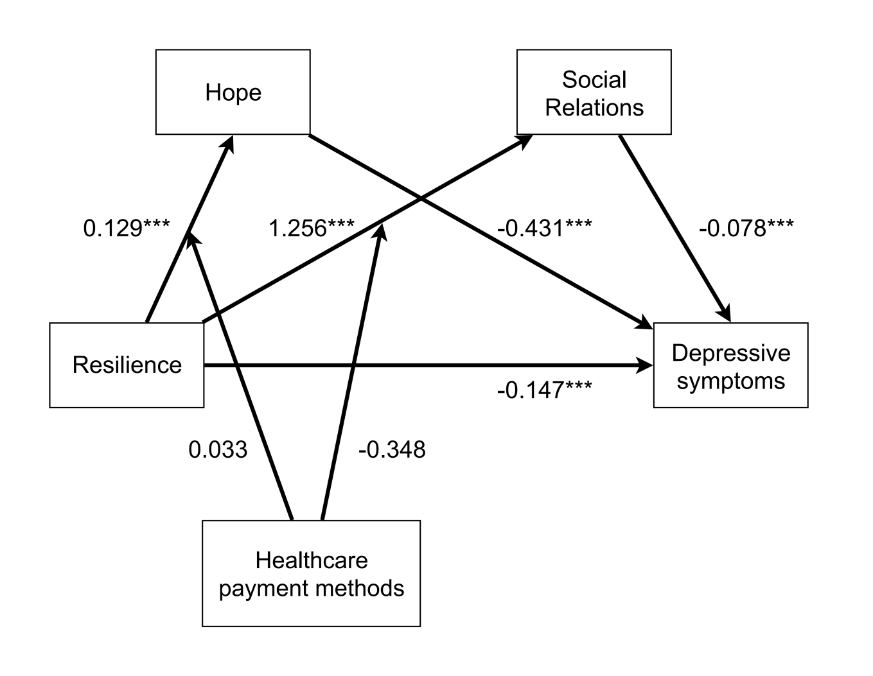
Appendix 4. Moderated Mediation Model with Household Income as a Moderator.
***p < 0.001.

