Supplementary Table 1 The regulated networks of key targets-top20 GO items
ONTOLOGY | ID | Description
BP | GO:0072593 | reactive oxygen species metabolic process
BP | GO:0009636 | response to toxic substance
BP | GO:0042493 | response to drug
BP | GO:0062197 | cellular response to chemical stress
BP | GO:0070482 | response to oxygen levels
BP | GO:0048545 | response to steroid hormone
BP | GO:0001676 | long-chain fatty acid metabolic process
BP | GO:0044706 | multi-multicellular organism process
BP | GO:0071466 | cellular response to xenobiotic stimulus
BP | GO:0006979 | response to oxidative stress
BP | GO:0000302 | response to reactive oxygen species
BP | GO:0009410 | response to xenobiotic stimulus
BP | GO:0006805 | xenobiotic metabolic process
BP | GO:0033559 | unsaturated fatty acid metabolic process
BP | GO:0120254 | olefinic compound metabolic process
BP | GO:0034599 | cellular response to oxidative stress
BP | GO:0055093 | response to hyperoxia
BP | GO:0033002 | muscle cell proliferation
BP | GO:0048146 | positive regulation of fibroblast proliferation
BP | GO:0007565 | female pregnancy
CC | GO:0000307 | cyclin-dependent protein kinase holoenzyme complex
CC | GO:0099056 | integral component of presynaptic membrane
CC | GO:0098889 | intrinsic component of presynaptic membrane
CC | GO:1902554 | serine/threonine protein kinase complex
CC | GO:1902911 | protein kinase complex
CC | GO:0005741 | mitochondrial outer membrane
CC | GO:0098981 | cholinergic synapse
CC | GO:0099055 | integral component of postsynaptic membrane
CC | GO:0005583 | fibrillar collagen trimer
CC | GO:0098643 | banded collagen fibril
CC | GO:0098936 | intrinsic component of postsynaptic membrane
CC | GO:0031968 | organelle outer membrane
CC | GO:0019867 | outer membrane
CC | GO:0043679 | axon terminus
CC | GO:0044306 | neuron projection terminus
CC | GO:0016529 | sarcoplasmic reticulum
CC | GO:0016327 | apicolateral plasma membrane
CC | GO:0099699 | integral component of synaptic membrane
CC | GO:0042734 | presynaptic membrane
CC | GO:0090575 | RNA polymerase II transcription regulator complex
MF | GO:0005496 | steroid binding
MF | GO:0035173 | histone kinase activity
MF | GO:0008227 | G protein-coupled amine receptor activity
MF | GO:0004497 | monooxygenase activity
MF | GO:0016705 | oxidoreductase activity, acting on paired donors, with incorporation or reduction of molecular oxygen
MF | GO:0099528 | G protein-coupled neurotransmitter receptor activity
MF | GO:0016712 | oxidoreductase activity, acting on paired donors, with incorporation or reduction of molecular oxygen, reduced flavin or flavoprotein as one donor, and incorporation of one atom of oxygen
MF | GO:0008395 | steroid hydroxylase activity
MF | GO:0020037 | heme binding
MF | GO:0046906 | tetrapyrrole binding
MF | GO:0044389 | ubiquitin-like protein ligase binding
MF | GO:0016709 | oxidoreductase activity, acting on paired donors, with incorporation or reduction of molecular oxygen, NAD(P)H as one donor, and incorporation of one atom of oxygen
MF | GO:0004879 | nuclear receptor activity
MF | GO:0098531 | ligand-activated transcription factor activity
MF | GO:0019887 | protein kinase regulator activity
MF | GO:0015464 | acetylcholine receptor activity
MF | GO:0004364 | glutathione transferase activity
MF | GO:0070330 | aromatase activity
MF | GO:0003707 | steroid hormone receptor activity
MF | GO:0019207 | kinase regulator activity
Note:
Abbreviations: BP:Biological Process,CC:Cellular Component,MF: Molecular Function，GO：Gene Ontology

Supplementary Table 2 The regulated networks of key
targets-top20 KEGG pathways
ID | Description
hsa05207 | Chemical carcinogenesis - receptor activation
hsa05418 | Fluid shear stress and atherosclerosis
hsa05161 | Hepatitis B
hsa04933 | AGE-RAGE signaling pathway in diabetic complications
hsa04657 | IL-17 signaling pathway
hsa05215 | Prostate cancer
hsa01522 | Endocrine resistance
hsa00982 | Drug metabolism - cytochrome P450
hsa04115 | p53 signaling pathway
hsa05417 | Lipid and atherosclerosis
hsa00980 | Metabolism of xenobiotics by cytochrome P450
hsa04218 | Cellular senescence
hsa04620 | Toll-like receptor signaling pathway
hsa01524 | Platinum drug resistance
hsa04110 | Cell cycle
hsa04926 | Relaxin signaling pathway
hsa05208 | Chemical carcinogenesis - reactive oxygen species
hsa05219 | Bladder cancer
hsa05204 | Chemical carcinogenesis - DNA adducts
hsa04066 | HIF-1 signaling pathway
Note:
Abbreviations: KEGG:Kyoto Encyclopedia of Genes and Genomes

Supplementary Table 3 The docking binding energy between
genes and active substances
Hub | Active ingredients | Uniprot ID | Total score(Kcal/mol)
ESR1 | (+)-catechin | Q9SAD4 | -8.2
FOS | baicalein | P01100 | -7.7
HSP90AA1 | Gentisein | P07900 | -7.4
JUN | quercetin | P05412 | -5.6
MMP9 | quercetin | P14780 | -8
Note:
Abbreviations: ESR1, FOS, HSP90AA1, JUN, MMP9 were gene names, Uniprot ID: protein data bank identifier of Universal Protein Resource.

Supplementary Figure 1 Docking diagram of hub genes and active ingredients of formula
A. Docking diagram of ESR1 and (+)-catechin. B. Docking diagram of FOS and baicalein. C. Docking diagram of HSP90AA1 and gentisein. D. Docking diagram of JUN and quercetin. E. Docking diagram of MMP9 and quercetin.

Supplementary Figure 2 Effects of quercetin on the migratory capacity of gastric cancer cells
A. Migration status of MKN45 and SGC7901 cells after quercetin treatment. B. Number of migrated MKN45 and SGC7901 cells after quercetin treatment ( ***‌p < 0.001).

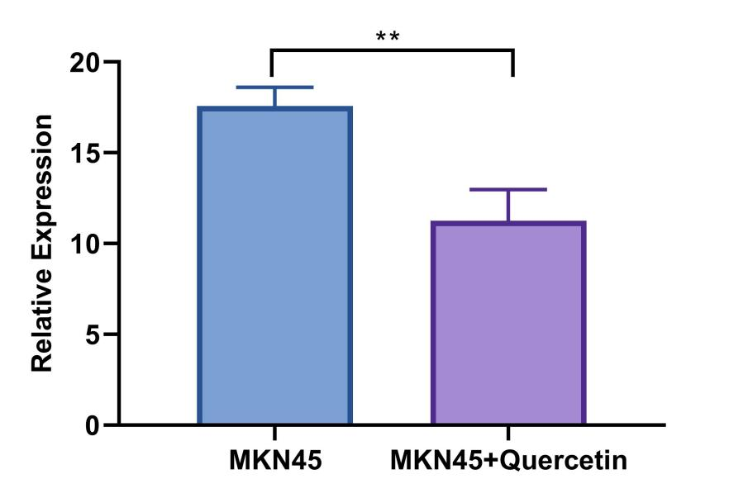
Supplementary Figure 3. Transcriptome sequencing results of FOSL1 gene expression in MKN45 cells following quercetin treatment( **‌p < 0.01).

