Supplementary Materials
Cost-Effectiveness Analysis and Priority Setting in the Transition from Iron-Folic Acid (IFA) to Multiple Micronutrient Supplementation (MMS) for Pregnant Women in Indonesia

Fitri Alfiani^{1,2}, Auliasari Meita Utami³, Neily Zakiyah^{3,4}, Nur Aizati Athirah Daud⁵, Auliya A Suwantika^{3,4,6}, Irma Melyani Puspitasari^{3,4}

¹Doctoral Program in Pharmacy, Faculty of Pharmacy, Universitas Padjadjaran, Bandung, Indonesia;
²Faculty of Health Science, Universitas Muhammadiyah Cirebon, Cirebon, Indonesia;
³Center of Excellence for Pharmaceutical Care Innovation (PHARCI), Universitas Padjadjaran, Bandung, Indonesia;
⁴Department of Pharmacology and Clinical Pharmacy, Faculty of Pharmacy, Universitas Padjadjaran, Bandung, Indonesia;
⁵Discipline of Clinical Pharmacy, School of Pharmaceutical Sciences, Universiti Sains Malaysia, 11800 USM, Penang, Malaysia;
⁶Center for Health Technology Assessment, Universitas Padjadjaran, Bandung, Indonesia

Figure S1. Maternal Health Outcomes

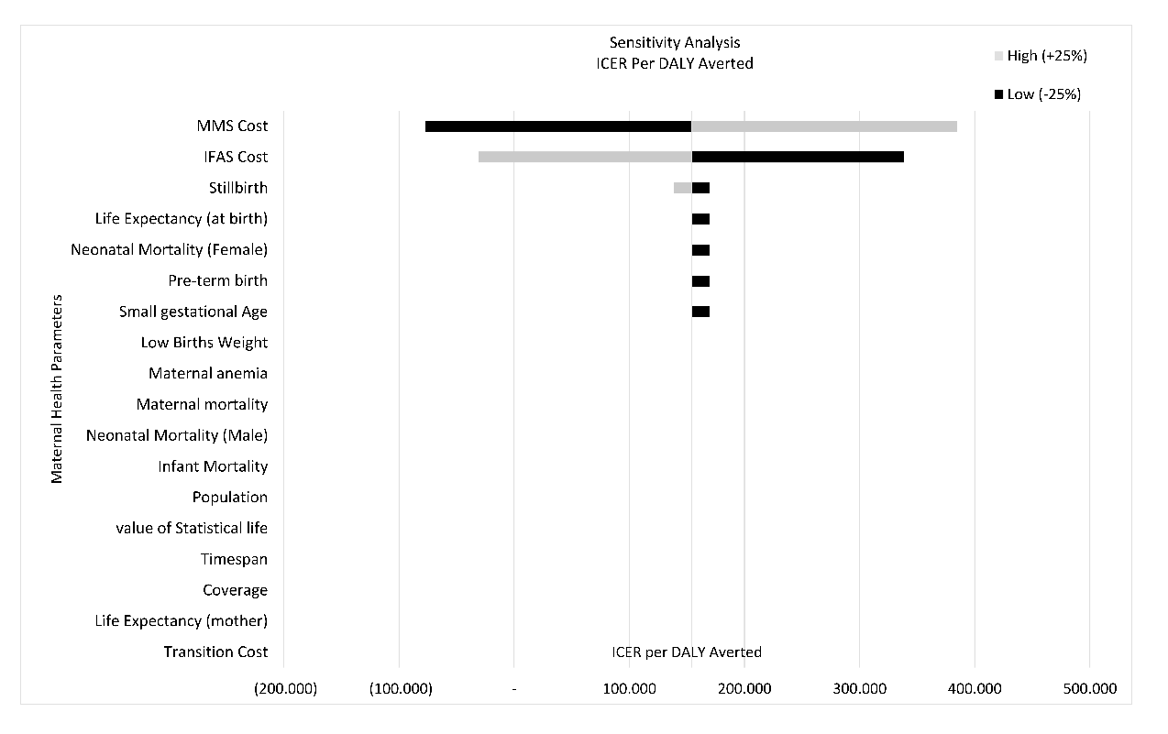
Figure S2. One-way deterministic sensitivity analysis

