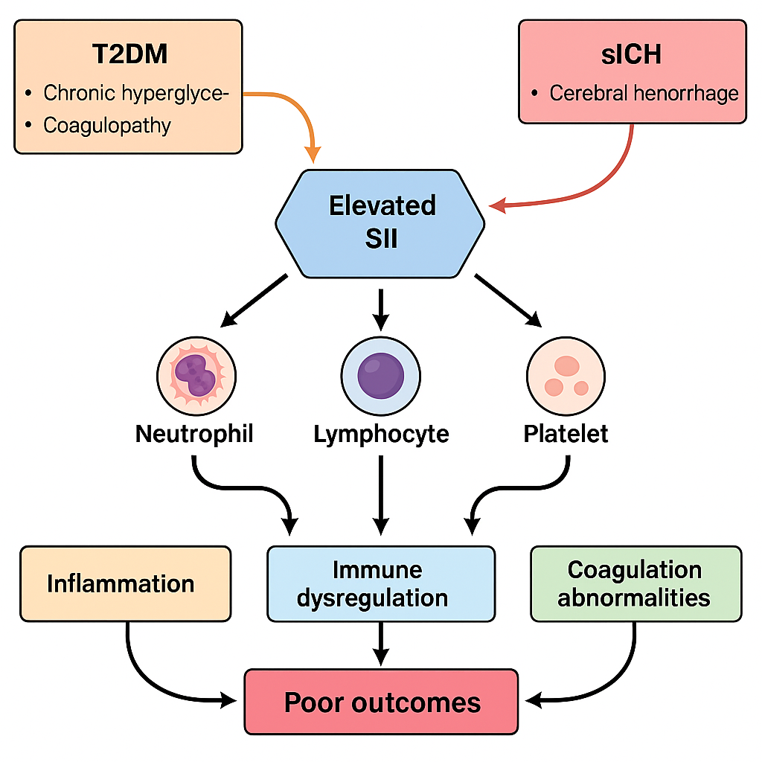
Figure S1. Proposed mechanistic pathway linking elevated SII to poor prognosis in patients with T2DM and sICH.
Caption: The SII, derived from platelet, neutrophil, and lymphocyte counts, reflects a combined state of inflammation, immune dysregulation, and coagulation abnormalities. In the context of T2DM and sICH, elevated SII indicates excessive neutrophil activation, lymphopenia, and platelet hyperactivity. These alterations contribute to blood-brain barrier disruption, microthrombosis, and secondary ischemic injury. Chronic hyperglycemia exacerbates this process via endothelial dysfunction and coagulopathy. The interplay among these mechanisms may lead to a vicious cycle of inflammation, immune suppression, and hemostatic imbalance, resulting in increased risk of mortality and poor outcomes.
SII, systemic immune-inflammation index; T2DM, type 2 diabetes mellitus; sICH, spontaneous intracerebral hemorrhage.

