Supplementary eTable 1. Standardized mean differences (SMDs) of baseline covariates before weighting between the propofol‑sufentanil (PS) and propofol‑fentanyl (PF) groups
Characteristics | PS group (n=49) | PF group (n=49) | SMD
Age (years), M(IQR) | 72 (69, 75) | 73 (70, 77) | -0.155
BMI (kg/m²), mean±SD | 23.4±2.6 | 24.0±3.6 | -0.215
Asa classification
Grade-I | 8 (16.3) | 11 (22.4) | -0.155
Grade-II | 35 (71.4) | 31 (63.3) | 0.175
Grade-III | 6 (12.3) | 7 (14.3) | -0.060
Hypertension (yes), n (%) | 24 (49.0) | 19 (38.8) | 0.207
Diabetes (yes), n (%) | 13 (26.5) | 10 (20.4) | 0.145
Coronary heart disease (yes), n (%) | 15 (30.6) | 10 (20.4) | 0.236
COPD (yes), n (%) | 7 (14.3) | 9 (18.4) | -0.111
Cerebrovascular disease (yes), n (%) | 6 (12.3) | 8 (16.3) | -0.117
Note: This table presents the standardized mean differences (SMDs) of covariates before weighting. An absolute SMD less than 0.1 is generally considered to indicate acceptable covariate balance. Before weighting, several covariates demonstrated imbalance (|SMD| > 0.1), justifying the use of propensity score-based methods for adjustment. PS, propofol-sufentanil; PF, propofol-fentanyl; BMI, body mass index; M(IQR), median and interquartile range; SD, standard deviation; COPD, chronic obstructive pulmonary disease.

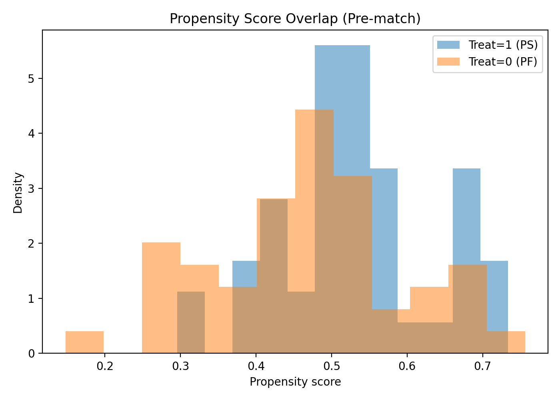
Supplementary eFigure 1. Distribution and overlap of estimated propensity scores between the propofol-sufentanil (PS) and propofol-fentanyl (PF) groups before weighting. The figure illustrates the distribution of estimated propensity scores (PS) in the propofol-sufentanil (PS, blue) and propofol-fentanyl (PF, orange) groups before applying any weighting or matching procedure. Sufficient overlap between the two groups is observed, which supports the assumption of positivity for causal inference using propensity score-based methods.

Supplementary eTable 2. Covariate Balance (Standardized Mean Differences) Before and After Weighting
Characteristics | PS group (n=49) | PF group (n=49) | Unweighted SMD | IPTW SMD | OVERLAP SMD
Age (years), M(IQR) | 72 (69, 75) | 73 (70, 77) | -0.155 | -0.007 | <0.001
BMI (kg/m²), mean±SD | 23.4±2.6 | 24.0±3.6 | -0.215 | -0.009 | <0.001
Asa classification
Grade-I | 8 (16.3) | 11 (22.4) | -0.155 | -0.021 | -0.015
Grade-II | 35 (71.4) | 31 (63.3) | 0.175 | 0.044 | 0.029
Grade-III | 6 (12.3) | 7 (14.3) | -0.060 | -0.037 | -0.023
Hypertension (yes), n (%) | 24 (49.0) | 19 (38.8) | 0.207 | 0.045 | 0.025
Diabetes (yes), n (%) | 13 (26.5) | 10 (20.4) | 0.145 | 0.036 | 0.016
Coronary heart disease (yes), n (%) | 15 (30.6) | 10 (20.4) | 0.236 | 0.065 | 0.040
COPD (yes), n (%) | 7 (14.3) | 9 (18.4) | -0.111 | -0.016 | -0.004
Cerebrovascular disease (yes), n (%) | 6 (12.3) | 8 (16.3) | -0.117 | -0.058 | -0.032
Note: This table summary of standardized mean differences (SMDs) for all baseline covariates across three conditions: unweighted, after IPTW, and after overlap weighting. Covariate balance substantially improved after both weighting methods, with overlap weighting yielding the smallest residual imbalance. PS, propofol-sufentanil; PF, propofol-fentanyl; BMI, body mass index; M(IQR), median and interquartile range; SD, standard deviation; COPD, chronic obstructive pulmonary disease.

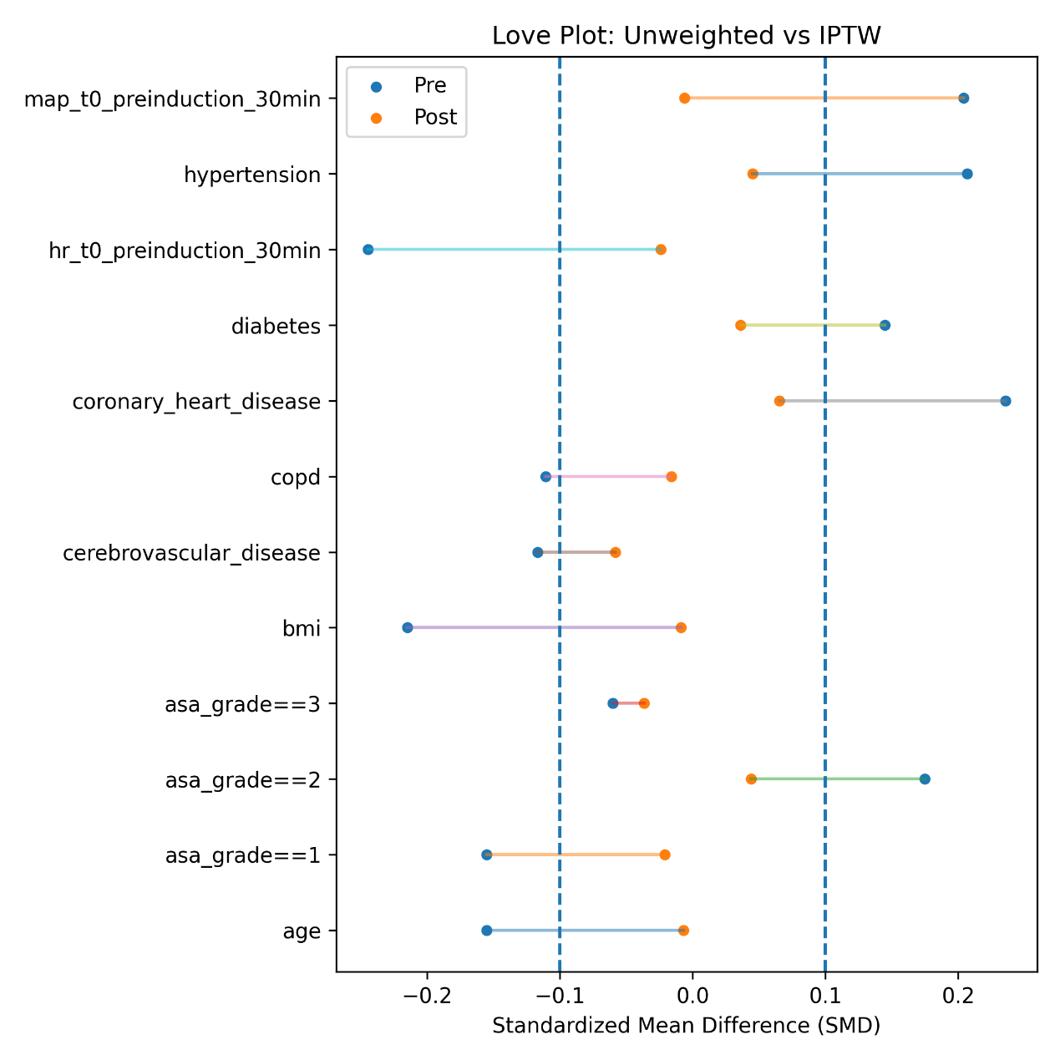
Supplementary eFigure 2. Love Plot of Covariate Balance Before and After IPTW Weighting. Love plot showing standardized mean differences (SMDs) for covariates before (blue) and after (orange) inverse probability of treatment weighting (IPTW). After IPTW, all covariates achieved substantial balance, with SMDs < 0.1. Dashed lines indicate commonly accepted threshold of ±0.1 for acceptable balance.

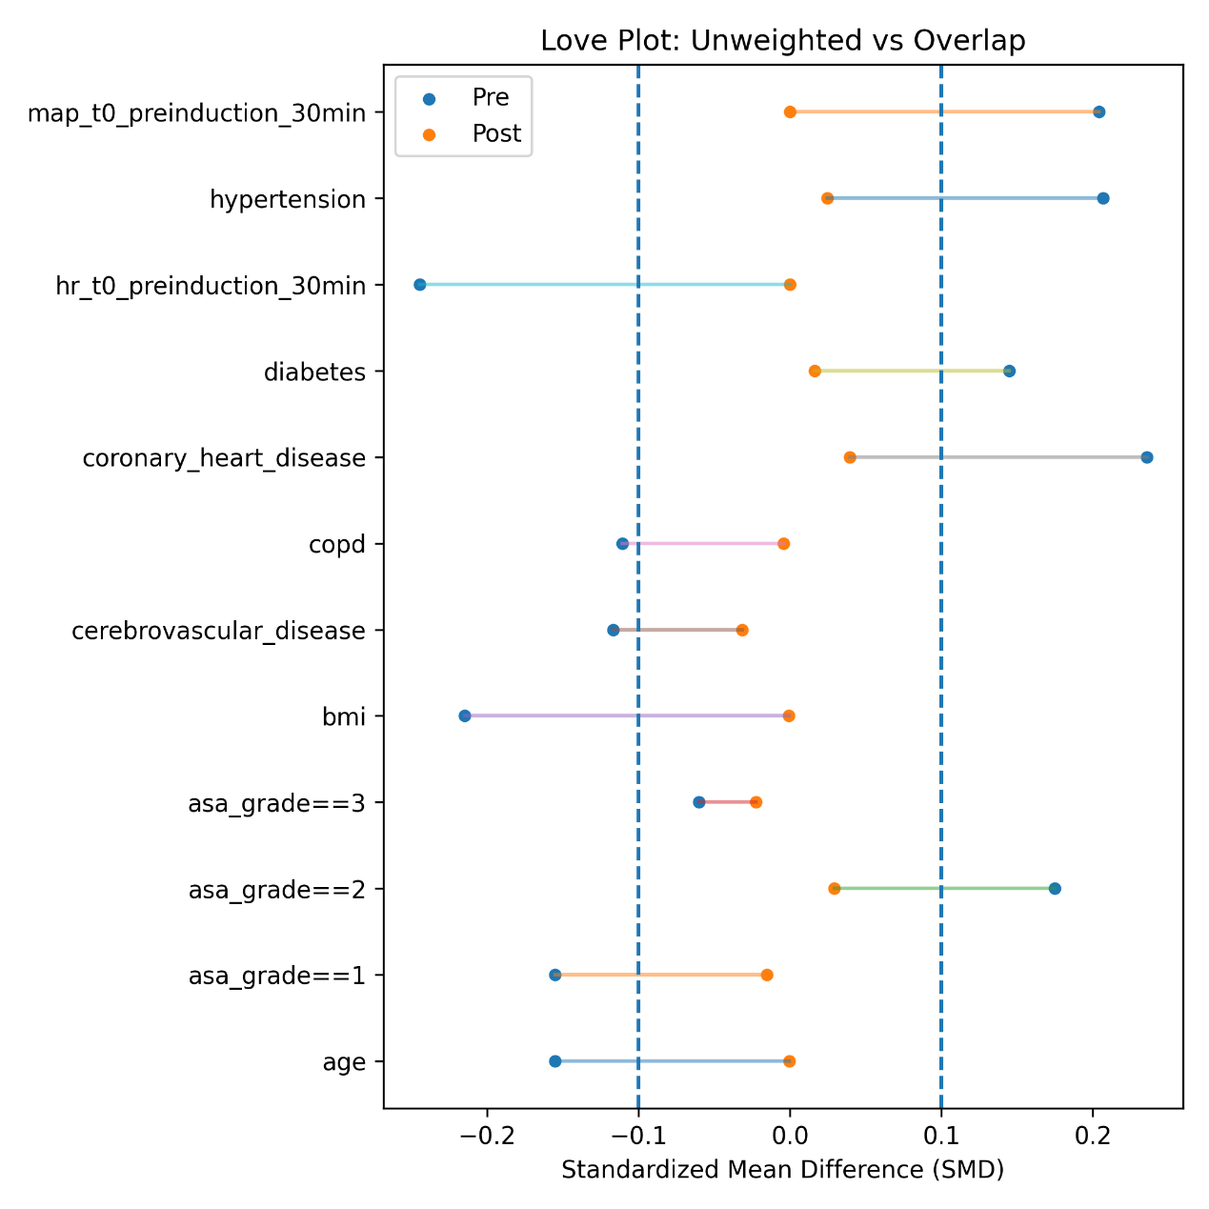
Supplementary eFigure 3. Love Plot of Covariate Balance Before and After Overlap Weighting. Love plot showing standardized mean differences (SMDs) before (blue) and after (orange) applying overlap weights. Compared to IPTW, overlap weighting achieved even better covariate balance, with all SMDs close to zero. Dashed lines at ±0.1 indicate standard thresholds.

Supplementary eTable 3. Comparison of anesthesia onset time, postoperative awakening time, and extubation time between two groups (adjusted using overlap weights)
Index | PS group (n=49) | PF group (n=49) | Diff(95%CI) | P
Onset time of anesthesia | 14 (11-16) | 16 (14-19) | -2.337 (-3.892, -0.782) | 0.003
postoperative awakening time | 12 (10-15) | 15 (12-16) | -2.616 (-4.174, -1.057) | 0.001
Extubation time after entering PACU | 15 (13-18) | 20 (17-23) | -4.742 (-6.653, -2.832) | <0.001
Note: Data are presented as median (interquartile range). Differences (Diff) with 95% confidence intervals (CI) were estimated using weighted least squares (WLS) models adjusted by overlap weights.
PS = propofol-sufentanil; PF = propofol-fentanyl; PACU = postanesthesia care unit.

​ Supplementary eTable 4. Comparison of postoperative cognitive dysfunction at different time points between two groups (adjusted using overlap weights)
Group | 6-hours after surgery | 24-hours after surgery | 72-hours after surgery
PS group (n=49) | 7 (14.3) | 3 (6.1) | 1 (2.0)
PF group (n=49) | 16 (32.7) | 10 (20.4) | 2 (4.1)
OR(95%CI) | 0.173 (0.033, 0.913) | 0.433 (0.059, 3.197 | 0.429 (0.013, 14.210)
P | 0.125 | 0.412 | 0.636
Note: Data are presented as frequency (percentage). Odds ratios (ORs) with 95% confidence intervals were estimated using generalized linear models (GLM) adjusted with overlap weights.
PS = propofol-sufentanil; PF = propofol-fentanyl.

Supplementary eTable 5. Comparison of complications within 72 hours after surgery between two groups (adjusted using overlap weights)
Index | PS group (n=49) | PF group (n=49) | OR(95%CI) | P
Bradycardia | 14 (28.6) | 10 (20.4) | 1.540 (0.288, 8.221) | 0.614
Hypotension | 10 (20.4) | 8 (16.3) | 1.453 (0.289, 7.313) | 0.650
PONV | 9 (18.4) | 6 (12.2) | 0.980 (0.136, 7.066) | 0.984
Urinary retention | 3 (6.1) | 7 (14.3) | 0.397 (0.046, 3.456) | 0.403
Respiratory depression | 4 (8.2) | 6 (12.2) | 37.989 (0.451, 3199.006) | 0.770
Note: Data are presented as frequency (percentage). Odds ratios (ORs) with 95% confidence intervals were estimated using generalized linear models (GLM) adjusted with overlap weights.
PS = propofol-sufentanil; PF = propofol-fentanyl; PONV = postoperative nausea and vomiting.

