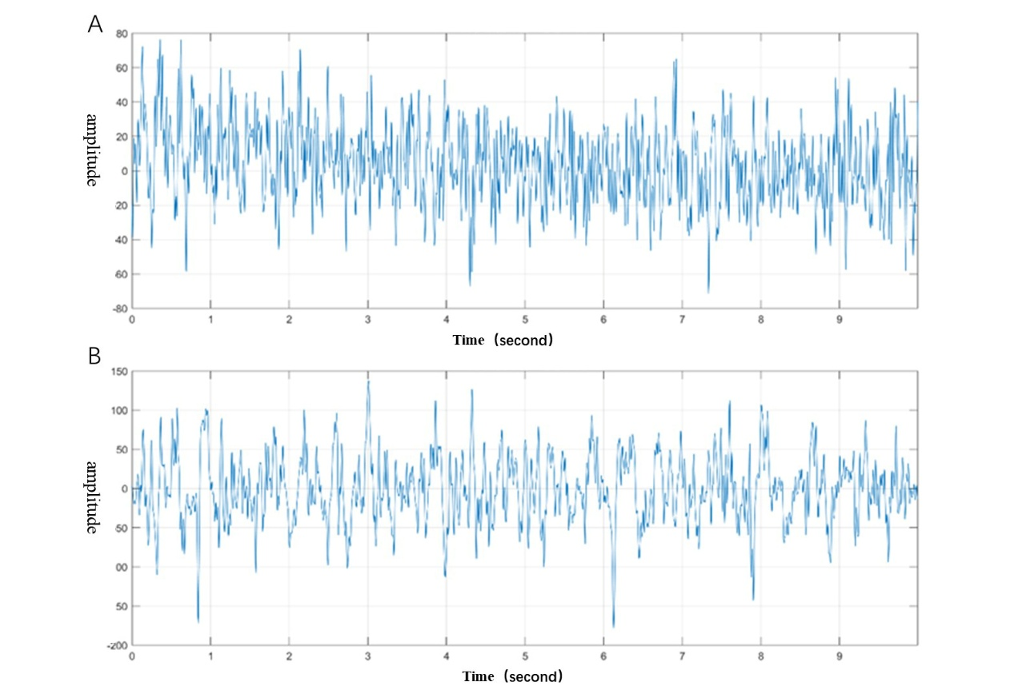
Supplementary Figure S1. Representative 10-second raw EEG traces with scale bars.
(A) Natural Sleep (NS): a 10-second frontal EEG segment during NREM sleep.
(B) Sleep Deprivation (SD): a 10-second frontal EEG segment during NREM sleep from a sleep-deprived mouse, showing the relative absence of spindle oscillations.

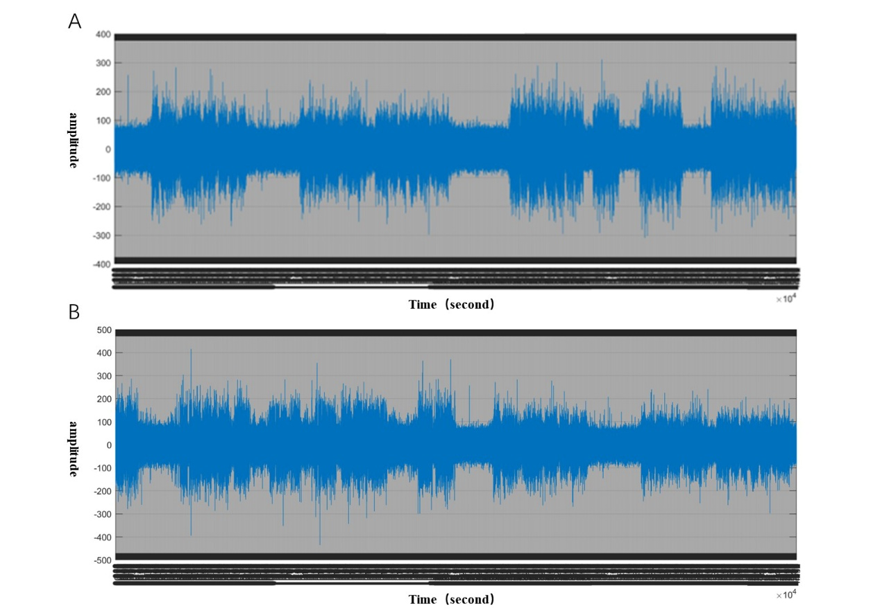
Supplementary Figure S2. Representative full-length EEG recordings for context.
(A) Natural Sleep (NS): a full-length frontal EEG trace during NREM sleep, showing periodic spindle events.
(B) Sleep Deprivation (SD): a full-length frontal EEG trace during NREM sleep from a sleep-deprived mouse, showing reduced or absent spindle oscillations across the recording.

