Supplementary Material

Supplementary Method S1. UK Biobank validation cohort
To validate the surrogate endpoint of a ≥ 30% eGFR decline over two years, we used data from the UK Biobank (UKB). The UKB is a large‐scale prospective cohort that enrolled 502,413 participants aged 40–69 across the United Kingdom between 2006 and 2010, and which we used for our validation cohort, can also be found elsewhere. ¹ We extracted a validation subcohort with complete baseline and follow‐up kidney function data as follows:
- Baseline cohort (2006–2010):
  - Initial sample: 502,413 participants.
  - Exclusions for analytical outliers:
    - 329 participants with serum cystatin C ≥ 2 mg/L and concurrent serum creatinine ≤ 90 µmol/L.
    - 439 participants with serum cystatin C ≤ 1 mg/L and concurrent serum creatinine ≥ 300 µmol/L.
  - Missing data: 33,488 participants missing baseline eGFR (estimated by the CKD‐EPI creatinine–cystatin C equation) were excluded.
- First follow‐up (2012–2013):
  - Analytical outliers at follow‐up:
    - 17 participants with serum cystatin C ≥ 2 mg/L and serum creatinine ≤ 90 µmol/L.
    - 36 participants with serum cystatin C ≤ 1 mg/L and serum creatinine ≥ 300 µmol/L.
  - Missing follow‐up eGFR: 452,305 participants were excluded for lacking a follow‐up eGFR measurement.
- Interval‐length restriction:
  - 10,239 participants were excluded because their follow‐up interval exceeded four years. We restricted to participants with a follow‐up interval between two and four years to align with the two‐year endpoint used in the elderly cohorts.
After applying all exclusions, the final UKB validation cohort comprised 5,560 participants (Figure S2). The mean age was 57.4 ± 7.2 years, and 50% were male (Table S1).
Statistical Analysis for Validation
Because it is difficult to observe ESRD or mortality over a relatively short timeframe in older adults—particularly those with multiple medical comorbidities—we chose a 30% reduction in estimated eGFR over two years as a surrogate endpoint for a rapid decline in kidney function. This approach has been applied in several previous meta-analyses. ² ³ ⁴ ⁵ However, these studies primarily focused on middle-aged cohorts (with a mean age of approximately 52 years, and a range of 37–65 years), where women comprised only 37% of the participants, and that predominately enrolled patients who had already been diagnosed with CKD. Our study sample, in contrast, included both community-dwelling older adults and individuals with CKD, meaning it encompassed a broader demographic. We used the UK Biobank cohort (n = 5560, mean age 57.4 ± 7.2 years, 50% male) to validate the feasibility and sensitivity of a 30% eGFR decline as a surrogate endpoint for adverse renal outcomes. After adjusting for possible confounders, including age, sex, diabetes mellitus, hypertension, cancer, stroke, baseline eGFR, and baseline serum albumin, significant associations were identified between three thresholds of eGFR decline (30%, 35%, and 50%) and all-cause mortality, with hazard ratios of 6. 37 (95% CI 2.33–17.38; p < 0.001), 4.93 (95% CI 1.20–20.21; p = 0.026), and 8.26 (95% CI 1.14–59.71; p = 0.036), respectively (Table S2). These findings further supported the utility of a 30% decline in eGFR as a robust surrogate indicator of rapid kidney function decline and facilitated subsequent risk stratification analyses.

Supplementary Method S2. Calculation of adjusted incidence rate probability
To control for confounding factors in the analysis of rapid renal function decline, a single logistic regression was utilized to calculate adjusted incidence rate probabilities. The methodology consisted of the following steps:
- Model Development
A multivariable logistic regression was used to model rapid kidney function decline (≥ 30% eGFR decrease over two years) as the outcome, with the following predictors:
- Age: Age was included as a continuous covariate to adjust for the known association between increasing age and kidney function decline.
- Hemoglobin: Hemoglobin (g/L) was included to adjust for the impact of anemia on renal functional reserve.
- Cholesterol and Triglycerides: Total cholesterol and triglycerides (mmol/L) were included as lipid‐related covariates, given their known associations with renal dysfunction.
- Aging classification: Aging classification (Healthy vs. Comorbidity vs. Chronic Kidney Disease) was included as a categorical variable and entered as two dummy variables in the model.
- Parameter Estimation
The final logistic model was specified as:
$$\text{logit}\left(P\right)=β_{0}+β_{1}×\text{Age}+β_{2}×\text{Hemoglobin}+β_{3}×\text{Cholesterol}+β_{4}×\text{Triglycerides + }β_{5}×comorbidity \text{+ }β_{6}×chronic kidney disease$$
where Comorbidity and CKD are dummy indicators (reference category: Healthy), and 𝑃 is the probability of rapid kidney function decline.
- Calculation of Adjusted Probabilities
For each individual, the adjusted incidence rate probability was computed from the logistic function:
$$adjusted incidence rate=\frac{1}{1+e^{-\left(β_{0}+β_{1}X_{1}+β_{2}X_{2}+β_{3}X_{3}+β_{4}X_{4}+β_{5}X_{5}+β_{6}6\right)}}$$
where $X_{1}$ = Age, $X_{2}$ = Hemoglobin, $X_{3}$ = Cholesterol, $X_{4}$ = Triglycerides, and $X_{5},X_{6}$ are the dummy indicators for Comorbidity and CKD (reference: Healthy).
Supplementary Method S3. Random forest modeling details
Algorithm and outcome
Cohort-specific random forest classifiers (Healthy, Comorbidity, CKD) predicted rapid decline (≥30%/2 years).
Predictors
eGFR categories (≥90, 75–<90, 60–<75, <60 mL/min/1.73 m²), ACR categories (<30, ≥30 mg/g), and covariates (age, hemoglobin, cholesterol, triglycerides).
Model specification
scikit-learn RandomForestClassifier with n_estimators=100, criterion=‘gini’, max_depth=None, max_features=‘sqrt’, bootstrap=True, min_samples_split=2, min_samples_leaf=1, oob_score=True, random_state=0, n_jobs=−1. No hyper-parameter tuning was performed to avoid overfitting; out-of-bag (OOB) estimates were used for internal generalization.
Validation and reporting
Feature importance was reported as mean decrease in Gini (MDI). For clinical context, phenotype-specific odds ratios (ORs) from 2×2 tables were computed as descriptive measures; these ORs were not used for model training.
Software
Python (scikit-learn, pandas, numpy, matplotlib). A fixed random seed ensures reproducibility.
Rationale
We chose 100 trees for stability, max_features='sqrt' to decorrelate trees, and max_depth=None to allow higher-order interactions, relying on bagging and OOB estimates to limit overfitting.
Supplementary Table S1. Demographic and clinical characteristics of participants at baseline in the UK Biobank cohort
 | UK Biobank (n = 5,560)
 | Validation cohort (n = 5,560)
Demographics
Age (years) | 57.4 ± 7.2
Sex, n (%)
Male | 2783 (50)
Female | 2777 (50)
Blood chemistry
Creatinine (μmol/L) | 72.3 ± 13.9
Cystatin C (mg/L) | 0.9 ± 0.1
eGFR (ml/min/1.73 m²) | 91 ± 12.4
ACR (mg/g) | 16.2 ± 61.1
ALT (U/L) | 23 ± 12.2
Albumin (g/L) | 45.3 ± 2.6
Calcium (mmol/L) | 2.4 ± 0.1
Uric acid (mmol/L) | 0.3 ± 0.1
Triglyceride (mmol/L) | 1.7 ± 0.9
LDL-C (mmol/L) | 3.6 ± 0.8
Cholesterol (mmol/L) | 5.8 ± 1.1
Hemoglobin (g/L) | 139.8 ± 23.8
High-sensitivity CRP (mg/L) | 2.2 ± 4
Outcomes (within 2 years)
eGFR declined by 30%, n (%) | 24 (0.4)
eGFR declined by 35%, n (%) | 13 (0.2)
eGFR declined by 50%, n (%) | 3 (0.1)
Values expressed as mean ± SD or number (percentage).
eGFR: estimated glomerular filtration rate (estimated by the CKD-EPI creatinine-cystatin C equation formula), ACR: urine albumin-to-creatinine ratio. ALT: alanine aminotransferase, LDL-C: Low-density lipoprotein, CRP: C-reactive protein.

Supplementary Table S1b. Ethnic background of the UK Biobank validation cohort (n=5,560)
Category (UKB coding) | n | %
White – British | 5222 | 93.9%
White – Irish | 125 | 2.2%
White – Other | 123 | 2.2%
Mixed – White and Black African | 4 | 0.1%
Mixed – White and Asian | 5 | 0.1%
Mixed – Other | 5 | 0.1%
Asian or Asian British – Indian | 8 | 0.1%
Asian or Asian British – Pakistani | 3 | 0.1%
Asian or Asian British – Other | 7 | 0.1%
Black or Black British – Caribbean | 8 | 0.1%
Black or Black British – African | 8 | 0.1%
Chinese | 12 | 0.2%
Any other ethnic group | 12 | 0.2%
White (major category) | 7 | 0.1%
Prefer not to answer | 11 | 0.2%

Supplementary Table S2. Association between eGFR decline thresholds and all‐cause mortality in the UK Biobank validation cohort
 | Model 1 |  |  | Model 2
 | HR (5% CI – 95% CI) | P |  | Adjusted HR (5% CI – 95% CI) | P
≥ 20% decline in eGFR | 2.03 (1.00 – 4.13) | 0.051 |  | 1.91 (0.93 – 3.91) | 0.076
≥ 30% decline in eGFR | 6.16 (2.28 – 16.62) | < 0.001 |  | 6.37 (2.33 – 17.38) | < 0.001
≥ 35% decline in eGFR | 5.5 (1.36 – 22.16) | 0.017 |  | 4.93 (1.20 – 20.21) | 0.026
≥ 50% decline in eGFR | 11.57 (1.62 – 82.73) | 0.015 |  | 8.26 (1.14 – 59.71) | 0.036
Model 1: Univariate Cox risk regression model.
Model 2: Multivariate Cox risk regression model with covariates: age, sex, history of diabetes mellitus, hypertension, cancer, and stroke, baseline eGFR, baseline serum albumin.
eGFR: estimated glomerular filtration rate (estimated by the CKD-EPI formula based on creatinine and cystatin C), ACR: urine albumin-to-creatinine ratio.
P-values < 0.05 were considered statistically significant in Model 1 and Model 2.

Supplementary Table S3. Sample size (n) per eGFR-by-ACR stratum within each cohort
 |  | GFR (ml/min/1.73 m²)
ACR (mg/g) | ≥ 90 |  | 75 - 90 |  | 60 - 75 | < 60
 |  |  |  | Healthy cohort
< 30 | 78 |  | 207 |  | 176 | 25
 |  |  |  | Comorbidity cohort
< 30 | 57 |  | 174 |  | 204 | 65
≥ 30 | 14 |  | 59 |  | 63 | 25
 |  |  |  | CKD cohort
< 30 | 3 |  | 13 |  | 22 | 61
≥ 30 | 29 |  | 56 |  | 69 | 139
Cells with n<10 were suppressed in heatmaps (blank). Counts correspond to the analytic samples used for adjusted incidence estimation.

Supplementary Table S4. Differential performance of eGFR and ACR categories: feature importance and odds ratios by cohort
 | Healthy cohort |  |  |  |  |  |  | Comorbidity cohort |  |  |  |  |  |  | CKD cohort
Feature |  | Importance | OR | P value | q value |  | Feature |  | Importance | OR | P value | q value |  | Feature |  | Importance | OR | P value | q value
eGFR < 60 |  | 0.03 | 6.15 | 0.00 | 0.02 |  | eGFR < 60 |  | 0.03 | 2.18 | 0.04 | 0.04 |  | eGFR < 60 |  | 0.04 | 4.35 | 0.00 | 0.00
60 ≤ eGFR < 75 |  | 0.02 | 1.99 | 0.12 | 0.16 |  | ACR < 30 |  | 0.03 | 0.40 | 0.00 | 0.00 |  | ACR ≥ 30 |  | 0.02 | 3.27 | 0.00 | 0.01
75 ≤ eGFR < 90 |  | 0.02 | 0.27 | 0.02 | 0.03 |  | 60 ≤ eGFR < 75 |  | 0.02 | 2.30 | 0.00 | 0.01 |  | ACR < 30 |  | 0.02 | 0.31 | 0.00 | 0.01
eGFR ≥ 90 |  | 0.01 | 0.48 | 0.56 | 0.56 |  | ACR ≥ 30 |  | 0.02 | 2.52 | 0.00 | 0.00 |  | 60 ≤ eGFR < 75 |  | 0.02 | 0.67 | 0.31 | 0.31
ACR ≥ 30 |  | — | — | — | — |  | 75 ≤ eGFR < 90 |  | 0.01 | 0.34 | 0.00 | 0.00 |  | 75 ≤ eGFR < 90 |  | 0.01 | 0.15 | 0.00 | 0.00
ACR < 30 |  | — | — | — | — |  | eGFR ≥ 90 |  | 0.01 | 0.00 | 0.00 | 0.00 |  | eGFR ≥ 90 |  | 0.00 | 0.00 | 0.01 | 0.01
CKD: chronic kidney disease, eGFR: estimated glomerular filtration rate (eGFR was estimated using the CKD-EPI creatinine–cystatin C equation), ACR: urine albumin-to-creatinine ratio.
Feature importance reflects the mean decrease in Gini (MDI) and is not an effect size. ORs were derived from phenotype-specific 2×2 tables (Fisher’s exact tests). p-values are nominal; q-values are Benjamini–Hochberg FDR-adjusted (α=0.05) for exploratory comparisons across eGFR/ACR indicators.
Figure S1. Flowchart for study and validation cohort construction
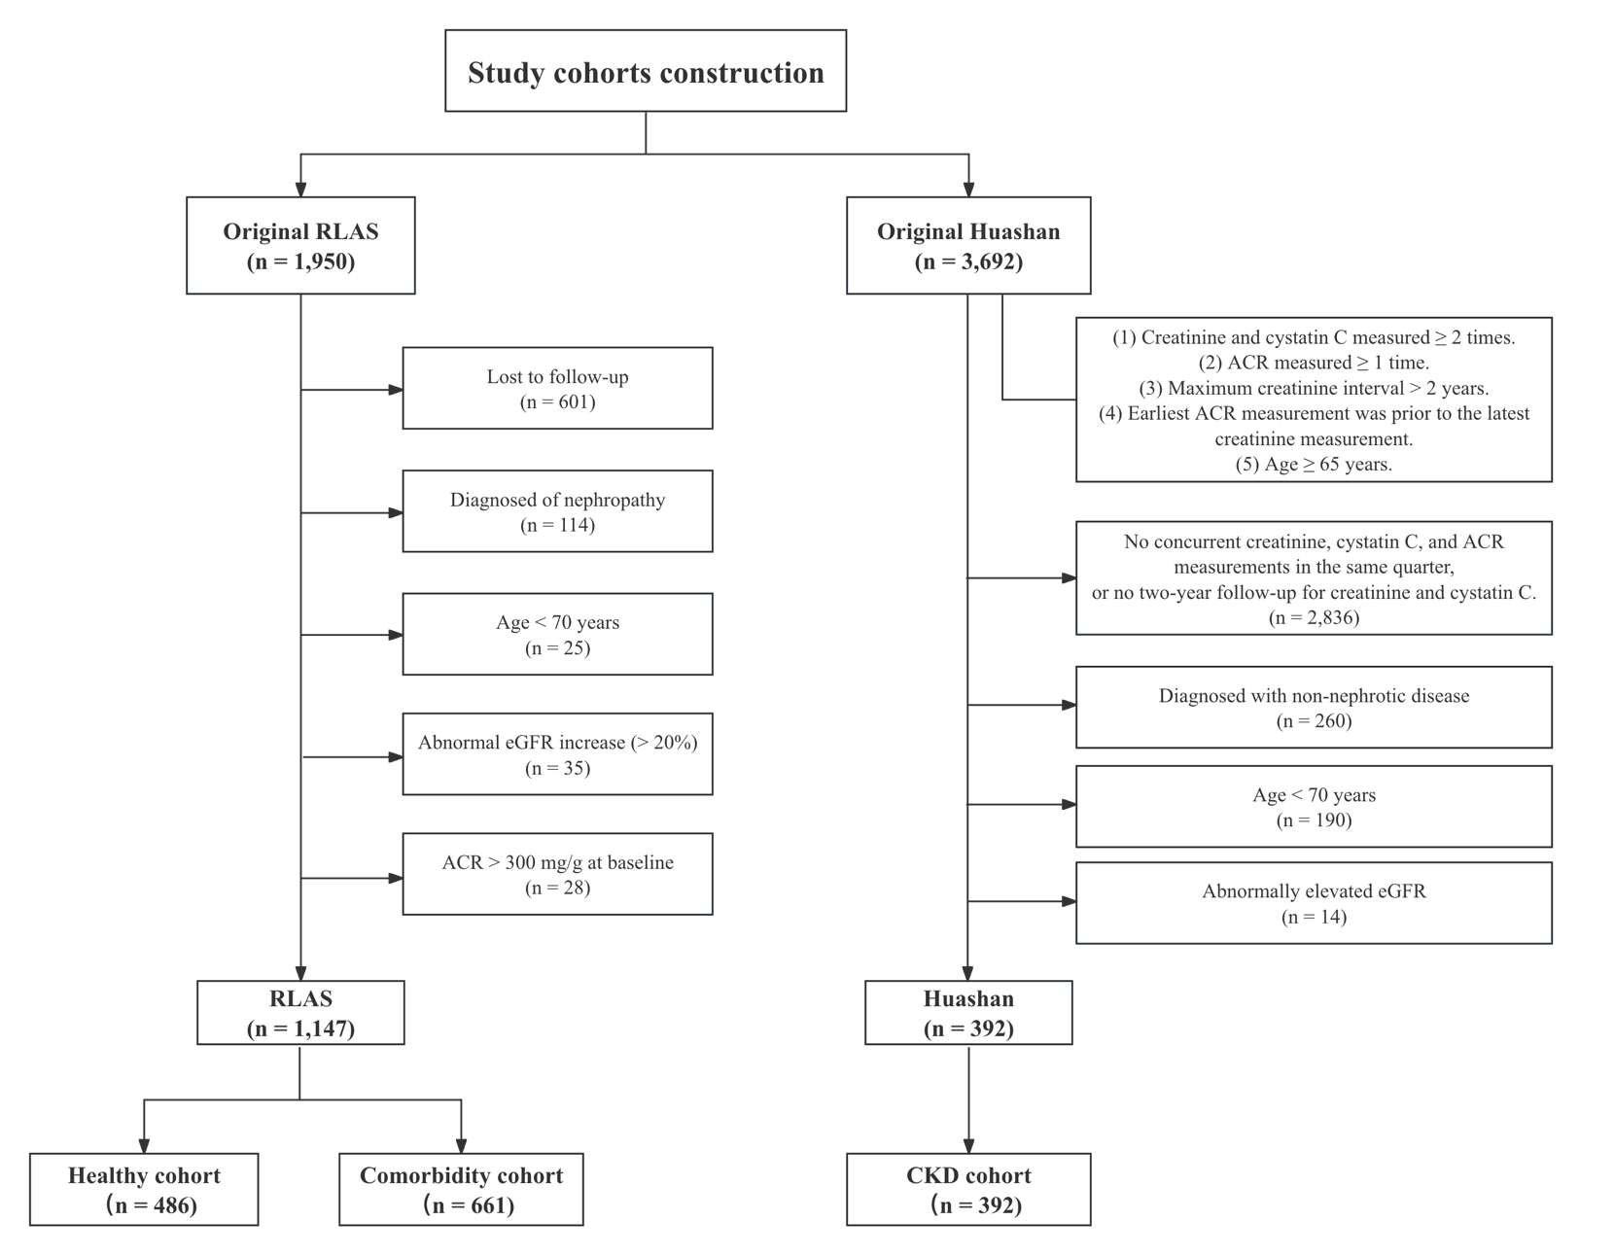
Comorbidity populations were defined as individuals without CKD but with conditions that have been directly associated with pathological renal changes (e.g., chronic inflammation and vascular injury), and can accelerate renal functional decline. The CKD cohort included participants with CKD and encompassed cases on the spectrum from acute kidney injury (AKI) to CKD.
CKD: chronic kidney disease, eGFR: estimated glomerular filtration rate (estimated by the CKD-EPI formula based on creatinine and cystatin C), ACR: urine albumin-to-creatinine ratio.

Figure S2. Flowchart for UK Biobank Cohort Selection
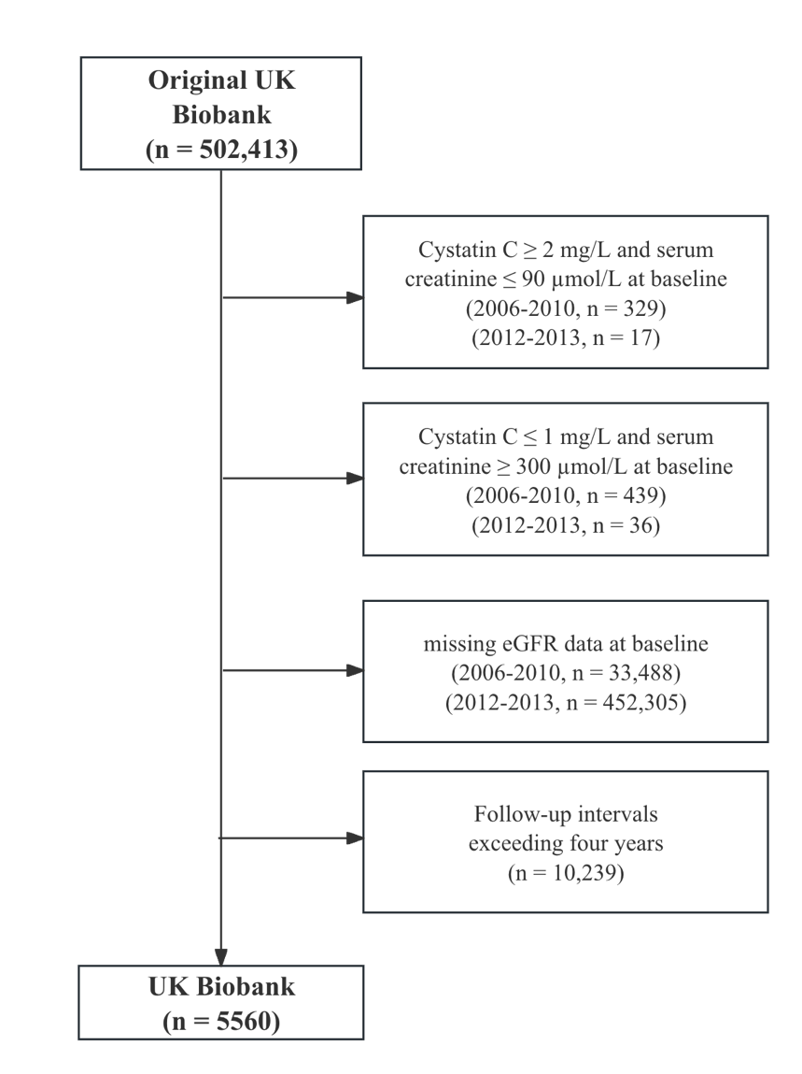
Participants were excluded at each step due to outlier biochemistry values or missing eGFR data.
Interval restriction ensured follow‐up between two and four years to match the two‐year endpoint used in our elderly cohorts.

Figure S3. Distribution of eGFR across three elderly populations
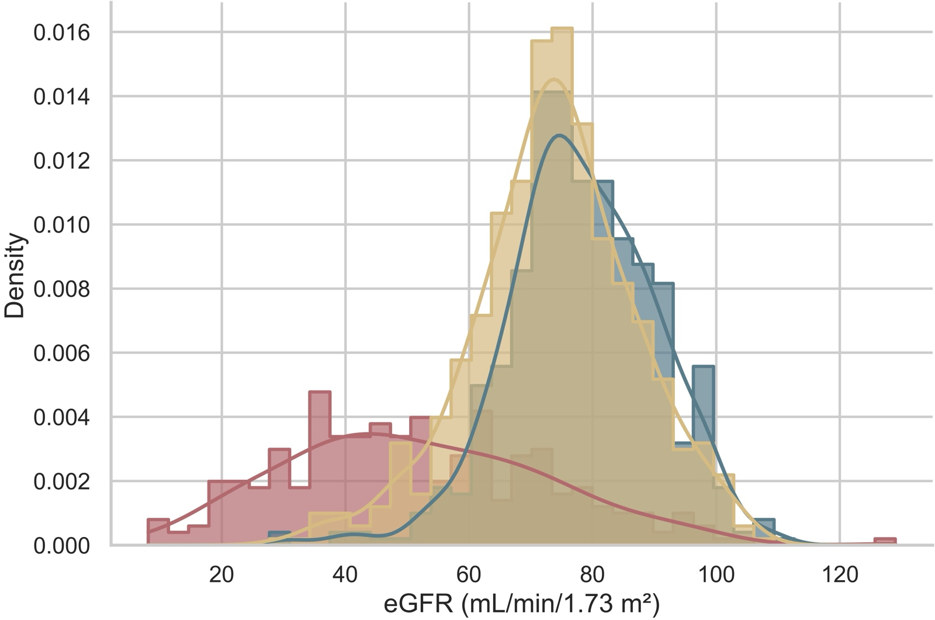
The kernel density overlay histogram displays the distribution of eGFR across three cohorts: the healthy cohort (blue curve/bar), the comorbidities cohort (beige curve/bar), and the chronic kidney disease cohort (brick-red curve/bar). eGFR was estimated using the CKD-EPI formula based on creatinine and cystatin C.
eGFR: estimated Glomerular filtration rate (estimated by the CKD-EPI formula based on creatinine and cystatin C)

Figure S4. Adjusted incidence rate of rapid kidney function decline by eGFR categories in elderly cohorts
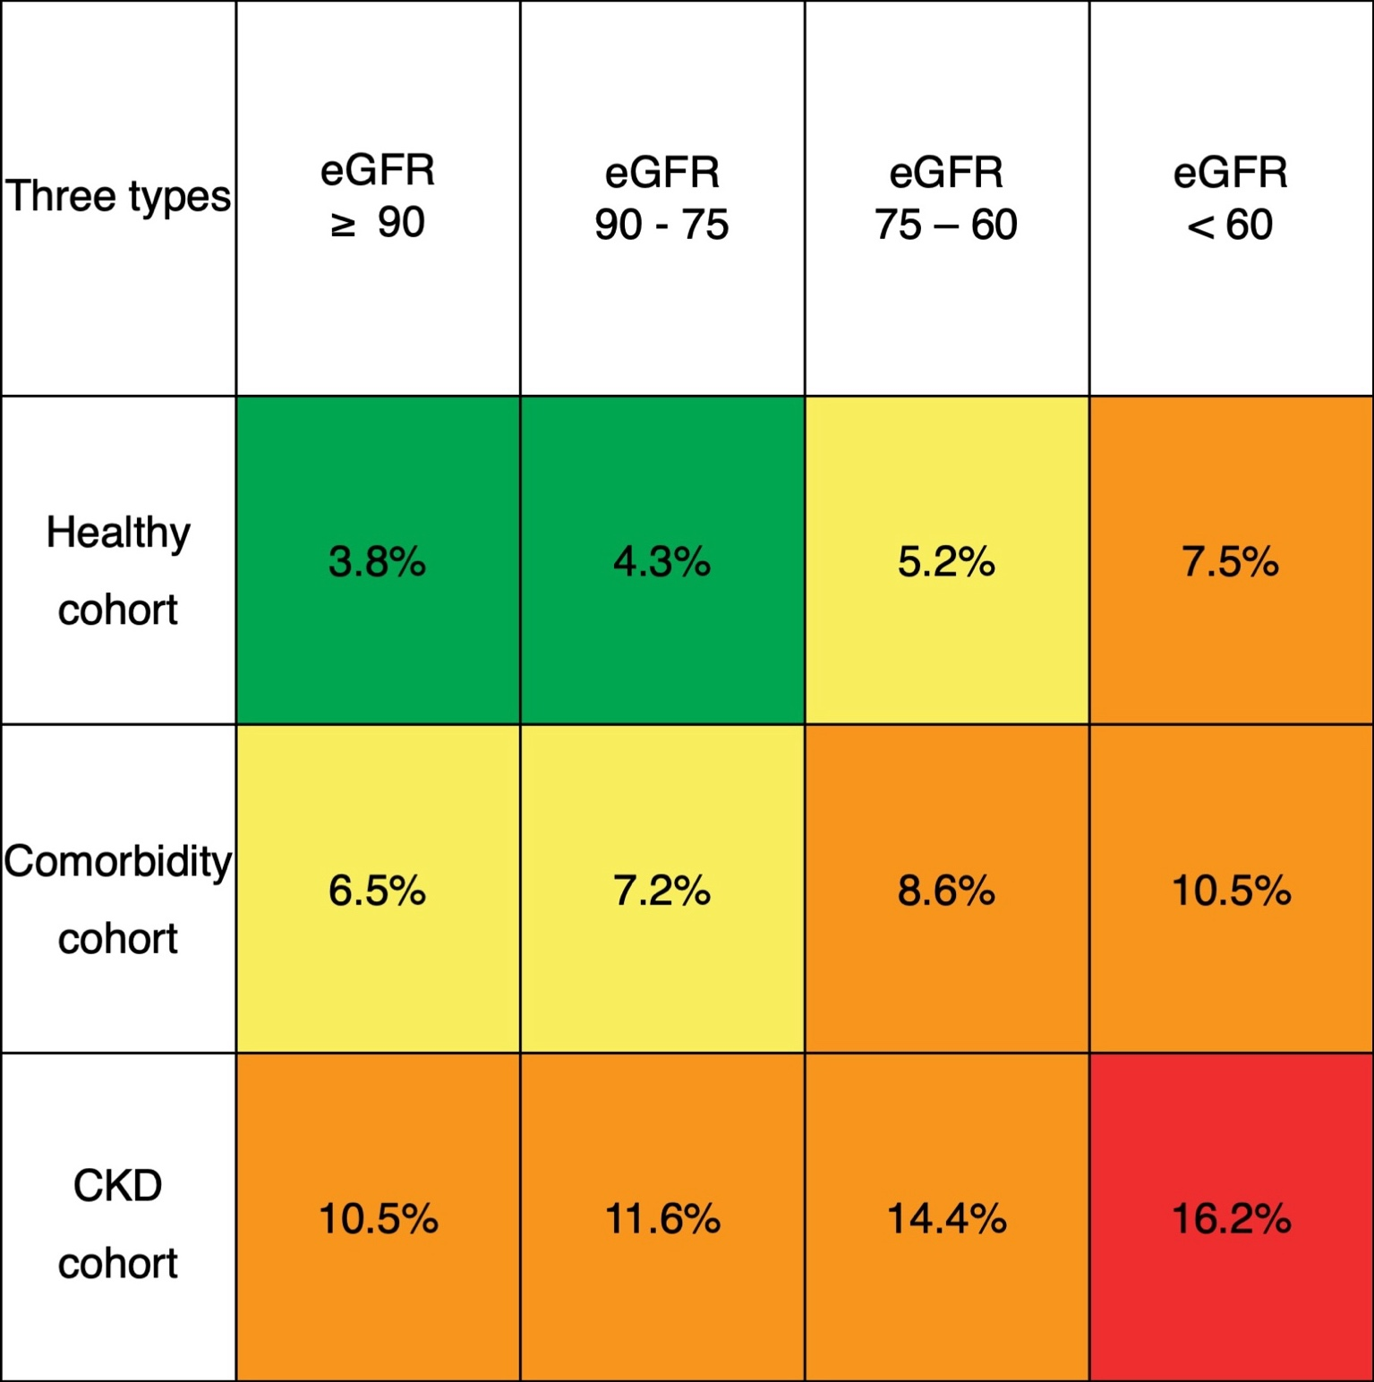
Color coding indicates adjusted incidence rate categories: Green (< 5%): No risk; Light yellow (5–7.5%): Low risk; Orange (7.5–15%): Moderate risk; Red (> 15%): High risk.
Rate probabilities were adjusted for age, hemoglobin, cholesterol, triglycerides, and phenotype. eGFR was estimated using the CKD-EPI creatinine–cystatin C equation; ACR denotes urine albumin-to-creatinine ratio.
Figure S5. Adjusted incidence rate of rapid kidney function decline by ACR categories in elderly cohorts
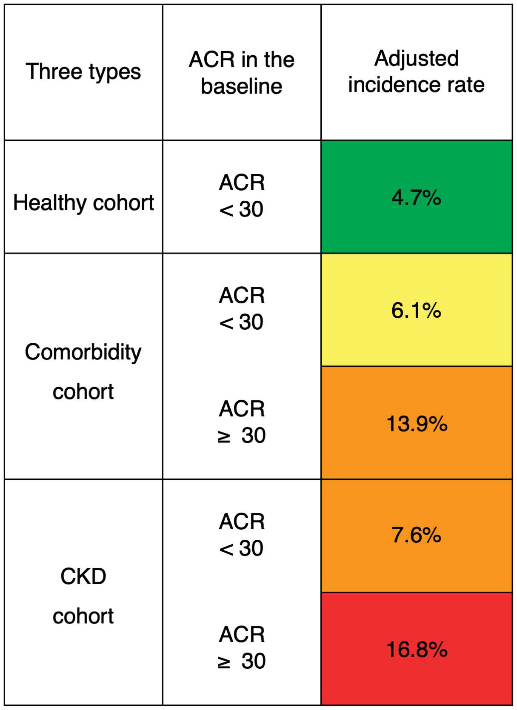
Color coding indicates adjusted incidence rate categories: Green (< 5%): No risk; Light yellow (5–7.5%): Low risk; Orange (7.5–15%): Moderate risk; Red (> 15%): High risk.
Rate probabilities were adjusted for age, hemoglobin, cholesterol, triglycerides, and phenotype. eGFR was estimated using the CKD-EPI creatinine–cystatin C equation; ACR denotes urine albumin-to-creatinine ratio.
REFERENCES
1. Bycroft C, Freeman C, Petkova D, et al. The UK Biobank resource with deep phenotyping and genomic data. Nature. Oct 2018;562(7726):203-209. doi:10.1038/s41586-018-0579-z
2. Coresh J, Turin TC, Matsushita K, et al. Decline in estimated glomerular filtration rate and subsequent risk of end-stage renal disease and mortality. JAMA. Jun 25 2014;311(24):2518-2531. doi:10.1001/jama.2014.6634
3. Lambers Heerspink HJ, Tighiouart H, Sang Y, et al. GFR decline and subsequent risk of established kidney outcomes: a meta-analysis of 37 randomized controlled trials. Am J Kidney Dis. Dec 2014;64(6):860-6. doi:10.1053/j.ajkd.2014.08.018
4. Levey AS, Inker LA, Matsushita K, et al. GFR decline as an end point for clinical trials in CKD: a scientific workshop sponsored by the National Kidney Foundation and the US Food and Drug Administration. Am J Kidney Dis. Dec 2014;64(6):821-35. doi:10.1053/j.ajkd.2014.07.030
5. Kovesdy CP, Coresh J, Ballew SH, et al. Past Decline Versus Current eGFR and Subsequent ESRD Risk. J Am Soc Nephrol. Aug 2016;27(8):2447-55. doi:10.1681/ASN.2015060687

