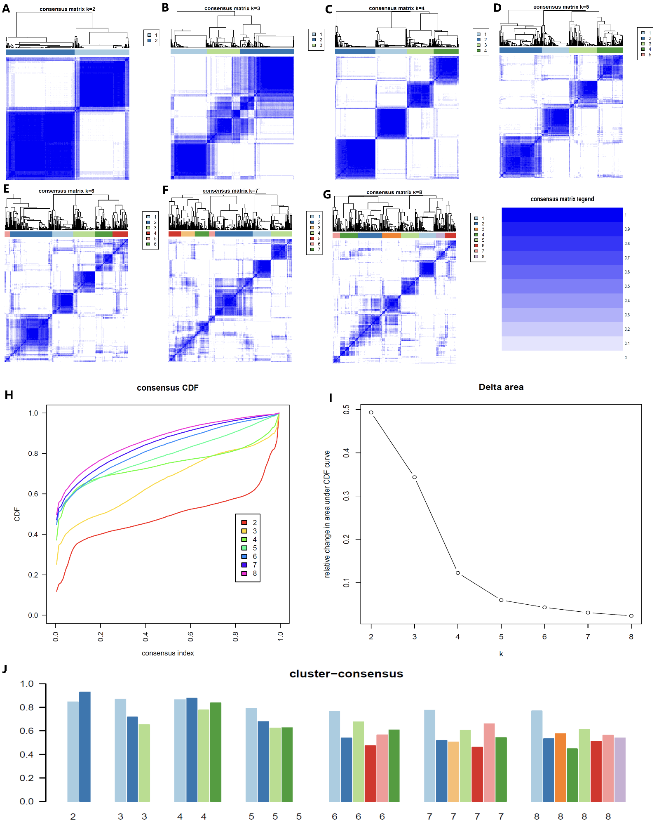
Supplementary Figure 1. Consensus matrix heatmaps and analyses to determine optimal cluster numbers using comorbidity-related factors (related to STAR Methods). (A) K=2; (B) K=3; (C) K=4; (D) K=5; (E) K=6; (F) K=7; (G) K=8; (H) Cumulative distribution functions (CDF) of consensus matrices for each K value; (I) Relative change in area under the CDF curve; (J) Mean consensus scores for different K values (K=2 to 8). For K=4, mean consensus scores were 0.86, 0.87, 0.77, and 0.80 for clusters 1–4, respectively.

Supplementary Table 1. Cluster centers determined by K-means clustering of the analysis datasets.
Cluster | SBP | BMI | FPG | LDL-c | IC
1 | -0.077098175 | 0.587734866 | 0.014270802 | 1.35906285 | 0.346256683
2 | -0.516196707 | 0.411511232 | -0.068301008 | -0.59270167 | 0.65527543
3 | 1.320751797 | -0.191982191 | -0.019516152 | -0.088054144 | -0.028535916
4 | -0.458699731 | -0.85506449 | -0.103760184 | -0.209548972 | -1.149144901
BMI, body mass index; SBP, systolic blood pressure; IC, intrinsic capacity; LDL-c, low density lipoprotein cholesterol; FPG, fasting plasma glucose.
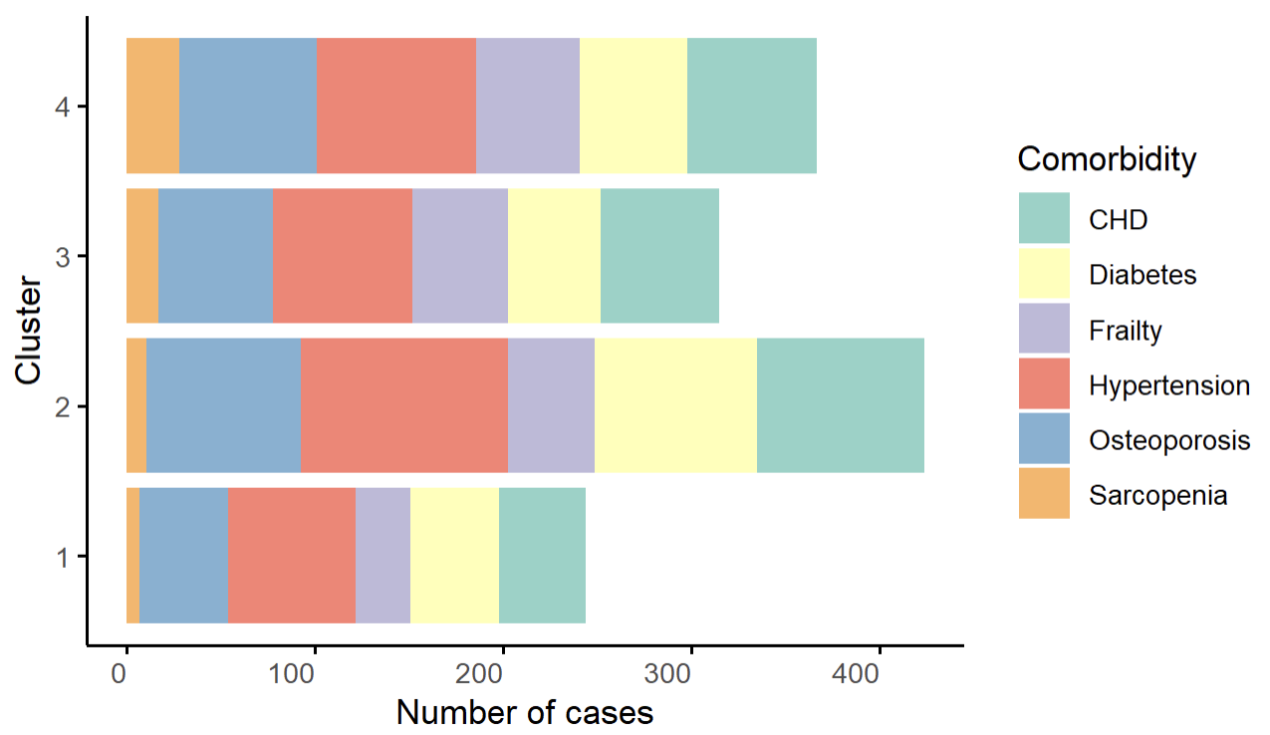
Supplementary Figure 2. Distribution of participants among comorbidity groups by cluster. CHD, coronary heart disease.

