Table S1
List of anatomical therapeutic chemical classification system codes (ATC-codes)
ATC-code | Type | Name
N02BE01 | Paracetamol | Paracetamol
M01AA01 | NSAID | Phenylbutazone
M01AB01 | NSAID | Indometacin
M01AB02 | NSAID | Sulindac
M01AB03 | NSAID | Tolmetin
M01AB05 | NSAID | Diclofenac
M01AB55 | NSAID | Diclofenac, combinations M01AB08 Etodolac
M01AB16 | NSAID | Aceclofenac
M01AC01 | NSAID | Piroxicam
M01AC02 | NSAID | Tenoxicam
M01AC05 | NSAID | Lornoxicam
M01AC06 | NSAID | Meloxicam
M01AE01 | NSAID | Ibuprofen
M01AE02 | NSAID | Naproxen
M01AE03 | NSAID | Ketoprofen
M01AE04 | NSAID | Fenoprofen
M01AE09 | NSAID | Flurbiprofen
M01AE11 | NSAID | Tiaprofenic acid
M01AE14 | NSAID | Dexibuprofen
M01AE17 | NSAID | Dexketoprofen
M01AE52 | NSAID | Naproxen and esomeprazole M01AG02 Tolfenamic acid
M01AH01 | NSAID | Celecoxib
M01AH02 | NSAID | Rofecoxib
M01AH05 | NSAID | Etoricoxib
N02BA01 | NSAID | Acetylsalicylic acid (Aspirin, Idotyl, Magnyl)
N02BA11 | NSAID | Diflunisal (Donobid)
N02BA5. | NSAID | Acetylsalicylic acid
N02AA01 | Opioid | Morphine
N02AA03 | Opioid | Hydromorphone
N02AA04 | Opioid | Nicomorphine
N02AA05 | opioid | Oxycodone
N02AA55 | Opioid | Oxycodone and naloxone
N03AB01 | Opioid | Ketobemidone
N02AB02 | Opioid | Pepthidine
N02AB03 | Opioid | Fentanyl
N02AC04 | Opioid | Dextropropoxyphene
N02AD01 | Opioid | Pentazocine
NO2AE01 | Opioid | Buprenorphine
N02AG02 | Opioid | Ketobemidone, antispasmodics
N02AJ06 | Opioid | Codeine, paracetamol
N02AJ07 | Opioid | Codeine, acetylsalicylic acid
N02BA75 | Opioid | Codeine, caffeine, propyphenazone, salicylamide, magnesium oxide
R05DA04 | Opioid | Codeine
NO2AX02 | Opioid | Tramadol
N02AX06 | Opioid | Tapentadol
NSAID: Non-steroidal anti-inflammatory drugs

Table S2
Characteristics of study participants lost to follow-up
Characteristic | Included sample, N = 2,803 | Lost to follow-up, N = 1,177
Sex
Male | 904 /2,803 (32%) | 390 /1,177 (33%)
Female | 1,899 /2,803 (68%) | 787 /1,177 (67%)
Age
Mean (SD) | 58 (12) | 55 (14)
Median (IQR) | 60 (51, 67) | 56 (46, 66)
Range | 20, 90 | 19, 88
Duration of LBP episode
Less than a year | 1,138 /2,777 (41%) | 472 /1,132 (42%)
More than a year | 1,639 /2,777 (59%) | 660 /1,132 (58%)
(Missing) | 26 | 45
Occupation status
Working | 1,543 /2,803 (55%) | 691 /1,177 (59%)
Under education | 17 /2,803 (0.6%) | 14 /1,177 (1.2%)
Unemployment | 20 /2,803 (0.7%) | 10 /1,177 (0.8%)
Welfare payment | 267 /2,803 (9.5%) | 150 /1,177 (13%)
Retirement | 916 /2,803 (33%) | 296 /1,177 (25%)
Other | 40 /2,803 (1.4%) | 16 /1,177 (1.4%)
Education level
Primary School/high school | 434 /2,775 (16%) | 224 /1,169 (19%)
Skilled worker/short-term education | 1,208 /2,775 (44%) | 537 /1,169 (46%)
Long/medium term higher education | 1,133 /2,775 (41%) | 408 /1,169 (35%)
Missing | 28 | 8
Body Mass Index (BMI) (kg/m³)
Mean (SD) | 27.6 (5.3) | 27.9 (5.5)
Median (IQR) | 26.6 (23.8, 30.4) | 26.9 (24.2, 30.7)
Range | 15.4, 62.5 | 16.7, 58.0
(Missing) | 24 | 26
BMI category
Underweight (BMI below 18.5) | 23 /2,743 (0.8%) | 10 /1,130 (0.9%)
Normal weight (BMI 18.5 to less than 25), | 944 /2,743 (34%) | 357 /1,130 (32%)
Overweight (BMI 25 to less than 30) | 1,015 /2,743 (37%) | 435 /1,130 (38%)
Obese (BMI above 30) | 761 /2,743 (28%) | 328 /1,130 (29%)
(Missing) | 60 | 47
Other chronic conditions
None | 2,000 /2,803 (71%) | 838 /1,177 (71%)
One or more | 803 /2,803 (29%) | 339 /1,177 (29%)
Backpain baseline
Mean (SD) | 5.36 (2.29) | 5.60 (2.31)
Median (IQR) | 6.00 (4.00, 7.00) | 6.00 (4.00, 7.00)
Range | 0.00, 10.00 | 0.00, 10.00
(Missing) | 15 | 38
ODI score baseline
Mean (SD) | 24 (12) | 26 (13)
Median (IQR) | 22 (16, 32) | 26 (18, 34)
Range | 0, 74 | 0, 72
(Missing) | 41 | 154
Illness perceptions baseline
Mean (SD) | 42 (11) | 44 (12)
Median (IQR) | 43 (35, 50) | 45 (36, 51)
Range | 3, 79 | 1, 76
(Missing) | 54 | 108
Self-efficacy baseline
Mean (SD) | 6.81 (1.86) | 6.53 (1.94)
Median (IQR) | 7.00 (5.50, 8.20) | 6.76 (5.20, 8.00)
Range | 1.00, 10.00 | 1.00, 10.00
(Missing) | 79 | 184
EQ-5D Baseline
Mean (SD) | 63 (19) | 59 (19)
Median (IQR) | 67 (50, 79) | 60 (49, 75)
Range | 0, 100 | 9, 100
(Missing) | 166 | 237
Visits before
Mean (SD) | 12 (16) | 10 (13)
Median (IQR) | 8 (2, 16) | 6 (1, 13)
Range | 0, 166 | 0, 108
Visits after
Mean (SD) | 9 (17) | 7 (13)
Median (IQR) | 2 (0, 10) | 0 (0, 8)
Range | 0, 137 | 0, 118
Visits change
Mean (SD) | -3 (14) | -4 (13)
Median (IQR) | -3 (-9, 1) | -3 (-8, 0)
Range | -81, 102 | -99, 76
Any visits in year before enrollment
None | 435 /2,803 (16%) | 205 /1,177 (17%)
One or more | 2,368 /2,803 (84%) | 972 /1,177 (83%)
Any visits in year after end of intervention
None | 1,236 /2,803 (44%) | 607 /1,177 (52%)
One or more | 1,567 /2,803 (56%) | 570 /1,177 (48%)
DDD redeemed in year before enrollment
Mean (SD) | 113 (172) | 119 (186)
Median (IQR) | 51 (0, 151) | 51 (0, 154)
Range | 0, 1,727 | 0, 1,426
DDD redeemed in year after end of intervention
Mean (SD) | 93 (167) | 106 (188)
Median (IQR) | 0 (0, 112) | 6 (0, 131)
Range | 0, 1,561 | 0, 1,237
DDD change
Mean (SD) | -20 (113) | -14 (113)
Median (IQR) | 0 (-50, 0) | 0 (-44, 0)
Range | -918, 785 | -726, 703
Any DDD redeemed in year before enrollment
None | 922 /2,803 (33%) | 371 /1,177 (32%)
One or more | 1,881 /2,803 (67%) | 806 /1,177 (68%)
Any DDD redeemed in year after end of intervention
None | 1,434 /2,803 (51%) | 562 /1,177 (48%)
One or more | 1,369 /2,803 (49%) | 615 /1,177 (52%)
Hospital care for LBP in year before enrollment | 410 /2,803 (15%) | 181 /1,177 (15%)
Hospital care for LBP in year after end of intervention | 258 /2,803 (9.2%) | 124 /1,177 (11%)
MRI of lumbar spine in year before enrollment | 641 /2,803 (23%) | 270 /1,177 (23%)
MRI of lumbar spine in year after end of intervention | 219 /2,803 (7.8%) | 121 /1,177 (10%)

Table S3
Associations between changes in PROMS and visits of analgesic use at follow-up for all models and all subgroups
 |  | Visits to primary care |  | Analgesics use
Sample | Model | IRR (95%CI) | P.value | IRR (95%CI) | P.value
Backpain
Total sample | Model 1 | 0.93 (0.86;1) | 0.053 | 0.99 (0.93;1.07) | 0.874
 | Model 2 | 0.92 (0.87;0.96) | <0.001 | 0.95 (0.9;0.99) | 0.025
 | Model 3 | 0.92 (0.88;0.97) | 0.001 | 0.96 (0.92;1.01) | 0.12
High users | Model 1 | 1.07 (0.92;1.25) | 0.399 | 0.96 (0.89;1.04) | 0.3
 | Model 2 | 0.96 (0.88;1.06) | 0.441 | 0.93 (0.88;0.98) | 0.012
 | Model 3 | 0.96 (0.87;1.06) | 0.433 | 0.94 (0.89;0.99) | 0.02
Medium users | Model 1 | 0.83 (0.71;0.96) | 0.015 | 0.87 (0.82;0.93) | <0.001
 | Model 2 | 0.83 (0.75;0.91) | <0.001 | 0.86 (0.81;0.91) | <0.001
 | Model 3 | 0.83 (0.75;0.91) | <0.001 | 0.87 (0.82;0.93) | <0.001
Low users | Model 1 | 0.85 (0.72;1.01) | 0.064 | 0.88 (0.8;0.97) | 0.012
 | Model 2 | 0.94 (0.84;1.04) | 0.242 | 0.86 (0.79;0.93) | <0.001
 | Model 3 | 0.95 (0.85;1.05) | 0.312 | 0.86 (0.79;0.94) | <0.001
ODI
Total sample | Model 1 | 0.95 (0.88;1.03) | 0.185 | 1.06 (0.99;1.13) | 0.085
 | Model 2 | 0.94 (0.9;0.99) | 0.014 | 1 (0.95;1.05) | 0.984
 | Model 3 | 0.94 (0.9;0.99) | 0.015 | 1.01 (0.96;1.06) | 0.673
High users | Model 1 | 0.9 (0.78;1.04) | 0.158 | 1 (0.94;1.07) | 0.945
 | Model 2 | 0.96 (0.88;1.06) | 0.433 | 0.97 (0.92;1.02) | 0.173
 | Model 3 | 0.96 (0.88;1.05) | 0.364 | 0.97 (0.92;1.02) | 0.232
Medium users | Model 1 | 0.91 (0.77;1.07) | 0.268 | 0.88 (0.82;0.94) | <0.001
 | Model 2 | 0.85 (0.77;0.94) | 0.002 | 0.86 (0.81;0.91) | <0.001
 | Model 3 | 0.85 (0.77;0.94) | 0.002 | 0.87 (0.82;0.93) | <0.001
Low users | Model 1 | 0.94 (0.78;1.14) | 0.527 | 0.88 (0.8;0.98) | 0.018
 | Model 2 | 0.98 (0.87;1.1) | 0.684 | 0.85 (0.77;0.92) | <0.001
 | Model 3 | 0.98 (0.87;1.11) | 0.766 | 0.85 (0.77;0.92) | <0.001
Self-efficacy
Total sample | Model 1 | 0.98 (0.91;1.06) | 0.645 | 1 (0.93;1.08) | 0.968
 | Model 2 | 0.91 (0.87;0.96) | <0.001 | 0.94 (0.9;0.98) | 0.01
 | Model 3 | 0.92 (0.87;0.96) | <0.001 | 0.96 (0.91;1) | 0.062
High users | Model 1 | 0.96 (0.81;1.14) | 0.636 | 1 (0.93;1.08) | 0.967
 | Model 2 | 0.97 (0.87;1.08) | 0.559 | 0.94 (0.89;0.99) | 0.02
 | Model 3 | 0.96 (0.86;1.07) | 0.456 | 0.95 (0.9;1) | 0.05
Medium users | Model 1 | 0.98 (0.85;1.13) | 0.788 | 0.87 (0.81;0.93) | <0.001
 | Model 2 | 0.84 (0.76;0.92) | <0.001 | 0.87 (0.82;0.93) | <0.001
 | Model 3 | 0.84 (0.77;0.93) | <0.001 | 0.89 (0.84;0.94) | <0.001
Low users | Model 1 | 0.99 (0.84;1.17) | 0.925 | 0.9 (0.82;0.99) | 0.034
 | Model 2 | 0.87 (0.79;0.97) | 0.011 | 0.89 (0.82;0.97) | 0.008
 | Model 3 | 0.87 (0.78;0.97) | 0.011 | 0.91 (0.83;0.98) | 0.019
Illness perceptions
Total sample | Model 1 | 0.97 (0.9;1.05) | 0.417 | 1.04 (0.98;1.11) | 0.226
 | Model 2 | 0.96 (0.92;1.01) | 0.153 | 0.98 (0.94;1.03) | 0.377
 | Model 3 | 0.97 (0.92;1.01) | 0.161 | 0.98 (0.94;1.03) | 0.477
High users | Model 1 | 0.96 (0.82;1.13) | 0.616 | 1.01 (0.94;1.08) | 0.877
 | Model 2 | 0.95 (0.86;1.04) | 0.268 | 0.97 (0.92;1.02) | 0.275
 | Model 3 | 0.94 (0.86;1.04) | 0.249 | 0.97 (0.92;1.02) | 0.209
Medium users | Model 1 | 0.98 (0.83;1.15) | 0.769 | 0.9 (0.85;0.96) | 0.002
 | Model 2 | 0.89 (0.8;0.99) | 0.031 | 0.88 (0.83;0.94) | <0.001
 | Model 3 | 0.89 (0.81;0.99) | 0.033 | 0.89 (0.83;0.94) | <0.001
Low users | Model 1 | 0.94 (0.8;1.11) | 0.498 | 0.92 (0.84;1.02) | 0.103
 | Model 2 | 1.02 (0.92;1.14) | 0.704 | 0.91 (0.83;0.99) | 0.026
 | Model 3 | 1.02 (0.91;1.14) | 0.732 | 0.91 (0.84;1) | 0.042
EQ-5D
Total sample | Model 1 | 0.95 (0.88;1.03) | 0.198 | 1.02 (0.96;1.09) | 0.52
 | Model 2 | 0.96 (0.92;1.01) | 0.143 | 0.97 (0.93;1.02) | 0.236
 | Model 3 | 0.97 (0.92;1.01) | 0.168 | 0.98 (0.93;1.03) | 0.358
High users | Model 1 | 0.93 (0.81;1.07) | 0.343 | 1 (0.94;1.07) | 0.928
 | Model 2 | 0.99 (0.9;1.09) | 0.839 | 0.97 (0.92;1.02) | 0.223
 | Model 3 | 0.99 (0.9;1.08) | 0.778 | 0.97 (0.92;1.03) | 0.32
Medium users | Model 1 | 1.03 (0.89;1.19) | 0.714 | 0.88 (0.83;0.94) | <0.001
 | Model 2 | 0.96 (0.87;1.06) | 0.467 | 0.87 (0.82;0.93) | <0.001
 | Model 3 | 0.97 (0.88;1.07) | 0.524 | 0.88 (0.83;0.93) | <0.001
Low users | Model 1 | 0.98 (0.82;1.18) | 0.825 | 0.87 (0.78;0.96) | 0.006
 | Model 2 | 1.02 (0.9;1.14) | 0.796 | 0.88 (0.81;0.97) | 0.008
 | Model 3 | 1.02 (0.91;1.14) | 0.788 | 0.89 (0.81;0.97) | 0.012
Incidence rate ratios (IRRs) are the exponentiated coefficients of the interaction between a PROM and time in the count part of the zero-inflated negative binomial regression analysis.
Model 1= crude model, Model 2 = adjusted for sex, age, duration of pain episode, education level, year of enrollment, use of visits or analgesics before enrollment, Model 3 = as model 2 but additionally adjusted for each PROM score.
Models with visits as outcome included random intercepts for ID and clinic.
Low visit use, n= 1.028 visits range 0 to 4. Medium visit use, n = 869 visits range 5 to 12. High visit use, n = 906 visits range 13 to 166. Low analgesics use, n=634 DDD range 1 to 59. Medium analgesics use, n=626, DDD range 61 to 165. High analgesics use, n=621 DDD range 165 to 1,727.
DDD: defined daily dose.
Table S4
Characteristics of subgroups based on visits before enrollment
 |  | Use of visits to physiotherapists or chiropractors before enrollment
Characteristic | Overall, N = 2,803 | Low use (0-4), N = 1,028 | Medium use (5-12), N = 869 | High use (12-166), N = 906
Female Sex | 1,899/2,803 (68%) | 651/1,028 (63%) | 587/869 (68%) | 661/906 (73%)
Age, mean (SD) | 58 (12) | 59 (12) | 57 (12) | 59 (12)
LBP episode lasting longer than one year | 1,639/2,777 (59%) | 625/1,022 (61%) | 465/860 (54%) | 549/895 (61%)
(Missing) | 26 | 6 | 9 | 11
Occupation status
Working | 1,543/2,803 (55%) | 576/1,028 (56%) | 526/869 (61%) | 441/906 (49%)
Under education | 17/2,803 (0.6%) | <1% | 8/869 (0.9%) | <1%
Retirement | 916/2,803 (33%) | 352/1,028 (34%) | 240/869 (28%) | 324/906 (36%)
Welfare payment | 267/2,803 (9.5%) | 75/1,028 (7.3%) | 73/869 (8.4%) | 119/906 (13%)
Unemployment | 20/2,803 (0.7%) | <1% | 8/869 (0.9%) | <1%
Other | 40/2,803 (1.4%) | 12/1,028 (1.2%) | 14/869 (1.6%) | 14/906 (1.5%)
Education level
Primary School/high school | 434/2,775 (16%) | 160/1,021 (16%) | 134/855 (16%) | 140/899 (16%)
Skilled worker/short-term education | 1,208/2,775 (44%) | 437/1,021 (43%) | 382/855 (45%) | 389/899 (43%)
Long/medium term higher education | 1,133/2,775 (41%) | 424/1,021 (42%) | 339/855 (40%) | 370/899 (41%)
Missing | 28 | 7 | 14 | 7
Body mass index, (kg/m³) median (25th, 75th percentile) | 26.6 (23.8, 30.4) | 26.5 (23.7, 29.8) | 26.7 (24.0, 30.5) | 26.8 (23.7, 30.9)
(Missing) | 24 | 11 | 6 | 7
One or more other chronic conditions before enrollment | 733/2,803 (26%) | 263/1,028 (26%) | 207/869 (24%) | 263/906 (29%)
Backpain baseline, mean (SD) | 5.36 (2.29) | 5.44 (2.32) | 5.24 (2.32) | 5.37 (2.23)
(Missing) | 15 | 5 | 5 | 5
Backpain 3 months, mean (SD) | 3.82 (2.41) | 3.71 (2.41) | 3.71 (2.43) | 4.06 (2.38)
(Missing) | 22 | 9 | 5 | 8
Backpain mean change (SD) | -1.53 (2.48) | -1.73 (2.52) | -1.54 (2.53) | -1.29 (2.36)
95% CI | -1.62, -1.43 | -1.88, -1.57 | -1.71, -1.37 | -1.44, -1.13
Oswestry Disability index baseline, mean (SD) | 24 (12) | 23 (12) | 23 (12) | 26 (12)
(Missing) | 41 | 16 | 10 | 15
Oswestry Disability index 3 months, mean (SD) | 19 (13) | 18 (13) | 18 (13) | 21 (13)
(Missing) | 126 | 49 | 41 | 36
Oswestry Disability index, mean change (SD) | -5.08 (9.67) | -4.79 (9.44) | -5.4 (9.76) | -5.11 (9.83)
95%CI | -5.45, -4.71 | -5.39, -4.19 | -6.07, -4.73 | -5.77, -4.45
Illness perceptions baseline, mean (SD) | 42 (11) | 42 (11) | 42 (11) | 43 (11)
(Missing) | 54 | 25 | 11 | 18
Illness perceptions 3 months, mean (SD) | 35 (14) | 34 (14) | 34 (14) | 36 (13)
(Missing) | 111 | 42 | 29 | 40
Illness perceptions, mean change (SD) | -8.07 (14.22) | -7.76 (14.05) | -8.49 (14.44) | -8 (14.21)
95% CI | -8.59, -7.54 | -8.62, -6.9 | -9.46, -7.53 | -8.93, -7.08
Self-efficacy baseline, mean (SD) | 6.81 (1.86) | 6.78 (1.94) | 7.09 (1.78) | 6.59 (1.82)
(Missing) | 79 | 31 | 17 | 31
Self-efficacy 3 months, mean (SD) | 6.88 (2.04) | 6.85 (2.05) | 7.06 (2.11) | 6.72 (1.93)
(Missing) | 203 | 83 | 58 | 62
Self-efficacy mean change (SD) | 0.04 (1.88) | 0.05 (1.91) | -0.04 (1.83) | 0.12 (1.88)
95% CI | -0.03, 0.12 | -0.08, 0.17 | -0.17, 0.09 | 0.00, 0.25
EQ-5D Baseline, mean (SD) | 63 (19) | 64 (19) | 64 (18) | 61 (19)
(Missing) | 166 | 60 | 53 | 53
EQ-5D 3 months, mean (SD) | 69 (18) | 70 (18) | 70 (18) | 66 (18)
(Missing) | 271 | 106 | 84 | 81
EQ-5D mean change (SD) | 5.43 (17.32) | 4.9 (17.04) | 6.23 (16.83) | 5.27 (18.07)
95% CI | 4.74, 6.13 | 3.77, 6.03 | 5.02, 7.44 | 4, 6.54
Visits before
Mean (SD) | 12 (16) | 1 (2) | 8 (2) | 28 (20)
Median (IQR) | 8 (2, 16) | 1 (0, 3) | 8 (6, 10) | 21 (16, 32)
Visits after
Mean (SD) | 9 (17) | 4 (10) | 6 (10) | 18 (24)
Median (IQR) | 2 (0, 10) | 0 (0, 4) | 1 (0, 8) | 9 (0, 26)
Visits change
Mean (SD) | -3 (14) | 3 (10) | -3 (10) | -10 (17)
Median (IQR) | -3 (-9, 1) | 0 (-1, 3) | -5 (-8, -1) | -13 (-18, -3)
Any visits before | 2,368/2,803 (84%) | 593/1,028 (58%) | 869/869 (100%) | 906/906 (100%)
Any visits in year after | 1,567/2,803 (56%) | 419/1,028 (41%) | 480/869 (55%) | 668/906 (74%)
Redeemed DDD before
Mean (SD) | 113 (172) | 96 (158) | 99 (166) | 144 (187)
Median (IQR) | 51 (0, 151) | 34 (0, 121) | 43 (0, 126) | 76 (1, 202)
Redeemed DDD after
Mean (SD) | 93 (167) | 81 (157) | 79 (156) | 119 (185)
Median (IQR) | 0 (0, 112) | 0 (0, 90) | 0 (0, 101) | 45 (0, 172)
DDD change
Mean (SD) | -20 (113) | -15 (104) | -20 (102) | -25 (132)
Median (IQR) | 0 (-50, 0) | 0 (-39, 0) | 0 (-50, 0) | 0 (-62, 0)
Any DDD redeemed before | 1,881/2,803 (67%) | 639/1,028 (62%) | 562/869 (65%) | 680/906 (75%)
Any DDD redeemed after | 1,369/2,803 (49%) | 454/1,028 (44%) | 397/869 (46%) | 518/906 (57%)
Hospital care before | 410/2,803 (15%) | 129/1,028 (13%) | 132/869 (15%) | 149/906 (16%)
Hospital care after | 258/2,803 (9.2%) | 88/1,028 (8.6%) | 65/869 (7.5%) | 105/906 (12%)
MRI of lumbar spine before | 641/2,803 (23%) | 194/1,028 (19%) | 201/869 (23%) | 246/906 (27%)
MRI of lumbar spine after | 219/2,803 (7.8%) | 82/1,028 (8.0%) | 52/869 (6.0%) | 85/906 (9.4%)
Visits include visits to physiotherapists and chiropractors.
DDD is the defined daily dose for paracetamol, NSAIDs, or opioids.
Before refers to the year before enrollment and after refers to the year after the end of intervention
Table S5
Characteristics of subgroups based on analgesic use before enrollment
 |  | Redeemed defined daily doses (DDD) before enrollment
Characteristic | Overall, N = 2,803 | No use, N = 922 | Low use (1-59), N = 634 | Medium use (61-165), N = 626 | High use (165-1,727), N = 621
Female sex | 1,899 /2,803 (68%) | 582 /922 (63%) | 430 /634 (68%) | 440 /626 (70%) | 447 /621 (72%)
Age, mean (SD) | 58 (12) | 57 (12) | 58 (12) | 58 (13) | 61 (11)
LBP episode lasting longer than one year | 1,639 /2,777 (59%) | 543 /917 (59%) | 344 /624 (55%) | 359 /620 (58%) | 393 /616 (64%)
(Missing) | 26 | 5 | 10 | 6 | 5
Occupation status
Working | 1,543 /2,803 (55%) | 580 /922 (63%) | 359 /634 (57%) | 322 /626 (51%) | 282 /621 (45%)
Under education | 17 /2,803 (0.6%) | 6 /922 (0.7%) | 7 /634 (1.1%) | <1% | <1%
Retirement | 916 /2,803 (33%) | 263 /922 (29%) | 199 /634 (31%) | 218 /626 (35%) | 236 /621 (38%)
Welfare payment | 267 /2,803 (9.5%) | 50 /922 (5.4%) | 52 /634 (8.2%) | 74 /626 (12%) | 91 /621 (15%)
Unemployment | 20 /2,803 (0.7%) | 7 /922 (0.8%) | 5 /634 (0.8%) | <1% | <1%
Other | 40 /2,803 (1.4%) | 16 /922 (1.7%) | 12 /634 (1.9%) | <1% | <1%
Highest completed education
Primary School/high school | 434 /2,775 (16%) | 105 /911 (12%) | 109 /630 (17%) | 96 /619 (16%) | 124 /615 (20%)
Skilled worker/short-term education | 1,208 /2,775 (44%) | 374 /911 (41%) | 271 /630 (43%) | 269 /619 (43%) | 294 /615 (48%)
Long/medium term higher education | 1,133 /2,775 (41%) | 432 /911 (47%) | 250 /630 (40%) | 254 /619 (41%) | 197 /615 (32%)
Missing | 28 | 11 | 4 | 7 | 6
Body mass index (kg/m³) | 26.6 (23.8, 30.4) | 25.8 (23.2, 29.0) | 26.7 (23.7, 30.4) | 26.9 (24.1, 30.7) | 28.1 (24.7, 32.0)
(Missing) | 24 | 8 | <1% | 9 | <1%
One or more other chronic conditions before enrollment | 733 /2,803 (26%) | 189 /922 (20%) | 154 /634 (24%) | 179 /626 (29%) | 211 /621 (34%)
Back pain intensity baseline
Mean (SD) | 5.36 (2.29) | 4.78 (2.18) | 5.21 (2.36) | 5.60 (2.35) | 6.11 (2.06)
(Missing) | 15 | 3 | 4 | 5 | 3
Back pain intensity 3 months
Mean (SD) | 3.82 (2.41) | 3.31 (2.28) | 3.48 (2.31) | 4.04 (2.41) | 4.71 (2.44)
(Missing) | 22 | 7 | 3 | 8 | 4
Back pain intensity, mean change (SD) | -1.53 (2.48) | -1.46 (2.45) | -1.72 (2.61) | -1.55 (2.49) | -1.40 (2.36)
95% CI | -1.62, -1.43 | -1.61, -1.3 | -1.93, -1.52 | -1.75, -1.36 | -1.58, -1.21
Oswestry Disability Index baseline
Mean (SD) | 24 (12) | 19 (10) | 23 (12) | 26 (12) | 31 (13)
(Missing) | 41 | 14 | 8 | 13 | 6
Oswestry Disability Index score 3 months
Mean (SD) | 19 (13) | 14 (10) | 17 (12) | 21 (13) | 26 (13)
(Missing) | 126 | 39 | 23 | 33 | 31
Oswestry Disability Index mean change (SD) | -5.08 (9.67) | -4.58 (8.51) | -5.75 (9.99) | -5.65 (10.36) | -4.58 (10.16)
95% CI | -5.45, -4.71 | -5.15, -4.02 | -6.55, -4.95 | -6.49, -4.81 | -5.4, -3.75
Illness perceptions baseline
Mean (SD) | 42 (11) | 39 (11) | 41 (12) | 44 (10) | 46 (11)
(Missing) | 54 | 16 | 13 | 14 | 11
Illness perceptions 3 months
Mean (SD) | 35 (14) | 31 (14) | 33 (13) | 37 (13) | 40 (13)
(Missing) | 111 | 34 | 18 | 27 | 32
Illness perceptions, mean change (SD) | -8.07 (14.22) | -8.25 (13.71) | -8.55 (14.34) | -8.09 (14.71) | -7.28 (14.36)
95% CI | -8.59, -7.54 | -9.13, -7.36 | -9.66, -7.43 | -9.25, -6.94 | -8.41, -6.15
Self-efficacy baseline
Mean (SD) | 6.81 (1.86) | 7.29 (1.70) | 6.94 (1.88) | 6.68 (1.86) | 6.12 (1.85)
(Missing) | 79 | 24 | 19 | 25 | 11
Self-efficacy 3 months
Mean (SD) | 6.88 (2.04) | 7.39 (1.89) | 7.11 (1.98) | 6.72 (2.03) | 6.02 (2.01)
(Missing) | 203 | 56 | 45 | 51 | 51
Self-efficacy, mean change (SD) | 0.04 (1.88) | 0.11 (1.77) | 0.15 (1.92) | 0.01 (1.89) | -0.13 (1.96)
95% CI | -0.03, 0.12 | 0.00, 0.23 | -0.01, 0.31 | -0.15, 0.16 | -0.29, 0.03
EQ-5D Baseline
Mean (SD) | 63 (19) | 69 (17) | 65 (18) | 59 (19) | 56 (19)
(Missing) | 166 | 44 | 39 | 47 | 36
EQ-5D 3 months
Mean (SD) | 69 (18) | 74 (16) | 71 (17) | 66 (19) | 61 (20)
(Missing) | 271 | 68 | 53 | 83 | 67
EQ-5D mean change (SD) | 5.43 (17.32) | 4.47 (15.63) | 6.23 (17.16) | 6.41 (17.92) | 5.14 (19.26)
95% CI | 4.74, 6.13 | 3.4, 5.54 | 4.8. 7.66 | 4.85, 7.97 | 3.49, 6.79
Visits before
Mean (SD) | 12 (16) | 10 (13) | 11 (14) | 13 (18) | 16 (19)
Median (IQR) | 8 (2, 16) | 6 (2, 12) | 7 (2, 14) | 8 (3, 16) | 10 (3, 20)
Visits after
Mean (SD) | 9 (17) | 7 (15) | 8 (16) | 9 (17) | 13 (20)
Median (IQR) | 2 (0, 10) | 1 (0, 7) | 1 (0, 9) | 2 (0, 11) | 4 (0, 17)
Visits change
Mean (SD) | -3 (14) | -3 (13) | -3 (13) | -4 (14) | -3 (15)
Median (IQR) | -3 (-9, 1) | -2 (-8, 0) | -3 (-8, 0) | -3 (-10, 0) | -3 (-10, 2)
Any visits before | 2,368 /2,803 (84%) | 754 /922 (82%) | 533 /634 (84%) | 538 /626 (86%) | 543 /621 (87%)
Any visits after | 1,567 /2,803 (56%) | 475 /922 (52%) | 348 /634 (55%) | 355 /626 (57%) | 389 /621 (63%)
Redeemed DDD before
Mean (SD) | 113 (172) | 0 (0) | 32 (17) | 106 (30) | 368 (204)
Median (IQR) | 51 (0, 151) | 0 (0, 0) | 34 (18, 51) | 101 (81, 134) | 301 (224, 459)
Redeemed DDD after
Mean (SD) | 93 (167) | 0 (0) | 41 (71) | 91 (102) | 285 (241)
Median (IQR) | 0 (0, 112) | 0 (0, 0) | 5 (0, 53) | 68 (1, 129) | 234 (101, 410)
DDD change
Mean (SD) | -20 (113) | 0 (0) | 9 (71) | -15 (100) | -83 (194)
Median (IQR) | 0 (-50, 0) | 0 (0, 0) | -10 (-33, 24) | -37 (-79, 17) | -83 (-189, 17)
Any redeemed DDD before | 1,881 /2,803 (67%) | 0 /922 (0%) | 634 /634 (100%) | 626 /626 (100%) | 621 /621 (100%)
Any DDD redeemed after | 1,369 /2,803 (49%) | 0 /922 (0%) | 335 /634 (53%) | 474 /626 (76%) | 560 /621 (90%)
Hospital care before | 410 /2,803 (15%) | 42 /922 (4.6%) | 67 /634 (11%) | 115 /626 (18%) | 186 /621 (30%)
Hospital care after | 258 /2,803 (9.2%) | 50 /922 (5.4%) | 51 /634 (8.0%) | 66 /626 (11%) | 91 /621 (15%)
MRI of lumbar spine before | 641 /2,803 (23%) | 103 /922 (11%) | 129 /634 (20%) | 184 /626 (29%) | 225 /621 (36%)
MRI of lumbar spine after | 219 /2,803 (7.8%) | 44 /922 (4.8%) | 41 /634 (6.5%) | 71 /626 (11%) | 63 /621 (10%)
Visits include visits to physiotherapists and chiropractors.
DDD is the defined daily dose for paracetamol, NSAIDs, or opioids.
Before refers to the year before enrollment and after refers to the year after the end of intervention

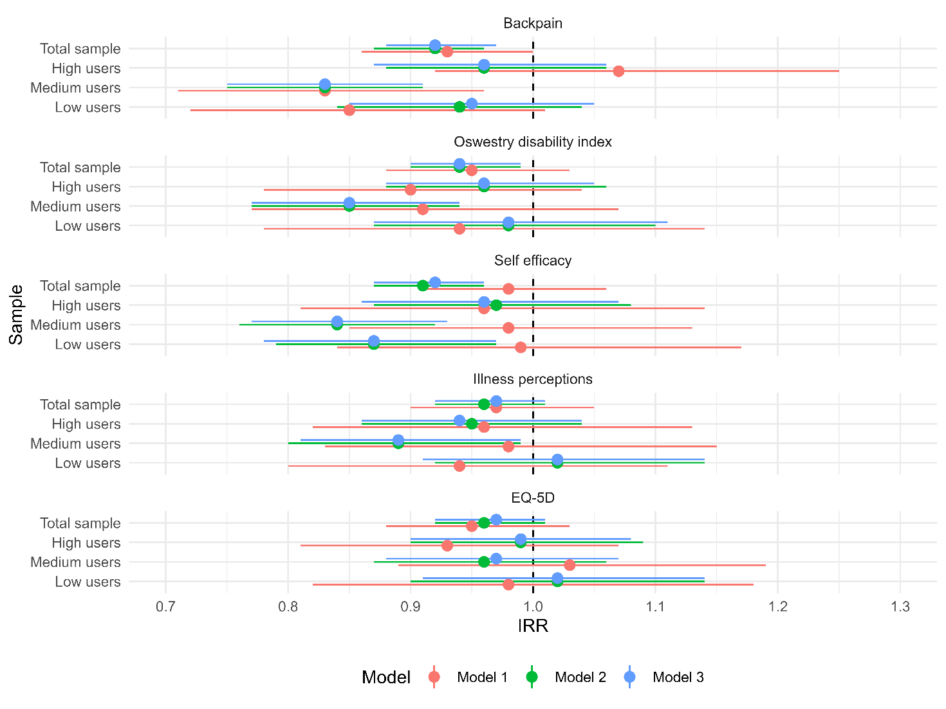

Figure S1 Associations between changes in PROMS and visits across models and samples

Incidence rate ratios (IRRs) are the exponentiated coefficients of the interaction between a PROM and time in the count part of the zero-inflated negative binomial regression analysis.
Model 1= crude model,
Model 2 = adjusted for sex, age, duration of pain episode, level of education, year of enrollment, use of visits or analgesics before enrollment,
Model 3 = as model 2 but additionally adjusted for each PROM score.
Models with visits as outcome included random intercepts for ID and clinic.
Low visit use, n= 1,028, visits range 0 to 4.
Medium visit use, n = 869, visits range 5 to 12.
High visit use, n = 906, visits range 13 to 166.

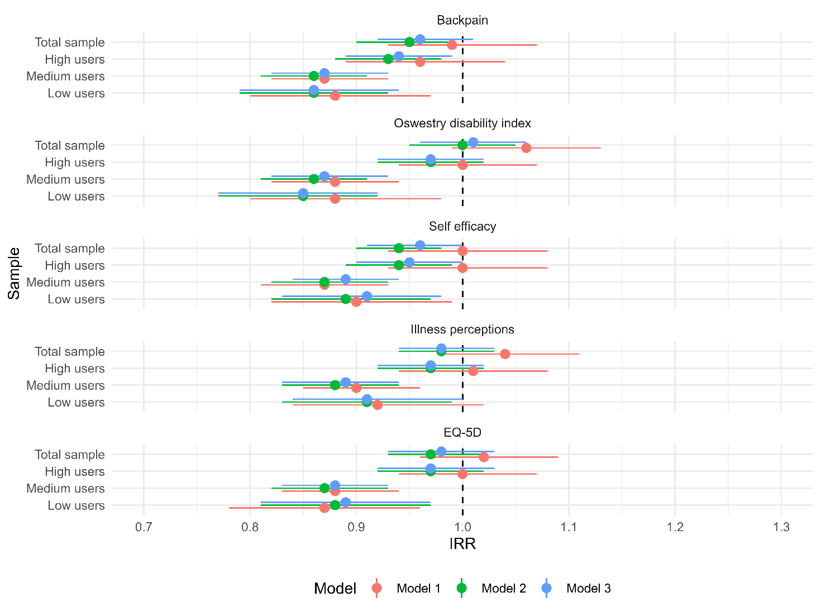
Figure S2 Associations between changes in PROMS and analgesics use across models and samples
Incidence rate ratios (IRRs) are the exponentiated coefficients of the interaction between a PROM and time in the count part of the zero-inflated negative binomial regression analysis.
Model 1= crude model,
Model 2 = adjusted for sex, age, duration of pain episode, level of education, year of enrollment, use of visits or analgesics before enrollment,
Model 3 = as model 2 but additionally adjusted for each PROM score.
Models with visits as outcome included random intercepts for ID and clinic.
Low analgesics use, n=634, DDD range 1 to 59.
Medium analgesics use, n=626, DDD range 61 to 165.
High analgesics use, n=621, DDD range 165 to 1,727.
DDD: defined daily dose

