Supplementary Figure 1. Univariable analysis of risk factors of CVD.
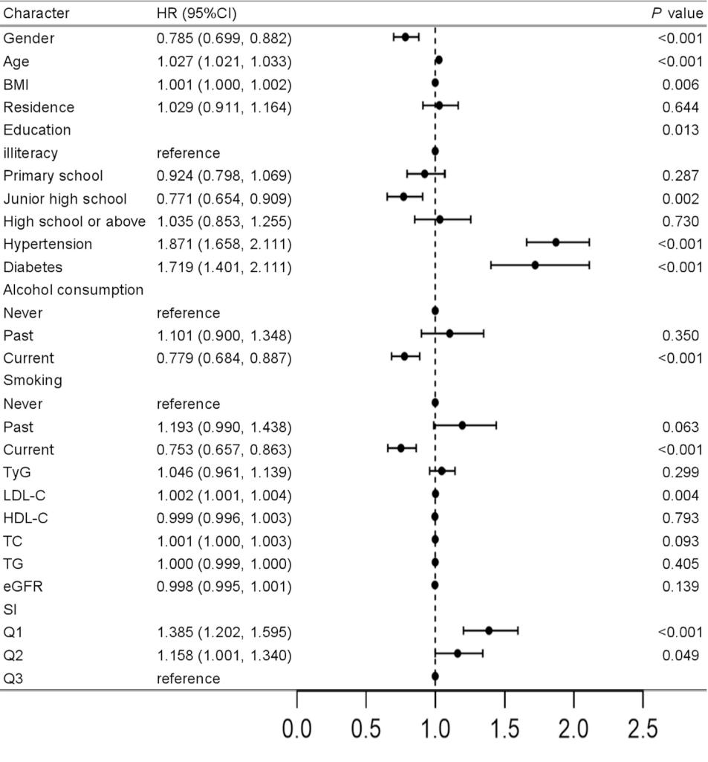
Abbreviations are the same as those shown in Table 1.SI levels, age, gender, hypertension, diabetes, smoking status, alcohol consumption, BMI, LDL-C, and education are associated with the risk of CVD.

Supplementary Figure 2. Subgroup analysis for the effect of SI on the risk of CVD.
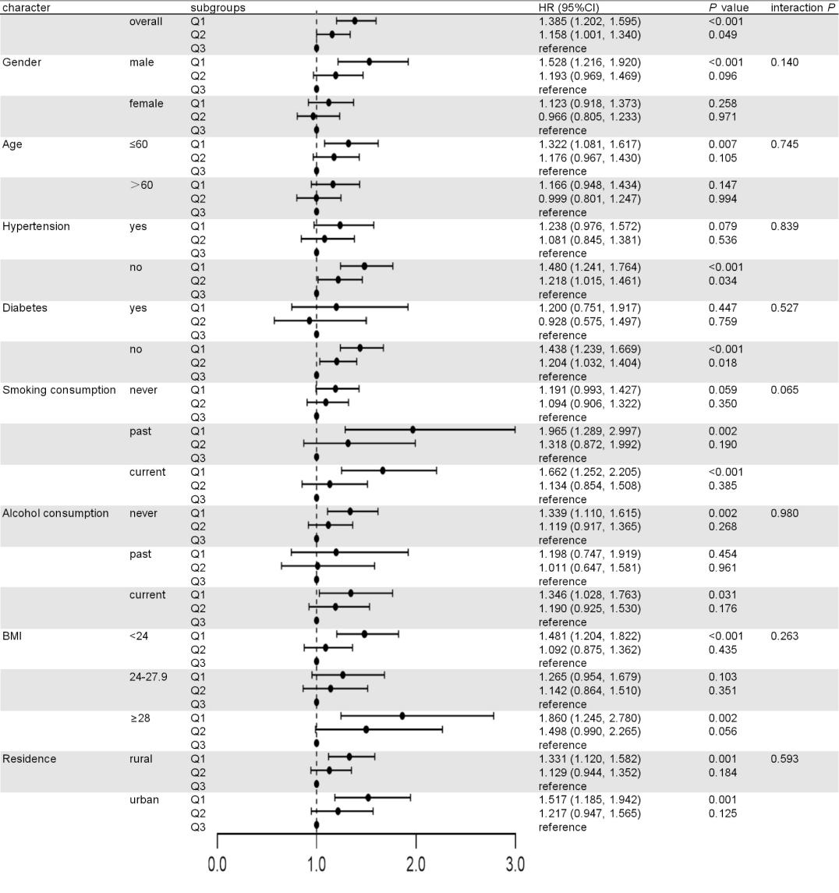
Crude model.

Supplementary Figure 3. The effect of SI on the risk of CVD in subgroups according to eGFR.
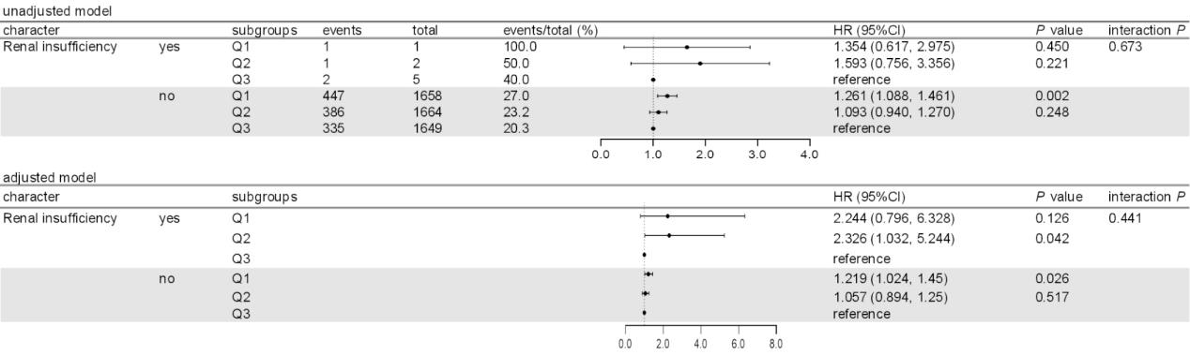
Adjusted model included age, gender, hypertension, diabetes, smoking status, alcohol consumption history, BMI, LDL-C and education.

