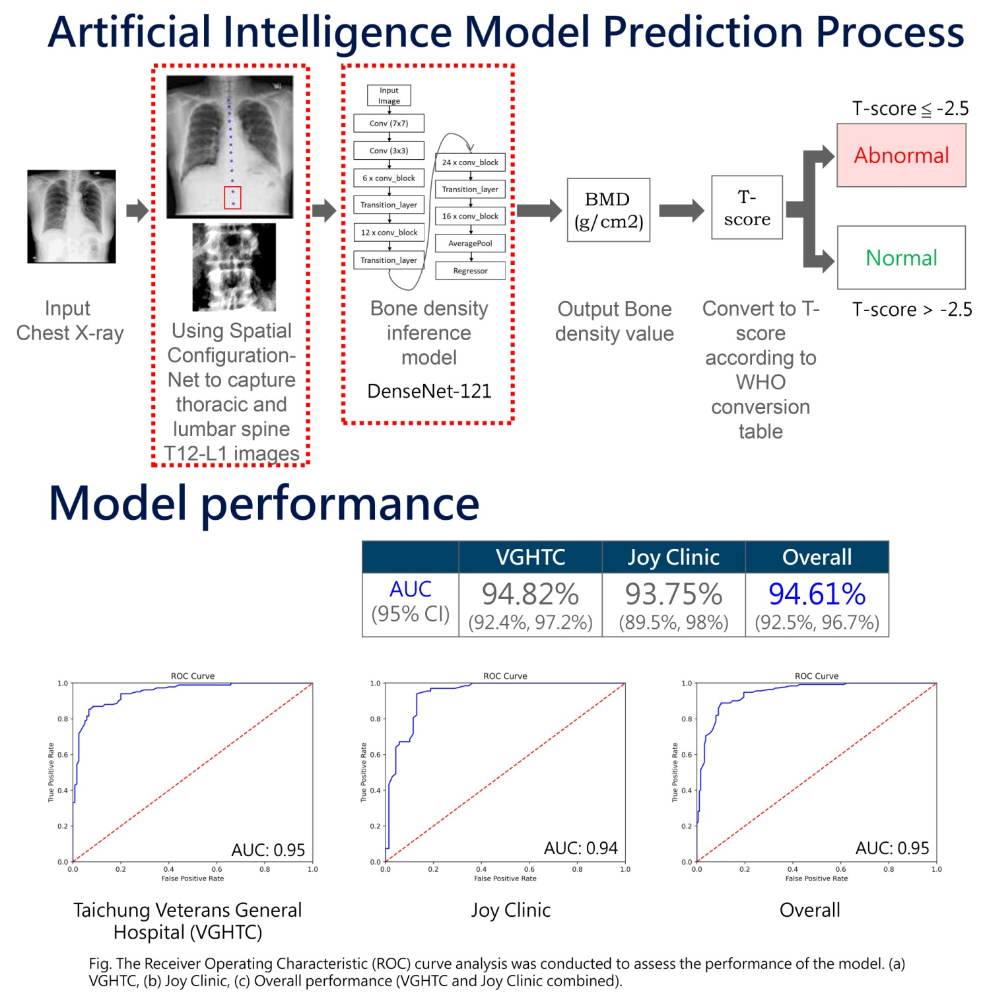
Figure S1. To develope and clinically validate VeriOsteo™ OP, an AI-powered software that analyzes routine chest X-rays (CXR) to estimate lumbar spine BMD and T-scores for opportunistic osteoporosis screening. First TFDA-approved AI software for osteoporosis screening in Taiwan.

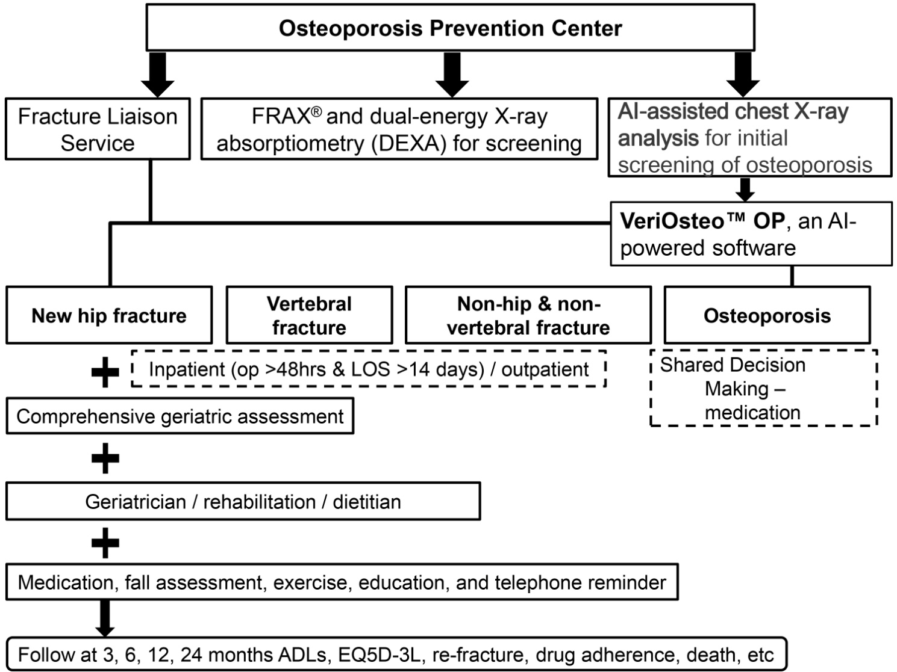

Figure S2. Osteoporosis prevention center and Fracture Liaison Service.
Abbreviations: ADLs, activities of daily living; EQ5D-3L, EuroQol-5 Dimensions 3 Level Version.

Table S1. Comparative analysis of clinical parameters and data from dual-energy X-ray absorptiometry across different sarcopenia and osteoporosis groups
 | Neither Sarcopenia nor Osteoporosis (n = 256)¹ |  | Sarcopenia alone (n = 85)² |  | Osteoporosis with/without Sarcopenia (n = 204)³ |  | p value | Dunn-Bonferroni post-hoc test
 | Median | (IQR) | Median | (IQR) | Median | (IQR) | p value | 1 vs 2 | 1 vs 3 | 2 vs 3
Age (yrs) | 63.7 | (54.1–74.3) | 69.5 | (55.4–81.9) | 74.9 | (65.3–82.2) | <0.001 | 0.018 | <0.001 | 0.007
<65, n (%) | 139 | (54.3) | 39 | (45.9) | 49 | (24.0) | <0.001 | <0.001 | <0.001 | <0.001
65-74, n (%) | 57 | (22.3) | 8 | (9.4) | 54 | (26.5)
75-84, n (%) | 54 | (21.1) | 28 | (32.9) | 78 | (38.2)
≥ 85, n (%) | 6 | (2.3) | 10 | (11.8) | 23 | (11.3)
Gender, n (%) |  |  |  |  |  |  | <0.001 | <0.001 | 0.072 | <0.001
Female | 178 | (69.5) | 42 | (49.4) | 174 | (85.3)
Male | 78 | (30.5) | 43 | (50.6) | 30 | (14.7)
ACCI | 2.0 | (1.0–4.0) | 2.0 | (0.5–4.0) | 3.0 | (1.0–4.8) | 0.060
BMI (kg/m²) | 25.0 | (22.9–27.6) | 20.6 | (19.2–23.5) | 22.6 | (20.8–25.4) | <0.001 | <0.001 | <0.001 | <0.001
Body composition
Android fat/Gynoid fat (A/G) ratio | 1.1 | (1.0–1.3) | 1.0 | (0.8–1.2) | 1.1 | (0.9–1.2) | 0.001 | 0.012 | 0.007 | 1.000
Total tissue (kg) | 62.7 | (55.3–69.9) | 50.8 | (46.1–59.0) | 51.7 | (47.1–58.2) | <0.001 | <0.001 | <0.001 | 1.000
Total fat (kg) | 22.3 | (18.3–27.1) | 16.4 | (14.2–20.7) | 18.7 | (15.5–22.9) | <0.001 | 0.012 | <0.001 | 0.020
Total lean tissue (kg) | 38.3 | (34.6–44.6) | 34.5 | (30.3–40.8) | 32.5 | (30.0–36.1) | <0.001 | <0.001 | <0.001 | 0.115
ASMI (kg/m²) | 6.8 | (6.0–7.6) | 5.3 | (5.1–6.4) | 5.9 | (5.4–6.5) | <0.001 | <0.001 | <0.001 | 0.014
BMD, L-spine | 1.113 | (0.997–1.249) | 1.118 | (0.970–1.238) | 0.871 | (0.788–0.992) | <0.001 | 1.000 | <0.001 | <0.001
BMD, left femoral neck | 0.830 | (0.754–0.912) | 0.817 | (0.760–0.918) | 0.644 | (0.577–0.685) | <0.001 | 1.000 | <0.001 | <0.001
BMD, right femoral neck | 0.831 | (0.767–0.918) | 0.840 | (0.764–0.916) | 0.641 | (0.591–0.681) | <0.001 | 1.000 | <0.001 | <0.001
T-score | -1.5 | (-2.1– -0.4) | -1.3 | (-2.0– -0.5) | -3.1 | (-3.6– -2.8) | <0.001 | 1.000 | <0.001 | <0.001
Fracture, n (%) | 26 | (10.2) | 7 | (8.2) | 47 | (23.0) | <0.001 | 0.678 | 0.001 | 0.004
Femur | 19 | (73.1) | 6 | (85.7) | 23 | (48.9) | 0.049 | 0.652 | 0.158 | 0.161
Radius | 2 | (7.7) | 1 | (14.3) | 4 | (8.5) | 0.697
Spine | 11 | (42.3) | 1 | (14.3( | 35 | (74.5) | 0.001 | 0.223 | 0.016 | 0.012
Laboratory data
Vitamin D (ng/mL) | 25.9 | (21.7–32.3) | 31.4 | (21.2–49.5) | 32.2 | (22.6–36.1) | 0.384
Creatinine (mg/dL) | 0.8 | (0.7–1.0) | 0.9 | (0.7–1.2) | 0.8 | (0.7–1.1) | 0.216
i-PTH (pg/mL) | 69.5 | (38.6–117.4) | 46.2 | (25.3–136.5) | 59.2 | (40.6–107.0) | 0.549
Albumin (g/dL) | 4.3 | (4.1–4.5) | 4.2 | (3.8–4.5) | 4.2 | (3.9–4.5) | 0.005 | 0.023 | 0.028 | 1.000
ALP (u/L) | 81.0 | (66.0–106.0) | 93.0 | (62.0–133.0) | 94.5 | (70.3–117.0) | 0.151
Medication, n (%) | 26 | (10.2) | 7 | (8.2) | 94 | (46.1) | <0.001 | 0.678 | <0.001 | <0.001
Number of medications | 1.0 | (1.0–1.3) | 1.0 | (1.0–1.0) | 1.0 | (1.0–1.0) | 0.404
Denosumab, n (%) | 10 | (38.5) | 1 | (14.3) | 60 | (63.8) | 0.004 | 0.378 | 0.038 | 0.038
Romosozumab, n (%) | 0 | (0) | 0 | (0) | 3 | (3.2) | 1.000
Fosamax, n (%) | 7 | (26.9) | 4 | (57.1) | 9 | (9.6) | 0.002 | 0.186 | 0.066 | 0.015
Raloxifene, n (%) | 9 | (34.6) | 1 | (14.3) | 18 | (19.1) | 0.213
Teriparatide, n (%) | 4 | (15.4) | 1 | (14.3) | 18 | (19.1) | 0.914
Zoledronic, n (%) | 2 | (7.7) | 0 | (0) | 6 | (6.4) | 0.801
Ibandronate, n (%) | 0 | (0) | 0 | (0) | 2 | (2.1) | 1.000
Abbreviations: ACCI, age-adjusted Charlson comorbidity index; BMI, body mass index; ASMI, appendicular skeletal muscle index; BMD, bone mineral density; i-PTH, intact parathyroid hormone; ALP, Alkaline phosphatase.

Table S2. Comparisons between survivors and deceased patients, as well as patients with or without sarcopenia and osteoporosis
 | Alive (n = 521) |  | Deceased (n = 24) |  | p value
 | Median | (IQR) | Median | (IQR) | p value
Follow-up years | 0.7 | (0.2–1.4) | 0.3 | (0.2–2.4) | 0.198
Sarcopenia & Osteoporosis, n (%) |  |  |  |  | <0.001
Neither Sarcopenia nor Osteoporosis | 254 | (48.8) | 2 | (8.3)
Sarcopenia alone | 78 | (15.0) | 7 | (29.2)
Osteoporosis alone | 117 | (22.5) | 9 | (37.5)
Both Sarcopenia and Osteoporosis | 72 | (13.8) | 6 | (25.0)
Sarcopenia & Osteoporosis, n (%) |  |  |  |  | 0.001
Neither Sarcopenia nor Osteoporosis | 254 | (48.8) | 2 | (8.3)
Osteoporosis alone | 117 | (22.5) | 9 | (37.5)
Sarcopenia with/without Osteoporosis | 150 | (28.8) | 13 | (54.2)
Age | 68.0 | (58.0–80.1) | 82.4 | (75.7–88.7) | <0.001
BMI (kg/m²) | 23.6 | (21.2–26.1) | 23.8 | (20.0–26.5) | 0.789
ACCI | 2.0 | (1.0–4.0) | 4.0 | (3.0–6.0) | 0.007
Body composition
Android fat/Gynoid fat (A/G) ratio | 1.1 | (1.0–1.3) | 1.2 | (1.1–1.3) | 0.179
Total tissue (kg) | 56.3 | (50.6–64.9) | 48.4 | (40.8–61.2) | 0.013
Total fat (kg) | 19.8 | (16.3–24.8) | 16.5 | (14.0–23.1) | 0.129
Total lean tissue (kg) | 35.5 | (31.9–41.0) | 33.4 | (27.5–38.8) | 0.031
ASMI (kg/m²) | 6.2 | (5.6–7.0) | 6.1 | (5.4–6.4) | 0.167
BMD, L-spine | 1.019 | (0.904–1.174) | 1.126 | (0.886–1.178) | 0.642
BMD, left femoral neck | 0.755 | (0.674–0.859) | 0.675 | (0.606–0.804) | 0.065
BMD, right femoral neck | 0.765 | (0.667–0.865) | 0.637 | (0.603–0.843) | 0.021
T-score | -2.1 | (-2.8– -1.2) | -3.0 | (-3.5– -1.6) | 0.021
Fracture, n (%) | 77 | (14.8) | 3 | (12.5) | 1.000
Femur | 48 | (62.3) | 0 | (0) | 0.060
Radius | 7 | (9.1) | 0 | (0) | 1.000
Spine | 44 | (57.1) | 3 | (100) | 0.264
Laboratory data
Vitamin D (ng/dL) | 28.8 | (21.9–35.2) | - | - | -
Creatinine (mg/dL) | 0.8 | (0.7–1.0) | 1.6 | (0.8–2.9) | <0.001
i-PTH (pg/mL) | 60.7 | (39.0–110.0) | 107.0 | (6.7–107.0) | 0.724
Albumin (g/dL) | 4.3 | (4.0–4.5) | 3.6 | (2.9–3.9) | <0.001
ALP (u/L) | 86.0 | (66.0–112.0) | 119.0 | (74.0–174.0) | 0.019
Physical performance
Timed up and go test (sec) | 11.9 | (9.1–13.2) | 18.7 | (12.0–40.5) | 0.052
6-meter walking test (sec) | 6.1 | (5.2–7.4) | 10.8 | (7.5–32.3) | 0.008
Handgrip strength (kg) | 20.0 | (14.8–24.6) | 6.4 | (6.0–13.5) | <0.001
Medication, n (%) | 116 | (22.3) | 11 | (45.8) | 0.008
Number of medications | 1.0 | (1.0–1.0) | 1.0 | (1.0–1.0) | 0.105
Denosumab, n (%) | 60 | (51.7) | 11 | (100) | 0.002
Romosozumab, n (%) | 3 | (2.6) | 0 | (0) | 1.000
Fosamax, n (%) | 20 | (17.2) | 0 | (0) | 0.211
Raloxifene, n (%) | 28 | (24.1) | 0 | (0) | 0.121
Teriparatide, n (%) | 23 | (19.8) | 0 | (0) | 0.213
Zoledronic, n (%) | 8 | (6.9) | 0 | (0) | 1.000
Ibandronate, n (%) | 2 | (1.7) | 0 | (0) | 1.000
Abbreviations: BMI, body mass index; ACCI, age-adjusted Charlson comorbidity index; BMD, bone mineral density; i-PTH, intact parathyroid hormone; ALP, Alkaline phosphatase.

Table S3. The statistical power was calculated based on the number of events (deaths).
Sarcopenia (by Asmi)
 | No (n=382) |  | Yes (n=163) |  | p value
 | n | (%) | n | (%) | p value
Mortality |  |  |  |  | 0.008**
No | 371 | (97.1%) | 150 | (92.0%)
Yes | 11 | (2.9%) | 13 | (8.0%)
Chi-Square test. Fisher's exact test. *p<0.05, **p<0.01.
Osteoporosis (by T-score)
 | No (n=341) |  | Yes (n=204) |  | p value
 | n | (%) | n | (%) | p value
Mortality |  |  |  |  | 0.009**
No | 332 | (97.4%) | 189 | (92.6%)
Yes | 9 | (2.6%) | 15 | (7.4%)
Chi-Square test. Fisher's exact test. *p<0.05, **p<0.01.

- Post hoc power calculation of sarcopenia (No 382 versus Yes 163) in survival status.
Exact - Proportions: Inequality, two independent groups (Fisher's exact test)
Options: Exact distribution
Analysis: Post hoc: Compute achieved power
Input: Tail(s) = Two
Proportion p1 = 0.0290000
Proportion p2 = 0.08
α err prob = 0.05
Sample size group 1 = 382
Sample size group 2 = 163
Output: Power (1-β err prob) = 0.6787769 (68%-Sarcopenia)
Actual α = 0.0402392

- Post hoc power calculation of osteoporosis (No 341 versus Yes 204) in survival status.
Exact - Proportions: Inequality, two independent groups (Fisher's exact test)
Options: Exact distribution
Analysis: Post hoc: Compute achieved power
Input: Tail(s) = Two
Proportion p1 = 0.0260000
Proportion p2 = 0.074
α err prob = 0.05
Sample size group 1 = 341
Sample size group 2 = 204
Output: Power (1-β err prob) = 0.7076415 (71%-Osteoporosis)
Actual α = 0.0402562

Table S4A. Cox regression analysis for all-cause mortality in patients with Denosumab
 | Multiple model |  | Multiple model |  | Multiple model
 | HR (95%CI) | p value | HR (95%CI) | p value | HR (95%CI) | p value
Sarcopenia & Osteoporosis
Neither Sarcopenia nor Osteoporosis | 1.00
Sarcopenia alone | 11.74 (2.42 - 56.86) | 0.002
Osteoporosis alone | 4.40 (0.86 - 22.40) | 0.074
Both Sarcopenia and Osteoporosis | 5.52 (1.04 - 29.38) | 0.045
Sarcopenia & Osteoporosis
Neither Sarcopenia nor Osteoporosis |  |  | 1.00
Osteoporosis alone |  |  | 5.09 (1.03 - 25.08) | 0.046
Sarcopenia with/without Osteoporosis |  |  | 8.27 (1.84 - 37.13) | 0.006
Sarcopenia & Osteoporosis
Neither SP nor OP |  |  |  |  | 1.00
SP alone |  |  |  |  | 11.72 (2.42 - 56.73) | 0.002
OP with/without SP |  |  |  |  | 4.82 (1.01 - 23.08) | 0.049
Denosumab | 3.25 (1.17 - 9.05) | 0.024 | 2.48 (1.04 - 5.94) | 0.041 | 3.21 (1.16 - 8.92) | 0.025
Cox regression. *p<0.05, **p<0.01.

Table S4B. Cox regression analysis for all-cause mortality in patients with Denosumab in the adjustment of age and ACCI
 | Multiple model |  | Multiple model |  | Multiple model
 | HR | p value | HR | p value | HR | p value
Sarcopenia & Osteoporosis
Neither Sarcopenia nor Osteoporosis | 1.00
Sarcopenia alone | 9.08 (1.78-46.36) | 0.008
Osteoporosis alone | 2.99 (0.59-15.21) | 0.187
Both Sarcopenia and Osteoporosis | 2.99 (0.54-16.42) | 0.208
Sarcopenia & Osteoporosis
Neither Sarcopenia nor Osteoporosis |  |  | 1.00
Osteoporosis alone |  |  | 3.59 (0.72-17.77) | 0.117
Sarcopenia with/without Osteoporosis |  |  | 5.20 (1.11-24.43) | 0.037
Sarcopenia & Osteoporosis
Neither SP nor OP |  |  |  |  | 1.00
SP alone |  |  |  |  | 9.08 (1.78-46.36) | 0.008
OP with/without SP |  |  |  |  | 2.99 (0.62-14.46) | 0.173
Age | 1.05 (1.01-1.10) | 0.024 | 1.05 (1.00-1.10) | 0.032 | 1.05 (1.01-1.10) | 0.023
ACCI | 1.20 (1.02-1.42) | 0.027 | 1.20 (1.01-1.41) | 0.035 | 1.20 (1.02-1.42) | 0.026
Denosumab | 2.53 (0.87-7.36) | 0.089 | 1.69 (0.70-4.12) | 0.246 | 2.53 (0.87-7.36) | 0.089
Cox regression. *p<0.05, **p<0.01.

Table S4C. Association between denosumab and patients with sarcopenia or osteoporosis
 | Without Denosumab (n=474) |  |  | With Denosumab (n=71)
 | Alive | Mortality | p value | Alive | Mortality | p value
Sarcopenia & Osteoporosis |  |  | 0.002 |  |  | 0.588
Neither Sarcopenia nor Osteoporosis | 244 (52.9) | 2 (15.4) |  | 10 (16.7) | 0 (0)
Sarcopenia alone | 77 (16.7) | 7 (53.8) |  | 1 (1.7) | 0 (0)
Osteoporosis alone | 84 (18.2) | 1 (7.7) |  | 33 (55.0) | 8 (72.7)
Both Sarcopenia and Osteoporosis | 56 (12.1) | 3 (23.1) |  | 16 (26.7) | 3 (27.3)
Sarcopenia & Osteoporosis |  |  | 0.002 |  |  | 0.470
Neither Sarcopenia nor Osteoporosis | 244 (52.9) | 2 (15.4) |  | 10 (16.7) | 0 (0)
Osteoporosis alone | 84 (18.2) | 1 (7.7) |  | 33 (55.0) | 8 (72.7)
Sarcopenia with/without Osteoporosis | 133 (28.9) | 10 (76.9) |  | 17 (28.3) | 3 (27.3)
Sarcopenia & Osteoporosis |  |  | 0.002 |  |  | <0.001
Neither SP nor OP | 244 (52.9) | 2 (15.4) |  | 10 (16.7) | 0 (0)
SP alone | 77 (16.7) | 7 (53.8) |  | 1 (1.7) | 0 (0)
OP with/without SP | 140 (30.4) | 4 (30.8) |  | 49 (81.7) | 11 (100)
Fisher-Freeman-Halton Exact test. *p<0.05, **p<0.01.

Table S5. 36-month survival rate and Log Rank test.
Figure 2a. Kaplan-Meier Plot based on categorization as neither sarcopenia nor osteoporosis, osteoporosis alone, and sarcopenia with/without osteoporosis at baseline.
 | 36M survival rate | Log Rank test
Neither SP nor OP vs OP alone vs OP±SP | 99.6% vs 96.8% vs 92.4% | 0.006**
Neither SP nor OP vs OP alone | 99.6% vs 96.8% | <0.001**
Neither SP nor OP vs OP±SP | 99.6% vs 92.4% | 0.013*
OP alone vs OP±SP | 96.8% vs 92.4% | 0.199

Figure 2b. Kaplan-Meier Plot based on categorization as neither sarcopenia nor osteoporosis, sarcopenia alone, and osteoporosis with/without sarcopenia at baseline.
 | 36M survival rate | Log Rank test
Neither SP nor OP vs SP alone vs OP±SP | 99.6% vs 89.4% vs 96.5% | 0.003**
Neither SP nor OP vs SP alone | 99.6% vs 89.4% | <0.001**
Neither SP nor OP vs OP±SP | 99.6% vs 96.5% | 0.013*
SP alone vs OP±SP | 89.4% vs 96.5% | 0.199

Table S6A. Mortality analysis of patients with or without osteoporosis medication use, comparing controls, osteoporosis alone, and sarcopenia with/without osteoporosis.
 | Without medication |  |  | With medication
 | Alive | Mortality | p value | Alive | Mortality | p value
Group 2 |  |  | 0.001** |  |  | 0.140
Neither Sarcopenia nor Osteoporosis | 228 (56.3) | 2 (15.4) |  | 26 (22.4) | 0 (0)
Osteoporosis alone | 65 (16.0) | 1 (7.7) |  | 52 (44.8) | 8 (72.7)
Sarcopenia with/without Osteoporosis | 112 (27.7) | 10 (76.9) |  | 38 (32.8) | 3 (27.3)
Fisher-Freeman-Halton Exact test. *p<0.05, **p<0.01.

Table S6B. Cox regression analysis for all-cause mortality in patients with or without osteoporosis medication among patient with sarcopenia and osteoporosis
 | Simple model
 | Total |  | Without medication |  | With medication
 | HR (95%CI) | p value | HR (95%CI) | p value | HR (95%CI) | p value
Group 2
Neither Sarcopenia nor Osteoporosis | 1.00 |  | 1.00 |  | ---
Osteoporosis alone | 7.53 (1.62 - 34.95) | 0.010 | 1.70 (0.15 - 18.76) | 0.665 | 1.00
Sarcopenia with/without Osteoporosis | 9.71 (2.19 - 43.04) | 0.003 | 9.96 (2.18 - 45.46) | 0.003 | 0.49 (0.13 - 1.84) | 0.289
With medication | 1.73 (0.76 - 3.93) | 0.194
Cox regression. *p<0.05, **p<0.01.

Table S6C. Cox regression analysis for all-cause mortality in patients with or without osteoporosis medication among patient with sarcopenia and osteoporosis
 | Simple model
 | Total |  | Without medication |  | With medication
 | HR (95%CI) | p value | HR (95%CI) | p value | HR (95%CI) | p value
Group 2
Neither Sarcopenia nor Osteoporosis | 1.00 |  | 0.10 (0.02-0.46) | 0.003 | ---
Osteoporosis alone | 7.53 (1.62 - 34.95) | 0.010 | 0.17 (0.02-1.34) | 0.092 | 2.05 (0.54-7.76) | 0.289
Sarcopenia with/without Osteoporosis | 9.71 (2.19 - 43.04) | 0.003 | 1.00 |  | 1.00
With medication | 1.73 (0.76 - 3.93) | 0.194
Cox regression. *p<0.05, **p<0.01.

