Supplementary figures and tables:
Figure S1. Flowchart of pediatric generalized pustular psoriasis (GPP) patients selection
The pediatric GPP inpatients (n=62) diagnosed according to Asia-Pacific consensus criteria (March 1, 2017 and February 29, 2024)

Excluded (n=1)：
The diagnosis was corrected to EKC syndrome at follow-up (n=1)

Pediatric patients for analysis (n=61)

34 patients with complete follow-up information on GPP flares at post-discharge, as of Jun. 2024
Patients excluded for efficacy analyses (n=6):
Pustules lacked pustules lesions at admission (n=3)
Patients who self-discharged (n=3)

38 patients with post-discharge GPPGA scores. n=38, 35, 26 at week 24, 48, 96, respectively.

Not for comparison in combination therapy (n=4)

51 inpatients with GPPGA scores for efficacy comparison

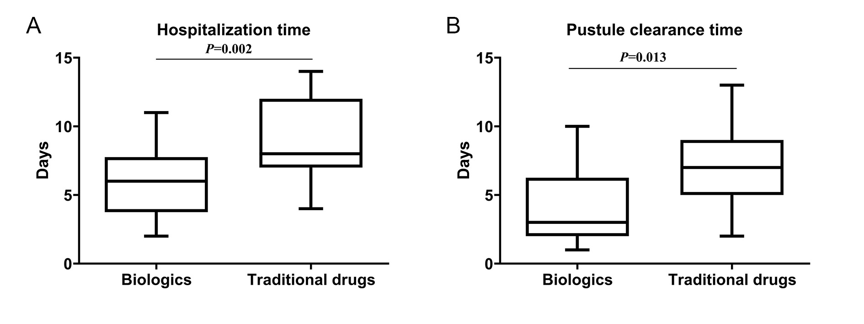
Figure S2. Differences in hospitalization time (A) and pustule clearance time (B) between biologics and traditional drugs.
Data presented are the mean values and extreme values.

Table S1. Comparison of demographic and clinical characteristics of GPP with PV and without PV.
 | All | GPP with PV | GPP without PV | P value
Male sex | 37 (60.7) | 15 (57.7) | 22 (62.9) | 0.683
Ag, year | 10.6±3.2 | 10.4±3.4 | 10.7±3.2 | 0.783
Age of GPP onset, year | 8.8±3.7 | 9.5±4.1 | 8.5±3.2 | 0.336
0-5 | 7 (11.5) | 4 (15.4) | 3 (8.6)
6-12 | 47 (77.0) | 18 (69.2) | 29 (82.9)
13-17 | 7 (11.5) | 4 (15.4) | 3 (8.6)
Weight, kg | 39.4±12.2 | 41.2±13.5 | 38.1±11.2 | 0.337
History of family psoriasis | 12 (19.7) | 8 (30.8) | 4 (11.4) | 0.060
Concomitant symptoms | 57 (93.4) | 23 (88.5) | 34 (97.1) | 0.406
Pruritus | 48 (78.7) | 20 (76.9) | 28 (80.0) | 0.772
Fever | 39 (63.9) | 18 (69.2) | 21 (60.0) | 0.458
Temp＞39℃ | 18 (29.5) | 6 (23.1) | 12 (34.3) | 0.343
Temp≤39℃ | 21 (34.4) | 12 (46.2) | 9 (25.7) | 0.097
Skin pain | 19 (31.1) | 6 (23.1) | 13 (37.1) | 0.241
Lower extremity edema | 4 (6.6) | 2 (7.7) | 2 (5.7) | ＞0.999
Arthralgia | 4 (6.6) | 0 (0.0) | 4 (11.4) | 0.208
GPPGA score at baselineª | 3.0 (3.0, 3.0) | 3.0 (3.0, 3.0) | 3.0 (3.0, 3.0) | 0.942
Pustule subscore at baselineª | 3.0 (2.0, 4.0) | 3.5 (3.0, 4.0) | 3.0 (2.0, 4.0) | 0.362
The hospitalization time, day | 8.0 (6.0, 12.0) | 9.0 (7.0, 11.0) | 8.0 (6.0, 13.0) | 0.817
The fever normalization time, day | 4.0 (2.0, 6.0) | 4.0 (2.5, 4.5) | 4.0 (1.3, 7.5) | 0.756
The pustule clearance time, day | 7.0 (4.0, 9.0) | 7.0 (5.0, 9.5) | 5.0 (3.0, 8.0) | 0.285
Effective rateª, % | 98.2 | 95.5 | 100.0 | 0.400
Pustule clearance rateª, % | 76.4 | 77.3 | 75.8 | 0.897
Data are presented as mean±SD, median (IQR), or n (%).
GPP, generalized pustular; PV, psoriasis; GPPGA, Generalized Pustular Psoriasis Physician Global Assessment.
ªData are available in 55 cases.
P values represent a comparison between GPP with PV vs GPP without PV.

