Macrophage-Derived Exosomal BMPR2 Mediates Alveolar Epithelial Repair and Cellular Crosstalk in Acute Lung Injury
Xiang Yun¹⁻³, Fei Li¹, Zhen Chen⁴, Jiahua Meng¹, Lin Zhang^{2,3,5}, Juxiang Yuan¹

1. School of Public Health, North China University of Science and Technology, Tangshan 063000, China.
2. Clinical Medical Research Center for Women and Children Diseases, Shandong Provincial Maternal and Child Health Care Hospital Affiliated to Qingdao University, Jinan 250001, China.
3. Key Laboratory of Occupational Exposure and Fertility Preservation for Women of Shandong Health Commission, Shandong Provincial Maternal and Child Health Care Hospital Affiliated to Qingdao University, Jinan 250001, China.
4. School of Public Health, Shandong Second Medical University, Weifang 261053, China
5. Henan Medical Key Laboratory for Research of Trauma and Orthopedics, The Third Affiliated Hospital of Xinxiang Medical University, Xinxiang 453000, China.

Correspondence to:
Juxiang Yuan M. D.
School of Public Health, School of Public Health, North China University of Science and Technology, Tangshan 063000, China. Email: yuanjx@ncst.edu.cn
Lin Zhang M. D.
Clinical Medical Research Center for Women and Children Diseases, Shandong Provincial Maternal and Child Health Care Hospital Affiliated to Qingdao University, Jinan 250001, China. Tel: +86-531-68795920, Email: zhanglin8901@sdu.edu.cn
Supplementary Figures
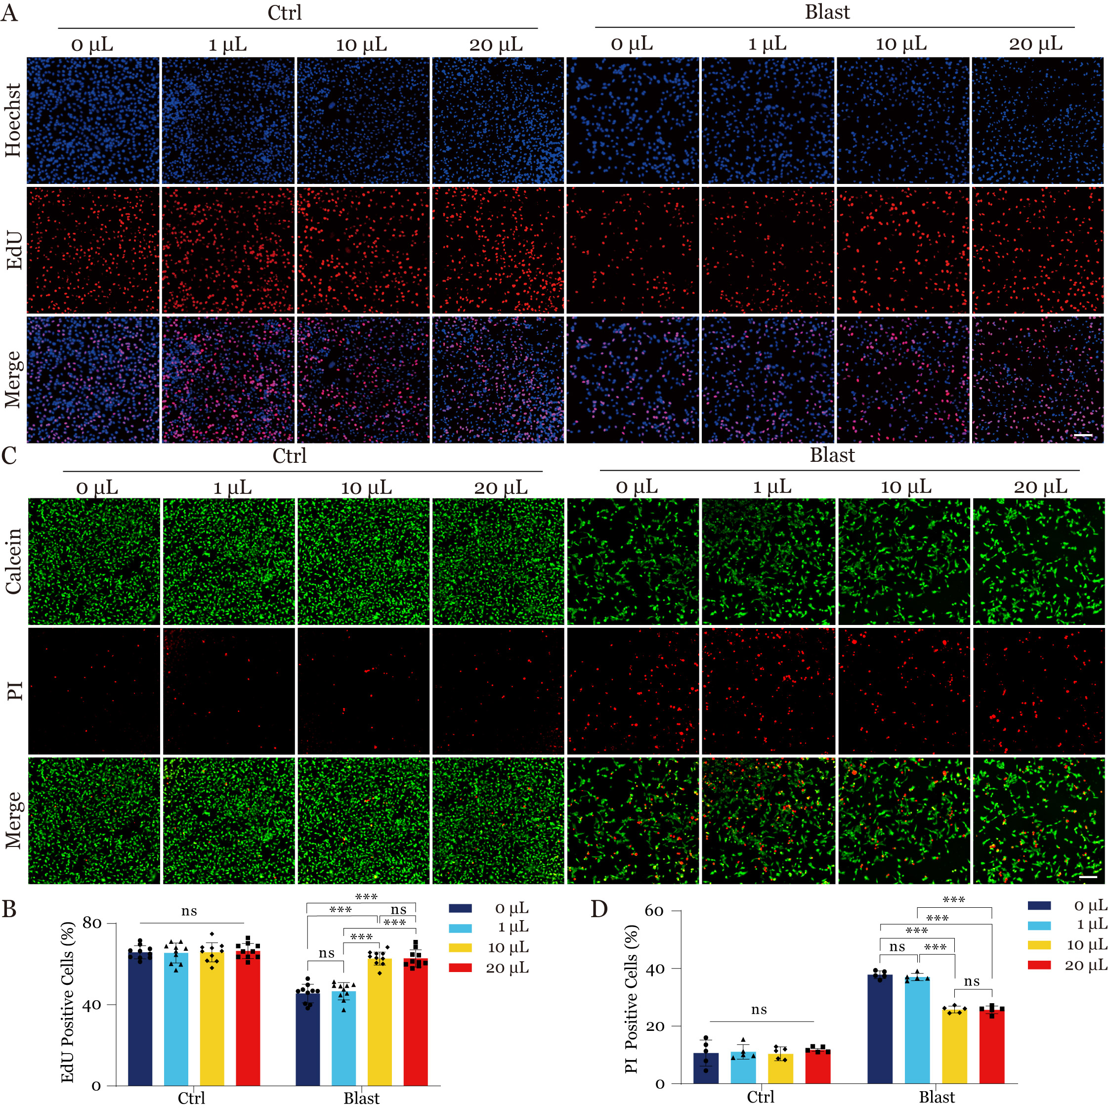
Figure S1. Effects of different exosome concentrations on type II alveolar epithelial cell proliferation and viability. (A) Representative EdU staining images showed the cell proliferation of different concentrations of extracellular vesicles in the Ctrl and Blast groups. Blue: Hoechst-stained nuclei; Red: EdU-positive cells. Scale bar = 100 μm. (B) Quantification of EdU-positive cells analysis across different concentrations of extracellular vesicles in the Ctrl and Blast groups. Data are presented as mean ± SD. Statistical significance: ***P < 0.001, ns: not significant. (C) Calcein-AM/PI double staining showing cell viability under exosome treatment conditions in different groups. (green: viable cells; red: dead cells). Scale bar = 100 μm. (D) Quantification of cell viability analysis across different concentrations of extracellular vesicles in the Ctrl and Blast groups. Data are presented as mean ± SD. Statistical significance: ***P < 0.001, ns: not significant.
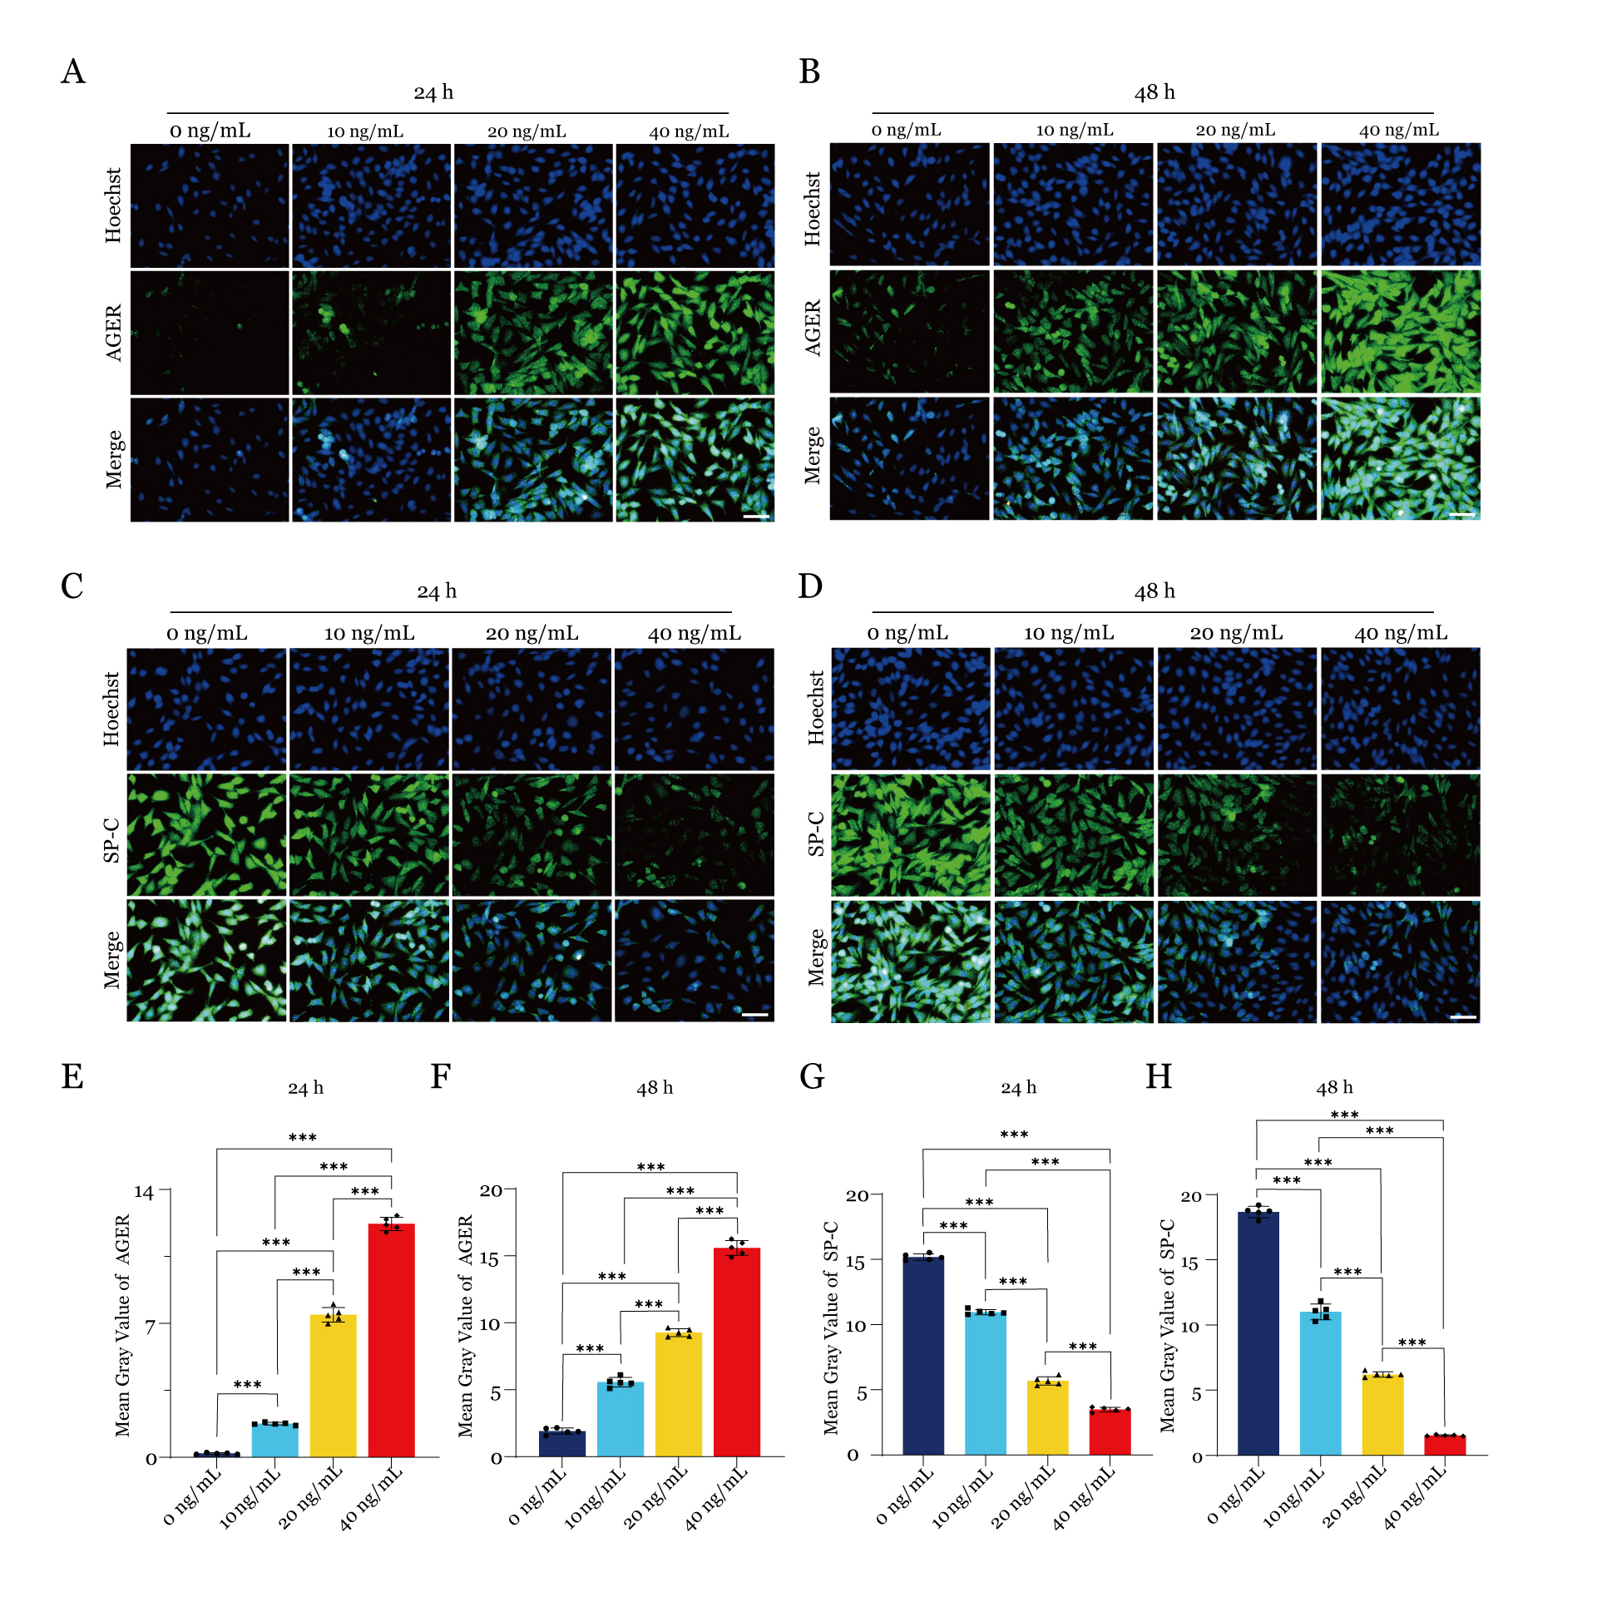
Figure S2. Effect of TGF-β on type II alveolar epithelial cell transdifferentiation. (A, B) Immunofluorescence analysis of AGER expression in response to different TGF-β1 concentrations at 24 hours (A) and 48 hours (B). (C, D) Immunofluorescence analysis of SP-C expression under the same conditions. (E-H) Quantification of mean gray values for AGER (E, F) and SP-C (G, H) at 24 and 48 hours. Data are presented as mean ± SD. Statistical significance: ***P < 0.001.
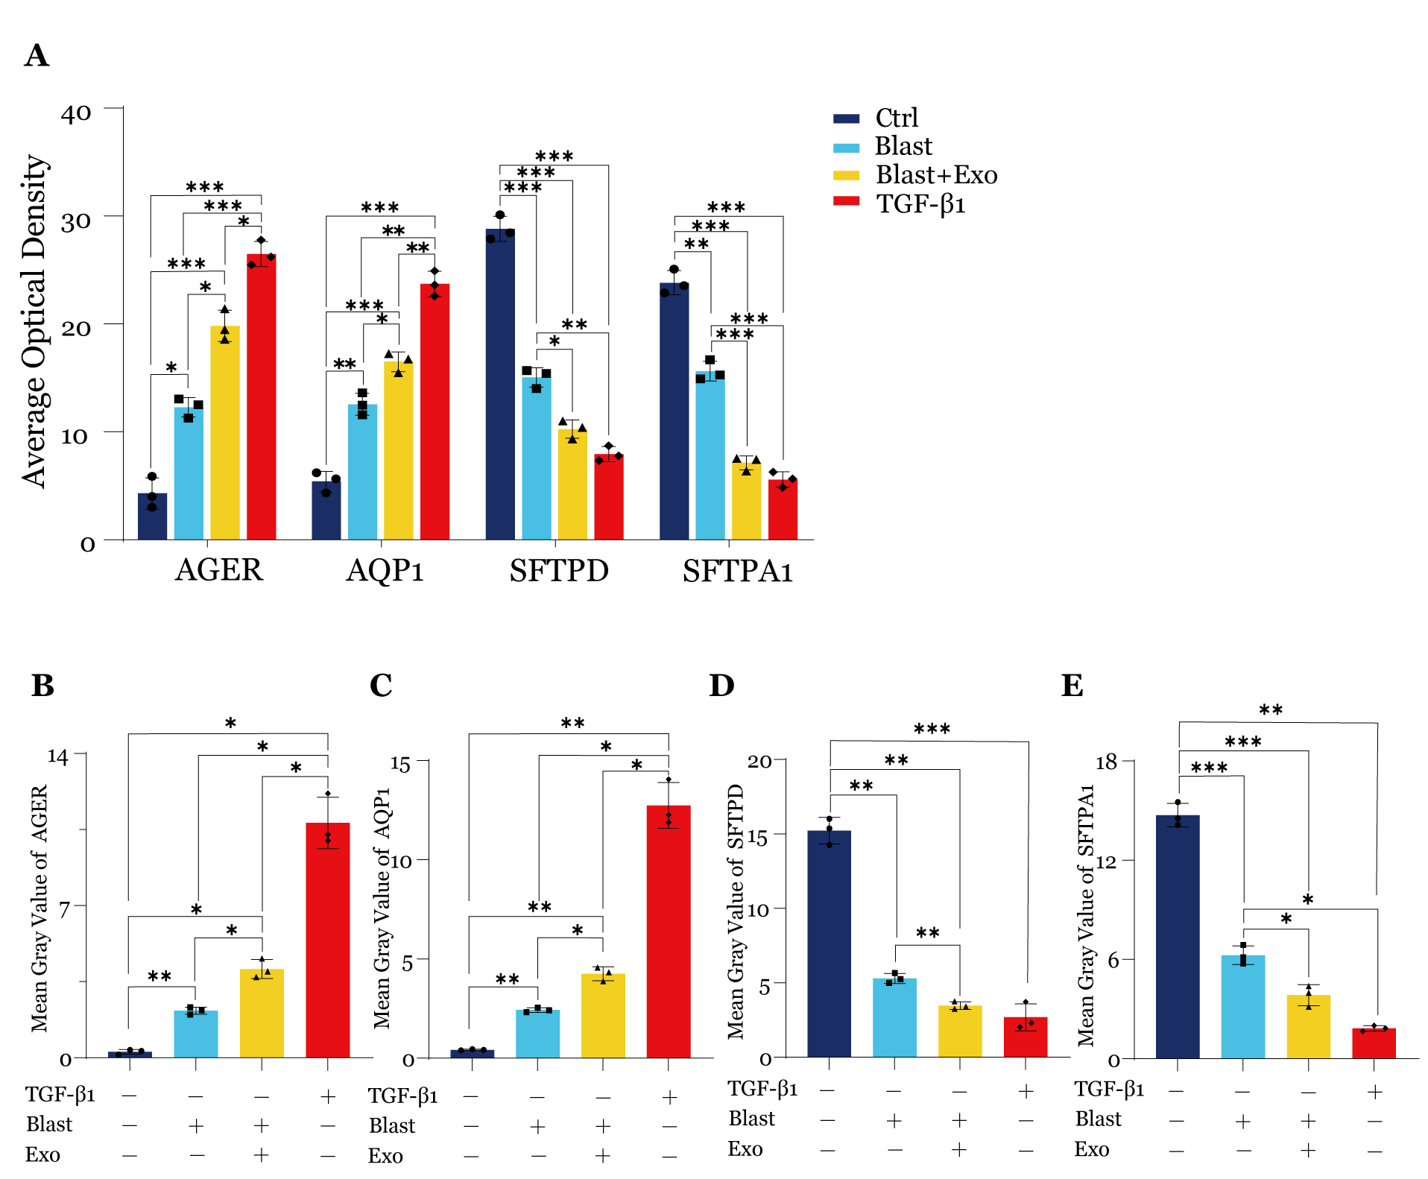
Figure S3. Quantitative analysis of immunohistochemistry and immunofluorescence results demonstrating macrophage exosome effects on type II alveolar epithelial cell transdifferentiation. (A) Quantification of average optical density across treatment groups. (B-E) Mean gray value analysis of immunofluorescence staining. Data are presented as mean ± SD. Statistical significance: *P < 0.05, **P < 0.01, ***P < 0.001.

