Supplementary Materials
Figure S1. Changes in cellular ratios between autoimmune diseases.
(A) UMAP plot showing cell distribution across different disease groups without batch effect integration. (B) UMAP plot displaying cell clustering after integration using the Harmony algorithm. (C) Cell integration effect based on Hamony algorithm. (D) LISI evaluation of the batch effect removal by the Harmony algorithm across different samples. (E) Bubble plot showing marker gene expression in peripheral blood cells of autoimmune diseases.
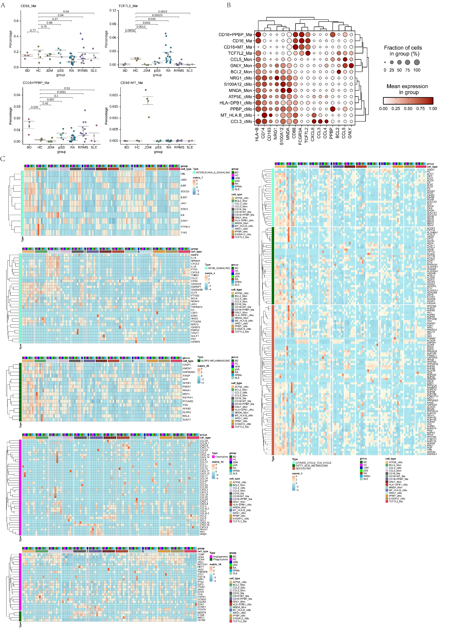
Figure S2. A. The cellular proportions of different monocyte-macrophage subsets in disease states. B. Characteristic marker genes of monocyte-macrophage subsets. C. The expression profiles of genes related to inflammation, immunity, metabolism, phagocytosis, and angiogenesis in monocyte-macrophage subsets.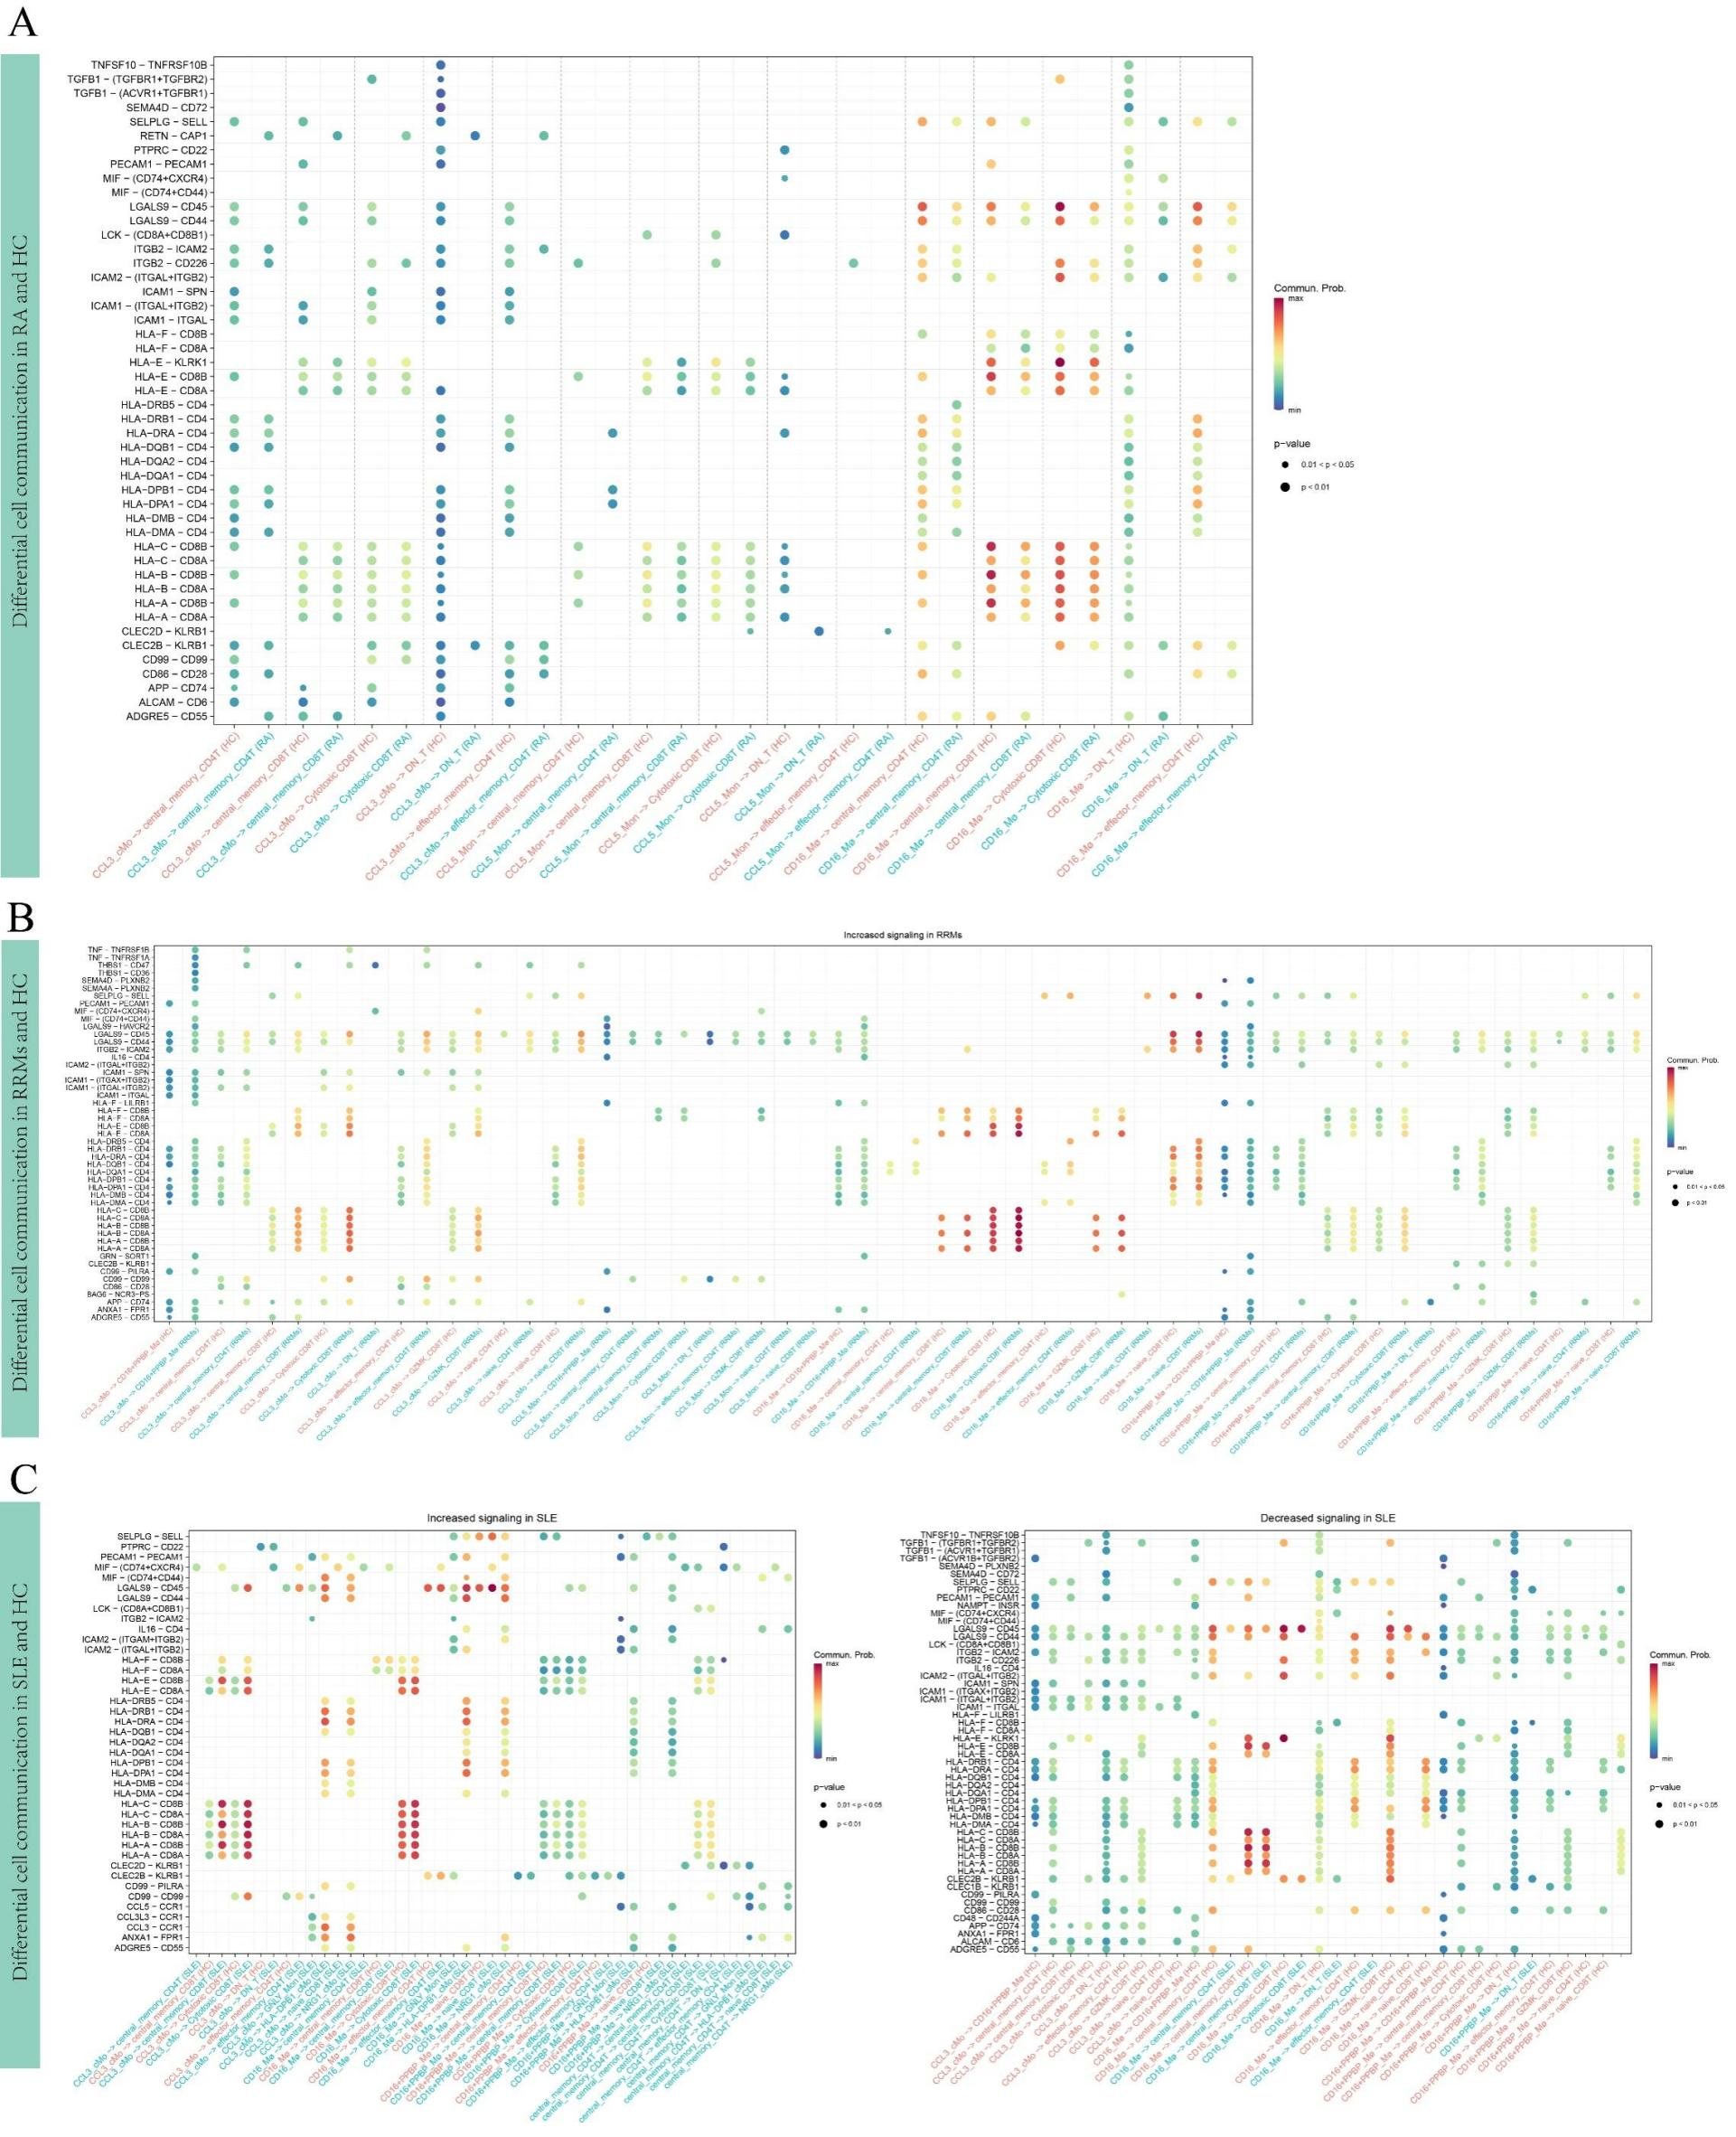
Figure S3. CCL3 monocytes enhance the antigen presentation function of T cells in SLE, RRMs, and RA. (A) Difference of signal communication between RA and healthy mononuclear phagocytes on T cells. (B) Difference of signal communication between RRMS and healthy mononuclear phagocytes on T cells. (C) Difference of signal communication between SLE and healthy mononuclear phagocytes on T cells.

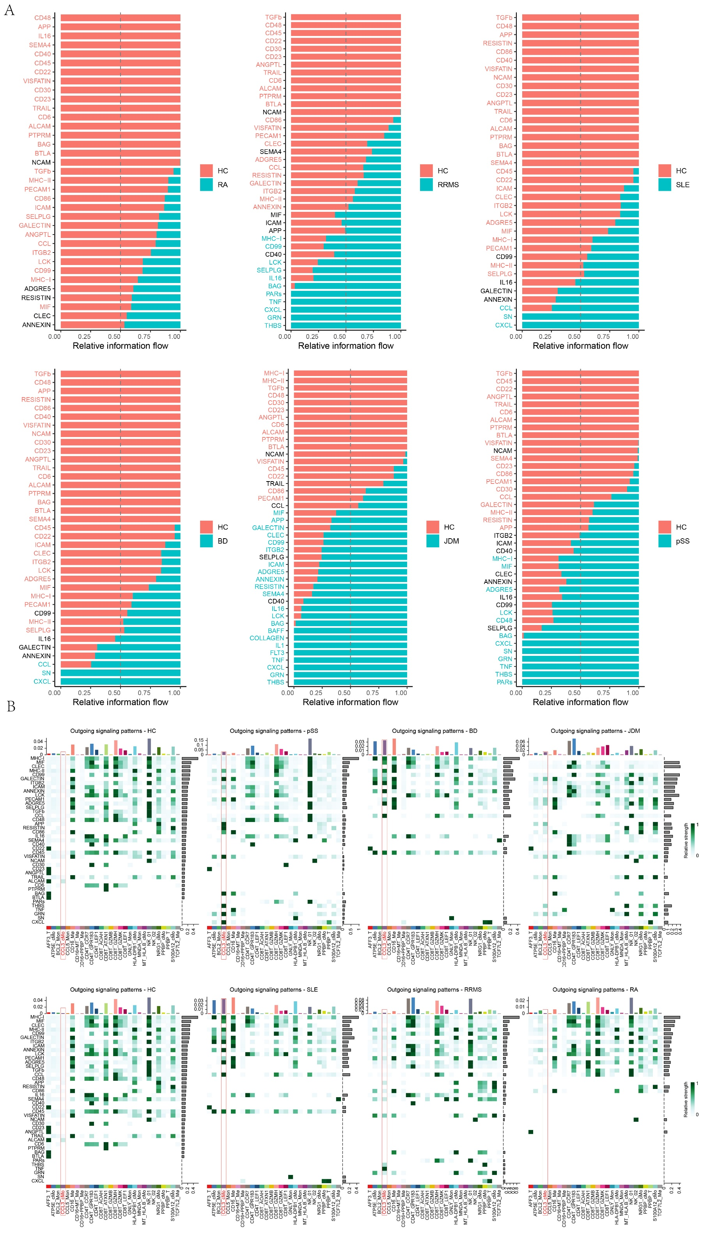
Figure S4. The immune communication network between monocytes/macrophages and NK/T cells in different autoimmune diseases. (A) The activation status of cell communication pathways between monocytes/macrophages and NK/T cells in peripheral blood mononuclear cells (PBMCs) from patients with different autoimmune diseases compared to healthy individuals. (B) The differences in the intensity of intercellular communication signals released by monocytes/macrophages in peripheral blood mononuclear cells (PBMCs) between patients with different autoimmune diseases and healthy individuals.
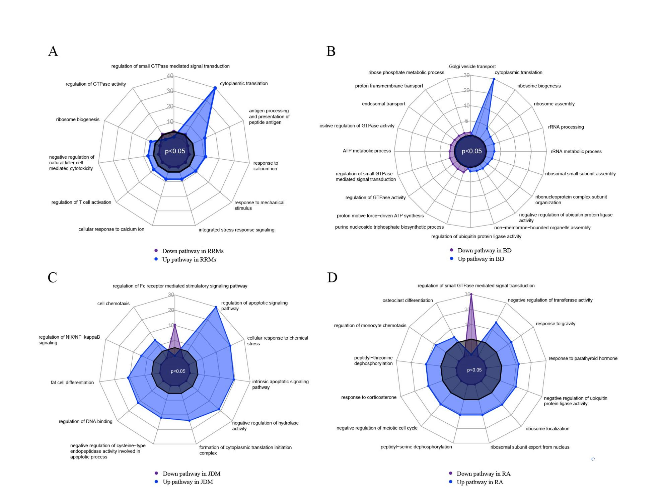Figure S5. The up-regulated and down-regulated functional pathways of CCL3_cMo cells in different autoimmune diseases. (A) Radar plot showing the functional changes of CCL3_cMo cells in healthy people and RRMs patients. (B) Radar plot showing the functional changes of CCL3_cMo cells in healthy people and BD patients. (C) Radar plot showing the functional changes of CCL3_cMo cells in healthy people and JDM patients. (D) Radar plot showing the functional changes of CCL3_cMo cells in healthy people and RA patients.
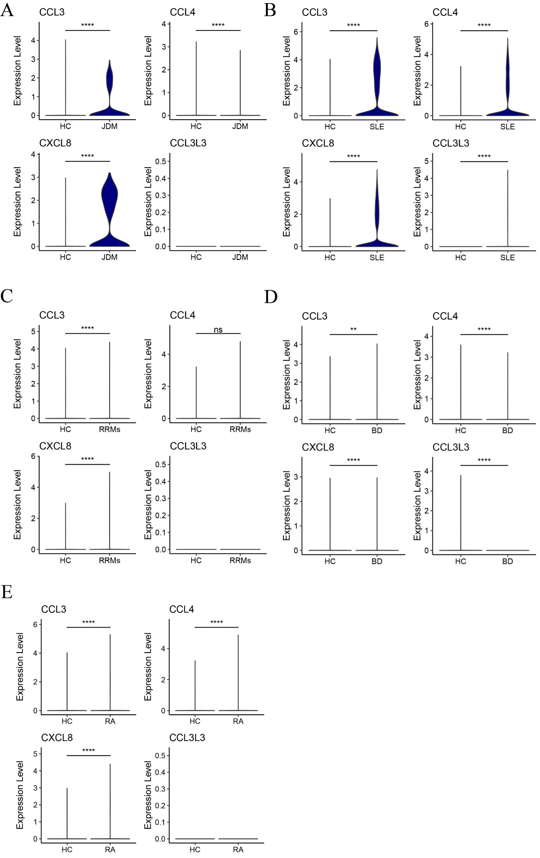
Figure S6. A, B, C, D, E. The expression of CCL3, CCL4, CXCL8 and CCL3L3 in peripheral blood mononuclear phagocytes of healthy people, and patients with JDM, SLE, RRMS, BD and RA. ** p < 0.01; **** p < 0.0001; ns, not significant. Wilcoxon two sample test.
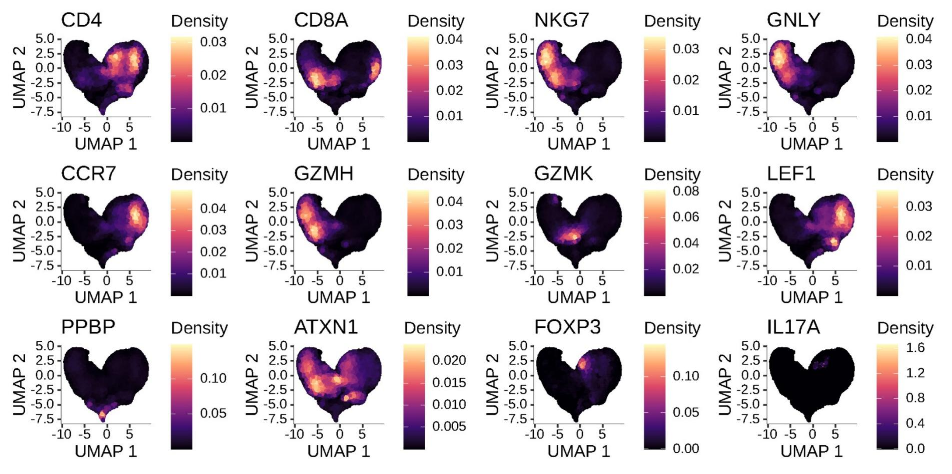
Figure S7. Marker genes of NK/T cell subsets.

Table S1. Cohort included in the peripheral blood single-cell atlas of multiple autoimmune diseases.
Dataset | Disease | Sample ID | Tissue
HRA000155 | Healthy | HRR059375 | Blood
HRA000155 | Healthy | HRR059376 | Blood
HRA000155 | Healthy | HRR059377 | Blood
HRA000155 | Healthy | HRR059378 | Blood
GSE142016 | systemic lupus erythematosus | GSM4217718 | Blood
GSE142016 | systemic lupus erythematosus | GSM4217719 | Blood
GSE142016 | systemic lupus erythematosus | GSM4217720 | Blood
GSE157278 | primary Sjögren’s syndrome | GSM4760625 | Blood
GSE157278 | primary Sjögren’s syndrome | GSM4760626 | Blood
GSE157278 | primary Sjögren’s syndrome | GSM4760627 | Blood
GSE157278 | primary Sjögren’s syndrome | GSM4760628 | Blood
GSE157278 | primary Sjögren’s syndrome | GSM4760629 | Blood
GSE190684 | juvenile dermatomyositis | GSM5728999-1 | Blood
GSE190684 | juvenile dermatomyositis | GSM5728999-2 | Blood
GSE190684 | juvenile dermatomyositis | GSM5728999-3 | Blood
GSE190684 | juvenile dermatomyositis | GSM5728999-4 | Blood
HRA000155 | rheumatoid arthritis | HRR059379 | Blood
HRA000155 | rheumatoid arthritis | HRR059380 | Blood
HRA000155 | rheumatoid arthritis | HRR059382 | Blood
HRA000155 | rheumatoid arthritis | HRR059385 | Blood
HRA000155 | rheumatoid arthritis | HRR059388 | Blood
HRA000155 | rheumatoid arthritis | HRR059390 | Blood
HRA000155 | rheumatoid arthritis | HRR059392 | Blood
HRA000155 | rheumatoid arthritis | HRR059394 | Blood
HRA000155 | rheumatoid arthritis | HRR059396 | Blood
HRA000155 | rheumatoid arthritis | HRR059399 | Blood
HRA000155 | rheumatoid arthritis | HRR059401 | Blood
HRA000155 | rheumatoid arthritis | HRR059404 | Blood
HRA000155 | rheumatoid arthritis | HRR059407 | Blood
HRA000155 | rheumatoid arthritis | HRR059410 | Blood
HRA000155 | rheumatoid arthritis | HRR183313 | Blood
HRA000155 | rheumatoid arthritis | HRR183315 | Blood
HRA000155 | rheumatoid arthritis | HRR183317 | Blood
HRA000155 | rheumatoid arthritis | HRR183320 | Blood
HRA000155 | rheumatoid arthritis | HRR183323 | Blood
GSE133028 | multiple sclerosis | RMS1 | Blood
GSE133028 | multiple sclerosis | RMS2 | Blood
GSE133028 | multiple sclerosis | RMS3 | Blood
GSE133028 | multiple sclerosis | RMS4 | Blood
GSE133028 | multiple sclerosis | RMS5 | Blood
GSE133028 | multiple sclerosis | RMS6 | Blood
GSE133028 | multiple sclerosis | RMS7 | Blood
GSE133028 | multiple sclerosis | RMS8 | Blood
GSE133028 | multiple sclerosis | RMS9 | Blood
GSE133028 | multiple sclerosis | RMS10 | Blood
GSE133028 | multiple sclerosis | RMS11 | Blood
GSE133028 | multiple sclerosis | RMS12 | Blood
GSE198616 | Behçet’s disease | GSM5953767 | Blood
GSE198616 | Behçet’s disease | GSM5953768 | Blood
GSE198616 | Behçet’s disease | GSM5953769 | Blood
GSE198616 | Behçet’s disease | GSM5953770 | Blood

