Supplementary Table 1 Correlation between V50%~V100% of bladder and the incidence of ≥grade 2 RT-induced acute and late GU toxicity
≥ grade 2  GU toxicity |  | Bladder
 |  | V50* | V65 | V75 |  | V80 | V90 | V100
Acute | ROC curve | 0.779 | 0.814 | 0.843 | 0.866 |  | 0.946 | 0.941
Acute | P value | <0.001 | <0.001 | <0.001 | <0.001 |  | <0.001 | <0.001
Late | ROC curve | 0.776 | 0.813 | 0.850 | 0.874 |  | 0.906 | 0.904
Late | P value | 0.037 | 0.018 | 0.008 | 0.005 |  | 0.002 | 0.003
*Vx values (percentage volume receiving at least x% of the prescription dose)

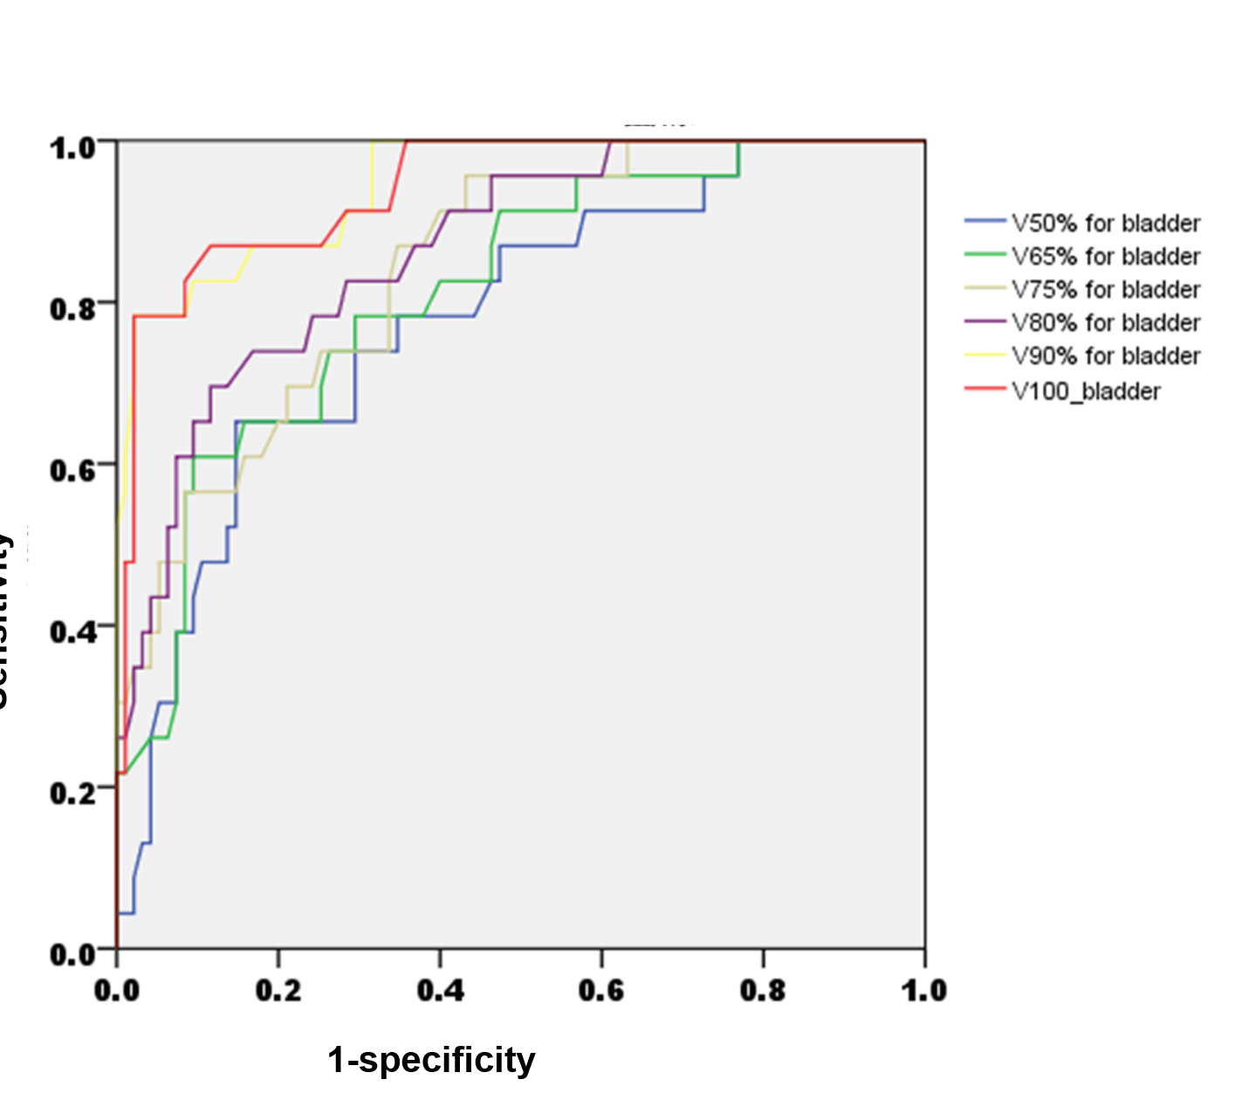

Supplementary Figure 1 the ROC curves for V50%~V100% of bladder to predict ≥grade 2 RT-induced acute GU toxicity

