SUPPLEMENTARY INFORMATION
Decreased sputum Type-2 gene expression in COPD current smokers
Thomas Southworth*^{1,2}, Andrew Higham¹, Augusta Beech^{1,2}, Jian Li¹, Sophie Wolosianka² and Dave Singh^{1,2}
Authors Affiliations:
- Division of Immunology, Immunity to Infection and Respiratory Medicine, School of Biological Sciences, Faculty of Biology, Medicine and Health, University of Manchester and Manchester University NHS Foundation Trust, Manchester, United Kingdom
- Medicines Evaluation Unit, Manchester, United Kingdom
*Corresponding Author: Thomas Southworth, Medicines Evaluation Unit, The Langley Building, Southmoor Road, Manchester, M23 9QZ, United Kingdom. Email: tsouthworth@meu.org.uk. Tel: +44 161 946 4066.

Supplementary Table 1: Correlations between gene expressions:
Gene 1 | Gene 2 | Rho | P-value
IL13 | CLCA1 | 0.138 | 0.243
IL13 | CCL26 | 0.666 | <0.0001
IL13 | CST1 | 0.101 | 0.396
CLCA1 | CCL26 | 0.133 | 0.263
CLCA1 | CST1 | 0.403 | 0.0004
CCL26 | CST1 | 0.287 | 0.0137
Comparisons between genes were assessed by Spearman’s correlation. Results in bold highlight significant correlations (p<0.05).

Supplementary Figure 1: Associations between the expression of the four T2 genes in sputum cells. Comparison between the levels of IL13, CLCA1, CCL26 and CST1 expression were assessed by Spearman’s rank test, with results of the gene pairs demonstrating significant correlations (p<0.05) being illustrated: IL13 vs CCL26 (A); CLCA1 vs CST1 (B); CCL26 vs CST1; (C) CCL26 vs CST1. Rho and p-values are presented for each analysis.

Supplementary Figure 2: Sputum T2 gene expression in ICS using and ICS naïve COPD patients. Gene expression was quantified by RT-PCR. Comparisons between ICS users and ICS naïve patients were by Mann-Whitney test: all non-significant.

Supplementary Figure 3: Comparisons of sputum eosinophil percentages with T2 gene expression in current and ex-smokers. Associations between eosinophil percentages and IL13 (A, E), CLCA1 (B, F), CCL26 (C, G) and CST1 (D, H) were assessed in samples from current smokers (A-D) and ex-smokers (E-H) by Spearman’s rank test with Rho and p-values are presented for each analysis.
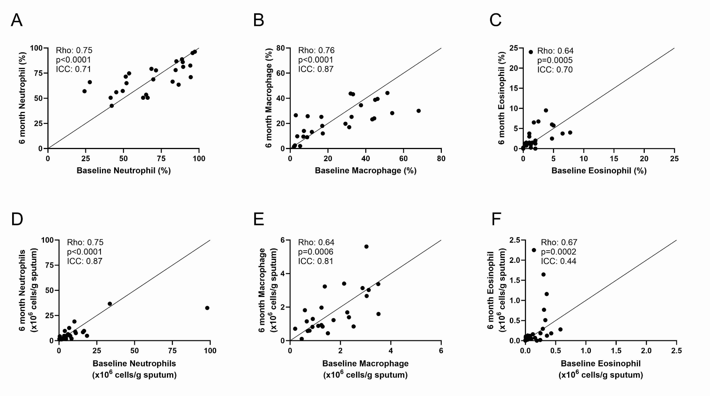
Supplementary Figure 4: Repeat analysis of sputum cell counts in COPD patients. Sputum samples were collected from 26 COPD patients at baseline and at 6 months. Differential cell counts were performed to assess neutrophils (A, D), macrophage (B, E) and eosinophils (C, F). Results are presented as both cell percentages (A-C) and numbers of cells per gram of sputum (D-F). Associations between baseline and 6-month measurements were assessed by Spearman’s rank test and Interclass coefficient analysis. Rho, p-values and ICC values are presented for each analysis.

