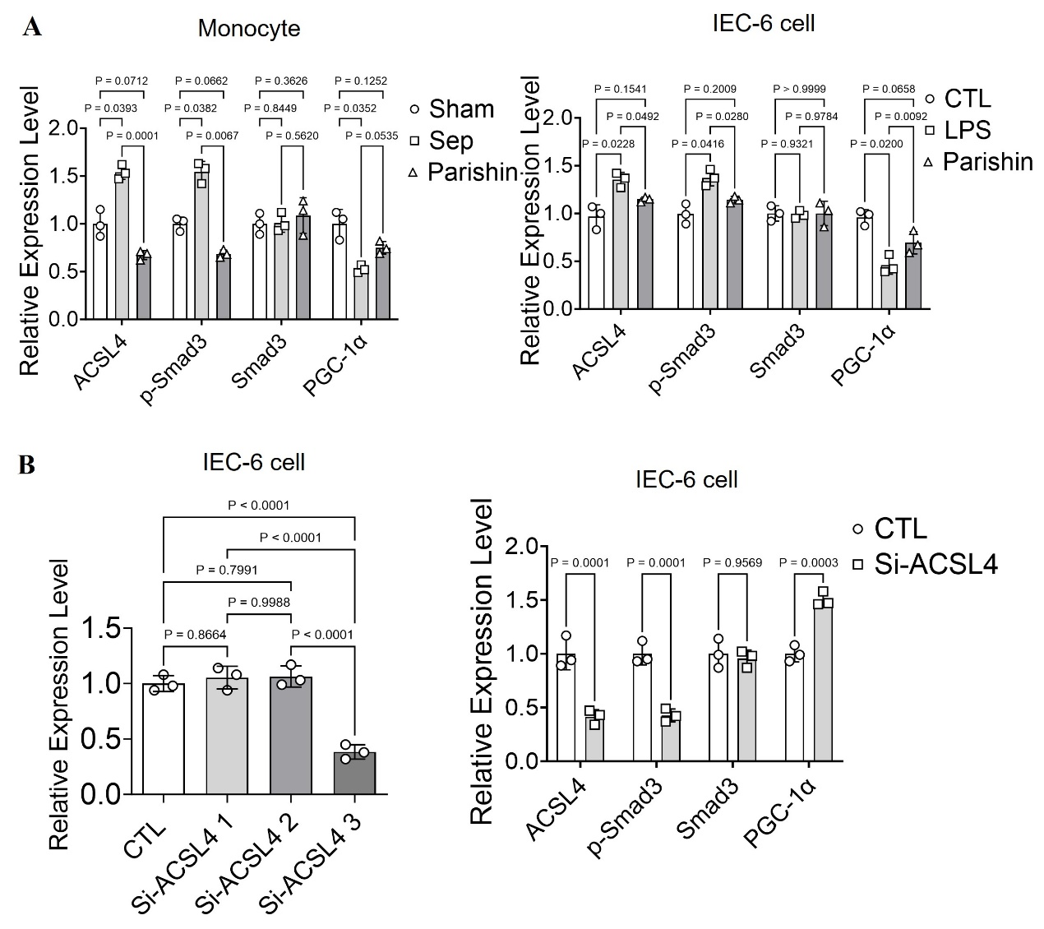
Supplementary Figure 1. The quantitative analysis of the expression of ACSL4, Smad3, phosphorylated Smad3 (p-Smad3), and PGC-1α in LPS-stimulated intestinal epithelial cells and monocytes(n=3). (B) The quantitative analysis of the expression of ACSL4 after treatment in Si-ACSL4 of IEC-6 cells(n=3).

Supplementary table 1. Statistical Descriptive Parameters for the Therapeutic Efficacy of Parishin in Alleviating Sepsis-Induced Intestinal Injury.
Monocyte-ACSL4 | group | n | mean | SD | P
Monocyte-ACSL4 | Sham | 3 | 1 | 0.12 | Sham vs Sep P=0.0004
Monocyte-ACSL4 | Sep | 3 | 17.97 | 4.2 | Sham vs Parishin P=0.0157
Monocyte-ACSL4 | Parshin | 3 | 9.23 | 0.95 | Parishin vs Sep P=0.012
Intestine-ACSL4 | Sham | 3 | 1 | 0.03 | Sham vs Sep P=0.0001
Intestine-ACSL4 | Sep | 3 | 8.57 | 1.3 | Sham vs Parishin P=0.0062
Intestine-ACSL4 | Parshin | 3 | 4.53 | 0.78 | Parishin vs Sep P=0.0032
Plasma DAO (U/L) | Sham | 6 | 27.43 | 5.33 | Sham vs Sep P＜0.0001
Plasma DAO (U/L) | Sep | 6 | 81.88 | 13.71 | Sham vs Parishin P=0.0002
Plasma DAO (U/L) | Parshin | 6 | 56.6 | 6.04 | Parishin vs Sep P=0.0007
Plasma D-Lac (mmol/L) | Sham | 6 | 0.54 | 0.17 | Sham vs Sep P＜0.0001
Plasma D-Lac (mmol/L) | Sep | 6 | 1.91 | 0.32 | Sham vs Parishin P=0.32
Plasma D-Lac (mmol/L) | Parshin | 6 | 0.76 | 0.27 | Parishin vs Sep P＜0.0001
Plasma LPS (U/L) | Sham | 6 | 2.92 | 1.08 | Sham vs Sep P＜0.0001
Plasma LPS (U/L) | Sep | 6 | 10.5 | 1.31 | Sham vs Parishin P=0.0008
Plasma LPS (U/L) | Parshin | 6 | 5.943 | 0.92 | Parishin vs Sep P＜0.0001
plasma TNF-α (pg/ml) | Sham | 6 | 164.8 | 49.65 | Sham vs Sep P＜0.0001
plasma TNF-α (pg/ml) | Sep | 6 | 379.2 | 44.45 | Sham vs Parishin P=0.0009
plasma TNF-α (pg/ml) | Parshin | 6 | 275.5 | 26.15 | Parishin vs Sep P=0.0016
Plasma IL-1β (pg/ml) | Sham | 6 | 87.83 | 10.72 | Sham vs Sep P＜0.0001
Plasma IL-1β (pg/ml) | Sep | 6 | 244 | 25.4 | Sham vs Parishin P＜0.0001
Plasma IL-1β (pg/ml) | Parshin | 6 | 160.2 | 17.39 | Parishin vs Sep P＜0.0001
Plasma IL-6 (pg/ml) | Sham | 6 | 182.2 | 43.92 | Sham vs Sep P＜0.0001
Plasma IL-6 (pg/ml) | Sep | 6 | 355.8 | 52.8 | Sham vs Parishin P=0.0462
Plasma IL-6 (pg/ml) | Parshin | 6 | 253.5 | 43.11 | Parishin vs Sep P=0.0048
Relative cell viability | CTL | 6 | 1 | 0.03 | CTL vs LPS P＜0.0001
Relative cell viability | LPS | 6 | 0.38 | 0.03 | LPS vs 20uM P=0.4077
Relative cell viability | 20uM | 6 | 0.42 | 0.06 | 20uM vs 50uM P＜0.0001
Relative cell viability | 50uM | 6 | 0.66 | 0.07 | LPS vs 50uM P＜0.0001

Supplementary Table 2. Statistical Descriptive Parameters for the Regulatory Effect of Parishin on Ferroptosis During Sepsis.
 |  | group | n | mean | SD | P
Intestine MDA |  | Sham | 6 | 3.14 | 1.1 | Sham vs Sep P＜0.0001
 |  | Sep | 6 | 17.32 | 2.8 | Sham vs Parishin P=0.0021
 |  | Parshin | 6 | 7.61 | 1.08 | Parishin vs Sep P＜0.0001
Intestine total Fe |  | Sham | 6 | 15.05 | 5.97 | Sham vs Sep P=0.0001
 |  | Sep | 6 | 49.4 | 8.85 | Sham vs Parishin P=0.0086
 |  | Parshin | 6 | 30.12 | 7.3 | Parishin vs Sep P=0.0012
Monocyte MDA |  | Sham | 6 | 5 | 1.73 | Sham vs Sep P＜0.0001
 |  | Sep | 6 | 22.22 | 8.44 | Sham vs Parishin P=0.097
 |  | Parshin | 6 | 11.53 | 1.62 | Parishin vs Sep P=0.0062
Monocyte total Fe |  | Sham | 6 | 32.05 | 7.22 | Sham vs Sep P＜0.0001
 |  | Sep | 6 | 80.97 | 9.59 | Sham vs Parishin P=0.0072
 |  | Parshin | 6 | 47.79 | 5.41 | Parishin vs Sep P＜0.0001
MFI of FerroOrange |  | Sham | 3 | 3629 | 549.19 | Sham vs Sep P=0.0013
 |  | Sep | 3 | 10086 | 1839.14 | Sham vs Parishin P=0.0595
 |  | Parshin | 3 | 6446 | 694.77 | Parishin vs Sep P=0214
MFI of Liperfluo |  | Sham | 3 | 660 | 90.81 | Sham vs Sep P=0.0127
 |  | Sep | 4 | 2531 | 932.34 | Sham vs Parishin P=0.9892
 |  | Parshin | 3 | 730.6 | 87.84 | Parishin vs Sep P=0.0154
Intestine | WB-GPX4 | Sham | 3 | 0.95 | 0.1 | Sham vs Sep P=0.0012
Intestine | WB-GPX4 | Sep | 3 | 0.35 | 0.12 | Sham vs Parishin P=0.0295
Intestine | WB-GPX4 | Parshin | 3 | 0.67 | 0.05 | Parishin vs Sep P=0.0469
Intestine | WB-SLC7A11 | Sham | 3 | 0.97 | 0.11 | Sham vs Sep P=0.0145
Intestine | WB-SLC7A11 | Sep | 3 | 0.39 | 0.09 | Sham vs Parishin P=0.0323
Intestine | WB-SLC7A11 | Parshin | 3 | 0.69 | 0.04 | Parishin vs Sep P=0.0340
Intestine | WB-COX2 | Sham | 3 | 0.93 | 0.08 | Sham vs Sep P=0.0092
Intestine | WB-COX2 | Sep | 3 | 1.57 | 0.03 | Sham vs Parishin P=0.0216
Intestine | WB-COX2 | Parshin | 3 | 1.25 | 0.03 | Parishin vs Sep P=0.0002
Monocyte | WB-GPX4 | Sham | 3 | 0.97 | 0.18 | Sham vs Sep P＜0.0001
Monocyte | WB-GPX4 | Sep | 3 | 0.46 | 0.08 | Sham vs Parishin P=0.0108
Monocyte | WB-GPX4 | Parshin | 3 | 0.69 | 0.04 | Parishin vs Sep P=0.0399
Monocyte | WB-SLC7A11 | Sham | 3 | 0.97 | 0.1 | Sham vs Sep P＜0.0001
Monocyte | WB-SLC7A11 | Sep | 3 | 0.44 | 0.09 | Sham vs Parishin P=0.0150
Monocyte | WB-SLC7A11 | Parshin | 3 | 0.7 | 0.06 | Parishin vs Sep P=0.0163
Monocyte | WB-COX2 | Sham | 3 | 0.97 | 0.16 | Sham vs Sep P＜0.0001
Monocyte | WB-COX2 | Sep | 3 | 1.74 | 0.06 | Sham vs Parishin P=0.0006
Monocyte | WB-COX2 | Parshin | 3 | 1.36 | 0.08 | Parishin vs Sep P=0.0008
IEC-6 cell | WB-GPX4 | CTL | 3 | 1 | 0.10 | CTL vs LPS P=0.0305
IEC-6 cell | WB-GPX4 | LPS | 3 | 0.53 | 0.10 | CTL vs Parishin P=0.1644
IEC-6 cell | WB-GPX4 | Parshin | 3 | 0.74 | 0.10 | Parishin vs LPS P=0.0305
IEC-6 cell | WB-SLC7A11 | CTL | 3 | 1 | 0.11 | CTL vs LPS P=0.0335
IEC-6 cell | WB-SLC7A11 | LPS | 3 | 0.49 | 0.11 | CTL vs Parishin P=0.0477
IEC-6 cell | WB-SLC7A11 | Parshin | 3 | 0.7 | 0.08 | Parishin vs LPS P=0.0194
IEC-6 cell | WB-COX2 | CTL | 3 | 1 | 0.04 | CTL vs LPS P=0.0102
IEC-6 cell | WB-COX2 | LPS | 3 | 1.73 | 0.04 | CTL vs Parishin P=0.0268
IEC-6 cell | WB-COX2 | Parshin | 3 | 1.41 | 0.07 | Parishin vs LPS P=0.0055

Supplementary Table 3. Statistical Descriptive Parameters for the Effect of Parishin on Improving Mitochondrial Function in LPS-Stimulated Intestinal Epithelial Cells and Monocytes.
 |  | group | n | mean | SD | P
Monocyte-ACSL4 |  | Sham | 3 | 1 | 0.14 | Sham vs Sep P=0.0039
 |  | Sep | 3 | 1.54 | 0.08 | Sham vs Parishin P=0.071
 |  | Parshin | 3 | 0.67 | 0.05 | Parishin vs Sep P=0.0001
Monocyte-p-Smad3 |  | Sham | 3 | 1 | 0.07 | Sham vs Sep P=0.0382
 |  | Sep | 3 | 1.54 | 0.11 | Sham vs Parishin P=0.0662
 |  | Parshin | 3 | 0.69 | 0.04 | Parishin vs Sep P=0.0067
Monocyte-Smad3 |  | Sham | 3 | 1 | 0.11 | Sham vs Sep P=0.8449
 |  | Sep | 3 | 1.01 | 0.10 | Sham vs Parishin P=0.3626
 |  | Parshin | 3 | 1.09 | 0.19 | Parishin vs Sep P=0.5620
Monocyte-PGC-1α |  | Sham | 3 | 1 | 0.15 | Sham vs Sep P＜0.0001
 |  | Sep | 3 | 0.53 | 0.04 | Sham vs Parishin P=0.32
 |  | Parshin | 3 | 0.75 | 0.07 | Parishin vs Sep P＜0.0001
IEC-6 cell-ACSL4 |  | CTL | 3 | 0.97 | 0.12 | CTL vs LPS P=0.0228
 |  | LPS | 3 | 1.35 | 0.08 | CTL vs Parishin P=0.1541
 |  | Parshin | 3 | 1.15 | 0.03 | Parishin vs LPS P=0.0492
IEC-6 cell-p-Smad3 |  | CTL | 3 | 0.99 | 0.11 | CTL vs LPS P=0.0416
 |  | LPS | 3 | 1.37 | 0.09 | CTL vs Parishin P=0.2009
 |  | Parshin | 3 | 1.14 | 0.04 | Parishin vs LPS P=0.02800
IEC-6 cell-Smad3 |  | CTL | 3 | 1 | 0.08 | CTL vs LPS P=0.9321
 |  | LPS | 3 | 1 | 0.04 | CTL vs Parishin P=0.9999
 |  | Parshin | 3 | 1 | 0.13 | Parishin vs LPS P=0.9784
IEC-6 cell-PGC-1α |  | CTL | 3 | 0.96 | 0.08 | CTL vs LPS P=0.0200
 |  | LPS | 3 | 0.46 | 0.1 | CTL vs Parishin P=0.0658
 |  | Parshin | 3 | 0.69 | 0.12 | Parishin vs LPS P=0.0092
IEC-6 cell |  | CTL | 3 | 1 | 0.07 | CTL vs Si-ACSL4 1 P=0.8664
 |  | Si-ACSL4 1 | 3 | 1.05 | 0.1 | CTL vs Si-ACSL4 2 P=0.7991
 |  | Si-ACSL4 2 | 3 | 1.06 | 0.09 | CTL vs Si-ACSL4 3 P＜0.0001
 |  | Si-ACSL4 3 | 3 | 0.38 | 0.07 | Si-ACSL4 2 vs Si-ACSL4 3 P＜0.0001
IEC-6 cell | CTL | ACSL4 | 3 | 1 | 0.15 | /
IEC-6 cell | CTL | p-Smad3 | 3 | 1 | 0.1 | /
IEC-6 cell | CTL | Smad3 | 3 | 1 | 0.14 | /
IEC-6 cell | CTL | PGC-1α | 3 | 1 | 0.08 | /
IEC-6 cell | Si-ACSL4 | ACSL4 | 3 | 0.41 | 0.07 | CTL vs Si-ACSL4 P=0.0001
IEC-6 cell | Si-ACSL4 | p-Smad3 | 3 | 0.43 | 0.06 | CTL vs Si-ACSL4 P=0.0001
IEC-6 cell | Si-ACSL4 | Smad3 | 3 | 0.96 | 0.08 | CTL vs Si-ACSL4 P=0.9569
IEC-6 cell | Si-ACSL4 | PGC-1α | 3 | 1.5 | 0.07 | CTL vs Si-ACSL4 P=0.0003

