Associations of Sleep-disordered Breathing and Insomnia with Incident Metabolic syndrome—The Hispanic Community Health Study/Study of Latinos
Yongming Wang, Wenqi Lyu, Xujun Feng, Rong Ren, Ye Zhang, Xiangdong Tang
Sleep Medicine Center, Mental Health Center, Department of Respiratory and Critical Care Medicine, West China Hospital, Sichuan University, Chengdu, China

Statistical analysis
The medications and laboratory data of Visit 2 were represented according to four groups (control, insomnia, SDB, COMISA), and analyzed by Chi-squared and Kruskal-Walli test. We also showed the sample characteristics of Visit 1, medications and laboratory data of the Visit 2 separately according to with or without incident MS. Data were demonstrated through number of subjects for categorial variables or mean and standard deviation for continuous variables and analyzed with bivariate tests including Chi-squared and Mann–Whitney test.
We explored the effect of SDB severity on the development of MS by dividing these patients into three groups according to AHI (normal AHI<5, mild 15>AHI≥5, moderate and severe AHI≥15). Model 1 only control for the sleep disorders, model 2 add age, sex, BMI, alcohol use, cigarette use, education and ethnic, model 3 further add metabolic syndrome components n.
The incidence of several metabolic syndrome components including hypertension, diabetes and dyslipidemia of different sleep disorder groups were presented through histogram according to sex and age, with errors bar indicate standard deviation, the difference between groups were tested by Bonferroni.
Survival analysis was conducted using the Kaplan–Meier method. The survival curves were presented for different sleep disorder groups, stratified by sex (women and men) and age group.
All statistical analyses were conducted in SPSS 27, and all tests are two sides, with significant P value 5%.

Result
In Table S1, we listed the medication and laboratory data of Visit 2 in different sleep disorders, which showed similar trend of Visit 1 as we found in the main study. As depicted in Tables S2-S3, we represented the sample characteristics of Visit 1and Visit 2 in relation to with or without incident MS. In Table S2, the prevalence of incident MS with average 6 years interval was found to be 23.6% (n=1090) and women had higher incident rate than men. Participants who developed MS were noted to be older, had higher BMI, waist circumference, number of metabolic components, fasting glucose, blood pressure, total cholesterol, triglycerides, LDL, AHI, and a higher proportion of hypertension, diabetes, medication use of antihypertensive, antidiabetic and antilipemic. Additionally, a lower level of education and HDL was observed in subjects with incident MS than their counterparts.
Table S4 showed the subgroups analysis of SDB. In model 1, both mild and moderate/severe groups showed significant association with incident MS (Mild, HR 1.76, 95%CI 1.46-2.13; Moderate/Severe, HR 2.17, 95%CI 1.71-2.76). After fully adjusted, the mild SDB is significant associated with incident MS (HR 1.34; 95%CI 1.09-1.64), while the moderate/severe SDB failed to show association with incident MS (HR 1.18; 95%CI 0.90-1.54). In Table S5, we conducted a sensitivity analysis that excluded the 27 CPAP users verifying the robustness of our primary findings. Results showed that the association between SDB and incident MS remained statistically significant, and its magnitude was consistent with that observed in the primary analysis. Furthermore, we analyzed the impact of insomnia with different sleep durations on MS, and the results remained negative (Table S6). We also re-ran the Cox regression analysis to examine the association between different severity of SDB and incident MS and the results remained unchanged (Table S7).
Figure S1, S2 represented the incidence of hypertension, diabetes and dyslipidemia in four groups (control, insomnia, SDB, COMISA) between V1 and V2 according to different sex and age groups. In Figure S1, the COMISA group had the highest incidence of hypertension in both sexes, followed by SDB and insomnia groups. For diabetes, the COMISA groups showed significant increasing incidence compared to all other three groups in women. For dyslipidemia, we failed to find such trend. In different age groups in Figure S2, we found that in participants younger than 60 years, all three sleep disorders groups showed significant elevated incidence compared to control group, and they showed a similar trend in hypertension and diabetes that the COMISA group had the highest incidence and followed by SDB and insomnia groups. In Figure S3, the Non-obese group showed significant elevated incidence of hypertension, while the similar trend exists in diabetes in obese group.
In Figure S4, the COMISA group had the lowest rate of not having incident MS, followed by SDB, insomnia and control groups in women. For the different age groups in Figure S5, such trend consistently existed in the younger group who is under 60 years old. The same trend also exists in Figure S6 in both Non-obese and obese group.
Furthermore, we also conducted performed test for the proportional hazard assumption by log-log plots (Figure S7). These curves are generally parallel, suggesting that the effect of the examined factors on survival risk remains consistent across time. The survival risk for all four groups changes proportionally, and this risk ratio does not vary over time.

Table S1. HCHS/SOL (2008–2017) Sample Characteristics of V2 in different sleep disorders
 |  | Control | Insomnia | SDB | COMISA |  | P
Subjects |  | 2310 | 1216 | 710 | 389
Medications, % (n)
 | Antihypertensive V2 | 26.2(299) | 31.1(244) | 43.8(210) | 48.2(149) |  | <0.001
 | Antidiabetic V2 | 8.1(93) | 10.3(81) | 15.0(72) | 15.5(48) |  | <0.001
 | Antilipemic V2 | 16.6(190) | 22.2(174) | 30.8(148) | 32.7(101) |  | <0.001
Comorbidities, % (n)
 | Hypertension V2 | 19.4(448) | 28.9(352) | 39.1(277) | 48.3(188) |  | <0.001
 | Diabetes V2 | 8.7(201) | 13.0(158) | 19.2(136) | 24.9(97) |  | <0.001
Met S components, n
 | MS n V2 | 1.6±1.1 | 1.7±1.2 | 2.0±1.1 | 2.2±1.1 |  | <0.001
Fasting Glucose, mmol/L
 | Glucose V2 | 98.4±24.2 | 99.8±27.1 | 106.4±32.3 | 103.3±20.6 |  | <0.001
BP, mmHg
 | Systolic V2 | 117.1±16.3 | 120.6±17.1 | 124.7±17.3 | 125.8±17.6 |  | <0.001
 | Diastolic V2 | 70±10.0 | 72.1±10.4 | 72.5±10.1 | 73.3±10.2 |  | <0.001
Cholesterol, mmol/L
 | Cholesterol Total V2 | 191.1±40.0 | 193.3±39.1 | 193.2±38.6 | 189.5±38.3 |  | 0.226
 | Triglycerides V2 | 108.9±101.9 | 105.7±72.1 | 113.8±63.9 | 110.6±51.2 |  | <0.001
 | HDL V2 | 53.7±15.3 | 56.6±16.2 | 51.9±14.3 | 54.0±14.2 |  | <0.001
 | LDL V2 | 115.9±33.9 | 115.5±33.8 | 118.8±34.0 | 113.5±33.9 |  | 0.048
Waist, cm
 | Waist V2 | 94.9±12.5 | 95.1±12.6 | 101.5±13.7 | 102.8±14.0 |  | <0.001
Data were represented with n, mean ± standard deviation or %(n) within each group. Definition of abbreviation：BMI=body mass index; AHI= apnea–hypopnea index; HS=high School; GED= general educational development credential; MS=metabolic syndrome; BP=blood pressure; HDL= high-density lipoprotein; LDL: low-density lipoprotein; Data were analyzed by Chi-squared or Kruskal-Wallis Test. P<0.05 considered statistically significant.
Table S2. HCHS/SOL (2008–2017) Sample Characteristics of V1 According to the Incidence of Metabolic Syndrome
 |  | Incident MS |  |  | P
 |  | No | Yes
Subjects |  | 3535 | 1090
Age, y |  | 43.5±13.6 | 47.9±12.0 |  | <0.001
Sex, % (n) |  |  |  |  | 0.010
 | Women | 59.3(2097) | 63.7(694)
 | Men | 40.7(1438) | 36.3(396)
BMI, kg/m² |  | 27.6±5.1 | 30.2±5.4 |  | <0.001
AHI, events/h |  | 3.9±7.8 | 6.1±10.4 |  | <0.001
Alcohol use, % (n) |  |  |  |  | 0.006
 | Never | 18.7(661) | 18.6(203)
 | Former | 29.4(1040) | 34.3(374)
 | Current | 51.8(1831) | 47.1(513)
Cigarette use, % (n) |  |  |  |  | 0.215
 | Never | 63.7(2249) | 60.9(663)
 | Former | 18.7(659) | 19.5(212)
 | Current | 17.6(622) | 19.6(213)
Education, % (n) |  |  |  |  | 0.006
 | Less Than HS | 31.4(1107) | 36.5(398)
 | HS or Equivalent | 27.5(969) | 25.1(273)
 | Greater than HS or Equivalent | 41.2(1453) | 38.4(418)
Ethnicity, % (n) |  |  |  |  | 0.262
 | Dominican | 10.5(372) | 9.5(103)
 | Central American | 10.4(368) | 10.5(114)
 | Cuban | 13.6(481) | 14.0(152)
 | Mexican | 40.0(1412) | 43.7(476)
 | Puerto Rican | 15.1(533) | 13.9(151)
 | South American | 7.6(268) | 6.5(71)
 | More than one/Other heritage | 2.7(97) | 2.0(22)
Time between visits, y |  | 6.0±0.8 | 6.0±0.8 |  | 0.745
Medications, % (n)
 | Antihypertensive V1 | 14.4(312) | 23.8((181) |  | <0.001
 | Antidiabetic V1 | 3.7(81) | 10.1(77) |  | <0.001
 | Antilipemic V1 | 10.7(233) | 18.0(137) |  | 0.004
Comorbidities, % (n)
 | Hypertension V1 | 14.7(520) | 23.7(258) |  | <0.001
 | Diabetes V1 | 5.2(184) | 14.0(152) |  | <0.001
Met S components, n
 | MSn V1 | 1.1±0.8 | 1.6±0.6 |  | <0.001
Fasting Glucose, mmol/L
 | Glucose V1 | 93.8±18.0 | 101.9±36.1 |  | <0.001
BP, mmHg
 | Systolic V1 | 116.5±15.4 | 120.6±15.8 |  | <0.001
 | Diastolic V1 | 70.0±9.7 | 72.8±9.8 |  | <0.001
Cholesterol, mmol/L
 | Cholesterol Total V1 | 195.6±41.1 | 202.0±41.5 |  | <0.001
 | Triglycerides V1 | 101.2±57.2 | 126.7±85.9 |  | <0.001
 | HDL V1 | 54.3±13.1 | 49.6±11.5 |  | <0.001
 | LDL V1 | 121.1±35.5 | 127.4±35.7 |  | <0.001
Waist, cm
 | Waist V1 | 92.7±11.9 | 99.2±13.2 |  | <0.001
Data were represented with n, mean ± standard deviation or % (n) within each group. Definition of abbreviation：BMI=body mass index; AHI=apnea–hypopnea index; HS=high School; GED=general educational development credential; MS=metabolic syndrome; BP=blood pressure; HDL=high-density lipoprotein; LDL: low-density lipoprotein; Data were analyzed with bivariate tests (Chi-squared or Mann–Whitney test). P<0.05 considered statistically significant.

Table S3. HCHS/SOL (2008–2017) Sample Characteristics of V2 According to the Incidence of Metabolic Syndrome
 |  | Incident MS |  |  | P
 |  | No | Yes
Subjects |  | 3535 | 1090
Medications, % (n)
 | Antihypertensive V2 | 26.1(509) | 51.1(393) |  | <0.001
 | Antidiabetic V2 | 6.8(133) | 20.9(161) |  | <0.001
 | Antilipemic V2 | 19.3(376) | 30.8(237) |  | <0.001
Comorbidities, % (n)
 | Hypertension V2 | 20.6(727) | 49.4(538) |  | <0.001
 | Diabetes V2 | 8.1(285) | 28.2(307) |  | <0.001
Met S components, n
 | MSn V2 | 1.2±0.8 | 3.3±0.6 |  | <0.001
Fasting Glucose, mmol/L
 | Glucose V2 | 97.0±23.0 | 111.4±32.5 |  | <0.001
BP, mmHg
 | Systolic V2 | 117.9±16.5 | 126.2±17.5 |  | <0.001
 | Diastolic V2 | 70.0±9.7 | 75.2±10.7 |  | <0.001
Cholesterol, mmol/L
 | Cholesterol Total V2 | 190.4±37.9 | 196.6±43.8 |  | <0.001
 | Triglycerides V2 | 93.6±51.1 | 158.6±140.1 |  | <0.001
 | HDL V2 | 56.7±15.3 | 46.3±12.9 |  | <0.001
 | LDL V2 | 115.1±33.7 | 119.0±34.5 |  | <0.001
Waist, cm
 | Waist V2 | 94.4±12.5 | 103.9±12.8 |  | <0.001
Data were represented with n, mean ± standard deviation or % (n) within each group. Definition of abbreviation：BMI=body mass index; AHI=apnea–hypopnea index; HS=high school; GED=general educational development credential; MS=metabolic syndrome; BP=blood pressure; HDL=high-density lipoprotein; LDL: low-density lipoprotein; Data were analyzed with bivariate tests (Chi-squared or Mann–Whitney test). P<0.05 considered statistically significant.

Table S4. Effect estimates from Survey Cox Regression Models for the association between SDB categorical model and 6-Year Incident metabolic syndrome in HCHS/SOL (2008–2017)

 |  | Model 1 |  |  | Model 2 |  |  | Model 3
Incident MS |  | HR | 95% CI |  | HR | 95% CI |  | HR | 95% CI
 | Normal | reference |  |  | reference |  |  | reference
 | Mild | 1.76* | 1.46-2.13 |  | 1.29† | 1.05-1.58 |  | 1.34* | 1.09-1.64
 | Moderate/Severe | 2.17* | 1.71-2.76 |  | 1.27 | 0.97-1.66 |  | 1.18 | 0.90-1.54

Definition of abbreviation：CI=confidence interval; HR=hazard ratio; SDB=sleep-disordered breathing (Normal: AHI<5; Mild: 5≤AHI<15; Moderate/Severe:15≤AHI)
Model 1 include SDB; Model 2 further controlled for Age, Sex, BMI, Alcohol use, Cigarette use, Education, Ethnicity; Model 3 further controlled for Mets S components n.
Statistically significant effect estimates are in bold text.
*P<=0.001
†P<0.01

Table S5. Effect estimates from Survey Cox Regression Models for the association between sleep disorders and 6-Year Incident metabolic syndrome in HCHS/SOL (2008–2017) (Further excluding CPAP (n=27))
 |  | Model 1 |  |  | Model 2 |  |  | Model 3
Incident MS |  | HR | 95% CI |  | HR | 95% CI |  | HR | 95% CI
Comorbid SDB and insomnia
 | Control | reference |  |  | reference |  |  | reference
 | Insomnia | 1.21‡ | 1.04-1.40 |  | 1.08 | 0.93-1.26 |  | 1.11 | 0.95-1.30
 | SDB | 1.89* | 1.61-2.22 |  | 1.33† | 1.11-1.58 |  | 1.32† | 1.11-1.58
 | COMISA | 2.36* | 1.95-2.86 |  | 1.36† | 1.11-1.67 |  | 1.41† | 1.15-1.74

Definition of abbreviation：CI=confidence interval; HR=hazard ratio; SDB=sleep-disordered breathing; MS=metabolic syndrome;
Model 1 include SDB and insomnia; Model 2 further controlled for Age, Sex, BMI, Alcohol use, Cigarette use, Education, Ethnicity; Model 3 further controlled for Mets S components n.
Statistically significant effect estimates are in bold text.
*P<=0.001
†P<0.01
‡P<0.05

Table S6. Effect estimates from Survey Cox Regression Models for the association between Insomnia/Short sleep duration and 6-Year Incident metabolic syndrome in HCHS/SOL (2008–2017)
 |  | Model 1 |  |  | Model 2 |  |  | Model 3
Incident MS |  | HR | 95% CI |  | HR | 95% CI |  | HR | 95% CI
Comorbid insomnia and
short sleep duration
 | Normal | reference |  |  | reference |  |  | reference
 | Insomnia | 1.23‡ | 1.05-1.45 |  | 1.10 | 0.93-1.30 |  | 1.11 | 0.94-1.32
 | Short sleep | 1.10 | 0.78-1.58 |  | 1.11 | 0.78-1.60 |  | 1.13 | 0.78-1.62
 | Insomnia & short sleep | 1.52‡ | 1.07-2.15 |  | 1.12 | 0.79-1.60 |  | 1.13 | 0.78-1.62
Definition of abbreviation：CI=confidence interval; HR=hazard ratio; Short sleep=self-reported short sleep duration (6 h or less).
Model 1 include SDB; Model 2 further controlled for Age, Sex, BMI, Alcohol use, Cigarette use, Education, Ethnicity; Model 3 further controlled for Mets S components n.
Statistically significant effect estimates are in bold text.
‡P<0.05

 |  | Model 1 |  |  | Model 2 |  |  | Model 3
Incident MS |  | HR | 95% CI |  | HR | 95% CI |  | HR | 95% CI
 | Normal | reference |  |  | reference |  |  | reference
 | Mild | 1.77* | 1.47-2.14 |  | 1.28* | 1.04-1.57 |  | 1.35† | 1.10-1.66
 | Moderate/Severe | 2.19* | 1.72-2.79 |  | 1.25 | 0.96-1.63 |  | 1.20 | 0.91-1.57
Table S7. Effect estimates from Survey Cox Regression Models for the association between SDB and 6-Year Incident metabolic syndrome in HCHS/SOL (2008–2017) (Further excluding CPAP (n=27))
Definition of abbreviation：CI=confidence interval; HR=hazard ratio; SDB=sleep-disordered breathing; MS=metabolic syndrome;
Model 1 include SDB and insomnia; Model 2 further controlled for Age, Sex, BMI, Alcohol use, Cigarette use, Education, Ethnicity; Model 3 further controlled for Mets S components n.
Statistically significant effect estimates are in bold text.
*P<=0.001
†P<0.01

Figure S1. Sex-Specific Incidence of Hypertension, Diabetes, Dyslipidemia.
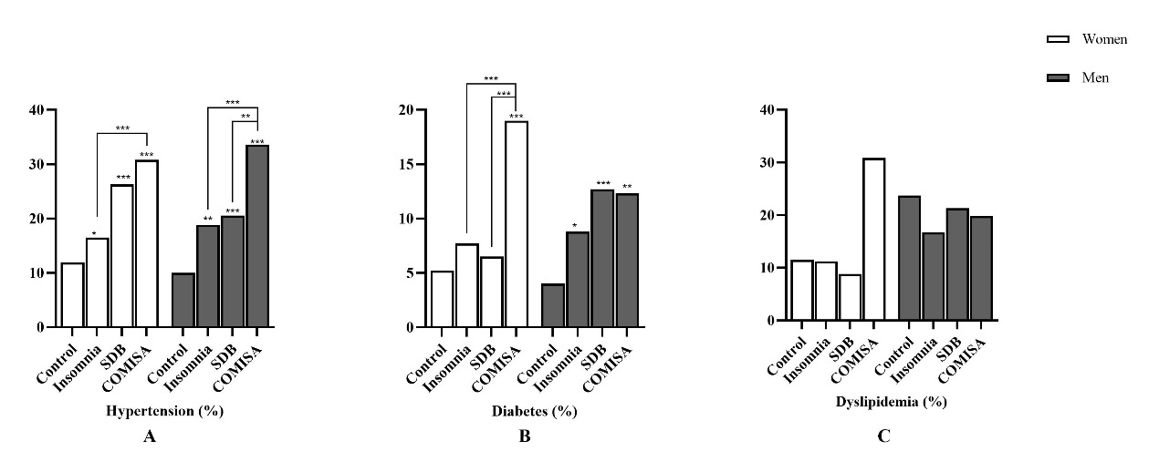
Utilizing Bonferroni test to compare disease prevalence in distinct groups within the same sex groups. ***P<0.001, **P<0.01, *P<0.05

Figure S2. Age-Specific Incidence of Hypertension, Diabetes, Dyslipidemia.
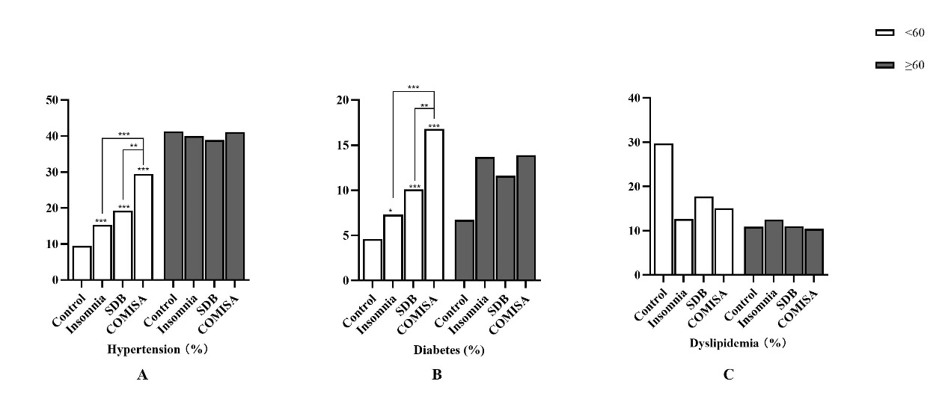
Utilizing Bonferroni test to compare disease prevalence in distinct groups within the same age groups. ***P<0.001, **P<0.01, *P<0.05

Figure S3. BMI-Specific Incidence of Hypertension, Diabetes, Dyslipidemia.
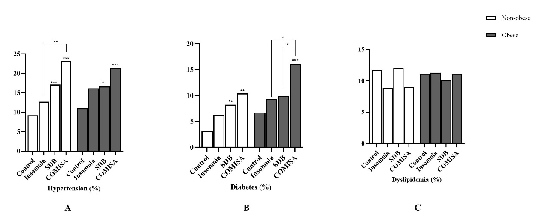
Utilizing Bonferroni test to compare disease prevalence in distinct groups within the same groups. Non-obese: BMI<28; Obese: BMI>=28. ***P<0.001, **P<0.01, *P<0.05

Figure S4. Survival analysis of incident MS prevalence from the HCHS/SOL of different sex. (2011-2017). 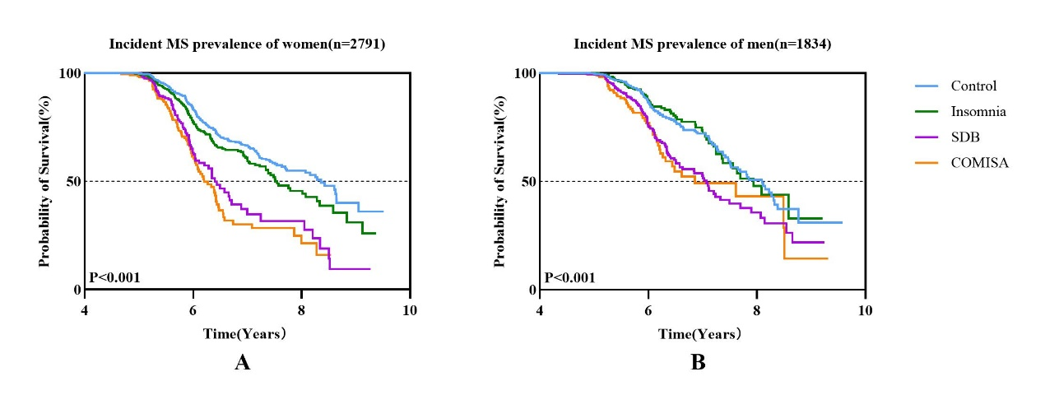
Kaplan–Meier curves of survival rate of prevalence of incident MS in different sex groups.

Figure S5. Survival analysis of incident MS prevalence from the HCHS/SOL of different age groups. (2011-2017).
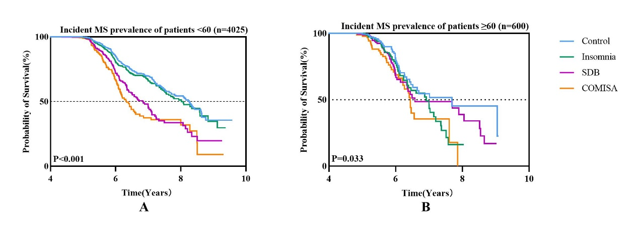
Kaplan–Meier curves of survival rate of prevalence of incident MS in different age groups.

Figure S6. Survival analysis of incident MS prevalence from the HCHS/SOL of different BMI groups. (2011-2017).
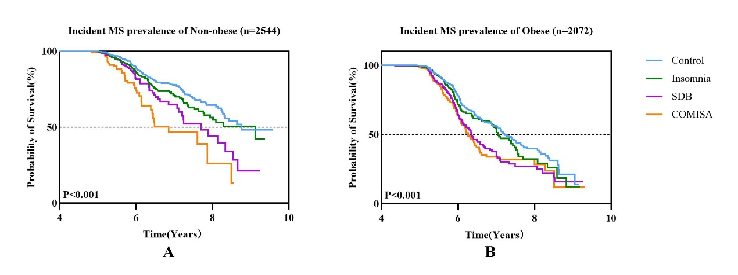
Kaplan–Meier curves of survival rate of prevalence of incident MS in different BMI groups. Non-obese: BMI<28; Obese: BMI≥28.

Figure S7. Log-log plots for proportional hazards (PH) assumption.
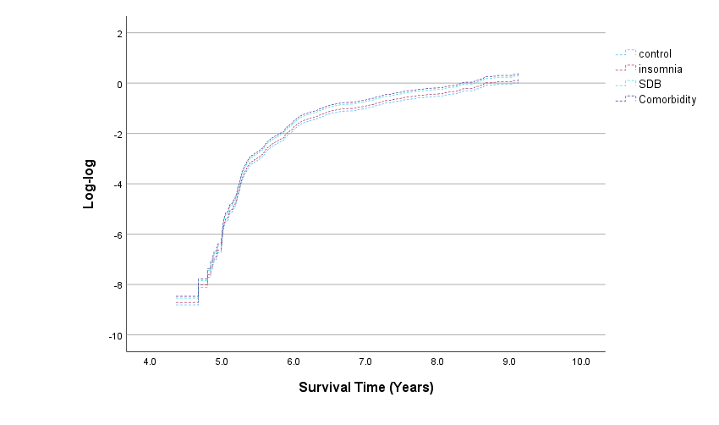

Figure S8. Stratified analysis on association between different levels of SDB severity and incident MS based on Sex.
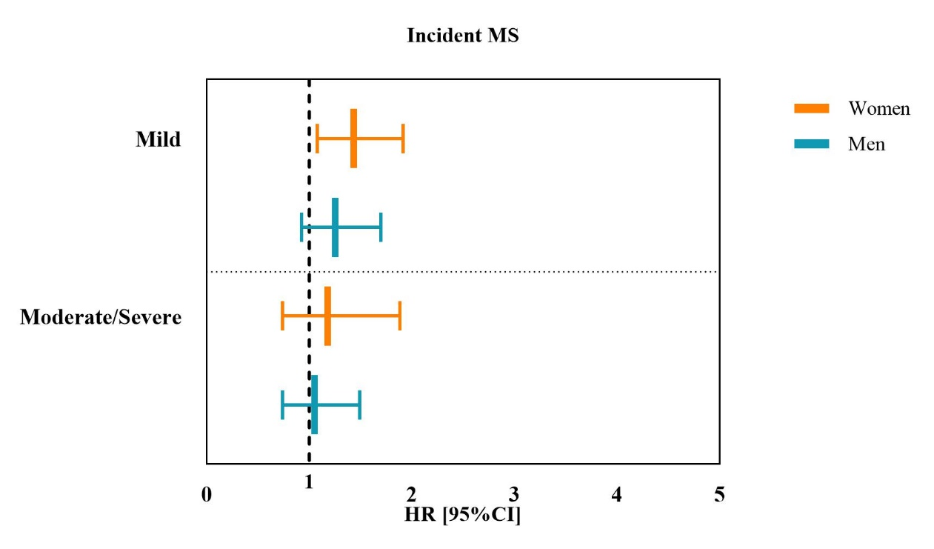

Survey cox regression adjusted for Age, BMI, Alcohol use, Cigarette use, Education, Ethnicity, Time between visits, Met S components n. HR=hazard ratio; CI=confidence interval; SDB=sleep-disordered breathing; MS=metabolic syndrome

