Supplementary material
Supplementary methods
Cohort formation overview is presented in Supplementary Figure 1. A raw cohort of patients that had at least one purchase of an obstructive airway drug purchase or a diagnosis of asthma or COPD at primary or secondary healthcare during 2000 and 2020, were included to the raw cohort of 2.38 million persons. The raw cohort was used as a basis to form the analytical cohort of 144,013 patients fulfilling the inclusion criteria, and further analyses were conducted on working-aged patients, and all patients (including working-aged patients). Four independently exclusive subgroups based on asthma severity and exacerbation frequency were formed: non-severe asthma with and without frequent exacerbations, and severe asthma with and without frequent exacerbations. For prevalence calculations, the cohort formation and subgroup criteria were applied to the raw cohort. The raw cohort included 2,318,746 persons, whereof all had an obstructive airway drug purchase (ATC: R03) and 737,791 (31%) persons had a diagnosis of asthma or COPD from primary or specialty healthcare.
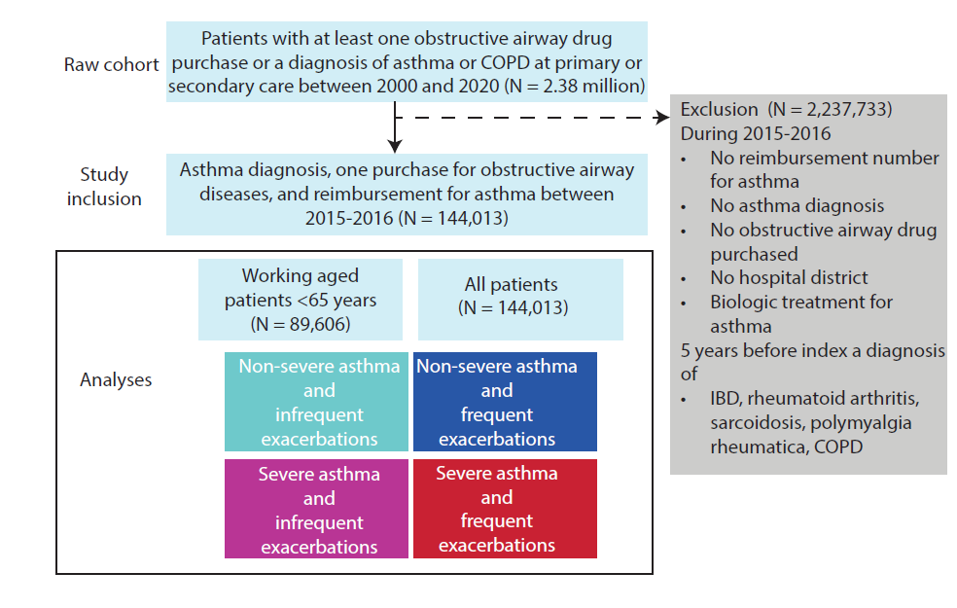
Supplementary Figure 1: Cohort formation overview.
Criteria for special reimbursement right for asthma medication in Finland
The Social Insurance in Finland covers the reimbursement of drugs that are linked with certain medical conditions such as asthma in this study with the reimbursement number 203. Entitlement to medicine reimbursement at a special rate is granted to asthma patients fulfilling the below criteria, and the application is filed by the treating physician.
The 203 right to special reimbursement for chronic asthma is granted when maintenance anti-inflammatory medication has lasted for at least 6 months and is continuing.
In addition to asthma symptoms, the diagnosis should be based on one of the following findings:
• In spirometry with bronchodilation test, forced vital capacity (FVC) or forced expiratory volume in one second (FEV1) is improved by at least 12% and 200 ml, respectively.
• In a two-week home PEF-monitoring
o at least three significant bronchodilation responses (at least 15 % and, in patients aged 12 years and over, at least 60 l/min), or
o at least three significant diurnal variations (at least 20% difference between morning and evening PEF before bronchodilator, and, in patients aged 12 years and over, at least 60 l/min).
• In a treatment trial containing a corticosteroid
o FEV1 improves by at least 15% and 200 ml or
o the mean PEF value (compared to 3-5 days before and after the treatment trial) improves by at least 20% and by at least 60 l/min in patients aged 12 years and over.
• In methacholine challenge test (patients 12 years of age and older), moderate to severe hyperreactivity (PD20FEV1 ≤ 0.6 mg).
• In exercise challenge test, EVH (eucapnic voluntary hyperventilation) test (in patients aged 10 years and older) or mannitol challenge test, FEV1 is reduced by at least 15%.

In 2020, Finland’s national reimbursement program began offering home-administered antibody-based therapies targeting inflammatory molecules for patients with severe uncontrolled asthma. Access is limited to those who, despite optimal high-dose inhaled corticosteroid and at least one other controller-long acting beta-agonist (ICS-LABA) treatment, experience at least three or four exacerbations per year, or two exacerbations per year despite maintenance oral corticosteroid use. Twelve patients were excluded from the analyses, as they had a purchase of a biological asthma drug during follow- up.
Supplementary table 1: Clinical characteristics of the overall cohort of patients with asthma stratified by asthma severity and exacerbation frequency
Characteristic |  | Non-severe with infrequent exacerbations (NSIE) | Non-severe with frequent exacerbations (NSFE) | Severe with infrequent exacerbations (SIE) | Severe with frequent exacerbations (SFE) | p-value | significant post-hoc tests
Number of patients |  | 111,006 | 16,532 | 10,767 | 5,708 | - | -
Patients < 65 years, N (%) |  | 71,493 (64%) | 8,967 (54%) | 6,118 (57%) | 3,028 (53%) | - | -
Age, median (25th, 75th quartile) |  | 57 (41, 69) | 63 (49, 74) | 62 (49, 72) | 63 (51, 74) | <0.001 | All
Female, N (%) |  | 70,407 (63%) | 11,389 (69%) | 6,841 (64%) | 3,998 (70%) | <0.001 | NSFE/NSIE SFE/NSIE SIE/NSFE SFE/SIE
Years from first reimbursement, median (25th, 75th quartile) |  | 10 (4, 16) | 12 (5, 20) | 10 (4, 18) | 14 (6, 23) | <0.001 | All
Age at reimbursement |  | 45 (29, 58) | 48 (35, 59) | 48 (37, 59) | 47 (35, 58) | <0.001 | NSFE/NSIE NSFE/SFE NSIE/SFE NSIE/SIE SFE/SIE
Charlson comorbidity indexª | 0 | 43,391 (39%) | 2,778 (17%) | 2,973 (28%) | 581 (10%) | <0.001 | All
Charlson comorbidity indexª | 1 | 53,909 (49%) | 9,544 (58%) | 6,012 (56%) | 3,659 (64%) | <0.001 | All
Charlson comorbidity indexª | 2 | 4,087 (3.7%) | 891 (5.4%) | 405 (3.8%) | 239 (4.2%) | <0.001 | All
Charlson comorbidity indexª | 3 | 7,274 (6.6%) | 2,275 (14%) | 1,016 (9.4%) | 862 (15%) | <0.001 | All
Charlson comorbidity indexª | 4 | 939 (0.8%) | 348 (2.1%) | 132 (1.2%) | 121 (2.1%) | <0.001 | All
Charlson comorbidity indexª | 5+ | 1,406 (1.3%) | 696 (4.2%) | 229 (2.1%) | 246 (4.3%) | <0.001 | All
Mean daily ICS dose, FP equivalent (μg)^{b,c} |  | 246 (123, 390) | 308 (178, 451) | 841 (657, 985) | 862 (657, 1,005) | <0.001 | NSFE/NSIE NSFE/SFE NSIE/SFE NSFE/SIE NSIE/SIE
No ICS purchases |  | 4,703 (4.2%) | 356 (2.2%) | 0 (0%) | 0 (0%)
Mean daily OCS dose, prednisolone equivalent (mg)^{b,c} |  | 0.82 (0.41, 0.82) | 1.85 (1.64, 3.28) | 0.82 (0.68, 0.82) | 2.46 (1.64, 3.97) | <0.001 | All
No OCS purchases |  | 89,669 (80.8%) | 1,001 (6.1%) | 7,066 (65.6%) | 258 (4.5%)
Number of add on maintenance drug classes used (LTRA/LABA/LAMA)^{b} |  |  |  |  |  | <0.001 | All
0 |  | 45,306 (41%) | 3,724 (23%) | 0 (0%) | 0 (0%)
1 |  | 49,716 (45%) | 7,401 (45%) | 5,566 (52%) | 1,763 (31%)
2 |  | 14,839 (13%) | 4,509 (27%) | 4,312 (40%) | 2,659 (47%)
3 |  | 1,145 (1.0%) | 898 (5.4%) | 889 (8.3%) | 1,286 (23%)
High SABA use, > 450 doses per 12 months |  | 13,636 (12%) | 3,929 (24%) | 2,709 (25%) | 2,359 (41%) | <0.001 | All
Respiratory antibiotic use^{b,d} |  | 31,342 (28%) | 9,220 (56%) | 4,213 (39%) | 3,903 (68%) | <0.001 | All
N (%), median (25th, 75th quartile); ª5 years before index; ^{b}during the two-year baseline; ^{c}among patients with purchases; ^{d}at least one purchase of doxycycline, amoxicillin, amoxicillin clavulanate, azithromycin, or clarithromycin. ICS, inhaled corticosteroid; OCS, oral corticosteroid; LTRA, leukotriene receptor antagonist; LABA, long-acting beta-agonist; LAMA, long-acting muscarinic antagonist.

Supplementary table 2: Impact of asthma severity and exacerbation frequency on direct healthcare costs in the overall cohort of 144 013 patients (primary or secondary healthcare contacts and medication costs)
 | Gamma regression, total direct costs per patient year
Variable | Level | β | exp (β) | 95 % CI (exp (β)) | P-value
Asthma severity  Reference: non-severe | Severe | 0.25 | 1.28 | 1.23 - 1.34 | <0.001
Exacerbation frequency  Reference: infrequent | Frequent | 0.32 | 1.38 | 1.34 -1.42 | <0.001
Age at index (years) |  | 0.02 | 1.02 | 1.02 - 1.02 | <0.001
Sex  Reference: female | Male | -0.53 | 0.59 | 0.55 - 0.63 | <0.001
Charlson comorbidity index  Reference: 0 | 1 | 0.38 | 1.46 | 1.42 - 1.49 | <0.001
Charlson comorbidity index  Reference: 0 | 2 | 0.98 | 2.66 | 2.51 - 2.83 | <0.001
Charlson comorbidity index  Reference: 0 | 3 | 1.13 | 3.1 | 2.97 - 3.25 | <0.001
Charlson comorbidity index  Reference: 0 | 4 | 1.52 | 4.57 | 4.14 - 5.16 | <0.001
Charlson comorbidity index  Reference: 0 | 5+ | 1.75 | 5.75 | 5.31 - 6.3 | <0.001
Interaction term of age at index and sex |  | 0.01 | 1.01 | 1.01 - 1.01 | <0.001
(Intercept) |  | 6.86 | 953.37 | 915.99 - 1002.25 | <0.001
CI – confidence interval

Supplementary table 3: Top 10 healthcare contact related diagnoses by respiratory (ICD-10: J*), cardiovascular disease (ICD-10: I*) causes, and other causes
 | Non-severe asthma |  |  | Severe asthma
Description |  | Infrequent exacerb. | Frequent exacerb. | Infrequent exacerb. | Frequent exacerb.
Respiratory
Asthma |  | 4.10 % | 8.10 % | 6.50 % | 11.60 %
Acute upper respiratory infections of multiple and unspecified sites |  | 0.70 % | 0.80 % | 0.60 % | 0.70 %
Primary care respiratory contacts |  | 0.60 % | 0.80 % | 0.70 % | 0.50 %
Vasomotor and allergic rhinitis |  | 0.30 % | 0.50 % | 0.40 % | 0.60 %
Chronic sinusitis |  | 0.20 % | 0.90 % | 0.30 % | 1.20 %
Acute sinusitis |  | 0.30 % | 0.50 % | 0.30 % | 0.50 %
Pneumonia |  | 0.20 % | 0.40 % | 0.40 % | 0.70 %
Nasal polyp |  | 0.20 % | 0.70 % | 0.10 % | 0.60 %
Acute bronchitis |  | 0.20 % | 0.30 % | 0.20 % | 0.40 %
Bronchiectasis |  | 0.10 % | 0.20 % | 0.30 % | 1.00 %
Cardiovascular
Essential (primary) hypertension |  | 1.30 % | 1.90 % | 1.40 % | 2.40 %
Atrial fibrillation and flutter |  | 0.30 % | 0.40 % | 0.30 % | 0.40 %
Chronic ischemic heart disease |  | 0.20 % | 0.20 % | 0.20 % | 0.30 %
Other cardiac arrhythmias |  | 0.10 % | 0.10 % | 0.20 % | 0.10 %
Cerebral infarction |  | 0.10 % | 0.10 % | 0.10 % | 0.10 %
Cardiomyopathy |  | 0.10 % | 0.10 % | 0.10 % | 0.10 %
Hemorrhoids |  | 0.10 % | 0.10 % | 0.10 % | 0.10 %
Heart failure |  | 0.10 % | 0.10 % | 0.10 % | 0.20 %
Sequelae of cerebrovascular disease |  | 0.10 % | 0.10 % | 0.10 % | 0.20 %
Pulmonary embolism |  | 0.00 % | 0.20 % | 0.10 % | 0.10 %
Other
Depression |  | 2.80 % | 2.70 % | 2.60 % | 1.90 %
Dental caries |  | 2.00 % | 1.50 % | 1.60 % | 1.30 %
Sleep disorders |  | 1.10 % | 1.40 % | 1.20 % | 1.80 %
Other anxiety disorders |  | 1.00 % | 0.80 % | 1.00 % | 0.90 %
Non-insulin-dependent diabetes mellitus |  | 0.90 % | 1.20 % | 1.00 % | 1.30 %
Dorsalgia |  | 0.90 % | 0.90 % | 0.80 % | 1.00 %
Diseases of pulp and periapical tissues |  | 0.80 % | 0.70 % | 0.70 % | 0.60 %
Obesity |  | 0.60 % | 1.10 % | 0.70 % | 1.00 %
Bipolar affective disorder |  | 0.70 % | 0.60 % | 0.70 % | 0.70 %
Other soft tissue disorders, not elsewhere classified |  | 0.60 % | 0.80 % | 0.70 % | 0.80 %
Malignant neoplasm of breast |  | 0.50 % | 1.20 % | 0.60 % | 0.60 %
*includes all subcodes in the ICD-10 hierarchy

Supplementary table 4: Top 10 Sick leave related diagnoses by respiratory (ICD-10: J*), cardiovascular disease (CVD; ICD-10: I*) causes, and other causes
 | Non-severe asthma |  | Severe asthma
Category | Infrequent exacerb. | Frequent exacerb. | Infrequent exacerb. | Frequent exacerb.
Respiratory
Asthma | 1.70 % | 3.80 % | 4.20 % | 13.10 %
Pneumonia | 0.40 % | 0.80 % | 1.20 % | 1.70 %
Acute upper respiratory infections of multiple and unspecified sites | 0.50 % | 0.60 % | 0.70 % | 0.90 %
Acute bronchitis | 0.20 % | 0.40 % | 0.40 % | 0.70 %
Acute sinusitis | 0.20 % | 0.30 % | 0.20 % | 0.60 %
Chronic sinusitis | 0.10 % | 0.40 % | 0.20 % | 0.30 %
Other chronic obstructive pulmonary disease | 0.10 % | 0.20 % | 0.30 % | 0.40 %
Chronic laryngitis and laryngotracheitis | 0.10 % | 0.10 % | 0.30 % | 0.10 %
Acute laryngitis and tracheitis | 0.10 % | 0.10 % | 0.20 % | 0.20 %
Diseases of vocal cords and larynx, not elsewhere classified | 0.10 % | 0.10 % | 0.30 % | 0.10 %
Cardiovascular
Cerebral infarction | 0.70 % | 0.60 % | 0.50 % | 0.30 %
Chronic ischemic heart disease | 0.30 % | 0.30 % | 0.50 % | 0.70 %
Atrial fibrillation and flutter | 0.20 % | 0.20 % | 0.20 % | 0.00 %
Cardiomyopathy | 0.20 % | 0.30 % | 0.20 % | 0.00 %
Heart failure | 0.20 % | 0.10 % | 0.20 % | 0.10 %
Other cardiac arrhythmias | 0.20 % | 0.20 % | 0.20 % | 0.00 %
Sequelae of cerebrovascular disease | 0.20 % | 0.10 % | 0.40 % | 0.10 %
Acute myocardial infarction | 0.10 % | 0.10 % | 0.10 % | 0.10 %
Angina pectoris | 0.20 % | 0.10 % | 0.10 % | 0.00 %
Pulmonary embolism | 0.10 % | 0.10 % | 0.10 % | 0.50 %
Other
Depression | 18.90 % | 17.50 % | 16.20 % | 13.50 %
Dorsalgia | 4.70 % | 4.60 % | 4.10 % | 3.90 %
Other anxiety disorders | 4.70 % | 3.50 % | 3.90 % | 4.00 %
Gonarthrosis [arthrosis of knee] | 3.90 % | 4.70 % | 5.60 % | 2.90 %
Other intervertebral disc disorders | 3.50 % | 3.30 % | 2.60 % | 3.60 %
Shoulder lesions | 3.30 % | 2.90 % | 2.70 % | 2.90 %
Reaction to severe stress, and adjustment disorders | 1.80 % | 1.60 % | 2.00 % | 1.40 %
Malignant neoplasm of breast | 1.60 % | 2.60 % | 1.60 % | 1.20 %
Mononeuropathies of upper limb | 1.90 % | 1.40 % | 1.10 % | 0.80 %
Coxarthrosis [arthrosis of hip] | 1.50 % | 1.90 % | 1.90 % | 0.80 %
*includes all subcodes in the ICD-10 hierarchy

Supplementary table 5: Top 10 disability pension related diagnoses by respiratory (ICD-10: J*), cardiovascular disease (CVD; ICD-10: I*) causes, and other causes
 | Non-severe asthma |  | Severe asthma
Description | Infrequent exacerb. | Frequent exacerb. | Infrequent exacerb. | Frequent exacerb.
Respiratory
Asthma | 2.10 % | 5.10 % | 5.40 % | 12.60 %
Other chronic obstructive pulmonary disease | 0.30 % | 0.40 % | 0.80 % | < 0.7%
Other interstitial pulmonary diseases | < 0.1% | 0.70 % | < 0.4% | < 0.7%
Bronchiectasis | 0.10 % | < 0.3% | < 0.4% | < 0.7%
Hypersensitivity pneumonitis due to organic dust | < 0.1% | < 0.3% | < 0.4% | < 0.7%
Other respiratory disorders | < 0.1% | < 0.3% | < 0.4% | < 0.7%
Diseases of vocal cords and larynx, not elsewhere classified | < 0.1% | < 0.3%
Chronic sinusitis | < 0.1% | < 0.3%
Vasomotor and allergic rhinitis | < 0.1% | < 0.3% | < 0.4%
Respiratory failure, not elsewhere classified | < 0.1% |  |  | < 0.7%
Cardiovascular
Cerebral infarction | 0.90 % | 0.50 % | 0.60 % | 0.90 %
Chronic ischemic heart disease | 0.70 % | 0.70 % | 0.50 % | < 0.7%
Sequelae of cerebrovascular disease | 0.50 % | 0.50 % | 1.00 % | < 0.7%
Cardiomyopathy | 0.40 % | 0.60 % | < 0.4% | < 0.7%
Angina pectoris | 0.40 % | < 0.3% | < 0.4% | < 0.7%
Subarachnoid hemorrhage | 0.30 % | < 0.3% | < 0.4% | < 0.7%
Atrial fibrillation and flutter | 0.30 % | < 0.3% | < 0.4% | < 0.7%
Heart failure | 0.20 % | < 0.3% | < 0.4%
Other cerebrovascular diseases | 0.20 % | 0.30 % | < 0.4% | < 0.7%
Atherosclerosis | 0.20 % | < 0.3% | < 0.4%
Other
Depression | 21.30 % | 20.30 % | 20.20 % | 20.60 %
Gonarthrosis [arthrosis of knee] | 5.10 % | 4.90 % | 6.20 % | 2.20 %
Other intervertebral disc disorders | 5.30 % | 4.20 % | 4.20 % | 4.70 %
Bipolar affective disorder | 4.70 % | 4.10 % | 4.80 % | 3.80 %
Schizophrenia | 3.90 % | 1.80 % | 4.10 % | 2.20 %
Spondylosis | 3.00 % | 2.00 % | 1.80 % | 2.30 %
Shoulder lesions | 2.80 % | 2.30 % | 1.80 % | 2.00 %
Mild mental retardation | 2.90 % | 1.30 % | 2.60 % | 1.90 %
Specific personality disorders | 2.00 % | 2.20 % | 4.00 % | 1.80 %
Other spondylopathies | 2.30 % | 1.40 % | 1.70 % | 1.90 %
*includes all subcodes in the ICD-10 hierarchy

Supplementary table 6: Per patient year results on units of direct HCRU and sick leaves, disability and mortality in working-aged patients (<65 years)
Subgroup | Type | Per patient year estimate | Lower 95% CI | Upper 95% CI
Non-severe with infrequent exacerbations | Emergency room visits | 0.3 | 0.3 | 0.4
Non-severe with frequent exacerbations | Emergency room visits | 0.6 | 0.6 | 0.6
Severe with infrequent exacerbations | Emergency room visits | 0.4 | 0.4 | 0.5
Severe with frequent exacerbations | Emergency room visits | 0.7 | 0.7 | 0.8
Non-severe with infrequent exacerbations | Inpatient days | 0.8 | 0.8 | 0.8
Non-severe with frequent exacerbations | Inpatient days | 1.5 | 1.4 | 1.7
Severe with infrequent exacerbations | Inpatient days | 1.1 | 0.9 | 1.2
Severe with frequent exacerbations | Inpatient days | 2 | 1.8 | 2.3
Non-severe with infrequent exacerbations | Outpatient visits at specialty care | 2.3 | 2.2 | 2.3
Non-severe with frequent exacerbations | Outpatient visits at specialty care | 4.4 | 4.3 | 4.6
Severe with infrequent exacerbations | Outpatient visits at specialty care | 3.1 | 2.9 | 3.3
Severe with frequent exacerbations | Outpatient visits at specialty care | 5.2 | 4.9 | 5.5
Non-severe with infrequent exacerbations | Outpatient visits at primary healthcare | 8.6 | 8.5 | 8.6
Non-severe with frequent exacerbations | Outpatient visits at primary healthcare | 12 | 11.6 | 12.3
Severe with infrequent exacerbations | Outpatient visits at primary healthcare | 10.9 | 10.5 | 11.2
Severe with frequent exacerbations | Outpatient visits at primary healthcare | 14.3 | 13.7 | 14.9
Non-severe with infrequent exacerbations | Home care visits | 0.7 | 0.6 | 0.8
Non-severe with frequent exacerbations | Home care visits | 2 | 1.1 | 2.8
Severe with infrequent exacerbations | Home care visits | 1.7 | 0.9 | 2.6
Severe with frequent exacerbations | Home care visits | 2.8 | 1.2 | 4.4
Non-severe with infrequent exacerbations | Number of medication puchasesª | 10.3 | 10.3 | 10.4
Non-severe with frequent exacerbations | Number of medication puchasesª | 15.9 | 15.7 | 16.1
Severe with infrequent exacerbations | Number of medication puchasesª | 18.5 | 18.2 | 18.8
Severe with frequent exacerbations | Number of medication puchasesª | 24 | 23.5 | 24.5
Non-severe with infrequent exacerbations | Sick leave related productivity loss days | 10.8 | 10.6 | 11
Non-severe with frequent exacerbations | Sick leave related productivity loss days | 16.2 | 15.6 | 16.9
Severe with infrequent exacerbations | Sick leave related productivity loss days | 13.5 | 12.7 | 14.2
Severe with frequent exacerbations | Sick leave related productivity loss days | 17.4 | 16.3 | 18.6
Non-severe with infrequent exacerbations | Disability pension related productivity loss days | 30.7 | 30 | 31.4
Non-severe with frequent exacerbations | Disability pension related productivity loss days | 49.9 | 47.4 | 52.3
Severe with infrequent exacerbations | Disability pension related productivity loss days | 49 | 46 | 52
Severe with frequent exacerbations | Disability pension related productivity loss days | 59.7 | 55.1 | 64.4
Non-severe with infrequent exacerbations | Premature mortality related productivity loss days | 1.4 | 1.2 | 1.5
Non-severe with frequent exacerbations | Premature mortality related productivity loss days | 4.2 | 3.5 | 4.9
Severe with infrequent exacerbations | Premature mortality related productivity loss days | 2.6 | 1.9 | 3.2
Severe with frequent exacerbations | Premature mortality related productivity loss days | 4.4 | 3.1 | 5.7

ªATC classes: R* (respiratory system), A10* (diabetes), C* (cardiovascular system), H02* (systemically used corticosteroids), J* (anti-infectives for systemic use), N06A* (antidepressants), M05* (drugs for the treatment of bone diseases); *includes all subcodes in the ATC hierarchy. CI – confidence interval

Supplementary table 7: Impact of severity and exacerbation frequency on direct costs among working-aged patients (primary or secondary healthcare contacts and medication costs)
Direct healthcare costs | Gamma regression, total direct costs per patient year
Variable | Level | β | exp (β) | 95 % CI (exp (β)) | P-value
Asthma severity  Reference: non-severe | Severe | 0.32 | 1.38 | 1.31 - 1.45 | <0.001
Exacerbation frequency  Reference: infrequent | Frequent | 0.34 | 1.40 | 1.35 - 1.46 | <0.001
Age |  | 0.00 | 1.00 | 1.00 - 1.00 | 0.225
Sex  Reference: female | Male | -0.95 | 0.39 | 0.35 - 0.43 | <0.001
Charlson comorbidity index  Reference: 0 | 1 | 0.43 | 1.54 | 1.49 - 1.58 | <0.001
Charlson comorbidity index  Reference: 0 | 2 | 1.05 | 2.86 | 2.61 - 3.16 | <0.001
Charlson comorbidity index  Reference: 0 | 3 | 1.17 | 3.22 | 2.97 - 3.49 | <0.001
Charlson comorbidity index  Reference: 0 | 4 | 1.65 | 5.21 | 3.97 - 6.96 | <0.001
Charlson comorbidity index  Reference: 0 | 5+ | 1.81 | 6.11 | 4.90 - 7.69 | <0.001
Interaction term of age at index and sex |  | 0.02 | 1.02 | 1.01 - 1.02 | <0.001
Intercept |  | 7.56 | 1919.9 | 1772.24 - 2059.05 | <0.001
CI – confidence interval
Supplementary table 8: Impact of severity and exacerbation frequency on productivity loss related costs arising from sick leaves, disability pensions, or premature mortality among working-aged patients
Productivity loss related costs
 |  | Cox proportional hazards model for having indirect costs during follow-up |  |  | Gamma regression, total indirect costs per patient year
Variable | Level | HR | 95% CI | P-value | β | exp (β) | 95 % CI (exp (β)) | P-value
Asthma severity  Reference: non-severe | Severe | 1.14 | 1.11 – 1.17 | <0.001 | 0.11 | 1.12 | 1.07 – 1.16 | <0.001
Exacerbation frequency  Reference: infrequent | Frequent | 1.23 | 1.20 – 1.27 | <0.001 | -0.02 | 0.97 | 0.94 – 1.01 | 0.339
Age at index (years) |  | 1.03 | 1.03 – 1.03 | <0.001 | 0.03 | 1.03 | 1.03 - 1.04 | <0.001
Sex  Reference: female | Male | 0.47 | 0.43 – 0.52 | <0.001 | 0.65 | 1.92 | 1.73 - 2.14 | <0.001
Charlson comorbidity index  Reference: 0 | 1 | 1.27 | 1.25 – 1.30 | <0.001 | 0.36 | 1.43 | 1.39 - 1.48 | <0.001
Charlson comorbidity index  Reference: 0 | 2 | 1.73 | 1.63 – 1.82 | <0.001 | 0.68 | 1.97 | 1.82 - 2.14 | <0.001
Charlson comorbidity index  Reference: 0 | 3 | 1.75 | 1.67 – 1.84 | <0.001 | 0.79 | 2.2 | 2.05 - 2.34 | <0.001
Charlson comorbidity index  Reference: 0 | 4 | 1.99 | 1.68 – 2.34 | <0.001 | 0.88 | 2.41 | 1.93 - 3.03 | <0.001
Charlson comorbidity index  Reference: 0 | 5+ | 2.46 | 2.18 – 2.77 | <0.001 | 1.05 | 2.86 | 2.46 - 3.39 | <0.001
Interaction term of age at index and sex |  | 1.01 | 1.01 – 1.01 | <0.001 | -0.01 | 0.99 | 0.99 - 0.99 | <0.001
Intercept |  |  |  |  | 7.37 | 1587.63 | 1495.18 - 1685.81 | <0.001
Cox HR model was used to assess the probability of having any productivity loss related costs during follow-up, and gamma regression was used to assess the impact of asthma severity and exacerbation frequency on the amount of costs (considering those with costs during follow-up). HR – hazard ratio; CI – confidence interval

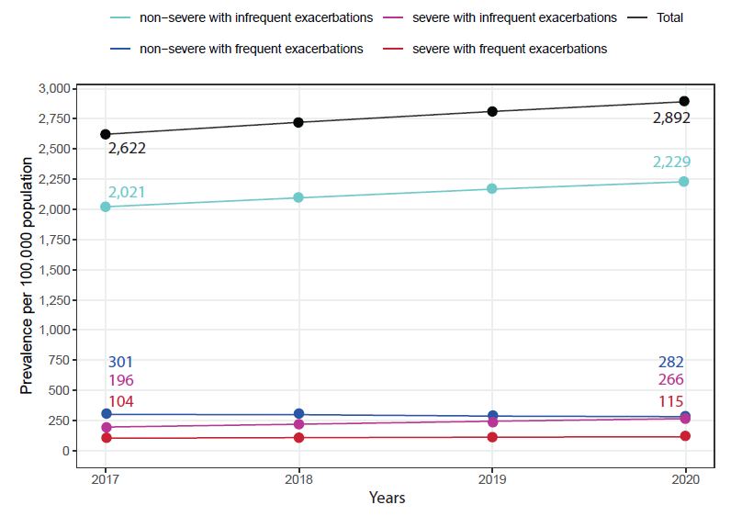
Supplementary Figure 2: Prevalence of patients with asthma fulfilling the eligibility criteria, per 100 000 persons, stratified by asthma severity and exacerbation frequency in the overall cohort of 144 013 patients. The change in prevalence was significant for the total (p<0.001), non-severe asthma and infrequent exacerbations (p<0.001), non-severe with frequent exacerbations (p 0.03), severe with infrequent exacerbations (p<0.001), and severe with frequent exacerbations (p 0.005). Prevalence was calculated by applying the cohort and subgroup criteria to the raw cohort, see supplementary methods.

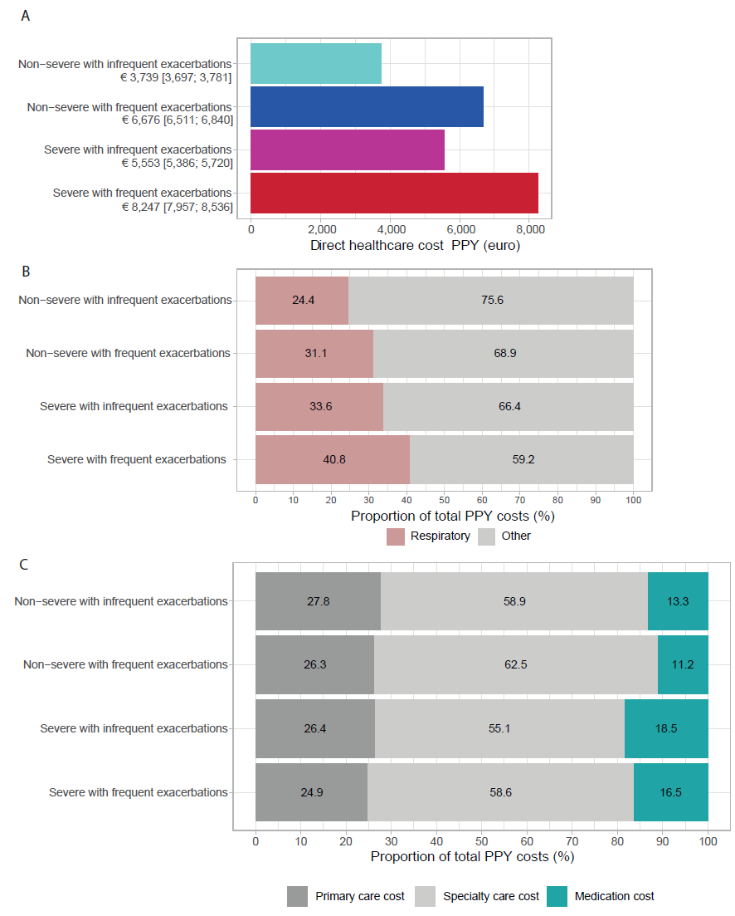
Supplementary Figure 3: Direct healthcare costs by subgroup in the overall cohort of 144,013 patients (A), proportion of direct healthcare costs related to respiratory causes (B), and distribution of direct healthcare costs by primary care, specialty care, and medication costs (C). Costs are presented as mean [95% CI] per patient year (PPY).

