Supplementary Material
Figure S1 Heatmap illustrating the expression patterns of DEGs between BC and normal tissues.

Figure S2 Risk curves illustrating the distribution of risk scores and survival status among high-risk and low-risk groups within training (A) and validation (B) cohorts.

Figure S3 Construction of regulatory network and analysis of differentially responsive drugs in HCC (A) The mRNA-miRNA-lncRNA regulatory network for prognostic genes. (B) The regulatory network for prognostic genes and chemical compound. (C) Differences in drug sensitivity between high and low risk groups.

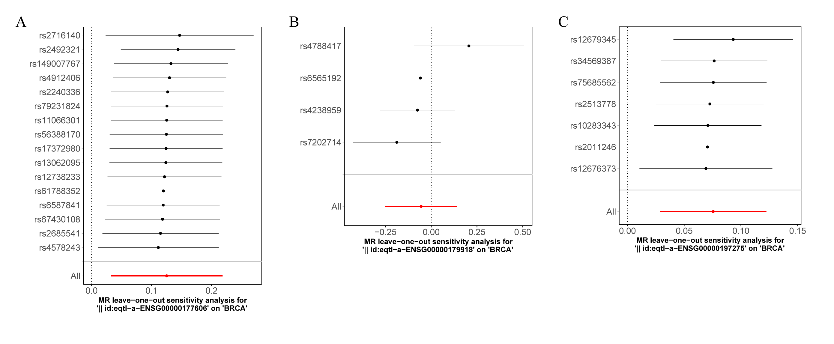
Figure S4 The forest plot for Leave-one-out test.

Figure S5 (A) Before and after plots of single-cell analysis for quality control. (B) Screening for highly variable genes. (C) Principal component analysis (PCA) scree plot analysis.

Table S1 The result of heterogeneity test
outcome | exposure | method | Q | Q_df | Q_pval
BRCA | || id:eqtl-a-ENSG00000177606 | MR Egger | 8.1828 | 14.0000 | 0.8796
BRCA | || id:eqtl-a-ENSG00000177606 | Inverse variance weighted | 8.4895 | 15.0000 | 0.9027
BRCA | || id:eqtl-a-ENSG00000179918 | MR Egger | 2.7647 | 2.0000 | 0.2510
BRCA | || id:eqtl-a-ENSG00000179918 | Inverse variance weighted | 5.1899 | 3.0000 | 0.1584
BRCA | || id:eqtl-a-ENSG00000197275 | MR Egger | 6.8701 | 5.0000 | 0.2305
BRCA | || id:eqtl-a-ENSG00000197275 | Inverse variance weighted | 7.5463 | 6.0000 | 0.2733
Q, Cochran's Q test estimate; Q_df, Q_degree of freedom.

Table S2 The result of horizontal pleiotropy test
outcome | exposure | egger_intercept | se | pval
BRCA | || id:eqtl-a-ENSG00000177606 | 0.0067 | 0.0120 | 0.5884
BRCA | || id:eqtl-a-ENSG00000179918 | 0.0386 | 0.0292 | 0.3164
BRCA | || id:eqtl-a-ENSG00000197275 | 0.0172 | 0.0246 | 0.5143
se, standard error

