Association of 24 conventional and unconventional anthropometric indicators with pre-hypertension or hypertension: A population-based cross-sectional study in Chinese population
Ying Han¹*
Huajing Chang²*
Jingru Huang³
Min Pan^{4,5,6}
Jin Gong^{4,5,6}
Bangbang Huang^{4,5,6}
Liangdi Xie^{4,5,6}
Xian-E Peng^{2†}
Huashan Hong^{7†}
¹Fujian Medical University Union Hospital, Fuzhou, China; ²Department of Epidemiology and Health Statistics, Fujian Provincial Key Laboratory of Environment Factors and Cancer, School of Public Health, Fujian Medical University, Fuzhou, China; ³College of Integrated Chinese and Western Medicine, Fujian University of Traditional Chinese Medicine, Fuzhou, China; ⁴Department of Geriatrics, The First Affiliated Hospital of Fujian Medical University, Fuzhou, China; ⁵Institution of Fujian Hypertension Research, The First Affiliated Hospital of Fujian Medical University, Fuzhou, China; ⁶Fujian Provincial Sub-center of National Clinical Research Center for Geriatric Disorders, The First Affiliated Hospital of Fujian Medical University, Fuzhou, China; ⁷Department of Geriatrics, Fujian Key Laboratory of Vascular Aging (Fujian Medical University), Fujian Institute of Geriatrics, Fujian Clinical Research Center for Senile Vascular Aging and Brain Aging, Fujian Medical University Union Hospital, Fuzhou, China.
*These authors contributed equally to this work.
†Correspondence: Xian-E Peng, Huashan Hong.

Supplementary Tables legends
Supplementary Table 1: STROBE Statement—Checklist of items that should be included in reports of cross-sectional studies
Supplementary Table 2: Univariate logistic regression analysis of conventional and unconventional anthropometric parameters with pre-hypertension and hypertension
Supplementary Table 3: Correlation matrix of the conventional and unconventional anthropometric parameters
Supplementary Table 4: Sensitivity analyses of the conventional and unconventional anthropometric parameters with prehypertension and hypertension

Supplementary Figures legends
Supplementary Figure 1: Heat map of the conventional and unconventional anthropometric parameters
Supplementary Figure 2: Subgroup analyses of the conventional and unconventional anthropometric parameters with prehypertension and hypertension

Supplementary Table 1 STROBE Statement—Checklist of items that should be included in reports of cross-sectional studies
 | Item No | Recommendation | Reported on  Section
Title and abstract | 1 | (a) Indicate the study’s design with a commonly used term in the title or the abstract | Title
Title and abstract | 1 | (b) Provide in the abstract an informative and balanced summary of what was done and what was found | Abstract
Introduction
Background/rationale | 2 | Explain the scientific background and rationale for the investigation being reported | Introduction, paragraphs 1-3
Objectives | 3 | State specific objectives, including any prespecified hypotheses | Introduction, paragraph 4
Methods
Study design | 4 | Present key elements of study design early in the paper | Methods, subsection 2.1. “Study design and population”
Setting | 5 | Describe the setting, locations, and relevant dates, including periods of recruitment, exposure, follow-up, and data collection | Methods, subsection 2.1. “Study design and population”
Participants | 6 | (a) Give the eligibility criteria, and the sources and methods of selection of participants | Methods, subsection 2.1. “Study design and population”, paragraph 2  Results, subsection 3.1. “Characteristics of the study population”  Figure 1
Variables | 7 | Clearly define all outcomes, exposures, predictors, potential confounders, and effect modifiers. Give diagnostic criteria, if applicable | Methods, subsections 2.2.-2.4.
Data sources/ measurement | 8* | For each variable of interest, give sources of data and details of methods of assessment (measurement). Describe comparability of assessment methods if there is more than one group | Methods, subsections 2.2.-2.4.
Bias | 9 | Describe any efforts to address potential sources of bias | Methods, subsection 2.5. “Statistical analysis”  Results, subsection 3.7. “Subgroup analyses and sensitivity analyses”
Study size | 10 | Explain how the study size was arrived at | Methods, subsection 2.1. “Study design and population”
Quantitative variables | 11 | Explain how quantitative variables were handled in the analyses. If applicable, describe which groupings were chosen and why | Methods, subsection 2.5. “Statistical analysis”
Statistical methods | 12 | (a) Describe all statistical methods, including those used to control for confounding | Methods, subsection 2.5. “Statistical analysis”
Statistical methods | 12 | (b) Describe any methods used to examine subgroups and interactions | Methods, subsection 2.5. “Statistical analysis”
Statistical methods | 12 | (c) Explain how missing data were addressed | Methods, subsection 2.1. “Study design and population”, paragraph 2  Figure 1
Statistical methods | 12 | (d) If applicable, describe analytical methods taking account of sampling strategy | N/A
Statistical methods | 12 | (e) Describe any sensitivity analyses | Results, subsection 3.7. “Subgroup analyses and sensitivity analyses”
Results
Participants | 13* | (a) Report numbers of individuals at each stage of study—eg numbers potentially eligible, examined for eligibility, confirmed eligible, included in the study, completing follow-up, and analysed | Methods, subsection 2.1. “Study design and population”  Results, subsection 3.1. “Characteristics of the study population”  Figure 1
Participants | 13* | (b) Give reasons for non-participation at each stage | Methods, subsection 2.1. “Study design and population”  Figure 1
Participants | 13* | (c) Consider use of a flow diagram | Results, subsection 3.1. “Characteristics of the study population”  Figure 1
Descriptive data | 14* | (a) Give characteristics of study participants (eg demographic, clinical, social) and information on exposures and potential confounders | Results, subsections 3.1.-3.2.  Table 1, Table 2
Descriptive data | 14* | (b) Indicate number of participants with missing data for each variable of interest | N/A
Outcome data | 15* | Report numbers of outcome events or summary measures | Results, subsection 3.4. “Association of conventional and unconventional anthropometric indicators with pre-hypertension and hypertension”  Table 3
Main results | 16 | (a) Give unadjusted estimates and, if applicable, confounder-adjusted estimates and their precision (eg, 95% confidence interval). Make clear which confounders were adjusted for and why they were included | Results, subsections 3.4.-3.7.  Table 3, Figure 3-4  Supplementary Materials-Table S4
Main results | 16 | (b) Report category boundaries when continuous variables were categorized | Methods, subsection 2.2. “Blood pressure measurement and definition of pre-hypertension or hypertension”, paragraph 2
Main results | 16 | (c) If relevant, consider translating estimates of relative risk into absolute risk for a meaningful time period | N/A
Other analyses | 17 | Report other analyses done—eg analyses of subgroups and interactions, and sensitivity analyses | Results, subsection 3.7. “Subgroup analyses and sensitivity analyses”  Supplementary Materials-Figure S2, Table S4
Discussion
Key results | 18 | Summarise key results with reference to study objectives | Discussion, paragraph 1
Limitations | 19 | Discuss limitations of the study, taking into account sources of potential bias or imprecision. Discuss both direction and magnitude of any potential bias | Discussion, paragraph 7
Interpretation | 20 | Give a cautious overall interpretation of results considering objectives, limitations, multiplicity of analyses, results from similar studies, and other relevant evidence | Discussion, paragraph 1-7
Generalisability | 21 | Discuss the generalisability (external validity) of the study results | Discussion, paragraph 7
Other information
Funding | 22 | Give the source of funding and the role of the funders for the present study and, if applicable, for the original study on which the present article is based | Funding
*Give information separately for exposed and unexposed groups.
Note: An Explanation and Elaboration article discusses each checklist item and gives methodological background and published examples of transparent reporting. The STROBE checklist is best used in conjunction with this article (freely available on the Web sites of PLoS Medicine at http://www.plosmedicine.org/, Annals of Internal Medicine at http://www.annals.org/, and Epidemiology at http://www.epidem.com/). Information on the STROBE Initiative is available at www.strobe-statement.org.

Supplementary Table 2 Univariate logistic regression analysis of conventional and unconventional anthropometric parameters with pre-hypertension and hypertension
Variables | Pre-hypertension |  |  | Hypertension
Variables | OR (95%CI) | P value |  | OR (95%CI) | P value
Height | 1.036 (1.029, 1.042) | <0.001 |  | 0.992 (0.986, 0.998) | 0.006
Weight | 1.053 (1.047, 1.058) | <0.001 |  | 1.056 (1.050, 1.061) | <0.001
WC | 1.060 (1.054, 1.067) | <0.001 |  | 1.113 (1.106, 1.121) | <0.001
FM | 1.042 (1.033, 1.051) | <0.001 |  | 1.091 (1.082, 1.101) | <0.001
FFM | 1.064 (1.057, 1.071) | <0.001 |  | 1.045 (1.039, 1.052) | <0.001
BFP | 1.000 (0.993, 1.007) | 0.955 |  | 1.046 (1.039, 1.054) | <0.001
VFI | 1.071 (1.056, 1.087) | <0.001 |  | 1.170 (1.152, 1.189) | <0.001
BMR | 1.0026 (1.0023, 1.0029) | <0.001 |  | 1.0018 (1.0015, 1.0020) | <0.001
BMI | 1.154 (1.135, 1.173) | <0.001 |  | 1.281 (1.258, 1.306) | <0.001
HtaW | 1.005 (1.004, 1.006) | <0.001 |  | 1.007 (1.006, 1.008) | <0.001
WHtR | 1.082 (1.071, 1.092) | <0.001 |  | 1.207 (1.194, 1.221) | <0.001
FMI | 1.055 (1.041, 1.069) | <0.001 |  | 1.149 (1.133, 1.166) | <0.001
FFMI | 1.144 (1.129, 1.160) | <0.001 |  | 1.124 (1.110, 1.139) | <0.001
WCI | 2.049 (1.900, 2.212) | <0.001 |  | 4.472 (4.089, 4.900) | <0.001
WWI | 1.373 (1.286, 1.466) | <0.001 |  | 2.993 (2.774, 3.235) | <0.001
BSA | 21.000 (15.359, 28.842) | <0.001 |  | 14.042 (10.408, 19.014) | <0.001
AIP | 4.695 (3.835, 5.760) | <0.001 |  | 12.665 (10.266, 15.678) | <0.001
LAP | 1.020 (1.017, 1.023) | <0.001 |  | 1.039 (1.036, 1.043) | <0.001
VAI | 1.259 (1.200, 1.324) | <0.001 |  | 1.623 (1.539, 1.714) | <0.001
TyG | 2.309 (2.091, 2.554) | <0.001 |  | 4.447 (3.999, 4.956) | <0.001
CI | 1.040 (1.034, 1.046) | <0.001 |  | 1.104 (1.097, 1.112) | <0.001
BRI | 1.535 (1.457, 1.618) | <0.001 |  | 2.727 (2.566, 2.902) | <0.001
ABSI | 1.483 (1.354, 1.626) | <0.001 |  | 3.221 (2.908, 3.574) | <0.001
CMI | 2.640 (2.280, 3.072) | <0.001 |  | 6.002 (5.084, 7.122) | <0.001
Abbreviations: WC, Waist Circumference; FM, Fat Mass; FFM, Fat-Free Mass; BFP, Body Fat Percentage; VFI, Visceral Fat Index; BMR, Basal Metabolic Rate; BMI, Body Mass Index; HtaW, Height-adjusted Weight; WHtR, Waist-Height Ratio; FMI, Fat Mass Index; FFMI, Fat-Free Mass Index; WCI, Waist Circumference Index; WWI, Weight-adjusted-Waist Index; BSA, Body Surface Area; AIP, Atherogenic Index of Plasma; LAP, Lipid Accumulation Product; VAI, Visceral Adiposity Index; TyG, Triglyceride-Glucose Index; CI, Conicity Index; BRI, Body Roundness Index; ABSI, A Body Shape Index; CMI, Cardiometabolic Index.

Supplementary Table 3 Correlation matrix of the conventional and unconventional anthropometric parameters
 | Height | Weight | WC | FM | FFM | BFP | VFI | BMR | BMI | HtaW | WHtR | FMI | FFMI | WCI | WWI | BSA | AIP | LAP | VAI | TyG | CI | BRI | ABSI | CMI
Height | 1.000
Weight | 0.602 | 1.000
WC | 0.266 | 0.760 | 1.000
FM | -0.015† | 0.641 | 0.637 | 1.000
FFM | 0.818 | 0.829 | 0.535 | 0.144 | 1.000
BFP | -0.483 | 0.119 | 0.274 | 0.771 | -0.391 | 1.000
VFI | -0.115 | 0.520 | 0.569 | 0.922 | 0.031 | 0.843 | 1.000
BMR | 0.822 | 0.828 | 0.529 | 0.189 | 0.962 | -0.384 | 0.037 | 1.000
BMI | 0.044 | 0.800 | 0.773 | 0.839 | 0.441 | 0.518 | 0.763 | 0.435 | 1.000
HtaW | 0.286 | 0.440 | 0.379 | 0.235 | 0.404 | -0.008† | 0.186 | 0.405 | 0.356 | 1.000
WHtR | -0.141 | 0.510 | 0.901 | 0.653 | 0.204 | 0.484 | 0.630 | 0.197 | 0.770 | 0.281 | 1.000
FMI | -0.166 | 0.532 | 0.584 | 0.986 | 0.015† | 0.842 | 0.930 | 0.060 | 0.819 | 0.193 | 0.668 | 1.000
FFMI | 0.703 | 0.845 | 0.589 | 0.191 | 0.982 | -0.334 | 0.079 | 0.940 | 0.542 | 0.415 | 0.306 | 0.078 | 1.000
WCI | 0.065 | 0.650 | 0.975 | 0.661 | 0.378 | 0.388 | 0.615 | 0.372 | 0.791 | 0.338 | 0.974 | 0.641 | 0.458 | 1.000
WWI | -0.259 | 0.097 | 0.686 | 0.278 | -0.071 | 0.290 | 0.305 | -0.079 | 0.323 | 0.110 | 0.830 | 0.315 | -0.001† | 0.775 | 1.000
BSA | 0.745 | 0.979 | 0.693 | 0.523 | 0.893 | -0.022 | 0.398 | 0.893 | 0.668 | 0.437 | 0.385 | 0.396 | 0.876 | 0.552 | 0.015† | 1.000
AIP | 0.168 | 0.417 | 0.460 | 0.321 | 0.323 | 0.100 | 0.285 | 0.322 | 0.416 | 0.211 | 0.402 | 0.289 | 0.354 | 0.442 | 0.255 | 0.385 | 1.000
LAP | 0.102 | 0.598 | 0.817 | 0.609 | 0.346 | 0.356 | 0.566 | 0.344 | 0.693 | 0.257 | 0.792 | 0.581 | 0.405 | 0.824 | 0.599 | 0.517 | 0.785 | 1.000
VAI | 0.004† | 0.322 | 0.466 | 0.384 | 0.148 | 0.257 | 0.368 | 0.150 | 0.415 | 0.117 | 0.476 | 0.375 | 0.188 | 0.483 | 0.367 | 0.265 | 0.951 | 0.835 | 1.000
TyG | 0.082 | 0.356 | 0.438 | 0.323 | 0.240 | 0.152 | 0.303 | 0.238 | 0.401 | 0.184 | 0.417 | 0.303 | 0.278 | 0.438 | 0.291 | 0.313 | 0.917 | 0.789 | 0.891 | 1.000
CI | 0.061 | 0.307 | 0.811 | 0.292 | 0.196 | 0.147 | 0.287 | 0.189 | 0.354 | 0.210 | 0.810 | 0.278 | 0.232 | 0.831 | 0.937 | 0.268 | 0.322 | 0.659 | 0.385 | 0.330 | 1.000
BRI | -0.141 | 0.510 | 0.901 | 0.653 | 0.204 | 0.484 | 0.630 | 0.197 | 0.770 | 0.281 | 1.000 | 0.668 | 0.306 | 0.974 | 0.830 | 0.385 | 0.402 | 0.792 | 0.476 | 0.417 | 0.810 | 1.000
ABSI | 0.051 | 0.075 | 0.605 | 0.043 | 0.069 | -0.012† | 0.062 | 0.061 | 0.065 | 0.107 | 0.603 | 0.034 | 0.074 | 0.618 | 0.889 | 0.073 | 0.211 | 0.476 | 0.278 | 0.223 | 0.945 | 0.603 | 1.000
CMI | 0.126 | 0.475 | 0.584 | 0.412 | 0.331 | 0.181 | 0.376 | 0.330 | 0.520 | 0.243 | 0.547 | 0.385 | 0.379 | 0.580 | 0.384 | 0.423 | 0.984 | 0.867 | 0.957 | 0.913 | 0.441 | 0.547 | 0.303 | 1.000
Abbreviations: WC, Waist Circumference; FM, Fat Mass; FFM, Fat-Free Mass; BFP, Body Fat Percentage; VFI, Visceral Fat Index; BMR, Basal Metabolic Rate; BMI, Body Mass Index; HtaW, Height-adjusted Weight; WHtR, Waist-Height Ratio; FMI, Fat Mass Index; FFMI, Fat-Free Mass Index; WCI, Waist Circumference Index; WWI, Weight-adjusted-Waist Index; BSA, Body Surface Area; AIP, Atherogenic Index of Plasma; LAP, Lipid Accumulation Product; VAI, Visceral Adiposity Index; TyG, Triglyceride-Glucose Index; CI, Conicity Index; BRI, Body Roundness Index; ABSI, A Body Shape Index; CMI, Cardiometabolic Index. Note: †, P > 0.05.

Supplementary Table 4 Sensitivity analyses of the conventional and unconventional anthropometric parameters with prehypertension and hypertension
 | Model 1 |  | Model 2 |  | Model 3 |  | Model 4
 | OR (95%CI) | P value | OR (95%CI) | P value | OR (95%CI) | P value | OR (95%CI) | P value
- Excluding participants with a family history of hypertension or cardiovascular diseases
Pre-hypertension (reference= normotension, N = 4511)
Weight | 2.458 (1.467, 4.162) | 0.001 | 2.332 (1.369, 4.010) | 0.002 | 2.296 (1.348, 3.949) | 0.002 | 2.242 (1.315, 3.860) | 0.003
FFM | 0.683 (0.515, 0.901) | 0.008 | 0.763 (0.574, 1.008) | 0.059 | 0.761 (0.573, 1.004) | 0.056 | 0.768 (0.578, 1.014) | 0.065
VFI | 1.019 (0.967, 1.073) | 0.487 | 1.004 (0.953, 1.059) | 0.868 | 1.006 (0.954, 1.060) | 0.831 | 1.003 (0.952, 1.058) | 0.903
BMR | 0.999 (0.998, 1.000) | 0.244 | 0.999 (0.998, 1.000) | 0.135 | 0.999 (0.998, 1.000) | 0.143 | 0.999 (0.998, 1.000) | 0.140
BMI | 4.606 (1.607, 13.341) | 0.005 | 5.102 (1.690, 15.552) | 0.004 | 4.866 (1.610, 14.851) | 0.005 | 4.601 (1.518, 14.079) | 0.007
HtaW | 1.000 (0.998, 1.001) | 0.644 | 0.998 (0.996, 1.000) | 0.014 | 0.998 (0.996, 1.000) | 0.015 | 0.998 (0.996, 1.000) | 0.020
FMI | 0.091 (0.020, 0.394) | 0.001 | 0.102 (0.022, 0.468) | 0.004 | 0.107 (0.023, 0.493) | 0.004 | 0.115 (0.024, 0.531) | 0.006
FFMI | 0.185 (0.053, 0.644) | 0.008 | 0.162 (0.043, 0.600) | 0.007 | 0.172 (0.046, 0.637) | 0.009 | 0.182 (0.048, 0.675) | 0.011
WWI | 1.061 (0.691, 1.624) | 0.786 | 1.203 (0.772, 1.869) | 0.412 | 1.203 (0.771, 1.868) | 0.414 | 1.182 (0.757, 1.836) | 0.460
AIP | 0.186 (0.083, 0.412) | <0.001 | 0.286 (0.125, 0.648) | 0.003 | 0.298 (0.130, 0.678) | 0.004 | 0.281 (0.102, 0.762) | 0.013
LAP | 0.986 (0.977, 0.996) | 0.004 | 0.999 (0.989, 1.009) | 0.862 | 0.999 (0.990, 1.009) | 0.910 | 0.999 (0.989, 1.009) | 0.774
VAI | 0.624 (0.493, 0.782) | <0.001 | 1.079 (0.814, 1.432) | 0.594 | 1.055 (0.794, 1.400) | 0.710 | 1.067 (0.803, 1.417) | 0.652
TyG | 4.746 (3.429, 6.604) | <0.001 | 2.725 (1.934, 3.860) | <0.001 | 2.697 (1.912, 3.824) | <0.001 | 2.610 (1.733, 3.966) | <0.001
BRI | 1.327 (0.805, 2.204) | 0.270 | 0.864 (0.516, 1.460) | 0.583 | 0.863 (0.515, 1.458) | 0.580 | 0.884 (0.527, 1.494) | 0.641
CMI | 4.065 (2.089, 8.159) | <0.001 | 0.698 (0.304, 1.623) | 0.399 | 0.736 (0.320, 1.716) | 0.472 | 0.791 (0.342, 1.857) | 0.585
Hypertension (reference= normotension, N = 4314)
Height | 1.016 (0.925, 1.117) | 0.734 | 1.032 (0.928, 1.146) | 0.564 | 1.030 (0.926, 1.144) | 0.589 | 1.032 (0.928, 1.147) | 0.560
WC | 0.777 (0.616, 0.978) | 0.032 | 0.754 (0.585, 0.967) | 0.027 | 0.774 (0.600, 0.995) | 0.047 | 0.771 (0.598, 0.991) | 0.044
FM | 1.802 (1.289, 2.552) | 0.001 | 1.443 (1.004, 2.086) | 0.048 | 1.473 (1.025, 2.135) | 0.037 | 1.483 (1.031, 2.151) | 0.034
BFP | 0.954 (0.921, 0.988) | 0.008 | 0.990 (0.951, 1.031) | 0.619 | 0.991 (0.952, 1.032) | 0.661 | 0.992 (0.952, 1.033) | 0.689
VFI | 1.088 (1.019, 1.164) | 0.013 | 0.994 (0.922, 1.071) | 0.873 | 0.998 (0.926, 1.076) | 0.959 | 0.996 (0.923, 1.073) | 0.909
BMR | 0.998 (0.997, 1.000) | 0.042 | 1.000 (0.999, 1.002) | 0.815 | 1.000 (0.999, 1.002) | 0.763 | 1.000 (0.999, 1.002) | 0.741
BMI | 0.835 (0.374, 1.885) | 0.661 | 0.731 (0.310, 1.729) | 0.473 | 0.812 (0.342, 1.939) | 0.635 | 0.815 (0.344, 1.948) | 0.642
HtaW | 1.003 (1.002, 1.005) | <0.001 | 0.999 (0.997, 1.001) | 0.185 | 0.999 (0.997, 1.001) | 0.175 | 0.999 (0.997, 1.001) | 0.169
WHtR | 1.839 (1.091, 3.095) | 0.022 | 1.780 (1.019, 3.103) | 0.042 | 1.677 (0.956, 2.930) | 0.070 | 1.697 (0.968, 2.964) | 0.063
FMI | 0.424 (0.165, 1.051) | 0.068 | 0.815 (0.303, 2.170) | 0.681 | 0.736 (0.271, 1.962) | 0.540 | 0.721 (0.264, 1.924) | 0.514
FFMI | 1.185 (0.739, 1.885) | 0.475 | 1.396 (0.846, 2.307) | 0.190 | 1.311 (0.789, 2.168) | 0.290 | 1.299 (0.781, 2.150) | 0.308
WWI | 1.297 (0.440, 3.918) | 0.640 | 1.911 (0.603, 6.541) | 0.284 | 1.950 (0.612, 6.717) | 0.271 | 1.867 (0.586, 6.440) | 0.304
AIP | 0.050 (0.020, 0.124) | <0.001 | 0.207 (0.076, 0.552) | 0.002 | 0.243 (0.089, 0.654) | 0.005 | 0.143 (0.043, 0.463) | 0.001
LAP | 0.981 (0.972, 0.990) | <0.001 | 1.001 (0.991, 1.011) | 0.876 | 1.001 (0.990, 1.011) | 0.913 | 1.002 (0.991, 1.013) | 0.777
VAI | 0.380 (0.292, 0.490) | <0.001 | 0.808 (0.569, 1.153) | 0.235 | 0.805 (0.567, 1.149) | 0.227 | 0.821 (0.577, 1.176) | 0.278
TyG | 14.650 (10.161, 21.302) | <0.001 | 4.685 (3.105, 7.128) | <0.001 | 4.377 (2.895, 6.675) | <0.001 | 5.075 (3.133, 8.330) | <0.001
BRI | 0.785 (0.301, 2.087) | 0.624 | 0.399 (0.141, 1.151) | 0.085 | 0.426 (0.151, 1.237) | 0.112 | 0.423 (0.149, 1.226) | 0.109
CMI | 17.058 (8.054, 38.104) | <0.001 | 1.272 (0.493, 3.331) | 0.620 | 1.266 (0.490, 3.321) | 0.627 | 1.348 (0.516, 3.580) | 0.544
- Excluding current smokers or current drinkers
Pre-hypertension (reference= normotension, N = 3920)
Weight | 2.451 (1.339, 4.531) | 0.004 | 1.954 (1.052, 3.669) | 0.035 | 1.971 (1.062, 3.700) | 0.033 | 1.943 (1.044, 3.653) | 0.038
FFM | 0.841 (0.601, 1.175) | 0.311 | 0.974 (0.694, 1.364) | 0.880 | 0.971 (0.691, 1.358) | 0.863 | 0.980 (0.697, 1.372) | 0.905
VFI | 1.048 (0.989, 1.110) | 0.114 | 1.014 (0.957, 1.075) | 0.644 | 1.013 (0.956, 1.074) | 0.660 | 1.011 (0.954, 1.072) | 0.704
BMR | 1.000 (0.998, 1.001) | 0.611 | 1.000 (0.998, 1.001) | 0.540 | 1.000 (0.998, 1.001) | 0.554 | 1.000 (0.998, 1.001) | 0.524
BMI | 6.753 (2.038, 22.696) | 0.002 | 4.825 (1.388, 16.985) | 0.014 | 4.904 (1.412, 17.249) | 0.013 | 4.750 (1.361, 16.779) | 0.015
HtaW | 0.999 (0.997, 1.001) | 0.344 | 0.998 (0.995, 1.000) | 0.028 | 0.998 (0.995, 1.000) | 0.024 | 0.998 (0.996, 1.000) | 0.029
FMI | 0.070 (0.012, 0.381) | 0.002 | 0.136 (0.023, 0.787) | 0.027 | 0.133 (0.023, 0.767) | 0.025 | 0.139 (0.023, 0.803) | 0.029
FFMI | 0.104 (0.025, 0.435) | 0.002 | 0.147 (0.033, 0.651) | 0.012 | 0.144 (0.032, 0.638) | 0.011 | 0.148 (0.033, 0.658) | 0.012
WWI | 1.088 (0.681, 1.737) | 0.725 | 1.145 (0.707, 1.855) | 0.583 | 1.140 (0.704, 1.849) | 0.594 | 1.111 (0.685, 1.801) | 0.669
AIP | 0.197 (0.080, 0.480) | <0.001 | 0.356 (0.143, 0.884) | 0.026 | 0.361 (0.144, 0.895) | 0.028 | 0.330 (0.106, 1.011) | 0.054
LAP | 0.990 (0.980, 1.000) | 0.059 | 0.999 (0.989, 1.010) | 0.880 | 0.999 (0.989, 1.010) | 0.886 | 0.998 (0.988, 1.009) | 0.741
VAI | 0.606 (0.457, 0.796) | <0.001 | 1.046 (0.738, 1.473) | 0.799 | 1.047 (0.739, 1.475) | 0.793 | 1.066 (0.752, 1.502) | 0.715
TyG | 4.534 (3.184, 6.498) | <0.001 | 2.530 (1.737, 3.702) | <0.001 | 2.514 (1.725, 3.678) | <0.001 | 2.471 (1.569, 3.929) | <0.001
BRI | 1.287 (0.745, 2.230) | 0.367 | 0.925 (0.527, 1.628) | 0.787 | 0.930 (0.529, 1.636) | 0.800 | 0.953 (0.543, 1.678) | 0.868
CMI | 4.444 (1.811, 11.570) | 0.002 | 0.716 (0.242, 2.191) | 0.549 | 0.711 (0.240, 2.179) | 0.542 | 0.755 (0.254, 2.328) | 0.616
Hypertension (reference= normotension, N = 3898)
Height | 0.857 (0.764, 0.959) | 0.008 | 0.878 (0.772, 0.996) | 0.044 | 0.880 (0.775, 0.999) | 0.049 | 0.884 (0.778, 1.003) | 0.057
WC | 1.100 (0.844, 1.430) | 0.479 | 1.134 (0.840, 1.521) | 0.407 | 1.129 (0.837, 1.516) | 0.421 | 1.090 (0.809, 1.462) | 0.569
FM | 1.173 (0.735, 1.852) | 0.498 | 0.998 (0.600, 1.646) | 0.995 | 1.017 (0.613, 1.669) | 0.948 | 0.970 (0.584, 1.587) | 0.902
BFP | 0.950 (0.916, 0.986) | 0.006 | 0.966 (0.925, 1.009) | 0.111 | 0.964 (0.924, 1.007) | 0.093 | 0.961 (0.921, 1.004) | 0.073
VFI | 1.143 (1.064, 1.229) | <0.001 | 1.020 (0.938, 1.110) | 0.647 | 1.021 (0.938, 1.110) | 0.634 | 1.015 (0.932, 1.104) | 0.738
BMR | 1.000 (0.999, 1.001) | 0.738 | 1.001 (0.999, 1.002) | 0.221 | 1.001 (1.000, 1.002) | 0.184 | 1.001 (0.999, 1.002) | 0.305
BMI | 0.643 (0.233, 1.761) | 0.393 | 0.746 (0.246, 2.251) | 0.602 | 0.767 (0.255, 2.298) | 0.635 | 0.693 (0.227, 2.085) | 0.515
HtaW | 1.004 (1.002, 1.006) | <0.001 | 0.999 (0.996, 1.001) | 0.353 | 0.999 (0.996, 1.001) | 0.335 | 0.999 (0.996, 1.001) | 0.354
WHtR | 1.100 (0.621, 1.943) | 0.744 | 0.957 (0.507, 1.799) | 0.890 | 0.962 (0.511, 1.807) | 0.905 | 0.958 (0.505, 1.806) | 0.894
FMI | 0.919 (0.264, 3.271) | 0.895 | 1.401 (0.359, 5.606) | 0.627 | 1.338 (0.347, 5.302) | 0.672 | 1.585 (0.413, 6.335) | 0.504
FFMI | 1.333 (0.730, 2.469) | 0.355 | 1.312 (0.679, 2.562) | 0.420 | 1.288 (0.668, 2.507) | 0.451 | 1.388 (0.720, 2.722) | 0.331
WWI | 0.986 (0.331, 3.104) | 0.981 | 1.342 (0.407, 4.774) | 0.636 | 1.345 (0.409, 4.812) | 0.634 | 1.542 (0.460, 5.692) | 0.496
AIP | 0.030 (0.011, 0.078) | <0.001 | 0.129 (0.043, 0.367) | <0.001 | 0.135 (0.046, 0.386) | <0.001 | 0.064 (0.016, 0.236) | <0.001
LAP | 0.973 (0.963, 0.981) | <0.001 | 0.993 (0.982, 1.005) | 0.234 | 0.993 (0.982, 1.005) | 0.236 | 0.996 (0.983, 1.009) | 0.550
VAI | 0.508 (0.375, 0.680) | <0.001 | 1.198 (0.840, 1.710) | 0.311 | 1.180 (0.828, 1.681) | 0.351 | 1.258 (0.867, 1.843) | 0.229
TyG | 18.328 (12.213, 27.781) | <0.001 | 5.208 (3.271, 8.365) | <0.001 | 5.026 (3.153, 8.080) | <0.001 | 6.141 (3.531, 10.838) | <0.001
BRI | 0.930 (0.345, 2.566) | 0.888 | 0.529 (0.180, 1.586) | 0.251 | 0.529 (0.180, 1.590) | 0.252 | 0.596 (0.201, 1.818) | 0.357
CMI | 15.498 (5.787, 44.695) | <0.001 | 0.705 (0.244, 2.277) | 0.536 | 0.741 (0.256, 2.400) | 0.596 | 0.670 (0.221, 2.258) | 0.497
- Excluding extreme values of weight, BMI, HtaW, FMI, FFMI, AIP, and TyG (outside the range of mean ± 3×standard deviation/ median ± 3×median absolute error)
Pre-hypertension (reference= normotension, N = 5413)
Weight | 2.950 (1.659, 5.276) | <0.001 | 2.668 (1.465, 4.887) | 0.001 | 2.578 (1.414, 4.728) | 0.002 | 2.593 (1.421, 4.761) | 0.002
FFM | 0.681 (0.495, 0.935) | 0.018 | 0.755 (0.543, 1.046) | 0.092 | 0.756 (0.544, 1.049) | 0.095 | 0.760 (0.546, 1.054) | 0.101
VFI | 1.041 (0.989, 1.096) | 0.127 | 1.012 (0.961, 1.066) | 0.648 | 1.014 (0.963, 1.069) | 0.591 | 1.012 (0.960, 1.066) | 0.659
BMR | 0.999 (0.998, 1.000) | 0.151 | 0.999 (0.997, 1.000) | 0.141 | 0.999 (0.998, 1.000) | 0.160 | 0.999 (0.997, 1.000) | 0.136
BMI | 7.065 (2.317, 21.701) | 0.001 | 6.856 (2.132, 22.211) | 0.001 | 6.282 (1.947, 20.411) | 0.002 | 6.361 (1.967, 20.722) | 0.002
HtaW | 1.000 (0.997, 1.002) | 0.667 | 0.998 (0.995, 1.000) | 0.046 | 0.998 (0.995, 1.000) | 0.052 | 0.998 (0.995, 1.000) | 0.052
FMI | 0.051 (0.010, 0.252) | <0.001 | 0.067 (0.012, 0.360) | 0.002 | 0.075 (0.014, 0.401) | 0.003 | 0.074 (0.013, 0.396) | 0.002
FFMI | 0.106 (0.028, 0.396) | 0.001 | 0.109 (0.027, 0.433) | 0.002 | 0.121 (0.030, 0.481) | 0.003 | 0.118 (0.029, 0.470) | 0.003
WWI | 1.010 (0.666, 1.528) | 0.961 | 1.117 (0.725, 1.714) | 0.613 | 1.116 (0.724, 1.712) | 0.619 | 1.097 (0.712, 1.684) | 0.673
AIP | 0.184 (0.082, 0.413) | <0.001 | 0.299 (0.130, 0.682) | 0.004 | 0.322 (0.140, 0.737) | 0.008 | 0.292 (0.105, 0.807) | 0.018
LAP | 0.986 (0.977, 0.995) | 0.003 | 0.999 (0.989, 1.009) | 0.826 | 0.999 (0.989, 1.009) | 0.870 | 0.999 (0.988, 1.009) | 0.777
VAI | 0.567 (0.447, 0.714) | <0.001 | 1.013 (0.754, 1.360) | 0.932 | 0.975 (0.724, 1.311) | 0.867 | 0.983 (0.730, 1.322) | 0.909
TyG | 4.890 (3.605, 6.663) | <0.001 | 2.756 (1.998, 3.817) | <0.001 | 2.698 (1.954, 3.740) | <0.001 | 2.708 (1.837, 4.022) | <0.001
BRI | 1.444 (0.887, 2.367) | 0.142 | 0.956 (0.578, 1.593) | 0.861 | 0.956 (0.578, 1.595) | 0.863 | 0.970 (0.586, 1.618) | 0.906
CMI | 5.425 (2.673, 11.232) | <0.001 | 0.813 (0.332, 2.015) | 0.651 | 0.893 (0.365, 2.222) | 0.807 | 0.950 (0.386, 2.374) | 0.912
- Excluding extreme values of FM, AIP, and TyG (outside the range of mean ± 3×standard deviation/ median ± 3×median absolute error)
Hypertension (reference= normotension, N = 5597)
Height | 0.935 (0.855, 1.023) | 0.142 | 0.937 (0.846, 1.037) | 0.212 | 0.941 (0.849, 1.041) | 0.237 | 0.936 (0.845, 1.036) | 0.205
WC | 0.921 (0.748, 1.133) | 0.438 | 0.917 (0.726, 1.154) | 0.462 | 0.938 (0.742, 1.183) | 0.592 | 0.923 (0.730, 1.164) | 0.500
FM | 1.264 (0.857, 1.878) | 0.241 | 1.034 (0.666, 1.589) | 0.880 | 1.094 (0.705, 1.681) | 0.685 | 1.043 (0.670, 1.607) | 0.850
BFP | 0.957 (0.927, 0.989) | 0.008 | 0.992 (0.957, 1.028) | 0.647 | 0.991 (0.956, 1.028) | 0.639 | 0.993 (0.957, 1.030) | 0.703
VFI | 1.085 (1.020, 1.154) | 0.010 | 0.996 (0.931, 1.065) | 0.902 | 1.002 (0.936, 1.071) | 0.964 | 0.991 (0.925, 1.060) | 0.792
BMR | 0.998 (0.996, 1.000) | 0.014 | 1.000 (0.998, 1.001) | 0.702 | 1.000 (0.998, 1.001) | 0.800 | 1.000 (0.998, 1.001) | 0.641
BMI | 0.630 (0.272, 1.471) | 0.283 | 0.590 (0.228, 1.517) | 0.274 | 0.694 (0.268, 1.788) | 0.451 | 0.627 (0.240, 1.628) | 0.339
HtaW | 1.002 (1.001, 1.004) | 0.001 | 0.998 (0.997, 1.000) | 0.063 | 0.998 (0.997, 1.000) | 0.064 | 0.999 (0.997, 1.000) | 0.084
WHtR | 1.172 (0.719, 1.910) | 0.524 | 1.089 (0.637, 1.846) | 0.753 | 1.023 (0.597, 1.739) | 0.932 | 1.003 (0.582, 1.714) | 0.990
FMI | 0.927 (0.316, 2.679) | 0.890 | 1.647 (0.510, 5.515) | 0.411 | 1.358 (0.420, 4.539) | 0.614 | 1.607 (0.493, 5.429) | 0.438
FFMI | 1.512 (0.905, 2.530) | 0.115 | 1.700 (0.962, 3.039) | 0.071 | 1.538 (0.870, 2.753) | 0.143 | 1.667 (0.938, 3.001) | 0.085
WWI | 1.619 (0.552, 4.896) | 0.387 | 2.272 (0.737, 7.669) | 0.167 | 2.365 (0.761, 8.065) | 0.151 | 2.730 (0.854, 9.585) | 0.102
AIP | 0.033 (0.014, 0.079) | <0.001 | 0.125 (0.047, 0.329) | <0.001 | 0.151 (0.056, 0.401) | <0.001 | 0.087 (0.027, 0.278) | <0.001
LAP | 0.973 (0.965, 0.982) | <0.001 | 0.996 (0.986, 1.007) | 0.458 | 0.996 (0.985, 1.006) | 0.412 | 0.996 (0.986, 1.008) | 0.512
VAI | 0.432 (0.340, 0.546) | <0.001 | 1.064 (0.761, 1.492) | 0.719 | 1.049 (0.750, 1.473) | 0.781 | 1.099 (0.781, 1.552) | 0.588
TyG | 17.502 (12.568, 24.534) | <0.001 | 5.649 (3.885, 8.265) | <0.001 | 5.251 (3.607, 7.692) | <0.001 | 6.170 (3.956, 9.718) | <0.001
BRI | 1.623 (0.651, 4.079) | 0.301 | 0.825 (0.310, 2.240) | 0.703 | 0.907 (0.339, 2.478) | 0.848 | 0.964 (0.358, 2.658) | 0.943
CMI | 19.761 (9.144, 43.881) | <0.001 | 0.881 (0.327, 2.421) | 0.804 | 0.901 (0.333, 2.482) | 0.839 | 0.862 (0.312, 2.429) | 0.777
Notes: Model 1 was not adjusted; Model 2 adjusted for age, gender, current residence, educational level, annual household income per capita, occupation, medical insurance, household size, marital status; Model 3 adjusted for age, gender, current residence, educational level, annual household income per capita, occupation, medical insurance, household size, marital status, smoking, drinking, regular sleep; Model 4 adjusted for age, gender, current residence, educational level, annual household income per capita, occupation, medical insurance, household size, marital status, smoking, drinking, regular sleep, family history of hypertension, family history of cardiovascular diseases, TC, LDL-C, UA (FBG, TG, and HDL-C were included in the calculation formulas of some anthropometric indicators and did not need to be adjusted). The first sensitivity analysis did not need to adjust for family history of hypertension or family history of cardiovascular diseases, and the second sensitivity analysis did not need to adjust for smoking or drinking.
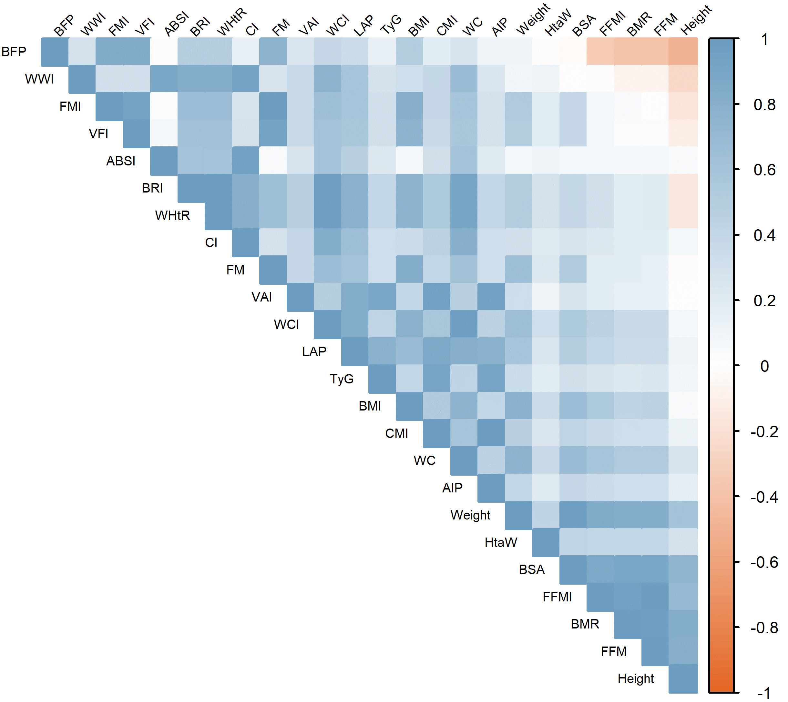

Supplementary Figure 1 Heat map of the conventional and unconventional anthropometric parameters
Abbreviations: WC, Waist Circumference; FM, Fat Mass; FFM, Fat-Free Mass; BFP, Body Fat Percentage; VFI, Visceral Fat Index; BMR, Basal Metabolic Rate; BMI, Body Mass Index; HtaW, Height-adjusted Weight; WHtR, Waist-Height Ratio; FMI, Fat Mass Index; FFMI, Fat-Free Mass Index; WCI, Waist Circumference Index; WWI, Weight-adjusted-Waist Index; BSA, Body Surface Area; AIP, Atherogenic Index of Plasma; LAP, Lipid Accumulation Product; VAI, Visceral Adiposity Index; TyG, Triglyceride-Glucose Index; CI, Conicity Index; BRI, Body Roundness Index; ABSI, A Body Shape Index; CMI, Cardiometabolic Index.
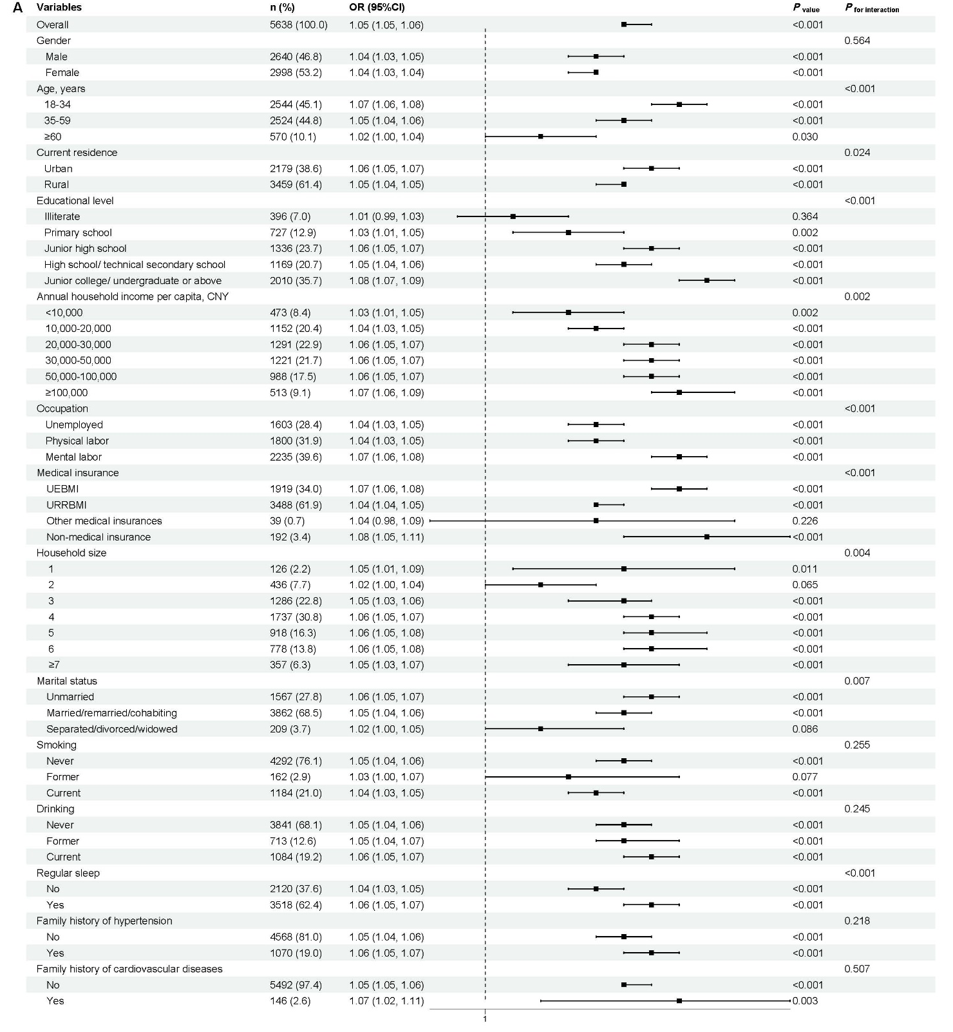
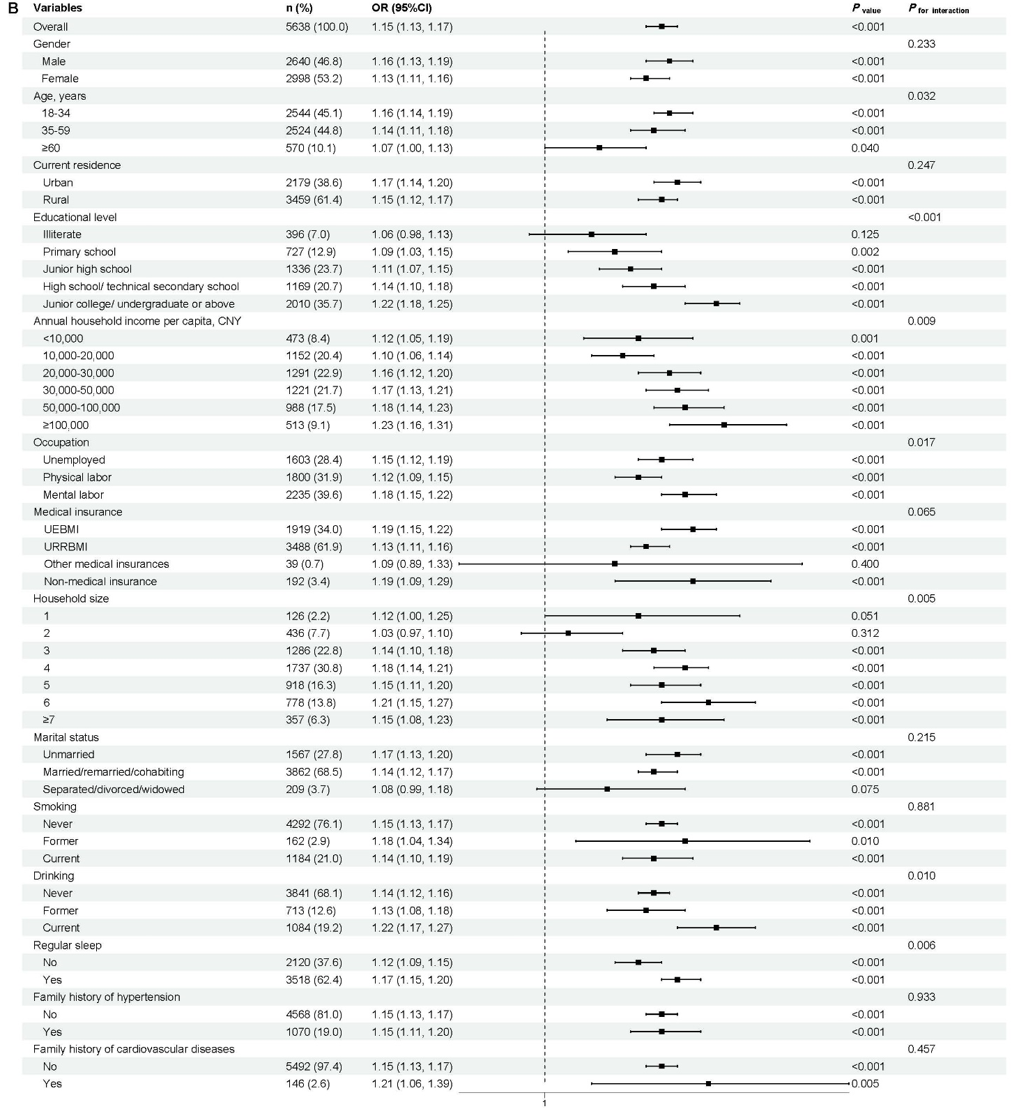
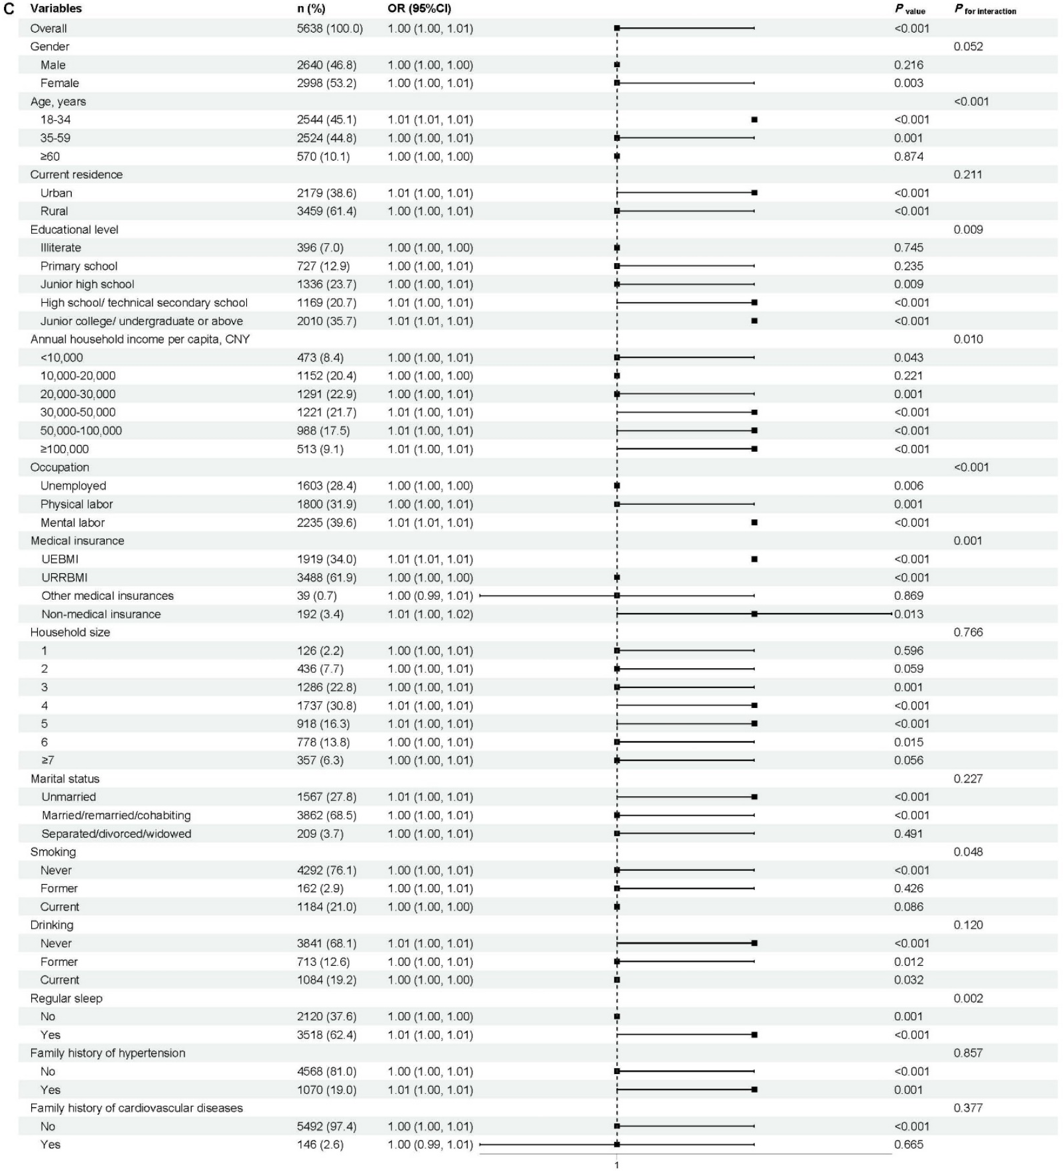
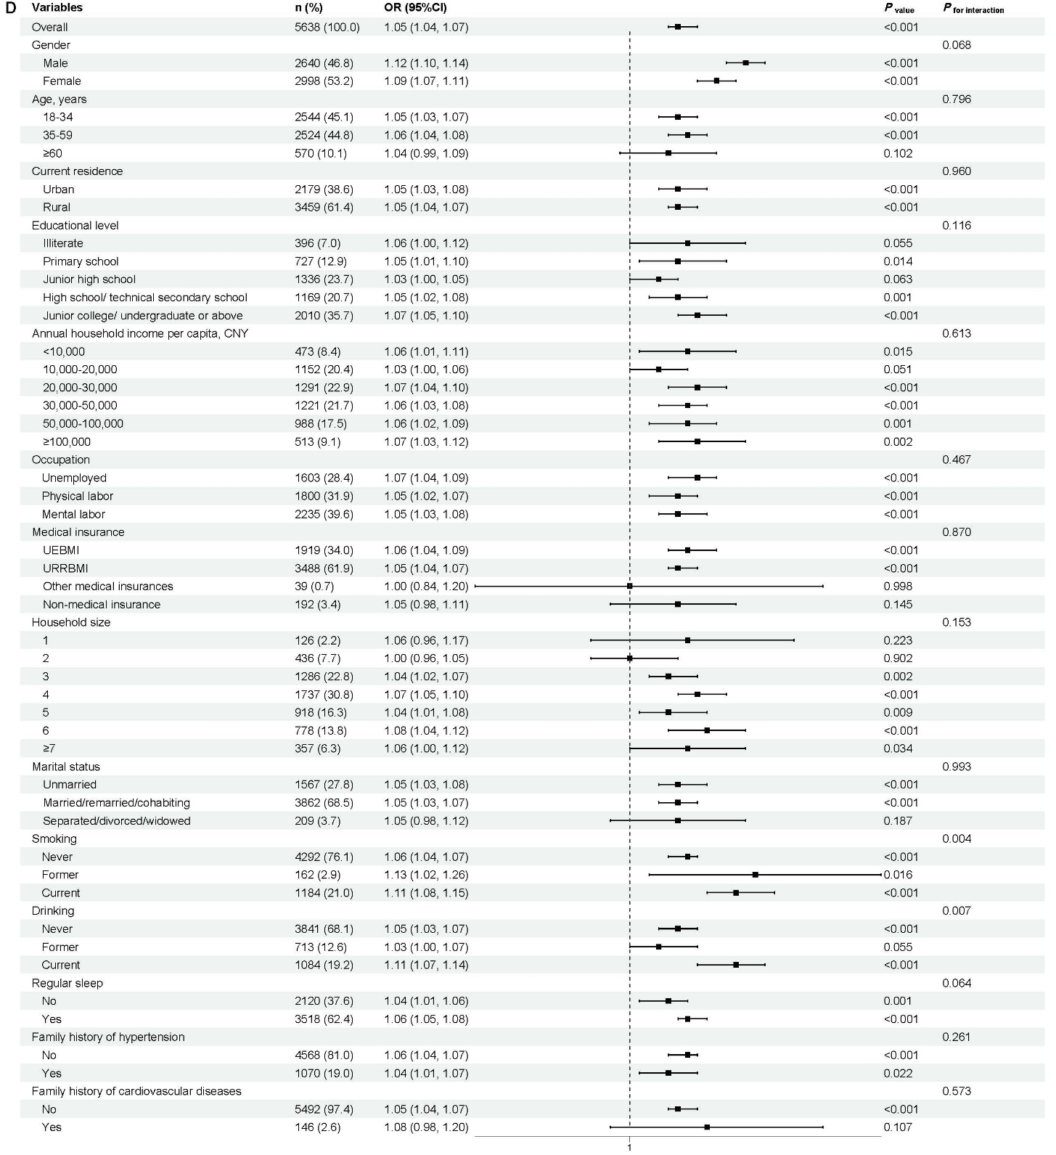
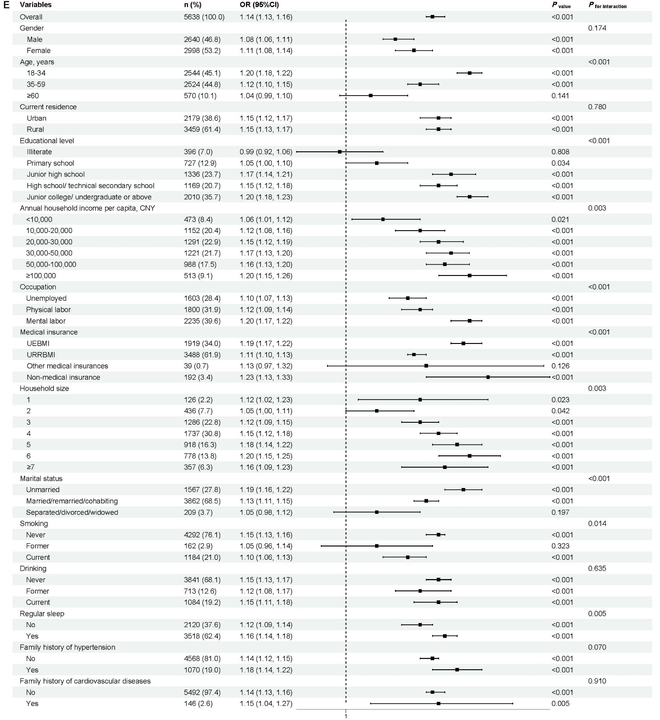
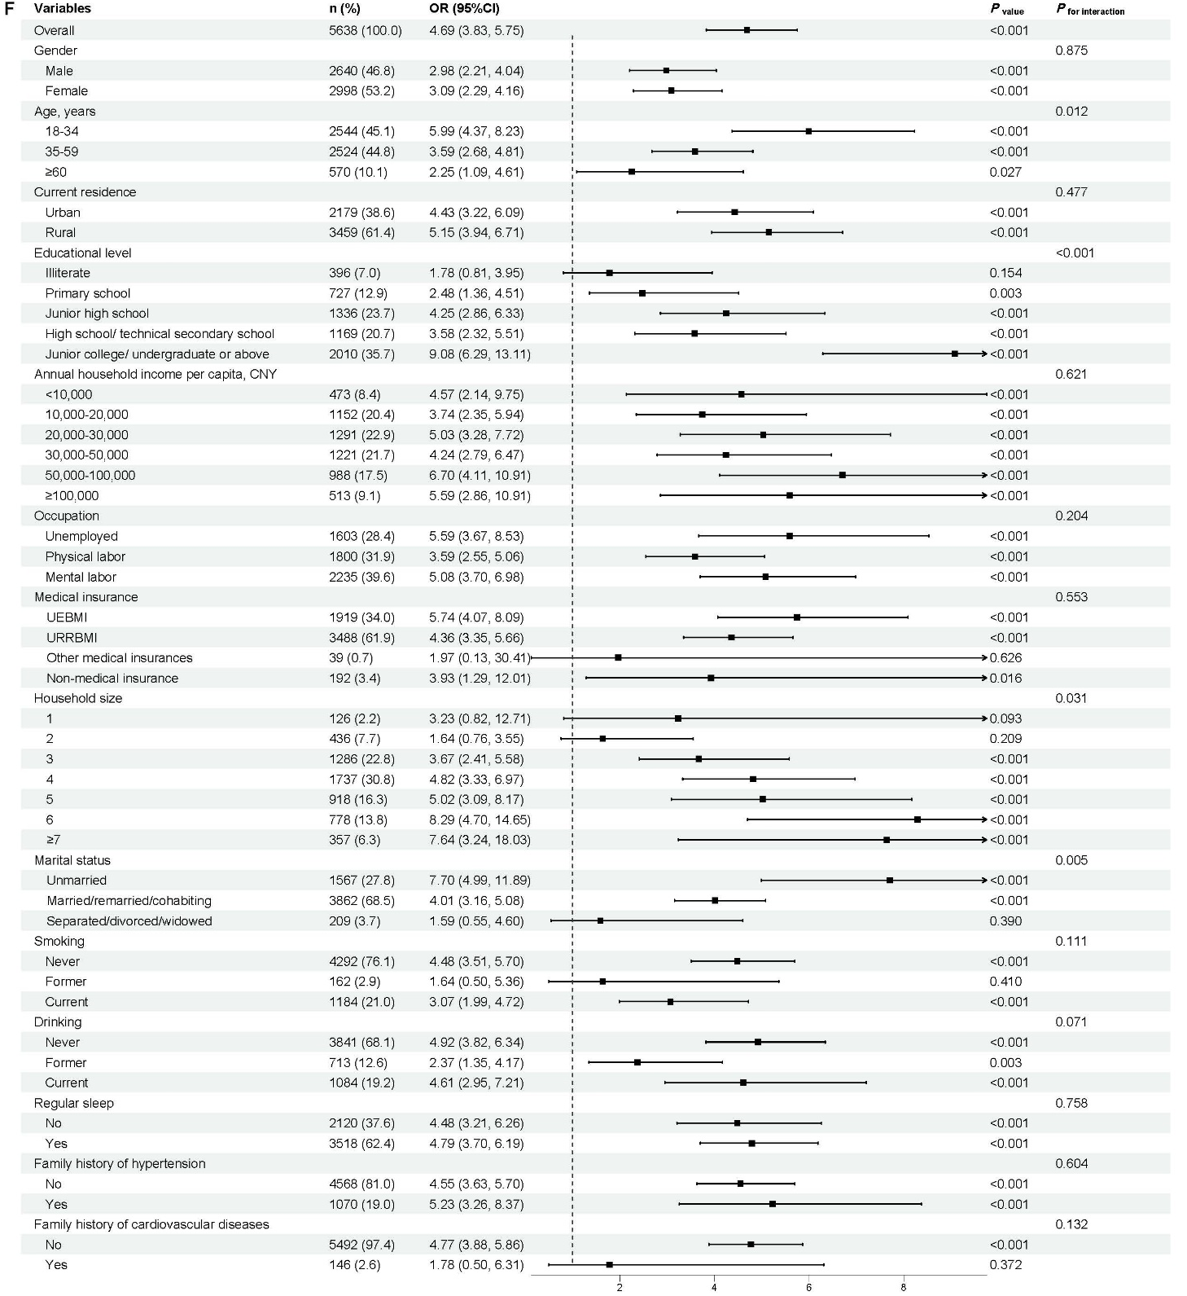
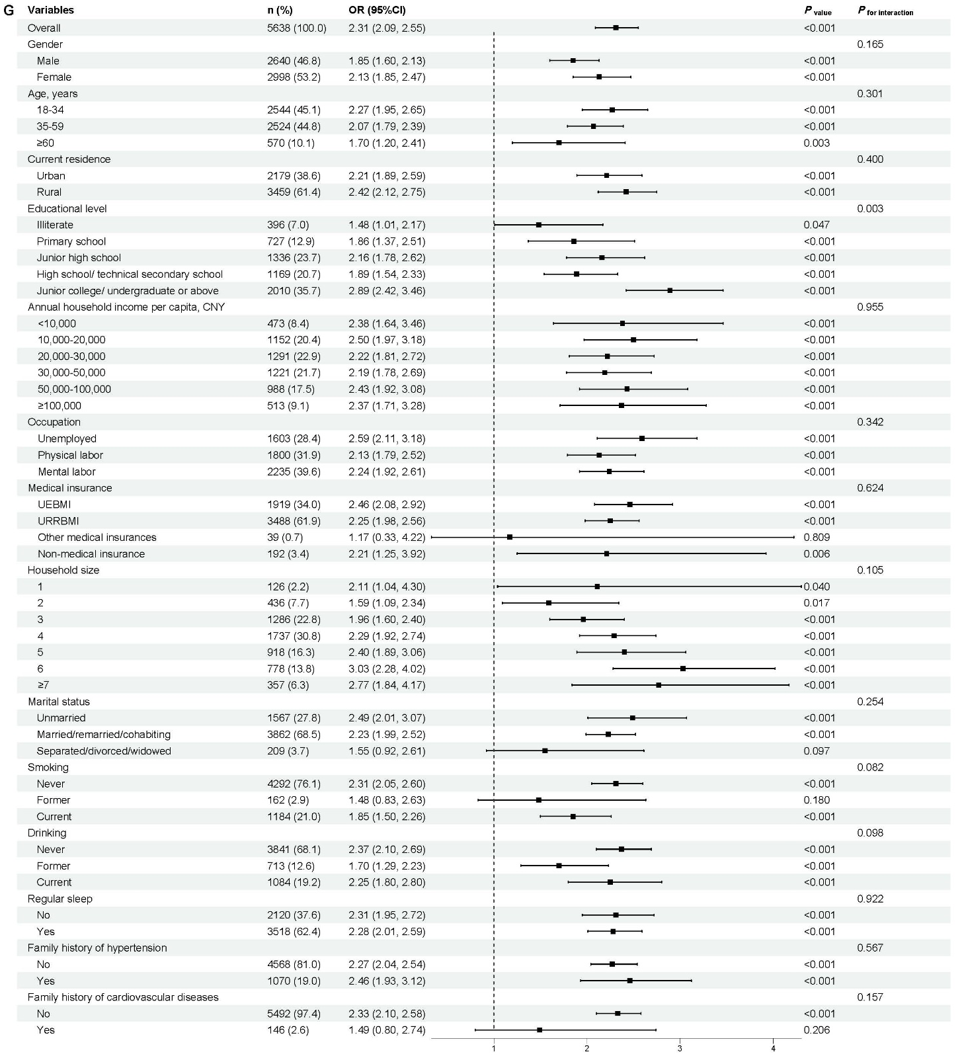
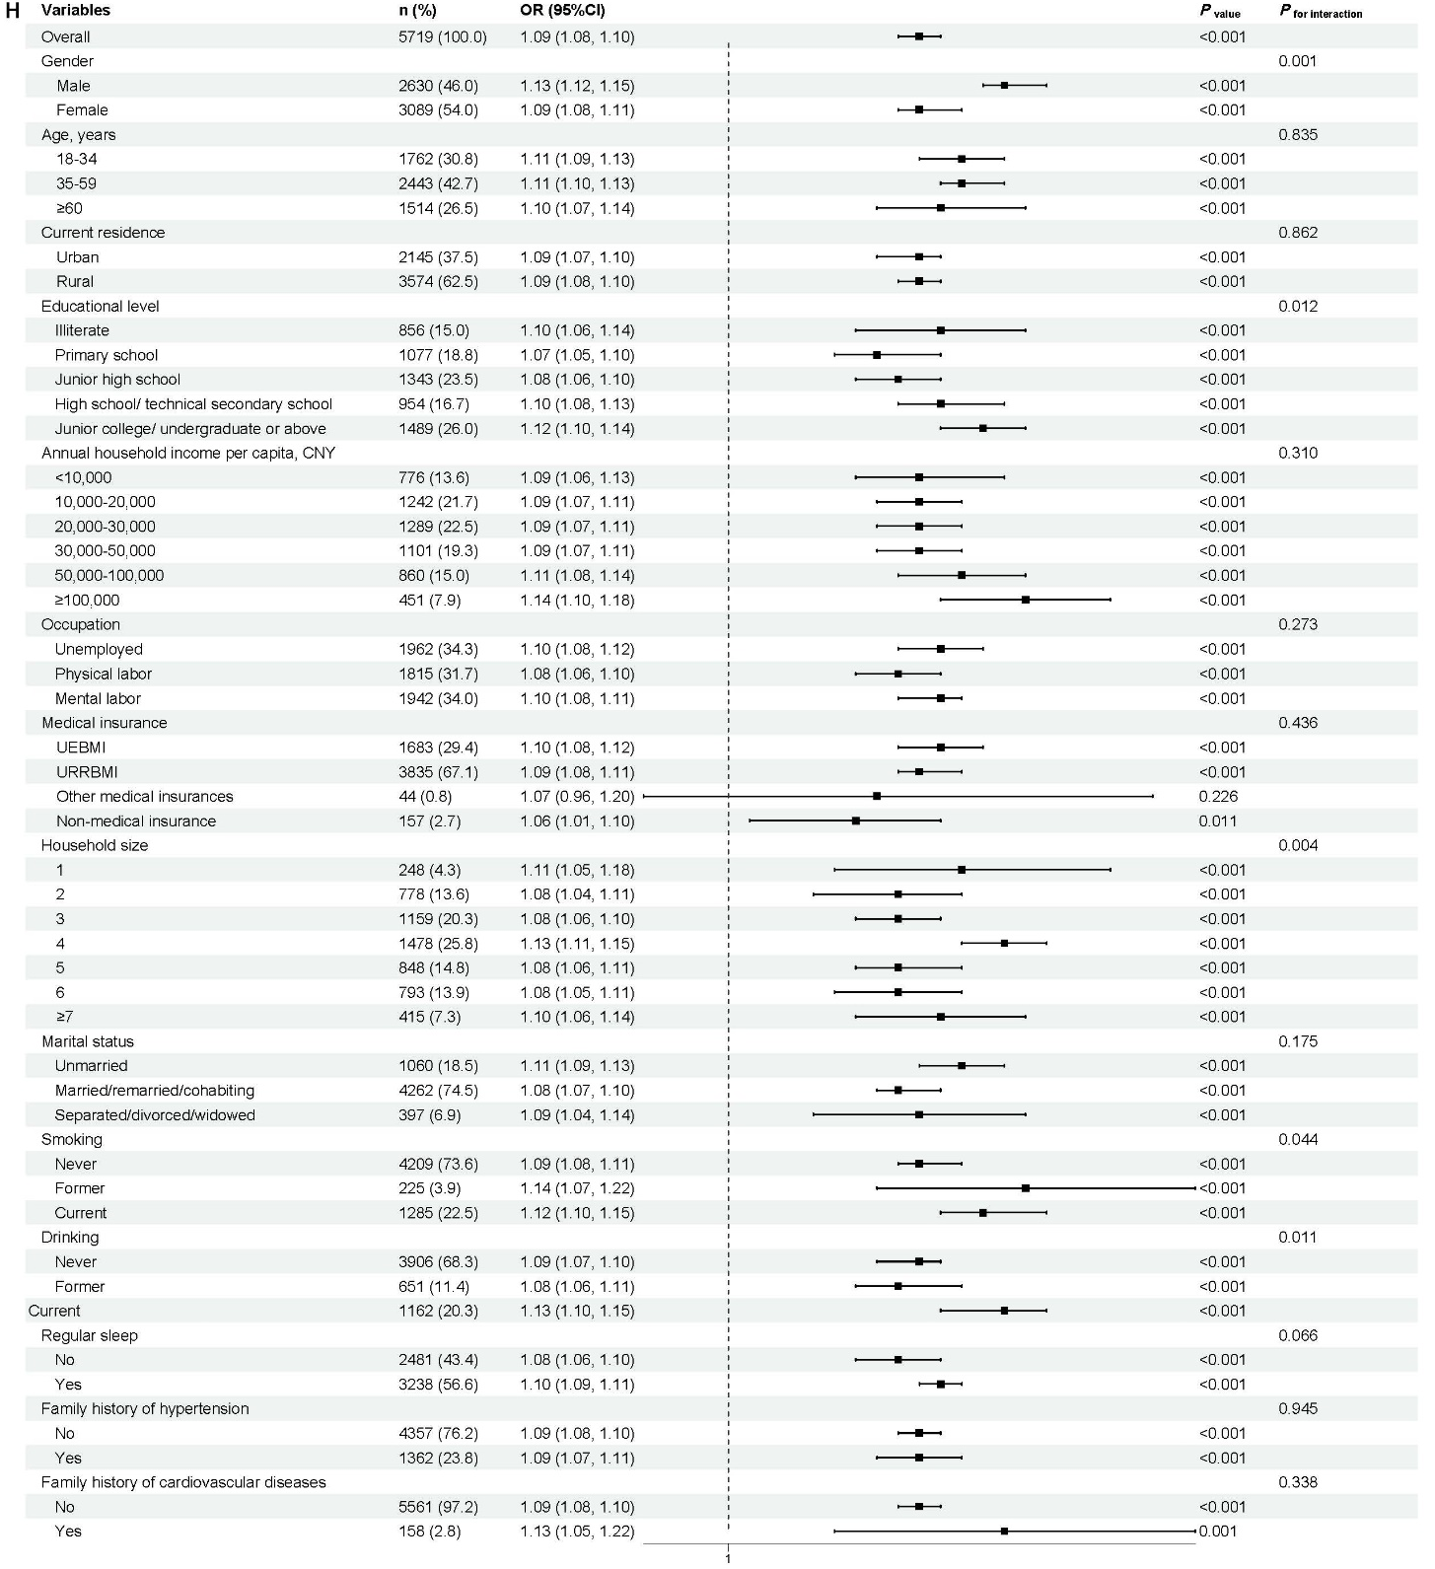
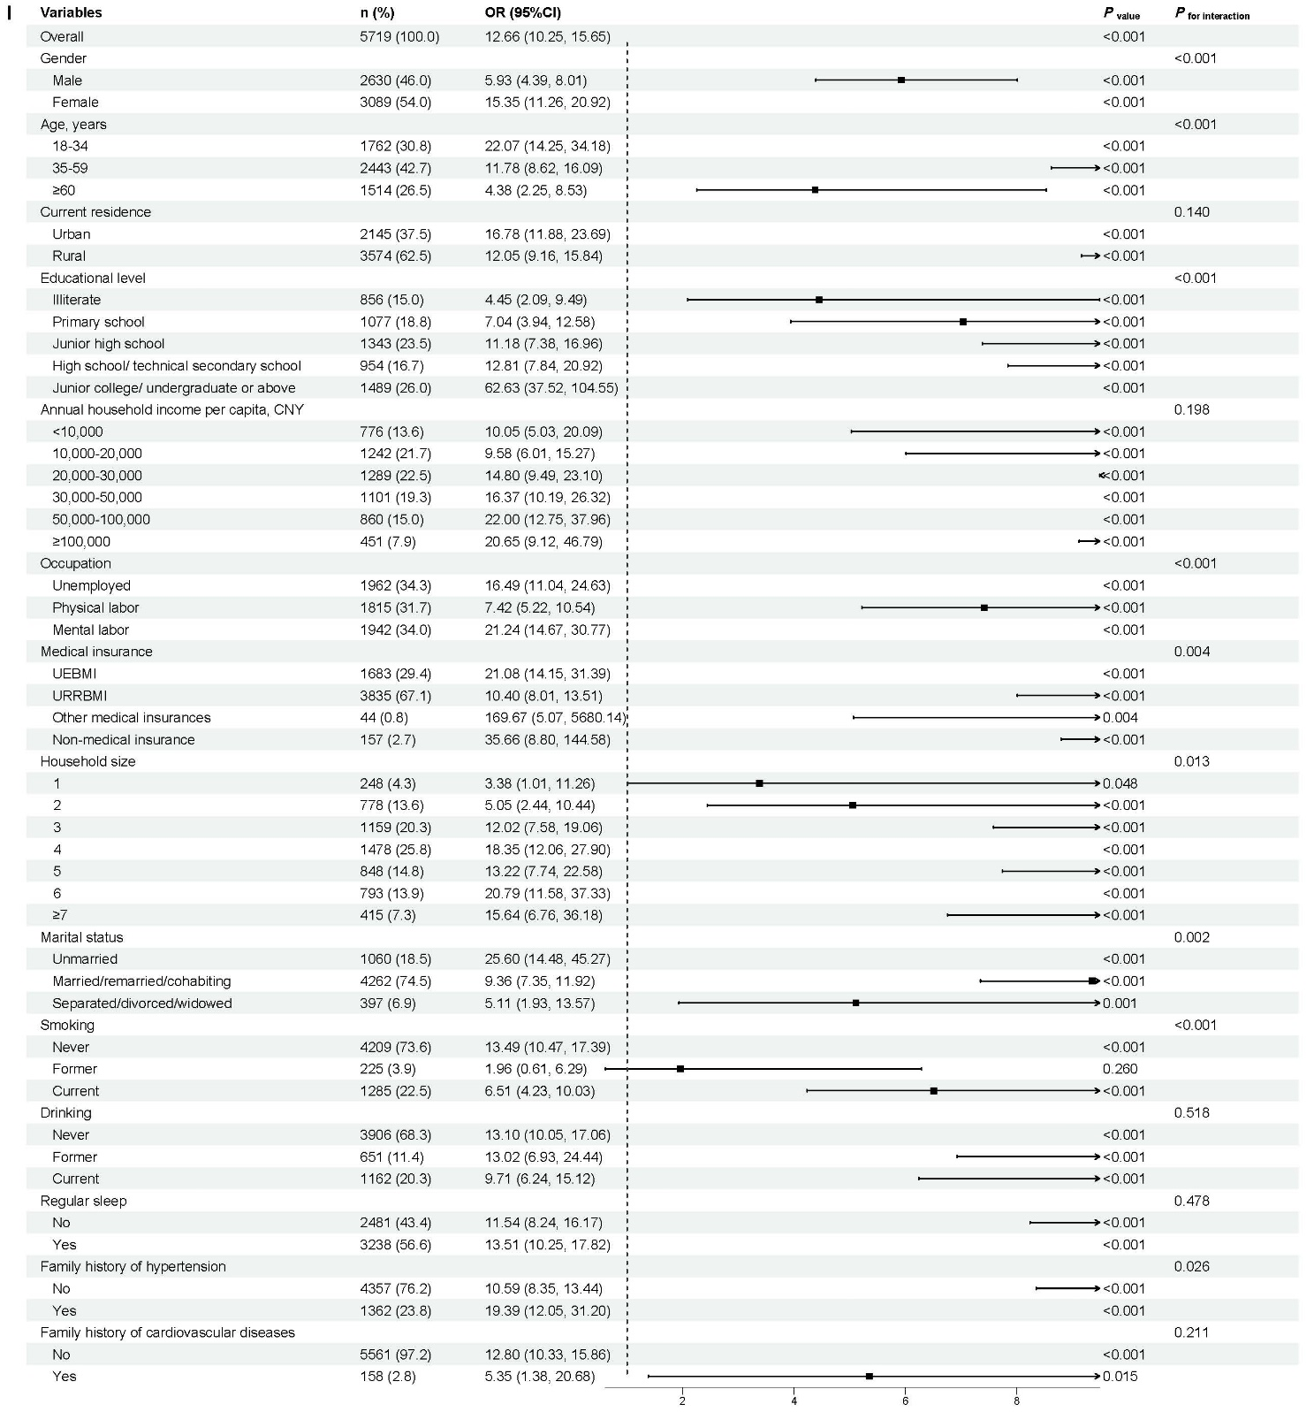
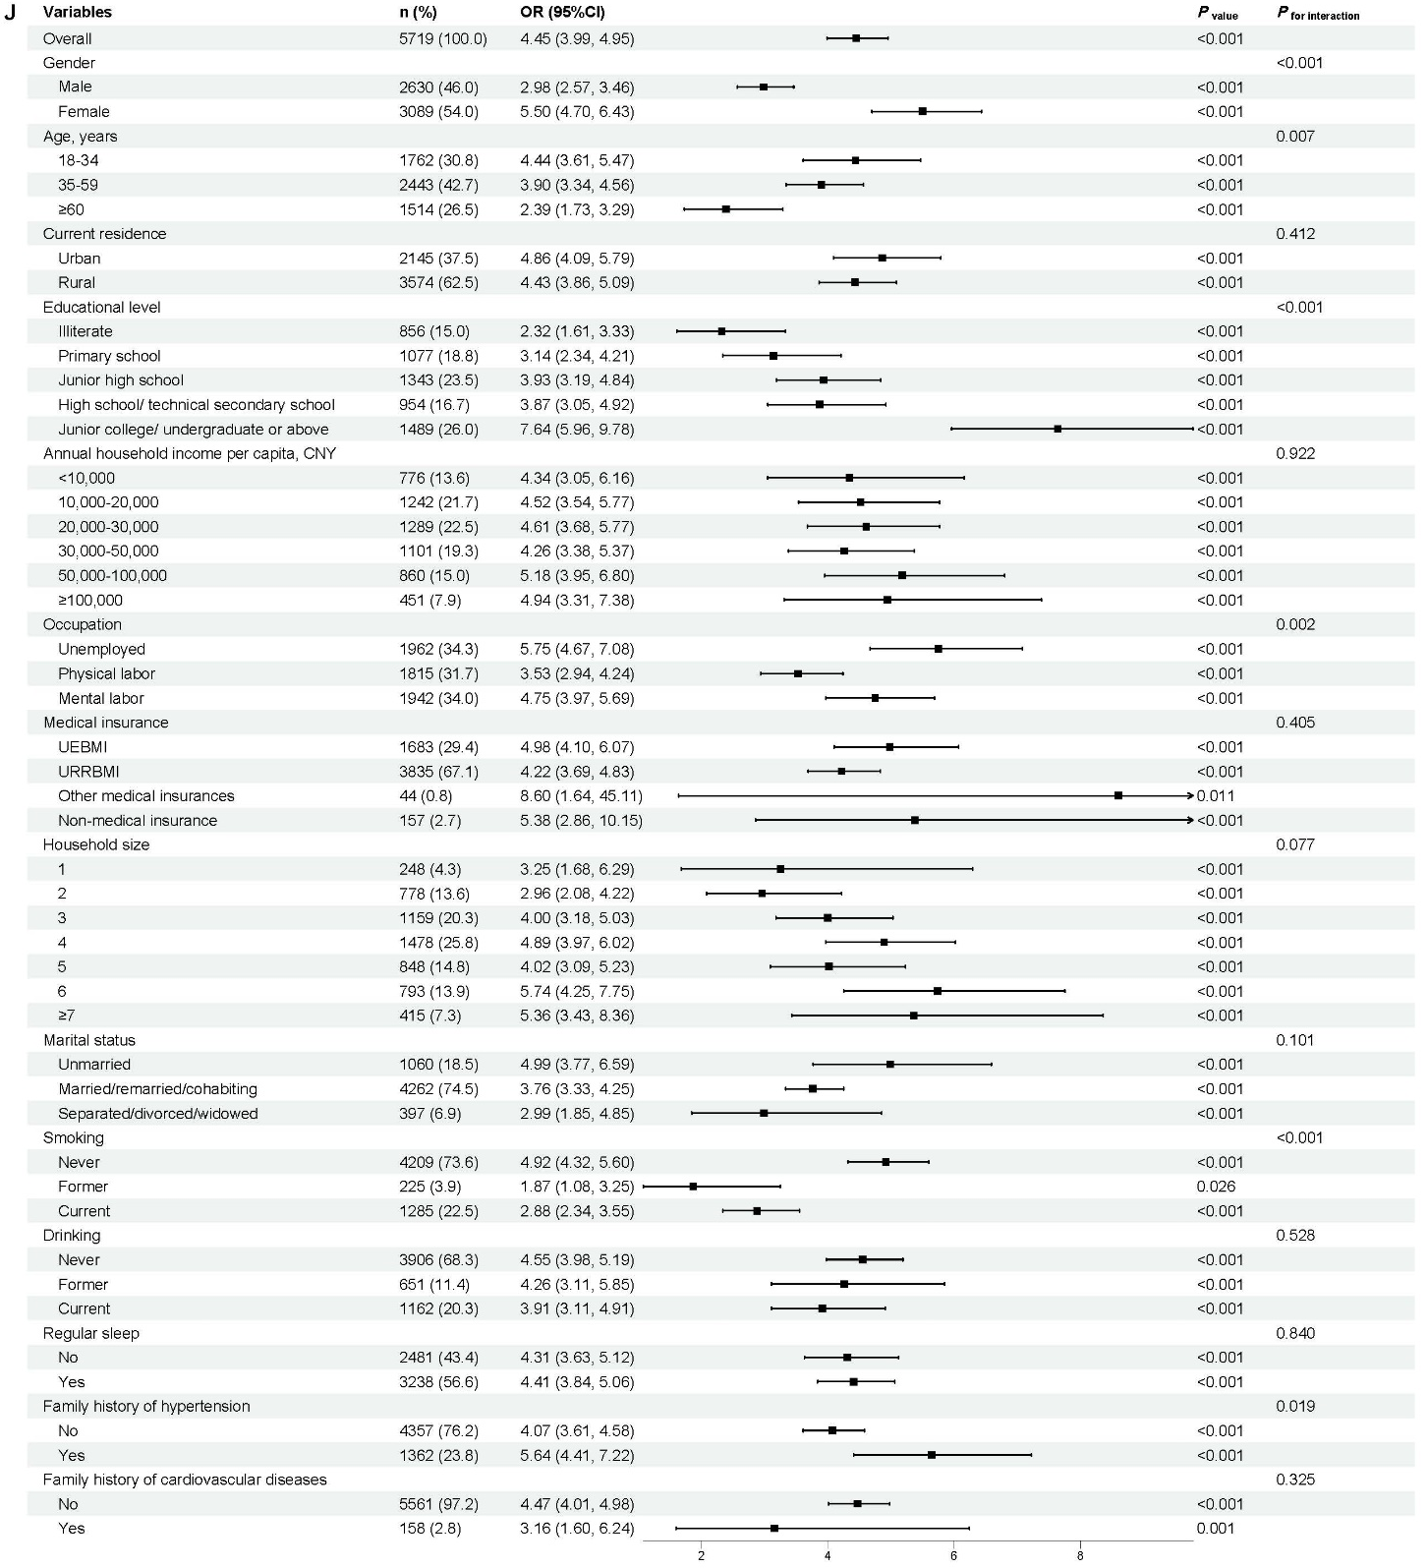

Supplementary Figure 2 Subgroup analyses of the conventional and unconventional anthropometric parameters with prehypertension and hypertension
Notes: (A) subgroup analysis of weight and pre-hypertension; (B) subgroup analysis of BMI and pre-hypertension; (C) subgroup analysis of HtaW and pre-hypertension; (D) subgroup analysis of FMI and pre-hypertension; (E) subgroup analysis of FFMI and pre-hypertension; (F) subgroup analysis of AIP and pre-hypertension; (G) subgroup analysis of TyG and pre-hypertension; (H) subgroup analysis of FM and hypertension; (I) subgroup analysis of AIP and hypertension; (J) subgroup analysis of TyG and hypertension.
Abbreviations: CNY, Chinese Yuan; UEBMI, Urban Employees Basic Medical Insurance; URRBMI, Urban and Rural Residents Basic Medical Insurance.

