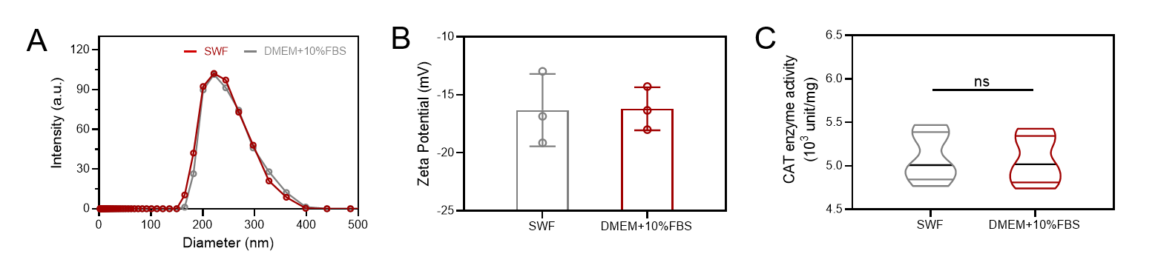
Figure S1. Stability evaluation under physiological conditions. (A) Hydrodynamic diameter, (B) zeta potential and (C) CAT-like activity quantified by ELISA under physiologic condition.

