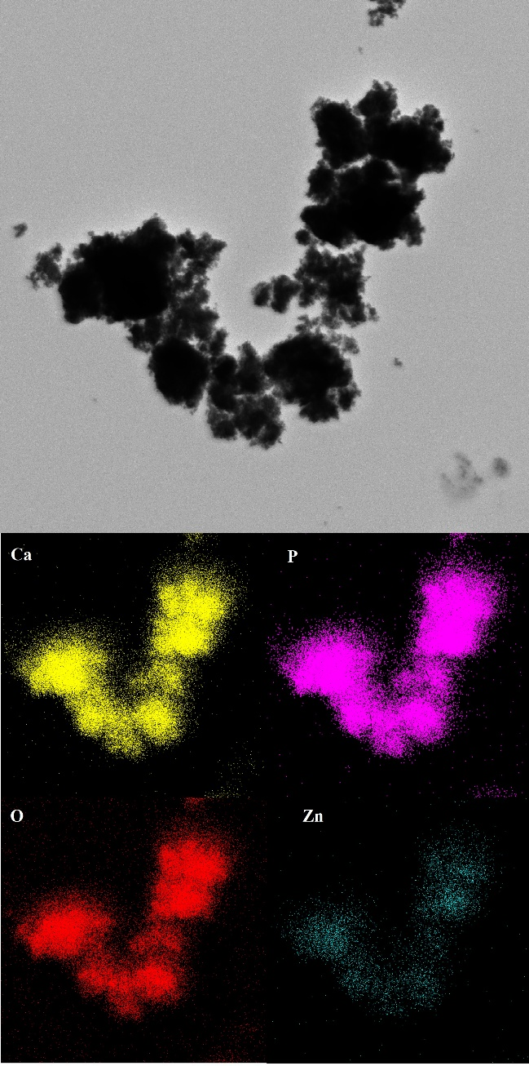
Table 1s. Zn content (wt.%) in synthesized materials determined by EDS method
 | Nominal Zn content (mol%) | Nominal Zn content (wt.%) | Experimental Zn content (wt.%) | Standard deviation  (wt.%) | %RSD
0.1ZnHA | 0.1 | 0.65 | 0.59 | 0.13 | 22.03
0.4ZnHA | 0.4 | 2.58 | 2.51 | 0.22 | 8.76
1.0ZnHA | 1.0 | 6.35 | 6.77 | 0.71 | 10.49
1.8ZnHA | 1.8 | 11.20 | 10,12 | 1.25 | 12.35

Figure 1s. EDS characterization of the 0.6ZnHA sample showing elemental distribution. Main image represents STEM micrograph (2× enlarged) with elemental maps displaying spatial distribution of calcium (Ca), phosphorus (P), oxygen (O), and zinc (Zn).
Figure 2s. Curve fitting results for the 700-490 cm⁻¹ region of the representative spectrum of the 06ZnHA sample.
Table 2s. Results of the curve fitting for the 700-490 cm⁻¹ region with the assignments of the lines.
line | wavenumber (cm⁻¹) | % of the total (700-490 cm⁻¹) area |  |  |  |  |  |  |  |  | Assignment[51, 52]
 |  | HA | 0.1ZnHA | 0.2ZnHA | 0.4ZnHA | 0.6ZnHA | 0.8ZnHA | 1.0ZnHA | 1.4ZnHA | 1.8ZnHA
1 | 628 | 17.1 | 13.5 | 14.7 | 15.3 | 14.9 | 13.8 | 12.8 | 10.7 | 10.1 | librational mode of structural OH groups
2 | 615 | - | 4.8 | 4.7 | 7.3 | 8.1 | 6.9 | 7.6 | 9.8 | 11.7 | PO₄³⁻ labile and poorly crystalline
3 | 603 | 28.6 | 26.3 | 26.8 | 20.1 | 16.9 | 15.9 | 14.4 | 15.8 | 14.6 | regular apatitic PO₄³⁻  environment
4 | 582 | - | 2.8 | 3.6 | 3.5 | 5.9 | 5.5 | 5.9 | 6.5 | 6.7 | terminal  PO₄³⁻ groups on the crystal surface
5 | 575 | 16.9 | 17.7 | 15.8 | 13.2 | 13.9 | 13.4 | 13.5 | 13.5 | 14.5 | regular apatitic PO₄³⁻  environment
6 | 565 | 35.2 | 28.8 | 26.6 | 28.4 | 28.0 | 28.1 | 27.2 | 23.9 | 25.8 | regular apatitic PO₄³⁻  environment
7 | 538 | 2.2 | 6.1 | 7.8 | 12.2 | 12.4 | 16.6 | 18.4 | 19.8 | 16.6 | P-OH groups (non-apatitic)

Figure 3s. Curve fitting results for the 1250-900 cm⁻¹ region of the representative spectrum of the 06ZnHA sample.
Table 3s. Results of the curve fitting for the 1250-900 cm⁻¹ region with the assignments of the lines.
line | wavenumber (cm⁻¹) | % of the fitted area |  |  |  |  |  |  |  |  | Assignment [61,51,52]
 |  | HA | 0.1ZnHA | 0.2ZnHA | 0.4ZnHA | 0.6ZnHA | 0.8ZnHA | 1.0ZnHA | 1.4ZnHA | 1.8ZnHA
1 | 1145 | 5.0 | 4.5 | 6.5 | 8.1 | 16.7 | 17.4 | 17.9 | 23.3 | 16.9 | HPO₄²⁻
2 | 1110 | 14.6 | 18.6 | 18.7 | 16.7 | 10.4 | 8.9 | 18.1 | 11.1 | 14.5 | poorly crystalline apatite
3 | 1097 | 7.7 | 9.3 | 10.4 | 13.9 | 7.9 | 10.6 | 6.1 | 13.1 | 14.9 | PO₄³⁻ labile and poorly crystalline
4 | 1060 | 18.9 | 19.1 | 20.5 | 22.5 | 22.0 | 18.9 | 13.2 | 11.4 | 10.5 | poorly crystalline  apatite PO₄³⁻  environment
5 | 1030 | 32.4 | 26.5 | 25.1 | 23.9 | 20.2 | 20.2 | 23.6 | 18.9 | 19.2 | regular apatitic PO₄³⁻  environment
6 | 1002 | 16.6 | 17.3 | 13.2 | 10.7 | 19.0 | 18.3 | 12.8 | 14.7 | 16.5 | regular apatitic PO₄³⁻  environment
7 | 961 | 4.8 | 4.7 | 5.6 | 3.9 | 3.8 | 5.7 | 8.3 | 7.5 | 7.5 | υ₁ PO₄³⁻

Table 4s. Peak fitting results and assignments for the ¹H BD ssNMR spectra [51,57,58].
line | ppm | assignments
1 | 7.06 | P-OH groups
2 | 5.41 | surface adsorber water
3 | 0.52 | disordered OH groups in c-channels
4 | 0.01 | well-ordered structural OH groups

Figure 4s. Curve fitting results for the ¹H BD ssNMR spectrum of the 06ZnHA sample.

Figure 5s. Curve fitting results for the ³¹P BD (left) and ³¹P CP (right) ssNMR spectra of the 06ZnHA sample.

Table 5s. Results of the curve fitting for ³¹P (BD and CP) NMR experiments.

line | ppm | % of the signal area |  |  |  |  |  |  |  |  | Assignment [55,56]
 |  | HA | 0.1ZnHA | 0.2ZnHA | 0.4ZnHA | 0.6ZnHA | 0.8ZnHA | 1.0ZnHA | 1.4ZnHA | 1.8ZnHA
BD
narrow component | 3.1 | 94.8 | 85.3 | 66.7 | 55.4 | 53.2 | 47.5 | 44.3 | 19.3 | 4.9 | ³¹P nuclei from crystalline core
broad component | 3.8 | 5.2 | 14.7 | 33.3 | 44.6 | 46.8 | 52.5 | 55.7 | 80.7 | 95.1 | ³¹P nuclei from hydrated Surface layer
CP
narrow component | 3.1 | 57.2 | 55.9 | 49.4 | 42.3 | 18.9 | 18.7 | 29.1 | 4.5 | 0.9 | ³¹P nuclei from crystalline core
broad component | 3.9 | 42.8 | 44.1 | 50.6 | 57.7 | 81.1 | 81.3 | 70.9 | 95.5 | 99.1 | ³¹P nuclei from hydrated Surface layer

