Supplementary Material S1 Part A: Preliminary Item Pool from Literature Review
Category | Item |  |  | Compliance (Yes/No)
Foot Cleaning | 1. Use a water thermometer to measure water temperature, ensuring it is ≤37°C. |  |  | Yes No
Foot Cleaning | 2. Limit foot washing/soaking time to 5-10 minutes (avoid using irritating soaps). |  |  | Yes No
Foot Cleaning | 3. Dry feet thoroughly with a soft cotton towel, especially between the toes. |  |  | Yes No
Foot Cleaning | 4. Apply moisturizer (e.g., urea cream, petroleum jelly) to the skin of both feet, avoiding the areas between the toes. In autumn and winter, use more intensive moisturizing products |  |  | Yes No
Foot Cleaning | 5. Use cornstarch-based powder to keep the areas between the toes dry. |  |  | Yes No
Foot Inspection | 6. Inspect feet under good lighting and after bathing. |  |  | Yes No
Foot Inspection | 7. Trim toenails straight across, not rounded, once a week.  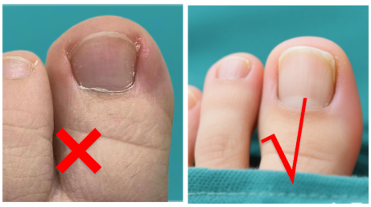  Last trimming date: Next trimming date: |  |  | Yes No
Foot Inspection | 8. Use a mirror or ask a family member to check for ingrown toenails, thickened nails, cracks, blisters, bleeding, calluses, corns, changes in skin color, fungal/bacterial infections, or edema (inspect the top, bottom, and between the toes). |  |  | Yes No
Foot Inspection | 9. If any of the above conditions are found, avoid self-treatment and seek medical assistance. |  |  | Yes No
Foot Inspection | - Use an electronic thermometer to monitor skin temperature changes. If the temperature difference between corresponding areas of the left and right feet exceeds 2.2°C for two consecutive days, reduce walking and seek medical help.  Skin temperature measurement areas: |  |  | Yes No
Foot Inspection | 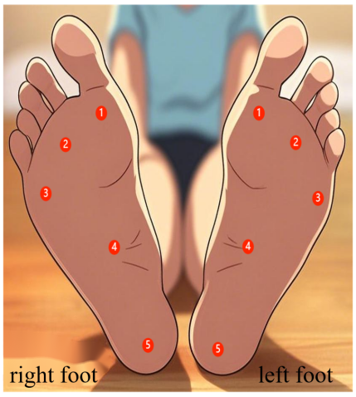 | Left Foot：  Area 1 Temperature: ℃,Difference: ℃  Area 2 Temperature: ℃,Difference: ℃  Area 3 Temperature: ℃,Difference: ℃  Area 4 Temperature: ℃,Difference: ℃  Area 5Temperature: ℃,Difference: ℃ | Right Foot:  Area 1 Temperature: ℃,Difference: ℃  Area 2 Temperature: ℃,Difference: ℃  Area 3 Temperature: ℃,Difference: ℃  Area 4 Temperature: ℃,Difference: ℃  Area 5 Temperature: ℃,Difference: ℃ | Yes No

Category | Item | Compliance (Yes/No)
Footwear Selection | 11. Choose seamless, breathable, light-colored cotton socks (or turn the seams inside out), ensuring the sock opening is not too tight. | Yes No
Footwear Selection | 12. Change and wash socks daily. | Yes No
Footwear Selection | 13. Select breathable, fully enclosed shoes with an inner length 1-2 cm longer than the foot, leaving 1 cm between the longest toe and the shoe edge (enough to fit a finger). | Yes No
Footwear Selection | 14. Avoid shoes that are too tight, have rough edges, or uneven seams. | Yes No
Footwear Selection | 15. Regularly check shoe wear and replace them as needed. | Yes No
Footwear Selection | 16. Before wearing shoes, check for foreign objects like sand and ensure the inside is smooth. | Yes No
Other | 17. Avoid walking barefoot or wearing only socks indoors or outdoors. Do not wear thin-soled slippers at home. | Yes No
Other | 18. Avoid using heaters or hot water bottles to warm feet. | Yes No
Other | 19. Avoid smoking and crossing legs. | Yes No
Other | 20. Schedule regular foot examinations at the hospital (every 3/6 months).  Last examination date: Next examination date: | Yes No
Execution Date: Executor:

Supplementary Material S1 Part B: Preliminary Draft of the Protocol after Interviews (Version B)
Class | Clauses and subclauses | Carry out  circumstances
Clean feet | 1. In order to prevent scalding your feet, use a thermometer to measure the water temperature when washing or soaking your feet, and the water temperature is 37-40℃. | Yes No
Clean feet | 2. Wash or soak your feet for 5-10 minutes (avoid using irritating soap). | Yes No
Clean feet | 3. In order to keep your feet clean, you should use your fingers to gently rub the dirt between your feet and toes when washing your feet. Do not just rinse them with water. | Yes No
Clean feet | 4. In order to prevent the formation of athlete's foot (Hong Kong foot), after soaking your feet, use a pure cotton gauze towel to dry the water on your feet, and use absorbent gauze between your toes to dry them, so as to keep your toes clean and dry. Do not use paper towels to dry your toes, as the residue of paper scraps can wear out your toes. | Yes No
Clean feet | 5. In order to prevent the feet from cracking due to dry skin, apply moisturizing cream (such as urea cream, Vaseline) to the feet before going to bed. Do not apply it between the toes (the wetness of the toes is easy to form foot fungus); in autumn and winter, you can use moisturizing products with strong moisturizing properties. | Yes No
Foot examination | 6. In order to see your feet more clearly, check them in good light and after a bath. | Yes No
Foot examination | - To avoid failing to detect abnormalities in time, family members or yourself can use a mirror and magnifying glass to check for conditions such as ingrown nails, thickened or cracked toenails, blisters, bleeding, corns (calluses), changes in skin color, athlete’s foot (Hong Kong foot), inflammation, and edema (comprehensive examination of the entire foot, sole, and between the toes). If any of these conditions appear, do not attempt to treat them yourself (to avoid worsening the situation due to improper handling), but seek medical help instead. The relevant foot conditions are as follows: | Yes No
Foot examination | 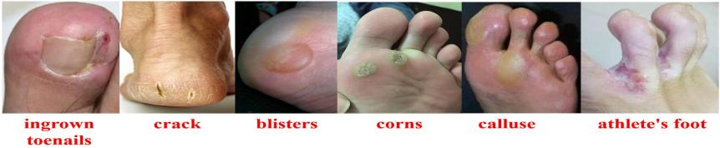 | Yes No

Class | Clauses and subclauses |  |  | Carry out  circumstances
Foot examination | 8. In order to detect the occurrence of foot ulcers as early as possible, use an electronic thermometer to measure the temperature change of the skin of the foot before washing or soaking the feet. If the temperature difference between the corresponding areas of the feet is greater than 2.2℃ for two consecutive days, reduce walking and seek help from a doctor. The temperature measurement area is as follows: |  |  | Yes No
Foot examination | 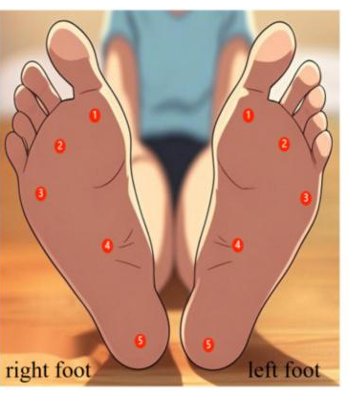 | Right foot:  Temperature 1: ℃, temperature difference: ℃;  Temperature 2: ℃, temperature difference: ℃;  Temperature 3: ℃, temperature difference: ℃;  Temperature 4: ℃, temperature difference: ℃;  Temperature 5: ℃, temperature difference: ℃; | Left foot：  Temperature 1: ℃, temperature difference: ℃;  Temperature 2: ℃, temperature difference: ℃;  Temperature 3: ℃, temperature difference: ℃;  Temperature 4: ℃, temperature difference: ℃;  Temperature 5: ℃, temperature difference: ℃; | Yes No
Footwear and sock selection | 9. To keep your feet clean and dry, choose light-colored socks made of pure cotton, seamless and breathable (or turn the seam over to avoid skin wear at the seam). The sock mouth should not be too tight. |  |  | Yes No
Footwear and sock selection | - In order to prevent the formation of athlete’s foot, socks should be changed and washed daily. |  |  | Yes No
Footwear and sock selection | 11. To avoid injury to your feet, choose shoes made of breathable material and fully wrapped. The inner length of the shoe should be 1-2 cm longer than your foot, leaving 1 cm (one finger) between the longest toe and the edge of the shoe. |  |  | Yes No
Footwear and sock selection | 12. In order to maintain the balance of the pressure on the sole and avoid the occurrence of ulcers, such as foot deformity and callus (callus) on the sole, it is recommended to customize shoes for diabetic foot. |  |  | Yes No
Footwear and sock selection | 13. In order to balance the pressure on the sole, observe the wear of the shoes and replace them in time. |  |  | Yes No
Footwear and sock selection | 14. In order to avoid injury to the sole, check whether there are sand and other foreign objects in the shoe before wearing it, and keep the interior of the shoe flat. |  |  | Yes No
Footwear and sock selection | 15. In order to avoid injury to both feet, it is forbidden to walk indoors or outdoors barefoot or only in socks. Do not wear thin-soled slippers at home, and do not wear slippers outside. |  |  | Yes No

Class | Clauses and subclauses |  | Carry out  circumstances
Else | - To avoid scratching the skin with your toenails, trim them once a week; trim them straight and round off the corners, and smooth them out. |  | Yes No
Else | 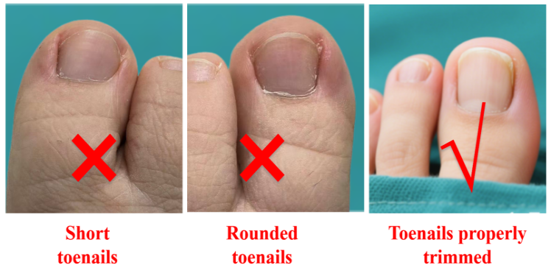 | Last pruning time:  Next pruning time: | Yes No
Else | 17. Monitor blood glucose regularly. If blood glucose is not well controlled, seek medical attention in time. |  | Yes No
Else | 18. In order to avoid scalding your feet, do not use a heater or electric hot water bag to warm your feet; you can use a silicone hot water bag filled with 50℃ of hot water and wrap it in a layer of towel for heating your feet. |  | Yes No
Else | 19. To keep your blood vessels healthy, you are not allowed to smoke or cross your legs. |  | Yes No
Else | - In order to keep your feet healthy, you should go to the hospital regularly (once every 3-6 months).  Last inspection date: Next inspection time: |  | Yes No

Foot self-examination flow chart | 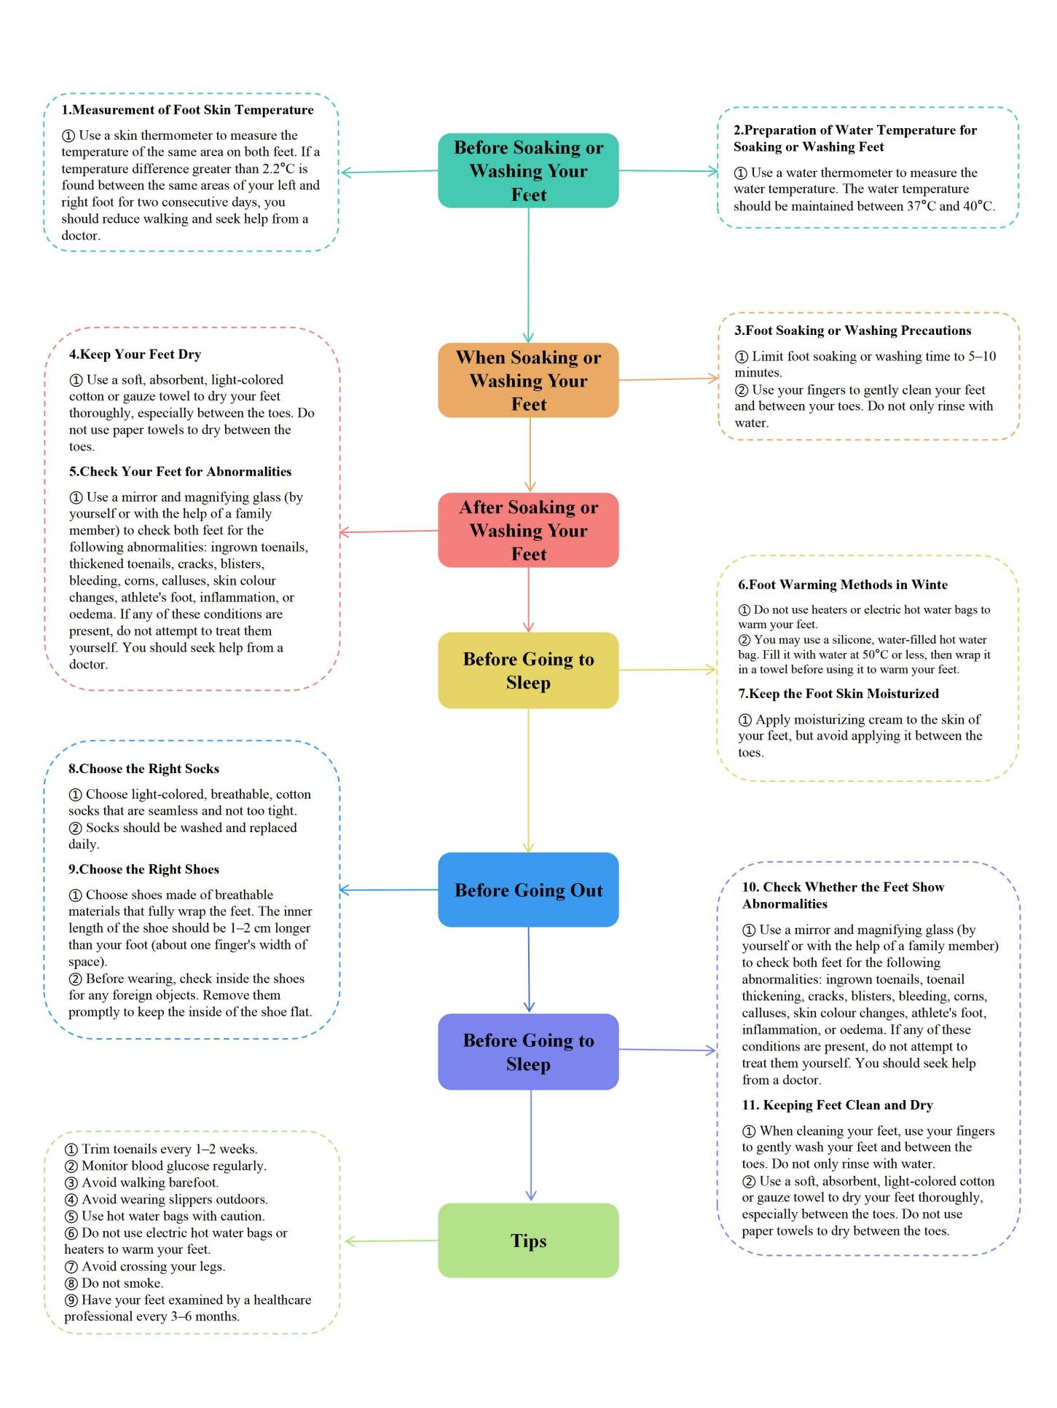
E-time: executant:

Supplementary Material S1 Part C: Final Patient-Centered Daily Foot Self-Care Protocol
Class | Clauses and subclauses |  |  | Carry out  circumstances
Foot self-examination | 1. For a clearer view of the feet, examination of the feet should be done in good light and after bathing. |  |  | Yes No
Foot self-examination | 2. For a closer look at the feet, if you are not comfortable performing a foot examination yourself (e.g., poor vision, limited mobility, etc.), you should ask a family member to perform a foot self-examination together. |  |  | Yes No
Foot self-examination | 3. To avoid failure to detect abnormalities in time, you can let your family members or yourself use mirrors and magnifying glasses to check your feet for ingrown toenails, thickened toenails, cracks, blisters, bleeding, corns, calluses (calluses), changes in skin colour, athlete's foot (athlete's foot), inflammation, oedema, and other abnormalities (comprehensively check the surface of the feet, the soles of the feet, and the joints between the toes); and if any of these occur, you should seek the help of a doctor. The relevant foot conditions are as follows: |  |  | Yes No
Foot self-examination | 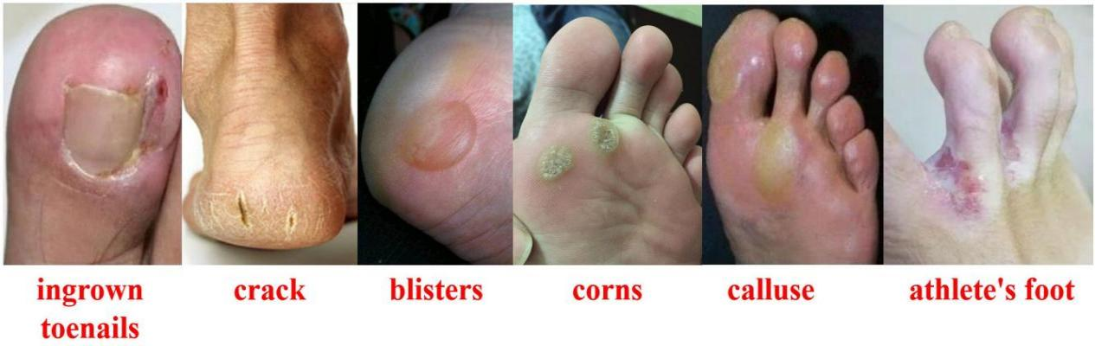 |  |  | Yes No
Foot self-examination | 4. In order to avoid the occurrence of foot ulcers, it is forbidden to trim and buy medication on your own to treat foot diseases such as ingrown nails, blisters, corns, calluses, etc. It is forbidden to treat them in pedicure stores and foot bath towns. |  |  | Yes No
Foot self-examination | - For early detection of foot ulcers, use an electronic temperature gun to measure changes in foot skin temperature before washing or soaking your feet. If the temperature difference between the opposite areas of the right and left feet is greater than 2.2°C for two consecutive days, you should reduce walking and seek medical help. The temperature measurement area is as follows: |  |  | Yes No
Foot self-examination |  | Right foot:  Temperature 1: ℃, temperature difference: ℃;  Temperature 2: ℃, temperature difference: ℃;  Temperature 3: ℃, temperature difference: ℃;  Temperature 4: ℃, temperature difference: ℃;  Temperature 5: ℃, temperature difference: ℃; | Left foot:  Temperature 1: ℃, temperature difference: ℃;  Temperature 2: ℃, temperature difference: ℃;  Temperature 3: ℃, temperature difference: ℃;  Temperature 4: ℃, temperature difference: ℃;  Temperature 5: ℃, temperature difference: ℃; | Yes No

Class | Clauses and subclauses | Carry out  circumstances
Foot hygiene and health care | 6. To prevent scalding your feet, use a thermometer to measure the temperature of the water when soaking or washing your feet, and keep the water temperature at 37-40 degrees Celsius. | Yes No
Foot hygiene and health care | 7. Keep foot soaks or foot washes to 5-10 minutes (avoid harsh soaps). | Yes No
Foot hygiene and health care | 8. To keep your feet clean, you should use your fingers to gently rub your feet and the dirt between your toes when washing your feet, and it is forbidden t to just rinse them casually with water. | Yes No
Foot hygiene and health care | 9. To prevent the formation of athlete's foot (athlete’s foot), use absorbent cotton light-coloured towels, gauze towels, or tough, soft paper towels to dry your feet after washing/soaking them. Dry between your toes to keep them clean and dry. Prohibit the use of poor-quality paper towels to avoid abrasion of your toes by the residue of paper shavings. | Yes No
Foot hygiene and health care | 10. To prevent your feet from cracking due to dry skin, use moisturizing creams (e.g., urea cream, petroleum jelly) on the skin of your feet before going to bed, and prohibit applying them between the toe seams (toe seams are prone to forming foot fungus if they are moist); in the fall and winter seasons, you can use emollient products with a high degree of moisturization. | Yes No
Shoes and socks | 11. To keep your feet clean and dry, choose cotton, seamless, breathable, light-coloured socks (or turn the seam side over to avoid abrasion of the skin at the seams) with loose, elastic cuffs, and maintain a cross-pull width of 25cm or more. | Yes No
Shoes and socks | 12. To prevent the formation of foot odour, socks should be changed and washed daily. | Yes No
Shoes and socks | 13. To avoid foot injuries, choose shoes that are made of breathable material, fully wrapped, have a firm heel and a roomy toe, and can still accommodate one finger after wearing them. | Yes No
Shoes and socks | 14. To avoid injuries to the soles of your feet, check for sand and other foreign objects in your shoes before wearing them and keep them flat. | Yes No
Shoes and socks | 15. To avoid foot injuries, it is forbidden to walk indoors or outdoors barefoot or wearing only socks, not to wear thin-soled slippers at home, and not to wear slippers or sandals outside. | Yes No
Shoes and socks | 16. To avoid foot injuries, walking on sandy beaches and cobblestone paths is prohibited. | Yes No
Shoes and socks | 17. If the bottoms of the feet have deformities and calluses, custom shoes for diabetic feet are recommended to maintain balanced plantar pressure and avoid ulcers. | Yes No
Shoes and socks | 18. To reduce the incidence of ulcers, shoes should be observed for wear and tear and replaced promptly if they are deformed, have perforated or torn soles, crack the uppers, or shift the insoles. | Yes No
Shoes and socks | 19. You should pay attention to the following matters when buying new shoes:  (Ⅰ) Shop for new shoes in the afternoon because the human foot swells in the afternoon, this time to choose the most suitable shoes;  (Ⅱ) When buying shoes, you need to wear socks to try shoes;  (Ⅲ)The new shoes should be taken off after 20-30 minutes of wearing to check whether there are any traces of redness or friction on the feet;  (Ⅳ) Do not wear new shoes for more than half an hour on the first day and more than one hour on the second day, and gradually extend the time of wearing new shoes. | Yes No

Class | Clauses and subclauses |  |  | Carry out  circumstances
Daily precautions | 20. To avoid scratching the skin, it is recommended to trim the toenails every 10 days to 2 weeks. The length of the toenails should be retained at 1-2mm, trimmed in a straight line, and the two corners should be trimmed in a curved shape and polished smoothly. The tools used for trimming toenails should be dedicated to one person or cleaned and disinfected before and after use. |  |  | Yes No
Daily precautions | 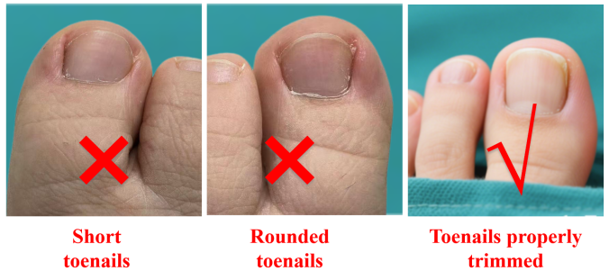 |  | Last pruning time:  Next pruning time: | Yes No
Daily precautions | 21. Monitor your blood glucose regularly and seek medical attention if your blood glucose is not well controlled.The normal value is as follows: |  |  | Yes No
Daily precautions | ① Young and middle-aged diabetic patients (40-59 years old):  Fasting blood glucose should be controlled at 4.4-7.0mmol/L.  2-hour postprandial blood glucose should be <10.0mmol/L. | ② Elderly diabetic patients (≥60 years old):  Fasting blood glucose should be controlled at 7.0-9.0mmol/L  2-hour postprandial blood glucose should be 8.0-11.0mmol/L |  | Yes No
Daily precautions | 22 .To avoid foot burns, prohibit the use of heaters or electric hot water bags to warm your feet; you can use silicone water-filled hot water bags filled with 45-50 ℃ hot water, and then use a layer of towels wrapped around the hot water bag for feet warming.
Daily precautions | 23. To avoid burns, do not get too close to heat sources such as heaters, do not use electric blankets, and do not use localized high-temperature items such as moxibustion alone. |  |  | Yes No
Daily precautions | 24.To improve blood circulation in the feet, you should do calf and foot exercises every day. |  |  | Yes No
Daily precautions | 25. To keep your blood vessels healthy, smoking and staring at your legs are prohibited. |  |  | Yes No
Daily precautions | - To keep your feet healthy, you should have them checked regularly at the hospital (every 3-6 months).  Last inspection date: Next inspection time: |  |  | Yes No

Daily foot self-care flow chart:
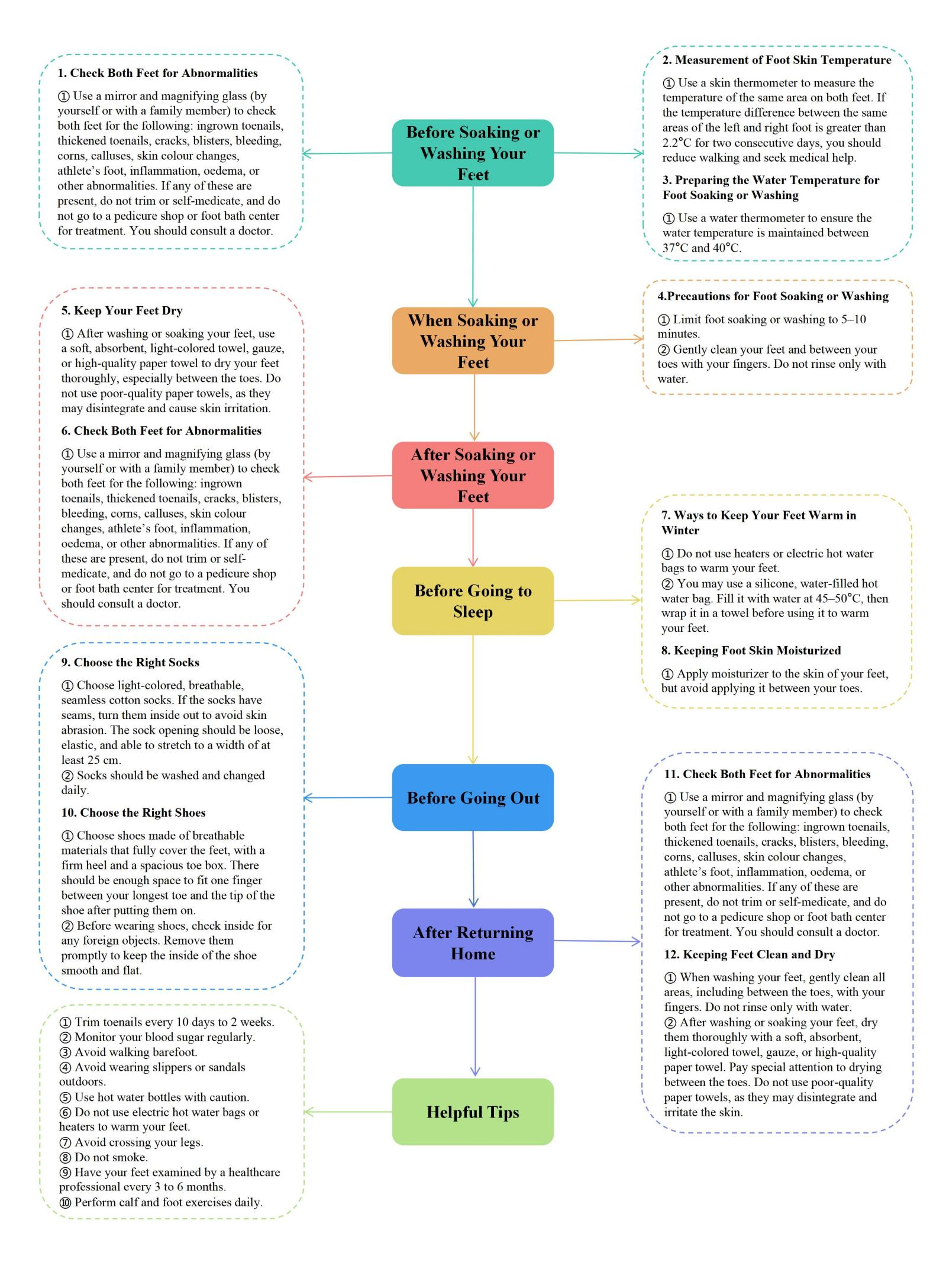

Supplementary Material S1 Part D:Table S1 Foot self-care program for patients with diabetic high-risk feet (round 1)
Subjects | Mean±SD | CV | Percentage of perfect scores (%)
1 Foot Cleaning | 5 | 0 | 100
1.1 To prevent scalding your feet, use a thermometer to measure the water temperature when soaking or washing your feet, which is 37-40 degrees Celsius. | 4.82±0.53 | 0.11 | 88.24
1.2 Keep foot soaks or foot washes to 5-10 minutes (avoid harsh soaps). | 4.71±0.47 | 0.10 | 70.59
1.3 To keep your feet clean, you should use your fingers to gently rub your feet and the dirt between your toes when washing them. It is forbidden to just rinse the water. | 4.82±0.39 | 0.08 |  | 82.35
1.4 To prevent the formation of foot odour (athlete's foot), use cotton gauze towels to dry your feet after soaking them, absorbent gauze to dry between the toe seams to keep them clean and dry, and prohibit the use of paper towels to dry the toe seams, as the residue of the paper shavings tends to abrade the toe seams. | 4.64±0.49 | 0.11 |  | 64.71
1.5 To prevent your feet from cracking due to dry skin, apply moisturizing creams (eg, urea cream, petroleum jelly) to the skin before going to bed, and prohibit applying them between the toe seams (toe seams are prone to forming foot fungus if they are moist). In the fall and winter seasons, you can use emollient products with a high degree of moisturization. | 4.82±0.39 | 0.08 |  | 82.35
2 Foot Exam | 4.88±0.33 | 0.07 |  | 88.24
2.1 For a clearer view of the feet, examination of the feet should be done in good light and after bathing. | 4.76±0.44 | 0.09 |  | 76.47
2.2 To avoid untimely detection of abnormalities, you can let your family members or yourself use mirrors and magnifying glasses to check your feet for ingrown toenails, thickened toenails, cracks, blisters, bleeding, corns, calluses , changes in skin colour, athlete's foot , inflammation, oedema, and other abnormalities (comprehensively check the surface of the foot, the soles of the feet, and the toes between the cracks); if the above situations occur, it is forbidden to treat them on your own (to avoid improper treatment, the situation will become serious), should seek medical help. Relevant foot conditions are as follows. | 4.88±0.33 | 0.07 |  | 88.24
2.3 To detect the occurrence of foot ulcers at an early stage, use an electronic temperature gun to measure the change in foot skin temperature before washing or soaking your feet. If the temperature difference between the opposite areas of the right and left feet is greater than 2.2°C for two consecutive days, you should reduce walking and seek medical help. The temperature measurement areas are as follows. | 4.41±0.71 | 0.16 |  | 52.94
3 Shoes and Socks | 4.88±0.33 | 0.07 |  | 88.24
3.1 To keep your feet clean and dry, choose cotton, seamless, breathable, light-coloured socks that are not too tight (or turn the seams inside out to avoid abrasion of the skin at the seams). | 4.76±0.44 | 0.09 |  | 76.47
3.2 To prevent the formation of foot odour, socks should be changed and washed daily. | 4.88±0.33 | 0.07 |  | 88.24
3.3 To avoid foot injuries, choose shoes made of breathable material and fully wrapped. The inner length of the shoe should be 1-2 centimetres longer than the foot, leaving 1 centimetre (enough to accommodate a finger) between the longest toe and the edge of the shoe. | 4.71±0.47 | 0.10 |  | 70.59
3.4 To maintain a balanced plantar pressure to avoid ulcers, such as foot deformities and calluses (calluses) on the soles of the feet, it is recommended to customize diabetic foot-specific shoes. | 4.71±0.47 | 0.10 |  | 70.59
3.5 To equalize the pressure on your feet's soles, you should observe the wear and tear of your shoes and replace them promptly. | 4.76±0.44 | 0.09 |  | 76.47
3.6 To avoid injuries to the soles of your feet, check for sand and other foreign objects in your shoes before wearing them and keep them flat. | 4.94±0.24 | 0.05 |  | 94.12
3.7 To avoid foot injuries, it is forbidden to walk indoors or outdoors barefoot or wearing only socks, to wear thin-soled slippers at home, or to go out in slippers. | 4.82±0.39 | 0.08 |  | 82.35
4 Otherwise | 4.29±0.47 | 0.11 |  | 29.41
4.1 To avoid scratching the skin, toenails should be trimmed weekly; they should be trimmed straight, and the corners should be curved and polished smooth. | 4.71±0.47 | 0.10 |  | 70.59
4.2 Monitor your blood glucose regularly and seek medical attention if your blood glucose is not well controlled. | 4.94±0.24 | 0.05 |  | 94.12
4.3 To avoid foot burns, prohibit the use of heaters or electric hot water bags to warm the feet; you can use silicone hot water bags filled with 50 ℃ hot water and then wrapped in a layer of towels. | 4.76±0.44 | 0.09 |  | 76.47
4.4 To keep your blood vessels healthy, smoking and staring at your legs are prohibited. | 4.71±0.47 | 0.10 |  | 70.59
4.5 To keep your feet healthy, you should have them checked regularly (at least every six months to a year).  Time of last inspection： Next inspection time： | 4.64±0.49 | 0.11 |  | 64.71
5 Daily Foot Self-Care Flowchart | 4.47±0.72 | 0.16 |  | 58.82
5.1 Structured procedural steps | 4.41±0.71 | 0.16 |  | 52.94

