SUPPLEMENTARY INFORMATION

Synthesis of precursors and MSNs

Scheme S1. Chemical structures of dopamine, L-DOPA, and carbidopa

Characterization of the DSDAs of L-dopa: N-Oleoyl-L-Dopa (L-dopa-C18)
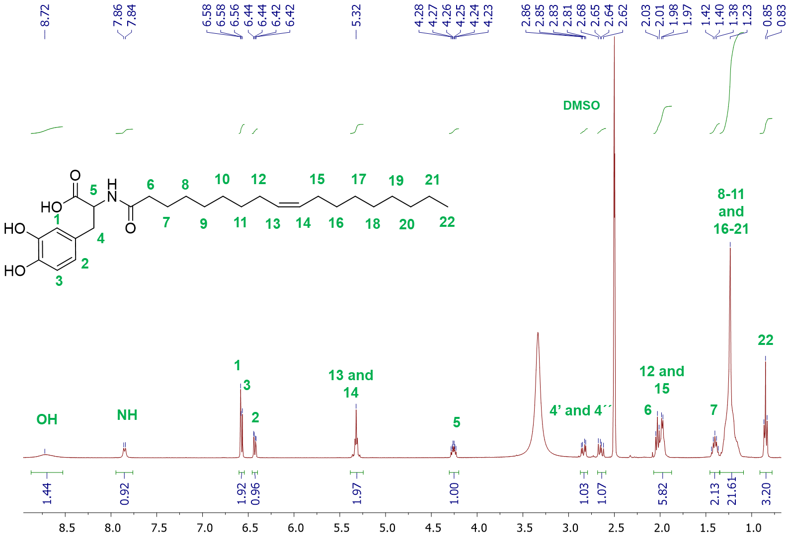
Figure S1. ¹H NMR of DSDA of L-dopa-C18.
¹H-NMR (400 MHz, d₆-DMSO), δ (ppm): 8.70 (s.a., 2H, OH), 7.88 (d, J = 7.8 Hz, 1 H, NH), 6.58 (d, J = 2.2 Hz, 1H, CH-1), 6.57 (d, J = 7.8 Hz, 1H, CH-3), 6.43 (dd, J =8 Hz, J =1.88 Hz, 1H, CH-2), 5.32 (t, J = 5.44 Hz, 2H, CH-13 and 14), 4.30-4.24 (m, 1H, CH-5), 2.83 (dd, J = 13.8 Hz, J = 5 Hz, 1H, CH₂-4), 2.64 (dd, J= 13.8 Hz, J= 5 Hz, 1H, CH₂-4), 2.03 (t, J = 7.32 Hz, 2H, CH₂-6), 1.97 (c, J =6 Hz, 4 H, CH₂-12 and 15), 1.40 (q, J= 7.48 Hz, 2H, CH₂-7), 1.23 (m, 20H, CH₂ 8-11/ 16-21), 0.85 (t, J = 6.68 Hz, 3H, CH₂-22).

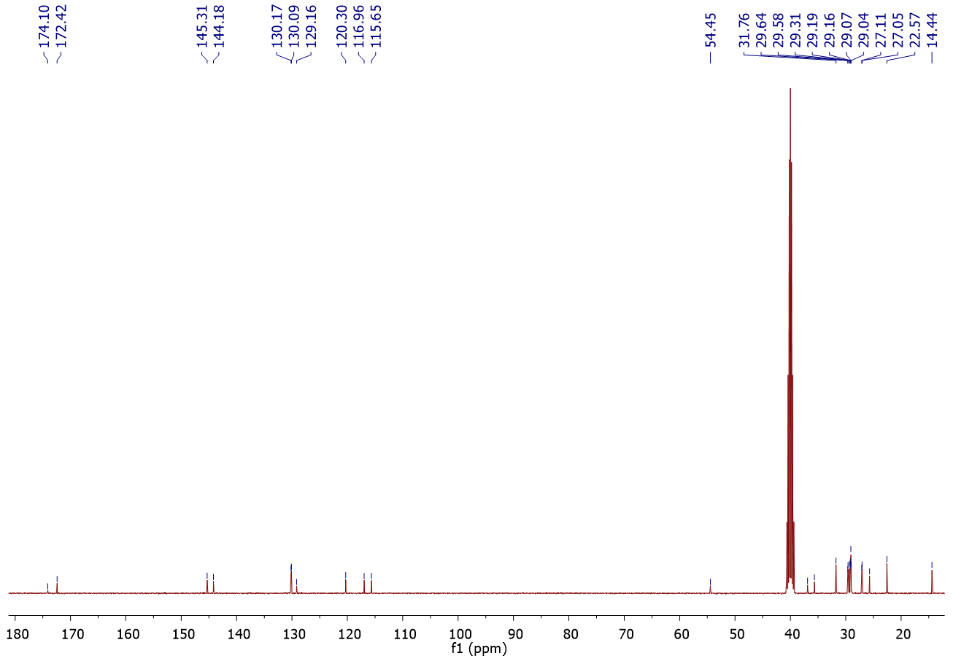
Figure S2. ¹³C NMR of L-dopa-C18 DSDA.
¹³C-NMR (400 MHz, d₆-DMSO), δ (ppm): 174.1 (N-C=O), 172.4 (O-C=O), 145.3 (C), 144.2 (C), 130.2 (C), 130.1 (CH), 129.1 (CH), 120.3 (CH), 116.9 (CH), 115.6 (CH), 54.4 (CH), 36.9 (CH₂), 35.6 (CH₂), 31.7 (CH₂), 29.6 (CH₂), 29.6 (CH₂), 29.3 (CH₂), 29.2 (CH₂), 29.1 (CH₂), 29.1 (CH₂), 29.0 (CH₂), 27.1 (CH₂), 27.0 (CH₂), 25.7 (CH₂), 22.6 (CH₂), 14.4 (CH₃).

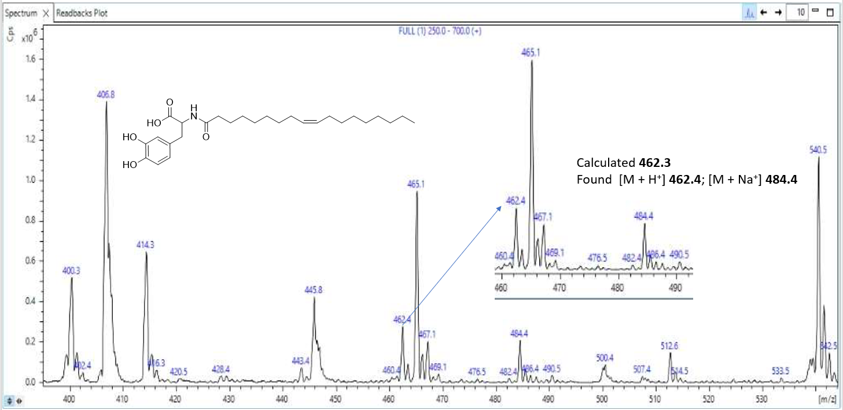
Figure S3. ESI Mass Spectrum of L-Dopa DSDA. Calculated for C₂₇H₄₃NO₅ m/z=461.3. Found m/z= 462.4 (M+H⁺) and 484.4 (M+Na⁺).

Figure S4. FTIR spectrum of DSDA of L-dopa-C18.
FTIR, ν: 3200 (br, OH), 2916, 2864 (C-H, st), 1718 (C=O, st) cm⁻¹.

Table S1. EA of DSDA L-dopa-C18.
 | %N | %C | %H
Calculated | 2.99 | 69.57 | 9.82
Found | 3.13 | 69.77 | 9.23

N-Decanoyl-L-Dopa (L-dopa-C10):
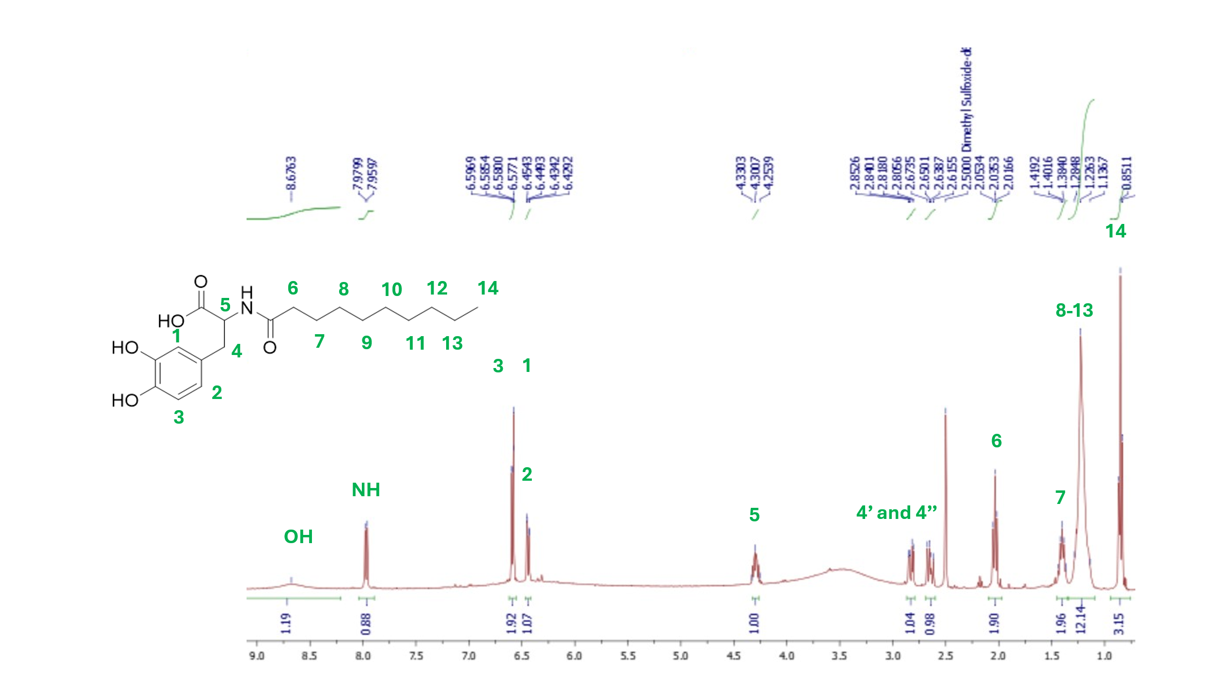
Figure S5. ¹H NMR of DSDA of L-dopa-C10.
¹H-NMR (400 MHz, d₆-DMSO), δ (ppm): 8.70 (s.a., 2H, OH), 7.97 (d, J = 8.1 Hz, 1H, NH), 6.59 (d, J =6.8 , 1H, CH-3), 6.58 (d, J =3.3 Hz, 1H, CH-1), 6.44 (dd, J =8.0 Hz, J =2.0 Hz, 1H, CH-2), 4.33-4.25 (m, 1H, CH-5), 2.83 (dd, J = 13.8 Hz, J = 5 Hz, 1H, CH₂-4), 2.64 (dd, J= 13.8 Hz, J= 5 Hz, 1H, CH₂-4), 2.04 (t, J = 7.2 Hz, 2H, CH₂-6), 1.40 (q, J= 7.2 Hz, 2H, CH₂-7), 1.28-1.36 (m, 12H, CH₂-8-13), 0.85 (t, J = 6.68 Hz, 3H, CH₂-14).

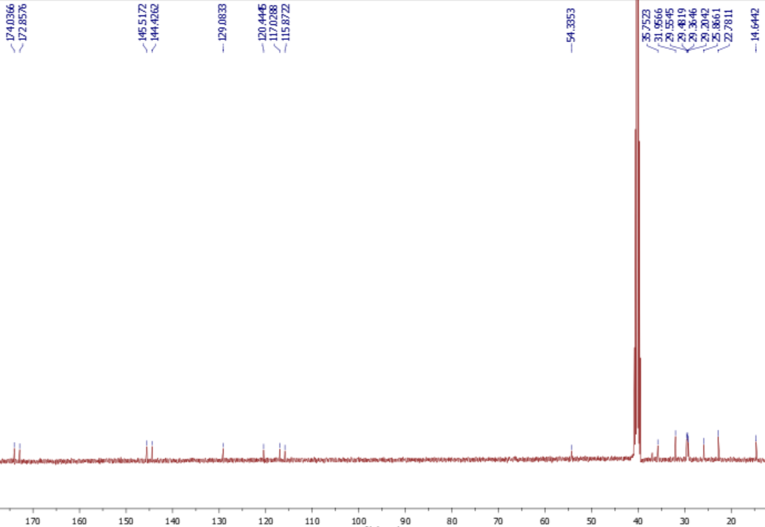
Figure S6. ¹³C NMR of DSDA of L-Dopa-C10.
¹³C-NMR (400 MHz, d₆-DMSO), δ (ppm): 174.0 (N-C=O), 172.9 (O-C=O), 145.5 (C), 144.4 (C), 129.1 (C), 120.4 (CH), 117.0 (CH), 115.9 (CH), 54.3 (CH), 35.7 (CH₂), 32.0 (CH₂), 29.5 (CH₂), 29.5 (CH₂), 29.4 (CH₂), 29.2 (CH₂), 25.9 (CH₂), 22.8 (CH₂), 14.6 (CH₃).

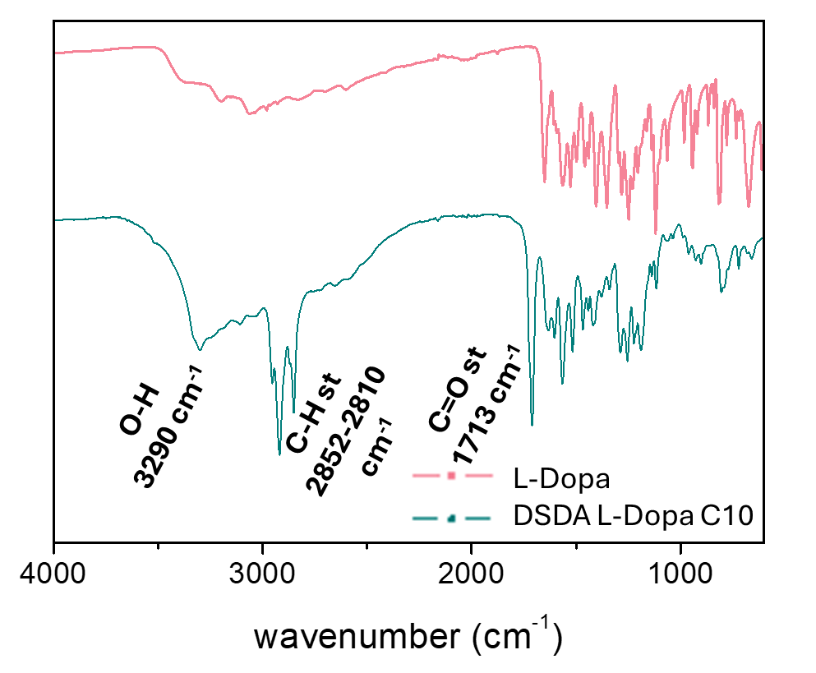
Figure S7. FTIR spectrum of DSDA of L-dopa-C10.
FTIR, ν: 3290 (br, OH), 2952, 2810 (C-H, st), 1713 (C=O, st) cm⁻¹.

Table S2. PAMPA-BBB assay of L-dopa-C18.
 | Permeability P_{e} (10⁻⁶ cm s⁻¹) | Classificationª
L-dopa | 0.94 ± 0.05 | CNS-
Oleic acid | 21.6 ± 0.23 | CNS+
DSDA L-dopa-C10 | 0.27 ± 0.01 | CNS-
DSDA L-dopa-C18 | 1.13 ± 0.02 | CNS-
ª CNS+ (indicative of high BBB permeation): P_{e} (10⁻⁶ cm s⁻¹) > 4.0; CNS+/-(discrete BBB permeation): Pe (10⁻⁶ cm s⁻¹) from 4.0 to 2.0. CNS- (indicative of low BBB permeation): Pe (10⁻⁶ cm s⁻¹) < 2.0. ND is not determined.

Characterization of L-dopa@MSN

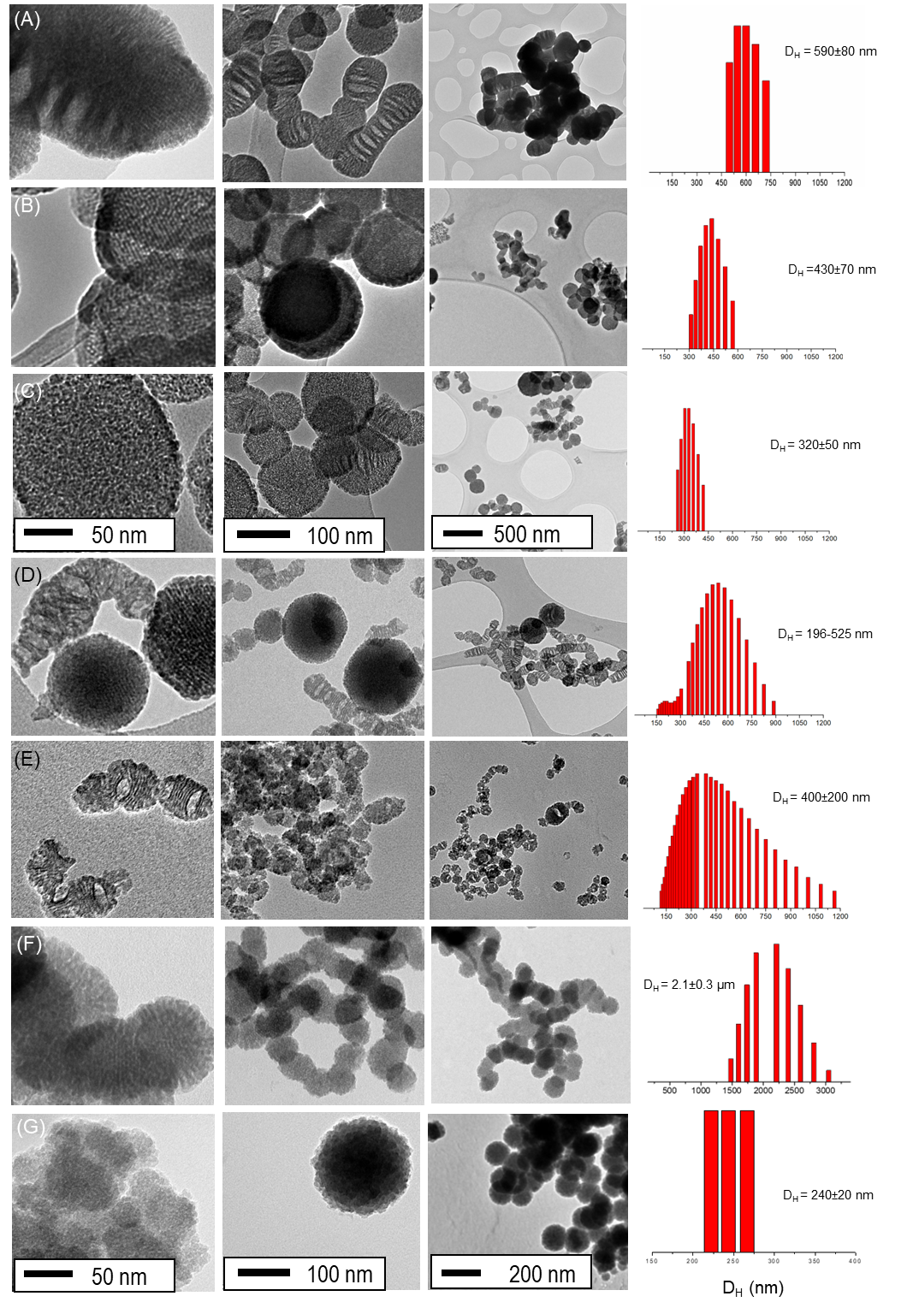
Figure S8. TEM images and DLS measurements of (A) L-dopa-C18@MSN-1, (B) L-dopa-C18@MSN-2, (C) L-dopa-C18@MSN-3, (D) L-dopa-C18@MSN-4, (E) L-dopa-C18@MSN-5, (F) L-dopa-C18@MSN-6 and (G) L-dopa-C10@MSN.
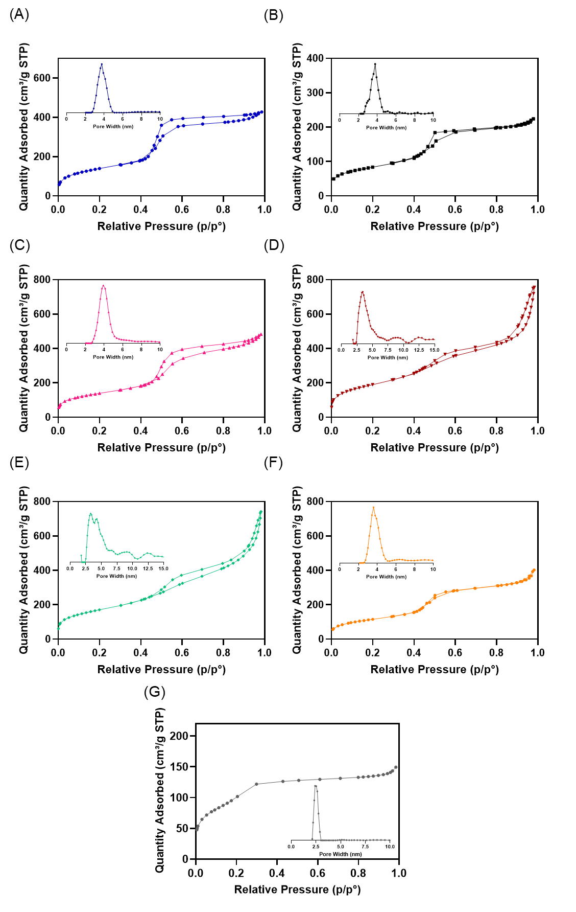
Figure S9. Adsorption N₂ isotherms and pore distribution of (A) L-dopa-C18@MSN-1, (B) L-dopa-C18@MSN-2, (C) L-dopa-C18@MSN-3, (D) L-dopa-C18@MSN-4, (E) L-dopa-C18@MSN-5, (F) L-dopa-C18@MSN-6 and (G) L-dopa-C10@MSN.

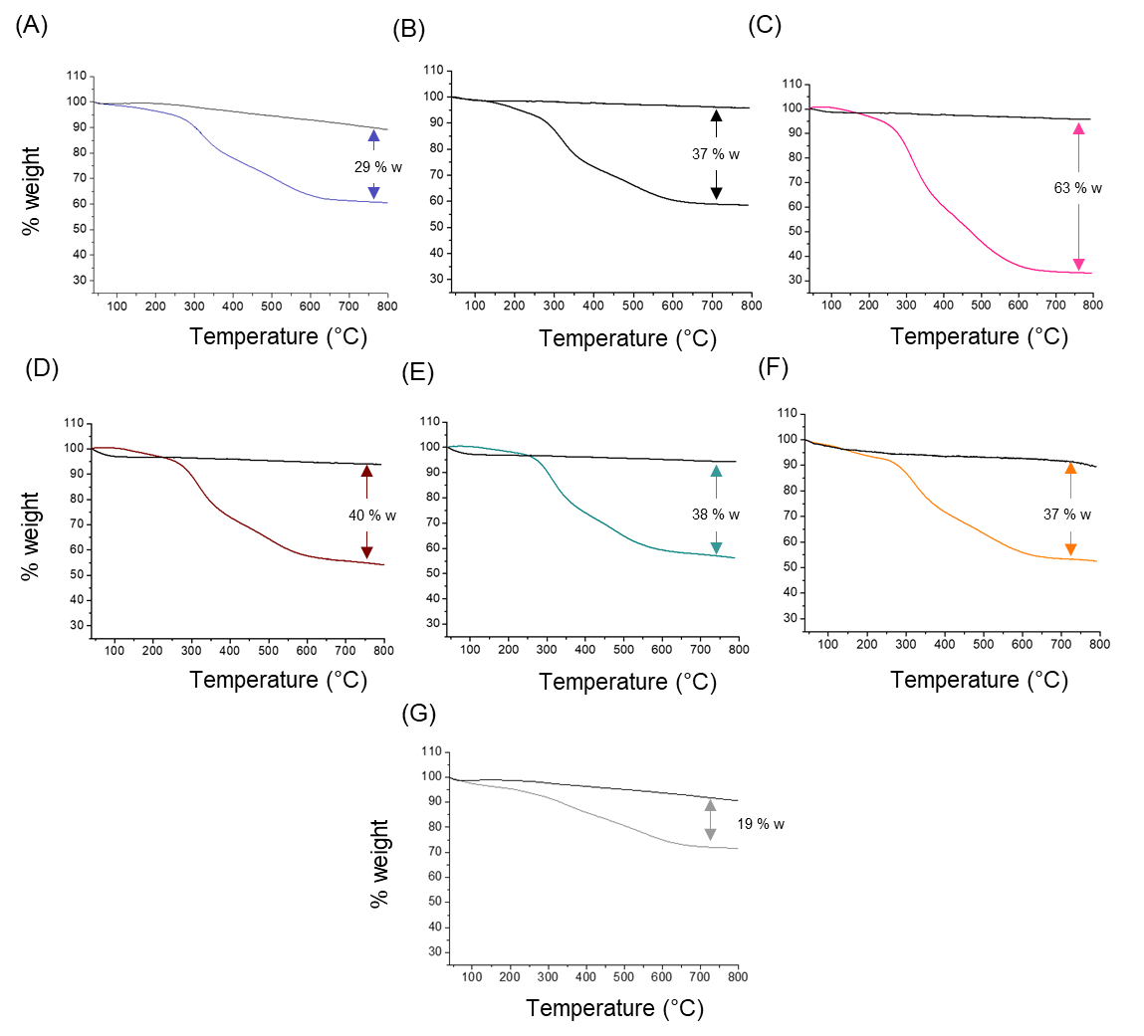
Figure S10. TGA of samples and calcinated samples (in black): (A) L-dopa-C18@MSN-1, (B) L-dopa-C18@MSN-2, (C) L-dopa-C18@MSN-3, (D) L-dopa-C18@MSN-4, (E) L-dopa-C18@MSN-5, (F) L-dopa-C18@MSN-6 and (G) L-dopa-C10@MSN.

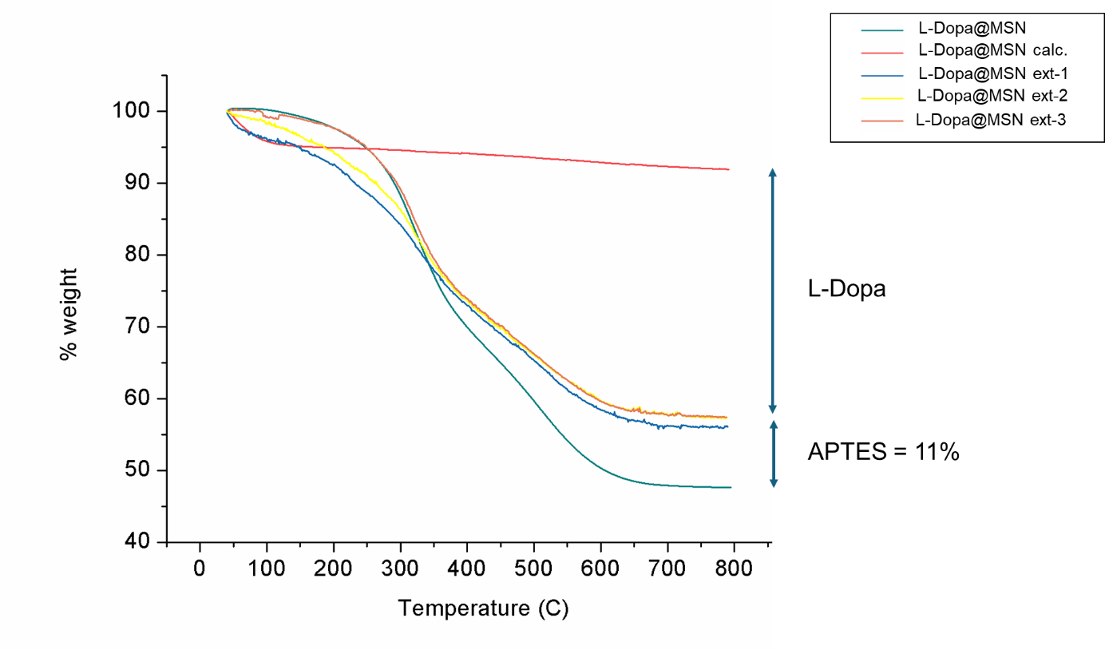
Figure S11. Thermogravimetric analysis of MSN-2 (as example) of the calcinated and extracted samples. Successive extractions of the samples with a mixture Ethanol/Hydrochloric acid were performed in order to remove completely L-dopa-C18. The weight loss observed in third extraction correspond uniquely to amount of APTES.
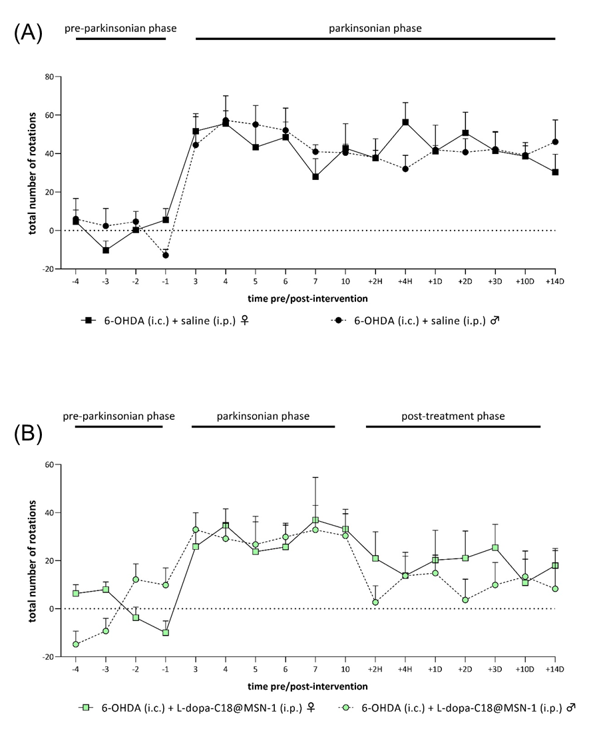
Figure S12. (A)Time course of 6-OHDA-injected female and of 6-OHDA-injected male mice. (B) Time course of 6-OHDA-injected female and of 6-OHDA-injected male mice treated with L-dopa-C18@MSN-1. Data are reported as total number of rotations made in the contraversive or ipsiversive direction in 15 min.

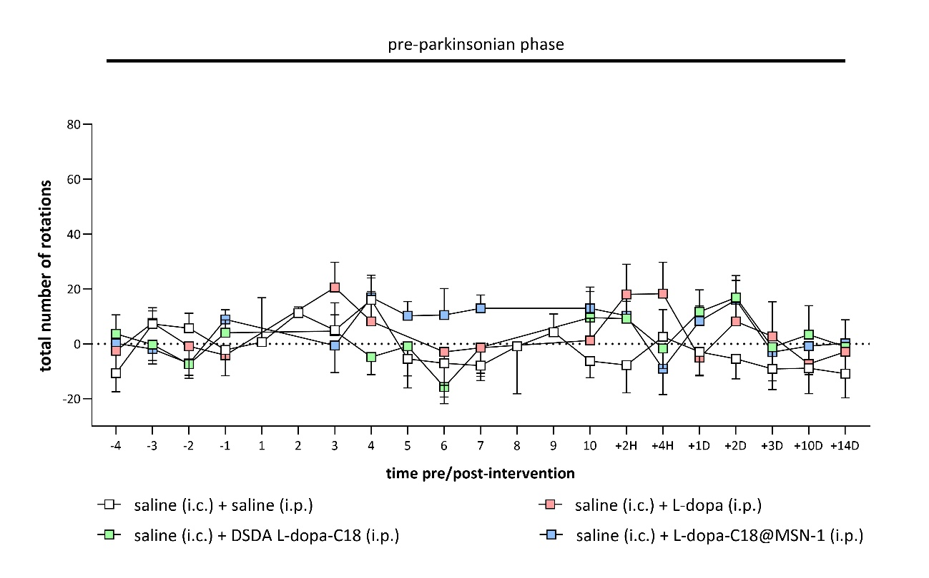
Figure S13. Time course of saline-injected mice treated groups. Data are reported as total number of rotations made in the contraversive or ipsiversive direction in 15 min.

