Supplemental Figure 1. Power Simulations for Logistic Regression Models

- Two continous variables
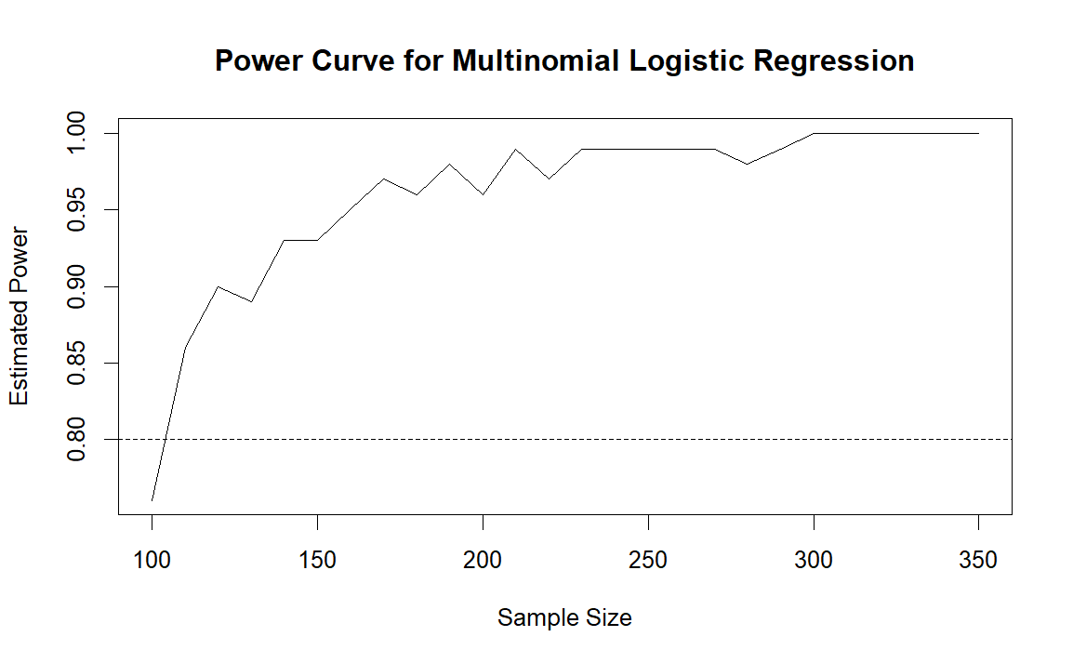
- A continous and dichotomous variable
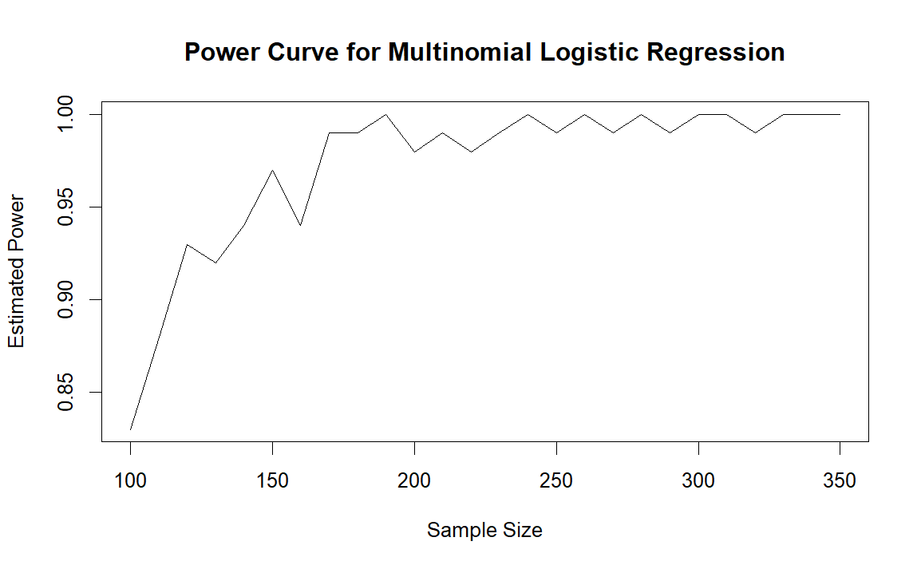
- Two dichotomous variables
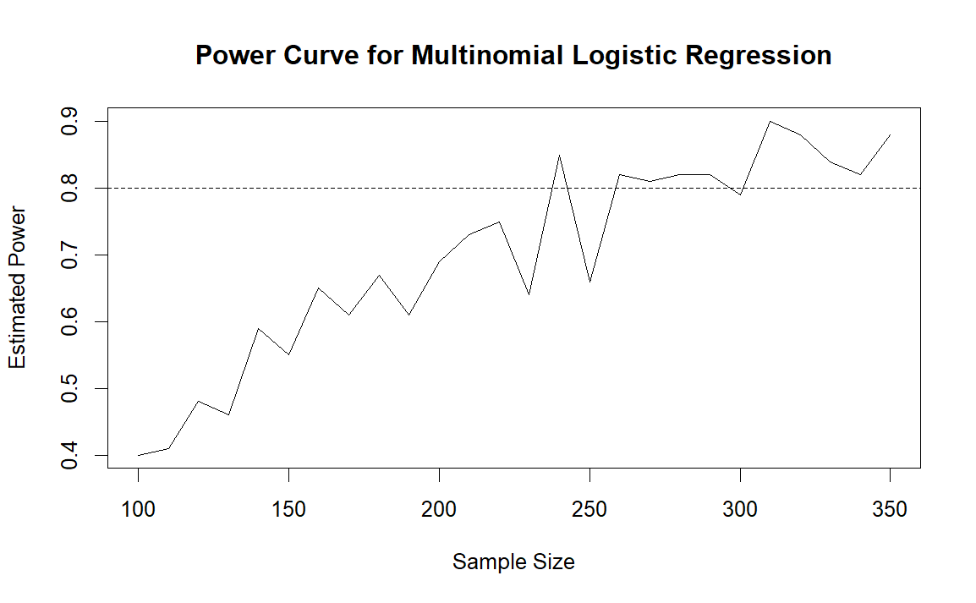

Simulation of power and sample size requirements for multinomial logistic regression using two variables with moderate-to-large effect sizes (odds ratios 1.5–3.0). Three predictor combinations were modeled: (A) two continuous variables (age and number of chronic conditions), (B) one continuous and one dichotomous variable (age and anticholinergic medication exposure), and (C) two dichotomous variables (sex and anticholinergic medication exposure).
Note: Simulations assumed a prevalence of 40% for mild cognitive impairment (MCI) and 10% for dementia.

