Supplementary Figure 1
The ancillary detection and analysis of copy number variants from the whole exome sequencing data also detected the in-frame deletion of DMD exons 50–51.
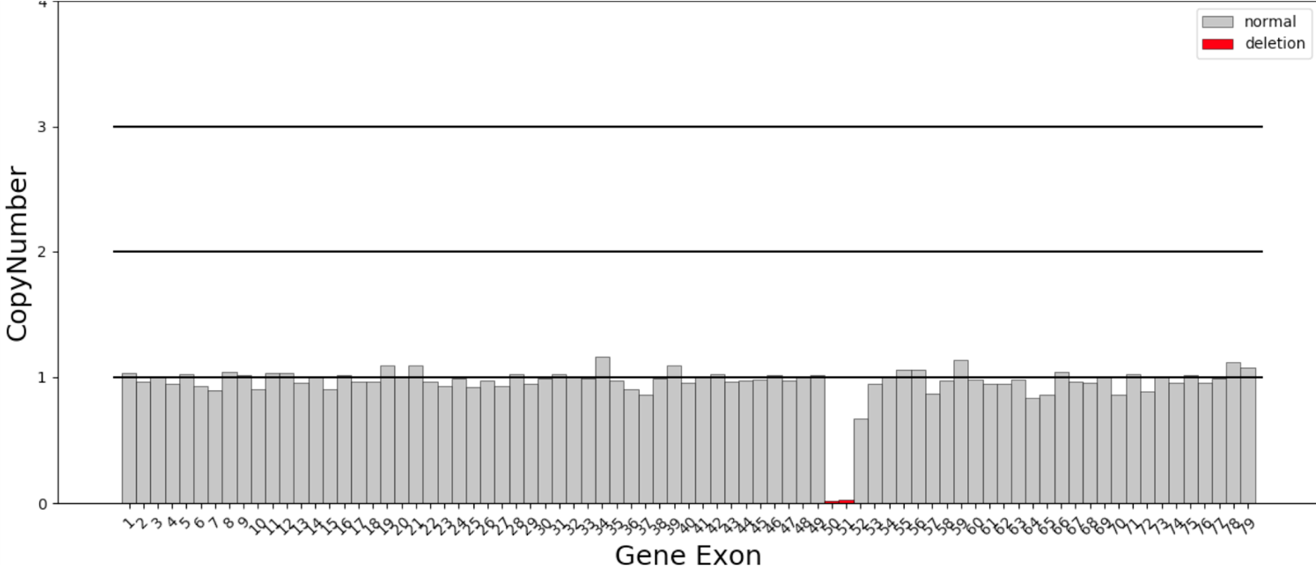

Supplementary Figure 2
The integrative genomics viewer screenshot of long-read sequencing showing the novel deletion variant in DMD gene. The red box indicated the genomic region currently in view.
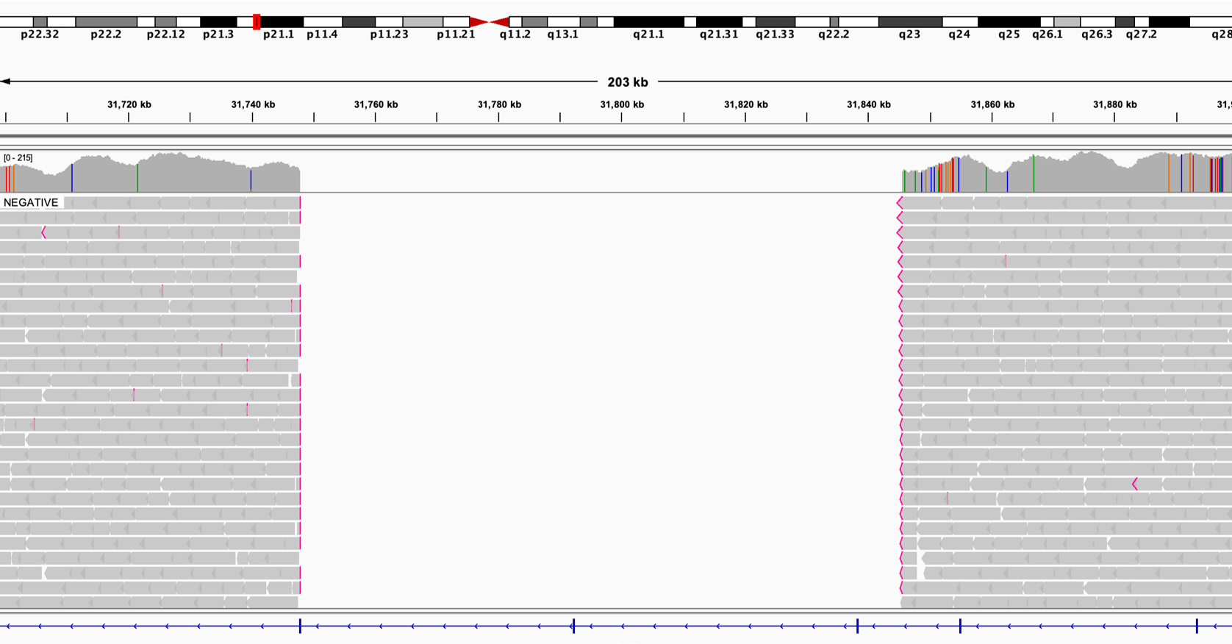

Supplementary Table 1. The list of primers used for the RT-PCR amplification of DMD mRNA.
Amplified fragments | Forward primer sequence (5′ -> 3′) | Reverse primer sequence (5′ -> 3′)
F1 (exons 1~ 7) | ACTGGAGCAATAAAGTTTGAAGAAC | CTGGCCTATGACTATGGATGAGA
F2 (exons 6~10) | AAGATTCTCCTGAGCTGGGTC | CTCCATCAATGAACTGCCAAA
F3 (exons 9~13) | GGCTGCTTATGTCACCACCTCT | TTCATCAACTACCACCACCATG
F4 (exons 12~17) | AGTACAACAACATAAGGTGCTTCA | AATCCACAGTAATCTGCCTCTTC
F5 (exons 17~21) | CACCACTCAGCCATCACTAACA | TAGCCGGTTGACTTCATCCTTA
F6 (exons 20~24) | CAGAACAACATCATCGCTTTCTAT | AAAACATCAACTTCAGCCATCC
F7 (exons 23~27) | AAATTGAGGGACGCTGGAA | GTGGAGCTTGAGCTATGACACTA
F8 (exons 26~30) | CTGTAAGCCTCCAGAAAGAT | CTGCTTGTCAATGAATGTGA
F9 (exons 30~34) | GAATCCAGGAGTCCCTCACAT | CAGGCAACTTCAGAATCCAAA
F10 (exons 34~37) | ATTGTCCCGTAAGATGCGAAAG | AGCTCTGAGATTTGGGGCTCTA
F11 (exons 37~41) | ATACGCCCAAAGGTGGACTC | CCTCAGCTTGCCTACGCACT
F12 (exons 40~44) | CAAATTAGCCAGCCTACCTG | GTCAAATCGCCCTTGTCG
F13 (exons 43~47) | TATTCATAGCAAGAAGACAGCAGCAT | GCACGGGTCCTCCAGTTTCA
F14 (exons 46~50) | GATAACATTGCTAGTATCCCACTT | CTAGGTCAGGCTGCTTTGC
F15 (exons 49~53) | AAAACCAGCCACTCAGCC | TGGTGTTCTTGTACTTCATCCC
F16 (exons 52~55) | AAAACAAGACCAGCAATCAAG | GAGTCTTCTAGGAGCCTTTCC
F17 (exons 55~59) | AAGTTTCTTGCCTGGCTTACA | TCCTCAGCCTGCTTTCGTAG
F18 (exons 58~63) | GACAGAGCAGCCTTTGGAAG | TTGTTTGAGTCTCGTGGTTGATA
F19 (exons 61~67) | GGACTTTGGTCCAGCATCTCA | GCAACTTCACCCAACTGTCTTG
F20 (exons 65~70) | CGGGACGAACAGGGAGGAT | TCTGCACTGGCAGGTAGCC
F21 (exons 69~75) | TTGCACTCCGACTACATCAGG | GTGTTGACGCAGTAGCTTGG
F22 (exons 75~79) | CTAAAGCAGCAGCACGAACA | CAAATCATCTGCCATGTGGA

Supplementary Material 1:. The details of the WES sequencing, dystrophin mRNA analysis, long-read sequencing of the entire DMD gene, and in silico bioinformatic analyses.
WES sequencing
Genomic DNA was extracted from peripheral blood and used for library construction with the KAPA Library Preparation Kit, followed by exome enrichment with the IDT xGen Exome Research Panel (Integrated DNA Technologies). Libraries were sequenced on the Illumina NovaSeq platform with 2×200 bp paired-end reads, achieving an average on-target coverage >100×. Reads were aligned to the GRCh37 reference genome using BWA-MEM, and variant calling was performed with GATK HaplotypeCaller for SNVs/indels and CNVkit for structural variants. Variants were annotated with ANNOVAR using public databases including ClinVar and gnomAD, and their pathogenicity was assessed according to ACMG/AMP guidelines.
Dystrophin mRNA analysis
Total muscle RNA was extracted from the remaining muscle tissue using the Ultra Pure Total RNA Extraction Kit (Simgen, Hangzhou, China) and subsequently reverse transcribed into cDNA using a HiScript II Q RT SuperMix kit (Vazyme, Nanjing, China) according to previous protocols[1]. Full-length dystrophin cDNA was amplified in 22 overlapping fragments using specific primer pairs (Supplementary Table 1)[2]. The amplified products were separated by agarose gel electrophoresis; and aberrant fragments were excised and subjected to Sanger sequencing on a 3730XL Sequencer to identify splice-altering variants and characterize the resulting transcripts. The obtained sequences were aligned to the reference sequence (NM_004006.2) using CodonCode Aligner 9.0.1(https://www.codoncode.com/).
Long-read dystrophin sequencing and splicing prediction analyses
Long-read sequencing on PacBio Sequel II/IIe targeted the DMD gene using muscle-derived DNA. PCR amplicons were repaired, end-prepped, and ligated into SMRTbell libraries with the SMRTbell Express 2.0 kit, then size-selected with AMPure XP beads. Libraries were quantified by Qubit and checked on an Agilent 2100. Mean target coverage exceeded 200×. Reads were processed via SMRT Link, aligned to GRCh37 with minimap2. DeepVariant, Sniffles, and AnnotSV were applied for detection and functional annotation of single-nucleotide variants, structural variants, and short tandem repeats, thus resolving complex splicing patterns and large alterations invisible to short reads. The identified variants were subsequently validated by Sanger sequencing[2]. In silico splicing prediction was carried out using Human Splicing Finder[3] and Maximum Entropy Scan[4] algorithms to evaluate the effect of detected variants on splicing.
Reference
[1] Jin M, Li JJ, Xu GR, Wang N, Wang ZQ. Cryptic exon activation causes dystrophinopathy in two Chinese families. Eur J Hum Genet 2020;28:947-955.http://dx.doi.org/10.1038/s41431-020-0578-z
[2] Xie Z, Sun C, Liu Y, et al. Practical approach to the genetic diagnosis of unsolved dystrophinopathies: a stepwise strategy in the genomic era. J Med Genet 2021;58:743-751.http://dx.doi.org/10.1136/jmedgenet-2020-107113
[3] Desmet FO, Hamroun D, Lalande M, Collod-Beroud G, Claustres M, Beroud C. Human Splicing Finder: an online bioinformatics tool to predict splicing signals. Nucleic Acids Res 2009;37:e67.http://dx.doi.org/10.1093/nar/gkp215
[4] Shamsani J, Kazakoff SH, Armean IM, et al. A plugin for the Ensembl Variant Effect Predictor that uses MaxEntScan to predict variant spliceogenicity. Bioinformatics 2019;35:2315-2317.http://dx.doi.org/10.1093/bioinformatics/bty960

