Supplementary Material
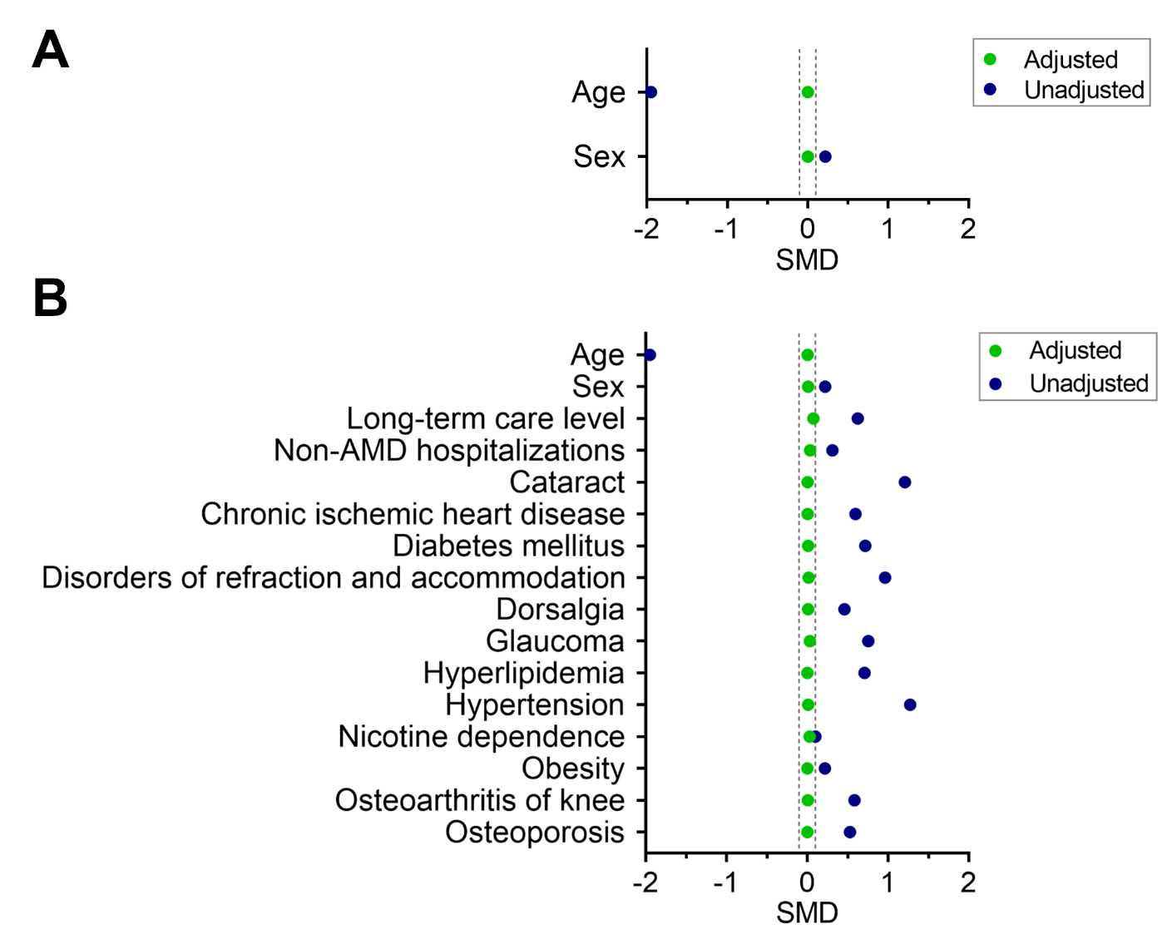
Figure S1. Covariate balance measured by standardized mean difference (SMD) before (unadjusted covariates) and after (adjusted covariates) propensity score matching for (A) age/sex-based matching of non-exudative AMD only patients to non-AMD controls as well as for (B) matching of non-exudative AMD only patients to non-AMD controls based on an extended number of covariates. The SMD was the difference in the means of each covariate between comparison groups divided by the standard deviation derived from both groups so that it is measured on a uniform scale. Adjusted SMDs falling between the grey, dashed lines (-0.1 and 0.1) indicate a well-balanced matching.

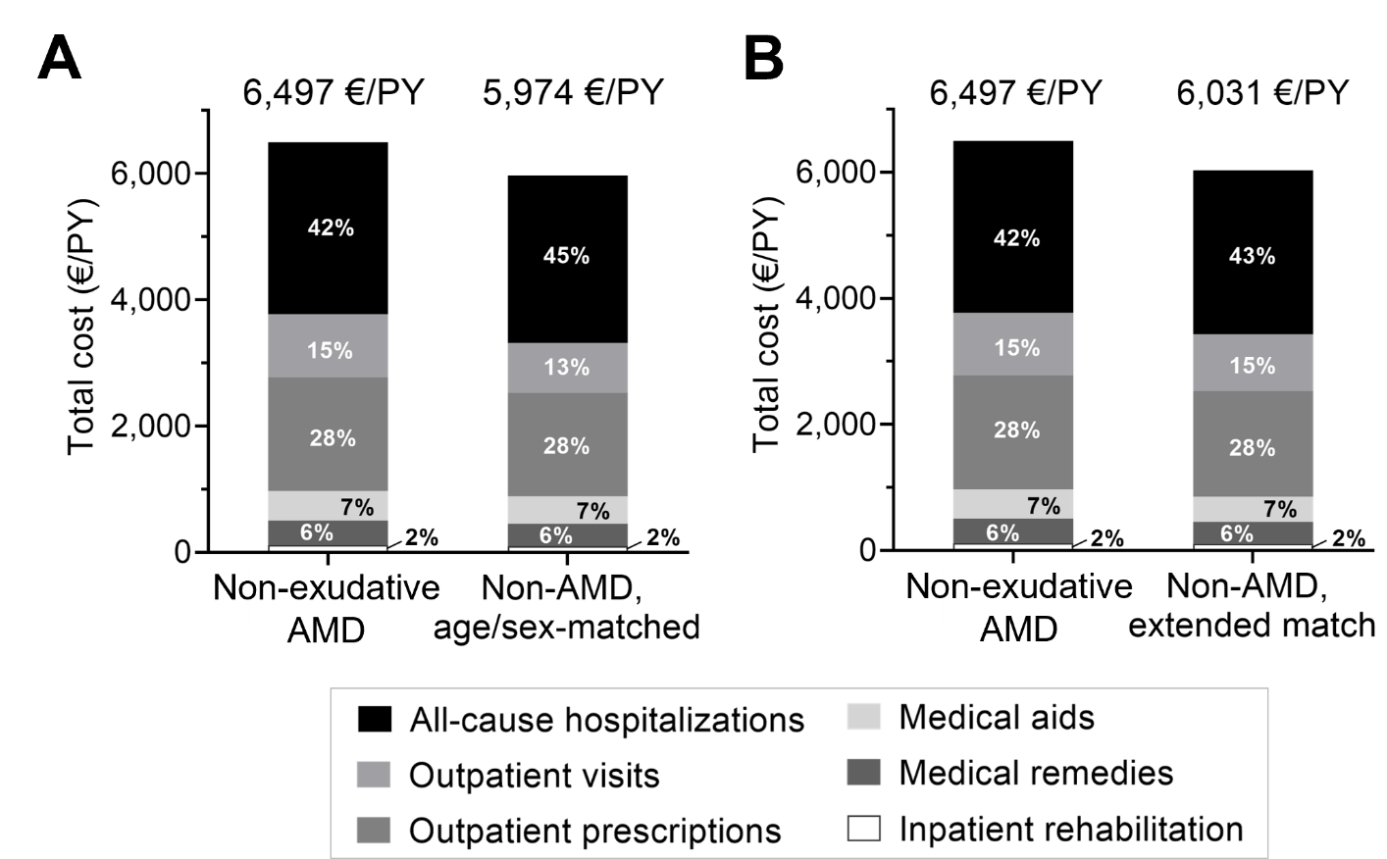
Figure S2. Composition and absolute amounts of the total direct healthcare costs in 2021 for prevalent non-exudative AMD only patients compared to non-AMD controls matched based on (A) age and sex and (B) on an extended list of covariates.

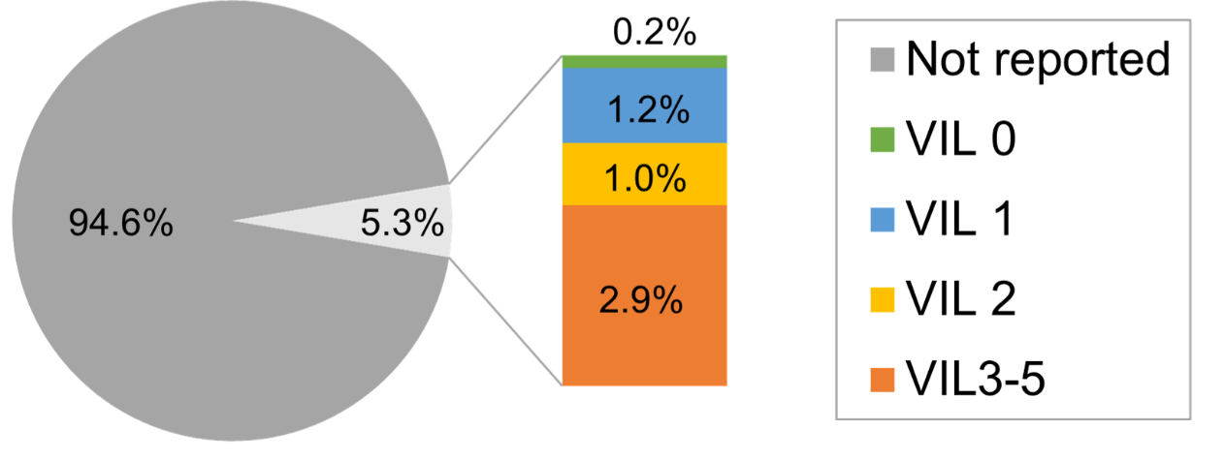
Figure S3. Proportions of reported visual impairment levels (mild [VIL 0], moderate [VIL 1], severe [VIL 2], high-grade/blindness [VIL 3-5]) among the study cohort.

Table S1. Codes used for detection of exudative AMD therapies.
Therapy Name | Code Name | Code Number
Anti-VEGF Therapy
Aflibercept | ATC | S01LA05, L01XX44  (no code for 2010-2012)
Aflibercept | OPS | 6-007.2  (no code for 2010-2014)
Bevacizumab | ATC | L01XC07
Brolucizumab | ATC | S01LA06  (no code for 2010-2019)
Pegaptanib | ATC | S01LA03
Pegaptanib | OPS | 6-003.d
Ranibizumab | ATC | S01LA04
Ranibizumab | OPS | 6-003.c
Injection of any medication into the back of the eye | OPS | 5-156.9
Photodynamic Therapy with Verteporfin
Destruction of affected tissue in retina and choroidea via photodynamic therapy | OPS | 5-155.6
Photodynamic therapy with verteporfin at the back of the eye | EBM | 06332

Table S2. Top-10 most frequent diagnoses for age/sex-matched non-AMD controls during baseline.
Top-10 diagnoses (ICD-10 code) | Non-AMD control  for non-exudative AMD  N = 25,439
Primary hypertension (I10) – n (%) | 20,261 (79.6)
Disorders of lipoprotein metabolism  and other lipidemias (E78) – n (%) | 11,924 (46.9)
Type 2 diabetes mellitus (E11) – n (%) | 9,108 (35.8)
Dorsalgia (M54) – n (%) | 7,268 (28.6)
Chronic kidney disease (N18) – n (%) | 6,721 (26.4)
Chronic ischemic heart diseases (I25) – n (%) | 6,654 (26.2)
Osteoarthritis of knee (M17) – n (%) | 6,515 (25.6)
Heart failure (I50) – n (%) | 6,038 (23.7)
Atrial fibrillation and flutter (I48) – n (%) | 4,933 (19.4)
Spondylosis (M47) – n (%) | 4,842 (19.0)

Table S3. Healthcare resource utilization during 2021 for prevalent non-exudative AMD only patients and two non-AMD controls (one was matched based on age and sex and the other one on an extended list of baseline characteristics).
 | Matching based on age & sex |  |  |  | Extended matchingª
 | Prevalent  non-exudative AMD | Non-AMD control | Difference^{b} | P value^{c} | Prevalent  non-exudative AMD | Non-AMD control | Difference^{b} | P value^{c}
Total number of patients | 25,439 | 25,439 |  |  | 25,438e | 25,438
Total number of observed person-  years (PY)^{d} | 23,905.6 | 24,284.9 |  |  | 23,904.6 | 24,614.1
Outpatient visits
Ophthalmologist visits^{f}
Pts with ≥1 ophthalmologist visit, n (%) | 20,981 (82.5) | 9,802 (38.5) | 11,179 | < 0.001^{g} | 20,980 (82.5) | 15,252 (60.0) | 5,728 | < 0.001^{g}
Frequency per PY | 2.0 | 0.8 | 1.2 | < 0.001^{g} | 2.0 | 1.5 | 0.5 | < 0.001^{g}
Inpatient stays
All-cause hospitalizations
Pts with ≥1 hospitalization, n (%) | 7,715 (30.3) | 7,482 (29.4) | 233 | 0.02^{g} | 7,714 (30.3) | 7,611 (29.9) | 103 | 0.32
Frequency per PY | 0.56 | 0.53 | 0.03 | < 0.001^{g} | 0.56 | 0.54 | 0.03 | < 0.001^{g}
Days per PY | 4.1 | 4.0 | 0.02 | 0.35 | 4.1 | 3.9 | 0.24 | < 0.001^{g}
Fracture-related hospitalizations
Pts with ≥1 hospitalization, n (%) | 1,697 (6.7) | 1,660 (6.5) | 37 | 0.51 | 1,696 (6.7) | 1,592 (6.3) | 104 | 0.06
Burn-related hospitalizations
Pts with ≥1 hospitalization, n (%) | 4 (0.02) | 8 (0.04) | -4 | 0.25 | 4 (0.02) | 7 (0.03) | -3 | 0.37
ª The calculation of the total number of observed person-years was performed under the assumption that one year consists of 365.25 days.
^{b} Propensity score matching was performed based on the following covariates: age at index, sex, long-term care level during baseline, nicotine dependence during baseline, obesity during baseline, top-10 comorbidities during baseline, number of non-AMD-related hospitalization during baseline.
^{c} Calculated using the chi-square test and the hcost program in Stata.
^{d} Calculated as prevalent non-exudative AMD cohort minus matched non-AMD control cohort.
^{e} One non-exudative AMD patient was not matched, i.e., no non-AMD matching partner was identified within the common support region.
^{f} Patients with ocular comorbidities were not excluded from analysis. Hence, the results may not exclusively be related to AMD.
^{g} Denotes statistically significant p-value (p < 0.05).

Table S4. Pre-defined ocular diagnoses during baseline for both study cohorts and the age/sex-matched non-AMD control. Patients with ocular comorbidities were not excluded from analysis. Hence, the results may not exclusively be related to AMD.
Diagnosis (ICD-10 code) | Prevalent non-exudative AMD only  N = 25,439 | Non-AMD control for non-exudative AMD only  N = 25,439 | Prevalent non-exudative & exudative AMD  N = 7,153
Visual impairment level (H54) – n (%)
Category 0 – mild | 37 (0.2) | 11 (0) | 13 (0.2)
Category 1 – moderate | 342 (1.2) | 123 (0.5) | 141 (2.0)
Category 2 – severe | 258 (1.0) | 50 (0.2) | 110 (1.5)
Category 3-5 – high-grade/blindness | 737 (2.9) | 226 (0.9) | 482 (6.7)
Not reported | 24,065 (94.6) | 25,029 (98.4) | 6,407 (89.6)
Visual disturbance (H53) – n (%) | 3,664 (14.4) | 1,217 (4.8) | 1,259 (17.6)

Table S5. Top-20 most common eye-related diagnostic and therapy monitoring procedures and services detected during baseline as coded by EBM codes. Dashes indicate that the respective code was not ranked among the top-20 for the respective cohort, hence no values are provided. Patients with ocular comorbidities were not excluded from analysis. Hence, the results may not exclusively be related to AMD.
EBM code, description – n (%) | Prevalent  non-exudative  AMD only  N = 25,439 | Prevalent  non-exudative & exudative AMD  N = 7,153
06211, Basic lump sum for 6-59 years old patients | 680 (2.7) | -
06212, Basic lump sum for 60+ years old patients | 24,494 (96.3) | 7,048 (98.5)
06220, Surcharge for basic ophthalmological care | 24,824 (97.6) | 6,567 (91.8)
06222, Surcharge for 06220 | 24,824 (97.6) | 6,567 (91.8)
06225, Surcharge for treatment by ophthalmologist(s) who does not perform surgeries | 24,544 (96.5) | 6,859 (95.9)
06227, Surcharge for 06210 and 06212 | 25,127 (98.8) | 7,118 (99.5)
06310, Continuous tonometry | 580 (2.3) | -
06321, Additional lump sum for examination and/or treatment of a binary vision disorder in 6+ years old patients | 547 (2.2) | -
06330, Perimetry | 7,865 (30.9) | 1,835 (25.7)
06331, Fluorescence angiography | 437 (1.7) | 1,392 (19.5)
06333, Binocular examination of the back of the eye | 16,696 (65.6) | 6,044 (84.5)
06334, Additional lump sum for patient care after surgery according to 31371, 31373, 36371 or 36373 on the right eye | - | 963 (13.5)
06335, Additional lump sum for patient care after surgery according to 31372, 31373, 36372 or 36373 on the left eye | - | 936 (13.1)
06336, Optical coherence tomography on right eye for diagnostics | 1,857 (7.3) | 2,179 (30.5)
06337, Optical coherence tomography on left eye for diagnostics | 1,876 (7.4) | 2,186 (30.6)
06338, Optical coherence tomography on right eye for therapy monitoring | - | 1,834 (25.6)
06339, Optical coherence tomography on left eye for therapy monitoring | - | 1,804 (25.2)
31341, Laser surgery, category W1 | 1,032 (4.1) | -
31351, Intraocular intervention, category X2 | 1,750 (6.9) | 780 (10.9)
31371, Intraocular intervention, category Z1: intravitreal administration of medication into the right eye | - | 2,098 (29.3)
31372, Intraocular intervention, category Z1: intravitreal administration of medication into the left eye | - | 2,066 (28.9)
31716, Post-surgical treatment after service has been provided according to 31331, 31350, 31371, 31372 or 31373, if referred by the surgeon | - | 3,147 (44.0)
31717, Post-surgical treatment ophthalmology XI/1b | - | 806 (11.3)
31718, Post-surgical treatment after service has been provided according to 31332, 31333 or 31351, if referred by the surgeon | 1,696 (6.7) | 766 (10.7)
31719, Post-surgical treatment after service has been provided according to 31332, 31333 or 31351, if conducted by the surgeon | 391 (1.5) | -
31724, Post-surgical treatment ophthalmology XII/1a | 628 (2.5) | -
31725, Post-surgical treatment after service has been provided according to 31341, if conducted by the surgeon | 482 (1.9) | -
31801, Retrobulbar and/or parabulbar and/or peribulbar anesthesia | 409 (1.6) | -

Table S6. Top-20 most common eye-related diagnostic and therapy monitoring procedures detected during baseline as coded by OPS codes. Dashes indicate that the respective code was not ranked among the top-20 for the respective cohort, hence no values are provided. Patients with ocular comorbidities were not excluded from analysis. Hence, the results may not exclusively be related to AMD.
OPS code, description – n (%) | Prevalent  non-exudative AMD only  N = 25,439 | Prevalent  non-exudative & exudative AMD  N = 7,153
1220, Intraocular pressure measurement | 116 (0.5) | 25 (0.3)
3300, Optical Coherence Tomography | 82 (0.3) | 37 (0.5)
3690, Angiography of the eye | - | 22 (0.3)
5091, Excision and destruction of (unhealthy) tissue of the eyelid | 55 (0.2) | 25 (0.3)
5093, Corrective surgery for entropion and ectropion | 22 (0.1) | 14 (0.2)
5124, Suture of the cornea | 26 (0.1) | 9 (0.1)
5129, Other surgeries of the cornea | 25 (0.1) | -
5131, Reduction of intraocular pressure by filtering surgeries | 37 (0.1) | 8 (0.1)
5132, Reduction of intraocular pressure by surgeries of the corpus ciliare | - | 11 (0.2)
5133, Reduction of intraocular pressure by improving the circulation of aqueous humour | 113 (0.4) | 23 (0.3)
5136, Other iridectomy and iridotomy | 24 (0.1) | -
5137, Other surgeries of the iris | 48 (0.2) | 14 (0.2)
5139, Other surgeries of the sclera, anterior chamber of the eye, iris, and corpus ciliare | 85 (0.3) | 58 (0.8)
5142, Capsulotomy of the lens | 1001 (3.9) | 441 (6.2)
5144, Extracapsular extraction of the lens | 2,642 (10.4) | 1,046 (14.6)
5146, (Secondary) insertion and replacement of an alloplastic lens | 36 (0.1) | 26 (0.4)
5154, Other surgeries for fixation of the retina | 109 (0.4) | 69 (1.0)
5155, Destruction of unhealthy tissue of the retina and choroidea | 130 (0.5) | 58 (0.8)
5156, Other surgeries of the retina | 271 (1.1) | 3,728 (52.1)
5158, Pars plana vitrectomy | 157 (0.6) | 96 (1.3)
5159, Vitrectomy via another access point and other surgeries on the corpus vitreum | 108 (0.4) | 60 (0.8)
8020, Therapeutic injection | 44 (0.2) | 27 (0.4)

Table S7. Direct medical costs estimated based on claims data from 2021 for non-exudative AMD only patients and two non-AMD controls (one was matched based on age and sex and the other one on an extended list of baseline characteristics).
 | Matching based on  age & sex |  | Extended matching
 | Prevalent non-exudative AMD | Non-AMD control | Prevalent non-exudative AMD | Non-AMD control
Total number of patients | 25,439 | 25,439 | 25,438ª | 25,438
Total number of observed person-years (PY) | 23,905.6 | 24,284.9 | 23,904.6 | 24,614.1
All-cause hospitalizations
€ per PY | 2,725.74 | 2,659.61 | 2,725.69 | 2,600.66
Outpatient visits
€ per PY | 997.25 | 787.26 | 997.26 | 903.88
Outpatient prescriptions
€ per PY | 1,805.38 | 1,640.70 | 1,805.41 | 1,671.62
Medical aids
€ per PY | 465.71 | 433.64 | 465.70 | 403.90
Remedies
€ per PY | 388.96 | 354.79 | 388.87 | 344.02
Inpatient rehabilitation
€ per PY | 113.74 | 98.10 | 113.74 | 107.40
Total all-cause costs
€ per PY | 6,496.76 | 5,974.11 | 6,496.68 | 6,031.48
ª One non-exudative AMD patient was not matched, i.e., no non-AMD matching partner was identified within the common support region.

Table S8. Direct medical costs estimated per PY based on claims data from 2021 for non-exudative AMD only patients stratified by visual impairment levels. Given the small number of patients in the VIL 0 subgroup (only 37 patients were identified), a separate cost analysis is not presented. Patients with ocular comorbidities were not excluded from analysis. Hence, the results may not exclusively be related to AMD.
 | Not reported | VIL 1 | VIL 2 | VIL 3-5
Total number of patients | 24, 065 | 342 | 258 | 737
Total number of observed PY | 22,647.9 | 317.7 | 240.0 | 665.7
All-cause hospitalizations
€ per PY | 2,692.82 | 2,838.65 | 2,943.74 | 3,755.91
Outpatient visits
€ per PY | 995.47 | 963.58 | 995.27 | 1,062.42
Outpatient prescriptions
€ per PY | 1,798.78 | 1,609.47 | 2,227.68 | 1,951.52
Medical aids
€ per PY | 457.49 | 419.54 | 572.50 | 718.12
Remedies
€ per PY | 384.36 | 418.99 | 465.40 | 495.13
Inpatient rehabilitations
€ per PY | 115.67 | 126.88 | 48.81 | 67.21
Total all-cause costs
€ per PY | 6,444.59 | 6,377.11 | 7,253.39 | 8,050.32

