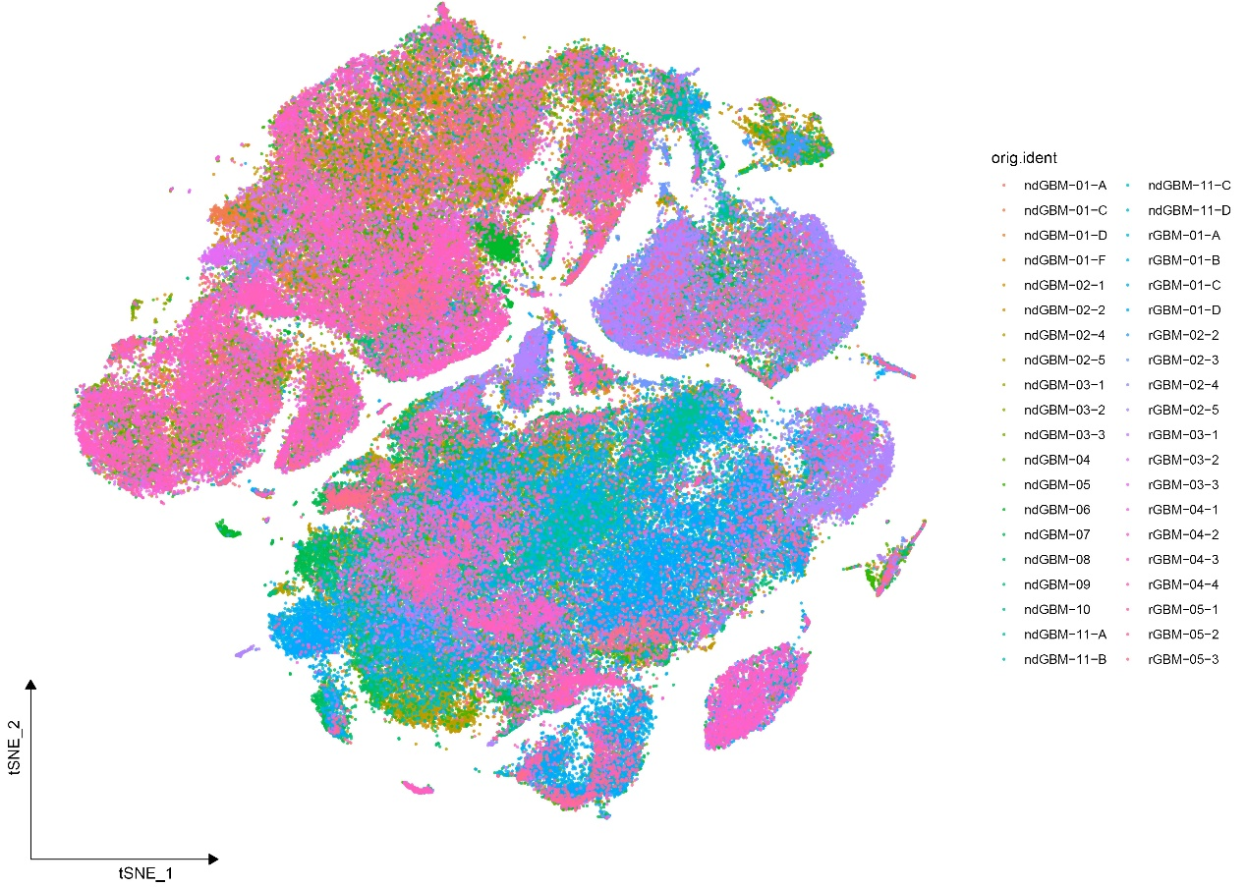
Supplementary Figure 1. t-SNE plot of scRNA-seq data (GSE182109) by sample

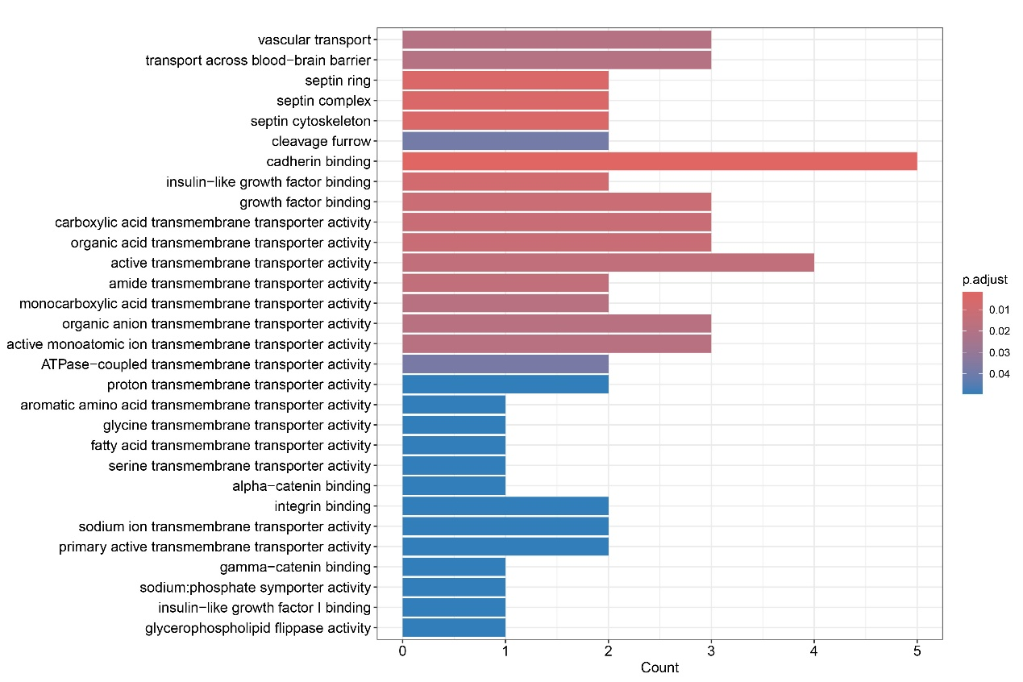
Supplementary Figure 2. GO enrichment analysis of characteristic genes in Endo0.

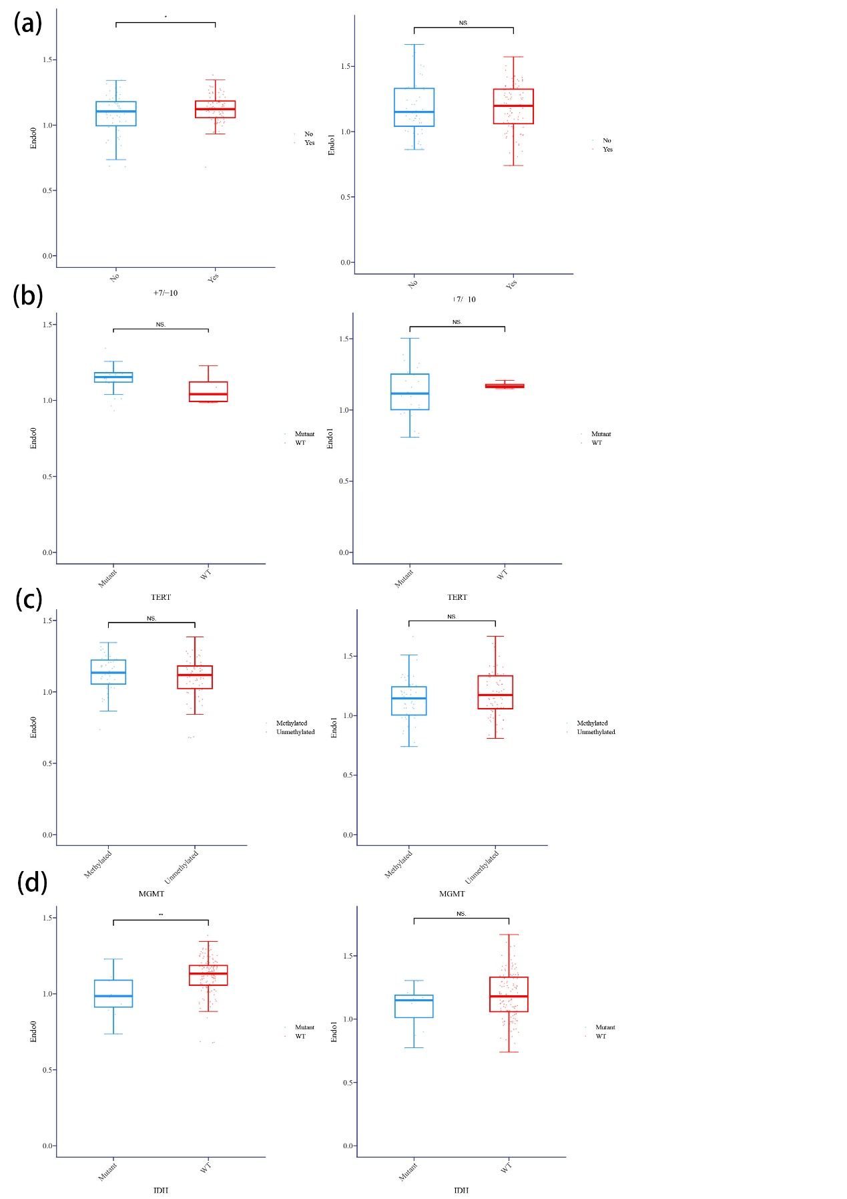
Supplementary Figure 3. Comparison of two endothelial scores across different statuses of (a) +7/10 chromosome copy-number alteration, (b) TERT promoter mutations, (c) MGMT methylation, and (d) IDH mutations in the GBM TCGA cohort. ^{ns}P > .05, *P < .05 and **P < .01.

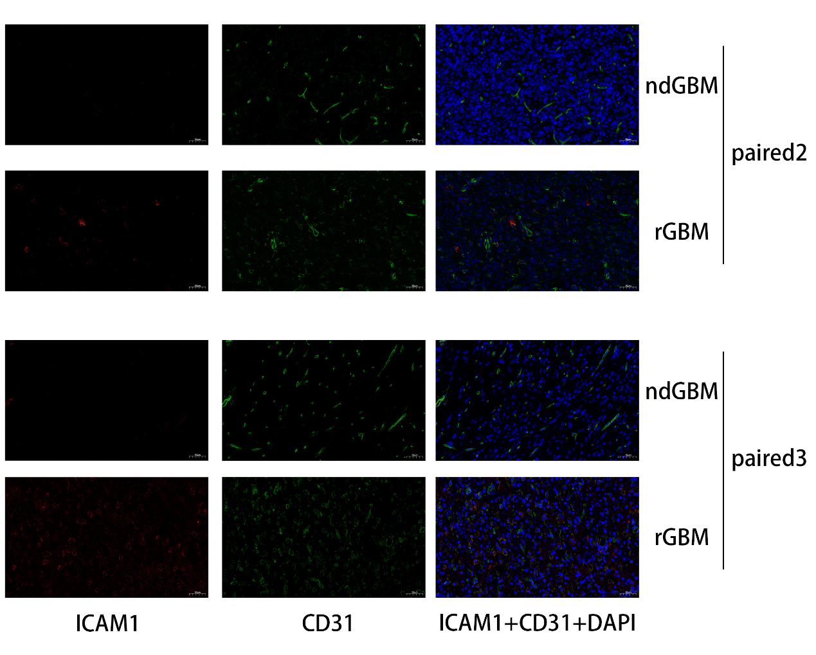
Supplementary Figure 4. The immunofluorescent staining of CD31 (green), ICAM1 (red) and DAPI (blue) in paired ndGBM and rGBM.

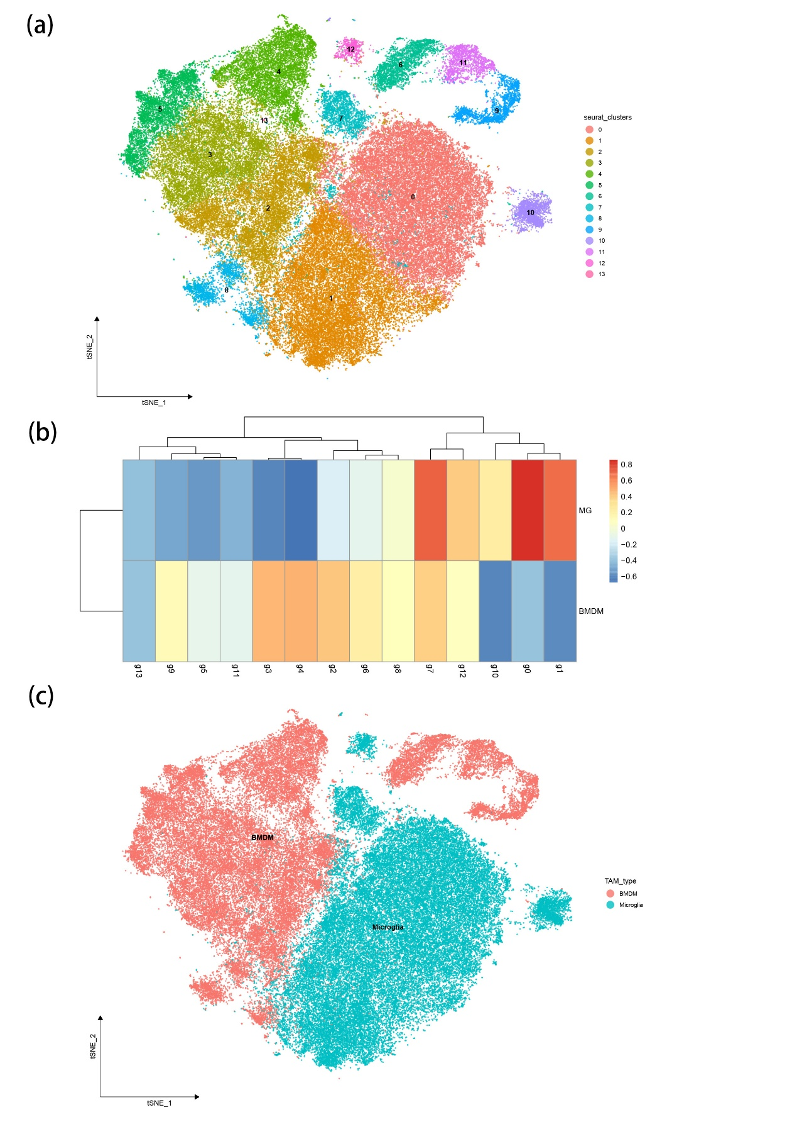
Supplementary Figure 5. Identification of BMDM and microglia. (a) t-SNE plot of TAM by sample. (b) GSVA analysis using myeloid cell to identify BMDM and microglia. (c) t-SNE plot of TAM by TAM types.

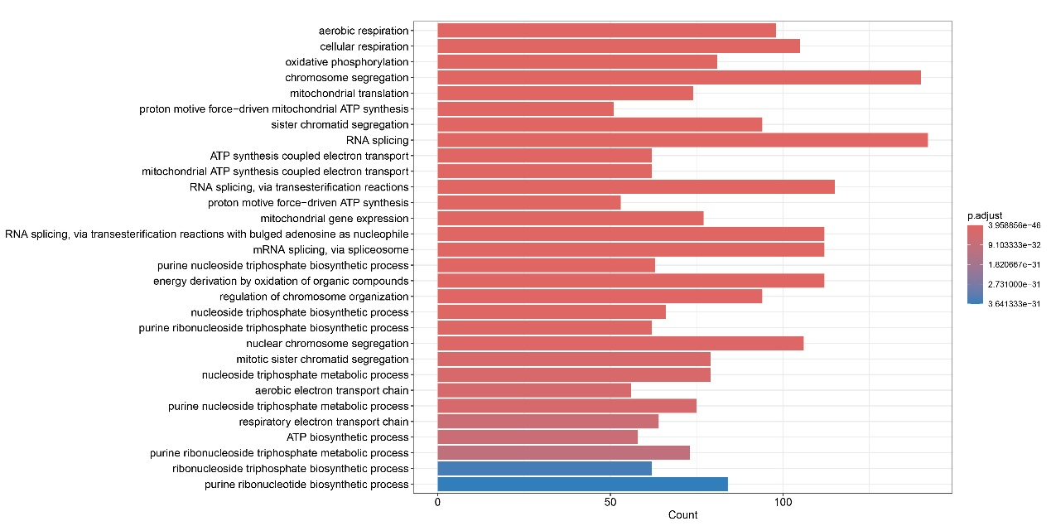
Supplementary Figure 6. GO enrichment analysis of characteristic genes in BMDM2.

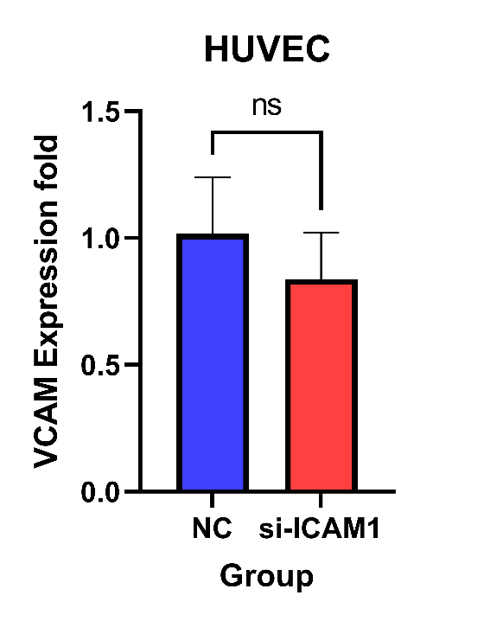
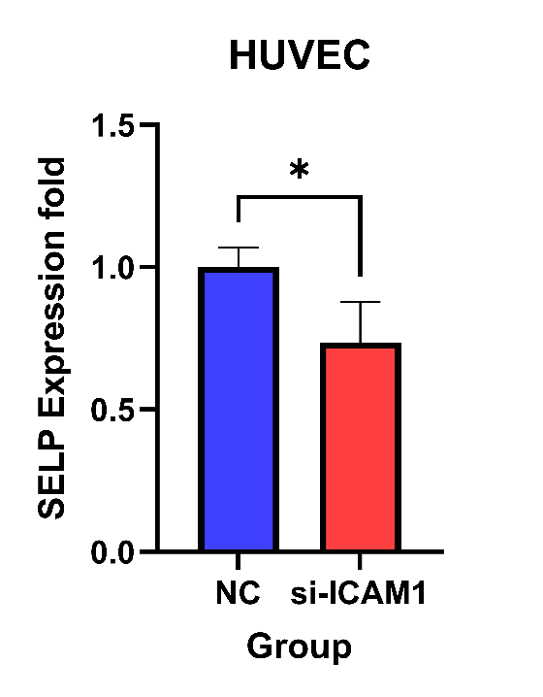
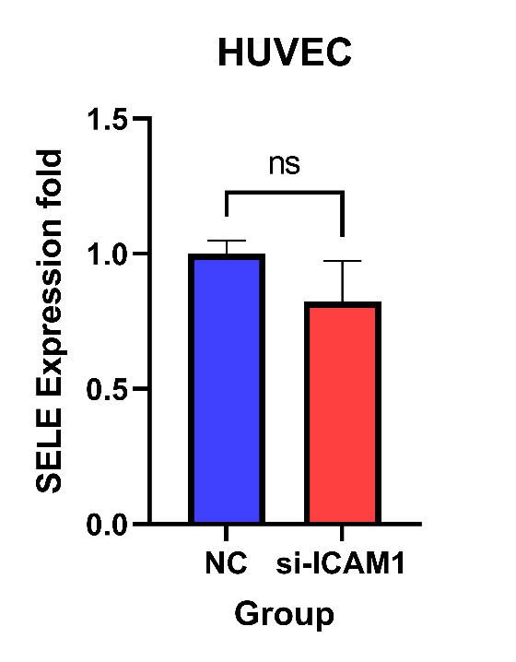
Supplementary Figure 7. mRNA expression levels of SELE, SELP, and VCAM1 measured by qPCR. ^{ns}P > .05 and *P < .05.

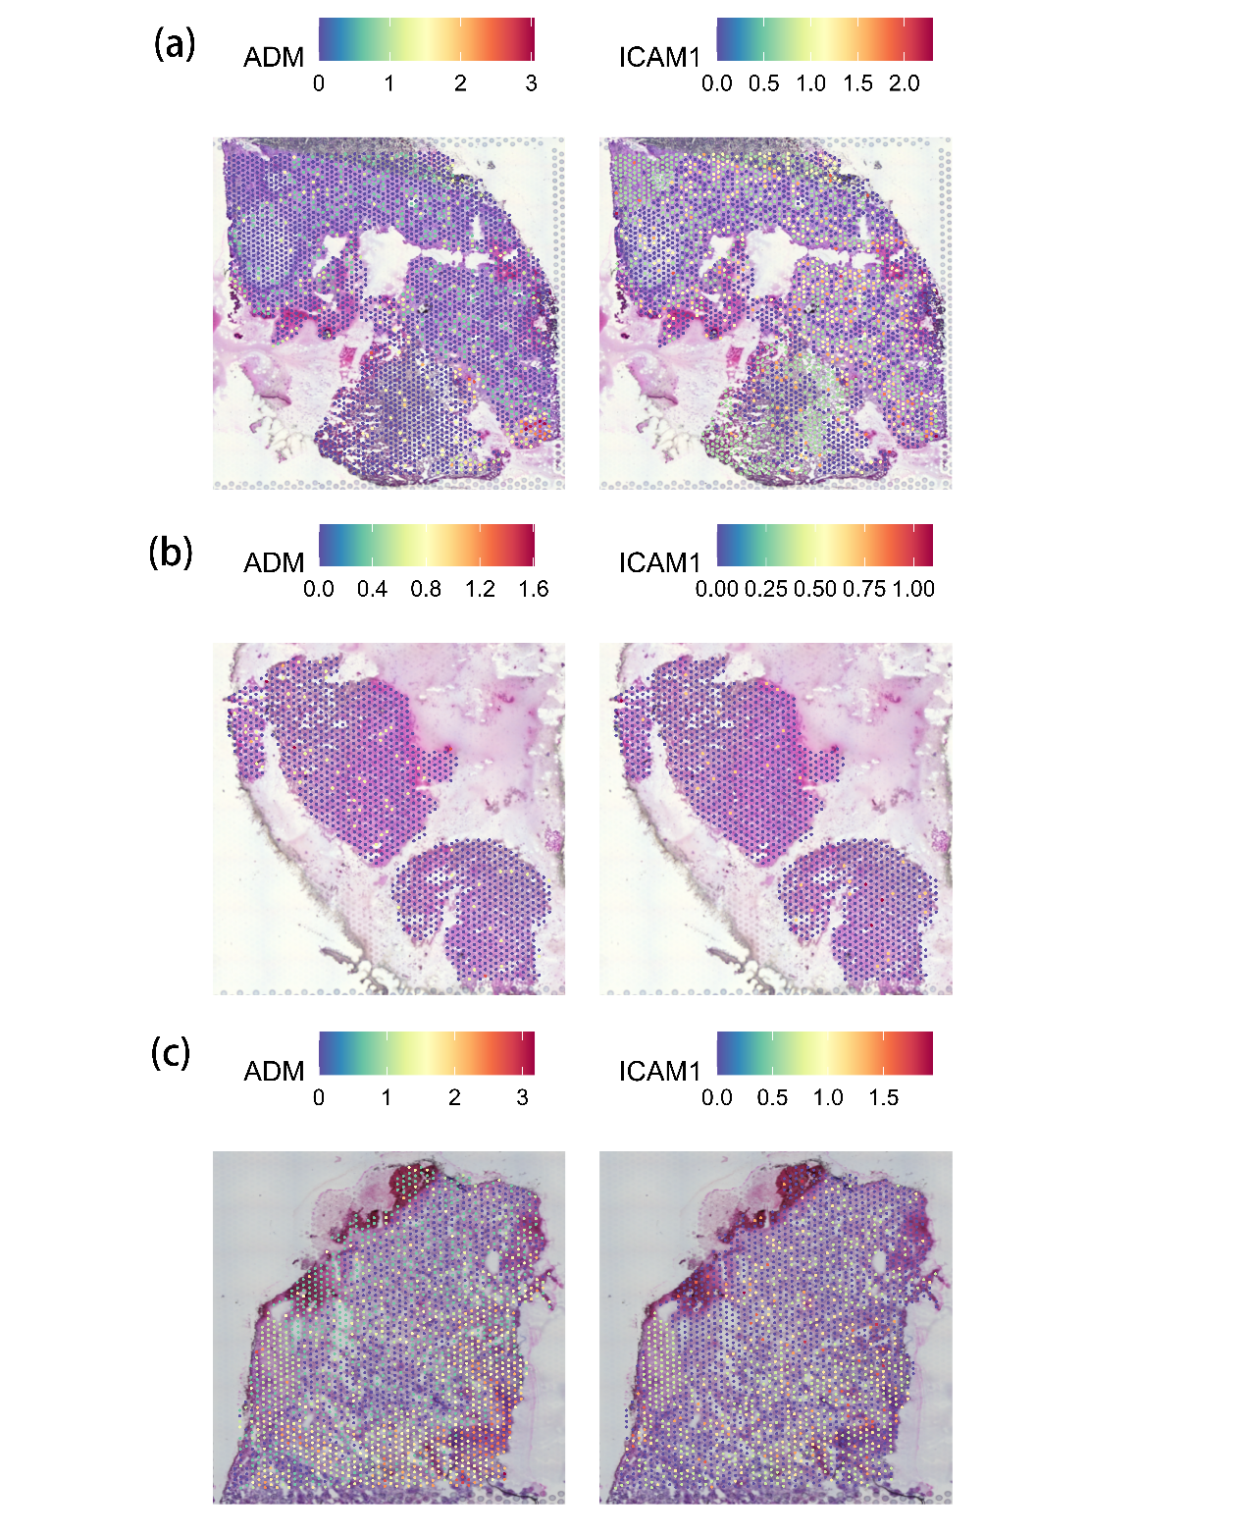
Supplementary Figure 8. Spatial transcriptomic analysis of ADM and ICAM1 expression levels in different tumor regions from the same patient in GSE237183: (a) T1-enhancing region, (b) infiltrative region, and (c) general tumor bulk region.
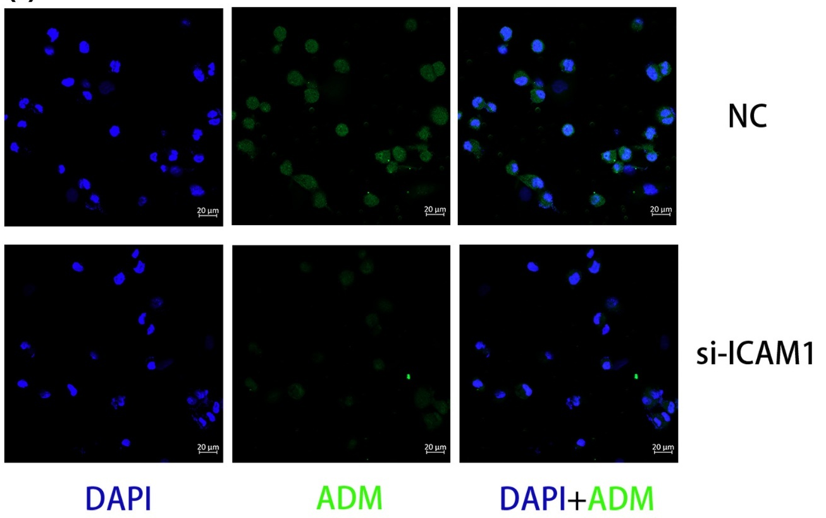
Supplementary Figure 9. Immunofluorescence staining of ADM (green) and nuclei (DAPI, blue) in co-cultured THP-1.

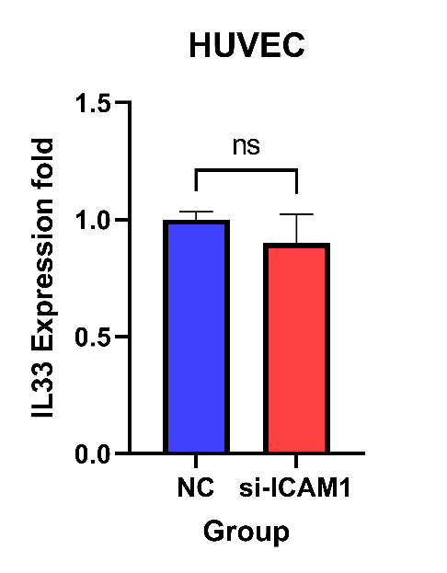
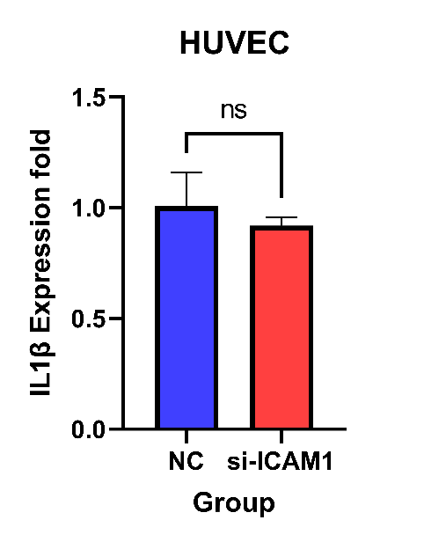
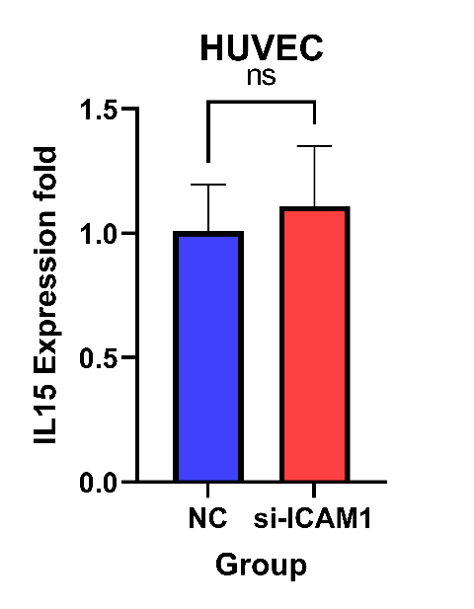
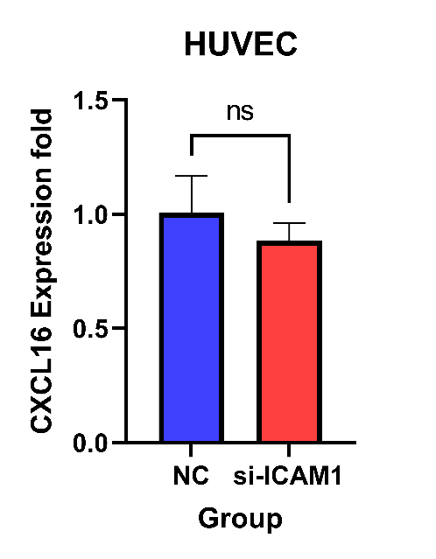
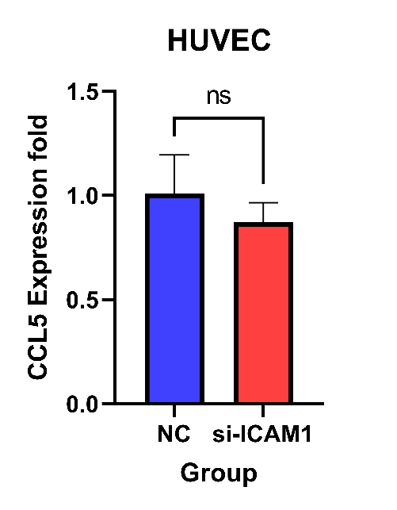
Supplementary Figure 10. mRNA expression levels of cytokines within Endo1 signature genes measured by qPCR. ^{ns}P > .05.

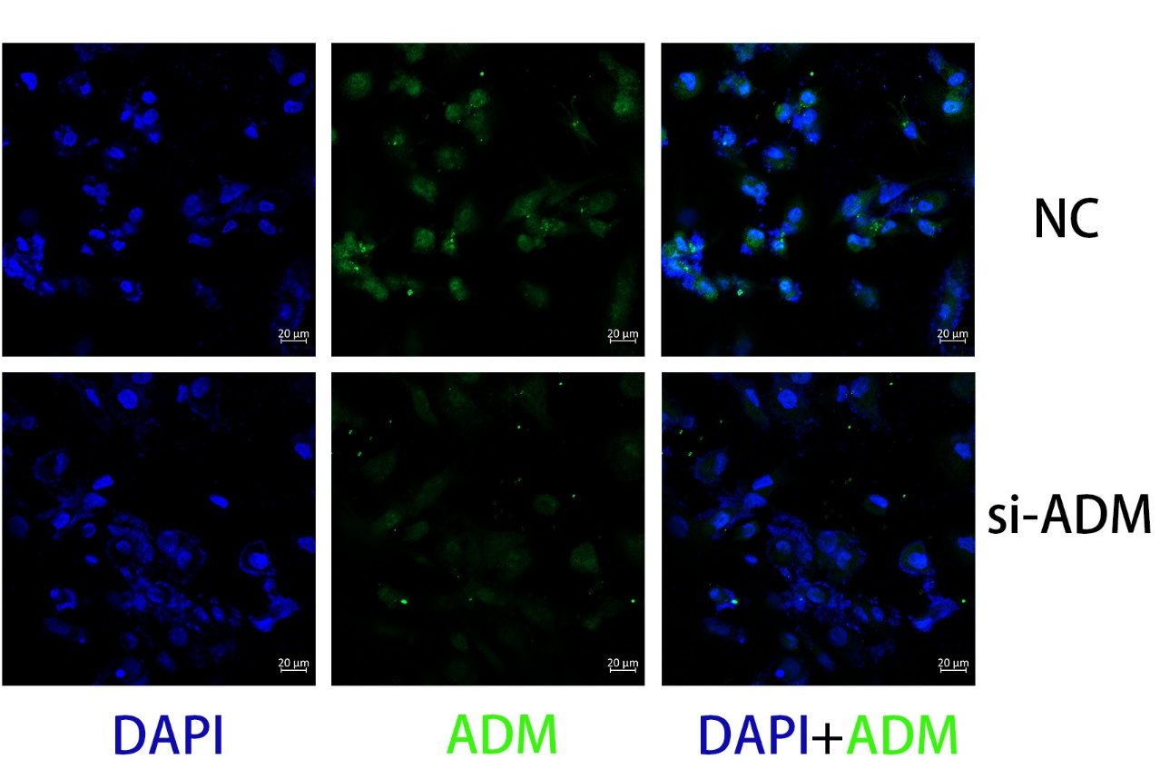
Supplementary Figure 11. Immunofluorescence staining of ADM (green) and nuclei (DAPI, blue) in ADM knockdown THP-1.

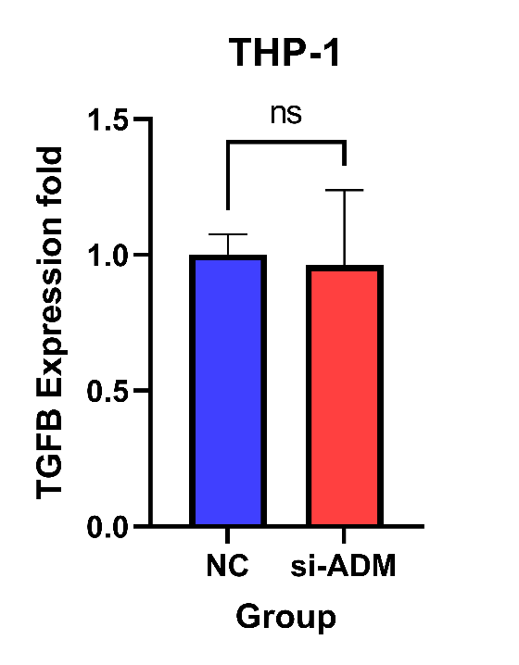
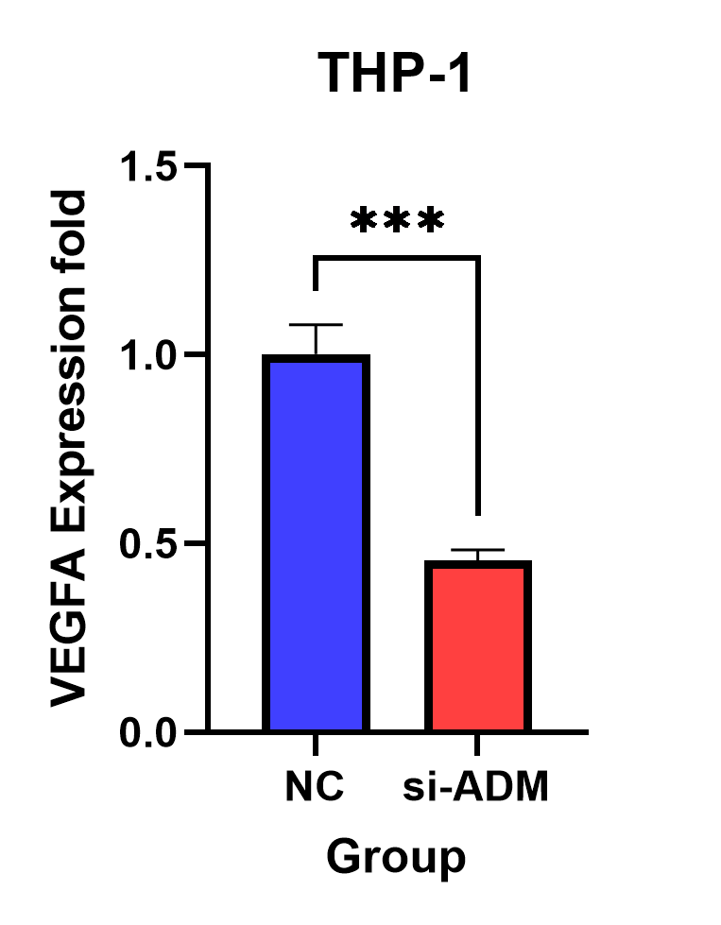
Supplementary Figure 12. mRNA expression levels of VEGFA and TGFB measured by qPCR. ^{ns}P > .05 and ***P < .001.

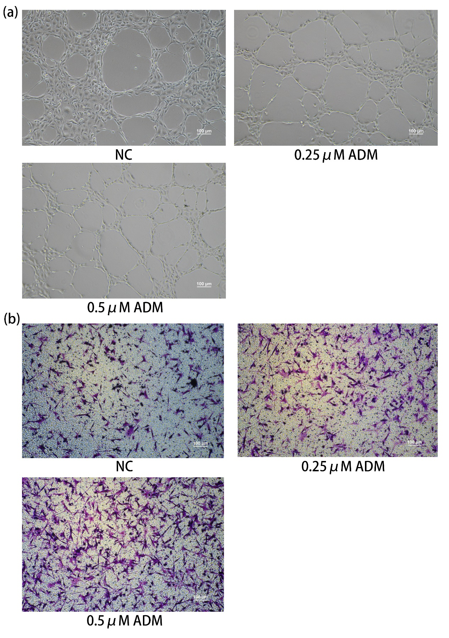
Supplementary Figure 13. Effects of ADM stimulation. (a) Angiogenesis assay of HUVECs cultured with ADM. (b) Transwell migration assay of U87 cells cultured with ADM.

siRNA sequences：
ADM sense | GCCAGAGCAUGAACAACUUTT
ADM antisense | AAGUUGUUCAUGCUCUGGCGG
ICAM1 sense | CAACCAAUGUGCUAUUCAATT
ICAM1 antisense | UUGAAUAGCACAUUGGUUGGC
Primer Sequences:
ADM forward sequence | ATGAAGCTGGTTTCCGTCG
ADM reverse sequence | GACATCCGCAGTTCCCTCTT
ICAM1 forward sequence | ATGCCCAGACATCTGTGTCC
ICAM1 reverse sequence | GGGGTCTCTATGCCCAACAA
GAPDH forward sequence | GGAGCGAGATCCCTCCAAAAT
GAPDH reverse sequence | GGCTGTTGTCATACTTCTCATGG
CCL2 forward sequence | CAGCCAGATGCAATCAATGCC
CCL2 reverse sequence | TGGAATCCTGAACCCACTTCT
IL33 forward sequence | GTGACGGTGTTGATGGTAAGAT
IL33 reverse sequence | AGCTCCACAGAGTGTTCCTTG
IL15 forward sequence | TTGGGAACCATAGATTTGTGCAG
IL15 reverse sequence | GGGTGAACATCACTTTCCGTAT
IL1B forward sequence | ATGATGGCTTATTACAGTGGCAA
IL1B reverse sequence | GTCGGAGATTCGTAGCTGGA
CXCL16 forward sequence | CCCGCCATCGGTTCAGTTC
CXCL16 reverse sequence | CCCCGAGTAAGCATGTCCAC
CCL5 forward sequence | CCAGCAGTCGTCTTTGTCAC
CCL5 reverse sequence | CTCTGGGTTGGCACACACTT
VCAM1 forward sequence | GGGAAGATGGTCGTGATCCTT
VCAM1 reverse sequence | TCTGGGGTGGTCTCGATTTTA
SELP forward sequence | ACTGCCAGAATCGCTACACAG
SELP reverse sequence | CACCCATGTCCATGTCTTATTGT
SELE forward sequence | AGAGTGGAGCCTGGTCTTACA
SELE reverse sequence | CCTTTGCTGACAATAAGCACTGG
Supplementary Table 1. SiRNA and primers sequences used in this study.

ONTOLOGY | GO | EVIDENCE | SYMBOL
BP | GO:0045765 | NAS | KRIT1
BP | GO:0045765 | TAS | CTNNB1
BP | GO:0045765 | IEA | EFNA1
BP | GO:0045765 | ISS | EPHA2
BP | GO:0045765 | IDA | EMP2
BP | GO:0045765 | IMP | EMP2
BP | GO:0045765 | NAS | ERBB2
BP | GO:0045765 | IMP | ETS1
BP | GO:0045765 | TAS | FGF2
BP | GO:0045765 | TAS | HMOX1
BP | GO:0045765 | IC | IL6
BP | GO:0045765 | NAS | KRT1
BP | GO:0045765 | IDA | LEP
BP | GO:0045765 | IMP | NF1
BP | GO:0045765 | IMP | PDE3B
BP | GO:0045765 | IMP | PIK3CG
BP | GO:0045765 | IEA | MAPK7
BP | GO:0045765 | IBA | RNH1
BP | GO:0045765 | IDA | RNH1
BP | GO:0045765 | ISS | SFRP1
BP | GO:0045765 | IMP | SP100
BP | GO:0045765 | IDA | WARS1
BP | GO:0045765 | IEA | RECK
BP | GO:0045765 | IMP | RAPGEF3
BP | GO:0045765 | NAS | GPNMB
BP | GO:0045765 | IDA | HTATIP2
BP | GO:0045765 | NAS | CXCL13
BP | GO:0045765 | NAS | PDCD10
BP | GO:0045765 | IBA | VASH1
BP | GO:0045765 | ISS | PLXND1
BP | GO:0045765 | ISS | TSPAN12
BP | GO:0045765 | ISS | ADGRA2
BP | GO:0045765 | ISS | EGLN1
BP | GO:0045765 | IBA | VASH2
BP | GO:0045765 | NAS | CCM2
BP | GO:0045765 | IEA | PROK1
BP | GO:0045765 | IMP | OR10J5
BP | GO:0045765 | IBA | BMPER
Supplementary Table 2. The gene set of Regulation of Angiogenesis (GO:0045765)

Endo0 | Endo1 | BMDM0 | BMDM1 | BMDM2
ABCG2 | SELP | SLCO2B1 | VCAN | PCLAF
CCN2 | CPXM2 | GPR34 | C15orf48 | STMN1
SEPTIN2 | SELE | SELENOP | FCN1 | CKS1B
SEPTIN7 | ACKR1 | A2M | SLC2A3 | TK1
SLC38A5 | AQP1 | C3 | NDRG1 | MKI67
CA2 | ZNF385D | C1QC | SMIM25 | TYMS
MFSD2A | LAMP3 | TREM2 | S100A12 | NUSAP1
IGFBP3 | S100A9 | CPM | ADM | CENPF
EEF1G | FAM198B | C1QB | IL1R2 | TOP2A
HOPX | NNMT | C1QA | MCEMP1 | BIRC5
PRXL2A | SEPT6 | IL18 | VEGFA | PTTG1
CDH2 | CORO1A | PLTP | HK2 | RPA3
MRTFB | CSF2RB | ADORA3 | AQP9 | CDK1
PALM2-AKAP2 | COL15A1 | AKR1B1 | FLNA | SMC2
SNHG29 | PTPRC | FUCA1 | UPP1 | DTYMK
SLC7A5 | C8orf59 | HLA-DQA1 | EREG | SMC4
CCN1 | S100A4 | EPB41L2 | ANPEP | ZWINT
TLE5 | MTHFD2 | HLA-DMB | SLC25A37 | CENPM
SORT1 | PTAFR | TMEM176B | TREM1 | PCNA
SPINK8 | HCST | VSIG4 | FOSL2 | PRC1
ITPRID2 | LYZ | MERTK | RGCC | MAD2L1
DIPK2B | IL33 | DNASE2 |  | CENPK
ITIH5 | S100A8 | AXL |  | TMEM106C
COBLL1 | CYR61 | GAA |  | CEP55
RBP1 | LITAF | SERPINF1 |  | LMNB1
RO60 | TMEM273 | PDK4 |  | CLSPN
MAGI2-AS3 | HLA-DMA | MS4A6A |  | CDKN3
MICOS10 | SEPT2 | CADM1 |  | DUT
BTNL9 | FAM129B | FRMD4A |  | CENPW
UBE2V1 | CD69 | CD302 |  | SKA2
MT1E | CD74 | MS4A4A |  | SNRNP25
TOMM6 | FAM167B | SLC1A3 |  | ASPM
SLC2A1 | LCP1 | FCHO2 |  | TPX2
RNASEK | PLXDC2 | SLC40A1 |  | UBE2C
ATP6V0C | POLR2J3.1 | MS4A7 |  | GGH
CIAO2B | MMP1 |  |  | RAD51AP1
SNHG5 | PABPC1 |  |  | RRM2
SNHG6 | MLXIP |  |  | LSM5
SNHG14 | SELL |  |  | CENPX
TRAPPC5 | DUSP2 |  |  | CENPU
MICOS13 | P2RY6 |  |  | DNMT1
MMP28 | SLC6A6 |  |  | HMGB3
SGPP2 | IL7R |  |  | TMPO
NIBAN2 | C19orf70 |  |  | DNAJC9
TUG1 | PTP4A1 |  |  | PARP1
SAMD12 | FRMD4A |  |  | HELLS
AL627171.2 | FBLN2 |  |  | GTSE1
PLLP | SMIM37 |  |  | RANBP1
LINC00472 | ABCC4 |  |  | ATAD2
MYEF2 | MAN1A1 |  |  | KPNA2
UNC5B | ALOX5AP |  |  | CKS2
LRATD1 | MUC20-OT1 |  |  | CARHSP1
DENND11 | CD44 |  |  | IDH2
SELENOP | RAC2 |  |  | MCM7
OIP5-AS1 | SLA |  |  | CBX5
DANCR | PQLC1 |  |  | PHF19
APCDD1 | ICAM1 |  |  | ITGB3BP
PLAAT3 | C15orf48 |  |  | SHCBP1
NID2 | GYPC |  |  | ANP32E
RESF1 | CD53 |  |  | HMMR
KIF5C | SAMSN1 |  |  | GMNN
TPD52 | LGALS9 |  |  | DHFR
LINC01578 | SPI1 |  |  | NASP
SORBS1 | NR4A2 |  |  | RRM1
GAS5 | TINAGL1 |  |  | LSM4
TMEM35B | CXorf36 |  |  | HIST1H4C
RBIS | SEPT7 |  |  | NUDT1
MATN3 | CMTM7 |  |  | CKAP2
ELOVL7 | MINOS1 |  |  | UQCC2
CGNL1 | IGHG1 |  |  | KIF11
 | FYB1 |  |  | KIF20B
 | HLA-DRA |  |  | SMC1A
 | COTL1 |  |  | FAM111A
 | OLFM1 |  |  | RBBP7
 | SLC11A1 |  |  | BRCA2
 | AES |  |  | TACC3
 | C19orf24 |  |  | MCM5
 | POSTN |  |  | NUF2
 | PRCP |  |  | CCNA2
 | CD37 |  |  | H2AFX
 | C9orf3 |  |  | USP1
 | MALL |  |  | MZT2A
 | HLA-DMB |  |  | PSIP1
 | HLA-DPB1 |  |  | KNL1
 | NEURL1B |  |  | LSM2
 | PPIF |  |  | CCDC167
 | ITGB2 |  |  | GGCT
 | C6orf48 |  |  | H2AFV
 | SSSCA1 |  |  | NME1
 | NUAK1 |  |  | SNRPD1
 | SEPT10 |  |  | MCM3
 | ARL4C |  |  | ANLN
 | CLEC7A |  |  | MCM4
 | PLEK |  |  | CCNB2
 | FCER1G |  |  | UHRF1
 | TYMP |  |  | FEN1
 | ABCF2.1 |  |  | SGO2
 | MKL2 |  |  | BRCA1
 | ITGAX |  |  | BUB3
 | FCGR1A |  |  | ATAD5
 | CD52 |  |  | TUBA1C
 | DOC2B |  |  | CCDC34
 | CD163 |  |  | SMC3
 | IGLC2 |  |  | TUBB
 | CTGF |  |  | CENPE
 | NR2F2 |  |  | TOMM5
 | LST1 |  |  | HNRNPAB
 | C3orf58 |  |  | TFDP1
 | FPR1 |  |  | TMEM160
 | SEPT11 |  |  | PSMC3
 | LHX6 |  |  | KIF22
 | SLC1A5 |  |  | HMGB2
 | FKBP2 |  |  | H2AFZ
 | TNFRSF1A |  |  | DDX39A
 | EHBP1L1 |  |  | PSME2
 | KIAA1551 |  |  | ZDHHC12
 | CD84 |  |  | SIVA1
 | LTC4S |  |  | BRI3BP
 | LYVE1 |  |  | BARD1
 | B3GNT5 |  |  | HIST1H1D
 | CD14 |  |  | AURKB
 | ZFP36L2 |  |  | TUBB4B
 | MCUB |  |  | NCAPG
 | BCL3 |  |  | BOLA3
 | BCL2A1 |  |  | ORC6
 | DOK5 |  |  | FAM111B
 | TSPO |  |  | SNRPF
 | RGS10 |  |  | CDC20
 | NCBP2-AS2 |  |  | MCM6
 | SEPT9 |  |  | HIST1H1E
 | CNKSR3 |  |  | DLGAP5
 | C1orf162 |  |  | ASF1B
 | LGI2 |  |  | TPRKB
 | RAMP3 |  |  | CENPN
 | SNHG15 |  |  | NUCKS1
 | PVT1 |  |  | LDHB
 | FAM208A |  |  | ESCO2
 | CCDC69 |  |  | MRPL51
 | FOSB |  |  | PRIM1
 | HLA-DQB1 |  |  | POLE3
 | MAST3 |  |  | TCF19
 | PARVG |  |  | FDPS
 | SBNO2 |  |  | CDKN2C
 | AIF1 |  |  | SGO1
 | UCP2 |  |  | DCTPP1
 | SERPINA1 |  |  | HSPB11
 | FCGR2A |  |  | CCNB1
 | PDLIM1 |  |  | SNRPB
 | ZDHHC13 |  |  | SSRP1
 | PLEKHO1 |  |  | PA2G4
 | MCTP1 |  |  | TMEM109
 | HLA-DRB1 |  |  | UBE2T
 | CYBB |  |  | NSD2
 | HCLS1 |  |  | NME4
 | IER3 |  |  | CMSS1
 | AREG |  |  | HAUS1
 | GPR183 |  |  | COMMD4
 | HLA-DPA1 |  |  | VDAC3
 | HAVCR2 |  |  | NCAPD2
 | PCDH17 |  |  | CDK4
 | CXCR4 |  |  | PRKDC
 | PMP22 |  |  | SAE1
 | G0S2 |  |  | EZH2
 | CTSS |  |  | DIAPH3
 | NCF1 |  |  | RAD21
 | APBB1IP |  |  | C19orf48
 | CD68 |  |  | PPM1G
 | EHD3 |  |  | MND1
 | PCAT1 |  |  | GINS2
 | BIRC3 |  |  | SNRPG
 | RPL22L1 |  |  | FANCI
 | CSF1R |  |  | CENPH
 | PTK2B |  |  | KIFC1
 | CPVL |  |  | NUCB2
 | STXBP2 |  |  | MRPL17
 | PRR5 |  |  | HINT2
 | CAPG |  |  | HIRIP3
 | DUSP23 |  |  | ANAPC11
 | MAP7D3 |  |  | NCAPG2
 | PABPC4 |  |  | HACD3
 | HSPA1B |  |  | MYBL2
 | FAP |  |  | RFC3
 | EVA1C |  |  | SPC25
 | IL15 |  |  | HADH
 | CCL2 |  |  | RACGAP1
 | CMIP |  |  | PAICS
 | SEMA4A |  |  | DCK
 | HIF1A |  |  | PPIH
 | ENO1 |  |  | HIST1H1B
 | MYC |  |  | CDT1
 | LMNA |  |  | IMPDH2
 | C19orf66 |  |  | CHEK1
 | OLR1 |  |  | FOXM1
 | C5AR1 |  |  | RAN
 | SLC38A2 |  |  | ARHGAP11A
 | FAM208B |  |  | NDC80
 | FAM171A1 |  |  | EBP
 | SLC29A1 |  |  | MELK
 | FAM84B |  |  | RPL39L
 | TLL1 |  |  | ANP32B
 | TNFRSF10B |  |  | SUZ12
 | KLHL6 |  |  | NCAPH
 | ADAMTS9 |  |  | HIST1H1C
 | COL6A2 |  |  | PRR11
 | SLCO2A1 |  |  | UBE2S
 | ERAP2 |  |  | SLBP
 | TRABD |  |  | LIG1
 | SEPT8 |  |  | HAT1
 | LYAR |  |  | BUB1
 | LIMD2 |  |  | MZT2B
 | SDF2L1 |  |  | EXOSC8
 | BZW2 |  |  | AURKA
 | THBD |  |  | TOPBP1
 | ASNA1 |  |  | NAP1L4
 | BNC2 |  |  | GLRX5
 | RASA4 |  |  | PGP
 | BAZ1A |  |  | CDCA5
 | COL4A3BP |  |  | TPGS2
 | RAB31 |  |  | SUPT16H
 | TKT |  |  | MAGOHB
 | NUPL2 |  |  | BUB1B
 | UPP1 |  |  | SAC3D1
 | NFKB1 |  |  | NCAPD3
 | APOPT1 |  |  | MZT1
 | ZNF331 |  |  | DEK
 | EFHD2 |  |  | YEATS4
 | ITGB4 |  |  | ACTL6A
 | RUNX1 |  |  | VRK1
 | MS4A6A |  |  | CSE1L
 | ACTN1 |  |  | KIF4A
 | SH3TC1 |  |  | PAFAH1B3
 | SLC39A14 |  |  | KIF14
 | THBS1 |  |  | CKAP2L
 | MAFB |  |  | COQ2
 | NOP16 |  |  | FADS1
 | AAED1 |  |  | WDR76
 | TRIM28 |  |  | RFC4
 | NFKBIZ |  |  | CDCA8
 | CTSL |  |  | DBF4
 | C6orf106 |  |  | WDR34
 | HLA-DQA1 |  |  | SNRPA1
 | CD83 |  |  | DEPDC1
 | GNB4 |  |  | CDCA3
 | ACSL1 |  |  | TUBA1B
 | FAM173A |  |  | HPF1
 | NPC2 |  |  | HMGN2
 | CRELD2 |  |  | HIST2H2AC
 | ARRB2 |  |  | RPA1
 | CCL4 |  |  | SPDL1
 | MAT2A |  |  | POLD2
 | ISOC2 |  |  | TUBG1
 | NRGN |  |  | KIF23
 | LRRC75A |  |  | CENPA
 | GPRIN3 |  |  | TROAP
 | MYO5A |  |  | RPA2
 | ARHGAP23 |  |  | CCDC14
 | RGS1 |  |  | SVIP
 | IMPDH2 |  |  | WEE1
 | PIP4K2A |  |  | LMNB2
 | FJX1 |  |  | MYCBP
 | CPLX1 |  |  | CIP2A
 | TYROBP |  |  | CKAP5
 | CLUH |  |  | MCM2
 | FKBP11 |  |  | PXMP2
 | ATP11C |  |  | PARPBP
 | SORL1 |  |  | POLR3K
 | ADAM15 |  |  | SNRNP40
 | TCOF1 |  |  | POP7
 | RRP12 |  |  | RFC2
 | BTN3A2 |  |  | CEP78
 | FAM110D |  |  | NPM3
 | STK17B |  |  | MAD2L2
 | LPCAT2 |  |  | FBXO5
 | FAM241A |  |  | TTF2
 | PYCARD |  |  | BCL2L12
 | NT5E |  |  | NUP210
 | RCN1 |  |  | RANGAP1
 | SLC25A37 |  |  | HERC5
 | FBN1 |  |  | CHAF1A
 | DUSP4 |  |  | CCDC18
 | C1orf21 |  |  | MRPL37
 | ARID5B |  |  | EEF1E1
 | IL1B |  |  | PLGRKT
 | DOCK8 |  |  | ECT2
 | TGFBR3 |  |  | DSN1
 | PLXNB2 |  |  | MPHOSPH9
 | SFMBT2 |  |  | LRR1
 | APLNR |  |  | POLD3
 | CSK |  |  | EMC9
 | MANF |  |  | ACAT2
 | POLD2 |  |  | ALYREF
 | RELB |  |  | ZWILCH
 | EPHB4 |  |  | RBBP8
 | ANXA6 |  |  | ICMT
 | PUS1 |  |  | PRADC1
 | KDM6B |  |  | NETO2
 | TRAF3 |  |  | MTHFD1
 | CELF2 |  |  | EXOSC9
 | JAK3 |  |  | CDKN2A
 | CITED2 |  |  | POLD1
 | IGFBP4 |  |  | MIS18A
 | TSPAN18 |  |  | RAD51C
 | BOP1 |  |  | CDCA7L
 | NDRG1 |  |  | PRPS2
 | TNFAIP3 |  |  | RBL1
 | FAM45A |  |  | GMPS
 | GLIPR1 |  |  | ALDH7A1
 | IQCA1 |  |  | RUVBL2
 | METRNL |  |  | CDC25B
 | METTL1 |  |  | CASP8AP2
 | CASP1 |  |  | CDK5RAP2
 | VARS |  |  | CRIP1
 | SPNS2
 | PAICS
 | MS4A7
 | SLC16A3
 | DNAAF5
 | GPATCH4
 | CXCL16
 | FNDC4
 | RIOX2
 | SEMA6B
 | NFATC1
 | EXOSC5
 | SERPINE2
 | ABI3
 | ATP2B1-AS1
 | CHTF8
 | NPM3
 | KAZN
 | BCAR1
 | RRS1
 | MYBBP1A
 | REL
 | TNFAIP2
 | GPSM3
 | ADAMTS4
 | NFKB2
 | PRKAR1B
 | KIAA1211L
 | RASAL3
 | CKS2
 | EHD1
 | NINJ1
 | NLN
 | NT5C
 | SF3B4
 | PHLDA3
 | LCP2
 | AEN
 | NIP7
 | ENTR1
 | MTHFD1L
 | RCAN1
 | SNHG12
 | TRIB1
 | SHKBP1
 | ZNF267
 | TUBB6
 | TOP1MT
 | FAM96A
 | OTUD1
 | MNT
 | EMP3
 | DPAGT1
 | EGR3
 | MRC1
 | CEBPB
 | SRGAP1
 | RNASET2
 | STAT5A
 | ZMAT3
 | MLST8
 | WDR12
 | PRKCE
 | RPP40
 | ALDH16A1
 | RIN3
 | RBM14
 | UBE2E2
 | PPRC1
 | FARSA
 | TMEM250
 | MYD88
 | CCL5
 | DNPH1
 | ATP6V1B2
 | CLSTN3
 | SAMD4A
 | EFEMP1
 | PFKFB3
 | MED16
 | MICAL2
 | CDC25B
 | CCNG2
 | APOC1
 | ATF3
 | PLEKHO2
 | CCL3
 | LAPTM5
Supplementary Table 3. The signature genes of the subclusters

MG_Markers | BMDM_Markers
CCL4 | HLA-DQA1
ADRB2 | MS4A6A
NAV3 | TGFBI
ADORA3 | HLA-DRB5
SIGLEC8 | CD74
SPRY1 | DSE
TAL1 | CD93
RHOB | FOSL2
BIN1 | PLTP
SALL1 | THBD
KLF2 | IFITM2
BHLHE41 | METRNL
SLC1A3 | IQGAP1
P2RY12 | PDE4B
 | FPR3
 | BHLHE40
 | TNFSF13
 | HLA-DMB
 | KYNU
 | ITGA4
 | CREM
 | GPR65
 | FGR
 | MXD1
 | IL1RN
 | FAM49A
 | SH3BGRL
 | EMB
 | S100A11
 | LYZ
 | PTPN7
 | SAMHD1
 | SPINT2
 | NFIL3
 | TMEM123
 | CIB1
 | CIITA
 | TREM1
 | VOPP1
 | IL10
 | PLAC8
 | DOK3
 | CYBB
 | CYTH1
 | GPR132
 | SYNGR2
 | PLBD1
 | PIM1
 | FXYD5
 | ARG2
 | PQLC3
 | MS4A7
Supplementary Table 4. The gene set used to identify BMDM and microglia

