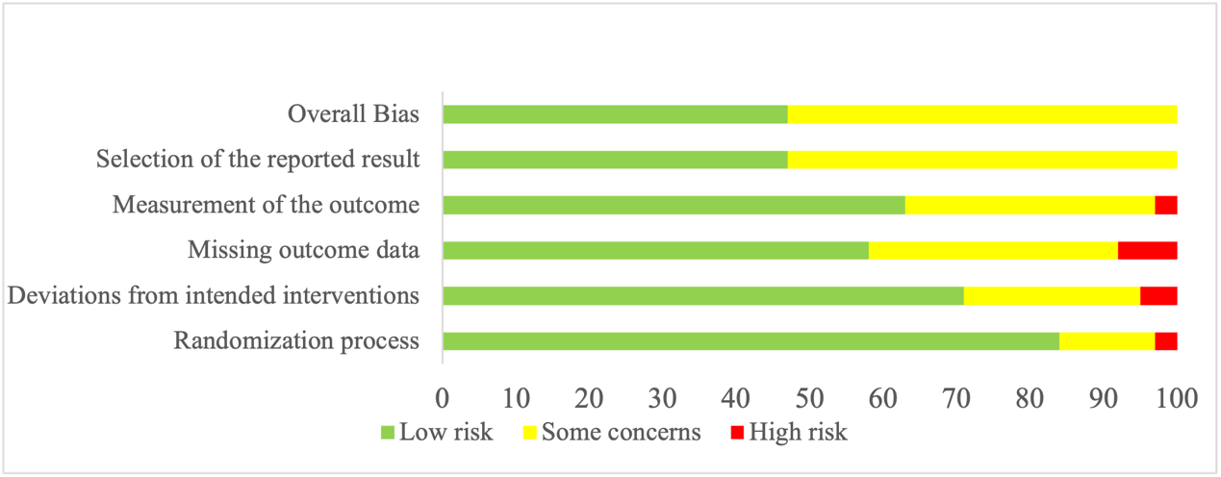
Supplementary Figure 1 Quality assessment of 38 RCTs, low risk of bias (green), some concerns (yellow), high risk (red).

 | D1 | D2 | D3 | D4 | D5 | Overall
Goruntla et al (2019) ³³
Kleinman et al (2017) ³⁴
Kandasamy et al (2019) ³⁵
Johncy et al (2020) ³⁶
Simon et al (2021) ³⁷
Nelson et al（2016）³⁸
Nelson et al（2021）³⁹
Ramachandran et al (2021) ⁴⁰
Burner et al (2025) ⁴¹
Sarayani et al (2018) ⁴²
Ranjbaran et al (2022) ¹¹
Elyasi et al (2024) ⁴³
Abbas et al (2023) ⁴⁴
Abubakar & Atif (2021) ⁴⁵
Ting et al (2021) ⁴⁶
Butt et al (2016) ⁴⁷
Trevisan et al (2020) ⁴⁸
Cani et al (2015) ⁴⁹
Vluggen et al (2021) ⁵⁰
Du Pon et al (2019) ⁵¹
Wungrath et al (2021) ⁵²
Poonprapaiet al (2022) ⁵³
Xin et al (2015) ⁵⁴
Zhou et al (2022) ⁵⁵
Huang et al (2019) ⁵⁶
Tan et al (2023) ⁵⁷
Alfian et al (2021) ⁵⁸
Caetano et al (2018) ⁵⁹
Abaza & Marschollek (2017) ⁶⁰
Doupis et al (2019) ⁵⁶
Gautier et al (2021) ⁶¹
Korcegez et al（2017）⁶²
Sugita et al (2017) ⁶³
Erku et al（2017）⁶⁴
Wishah et al (2015) ⁶⁵
Caballero et al (2025) ¹³
Chang et al (2025) ¹²
El-Deyarb et al (2024) ⁶⁶

Supplementary Figure 2 Risk of bias summary of 38 RCTs, Low risk of bias (green), some concerns (yellow), high risk (red). D1-Randomization process, D2-Deviations from the intended interventions, D3-Missing outcome data, D4-Measurement of the outcome, D5--Selection of the reported result

