Supplementary Information
To determine a suitable concentration range for E-CNDs treatment, MDA-MB-231 cells were incubated overnight with 0.1, 0.5, 0.8, 1.6, and 3.2 mg/mL E-CNDs after stepwise serum reduction (5%, 2%, and 1% FBS, each for 2 hours).
At 1.6 and 3.2 mg/mL, more cells were found floating in the media, while no detachment was seen at lower concentrations (Figure S1A). This suggested that higher doses might affect how well cells stay attached.
Trypan blue staining showed that over 65% of those floating cells at the higher concentrations were non-viable (Figure S1B). Because of this, 1.6 and 3.2 mg/mL were not used in the later experiments to avoid possible issues from cell loss or stress.

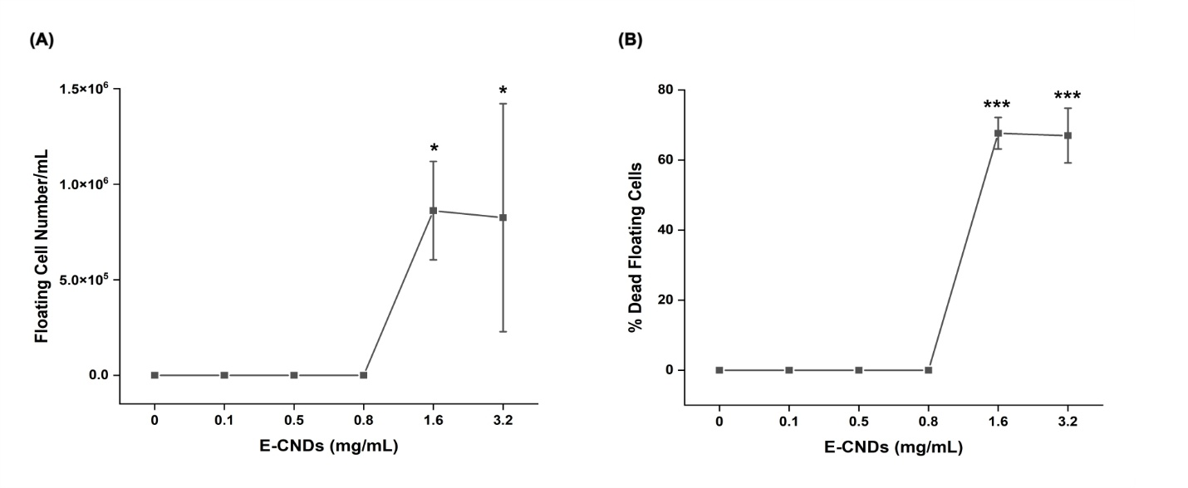
Figure S1. Higher E-CNDs concentrations caused significant cell detachment and death.
(A) Floating cell counts per mL increased significantly at 1.6 and 3.2 mg/mL (p = 0.0177 and p = 0.0236, respectively), while no detached cells were observed at lower concentrations. (B) The percentage of dead cells among floating populations is shown for all groups. Values at 0, 0.1, 0.5, and 0.8 mg/mL are reported as zero, as no floating cells were observed in these groups (A). At 1.6 and 3.2 mg/mL, dead cell percentages were calculated based on the detached cell population. Data are presented as mean ± SD from at least three independent experiments. Asterisks indicate statistical significance (*p < 0.05, ***p < 0.001).

To further support the qualitative imaging observations, additional colocalization metrics were evaluated using Fiji (ImageJ). Pearson’s correlation coefficients were calculated following Otsu thresholding to assess the linear intensity relationship between E-CNDs (cyan) and mitochondrial (red) signals. The mean Pearson’s coefficient was 0.26 ± 0.10, indicating a weak to moderate intensity correlation across analyzed cells. In addition, the spatial extent of overlap was quantified by measuring the physical area where the two fluorophores co-occurred. The average overlapping area was 18.03 ± 7.96 µm², reflecting localized physical association between E-CNDs and mitochondria. These data complement the Mander’s coefficient analysis, supporting a pattern of partial colocalization rather than full mitochondrial targeting.
Figure S2 presents a larger field of view from the confocal image shown in the main text, capturing additional MDA-MB-231 cells stained with MitoTracker™ Red. These images further support the consistent distribution pattern of E-CNDs across the same imaging set.

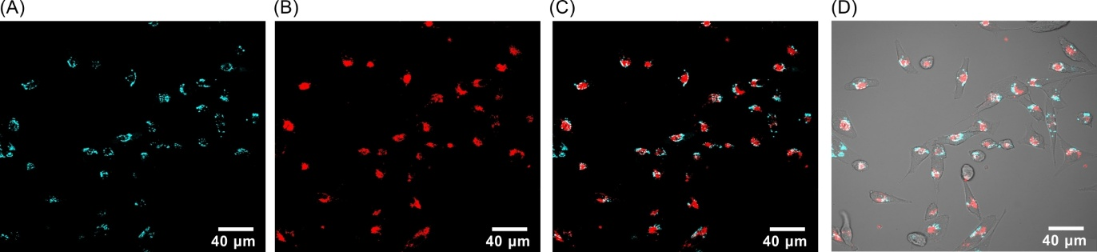

Figure S2. Additional examples of E-CNDs localization relative to mitochondria in MDA-MB-231 cells. (A) Fluorescence signal of E-CNDs (cyan). (B) Mitochondria labeled with MitoTracker™ Red. (C) Merged image of E-CNDs and mitochondria. (D) Overlay of fluorescence channels with the bright-field image for structural context. Scale bars = 40 µm.

