Supplementary materials
Title: A Novel NPR48-Based Model for Early Prediction of Severe Acute Pancreatitis: Development and Multicenter Validation in Comparison with Traditional Clinical Scores

Table S1: Missing data of variables.
Variables | Available quantity | Missing quantity | Missing value percentage
Age | 343 | 0 | 0
Gender | 343 | 0 | 0
BMI | 266 | 77 | 22.4
Hypertension | 343 | 0 | 0
Diabetes | 343 | 0 | 0
Fatty liver | 343 | 0 | 0
Hyperlipidemia | 343 | 0 | 0
Alcohol | 343 | 0 | 0
Smoking | 343 | 0 | 0
WBC | 343 | 0 | 0
RBC | 343 | 0 | 0
Hb | 343 | 0 | 0
HCT | 343 | 0 | 0
Neut0 | 343 | 0 | 0
Neut48 | 343 | 0 | 0
Ly0 | 343 | 0 | 0
Ly48 | 343 | 0 | 0
Mon0 | 343 | 0 | 0
Mon48 | 343 | 0 | 0
PLT0 | 343 | 0 | 0
PLT48 | 343 | 0 | 0
SII0 | 343 | 0 | 0
SII48 | 343 | 0 | 0
SII48/SII0 | 343 | 0 | 0
NLR0 | 343 | 0 | 0
NLR48 | 343 | 0 | 0
NLR48/NLR0 | 343 | 0 | 0
PLR0 | 343 | 0 | 0
PLR48 | 343 | 0 | 0
PLR48/PLR0 | 343 | 0 | 0
LMR0 | 343 | 0 | 0
LMR48 | 343 | 0 | 0
LMR48/LMR0 | 343 | 0 | 0
NPR0 | 343 | 0 | 0
NPR48 | 343 | 0 | 0
NPR48/NPR0 | 343 | 0 | 0
SIRI0 | 343 | 0 | 0
SIRI48 | 343 | 0 | 0
SIRI48/SIRI0 | 343 | 0 | 0
TBil | 343 | 0 | 0
ALB | 343 | 0 | 0
ALT | 340 | 3 | 0.9
AST | 342 | 1 | 0.3
ALP | 336 | 7 | 2
Glu | 309 | 34 | 9.9
BUN | 342 | 1 | 0.3
SCr | 342 | 1 | 0.3
K⁺ | 342 | 1 | 0.3
Na⁺ | 342 | 1 | 0.3
Cl⁻ | 342 | 1 | 0.3
Ca²⁺ | 330 | 13 | 3.8
TC | 331 | 12 | 3.5
TG | 331 | 12 | 3.5
HDL | 329 | 14 | 4.1
LDL | 329 | 14 | 4.1
PT | 320 | 23 | 6.7
APTT | 320 | 23 | 6.7
INR | 320 | 23 | 6.7
Abbreviations: BMI, body mass index; WBC, white blood cell; RBC, red blood cell; Hb, hemoglobin; HCT, hematocrit; Neut, neutrophil count; Neut0, Neut at admission; Neut48, Neut at 48 h; Ly, lymphocyte count; Ly0, Lyat admission; Ly48, Ly at 48 h; Mon, monocyte count; Mon0, Mon at admission; Mon48, Mon at 48 h; PLT, platelet count; PLT0, PLT at admission; PLT48, PLT at 48 h; SII, systemic immune-inflammation index; SII0, SII at admission; SII48, SII at 48 h; SII48/SII0, SII48 to SII0 ratio; NLR, neutrophil to lymphocyte ratio; NLR0, NLR at admission; NLR48, NLR at 48 h; NLR48/NLR0, NLR48 to NLR0 ratio; PLR, platelet to lymphocyte ratio; PLR0, PLR at admission; PLR48, PLR at 48 h; PLR48/PLR0, PLR48 to PLR0 ratio; LMR, lymphocyte to monocyte ratio; LMR0, LMR at admission; LMR48, LMR at 48 h; LMR48/LMR0, LMR48 to LMR0 ratio; NPR, neutrophil to platelet ratio; NPR0, NPR at admission; NPR48, NPR at 48 h; NPR48/NPR0, NPR48 to NPR0 ratio; SIRI, systemic inflammatory response index; SIRI0, SIRI at admission; SIRI48, SIRI at 48 h; SIRI48/SIRI0, SIRI48 to SIRI0 ratio; TBil, total bilirubin; ALB, serum albumin; ALT, alanine aminotransferase; AST, aspartate transaminase; ALP, alkaline phosphatase; Glu, glucose; BUN, blood urea nitrogen; SCr, serum creatinine; K⁺, serum potassium; Na⁺, serum sodium; Cl⁻, serum chlorine; Ca²⁺, serum calcium; TC, total cholesterol; TG, triglyceride; HDL, high-density lipoprotein cholesterol; LDL, low-density lipoprotein cholesterol; PT, prothrombin time; APTT, activated partial thromboplastin time; INR, international normalized ratio.

Table S2: Multivariate logistic regression analysis of the predictors of SAP (N=306)
Variables | β | SE | Z value | Prediction Model
 |  |  |  | P-value | OR | 95% CI
Hb | 0.020 | 0.008 | 2.372 | 0.018 | 1.020 | 1.003–1.037
BUN | 0.255 | 0.073 | 3.509 | <0.001 | 1.290 | 1.119–1.487
Ca²⁺ | -4.747 | 0.762 | -6.229 | <0.001 | 0.009 | 0.002–0.039
PT | 0.561 | 0.177 | 3.179 | 0.001 | 1.753 | 1.240–2.478
NPR48 | 0.011 | 0.006 | 1.824 | 0.068 | 1.011 | 0.999–1.023
Abbreviations: SAP, severe acute pancreatitis; β, regression coefficient; SE, standard error; OR, odds ratio; CI, confidence interval; Hb, hemoglobin; BUN, blood urea nitrogen; Ca²⁺, serum calcium; PT, prothrombin time; NPR, neutrophil to platelet ratio; NPR48, NPR at 48 h.

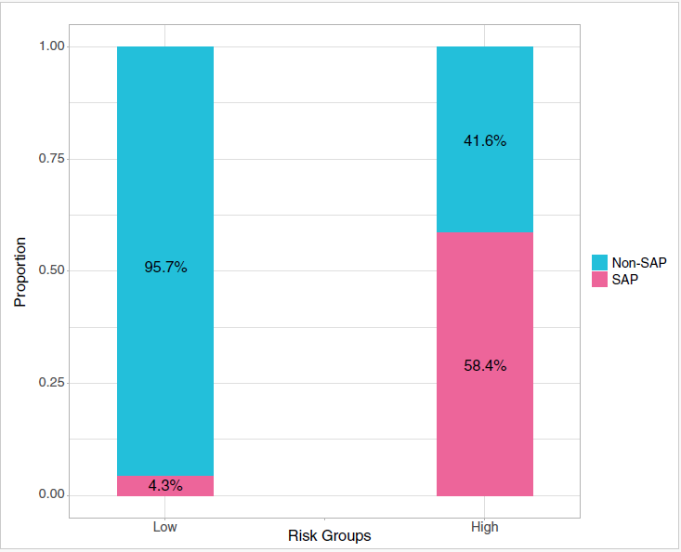

Figure S1: The incidence of SAP in the low-risk group and the high-risk group.
Abbreviations: SAP, severe acute pancreatitis.

