Gene | FP | RP
CD80 | GTCGCCTCTCTGAAGATTACCC | GCTCACGTAGAAGACCCTCC
CD84 | TCTGCTTGTTCTCATTCTGTCTTC | TGTGTTCACTGGCTCTTCCTT
CD274 | CTGGCATTTGCTGAACGCAT | AGGTCTTCCTCTCCATGCAC
IL15 | GGCCCAAAGCACCTAACCTA | AGGAAGCCCTGCACTGAAAC
IL10 | CCAGACATCAAGGCGCATGT | CATTCTTCACCTGCTCCACGG
TIGIT | CCCTCGCCTCAGGAATGATG | ACAAATGGCCAGAAGCTGGT
IL2 | ACTCACCAGGATGCTCACATT | CAAGTCAGTGTTGAGATGATGCT
GAPDH | CTCCCACTCTTCCACCTTCG | TTGCTGTAGCCGTATTCATT
ACTB | CATGTACGTTGCTATCCAGGC | CTCCTTAATGTCACGCACGAT
Supplemental Table 1. Primer sequences

Supplemental Table 2. Downregulated genes in CPX group
Gene.symbol | CPX4 | CPX5 | CPX6 | DMSO4 | DMSO5 | DMSO6
AHNAK | 10885 | 6463 | 8497 | 21489 | 32075 | 24547
PLEC | 14040 | 11951 | 10926 | 20717 | 26311 | 23997
TUBB | 5256 | 6262 | 5936 | 9762 | 12183 | 13016
MDFIC | 4687 | 5038 | 3989 | 7211 | 9539 | 8577
PAX5 | 2926 | 2825 | 2771 | 4678 | 6212 | 4501
LMNA | 5596 | 6441 | 5976 | 11339 | 16019 | 7754
ADGRE5 | 5506 | 6896 | 6368 | 10244 | 14367 | 9436
MKI67 | 2130 | 1606 | 2752 | 4032 | 5827 | 8429
RESF1 | 3311 | 2294 | 1920 | 8211 | 6705 | 3316
VOPP1 | 2800 | 2884 | 2182 | 5154 | 4980 | 4050
CBX6 | 3307 | 4346 | 5114 | 6690 | 10838 | 8989
GBP2 | 1936 | 2903 | 1893 | 3848 | 5584 | 6151
HDAC9 | 2601 | 2589 | 2159 | 6042 | 7315 | 5437
BMF | 620 | 780 | 755 | 1561 | 2626 | 2524
CDK6 | 3472 | 2843 | 2202 | 6389 | 8290 | 5786
MCM3 | 1458 | 1258 | 1129 | 2117 | 2432 | 2462
TOP2A | 1078 | 1175 | 1613 | 2181 | 3018 | 4476
DTX3L | 1799 | 2186 | 2339 | 3448 | 4913 | 4321
NSD2 | 1783 | 1681 | 1758 | 2595 | 3571 | 3906
TMED8 | 1660 | 1558 | 1957 | 2526 | 3673 | 3659
IRF5 | 1048 | 1419 | 1150 | 2234 | 2816 | 2421
PLXNA1 | 1274 | 925 | 1166 | 2565 | 2324 | 1636
NFATC2 | 1740 | 1697 | 1650 | 2616 | 3162 | 3525
FAR1 | 1550 | 1318 | 1489 | 2673 | 2830 | 2868
FCHSD2 | 720 | 734 | 892 | 1341 | 1854 | 1483
VAT1 | 576 | 610 | 667 | 1047 | 1180 | 1272
TTLL12 | 917 | 1057 | 997 | 2828 | 2158 | 1382
CFAP97 | 1201 | 1133 | 1110 | 2122 | 2211 | 2093
ANKRD28 | 1156 | 1127 | 1134 | 2112 | 2860 | 1738
TTF2 | 891 | 961 | 1029 | 2207 | 2930 | 1910
PKIG | 513 | 718 | 566 | 1004 | 1457 | 1184
CENPF | 469 | 407 | 715 | 1060 | 1501 | 1003
NEK6 | 706 | 511 | 588 | 1320 | 1294 | 1109
MORC2 | 860 | 842 | 693 | 1765 | 2093 | 1031
ATP6V0A2 | 1102 | 954 | 916 | 1904 | 1871 | 1696
ZBTB32 | 808 | 1560 | 996 | 1815 | 4194 | 2502
CRYBG1 | 480 | 450 | 684 | 915 | 1308 | 1183
DYRK2 | 572 | 642 | 687 | 1012 | 1312 | 1192
PCID2 | 827 | 1014 | 796 | 1500 | 2119 | 1324
ATP8B2 | 814 | 835 | 937 | 1625 | 1821 | 1171
LEMD2 | 632 | 684 | 744 | 1086 | 1321 | 1279
ASPM | 449 | 453 | 764 | 1053 | 1909 | 1187
CD84 | 111 | 94 | 154 | 307 | 479 | 345
INCENP | 291 | 278 | 374 | 707 | 923 | 1069
KIF1C | 377 | 394 | 330 | 811 | 753 | 525
KCNC4 | 530 | 548 | 505 | 875 | 1304 | 921
AMIGO2 | 494 | 521 | 540 | 1288 | 1173 | 1326
COBLL1 | 521 | 540 | 451 | 1026 | 1247 | 1050
CCNB1 | 421 | 486 | 472 | 769 | 1034 | 671
N4BP2 | 632 | 419 | 489 | 912 | 1132 | 1244
MAML2 | 594 | 521 | 471 | 916 | 1153 | 1215
ENPP4 | 808 | 623 | 649 | 1266 | 1436 | 1189
NHLRC2 | 363 | 356 | 396 | 564 | 966 | 699
MBNL3 | 430 | 286 | 468 | 675 | 959 | 809
TFEC | 493 | 393 | 350 | 1030 | 1016 | 1076
MAP3K4 | 432 | 329 | 347 | 743 | 702 | 766
MTAP | 624 | 655 | 646 | 1133 | 1393 | 899
TBC1D14 | 297 | 322 | 307 | 659 | 724 | 443
HOMER2 | 380 | 411 | 396 | 923 | 1192 | 544
DOP1B | 480 | 467 | 440 | 883 | 927 | 740
SLC29A1 | 653 | 578 | 340 | 1527 | 1154 | 889
CENPC | 464 | 428 | 501 | 699 | 953 | 842
CCNA2 | 285 | 344 | 299 | 575 | 844 | 841
ICMT | 443 | 398 | 312 | 731 | 818 | 584
ZNF507 | 366 | 301 | 509 | 866 | 927 | 1230
TP73-AS1 | 301 | 375 | 308 | 681 | 741 | 577
TTC13 | 336 | 382 | 336 | 655 | 798 | 474
RANBP6 | 319 | 303 | 306 | 548 | 763 | 585
CEP152 | 405 | 306 | 326 | 764 | 980 | 1014
CD274 | 434 | 433 | 483 | 773 | 927 | 1719
BRD3 | 425 | 439 | 343 | 739 | 925 | 565
FAN1 | 219 | 272 | 249 | 390 | 571 | 398
GPR174 | 332 | 406 | 292 | 515 | 922 | 717
TRNT1 | 454 | 410 | 424 | 738 | 789 | 747
RPE | 444 | 427 | 404 | 701 | 784 | 736
ZSCAN18 | 381 | 351 | 372 | 588 | 760 | 663
PKP4 | 265 | 346 | 279 | 608 | 778 | 652
HJURP | 275 | 261 | 430 | 621 | 750 | 899
PRMT3 | 415 | 606 | 464 | 915 | 1120 | 753
CCNF | 152 | 148 | 161 | 330 | 371 | 400
ANGEL1 | 353 | 441 | 427 | 707 | 874 | 666
UNG | 231 | 209 | 212 | 367 | 515 | 519
DCAF17 | 250 | 257 | 278 | 416 | 644 | 542
B3GNT7 | 378 | 342 | 336 | 663 | 628 | 690
KIF23 | 193 | 221 | 344 | 518 | 606 | 865
SORD | 371 | 377 | 370 | 913 | 958 | 507
PAXIP1 | 310 | 262 | 298 | 561 | 524 | 785
CYP1B1 | 77 | 68 | 77 | 395 | 198 | 107
USP45 | 334 | 293 | 324 | 506 | 634 | 566
BUB1B | 157 | 138 | 257 | 371 | 489 | 794
NDC80 | 203 | 177 | 253 | 437 | 441 | 673
MT-TC | 55 | 19 | 49 | 626 | 516 | 193
LMO2 | 263 | 332 | 166 | 846 | 911 | 391
FYCO1 | 203 | 218 | 212 | 422 | 675 | 827
LPCAT4 | 147 | 226 | 192 | 321 | 649 | 477
B4GALT2 | 359 | 518 | 348 | 1037 | 1071 | 591
LRRC8B | 397 | 454 | 407 | 817 | 1000 | 561
MAP7D3 | 365 | 365 | 322 | 603 | 668 | 566
METTL8 | 227 | 222 | 209 | 425 | 541 | 444
ATP2B4 | 175 | 125 | 123 | 419 | 436 | 262
ZNF514 | 115 | 162 | 187 | 273 | 426 | 278
PALB2 | 283 | 256 | 277 | 456 | 534 | 463
STX2 | 280 | 337 | 292 | 721 | 731 | 454
DSTN | 165 | 199 | 151 | 284 | 378 | 377
TTLL5 | 242 | 226 | 227 | 389 | 572 | 524
KIF18B | 160 | 183 | 163 | 309 | 423 | 478
LIPE | 241 | 264 | 234 | 491 | 747 | 322
DCLRE1A | 205 | 182 | 181 | 355 | 420 | 294
CDCA7 | 177 | 89 | 151 | 343 | 266 | 520
FAM214B | 161 | 230 | 201 | 448 | 550 | 401
MMD | 177 | 246 | 206 | 451 | 725 | 616
SEPSECS | 169 | 168 | 159 | 258 | 420 | 372
CD80 | 189 | 83 | 117 | 360 | 279 | 596
CD226 | 341 | 255 | 176 | 797 | 921 | 471
RAB11FIP2 | 239 | 210 | 194 | 411 | 455 | 353
NUDT16 | 81 | 120 | 144 | 341 | 386 | 190
LINC02210 | 154 | 210 | 180 | 261 | 525 | 383
GINS1 | 54 | 67 | 114 | 158 | 201 | 441
ETAA1 | 129 | 128 | 120 | 249 | 310 | 453
ARNTL2 | 249 | 312 | 225 | 459 | 589 | 653
FBXO5 | 133 | 115 | 158 | 260 | 270 | 408
GTPBP3 | 165 | 216 | 122 | 349 | 491 | 269
TRIM14 | 111 | 202 | 196 | 375 | 551 | 319
HNRNPLL | 161 | 197 | 176 | 307 | 421 | 316
USP31 | 255 | 146 | 169 | 585 | 499 | 359
GCFC2 | 248 | 250 | 254 | 500 | 529 | 354
IRS1 | 167 | 116 | 182 | 308 | 420 | 270
ZNF319 | 159 | 158 | 123 | 371 | 415 | 204
CKAP2L | 152 | 168 | 176 | 392 | 505 | 420
ACVR2B | 147 | 136 | 204 | 327 | 420 | 639
GPAM | 100 | 123 | 124 | 318 | 310 | 163
SUV39H2 | 144 | 122 | 134 | 224 | 290 | 306
PPARGC1B | 114 | 150 | 113 | 441 | 511 | 329
MAPK12 | 89 | 130 | 80 | 243 | 267 | 179
TSC22D1 | 142 | 124 | 155 | 293 | 396 | 231
ACTR5 | 184 | 175 | 186 | 376 | 348 | 396
FANCF | 94 | 126 | 117 | 233 | 317 | 180
ECT2 | 102 | 95 | 130 | 202 | 284 | 302
NEMP2 | 155 | 121 | 134 | 230 | 296 | 364
CASZ1 | 236 | 180 | 135 | 418 | 453 | 300
ALDH1B1 | 165 | 193 | 155 | 360 | 400 | 280
CAV1 | 39 | 40 | 26 | 174 | 148 | 153
ALKBH8 | 174 | 177 | 179 | 322 | 382 | 268
DPY19L4 | 90 | 64 | 65 | 138 | 182 | 182
CCNE1 | 92 | 59 | 69 | 189 | 191 | 202
ZDHHC23 | 90 | 146 | 129 | 236 | 314 | 265
RUNX2 | 174 | 236 | 244 | 517 | 564 | 630
HCG11 | 80 | 92 | 81 | 191 | 234 | 164
TRIP13 | 122 | 154 | 107 | 281 | 328 | 207
AMER1 | 76 | 118 | 119 | 232 | 324 | 274
ANLN | 45 | 36 | 57 | 82 | 126 | 239
MT-TY | 19 | 8 | 26 | 292 | 251 | 34
CRNDE | 138 | 153 | 139 | 370 | 435 | 378
TMOD2 | 51 | 72 | 65 | 90 | 216 | 201
TSPYL5 | 116 | 118 | 132 | 243 | 242 | 257
TMTC4 | 58 | 82 | 85 | 286 | 221 | 141
ITPRIPL1 | 86 | 168 | 116 | 274 | 357 | 315
PCYOX1L | 49 | 95 | 62 | 145 | 219 | 131
CMAHP | 88 | 125 | 136 | 301 | 465 | 276
ALG10 | 74 | 98 | 67 | 132 | 229 | 178
SLC45A3 | 107 | 141 | 139 | 284 | 293 | 246
C18orf54 | 64 | 56 | 55 | 100 | 140 | 310
LINC02416 | 103 | 145 | 146 | 307 | 397 | 474
GALNT12 | 105 | 132 | 97 | 221 | 248 | 289
CLIC5 | 145 | 139 | 165 | 445 | 431 | 443
LINC00158 | 108 | 168 | 112 | 185 | 444 | 635
DGAT2 | 48 | 71 | 75 | 223 | 245 | 175
MT-TN | 32 | 23 | 20 | 124 | 125 | 83
FAM86B3P | 61 | 86 | 82 | 128 | 272 | 176
PLD6 | 66 | 76 | 100 | 295 | 210 | 271
IL15 | 71 | 102 | 89 | 172 | 263 | 212
CENPA | 64 | 60 | 39 | 175 | 223 | 124
ZNF660 | 41 | 51 | 39 | 96 | 113 | 89
LRRC8C-DT | 70 | 63 | 35 | 213 | 204 | 84
TIGIT | 32 | 68 | 56 | 127 | 257 | 123
KCTD6 | 37 | 31 | 26 | 94 | 100 | 102
RAD50 | 63 | 49 | 50 | 103 | 140 | 138
FAM86DP | 61 | 63 | 90 | 227 | 226 | 128
TMEM231 | 60 | 83 | 45 | 156 | 252 | 104
FAM72B | 37 | 47 | 63 | 118 | 166 | 164
TCTN2 | 46 | 53 | 34 | 87 | 149 | 118
CSF2 | 60 | 116 | 65 | 218 | 371 | 178
IL10 | 35 | 64 | 43 | 153 | 202 | 280
GARNL3 | 38 | 50 | 45 | 156 | 153 | 101
PLAU | 19 | 60 | 35 | 259 | 296 | 71
STOML1 | 22 | 30 | 37 | 70 | 123 | 72
TRERF1 | 15 | 31 | 19 | 122 | 170 | 58
MLF1 | 30 | 54 | 40 | 113 | 160 | 91
TNFRSF8 | 38 | 37 | 24 | 101 | 105 | 107
AL356276.1 | 16 | 22 | 11 | 31 | 131 | 75
DLG5 | 23 | 16 | 19 | 63 | 81 | 47
FAM72D | 13 | 18 | 23 | 41 | 67 | 111
IL2 | 14 | 29 | 3 | 228 | 200 | 12
TRIM6 | 18 | 25 | 16 | 28 | 96 | 133
PTCHD1 | 15 | 5 | 12 | 66 | 64 | 30
ALG1L13P | 13 | 14 | 15 | 33 | 59 | 53
AL353152.2 | 14 | 14 | 18 | 35 | 48 | 119
ENPP5 | 8 | 8 | 11 | 24 | 32 | 97
ZNF385C | 17 | 20 | 15 | 31 | 48 | 171
AL590550.1 | 3 | 18 | 18 | 41 | 169 | 79
PPIAP45 | 4 | 11 | 14 | 37 | 45 | 56
CD2 | 8 | 24 | 13 | 39 | 91 | 91
TOX | 2 | 2 | 1 | 23 | 33 | 26
AL049830.3 | 1 | 2 | 2 | 8 | 19 | 27
MT-TV | 6 | 2 | 3 | 46 | 38 | 25
CFAP69 | 9 | 14 | 9 | 44 | 79 | 27
MAPK10 | 6 | 3 | 2 | 35 | 34 | 22
AC092112.1 | 1 | 3 | 2 | 7 | 40 | 17

Supplemental Table 3. Upregulated genes in CPX group
Gene.symbol | CPX1 | CPX2 | CPX3 | DMSO1 | DMSO2 | DMSO3
LDHA | 50980 | 43811 | 35320 | 11252 | 13297 | 23587
UBC | 26345 | 24190 | 22574 | 13394 | 17327 | 14404
MT2A | 990 | 256 | 120 | 117 | 177 | 86
HSPH1 | 5391 | 4138 | 4715 | 3286 | 3243 | 1992
HMOX1 | 2378 | 1314 | 849 | 142 | 93 | 142
MOB3A | 19320 | 19855 | 16692 | 8221 | 10164 | 10823
TXNRD1 | 8291 | 4488 | 4474 | 3514 | 2989 | 2344
HK2 | 32127 | 22013 | 20725 | 6842 | 6560 | 11500
HSPA1A | 2425 | 2245 | 2500 | 777 | 211 | 522
HK1 | 13614 | 11841 | 9927 | 4546 | 4743 | 6464
FTH1 | 6616 | 6081 | 9295 | 4207 | 5198 | 4160
GRB2 | 10642 | 9863 | 9743 | 6483 | 8251 | 6100
ZMIZ1 | 12434 | 10006 | 11572 | 8092 | 8310 | 7094
CXCR4 | 14967 | 13650 | 12717 | 6736 | 7463 | 5810
PFKFB3 | 9816 | 6958 | 9049 | 3197 | 3026 | 3626
DNAJB6 | 4597 | 3780 | 4121 | 3002 | 3576 | 2201
PSD4 | 9627 | 7942 | 9130 | 7015 | 7247 | 6221
DNAJA1 | 4339 | 3156 | 3675 | 2539 | 2499 | 2109
NR4A3 | 18600 | 13262 | 17601 | 5492 | 8482 | 8366
DNAJB1 | 3258 | 4279 | 4040 | 1046 | 928 | 1701
P4HB | 10162 | 8101 | 6267 | 4916 | 5076 | 5202
DDIT4 | 15832 | 12942 | 13339 | 4858 | 4693 | 9979
PFKP | 14168 | 11876 | 8945 | 7730 | 8609 | 4261
ITGB2 | 13629 | 14937 | 11444 | 3746 | 6032 | 6886
SUPT5H | 6696 | 5828 | 7307 | 5029 | 5681 | 4378
SLCO4A1 | 13858 | 12541 | 9697 | 8182 | 7614 | 7038
WDR26 | 9306 | 7019 | 8372 | 5904 | 7080 | 5601
TOP2B | 8252 | 7882 | 7269 | 4938 | 7323 | 4948
CSRNP1 | 15560 | 12072 | 11643 | 6318 | 6684 | 6786
FOSB | 14768 | 10476 | 15889 | 7521 | 7226 | 6064
PIK3AP1 | 6804 | 7000 | 5708 | 3978 | 5872 | 3396
MAP1LC3B | 7795 | 6855 | 6300 | 5702 | 5776 | 3163
CDKN1A | 9632 | 9156 | 8602 | 4533 | 4713 | 7043
NSMF | 7875 | 7248 | 5477 | 2243 | 2434 | 2302
SLC2A1 | 12497 | 9811 | 6855 | 1653 | 1908 | 3775
JUND | 6209 | 8078 | 7284 | 4046 | 6082 | 3677
LY9 | 5839 | 5519 | 7146 | 4771 | 5043 | 2551
SCD | 7206 | 8398 | 10235 | 2620 | 3743 | 6403
MGAT1 | 7760 | 8016 | 5973 | 3005 | 3257 | 3029
AMPD3 | 8696 | 8070 | 8381 | 4039 | 5966 | 3140
HSPA1B | 1076 | 1259 | 1466 | 362 | 153 | 536
ZBTB1 | 7135 | 5304 | 6170 | 1298 | 1855 | 3696
LONP1 | 7441 | 6794 | 5060 | 4190 | 5029 | 3826
PLEK | 6590 | 6719 | 4877 | 3100 | 4817 | 4231
TSPYL2 | 3421 | 3118 | 4041 | 2141 | 2795 | 2586
PER1 | 7828 | 8053 | 9184 | 2764 | 3841 | 5185
VEGFA | 10080 | 8350 | 8080 | 2064 | 2507 | 4855
DNAJA4 | 1220 | 1085 | 1197 | 570 | 584 | 290
ST3GAL1 | 7728 | 6248 | 7975 | 5257 | 6414 | 3997
BNIP3L | 6957 | 6029 | 5191 | 664 | 1021 | 3014
NXF1 | 5229 | 4220 | 4236 | 3225 | 3313 | 1814
FOSL2 | 7081 | 5974 | 9888 | 2643 | 4501 | 4334
PDXK | 3510 | 3654 | 3719 | 1654 | 2800 | 2584
NFATC1 | 5531 | 4921 | 4923 | 2193 | 2775 | 3582
MT1E | 86 | 20 | 7 | 1 | 0 | 0
TENT5C | 3479 | 4608 | 4538 | 1224 | 2803 | 2753
ZFP36L2 | 7847 | 7632 | 5425 | 2763 | 3375 | 3125
MALT1 | 5191 | 4556 | 6168 | 3479 | 4342 | 3441
ERO1A | 8712 | 6860 | 6505 | 1717 | 2297 | 3610
RIOK3 | 6155 | 5370 | 4991 | 3294 | 4143 | 3856
DDX24 | 4781 | 4370 | 4764 | 3353 | 3644 | 3581
SLC16A3 | 5770 | 6034 | 4976 | 718 | 1137 | 2364
INSIG2 | 6989 | 7146 | 9190 | 2304 | 3658 | 4741
RNASET2 | 4707 | 5808 | 4372 | 639 | 1093 | 3371
EIF2AK3 | 5664 | 4609 | 5114 | 3634 | 4445 | 3135
CRKL | 4786 | 3965 | 4349 | 2588 | 2959 | 3454
POM121C | 5525 | 4681 | 4987 | 2727 | 3197 | 2801
N4BP3 | 7944 | 6765 | 6621 | 1192 | 1689 | 3243
HSPA6 | 761 | 1026 | 855 | 87 | 60 | 128
ZNF395 | 4828 | 3845 | 3870 | 929 | 1011 | 2928
SASH3 | 3372 | 3444 | 3103 | 2532 | 3205 | 1805
MACROD2 | 4753 | 7560 | 3370 | 1967 | 4311 | 2481
SLC25A36 | 5272 | 4345 | 3808 | 2226 | 3222 | 3431
NGLY1 | 6772 | 5637 | 6717 | 1644 | 2344 | 3748
JOSD1 | 4811 | 4205 | 5060 | 3416 | 4490 | 2730
PDE7A | 3003 | 3272 | 3833 | 2436 | 3140 | 2243
NDRG1 | 4524 | 3467 | 3496 | 1675 | 2074 | 1552
PNRC1 | 4033 | 3924 | 3483 | 1359 | 1808 | 2389
AP5B1 | 3312 | 3056 | 2977 | 1365 | 2039 | 1087
MAP2K1 | 5917 | 5008 | 3746 | 2183 | 2426 | 2256
KDM7A | 5244 | 3352 | 4640 | 1904 | 2071 | 2145
DDX41 | 3318 | 3136 | 2247 | 1843 | 1971 | 980
FOS | 7021 | 5935 | 6281 | 4543 | 5082 | 4163
POM121 | 5434 | 4094 | 4354 | 3201 | 3063 | 2266
ZHX2 | 2938 | 1948 | 2246 | 1200 | 1523 | 1442
DNAJB2 | 3125 | 3225 | 2910 | 1034 | 1703 | 1505
SEC24A | 7251 | 4941 | 5565 | 1885 | 2053 | 3279
ALKBH5 | 5472 | 4691 | 3988 | 1588 | 1883 | 2229
PLEKHA2 | 2893 | 2615 | 2751 | 1121 | 1571 | 1788
TENT4A | 5787 | 4461 | 5067 | 2498 | 2960 | 3498
USP11 | 3725 | 3740 | 3428 | 2636 | 3358 | 1841
ATP6V0A1 | 1920 | 2135 | 2072 | 1283 | 2111 | 1075
BAG3 | 1304 | 1018 | 935 | 467 | 335 | 354
ARID5A | 3619 | 3875 | 4264 | 2738 | 3614 | 2507
EHBP1L1 | 3001 | 2908 | 3557 | 1917 | 2482 | 2034
TUBA4A | 2894 | 3577 | 3058 | 1240 | 1599 | 1688
SLC12A7 | 2479 | 2506 | 1977 | 1509 | 1931 | 1402
GUK1 | 4218 | 4142 | 5348 | 1669 | 2175 | 2620
VPS37B | 4108 | 3630 | 4596 | 2651 | 3024 | 1622
LGALS8 | 3728 | 2612 | 3208 | 1070 | 1329 | 1948
RB1 | 3437 | 2910 | 3358 | 1952 | 2857 | 2432
ARRDC2 | 2754 | 2660 | 3278 | 1418 | 1804 | 2203
EIF4A3 | 3880 | 3390 | 3237 | 2735 | 2334 | 2086
ATP6V0D1 | 2002 | 2093 | 2033 | 1441 | 1869 | 1392
SLC15A4 | 2839 | 2549 | 3125 | 1527 | 1728 | 2027
LDLRAD4 | 4312 | 3848 | 4207 | 2505 | 3400 | 2786
GCLM | 1152 | 752 | 940 | 406 | 371 | 357
KDM5B | 3764 | 2589 | 2327 | 1924 | 2096 | 1935
BIN1 | 2313 | 2431 | 2465 | 1286 | 1594 | 1546
RASAL1 | 1126 | 1367 | 1230 | 448 | 571 | 890
NR4A2 | 3120 | 3915 | 6680 | 1070 | 3013 | 1644
RYBP | 4403 | 3206 | 3484 | 2016 | 1984 | 2284
IMPAD1 | 4115 | 3483 | 3751 | 2336 | 2810 | 2425
EGLN1 | 1882 | 1229 | 967 | 195 | 210 | 413
MARCKS | 2347 | 1830 | 1406 | 1325 | 1265 | 1133
RIC8A | 2029 | 2598 | 2550 | 1682 | 2075 | 1368
RLF | 2638 | 1954 | 2512 | 1091 | 1276 | 1835
UBE2O | 2929 | 2861 | 2580 | 1756 | 1969 | 1741
LUZP1 | 2160 | 1200 | 1292 | 837 | 950 | 888
CREM | 2815 | 3014 | 4914 | 1406 | 2475 | 883
CCDC47 | 2911 | 2621 | 2632 | 1947 | 2334 | 1665
MT1X | 130 | 23 | 4 | 8 | 7 | 1
P4HA1 | 4115 | 3020 | 2740 | 459 | 557 | 1904
SKI | 3150 | 2774 | 2997 | 1406 | 1632 | 2178
PDK1 | 3289 | 2274 | 2305 | 905 | 1013 | 1977
RARA | 2958 | 3242 | 3075 | 1784 | 1989 | 1972
UPP1 | 3820 | 5080 | 2670 | 2496 | 2796 | 2102
GPT2 | 4599 | 4264 | 2684 | 2544 | 2551 | 1070
SYTL1 | 2469 | 3312 | 2524 | 831 | 1750 | 1845
RELT | 2886 | 2576 | 2895 | 1241 | 1509 | 2091
AK4 | 4128 | 3683 | 2354 | 478 | 751 | 1709
DEDD2 | 818 | 785 | 836 | 434 | 521 | 512
CHST2 | 3730 | 2418 | 1647 | 1567 | 1645 | 543
CLN8 | 1338 | 1507 | 1677 | 575 | 720 | 873
HPCAL1 | 2021 | 2304 | 1774 | 666 | 627 | 1087
SLC35E1 | 3001 | 2649 | 2463 | 1433 | 1377 | 1364
ZNF331 | 1887 | 1853 | 3659 | 535 | 1175 | 1246
ZDBF2 | 3669 | 1919 | 4815 | 1383 | 1611 | 1438
SH3TC1 | 1369 | 1761 | 2183 | 759 | 1103 | 765
ELL2 | 2720 | 2021 | 3809 | 1700 | 1854 | 1476
WDR45B | 3033 | 2907 | 2648 | 1104 | 1308 | 2110
MAFF | 4748 | 3633 | 4216 | 1239 | 1073 | 1411
MYLIP | 3461 | 2870 | 1732 | 1846 | 1565 | 1275
PAF1 | 1534 | 1641 | 2006 | 967 | 1313 | 1019
SPHK1 | 2395 | 2997 | 3186 | 1774 | 2168 | 1986
ZFAND2A | 1368 | 1042 | 1121 | 490 | 562 | 393
STX4 | 1523 | 1270 | 1635 | 933 | 1011 | 781
NARF | 1802 | 1853 | 1762 | 644 | 866 | 1020
UAP1L1 | 1112 | 1283 | 1042 | 330 | 412 | 825
TPD52 | 1469 | 1524 | 1282 | 610 | 953 | 1017
PNPLA8 | 1964 | 1298 | 1841 | 1061 | 935 | 1182
GPR183 | 2320 | 1830 | 2189 | 1246 | 1272 | 866
RIT1 | 1970 | 1163 | 1242 | 548 | 507 | 655
FAM210A | 3057 | 2711 | 3034 | 960 | 931 | 1887
CRIM1 | 3286 | 1598 | 1788 | 1338 | 1078 | 414
CTDP1 | 2026 | 1927 | 1860 | 1164 | 1084 | 960
CRELD2 | 1096 | 1392 | 1805 | 477 | 747 | 1055
ETV3 | 1916 | 1093 | 3313 | 688 | 885 | 1004
PPME1 | 2952 | 2841 | 2005 | 688 | 847 | 831
PIK3C3 | 1819 | 1519 | 1422 | 1113 | 1389 | 1141
JMJD6 | 2522 | 2066 | 2031 | 1025 | 953 | 1433
ZCCHC2 | 1820 | 1177 | 1764 | 983 | 1050 | 891
CERK | 1216 | 997 | 1052 | 398 | 667 | 482
FAM168A | 1539 | 1388 | 1593 | 616 | 990 | 625
LIMD1 | 1173 | 1024 | 850 | 644 | 872 | 590
C7orf50 | 1070 | 1356 | 1068 | 311 | 395 | 530
SPOCK2 | 1060 | 863 | 1299 | 496 | 599 | 536
PLIN2 | 2170 | 1563 | 997 | 1024 | 808 | 542
SH3GL1 | 1991 | 2054 | 1795 | 857 | 966 | 1174
ARL4C | 1840 | 1816 | 2344 | 1244 | 1473 | 1404
SERTAD1 | 2745 | 2607 | 2077 | 686 | 764 | 1079
ERF | 1793 | 1814 | 1759 | 980 | 1099 | 1276
ZNF654 | 1616 | 1031 | 1119 | 550 | 664 | 803
BMPR2 | 1317 | 869 | 1025 | 664 | 852 | 623
PXDC1 | 1985 | 2212 | 2029 | 881 | 1184 | 1036
VGLL4 | 1983 | 1643 | 1369 | 445 | 583 | 1080
SLC25A19 | 1731 | 1811 | 1679 | 983 | 1106 | 1014
TOM1 | 677 | 604 | 639 | 497 | 482 | 374
ALG13 | 1505 | 1299 | 1568 | 998 | 1330 | 961
FSCN1 | 1906 | 2151 | 2140 | 396 | 408 | 889
CD5 | 2378 | 2364 | 2841 | 1017 | 1076 | 483
MOAP1 | 1783 | 1477 | 1721 | 1068 | 1133 | 1086
RUNDC1 | 1515 | 1232 | 1280 | 749 | 1169 | 858
SHF | 1144 | 1358 | 1046 | 407 | 722 | 882
FKBP15 | 826 | 945 | 967 | 577 | 922 | 553
MXD1 | 1060 | 1023 | 1001 | 472 | 620 | 816
ATG9A | 1332 | 1376 | 1211 | 645 | 926 | 555
FLT1 | 3732 | 2051 | 1422 | 1394 | 1273 | 736
VAPB | 1104 | 1313 | 1120 | 740 | 1022 | 782
SRA1 | 1244 | 1151 | 1222 | 713 | 814 | 480
KCNC3 | 1053 | 1156 | 990 | 558 | 851 | 424
KCTD5 | 1123 | 1047 | 1008 | 835 | 868 | 518
SPTBN4 | 1305 | 709 | 863 | 185 | 133 | 129
RAP2B | 1038 | 872 | 886 | 463 | 583 | 510
PNPLA7 | 643 | 564 | 537 | 260 | 339 | 303
PER2 | 1748 | 1239 | 1679 | 899 | 1061 | 1147
PPP1R3E | 503 | 680 | 579 | 99 | 308 | 366
ATP7A | 699 | 617 | 583 | 275 | 447 | 357
PRKRIP1 | 1304 | 1219 | 1038 | 560 | 688 | 538
NUMBL | 974 | 1034 | 1248 | 494 | 539 | 743
PIGA | 1998 | 1165 | 1775 | 590 | 607 | 812
RMND5B | 1061 | 1095 | 939 | 525 | 618 | 623
BCKDK | 890 | 1140 | 764 | 654 | 835 | 566
ZNF394 | 853 | 738 | 951 | 598 | 748 | 591
ISCA1 | 1268 | 1012 | 947 | 773 | 749 | 591
CREB3 | 746 | 880 | 864 | 486 | 715 | 445
C4orf3 | 945 | 1046 | 739 | 310 | 387 | 655
UPRT | 2320 | 2109 | 1386 | 344 | 505 | 485
IPMK | 1785 | 1136 | 1274 | 544 | 586 | 965
SIRT2 | 728 | 664 | 678 | 489 | 692 | 432
THUMPD3-AS1 | 718 | 494 | 701 | 439 | 495 | 366
RNF24 | 1115 | 925 | 936 | 492 | 665 | 615
RGS2 | 921 | 933 | 1272 | 493 | 794 | 297
FBXO42 | 1124 | 879 | 763 | 512 | 481 | 534
GABARAPL1 | 800 | 466 | 732 | 411 | 516 | 339
APBB3 | 519 | 543 | 626 | 278 | 380 | 328
DNAJC4 | 904 | 1105 | 881 | 585 | 829 | 498
POLR2H | 1091 | 1083 | 874 | 701 | 931 | 719
CASP9 | 902 | 1141 | 1829 | 515 | 723 | 338
DCXR | 613 | 701 | 652 | 515 | 602 | 393
TBC1D27P | 771 | 1238 | 1079 | 276 | 797 | 594
BLVRB | 677 | 660 | 665 | 171 | 186 | 321
ESR2 | 1071 | 1096 | 1766 | 375 | 775 | 620
KCTD11 | 1517 | 1367 | 1211 | 172 | 233 | 674
CDK5R1 | 1307 | 1208 | 1407 | 933 | 1255 | 825
TSPOAP1 | 1140 | 1349 | 1799 | 590 | 1146 | 535
GPER1 | 515 | 463 | 233 | 33 | 27 | 112
HIC1 | 1635 | 1901 | 1591 | 771 | 862 | 1034
ADPRS | 945 | 859 | 737 | 647 | 649 | 515
GALNS | 913 | 691 | 750 | 609 | 597 | 384
VAMP2 | 775 | 946 | 920 | 537 | 776 | 503
DIPK2A | 1509 | 926 | 828 | 378 | 358 | 366
MCRIP2 | 748 | 880 | 715 | 559 | 730 | 426
AL079338.1 | 1456 | 1403 | 522 | 378 | 585 | 179
TLCD3A | 1866 | 1580 | 892 | 363 | 455 | 478
RNF113A | 1050 | 1019 | 840 | 512 | 689 | 589
ZNF667 | 1066 | 829 | 808 | 374 | 675 | 442
PPAN | 1056 | 1173 | 1004 | 658 | 769 | 373
OPA3 | 831 | 717 | 846 | 597 | 593 | 483
AC006001.3 | 716 | 906 | 862 | 521 | 656 | 466
FAM117B | 791 | 653 | 743 | 453 | 632 | 477
ACBD5 | 879 | 797 | 860 | 458 | 623 | 445
ZNF470 | 515 | 565 | 471 | 292 | 478 | 304
QPCTL | 825 | 962 | 988 | 578 | 755 | 272
TMUB2 | 522 | 574 | 843 | 369 | 528 | 363
LGMN | 219 | 332 | 271 | 152 | 182 | 160
P2RY11 | 794 | 1002 | 714 | 429 | 682 | 227
BMT2 | 707 | 617 | 605 | 237 | 270 | 401
NIBAN2 | 1532 | 841 | 678 | 472 | 248 | 228
PGRMC2 | 690 | 664 | 642 | 491 | 586 | 395
RAPGEFL1 | 171 | 130 | 138 | 101 | 86 | 66
TRIB2 | 356 | 299 | 201 | 115 | 194 | 135
FOSL1 | 1058 | 1168 | 1039 | 877 | 946 | 549
ANKRD37 | 975 | 919 | 1163 | 255 | 265 | 697
LINC01128 | 854 | 753 | 887 | 557 | 563 | 482
SDF2 | 625 | 565 | 583 | 407 | 483 | 275
RAB40C | 417 | 394 | 454 | 274 | 311 | 216
PLEKHA8 | 834 | 651 | 812 | 375 | 392 | 433
PPP1R37 | 571 | 593 | 715 | 411 | 524 | 347
RAB20 | 588 | 389 | 338 | 171 | 100 | 231
SIK1B | 1166 | 885 | 778 | 303 | 392 | 207
CERNA2 | 440 | 364 | 273 | 49 | 58 | 50
SRD5A1 | 660 | 763 | 582 | 447 | 600 | 413
SLC37A2 | 371 | 518 | 834 | 194 | 341 | 237
APOL1 | 518 | 666 | 284 | 124 | 287 | 218
PLAUR | 1305 | 1012 | 1087 | 623 | 404 | 637
RXRA | 1168 | 735 | 659 | 181 | 141 | 466
PPP1R13L | 795 | 801 | 818 | 314 | 393 | 461
CISD2 | 599 | 539 | 508 | 371 | 376 | 238
RALGDS | 650 | 647 | 640 | 379 | 402 | 309
C2orf42 | 359 | 407 | 492 | 271 | 367 | 234
TRIM39 | 493 | 501 | 600 | 374 | 471 | 241
ZNF432 | 526 | 520 | 446 | 320 | 476 | 265
C1orf159 | 514 | 551 | 718 | 430 | 491 | 348
PWWP2B | 567 | 522 | 460 | 343 | 484 | 266
ZNF667-AS1 | 562 | 565 | 558 | 337 | 355 | 194
TP53INP2 | 482 | 443 | 542 | 287 | 380 | 224
CRYBB2P1 | 578 | 499 | 410 | 240 | 389 | 328
PPP1R3B | 543 | 235 | 574 | 88 | 91 | 275
SLC25A4 | 569 | 545 | 505 | 304 | 287 | 282
USE1 | 513 | 531 | 568 | 288 | 298 | 320
SNAPC1 | 737 | 614 | 706 | 257 | 200 | 230
ATG9B | 97 | 75 | 41 | 24 | 33 | 21
PIF1 | 354 | 404 | 407 | 160 | 280 | 197
AC099489.1 | 339 | 163 | 225 | 95 | 148 | 67
NAA38 | 366 | 363 | 441 | 193 | 277 | 234
ZNF296 | 523 | 579 | 527 | 161 | 198 | 259
GTF2IRD2B | 163 | 157 | 168 | 68 | 119 | 100
PRR7 | 704 | 790 | 602 | 362 | 466 | 372
RTL8C | 448 | 491 | 312 | 272 | 347 | 183
AC009690.1 | 63 | 34 | 62 | 17 | 19 | 17
KCND1 | 575 | 667 | 739 | 352 | 562 | 479
OXSM | 446 | 399 | 470 | 99 | 163 | 82
SAP30 | 700 | 606 | 601 | 155 | 213 | 379
ZNF829 | 329 | 303 | 389 | 236 | 277 | 223
SCAND2P | 194 | 149 | 92 | 38 | 70 | 45
HIF1A-AS3 | 838 | 660 | 282 | 28 | 40 | 127
DHRS13 | 303 | 323 | 315 | 102 | 178 | 221
TNS1 | 437 | 234 | 153 | 167 | 92 | 98
ALDOA | 583 | 501 | 554 | 97 | 136 | 292
AC138393.1 | 353 | 367 | 381 | 149 | 239 | 211
HAVCR2 | 361 | 436 | 352 | 90 | 223 | 112
DLL1 | 331 | 524 | 900 | 197 | 352 | 88
PANX2 | 312 | 254 | 233 | 42 | 89 | 131
SPSB2 | 656 | 407 | 386 | 83 | 157 | 62
GIPR | 543 | 556 | 423 | 225 | 245 | 97
ITGA6 | 273 | 209 | 184 | 119 | 124 | 87
ORAI3 | 183 | 313 | 236 | 96 | 199 | 129
SERPINE1 | 476 | 323 | 375 | 194 | 153 | 108
TRIM9 | 653 | 372 | 215 | 149 | 201 | 136
GPR146 | 374 | 358 | 206 | 1 | 11 | 43
LRP2BP | 216 | 213 | 196 | 116 | 182 | 132
SPON2 | 436 | 392 | 484 | 73 | 93 | 110
FAM13A-AS1 | 441 | 430 | 452 | 34 | 83 | 255
SWT1 | 277 | 300 | 353 | 176 | 266 | 194
FABP3 | 119 | 117 | 31 | 38 | 34 | 25
PDXP | 261 | 354 | 271 | 168 | 212 | 152
HSPA1L | 27 | 42 | 48 | 12 | 15 | 16
TXNDC17 | 271 | 304 | 288 | 193 | 221 | 143
CSPG4P10 | 129 | 110 | 102 | 55 | 64 | 59
SMOX | 553 | 391 | 427 | 287 | 187 | 76
DUOX2 | 56 | 28 | 19 | 11 | 2 | 0
MC1R | 213 | 249 | 358 | 104 | 163 | 115
NOCT | 334 | 328 | 284 | 107 | 177 | 234
GLI1 | 335 | 281 | 472 | 149 | 333 | 157
TMEM88 | 472 | 417 | 514 | 320 | 378 | 227
AC092053.4 | 583 | 352 | 500 | 216 | 228 | 269
ZNF10 | 134 | 104 | 170 | 61 | 96 | 55
SMAP1 | 306 | 287 | 230 | 178 | 187 | 169
COL7A1 | 209 | 194 | 185 | 71 | 111 | 109
RAB33A | 446 | 506 | 313 | 208 | 221 | 219
PARD6G | 85 | 126 | 124 | 26 | 37 | 7
LINC01145 | 198 | 271 | 196 | 126 | 178 | 102
KIRREL2 | 458 | 482 | 387 | 140 | 198 | 114
ZNF668 | 207 | 165 | 220 | 122 | 170 | 108
WDR83 | 224 | 207 | 190 | 137 | 163 | 114
SERINC2 | 115 | 133 | 117 | 82 | 84 | 40
EMC9 | 216 | 260 | 187 | 72 | 145 | 143
CBARP | 216 | 338 | 292 | 174 | 222 | 135
DUOX1 | 262 | 183 | 219 | 91 | 148 | 110
CCL28 | 174 | 226 | 159 | 72 | 88 | 129
AC091729.1 | 630 | 434 | 206 | 28 | 40 | 75
MTRNR2L8 | 362 | 226 | 357 | 112 | 194 | 159
PSMD6-AS2 | 193 | 134 | 186 | 78 | 94 | 73
EGR4 | 358 | 413 | 526 | 185 | 255 | 122
NLRP3 | 500 | 339 | 498 | 128 | 123 | 64
AC004980.1 | 464 | 239 | 188 | 140 | 139 | 75
AL021707.6 | 249 | 285 | 270 | 108 | 221 | 106
KPTN | 161 | 204 | 322 | 101 | 115 | 61
MTARC1 | 29 | 11 | 131 | 13 | 5 | 9
MROH6 | 227 | 288 | 278 | 92 | 165 | 63
OTUD7A | 270 | 205 | 166 | 88 | 71 | 88
PTAFR | 235 | 261 | 131 | 89 | 78 | 98
AC078883.1 | 236 | 133 | 133 | 23 | 28 | 53
HES4 | 231 | 222 | 411 | 119 | 140 | 89
YJEFN3 | 163 | 170 | 187 | 113 | 130 | 79
LINC01409 | 192 | 141 | 179 | 74 | 93 | 75
SLC8A2 | 224 | 233 | 509 | 12 | 52 | 15
PARD6G-AS1 | 52 | 37 | 90 | 15 | 26 | 7
KIAA1614 | 100 | 88 | 112 | 32 | 75 | 34
AC107959.1 | 254 | 296 | 165 | 90 | 162 | 18
AL162274.1 | 181 | 79 | 119 | 4 | 8 | 56
NPHS1 | 383 | 289 | 293 | 98 | 101 | 22
C15orf48 | 161 | 143 | 113 | 81 | 31 | 55
AC090617.5 | 280 | 335 | 323 | 66 | 94 | 63
PLCD1 | 100 | 73 | 123 | 42 | 54 | 53
SEC14L2 | 121 | 98 | 120 | 29 | 54 | 53
APLP1 | 226 | 174 | 177 | 84 | 117 | 60
AC104581.4 | 198 | 129 | 204 | 70 | 105 | 61
MPND | 122 | 104 | 88 | 49 | 79 | 57
ATP6V1FNB | 151 | 76 | 134 | 49 | 76 | 25
NOP2 | 157 | 118 | 154 | 60 | 79 | 46
LPAR6 | 253 | 229 | 260 | 108 | 101 | 95
VKORC1 | 116 | 141 | 137 | 83 | 105 | 67
KCNIP2 | 136 | 181 | 126 | 37 | 68 | 52
FHDC1 | 265 | 151 | 140 | 61 | 96 | 22
ASTL | 207 | 196 | 240 | 93 | 128 | 141
STAC2 | 122 | 81 | 39 | 32 | 29 | 28
DSTNP2 | 256 | 182 | 170 | 26 | 26 | 20
MTUS2-AS1 | 120 | 64 | 58 | 16 | 42 | 2
AC105046.1 | 333 | 188 | 191 | 106 | 93 | 145
HTR3A | 294 | 157 | 142 | 84 | 65 | 84
ATP2A1 | 156 | 146 | 125 | 54 | 122 | 55
DPP4 | 221 | 234 | 156 | 96 | 146 | 52
MTX1P1 | 46 | 72 | 101 | 23 | 47 | 29
AP001062.1 | 140 | 164 | 105 | 58 | 113 | 38
AC009690.2 | 17 | 17 | 52 | 6 | 3 | 6
KDM7A-DT | 181 | 97 | 81 | 43 | 37 | 27
CCDC107 | 123 | 101 | 145 | 40 | 51 | 74
AC121761.1 | 164 | 138 | 150 | 85 | 119 | 87
TUBB3 | 23 | 33 | 54 | 8 | 17 | 11
SNRPN | 65 | 96 | 89 | 44 | 45 | 43
GAL3ST2 | 266 | 143 | 146 | 89 | 81 | 84
LY6G5C | 170 | 164 | 174 | 78 | 131 | 55
AL118516.1 | 214 | 168 | 129 | 28 | 54 | 57
FNTB | 110 | 147 | 78 | 41 | 57 | 68
CIART | 106 | 87 | 64 | 29 | 41 | 43
BTBD11 | 92 | 75 | 168 | 42 | 61 | 42
CCDC62 | 120 | 101 | 126 | 44 | 80 | 42
SLC29A4 | 40 | 64 | 65 | 16 | 13 | 26
HSPA4L | 37 | 40 | 54 | 5 | 14 | 14
LINC01679 | 118 | 85 | 153 | 23 | 33 | 60
LINC01138 | 90 | 125 | 82 | 38 | 65 | 52
CYGB | 86 | 149 | 168 | 60 | 85 | 16
ATL1 | 88 | 88 | 49 | 22 | 44 | 27
C17orf107 | 158 | 120 | 246 | 68 | 73 | 39
KCNH3 | 98 | 138 | 73 | 35 | 50 | 28
ADRA2B | 138 | 157 | 178 | 35 | 40 | 65
CCDC17 | 99 | 108 | 150 | 76 | 75 | 50
RPL13P5 | 190 | 154 | 75 | 24 | 16 | 8
AC139100.2 | 37 | 42 | 47 | 9 | 15 | 3
ANK1 | 103 | 81 | 96 | 21 | 50 | 34
PLOD2 | 182 | 71 | 42 | 3 | 4 | 39
AC084117.1 | 184 | 125 | 120 | 14 | 16 | 52
AC009630.4 | 235 | 116 | 159 | 58 | 26 | 46
AL117336.1 | 105 | 96 | 146 | 42 | 67 | 34
GPRC5A | 246 | 98 | 87 | 56 | 35 | 20
SCN1B | 147 | 121 | 187 | 31 | 35 | 27
TACR2 | 166 | 99 | 107 | 20 | 4 | 19
RAB42 | 61 | 56 | 22 | 8 | 8 | 14
MYEOV | 131 | 159 | 135 | 75 | 57 | 33
NAGS | 152 | 110 | 70 | 30 | 50 | 50
ADAMTSL4-AS1 | 81 | 74 | 84 | 39 | 56 | 32
AC008267.3 | 74 | 54 | 82 | 27 | 36 | 15
AL049757.2 | 85 | 101 | 93 | 35 | 48 | 15
RHBDL1 | 92 | 110 | 78 | 28 | 57 | 33
CFAP53 | 92 | 64 | 121 | 20 | 43 | 32
ZNF565 | 50 | 43 | 71 | 21 | 23 | 26
SPRED3 | 101 | 76 | 71 | 17 | 25 | 41
MIF-AS1 | 118 | 44 | 76 | 32 | 26 | 32
RN7SL402P | 120 | 137 | 86 | 56 | 56 | 31
MPP2 | 83 | 76 | 46 | 12 | 26 | 38
LYPD3 | 33 | 29 | 94 | 18 | 15 | 13
AC120049.1 | 50 | 36 | 30 | 10 | 14 | 18
RHOU | 95 | 25 | 23 | 13 | 11 | 5
AL356273.6 | 91 | 50 | 109 | 35 | 38 | 39
PKD1L1 | 70 | 42 | 66 | 21 | 17 | 13
AC120057.3 | 63 | 62 | 94 | 29 | 43 | 19
AC024051.10 | 111 | 101 | 72 | 33 | 26 | 19
TACSTD2 | 212 | 76 | 76 | 8 | 15 | 7
AL021407.3 | 55 | 43 | 55 | 12 | 15 | 5
SLC6A13 | 88 | 70 | 68 | 14 | 29 | 2
NOTCH3 | 31 | 36 | 18 | 10 | 5 | 3
RNF223 | 68 | 54 | 112 | 24 | 27 | 35
AC144831.1 | 93 | 93 | 84 | 27 | 45 | 16
AL591845.1 | 59 | 34 | 56 | 10 | 8 | 8
NXN | 40 | 25 | 29 | 14 | 3 | 4
SLC23A3 | 43 | 23 | 45 | 13 | 8 | 11
BACH1-IT2 | 76 | 38 | 68 | 25 | 28 | 25
AL731571.1 | 94 | 48 | 52 | 28 | 23 | 12
AC104365.3 | 74 | 55 | 71 | 21 | 27 | 11
AL353795.3 | 41 | 24 | 72 | 22 | 10 | 6
AC092053.3 | 61 | 47 | 97 | 20 | 25 | 27
AC253572.2 | 79 | 47 | 56 | 13 | 9 | 32
PRRT1B | 45 | 20 | 58 | 11 | 8 | 3
PPP1R3G | 66 | 35 | 17 | 4 | 1 | 9
NOVA2 | 51 | 28 | 54 | 16 | 16 | 3
LINC00996 | 46 | 30 | 43 | 15 | 16 | 8
AC131392.1 | 21 | 56 | 54 | 3 | 21 | 5
PCAT6 | 49 | 71 | 30 | 4 | 11 | 24
AC087164.1 | 60 | 39 | 44 | 4 | 4 | 11
RPL35AP32 | 46 | 31 | 36 | 10 | 15 | 16
AC027031.2 | 40 | 61 | 49 | 8 | 13 | 17
BX323046.2 | 17 | 11 | 19 | 4 | 2 | 0
CAMK2N2 | 36 | 41 | 49 | 13 | 18 | 4
AL355377.3 | 14 | 23 | 37 | 5 | 4 | 2
AC010655.2 | 45 | 47 | 17 | 0 | 2 | 2
PRODH2 | 72 | 30 | 20 | 5 | 4 | 1
ATP6V0CP4 | 34 | 41 | 58 | 10 | 8 | 7
AC068946.1 | 18 | 19 | 9 | 2 | 3 | 2
MIR212 | 23 | 59 | 50 | 8 | 14 | 6
PERCC1 | 36 | 33 | 27 | 6 | 9 | 0
EPHA8 | 13 | 26 | 21 | 0 | 1 | 2
DUOXA1 | 51 | 15 | 29 | 4 | 14 | 2
DBIL5P | 28 | 32 | 35 | 4 | 4 | 5
PDLIM3 | 29 | 16 | 41 | 5 | 3 | 6
TAC3 | 26 | 29 | 17 | 7 | 8 | 3
AC007448.5 | 35 | 29 | 23 | 1 | 4 | 2
TGFBR3L | 16 | 14 | 17 | 1 | 4 | 1
GJB7 | 42 | 19 | 8 | 3 | 6 | 2
CASQ1 | 28 | 19 | 32 | 10 | 9 | 3
LMAN1L | 30 | 33 | 16 | 3 | 8 | 2
BGLAP | 10 | 19 | 23 | 3 | 4 | 3
EIF1P6 | 19 | 28 | 17 | 6 | 5 | 2
OVOL1-AS1 | 24 | 7 | 21 | 1 | 0 | 2
ENO1-AS1 | 16 | 14 | 19 | 2 | 3 | 1
TAL1 | 31 | 10 | 17 | 4 | 2 | 0
AC010335.1 | 20 | 18 | 14 | 4 | 1 | 1

Supplemental figures

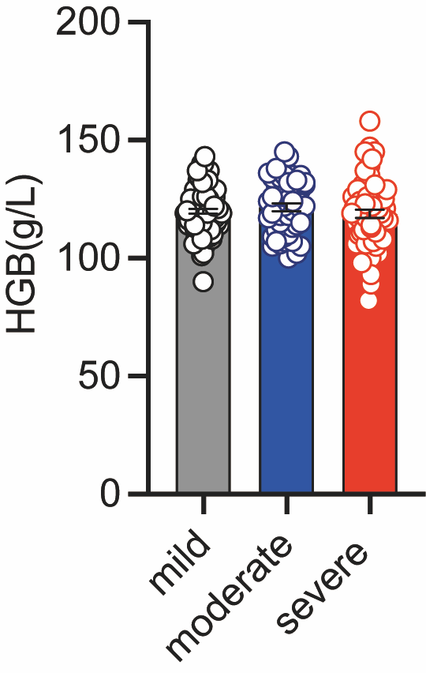
Supplemental Figure 1. The levels of hemoglobin (HGB) in pediatric AD. The levels of HGB in peripheral blood of children with mild (n=100), moderate (n=48), and severe AD (n=69). No significant differences were observed (Ordinary one-way ANOVA and Tukey’s multiple comparisons test was used).
Supplemental Figure 2. The percentage of CD19⁺ B cells and CD24⁺CD27⁺CD19⁺ Breg cells in pediatric AD. Representative flow cytometry and quantification of CD19⁺ B cells (A) and CD24⁺CD27⁺CD19⁺ Breg cells (B) in healthy donors (n=31) and children with AD (n=24). No significant differences were observed (Unpaired 2-tailed Student’s t test for A and B).
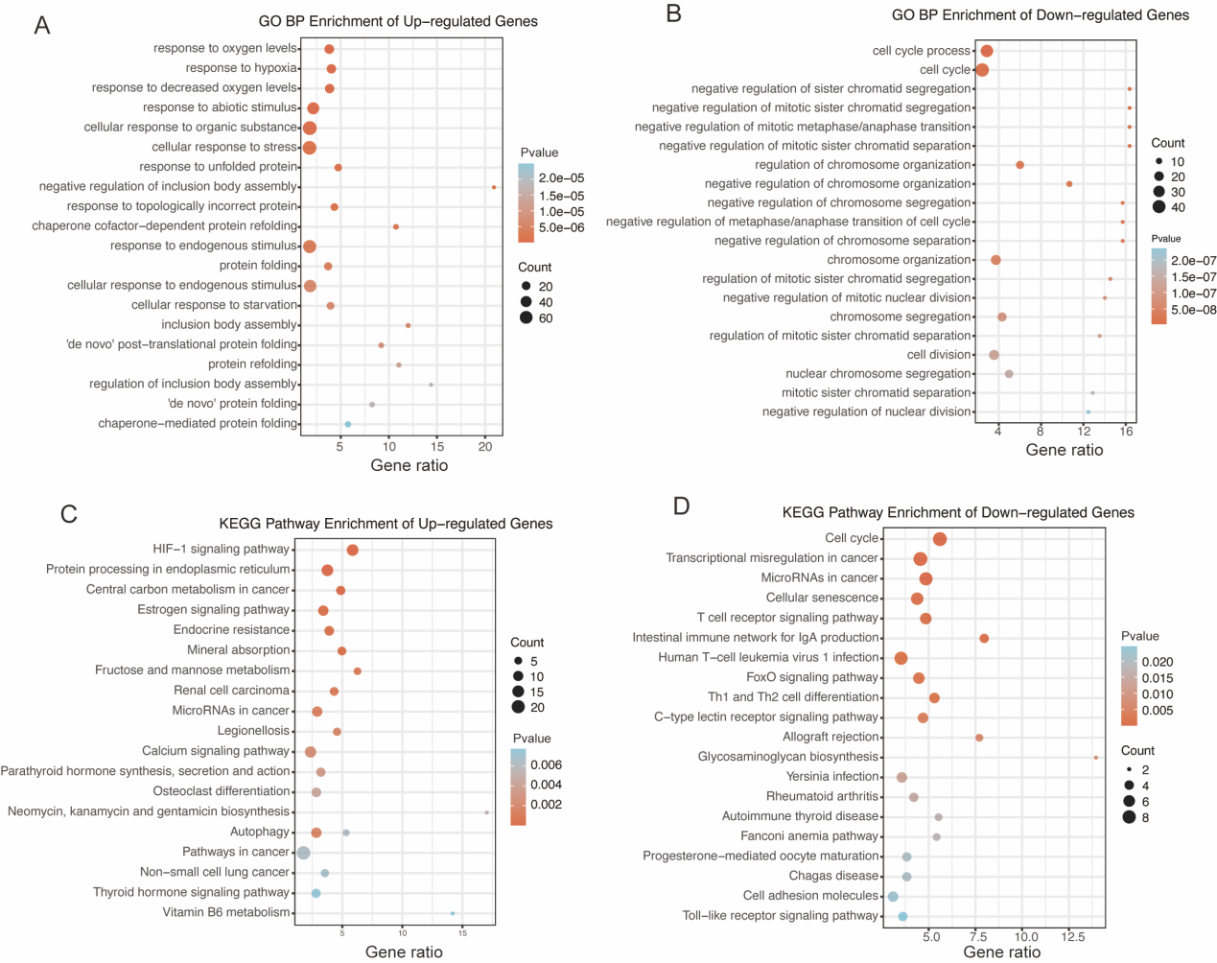
Supplemental Figure 3. The functional enrichment analysis of the differentially expressed genes. The top biological processes (BP) enriched in CPX (A) and DMSO (B). The significantly enriched KEGG pathways in CPX (C) and DMSO (D).
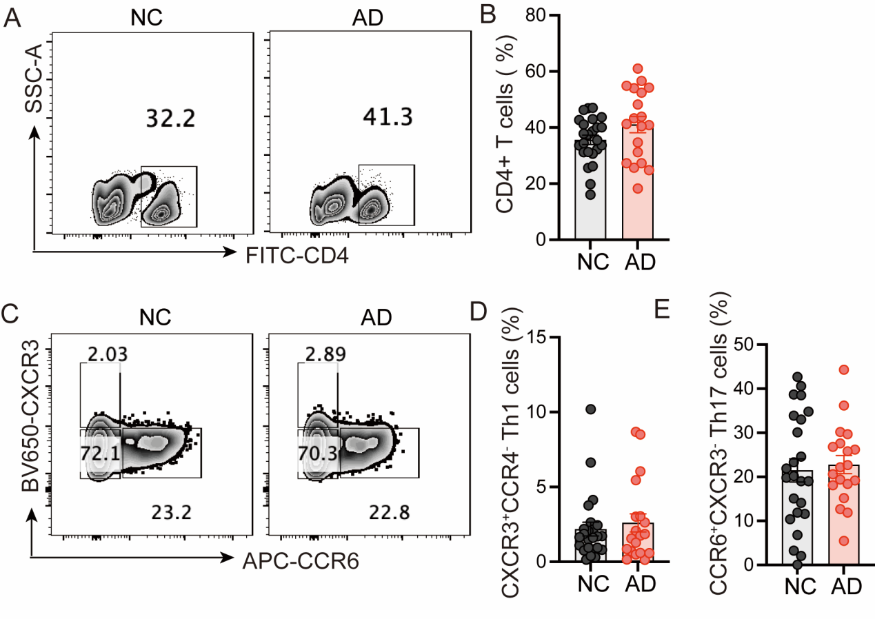
Supplemental Figure 4. The proportions of CD4⁺ T cells, Th1, and Th17 cells between AD patients and healthy controls. (A and B) Representative flow cytometry (A) and quantification (B) of CD4⁺ T cells in healthy controls (n=24) and children with AD (n=19). (C-E) Representative flow cytometry (C) and quantification of CD4⁺CXCR3⁺CCR6⁻ Th1 cells (D), and CD4⁺CCR6⁺CXCR3⁻ Th17 cells (E) in healthy controls (n=24) and children with AD (n=20). No significant differences were observed (unpaired 2-tailed Student’s t test for B, D and E).

