Supplementary Materials

Supplementary Table S1: Pulmonary function tests data of hemodialysis patients with COPD

Parameter | N | Value, mean±SD
FEV1%pred | 43 | 59.6±22.3
FEV1, L | 43 | 1.64±0.83
FVC%pred | 43 | 71.4±20.2
FVC, L | 43 | 2.63±0.98
FEV1/FVC | 43 | 0.61±0.1
DLCO | 30 | 49.6±20
DLCO, diffusion capacity for carbon monoxide; FEV1, forced expiratory volume in 1 second; FVC, forced vital capacity.

Supplementary Table S2: Multivariate regression analysis of predictors for ACS

Variable | OR | 95%CI | p-value
Age at HD initiation | 1.004 | 0.98-1.03 | 0.741
Male gender | 2.5 | 1.13-5.53 | 0.024
COPD group | 2.19 | 0.98-4.93 | 0.056
IHD | 4.99 | 2.23-11.16 | <0.001
Heart failure | 0.86 | 0.43-1.74 | 0.671
Diabetes mellitus | 1.65 | 0.82-3.33 | 0.171
ACS, acute coronary syndrome; COPD, chronic obstructive pulmonary disease; IHD, history of ischemic heart disease
Significant p-values (<0.05) are presented in bold.

Supplementary Figure S1: Flowchart of study participants

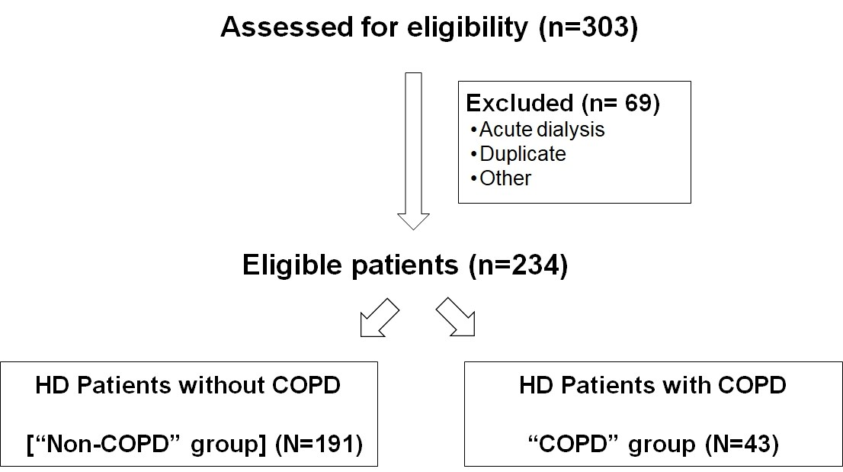

COPD, chronic obstructive pulmonary disease; HD, hemodialysis.

